IN-VITRO STUDY OF BIODEGRADATION OF SPENT LUBRICATING OIL BY ASPERGILLUS NIGER

^{1*}Stephen, E., Emmanuel, O.E., Okpanachi, O.S., Emmanuel, S., Temola, O.T., Musa, K. and Ebiloma, I.P²

- Department of Microbiology, Kogi State University, Anyigba, Nigeria
- Department of Science, Kogi State Polytechnic, Lokoja, Nigeria
psychsea07@gmail.com

Abstract: Biodegradation of spent lubricating oil by Aspergillus niger was studied in vitro for 16 days. The pH, turbidity, nitrate and gas chromatographic analysis (GC-MS) of the medium was carried out. The result showed increase in pH and turbidity in the course of the study while nitrate concentration declined over the same period. There were significant differences (p<0.05) in pH, turbidity and nitrate concentrations between the controls and the inoculated samples. The GC-MS revealed that alkanes were degraded into carboxylic acids while benzene and azulene were not degraded by Aspergillus niger. This study suggests that Aspergillus niger can grow and metabolize some compounds in spent lubricating oil.
[Stephen, E., Emmanuel, O.E., Okpanachi, O.S., Emmanuel, S., Temola, O.T, Musa, K. and Ebiloma, I.P. IN-VITRO STUDY OF BIODEGRADATION OF SPENT LUBRICATING OIL BY ASPERGILLUS NIGER. Nat Sci 2013;11(10):40-44]. (ISSN: 1545-0740). http://www.sciencepub.net/nature. 8

Key words: Biodegradation, In-Vitro, Aspergillus niger, Turbidity, GC-MS

1. Introduction
Biodegradation refers to biological activities resulting in the breakdown of a compound (Ismail, 2008). Biodegradation of complex molecules usually involves the interactive effort of mixed populations of microorganisms and relies on the metabolic versatility of bacteria and fungi and the rate of degradation depends on the composition of the molecules (George and Metting, 1993). According to Hawrot and Nowak (2006), biological degradation of hydrocarbons in the environment is linked to a number of physical and chemical factors including the concentration and chemical structure of contaminant, moisture, oxygen, temperature and pH.
The rate and efficiency of biodegradation depends on the occurrence of adequately numerous and active microflora in the contaminated environment (Hawrot and Nowak, 2006, Anene and Chika, 2011). Organisms that have been reported to be capable of degrading hydrocarbons include Pseudomonas aeruginosa, Bacillus subtilis, Alcaligenes, Acinetobacter iwoffi, Flavobacterium spp, Micrococcus roseus, Cornybacterium, Trichoderma spp, Candida spp, Aspergillus spp, Rhizopus spp (Anene and Chika, 2011, Khaled et al., 2012). Aspergillus spp especially A. niger and A. flavus have been reported as fungi that degrades hydrocarbons. Kuiper et al. (2004), Okereke et al. (2007), Chikere et al. (2009) reported the presence of A. niger, A. flavus and A. fumigatus in oil spilled site and their crude oil degradation abilities. Watkinson and Morgan (1990) reported that Aspergillus spp are capable of initiating the degradation of n-alkanes by sub-terminal oxidation, hence their relative abundance in soil polluted by hydrocarbons.
Spent lubricating oil refers to any lubricating oil that has served its service properties and considered not fit for its initial purpose (Abdulhadi and Kawo, 2006). Khaled et al. (2012) reported that huge amount of spent lubricating oils are produced world wide. All types of lubricants become contaminated and lose their performance due to changes in some of their properties (Shakirullah et al., 2006). Hertzman et al. (1985) reported that 600,000 tons of lubricant is lost to the environment annually. This may constitute serious environmental hazard to the environment and also a potential hazard to the long-term health status of the population (Wright et al., 1993).
Some compounds in hydrocarbons may not be degraded by organisms (Atlas and Brag, 2009). Others may be degraded and broken down into carbon dioxide, water and cell mass (fatty acids) (Anene and Chika, 2011) while others may be transformed into other compounds. Hence, this study was undertaken to determine the potential of Aspergillus niger to degrade spent lubricating oil alone and the products of the degradation.

2.Materials and methods
Collection of isolate and lubricating oil:
Aspergillus niger was collected from stock culture from the Department of Microbiology, Kogi State University Anyigba while spent lubricating oil was collected from the mechanic workshop opposite First city Monument Bank, Anyigba, Nigeria. Aspergillus niger was inoculated into peptone broth for 24 hours. Mineral Salt Medium containing 2.0g of Na₂HPO₄, 0.17g of K₂SO₄, 4.0g of NH₄NO₃, 0.53g of KH₂PO₄, 0.10g of MgSO₄.7H₂O was prepared in 1000ml of distilled water. 10 ml of Mineral Salt Medium was dispensed into ten test tubes. 2ml of spent lubricating oil was added and the solution sterilized by autoclaving. 2ml of overnight broth culture (peptone broth) of Aspergillus niger was seeded into five test tubes while the remaining five without Aspergillus niger served as the control. The test tubes were incubated at ambient temperature for 16 days without shaking. Degradation of the spent lubricating oil was monitored at 4 days interval for 16 days. Growth pattern of Aspergillus niger was determined by measuring the turbidity using turbidity meter (WGZ-113 Shanghi, China). pH was determined at ambient temperature using glass electrode pH and conductivity meter (Hannia, Italy). Nitrogen was determined by the micro Kjedahl method as described by Ibitoye (2006).

Gas Chromatography-Mass Spectrophometry:
The Gas Chromatographic –Mass Spectrophotometric analysis was carried out at day 0 (for control) and days 7 and 14 (for spent lubricating oil inoculated with Aspergillus niger). The mineral salt medium containing spent lubricating oil and Aspergillus niger was decanted into a 50 ml beaker using Whatmann filter paper. The oil on the filter paper was recovered by rinsing with 25ml of carbon trichloromethane (chloroform) in another 50ml beaker. The oil was placed in a water bath for 20 minutes to evaporate the solvent. The oil was then analysed using gas-liquid chromatography- mass spectrophotometer (GCMS Qp2010 plus, Shimadzu, Japan).

Statistical analysis:
Data obtained was subjected to T-test using MINITAB 14 Statistical software. Experimental precision achieved was reported at p≤0.05 level.

3.Results
The change in pH of the spent lubricating oil is shown in figure 1. Higher pH was observed in Aspergillus niger (ASP) inoculated medium than the control after four days. This continued till the end of the study. Significant difference (p> 0.05) was observed in the pH between the control (C) and the ASP medium.
The turbidity of the ASP medium was higher than that of the control (figure 2). The turbidity increased gradually after day 0 until it reached its peak at day 16. There was significant difference in the turbidity between the control and the ASP medium.
Nitrate utilization was profound in inoculated spent lubricating oil than the control (Figure 3). The nitrate level decreased greatly after 4 days. This decreased continued until day 16. Significant difference (p<0.05) was observed in the nitrate levels between the control and the inoculated sample.
Figure 4 shows the gas chromatographic tracing of the uninoculated spent lubricating oil (control). The compounds present were methylbenzene, ethylbenzene, o-xylene, propylbenzene, octane, pentadecane and hexane. The chromatogram showed that spent lubricating oil had more aromatic and cycloalkanes than straight chain alkanes.
Figure 5 shows the chromatogram of the spent lubricating oil inoculated with Aspergillus niger after one week (7 days). The branched aromatic compounds were degraded after one week. There was a reduction in the peak heights after one week. New compounds such as azulene (bicyclo (5,3,0) decapentene) was introduced as a result of the metabolism of the spent oil by Aspergillus niger.
The chromatogram of the inoculated spent oil after 14 days is shown in figure 6. The peak heights and compounds were further reduced compared to figures 4 and 5. Organic acids were more in figure 6 than 5. The compounds remaining in the spent lubricating oil after 14 days were benzene, azulene, dodecane, tetradecane, heptadecane, hexadecanoic acid, 9-octadecanoic acid and octadecanoic acid.

Fig 1: pH of spent lubricating oil undergoing biodegradation
C: control, Asp: Aspergillus niger
Fig 2. Growth pattern of Aspergillus niger in spent lubricating oil undergoing biodegradation
C: control, Asp: Aspergillus niger
Fig 3:Nitrate utilization by Aspergillus niger in spent lubricating oil undergoing biodegradation
C: control, Asp: Aspergillus niger
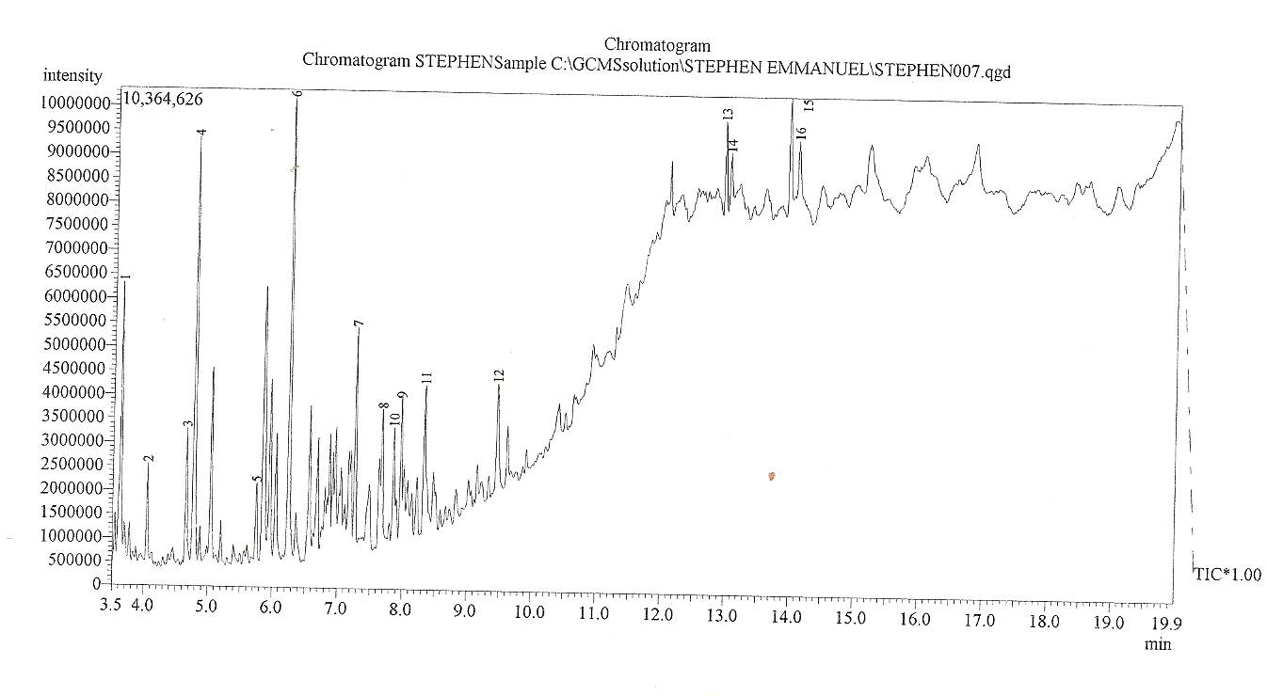
Fig 4: Gas Chromatographic analysis of Spent Lubricating Oil, SLO.

Peak sequences: 1: methylbenzene 2: octane 3: ethylbenzene 4: o-xylene 5: propylbenzene 6: ethylbenzene 7: benzene 8: 1-bromomethyl-4-isopropylbenzene 9: methyl-p-ethyltoluene 10: 1-phenyl-1-butene 11: cyclopentacycloheptene 12: 1,6-methanol 13: pentadecane 14: pentadecane 15: Hexadecane 16: hexadecane

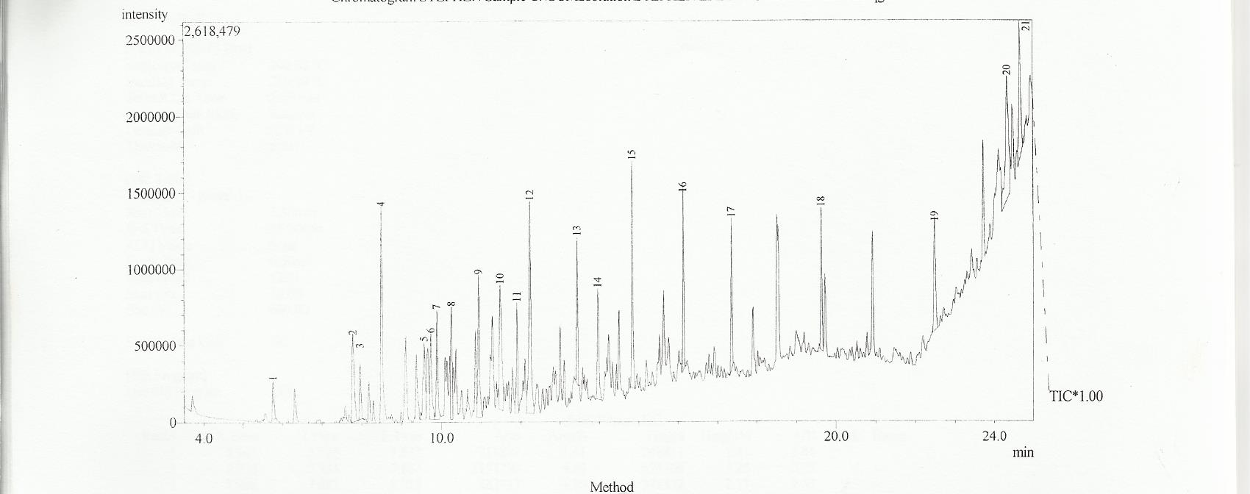

Fig 5: Gas chromatographic analysis of spent lubricating oil degraded by Aspergillus niger after one week.

Peak sequences: 1: benzene 2: benzene3: benzene 4: benzene 5: benzene 6: benzene 7: 4,7-methanoindene 8: 1,3-cyclohexadiene 9: benzene 10: 3-phenyl-1-butene 11: undecane 12: azulene 13: undecane 14: napthalene 15: tetradecane 16: pentadecane 17:hexadecane 18:heptadecane 19: heptadecane 20: tetracosanoic acid 21: tricontane

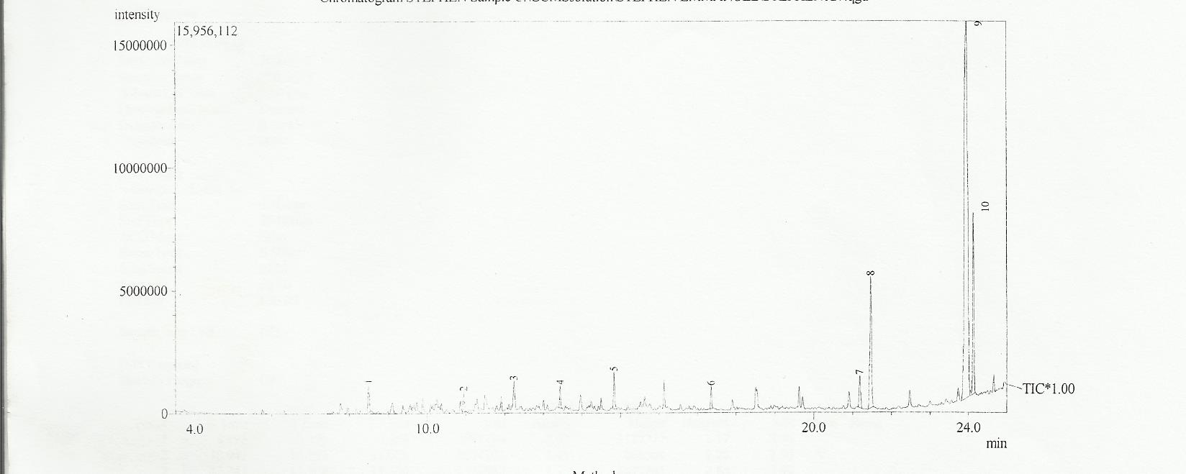
Fig 6: Gas chromatographic analysis of spent lubricating oil degraded by Aspergillus niger after two weeks.

Peak sequences: 1: benzene 2: benzene 3: azulene 4: dodecane 5: tetradecane 6: heptadecane 7: hexadecanoic acid 8: hexadecanoic acid 9: 9-octadecanoic acid 10: octadecanoic acid

4. Discussion
The pH of the results tends towards alkalinity (5.3-7.8). This range of pH has been reported to favour biodegradation of hydrocarbons (Bossert and Bartha, 1994, Stephen and Egene, 2012, Stephen et al., 2013). The higher pH in the inoculated spent lubricating oil than the control may be due to metabolism of the spent lubricating oil by the Aspergillus niger.
Turbidity was higher in the inoculated sample than the control. This indicates that Aspergillus niger was able to grow and utilize the lubricating oil as carbon source. The reason for the increased turbidity after 4 days till the end of the study may be due to the presence of nitrogen and phosphorus in the mineral salt medium which is necessary for biodegradative activity (Adesodun and Mbagwu, 2008) and also play a role in overcoming nutrient limitation during the biodegradation process (Sanyaolu et al., 2012).
Nitrate concentration was lower in the inoculated sample than the control. The decline in the concentration of nitrate between day 0 and 4 could be attributed to high metabolic activity and utilization of nitrate during the biodegradation process by Aspergillus niger (Sanyaolu et al., 2012).
Some of the compounds present in the control sample may be due to prolonged usage of the oil leading to its contamination by chemical impurities (Dominguez-Rosado and Pichtel, 2004). This observation is in line with the report of Diab (2008) that larger amounts of hydrocarbons are present in spent lubricating oil than normal alkanes.
The GCMS analysis of the inoculated sample after 7 days revealed the presence of more benzene than the control. This may be due to the cleaving of the methyl, ethyl, propyl branches as observed in the control. This also shows that benzene can not be degraded by Aspergillus niger. This is in agreement with Atlas and Brag (2009). These researchers reported that some aromatic hydrocarbons can not be degraded by some organisms.
The GCMS analysis of the inoculated sample after 14 days revealed reduced peaks and compounds. This may be attributed to increased biodegradation (Susarla et al., 2002). The chromatogram also revealed that benzene and azulene could not be degraded even after 14 days. The increased number of carboxylic acids (hexadecanoic acid, octadecanoic acid and 9-octadecanoic acid) is an indication of biodegradation of the alkanes found in the control (Meredith et al., 2000).

Conclusion
This study revealed that Aspergillus niger was capable of utilizing and growing in spent lubricating oil. Its metabolic activities increased the pH and turbidity of the growth medium. Methylbenzene, ethylbenzene, propylbenzene, hexadecane and octane were degraded into benzene, hexadecanoic acid, octanaoic acid respectively. The study also revealed that benzene and azulene were compounds that could not be degraded by Aspergillus niger.

Corresponding Author:
Dr. Stephen Emmanuel
Department of Microbiology,
Kogi State University, Anyigba,
Nigeria

References
1.Adesodun, J.K. and Mbagwu, J.S.C. (2008). Biodegradation of waste lubricating petroleum oil in a tropical alfisol as mediated by animal droppings. Bioresouce Technology, 99, 5659-5665.
2.Abdulhadi, S.K. and Kawo, A.H. (2006). The effects of used engine oil pollution of soil in the growth and yield of Arachis hypogaea.L and Zea mays L. African Scientist, 7(3),155-160.
3.Anene, M. and Chika, N. (2006). Studies on the bioutililization of some petroleum hydrocarbons by single and mixed cultures of some bacterial species. African Journal of Microbiology Research, 5(12), 1457-1466.
4.Atlas, R. and Brgg, J. (2009). Bioremediation of marine oil spills; when and when not- the Exxon valdex experience. Microb. Biotechnol., 2, 213-221.
5.Bossert, I. and Bartha, R. (1994). The fate of petroleum in soil ecosystem. In: Petroleum Microbiology, Macmillan, New York, U.S.A, pp 435-473.
6.Chikere, C.B., Okpokwasili, G.C. and Chikere, B.O. (2009). Bacterial diversity in a tropical oil polluted soil undergoing bioremediation. African Journal of Biotechnology, 8(11), 2535-2540.
7.Diab, E.A. (2008). Phytoremediation of polycyclic aromatic hydrocarbons (PAHs) in a polluted desert soil with special reference to the biodegradation of the carcinogenic PAHs. Australian Journal of Basic and Applied Sciences, 2 (3), 757-762.
8.Dominquez-Rosado, E. and Pichtel, J. (2004). Phytoremediation of soil contaminated with used motor oil. Journal of Environmental Engineering Science, 21 (2), 169-173.
9.George, J.S. and Metting, Jnr. (1993). Soil Microbial Ecology: Application in Agricultural Environmental Management, Mercel Dekker, Inc New York.
10.Hawrot, M. and Nowak, A. (2006). Effects of different soil treatments on diesel fuel biodegradation. Polish Journal of Environmental Studies, 15 (4),643-646.
11.Hertzman, P.E., Bertholot, J.P., Hopper, W.C., Pollit, A.O., Smith, J.D. and Vickers, B.G. (1985). The collection, disposal and regeneration of waste oil and related materials. CONCAWE report 85/53. The Hague, Netherland.
12.Ibitoye, A.A. (2006). Laboratory Manual on Basic Soil Analysis (2nd ed). Foladave Nigeria Limited, Akure, pp 30-37.
13.Ismail, S. (2008). Bioremediation Laboratory Manual. Department of Biotechnology, Islamic University, Gaza, Isreal, pp 8-15.
14.Khaled, M.A.R., Abdel Azeiz, A.Z., Hassanien, S.E. and Eissa, H.F. (2012). Biodegradation of used lubricating and diesel oils by new yeast strain Candida viswanathii Kc-2011. African journal of biotechnology, 11 (77), 14166-14174.
15.Kuiper, I., Lagendijk, E.L., Bloemberg, G.V. and Lugtenberg, J.J.B. (2004). Rhizoremediation: A beneficial plant-microbe interaction. The American Phytopathological Society, 17 (1), 6-15.
16.Meredith, W., Kelland, S.J. and jones, D.M. (2000). Influence of biodegradation on crude oil acidity and carboxylic composition. Organic Geochemistry, 31, 1059-1075.
17.Okereke, J.N., Obiekezie, S.O. and Obasi, K.O.(2007). Microbial flora of oil spilled sites in Egbema, Imo State, Nigeria. African Journal of Biotechnology, 6(4), 991-993.
18.Sanyaolu, A.A., Sanyaolu, V.T., Kolawole, J.O. and Jawndo, S.S. (2012). Biodeterioration of premium motors spirit (PMS) by fungal species. International Journal of Science and Nature, 3(2), 276-285.
19.Shakirullah, M., Saad, I.A.M., Khan, M.A., Rehmany, H., Ishaa, M. and Shah, A.A.(2006). Environmentally friendly recovery and characterization of oil from used engine lubricants. Journal of Chinese Chemical Society, 53 (2), 335-342.
20.Stephen, E. and Egene, U.M. (2012). Microbiology and physicochemical properties of soil polluted with lubricating oil in Anyingba, Kogi State, Nigeria. Nigerian Journal of Technological Research, 7(2), 49-52.
21.Stephen, E., Job, O.S. and Abioye, O.P. (2013). Study on Biodegradation of Diesel Contaminated Soil Amended with Cowpea Chaff. Journal of Science & Multidisciplinary Research Vol. 2(1), 14-18
22.Susarla, S., Medina, V.F. and McCutcheon, S.C. (2002). Phytoremediation: an ecological solution to organic chemical contamination. Ecological Engineering, 18,662-668.
23.Watkinson, R.J. and Morgan, P. (1990). Physiology of aliphatic hydrocarbon degrading microorganisms. Biodegradation,1, 79-92.
24.Wright, M.A., Taylor, F., RandleS, S.J., Brown, D.E., Higgins, I.J. (1993). Biodegradation of a synthetic lubricant by Micrococcus roseus. Applied Environmental Microbiology, 59 (4), 1072-1076.

7/19/2013

