Effects of Ethanolic Purslane Shoot and Seed Extracts on Doxorubicin-Induced Hepatotoxicity in Albino Rats

Osama M. Ahmed^{1, 3}; Walaa G. Hozayen²; Haidy Tamer Abo Sree ³; Mohamed B; Ahmed⁴

¹Physiology Division, Zoology Department, Faculty of Science, Beni- Suef, Beni-Suef University Egypt
²Biochemistry Division, Chemistry Department, Faculty of Science, Beni-Suef University, Beni-Suef, Egypt
³Biochemistry Division, Faculty of Oral and Dental Medicine Nahda University, Beni-suef, Egypt
osamamoha@yahoo.com; walaahozayen@hotmail.com; haidyalshafeey@yahoo.com

Abstract: Doxorubicin (DOX), an anthracycline antibiotic, is a broad-spectrum antineoplastic agent, which is commonly used in the treatment of uterine, ovarian, breast and lung cancers, Hodgkin's disease and soft tissue sarcomas as well as in several other cancer types. The effect of doxorubicin (4 mg/kg b.w.week) without or with oral administration of ethanolic purslane (Portulaca oleracea) shoot (leaves and stems) extract (50 mg/kg b.w.day) or ethanolic purslane seeds extract (50 mg/kg b.w.day) co-treatments for 6 weeks was evaluated in adult male rats. Serum ALT, AST, ALP, GGT, total bilirubin,total protein and albumin levels were assayed. Lipid peroxidation (indexed by MDA) and antioxidants like hepatic glutathine, glutathione transferase, peroxidase, SOD, CAT were assessed. There was an increase in serum levels of ALT, AST, ALP, GGT and total bilirubin. In addition, hepatic glutathine, glutathione transferase, peroxidase, SOD, CAT activities were decreased while lipid peroxidation in the liver was increased. Co-administration of ethanolic purslane and seed extracts successfully improved the adverse changes in the liver functions with an increase in antioxidants activities and reduction of lipid peroxidation. In coclusion, it can be supposed that dietary purslane extract supplementation may provide a cushion for a prolonged therapeutic option against DOX hepatopathy without harmful side effects. However, further clinical studies are required to assess the safety and efficacy of these extract in human beings.
[Osama M. Ahmed; Walaa G. Hozayen; Haidy Tamer Abo Sree; and Mohamed B; Ahmed. Effects of Ethanolic Purslane Shoot and Seed Extracts on Doxorubicin-Induced Hepatotoxicity in Albino Rats. Nat Sci 2013;11(10):94-101]. (ISSN: 1545-0740). http://www.sciencepub.net/nature. 15

Key words: Doxorubicin, purslane, hepatotoxicity and antioxidants.

1.Introduction
Doxorubicin (DOX) obtained from soil actinomycetes Streptococcus peucetius is used for the treatment of solid tumors such as those arising in the breast, bile ducts, endometrial tissue, esophagus and liver, osteosarcomas, soft-tissue sarcomas and non-Hodgkin's lymphoma (Tikoo et al., 2011). DOX is known as a powerful anthracycline antibiotic widely used to treat many human cancers, but significant cardiotoxicity (Kuznetsova et al., 2011), hepatptoxicity (Patela et al., 2010), nephrotoxicity (Mohana et al., 2010) and testicular toxicity (Trivedi et al., 2011) limits its clinical application. Mitochondria are considered to be one of the primary targets of DOX through mitochondria-mediated apoptosis, remarkable modification of mitochondrial membranes (e.g. via binding with cardiolipin), which is also associated with changes in various mitochondrial functional parameters and activities of respiratory chain complexes (Trivedi et al., 2011). Moreover, doxorubicin significantly damages energy-transferring and -signalling systems like creatine kinase and AMP-activated protein kinase (Kuznetsova et al., 2011) Doxorubicin causes disturbances in the balance between oxidative stress and antioxidant defence system leading to tissue injuries (Saad et al., 2001; Karaman et al., 2006).
A number of studies were conducted for antioxidants screening from the natural medicine aiming to minimize oxidative injury by DOX. Several natural antioxidants have been shown to alleviate the DOX-induced cell damage without compromising its anti-tumor efficacy in the animal studies (Xin et al., 2011). Portulaca oleracea L, is commonly known as purslane. It is a warm climate, annual, green shoot (Al-Quraishy et al., 2012). Recent research indicates that purslane offers better nourishment than the major cultivated vegetables due to its shoot that is a rich source of X9-3-fatty acids, α-tocopherols, ascorbic acid, β-carotene and glutathione. Its seeds also contain a high percentage of α-linolenic acid (LNA) (Al-Quraishy et al., 2012). These features contribute to the anti-oxidative properties of purslane which derive from the following pharmacologically active substances, including: 28% flavonoids, that are nearly exclusively flavonol-O-glycosides; 8% terpenoids (principally ginkgolides A, B, C and bilobalide); 6–12% organic acids; and >0.5% proanthocyanidins defined as flavonoid-based polymers. Purslane is effective as an antioxidant agent (Dkhil et al., 2011) as well as providing nourishment for the liver, kidneys and testes. Experimental evidence has also shown that purslane has an anti-oxidative effect in heart tissues in mice by increasing superoxide dismutase activity (Al-Quraishy et al., 2012). Other outhors reported that the purslane contains many compounds, including alkaloids, omega-3 fatty acids, coumarins, flavonoids, polysaccharide, cardiac glycosides, anthraquinone glycosides. and containing β-sitosterol (Mohamed et al., 2011).
Based on these issues and concerns, the present study was designed to investigate the preventive effect of ethanolic extract of purslane shoot parts and seeds on liver dysfunction and oxidative stress in doxorubicin-administered rats.
2.Material and methods
I- Experimental animals:
Male Wistar albino rats weighing about 140-180g were used as experimental animals in the present investigation. They were obtained from the animal house of Research Institute of Opthalmology, El-Giza, Egypt. They were kept under observation for about 15 days before the onset of the experiment to exclude any intercurrent infection. The chosen animals were housed in plastic cages with good aerated covers at normal atmospheric temperature (25±5ºC) as well as 12 hours daily normal light periods. Moreover, they were given access of water and supplied daily with standard pellet diet ad libitum. All animal procedure are in accordance with the recommendations of the Canadian committee for care and use of animals (Canadian council on Animal care [CCAC], 1993).
2. Chemicals and drugs
Doxorubicin was purchased from EBEWE pharma, Ges. m.b.H. Nfg. KG A-4866 Unterach, Austria., Purslane shoot parts and seeds were purchased from Harraz Medicinal plant company, Cairo, Egypt (WWW.harrazegypt.com).Total billirubin and ALP (alkaline phosphatase) kits were obtained from SCICO Diagnostic Company and ALT (alanine aminotransferase), AST (aspartate aminotransferase) and GGT (gamma-glutamyl transferase) kits were purshased from Quimica Clinica Aplicada S.A. Company, (Spain), Albumin and total protein kits were obtained from Diamond Diagnostics, Egypt. Chemicals used in measurement of antioxidants were obtained from Sigma Chemical Company, USA.
3. Shoot and seed extract
The shoot parts of the plant and seeds were dried in the shade.They were powdered by an electric grinder then, they were exhaustively extracted with 80% ethanol. The solvent was removed by evaporation under reduced pressure using Bucchi Rotary Evaporator (Wang et al., 2012).
4. Experimental Animal grouping and experimental design:
The animals of the present experiment were allocated into 4 groups:

1-Normal control: The rats of this group were given the equivalent volume of vehicle (0.9% NaCl ) for 45 days

2-Doxorubicin–administered control: The rats of this group was administered intraperitoneally a dose of 4 mg/Kg b.w.week for 6 weeks (Trivedi et al., 2011).
3-Doxorubicin-administered group treated with purslane shoot extract: This group was orally treated with purslane shoot extract at dose level of 50 mg/kg b.w.day for 6 weeks (Ali and Bashir, 1994; Fayong Gong et al., 2009).
4- Doxorubicin-administered group treated with purslane seeds extract: This group was orally treated with purslane seeds extract at dose level of 50 mg/kg b.w.day for 6 weeks (Ali and Bashir, 1994; Fayong Gong et al., 2009).
5. Preparation of blood and tissue homogenates

By the end of the experimental periods (6 weeks), rats were scarified under mild diethyl ether anesthesia at fasting state. Blood samples were collected and allowed to coagulate at room temperature. The clear, non-haemolysed supernatant sera were quickly removed divided into four portions for each individual, and stored at - 20˚ C for subsequent analysis. Liver was quickly excised, weighed and homogenized in a saline solution (0.9 %NaCl) (10% w/v) using Teflon homogenizer (Glas-Col, Terre Haute, USA), The homogenates were centrifuged at 3000 r.p.m. for 15 minute and the supernatants were kept at -20 C° for the assay of biochemical parameters related to oxidative stress and antioxidant defense system.
6. Assay of liver function:
ALT and AST activities in serum was determined according to the method of Reitman and Frankel (1957) using reagent kits purchased from Quimica Clinica Aplicada S. A. Company (Spain). GGT activity was measured according to the method of Szasz (1969) using reagent kits obtained from Quimica Clinica Aplicada S. A. Company, (Spain). ALP activity was measured according to the method of Kind and King (1954) by using reagent kits obtained from SCICO Diagnostic Company, Egypt. Total bilirubin concentration in serum was determined in serum according to the method of Jendrassik and Grof (1938), using the reagent kits purchased from SCICO Diagnostic Company, Egypt. Albumin concentration was determined in serum according to the method of Doumas et al. (1971), using the reagent kits purchased from Diamond Diagnostics, Egypt. Serum globulin concentration and albumin/globulin ratio were calculated according to Rojkin et al. (1974). Serum total proteins concentration was determined according to the method of Henry (1964), using reagent kits purchased from Diamond Diagnostics, Egypt.

7. Assay of Lipid peroxidation and antioxidant parameters
Liver oxidative stress and antioxidant defense parameters were estimated using chemicals purchased from Sigma Chemical Company (USA) and using Jenway Spectrophotometer (Germany), Glutathione activity in homogenates was determined according to the chemical method of Beutler et al. (1963) with little modification. Lipid peroxidation concentration in homogenates was determined according to the chemical method of Preuss et al. (1998). Peroxidase (POX. EC 1.11.1.7) activity in homogenates was estimated according to the modified chemical method of Kar and Mishra (1976). Superoxide dismutase (SOD EC 1.15.1.1) activity in homogenates was determined according to the chemical method of Marklund and Marklin (1974). Glutathione-s-transferase (GST. EC 2.5.1.18) concentration in homogenates was determined according to the chemical method of Mannervik and Guthenberg (1981). Catalase (CAT, EC 1.11.1.6) activity in homogenates was assayed according to the chemical method of Cohen et al. (1970).
8-Histological examination:
After sacrifice and dissection at specific time intervals, pieces of liver from all groups were immediately removed from each animal, fixed in 10% neutral buffered formalin and transferred to Department of Histopathology, Faculty of Veterinary medicine, Beni-Suef University, Egypt for preparation, sectioning and staining with haemotoxylin and eosin (H&E) (Bancroft and Stevens, 1982).
9. Statistical analysis
The data in the present study were analyzed using the one-way analysis of variance (ANOVA) (PC-STAT, University of Georgia, 1985) followed by LSD test to compare various groups with each other. Results were expressed as mean ± standard error (SE) and values of P >0.05 were considered non-significantly different, while those of P<0.05 and P <0.01 were considered significantly and highly significantly different, respectively.

3.Results
Biochemical effects
The doxorubicin-administered rats showed a highly significant increase (P <0.01) in serum ALT, AST, GGT and ALP activities as compared to normal control group. The treatment of doxorubicin-administered rats with purslane shoot and seed ethanolic extracts induced a highly significant decrease of the elevated serum of ALT, AST, GGT and ALP (P <0.01) activities as compared to doxorubicin-administered rats (Figures, 2 & 3). The doxorubicin-administered rats showed a highly significant increase (P <0.01) in serum level of total bilirubin concentration as compared to normal control group. The treatment of doxorubicin-administered rats with purslane shoot and seed ethanolic extracts induced a highly significant decrease of the elevated serum total bilirubin (P <0.01) level as compared to doxorubicin-administered rats. (Figures 4 & 5). The doxorubicin-administered rats showed a highly significant decrease (P <0.01) in serum level of total protein, albumin and globulin levels as compared to normal control group. The treatment of doxorubicin injected rats with purslane shoot ethanolic extract induced a significant increase of the serum total protein, albumin and globulin (P < 0.05) level. The treatment of doxorubicin-administered rats with purslane seeds ethanolic extracts induced a highly significant increase (P <0.01) of serum total protein, albumin and globulin as compared to doxorubicin-administered rats (Figures, 7 & 8). The liver antioxidants levels of glutathione, catalase, SOD, peroxidase and glutatione-S-transferase in doxorubicin-administered rats showed a highly significant decrease (P <0.01) recording percentage decreases of -68.49, -86.70, -168.50, -39.7 0 and -47.30% respectively as compared to normal control group. Lipid peroxidation exhibited a highly significant increase in doxorubicin-injected rats as compared to normal rats. The treatment of doxorubicin-administered rats with purslane shoot ethanolic extract induced a highly significant increase of the serum glutathione, catalase, SOD, peroxidase and glutatione-S-transferase levels (P <0.01); the recorded percentage increases were 83.89, 222.6, 98.30, 30 and 44.30% respectively as compared to doxorubicin-administered rats. The treatment of doxorubicin-administered rats with purslane seeds ethanolic extracts induced a highly significant increase (P <0.01) in serum glutathione, catalase, SOD, peroxidase and glutatione-S-transferase activities (P <0.01) recording percentage increases of 141.89, 548.60, 121.90, 58.90 and 75.80 % respectivily as compared to doxorubicin-administered rats. Liver peroxidation was profoundly (P <0.01) improved in doxorubicin-administered rats treated with purslane shoot and seed extracts. In general, the seed extract seemed to be the most potent in improving liver function and antioxidant defense system (Figures 9-14).
Histological changes
The normal liver histological architecture is shown in figure 15. The hepatocytes are arranged in hepatic strands radiating from the central vein. The hepatic sinusoids are found between hepatic strands.
The liver of doxorubicin-administered rats showed congested or hyperemic hepatic portal and central veins as well as the hepatic sinusoids. There was mild perivascular fibrosis, fatty change, kupher cell multiplication and hemorrhages.
A larg numbers of hepatocytes showed vascular degeneration and had a peripheral distribution within the hepatic lobules and there was hyperplasia of the bile ducts.
The treatment of doxorubicin-administered rats with purslane shoot and seed extracts produced marked improvement of liver histological changes. Mild vascular changes and kupffer cell multiplication were noticed in liver of doxorubicin-administered rats which were treated with purslane shoot ethanolic extract (Figures 17a & 17b ). Also, congested hyperemic central vein and kupffer cells polifiration were observed in liver section of doxorubicin-administered rats treated with purslane seed extracts (Figures 18a & 18b).

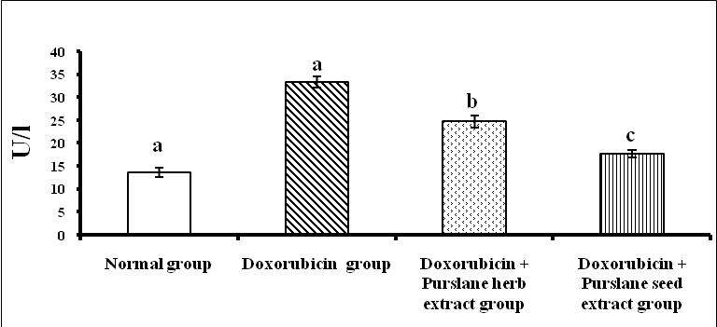
Figure 1: Effect of purslane shoot and seed ethanolic extracts on serum ALT activity in doxorubicin-administered rats.LSD at the 5% level: 3.235; LSD at the 1% level: 4.413.
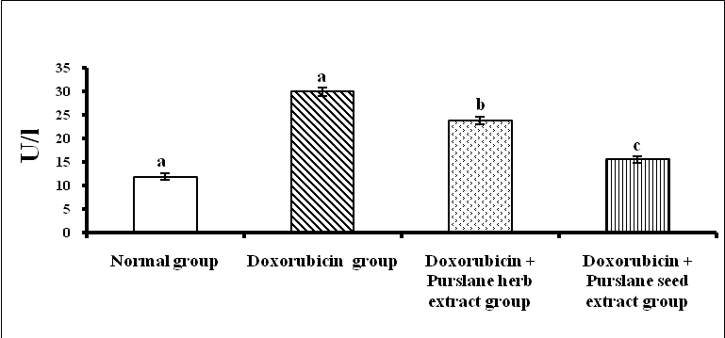
Figure 2: Effect of purslane shoot and seed ethanolic extracts on serum AST activity in doxorubicin-administered rats. LSD at the 5% level: 2.345; LSD at the 1% level: 3.202
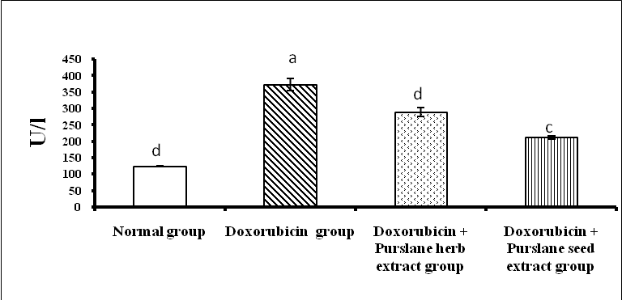
Figure 3: Effect of purslane shoot and seed ethanolic extracts on serum Alkaline Phosphatase activity in doxorubicin-administered rats. LSD at the 5% level: 35.753; LSD at the 1% level: 48.762

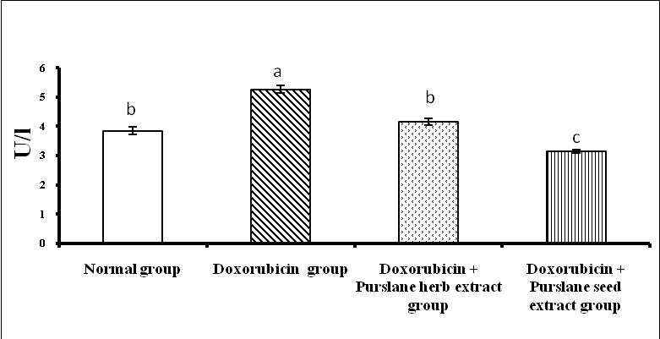
Figure 4: Effect of purslane shoot and seed ethanolic extracts on serum GGT activity in doxorubicin-administered rats. LSD at the 5% level: 0.330; LSD at the 1% level: 0.450.
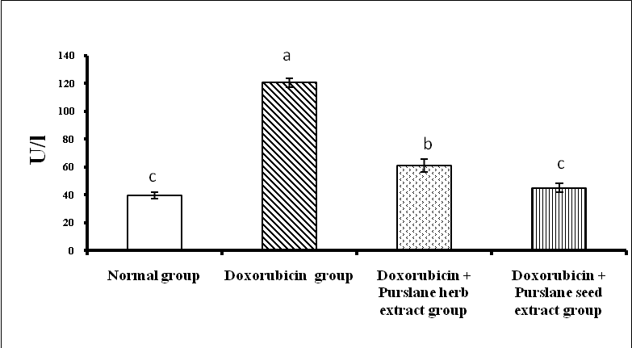
Figure 5: Effect of purslane shoot and seed ethanolic extracts on total bilirubin level in doxorubicin-administered rats. LSD at the 5% level: 10.214; LSD at the 1% level: 13.931
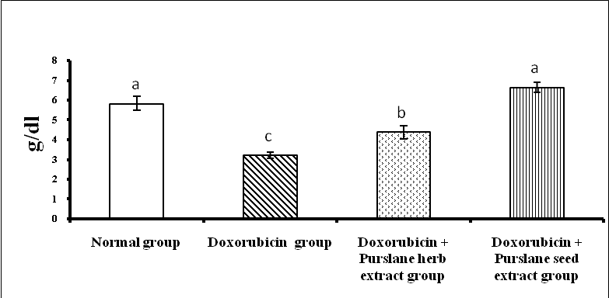
Figure 6: Effect of purslane shoot and seed ethanolic extracts on serum total protein level in doxorubicin-administered rats. LSD at the 5% level: 0.839; LSD at the 1% level: 1.145.
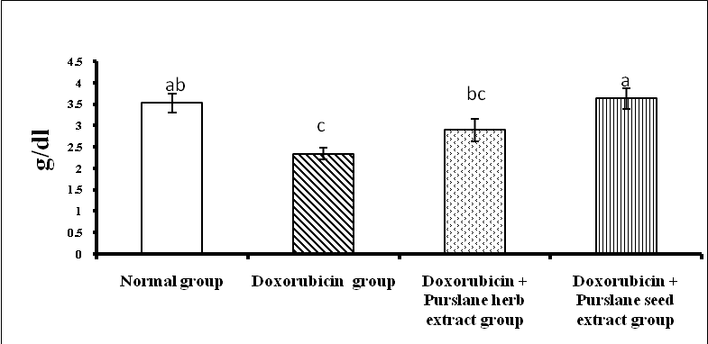
Figure 7: Effect of purslane shoot and seed ethanolic extracts on serum albumin level in doxorubicin-administered rats. LSD at the 5% level: 0.648; LSD at the 1% level: 0.883.
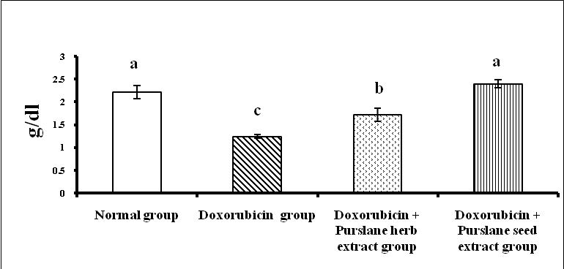
Figure 8: Effect of purslane shoot and seed ethanolic extracts on serum globulin level in doxorubicin-administered rats. LSD at the 5% level: 0.348; LSD at the 1% level: 0.474.
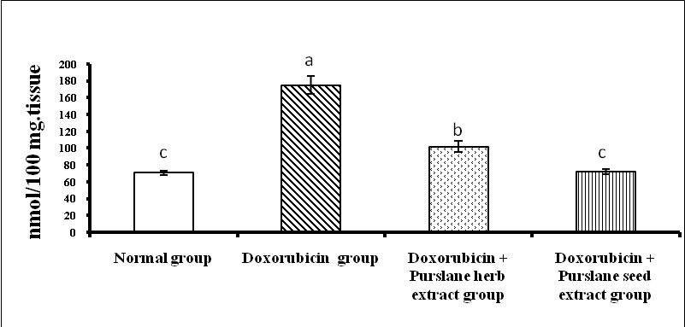
Figure 9: Effect of purslane shoot and seed ethanolic extracts on hepatic MDA in doxorubicin-administered rats. LSD at the 5% level: 19; LSD at the 1% level: 25.91.
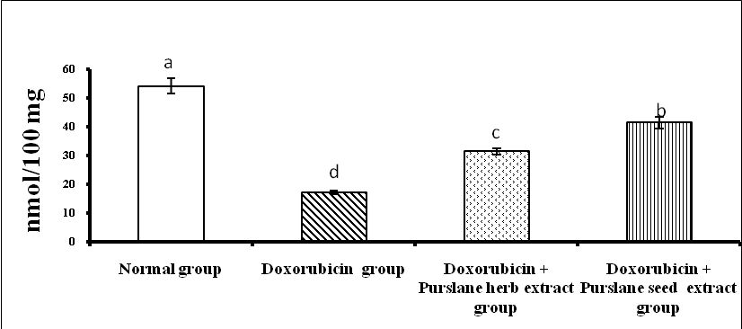
Figure 10: Effect of purslane shoot and seed ethanolic extracts on Hepatic glutathione in doxorubicin-administered rats. LSD at the 5% level: 5.388; LSD at the 1% level: 7.348.
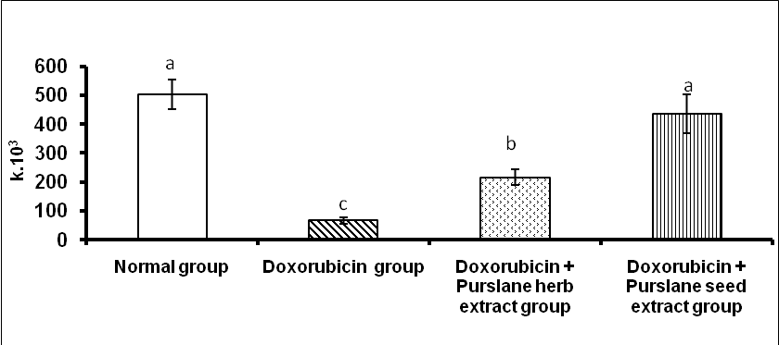
Figure 11: Effect of purslane shoot and seed ethanolic extracts on Hepatic catalase in doxorubicin-administered rats. LSD at the 5% level: 131.558; LSD at the 1% level: 179.427.

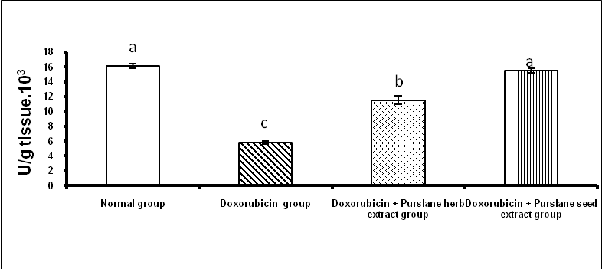
Figure 12: Effect of purslane shoot and seed ethanolic extracts on hepatic SOD activity of doxorubicin-administered rats. LSD at the 5% level: 1.120; LSD at the 1% level: 1.528. 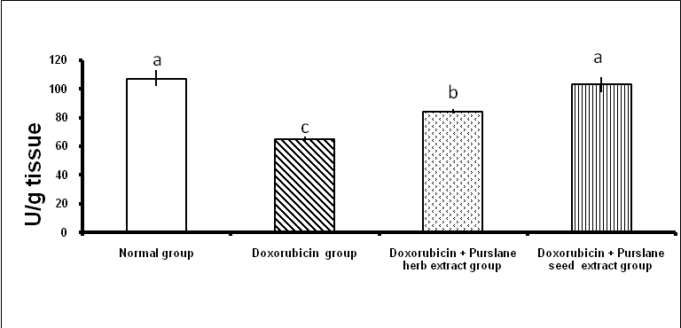
Figure 13: Effect of purslane shoot and seed ethanolic extracts on hepatic peroxidase activity of doxorubicin-administered rats. LSD at the 5% level: 12.317; LSD at the 1% level: 16.799.
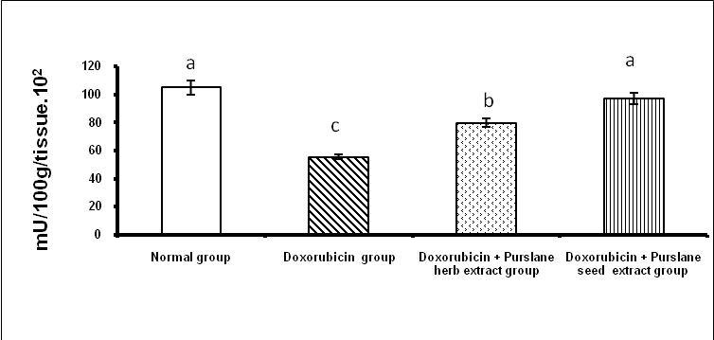
Figure 14: Effect of purslane shoot and seed ethanolic extracts on hepatic glutathione transferase activity of doxorubicin-administered rats. LSD at the 5% level: 10.744;LSD at the 1% level: 14.653.
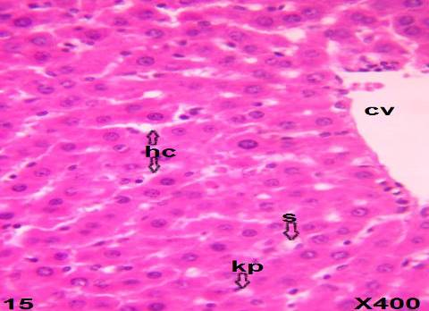
Figure 15: Photomicrograph of liver section showing normal rats histological architecture. Central vein (CV), hepatic strands (hs), sinusoids (s) and kupher cells (kp) are noticed.

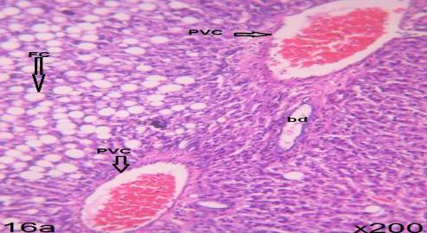
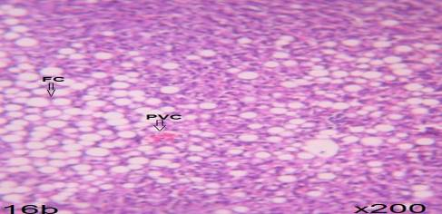
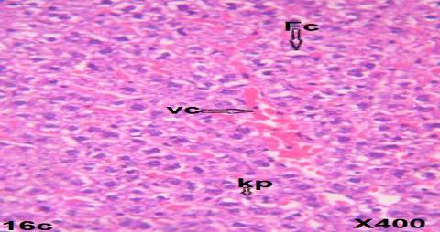
Figure 16: Photomicrograph of liver section of doxorubicin administered rats showing fatty change (FC), perivascular fibrosis (PVF), congested portal vein (CPV) and bile ductules (bd) proliferation as well as hemorrhage (hr),vascular degeneration (VD) and kupffer cells (kp) multiplications (Figures 16 a,b and c).
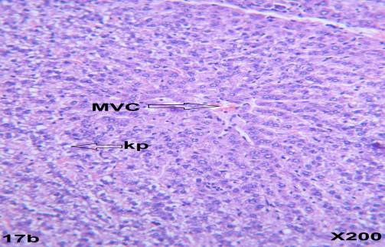
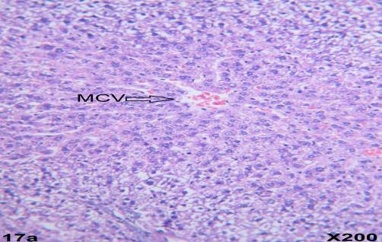
Figure 17: photomicrograph of liver section doxorubicin administered rats treated with purslane shoot ethanolic extracts showing moderate vascular changes (MVC) and kupffer cells (kp) proliferation (Figures 17 a and b).
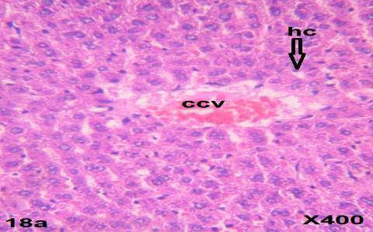

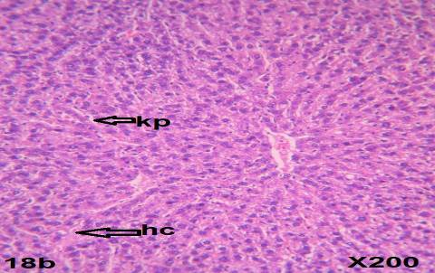
Figure 18: photomicrograph of liver section doxorubicin administered rats treated with purslane seed ethanolic extracts showing congested central vein (ccv) (figure 18 a), kupffer cells (kp) multiplication and hydropic cells (hc) (Figures 18a and 18b).

4.Discussion
Doxorubicin, a quinone-containing anthracycline antibiotic, is an important agent against a wide spectrum of human neoplasms. However, its toxicity limits usage in cancer chemotherapy (Singal et al., 1987; Fadillioglu et al., 2003). It has been shown that free radicals are involved in doxorubicin-induced toxicities (Yagmurca et al., 2004). The chemical structure of doxorubicin causes the generation of free radicals and the induction of oxidative stress that correlates with cellular injury (Saad et al., 2001). Doxorubicin causes an imbalance between free oxygen radicals (ROS) and antioxidants. The disturbance in oxidant–antioxidant systems results in tissue injury that is demonstrated with lipid peroxidation and protein oxidation in tissue (Karaman et al, 2006).
The present study revealed that intraperitoneal injection of 4 mg doxorubicin/ kg b.w. for 6 weeks induced hepatoxicity manifested biochemically by a significant increase of serum ALT, AST, ALP and GGT activities and bilirubin concentration in addition to a significant decrease in serum total protein, albumin and globulin levels. These results are in accordance with Injac et al. (2008) who attributed the increase in the serum enzyme levels to their increased leakage from damaged and necrotic hepatocytes as a result of toxicity. El-Maraghy et al. (2009) attributed alteration in serum protein to changes in protein and free amino acids and their synthesis in the injured liver cells and/ or increased protein degradation.
The increase in serum total bilirubin may be owing to blockage of bile ducules as the inflammation and fibrosis in the portal triads and/ or due to regurgitation of conjugated bilirubin from the necrotic hepatocytes to sinusoids (Ahmed, 2001).
The previous deleterious biochemical alterations of the present study were associated with a marked elevation of liver lipid peroxidation and a significant decrease of non-enzymatic antioxidant (glutathione) content and enzymatic antioxidants (catalase, superoxide dismutase, peroxidase and glutathione- S – transferase) enzyme activities. These results are in agreement with many other authors (Abd El-Aziz et al., 2001; Kalender et al., 2005; Yagmurcaa et al., 2007) who stated that one of the most prevailing hypothesis of hepatic damage from doxorubicin administration is the ability of the drug to produce reactive oxygen species (ROS) and suppress antioxidant defense mechanism. They also revealed that the increased lipid peroxidation play a critical role in liver injury.
Histopathological examination of liver sections of doxorubicin-administration rats supported the previous biochemical results. The liver exhibited fatty changes, vascular and hydropic degeneration, perivascular fibrosis, necrosis of some hepatocytes, haemrrhage, kupffer cell multiplication and bile ductule proliferation. These results are in concurrence with Yagmurcaa et al. (2007) who noticed degradation of hepatocytes, congestion, necrosis and proliferation of bile ductules in doxorubicin-treated rats.
The treatment of doxorubicin-administered animals with purslane shoot and seed ethanolic extracts successfully improved the elevated serum activities of ALT, AST, ALP and GGT and serum bilirubin concentration. The lowered serum total protein, albumin and globulin levels were potentially ameliorated in doxorubicin -administered rats treated with the tested extracts. These results are in agreement with previously published reports (Singal et al., 1987; Fadillioglu et al., 2003; Yagmurca et al., 2004 and Karaman et al, 2006). Moreover, Tawfeq (2008) reported that the purslane extract caused a significant reduction in the doxorubicin-induced toxicity in mice. Omoniyi and Mathew (2006) found that the aqueous extract of purslane potentially improved the functional status of liver as indicated by a decrease in serum activities of classical enzymes of liver function.
These ameliorations in biochemical serum parameters of liver functionin the present study are associated with the improvement in liver histological changes. The seed extract seemed to be more potent than shoot parts. The liver showed moderate vascular changes as a result of shoot extract and hyperemic central vein and kupffer cell multiplication as a result of treatment with seed extract.
The improvement of liver function and intergrity may be mediated via the antioxidant activity of purslane shoot and seed extracts. This is confirmed by the current study which revealed a significant decrease of lipid peroxidation and increase in CAT, SOD, peroxidase and glutathaione- S-transferase activities and glutathione levels.

Conclusion
The co-administration of purslane shoot and seed ethanolic extracts potentially prevented the deleterious effects of doxorubicin on liver. The effect of seed ethanolic extract seemed to be more potent than that of shoot ethanolic extracts. This improvement effect in liver injury may be mediated via enhancement of the antioxidant defense system. However, further clinical studies on human beings are required to assess the efficacy and safety of the purslane ethanolic extracts.

References
- Abd El-Aziz, M.A.; Othman. A.I; Amer.M and El-Missiry, M.A. (2001): Potential protective role of angiotensin-converting enzyme inhibitors captopril and enalapril against adriamycin-induced acute cardiac and hepatic toxicity in rats. J. Appl. Toxicol., 21: 469–473.
- Ahmed O. M (2001): Histopathological and biochemical evaluation of liver and kidney lesions in streptozotocin diabetic rats treated with glimepiride and various plant extracts. J.Union Arab Biol., 16A:585-625.
- Ali, B.H.; Bashir, A.A. (1994): Effect of fish oil treatment on gentamicin nephrotoxicity in rats. Ann. Nutr. Metab., 38(6): 336-9.
- Al-Quraishy, S.A.; Mohamed, A.; Dkhil. A.B.; Ahmed, E.; Abdel Moneim, B.C. (2012): Protective effects of Portulaca oleracea against rotenone mediated depletion of glutathione in the striatum of rats as an animal model of Parkinson’s disease. Pesticide Biochemistry and Physiology, 103(2):108–114.
- Bancroft, J.D.; and Stevens, A. (1982): Theory and practice of histological techniques. 2ndedition.Churchill Livingestone, 374-375.
- Beutler, E.; Duren, O. and Kelly, B. M. (1963): Improved method for the determination of blood glutathione. J. Lab & clin. Med., 61(5): 882-888.
- Canadian council on Animal care (CCAC) (1993): Guide to the care and use of Experimental Animals, CCAC, Ottawa, Ontario, Canada, 1-298.
- Cohen, G.; Dembiec, D. and Marcus, J. (1970): Measurement of catalase activity in tissue. Analytical Biochemistry, (34): 30-38.
- Dkhil, M.A.; Abd elMoneim, A.E.; Al-Quraishy, S.; Saleh, R.A. (2011): Antioxidant effect of purslane (Portulaca oleracea) and its mechanism of action. J. Med. Plants Res., 5: 1589–1593.
- Doumas, B.T.; Watson, W.A. and Biggs, H.G. (1971): Determination of serum albumin. J. Clin. Chem. Acta., 31:87-89.
- EL-Maragy, S.A; Rizk, S.A. and EL-Sawalhi, M.M. (2009): Hepatoprotective potential of crocin and curcumine against iron overload- iduced biochemical alterations in rat. Arf. J. Biochem. Res., 3(5): 215-221.Fadilloglue, E.; Oztas, E.; Erdogan, H.; Yagmurca, M.; Sogut, S.; Ucar, M. and Irmac. M.K. (2004): Protective effect of caffeic acid phenyl ethyl ester of doxorubicin induced nephrotoxicity in rats, J. Appl. Toxicol., 24: 47–52.
- Fayong, G.; Fenglin, L.; Lili, Z.; Jing, L.; Zhong, Z. and Guangyao, W. (2009): Hypoglycemic Effects of Crude Polysaccharide from Purslane. Int. J. Mol. Sci., 10: 880-888.
- Henry, R.J. (1964): Clinical Chemistry, Principles and Technics, 2nd Edition, Harper and Row., P.525,1974.
- Injac, R.; Boskovic, M.; Perse, M.; Koprivec-Furlan, E.; Cerar, A.; Djordjevic, A. and Strukelj, B. (2008): Acute doxorubicin nephrotoxicity in rats with malignant neoplasm can be successfully treated with fullerenol C60 (OH) 24 via suppression of oxidative stress. Pharmacol. Rep., 60: 742–749.
- Jendrassik, L. and Grof., (1938): Biochem.,7297:81.
- Kalender, Y.; Yel, M. and Kalender, S. (2005): Doxorubicin hepatotoxicity and hepatic free radical metabolism in rats. The effects of vitamin E and catechin. Toxicology, 209(1): 39-45.
- Kar, M. and Mishra, D. (1976): Catalase, Peroxidase, and Polyphenoloxidase Activities during Rice Leaf Senescence. Plant Physiol., 57(2):315-319.
- Karaman, A.; Fadillioglu, E.; Turkmen, E.; Tas, E. and Yilmaz, Z. (2006): Protective effects of leflunomide against ischemia reperfusion injury of the rat liver. Pediatr. Surg. Int., 22: 428–434.
- Kind, P.R.N. and King, E.G. (1954): Estmation of plasma phosphate by determination of hydrolysed phenol with amino-antipyrine. J. Clin. Path., 7:322.
- Kuznetsova, A.V.; Raimund, M.; Albert, A.; Valdur, S. and Michael, G.; (2011): Changes in mitochondrial redox state, membrane potential and calcium precede mitochondrial dysfunction in doxorubicin-induced cell death, Biochimica et Biophysica Acta (BBA) – Molecular cell Research, 1813(6): 1144-1152.
- Mannervik, B. and Guthenberg, C. (1981): Glutathione transferase (human placenta). Methods Enzymol., 77: 231-235.
- Marklund, S. and Marklin, G. (1974): Involvement of the superoxide anion radical in the autoxidation of pyrogallol and a convenient assay for superoxide dismutase. Eur. J. Biochem., 47:469-474.
- Mohamed, I. K.E., (2011): Effects of Portulaca oleracea L. seeds in treatment of type-2 diabetes mellitus patients as adjunctive and alternative therapy. Journal of Ethnopharmacology, 137(1): 643-651.
- Mohana, M.; Sarika, K.; Prakash, G. and Sanjay, K. (2010): Protective effect of Solanum torvum on doxorubicin-induced nephrotoxicity in rats. Food and Chemical Toxicology, 48(1): 436-440.
- Omoniyi, K.Y.; Mathew, C.I., (2006): Protective effects of Zingiber officinale (Zingiberacae) against carbon tetrachloride and acetaminophen-induced hepatotoxicity in rats. Phyto. Therap Res., 20:997–1002.
- Patela, N.; Ceci, J.; George, B.; Corcoranb, and Sidhartha, D.R., (2010): Silymarin modulates doxorubicin-induced oxidative stress, Bcl-xL and p53 expression while preventing apoptotic and necrotic cell death in the liver. Toxicology and Applied Pharmacology, 245(2): 143-152.
- PC-STAT (1985): One way analysis of variance. Version IA (c) copyright. Programes coded by Roa, M.; Blane, K. and Zonneberg, M. University of Georgia, USA.
- Preuss, H. G.; Jarrel, S. T.; Scheckenobac, R.; Lieberman, S. and Anderson. R. A., (1998): comparative effects of chromium vanadium of Gymnema Sylvester on sugar-induced blood pressure elevations in SHR. J. Americane College of Nutrition, 17 (2): 116-123.
- Reitman, S and Frankel, A. S.,(1957): J. Clin. Path., 28:56.
- Rojkin, M.L.; Olguin del, M.M.C.; Drappo, G.A. and Y Sosa, C.F. (1974): Fraccionamiento proteico por determinacion directa albumina. Bioq. Clin., VII, 4:241.
- -Saad, S.Y.; Najjar, T.A. and Al-Rikabi, A.C., (2001): The preventive role of deferoxamine against acute doxorubicin-induced cardiac, renal and hepatic toxicity in rats. Pharmacol. Res., 43: 211–218.
- Singal, P.K.; Deally, C.M. and Weinberg, L.E., (1987): Subcellular effects of adriamycin in the heart: a concise review, J. Mol. Cell. Cardiol., 99: 817–828.
- Szasz, G. (1969): A kinetic photometric method for serum-glutamyl transpeptidase. Clin. Chem., 15:124-136.
- Tawfeq, A.A., (2008): Protective effect of purslane on rat liver injury induced by carbon tetrachloride. Saudi Pharmaceutical Journal, 16, Nos: 3-4.
- Tikoo, K.; Mukta, S.S. and Chanchal, G. (2011): Tannic acid ameliorates doxorubicin-induced cardiotoxicity and potentiates its anti-cancer activity: Potential role of tannins in cancer chemotherapy. Toxicology and Applied Pharmacology, 251(3): 191-200.
- Trivedi, P.P.; Kushwaha, S.; Tripathi, D.N. and jena. G.B., (2011): cardioprotective effects of Hesperetin against Doxorubicin-induced oxidative stress and DNA damage in rat. Food and Chemical Toxicology, 11(3):215-25.
- Wang, W.; Dong, L.; Jia, L.; Xin, H.; Ling, C.; Li, M., (2012): Ethanol extract of Portulaca oleracea L. protects against hypoxia-induced neuro damage through modulating endogenous erythropoietin expression, The Journal of Nutritional Biochemistry, 23(4): 385-391.
- Xin, Y.; Li-Li, Wan, J.; Peng and Cheng, G. (2011): Alleviation of the acute doxorubicin-induced cardiotoxicity by Lycium barbarum polysaccharides through the suppression of oxidative stress. Food and Chemical Toxicology, 49 (1): 259-264.
- Yagmurcaa, M.; Hasan, E.; Mustafa, I.; Songurd, M.; Ucare, and Ersin, F., (2004): Caffeic acid phenethyl ester as a protective agent against doxorubicin nephrotoxicity in rats. Clinica Chimica Acta , 348(1-2): 27-34.
- Yagmurcaa, M.; Orhan, B.; Hakan, M.; Onder, S.; Ahmet, N.; Ozcan, K. and Ahmet, S., (2007): Protective effects of erdosteine on doxorubicin-induced hepatotoxicity in rats. Archives of Medical Research, 38(4): 380-385.

9/1/2013

