The Socioeconomic Impact of Adopted Agroforestry Practices on the Livelihoods of Rural Small Scale Farmers in Northern Rwanda

Isaac Emukule Ekise ¹, Alphonse Nahayo¹, Jennifer Rono¹ and Jean Berchmans Twahirwa².

¹ Department of Forestry and Nature Conservation, Higher Institute of Agriculture and Animal Husbandry, P.O. Box 210, Musanze, Rwanda
² Department of Rural Development and Agribusiness, Higher Institute of Agriculture and Animal Husbandry P.O. Box 210, Musanze, Rwanda
iekise@yahoo.com

Abstract: Understanding the impact of agroforestry practices on rural farming households’ livelihoods is the best way of seeking strategies to improve the farming systems and hence improve the welfare of households. In this regard, a survey on the impact of agroforestry practices was conducted in Jenda Sector in 2012 with the aim of obtaining information of the contribution of these new techniques using a sample size of 116 households selected using random sampling method. SPSS and Excel programs were used to process and analyze data. The results of the survey showed that woodlots (59%), windbreaks (3%), fruit trees (3%), boundary tree planting (62%), live fences (31%), intercropping or Taungya (5%) and homegardens (28%) are the most commonly preferred agroforestry practices among households in the sector. The most preferred tree species are Erythrina abysssinica (100%), Alnus acuminata (94%), Grevillea robusta (77%) and Iboza liparia (72%). The households affirmed that agroforestry practices increased soil fertility (65%), increased farm income (59%), conserved soil and water (76%), reduced chances of crop failure through diversification (42%), saved time used to collect fodder and fuelwood from forests (46%) and maintaining and improving surrounding environment (39%). Honey (4%), timber (8.9%), fodder (45%), firewood (74%), stakes (82%), fruits (24%), charcoal (17%), building poles (46%), and medicines (32%) are some of the agroforestry products produced on their farms. Agroforestry practices on the farms accounted for 40% of total annual income. The estimated multiple linear regression model showed that the socioeconomic factors influencing income generation positively were age, sex, experience in farming, household size, education, health status and land size with an R² value of 50%. The variation in income due to the stochastic error term was accounted for by 50%. The study also showed that lack of capital (1.12 mean rank), lack of planting materials (1.71 mean rank), lack of labour (3.06 mean rank), and lack of technical advice (mean rank 3.19) were the major constraints hampering the full agroforestry impact. In conclusion, this study has established that agroforestry practices (techniques) are indeed transforming the rural livelihoods of households and these practices should be upscaled in other sectors of the country.
[Ekise I.E, Nahayo A, Rono J, Twahirwa J.B. How Agroforestry Practices are Transforming the Livelihoods of Rural Small Scale Farmers in Northern Rwanda. Nat Sci 2013;11(10):109-117]. (ISSN: 1545-0740). http://www.sciencepub.net/nature. 17

Keywords: Agroforestry practices, transforming , livelihoods, rural small scale farmers.

1. Introduction
Considering high population growth rates, increasing poverty levels and scarcity of land, the need for technologies that would boost food production including crops and animals, forest and wood products as well as sustaining the use of land cannot be over emphasized (Young, 2004). International concern is to find alternative farming systems that are ecologically and economically sustainable as well as culturally acceptable to farmers.
Agroforestry, which is a collective name for all land-use systems and practices where woody perennial plants are deliberately grown on the same land management unit as agricultural crops and/or animals, either in spatial mixture or in temporal sequence (ICRAF, 2003) has been suggested by several development experts as a new solution to rural development needs (Rocheleau et al, 1989).
An agroforestry practice denotes as a distinctive arrangement of components in space and time (Nair, 1993). Examples of agroforestry practices are tree home gardens, woodlot, windbreaks/shelterbelts, boundary planting, live fences, alley cropping, improved fallow, Taungya, plantation crop combinations, silvopastoral practices, Agroforestry for fuelwood production, intercropping under scattered or regularly planted trees, Agroforestry for reclamation of problem soils, Buffer – zone agroforestry, apiforestry and acquaforestry.
Agroforestry practice leads to the production of some economic products such as food, fodder, fuelwood, medicinal substances, gums and resins, tannins, essential oils, fibers and waxes (Rehm and Espig, 1991). Oram (1993) reported that agrofoestry provides a wider range of products, more secure subsistence or more cash income from wood products to enable the farmer to buy food. Nair (1993) indicated that the combination of several types of products which are both subsistence and income generating, helps farmers to meet their basic needs and minimizes the risk of the production system’s total failure.
Some important service roles of agroforestry are: soil conservation, either erosion control (presence of a permanent soil cover, barrier effect against run-off), soil fertility maintenance (incorporation of organic matter into the soil, nutrient pumping from the deep layers of the soil through the tree’s roots, these nutrients then improve the crops through litter and mulch, nitrogen fixation) or soil physical properties maintenance (Young, 1989).
Also, agroforestry practices, through different products, help farmers to pay schools fees for the children, provide house building materials, and fodder for the animals, honey and stakes among others. In addition, the agroforestry practices contribute to income generation for the farmers as well as they are able to pay health insurance, increase social relationship between the households and reduce the poverty in the households. Agroforestry therefore helps to mitigate deforestation, combat land depletion, and as a result, can contribute to the alleviation of rural poverty (ICRAF, 2001).
The contribution of agroforestry and forest products is particularly important to rural communities in terms of food and nutritional requirements, medicines, fodder for livestock, gums, fibre, construction materials and related domestic requirements. In addition many agroforestry products like honey, wax and bamboo generate income to rural communities once they are marketed, hence of improving the well-being or livelihood of rural populations (FAO, 2009).
This study has determined the contribution of agroforestry practices to the livelihoods of rural farmers in Jenda Sector. The results from the present study provide information on commonly used agroforestry products, their contribution to income generation and social uses in the study area. The results also can be used for decision making on agroforestry use in order to improve the well-being of the rural people while promoting the sustainable use of agroforestry practices without compromising our environment.
The combination of several types of products in agroforestry, which are both subsistence and income generating helps farmers to meet their basic needs and minimizes the risk of the production system’s total failure. Agroforestry can help mitigate deforestation because it addresses in general, the issues of tree planting, can combat land depletion because of its potential for soil conservation and as a result contribute to the alleviation of rural poverty (ICRAF, 2003).
Given the immense agricultural and environmental potential of agroforestry it is no wonder that it is being promoted for adoption among farmers in most developing countries especially in Africa where productivity is low and more marginal lands are increasingly being brought under cultivation. Also, the agroforestry practices, through different products, help the farmers to get the schools fees for the children, house building materials, and fodder for the animals, honey and stakes. In addition, the agroforestry practices contribute to income generation for the farmers as well as they are able to pay health insurance, increase social relationship between the households and reduce the poverty in the households.
In Rwanda, there is a national concern to combat environmental degradation and those emanating from poor agricultural practices (deforestation, soil erosion) have received a lot of attention. However, technology transfer and adoption has not been very easy in the country as a result of several existing barriers, which have not yet been fully overcome. Some of the barriers that militate against agroforestry adoption include illiteracy, inadequate credit facilities, non-availability of farm inputs and socio-cultural factors (MINAGRI, 2007).
In Nyabihu District, as elsewhere in the country the integration of trees in farm management unit was considered as the strategies adopted for enhancing the diversification of the productions ( Nyabihu, 2011). Trees are the principal source of energy for cooking, materials for construction, domestic utensils mostly in rural areas, with a wide range of other product and services including fruit, medicine, livestock feeding, fencing, etc.
The understanding of the importance of agroforestry by the farmers in Nyabihu District in general and in Jenda Sector in particularly would be the best way of improving that technique ,hence result in improving the households’ welfare. In that context, a research study on the socio-economic impact of agroforestry practices was conducted in Jenda Sector with the aim of getting the real information of the contribution of these new techniques introduced in agricultural farming on the livelihood of households in this study area.

2. Material and Methods
2.1. Description of the study site
Jenda Sector is one of the twelve Sectors of Nyabihu District in Western province. It is bordered at the East by Mukamira Sector, to the North by Democratic Republic of Congo, to the West by Bigogwe Sector, to the South by Karago Sector. Its surface area is 36.6 km² for 39,365 inhabitants. The number of households is 5415. Jenda Sector is subdivided into seven cells, such as Bukinanyana, Gasizi, Kabatezi, Kareba, Nyirakigugu and Rega and it consists 40 villages (Imidugudu), (Jenda Sector, 2012).
Jenda Sector experiences four seasons well distributed during the whole year as follows:
Short dry season: December till February
Large wet season: March till May
Large dry season: June till August
Short wet season: September to November
The average temperature is 14.9º centigrade and the average annual rainfall is 1337.2 mm.
The altitude of Jenda Sector is between 2000 m and 2500 m. It means that there are many mountains and hills because it is located in the North of Rwanda where there are chains of mountains (Jenda Sector, 2012).
The soil is volcano soil that has fertility. The reaction of soil is neutral; it is a better soil when it is exploited in the best conditions. The soil of Jenda Sector is very permeable with low depth on mountains. This type of soil is vulnerable to many erosion phenomena in the area with abrupt slope; in general the soil of Jenda is very fertile (Jenda Sector, 2012).
This Sector has one health center, six primary schools, and three secondary schools, 76.4% of households have access to health care and 87% of households use the clean water (Jenda, 2012). In Jenda Sector there are the following household categories: Vulnerable (in abject poverty), very poor, poor, the resourceful poor, the food rich and the money rich (Jenda Sector, 2012).
The economy of Jenda is based on agriculture and livestock farming. The main crops grown in Jenda Sector are food crops (potato, maize, sorghum, wheat, beans, marketing gardening and fruits) and cash crops (tea and pyrethrum). The system of keeping is still traditional. The animals kept are .cows, goats, sheep, pig, hens, rabbits, and bee keeping and the exotic races are still at low level (Jenda Sector, 2012). This Sector is crossed by road and electric line from Musanze District to Rubavu District. This allows transport of products and supplying different centers with electric power. Some people of Jenda Sector use biomass energy. The crops like potatoes are sold in different areas of Jenda Sector where the farmers have set up the commercial site. The prices are fixed by farmer and his/her customer. There are also some roads facilitate the forwarding of these crops (Jenda Sector, 2012).

2.2. Sampling procedures in the study

Determination of sample size at sector level
A sample is a portion of the population selected to achieve the objectives of the study. This study adopts purposive sampling procedure where a sample of n private households is selected by using the formula by Kothari (2004) as given by Dagnelie (2006) below:
$n=\frac{z^{2}×p×q×N}{d^{2}(N−1)+z^{2}×p×q}$
Where:
n= sample size,
N= size of population (number of households),
Z= coefficient normal distribution,
q= probability of failure,
d= margin error,
p= probability of success.
In Kothari (2004) the margin of error varies between 5 % and 10 %. The study used the margin error of 9 %, the confidence level of 95 %, probability of success p=0.5, failure probability is q=0.5, and tabulated Z_{0.25}=1.96. The sample was selected proportionally from 5415 households of the study Sector.
The Dermination of sample size at sector level
For determining the sample size at Sector level the proportional allocation formula is used:
$$\text{ni}=\frac{\text{Ni}×n}{N}$$
Where:
ni= the sample size proportion to be determined;
Ni= the population proportion in the stratum;
n= the sample size;
N= the total population.
Using proportionate sampling the number of households interviewed in each cell is depicted in Table 1 below.

Table 1: Number of Households and sample size in each cell
Cell | Number of households/cell | The sample size proportion determined
Bukinanyana | 1023 | 22
Gasizi | 876 | 19
Kabatezi | 938 | 20
Kareba | 891 | 19
Nyirakigugu | 773 | 16
Rega | 914 | 20
Total | 5415 | 116

2.3. Data collection
Data was collected through household interviews for households selected in each cell. A structured questionnaire was the principal instrument in this exercise. First, the questionnaire was pretested using 10 households, adjusted and then used finally to collect data. The questionnaire was translated into the local language to facilitate communication with household heads who usually are only proficient using the local language called “Kinyarwanda”.

3. Results

3.1. Types of Agroforestry Practices adopted by households in Jenda Sector
Figure 1 shows the different Agroforestry practices adopted by farmers in Jenda Sector.

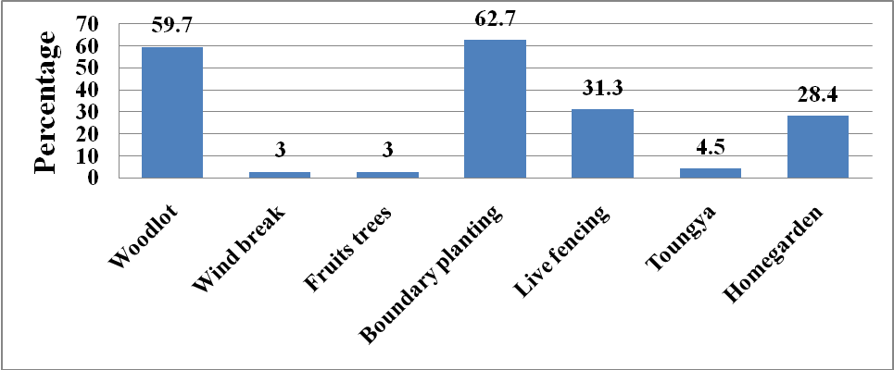
Figure 1: Agroforestry practices in Jenda

Agroforestry practices adopted by farmers in the study area include Boundary planting, (62.7 %), woodlot (59.7%), life fencing (31.4%), home gardens (28.4 %), taungya (4.5%), windbreaks (3 %) and fruits trees in intercropping practice (3 %). From that, it is clear that in Jenda Sector, the farmers do and adopt agroforestry practices in their farms with socio-economic and environmental considerations. The boundary planting is one of the agroforestry practices which is preferred by the farmers in Jenda Sector.

Types of agroforestry species planted in the study area
The tree crops in the land use system included Persea americana, Alnus accuminata, Leucaena diversifolia, Calliandra sp, Erythrina abyssinica, Iboza riparia, Markhamia lutea, Cyphomandra betacea, etc.
Figure 2 presents the proportions of farmers growing various species in the study area.
In figure 2, the most grown species in Jenda Sector are Erythrina abyssinica, Alnus accuminata, Grevillea rubusta and Iboza riparia corresponding to 100 %, 94 %, 77.6 % and 71.6 % respectively. These species have been shown to be more adaptable and productive in the highlands area like Busogo area. In addition, the fruit trees grown are Persea americana and Cyphomandra betacea with 7.5 % and 6 %. The Erythrina abyssinica specie is very dominant in Jenda Sector due to its considerable role in traditional believes.

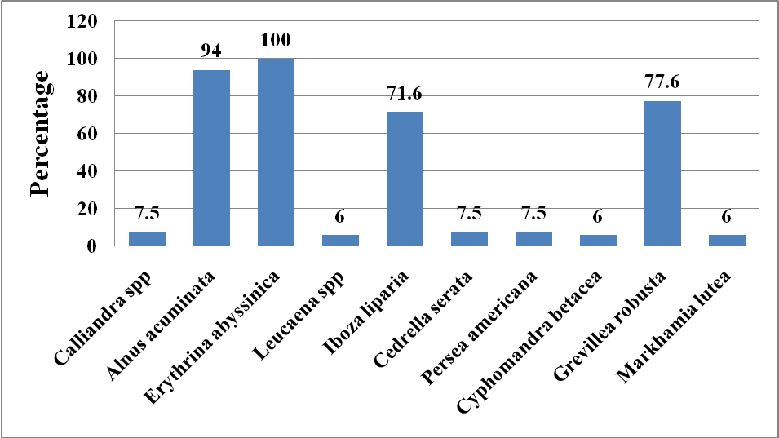
Figure 2: Types of Agroforestry species adopted in Jenda Sector

The Roles of Agroforestry practices in Jenda Sector

Service roles
The service functions of agroforestry practices known by the farmers of Jenda Sector are presented on the figure 21 bellow.
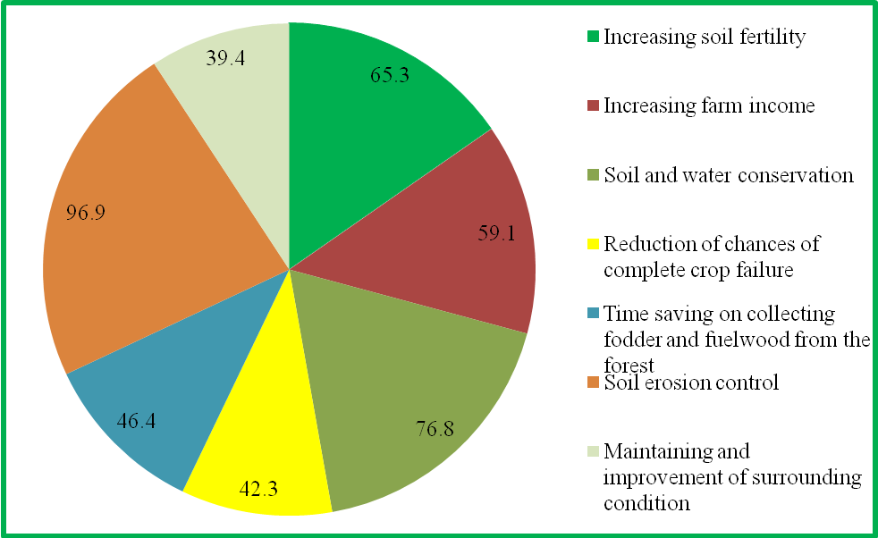
Figure 3: Service roles of agroforestry practices in Jenda Sector

The results presented on figure 21 show that the farmers of Jenda Sector 96.9% of them agree that the agroforestry practices play a vital service role in soil erosion control and 76.8 % of the farmers know that the agroforestry practices contribute in soil and water conservation; while the 65.3 %,59.1 %,46.4 %, 42.3 % and 39.4 % of farmers are aware of increased soil fertility, increased farm income, saved time for collecting fodder and fuel wood from the forest, reduced chances of complete crop failure and maintained and improved surrounding condition as the service roles of agroforestry practices in Jenda Sector respectively. In terms of improving surrounding condition, agroforestry like forestry purifies air i.e. it reduces green house gases, creates microclimate, protects livings things against sun light and provides shade.

Productive roles
A part from the service roles of agroforestry practices there are productive roles that are played by those practices in the study area. The most productive roles of agroforestry practices found in Jenda Sector are mentioned on the figure 22.

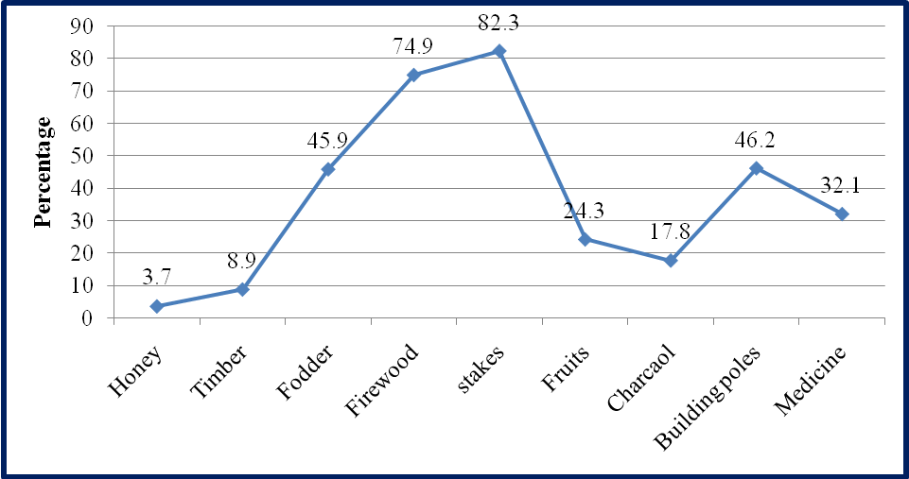
Figure 4: Productive roles of agroforestry practices in Jenda Sector

In figure 4, the products gained from agroforestry practices which are found in Jenda sector are stakes (82.3 %), firewood (74.9 %), building poles (46.2 %), fodder for animals (45.9%), medicines (32.1 %), fruits (24.3 %), charcoal (17.8 %), timber (8.9 %) and honey (3.7 %).

Social roles of Agroforestry practices
The social uses of agroforestry products in Jenda Sector are shown in figure 5 presented below.
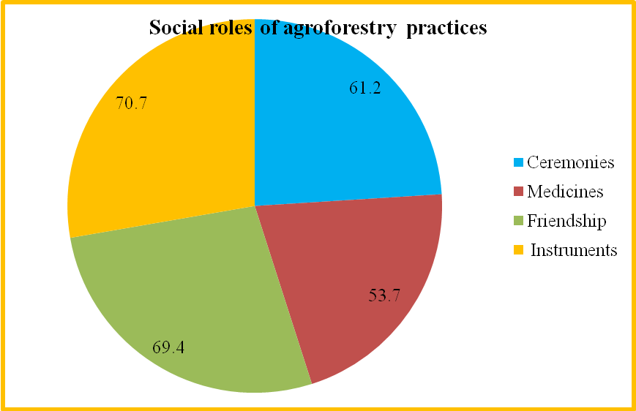
Figure 5: Social use of agroforestry products

As indicated in figure 5, the social uses of agroforestry products are varied. Instruments are ranked highly by 70.7 % of households, maintaining friendship with the neighbors is ranked second by 69.4 % for example when one farmer gives his/her neighbor or friend a bundle of firewood or stakes, the society or community is made cohesive and use in ceremonies (like marriage, funerals and birth celebration) is affirmed by 61.2 % of households while provision of medicines is ranked 4th by 53.7 % of households.

3.3. The socio-economic factors affecting the income levels of the farmers
Table 2 below summarizes the influence of socioeconomic factors on household income.

Table 2: Coefficient of regression model on income
Model | Unstandardized Coefficients | p-value
Model | Betas | p-value
(Constant) | -144045 | 0.189
Age (X₁) | 25689.7 (β1) | 0.350
Sex (X₂) | 36815.4 (β2) | 0.446
Experience in farming (X₃) | 789.3(β3) | 0.988
The size of the family (X₄) | 49106.3(β4) | 0.005
Education (X₅) | 146417.8(β5) | 0.000
Health status (X₆) | 10392.6(β6) | 0.768
The land size (X₇) | 101338.6(β7) | 0.000
Source: Survey data
The regression model equation is:
Y= -144045 +25689.7X₁+36815.4X₂+ 789.3X₃ - 49106.3 X₄ +146417.8 X₅ +10392.6 X₆ 10138.6 X7 + ε_{i.}
The size of the family, education and the land size are statistically significant at 5% level of significance because the p-value (0.005, 0.000, 0.000 respectively) are less than an α-value (significance level) of 0.05 while others factors are not statistically significant because the p-values (0.446, 0.350, 0.998, 0.800, 0.768 respectively) are greater than an α value of 0.05.

3.4. Constraints affecting adoption of Agroforestry in the study area
The results obtained on the constraints affecting the adoption of agroforestry practices in the study area are presented in the figure 6.
According to the results indicated in Figure 6, 86.1 % of the surveyed farmers had the constraints of lacking capital, 75.8 % of them had the constraints of lacking seedlings, and 17.2 % are still lacking technical advice while 13.6 % presented the constraints of lacking labour or manpower. This is because some farmers were old and could not use larger portion of their land for agroforestry since it was labour-intensive. The statistical analysis of the results obtained on the relationship between farmers constraints and the adoptions of agroforestry in Jenda Sector are presented in table 7.

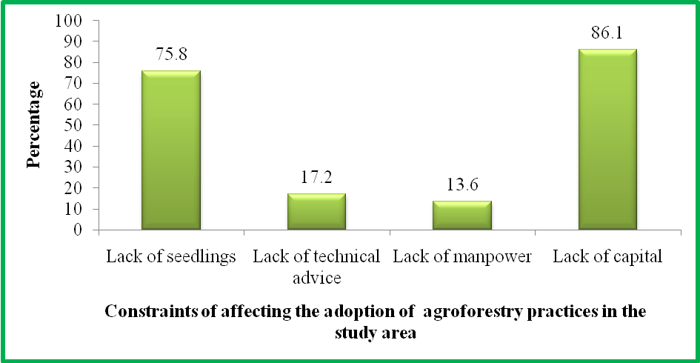
Figure 6: Constraints affecting adoption of agroforestry in the study area

Table 3: Statistical analysis on the farmers ‘constraints in adoption of agroforestrypractices
Farmers ‘constraints | Mean Rank
Lack of seedlings as a constraints for agroforestry practice | 1.71
Lack of technical advice as a constraints for agroforestry practice | 3.19
Lack of labor as a constraints for agroforestry practices | 3.06
Lack of capital as a constraint for agroforestry practices | 1.12

According to Friedman Test as indicated in Table 3, the lack of capital and seedlings had the lowest mean ranks, this allows us to affirm that lack of capital and seedlings are viewed as the most critical constraints affecting farmers adoption of agroforestry practices in Jenda Sector. Therefore the hypothesis is accepted. In general, the constraints have the different negative effect on adoption of agroforestry practices as shown by the analysis where p-value (0.000) < α (0.05).

3.5. Solutions suggested by farmers to alleviate the constraints

After identifying different constraints that affect the adoption of agroforestry practices it was very necessary to find out the possible suggestions in order to overcome those constraints. The results obtained on them are presented in Figure 7 below.

Referring to the results obtained on the suggestions of farmers in order to overcome the mentioned constraints, 91.8% suggest the availability of financial capital, either by loans, credit or subsidies for enhancing the agroforestry practices, (82.3 %) request the availability of different agroforestry species and75.9 % of the farmers prefer the availability sufficient nurseries establishment for getting planting materials.

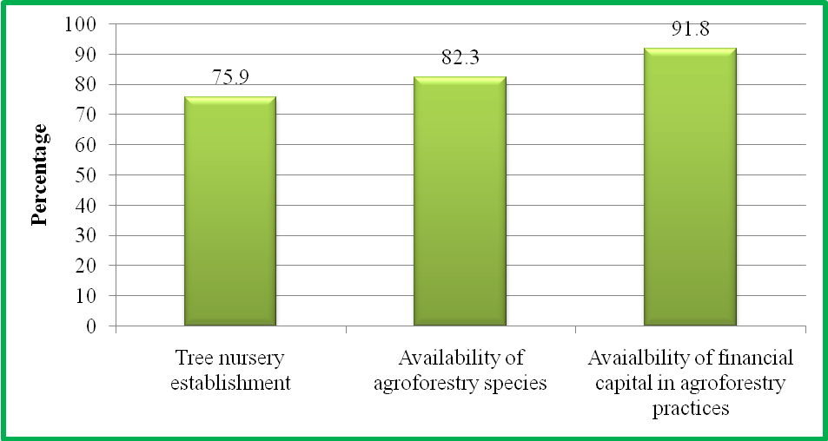
Figure 7: Suggested solutions to mentioned constraints

4. Discussions
The age range 40-59 years constitute the majority of respondents (62%), which shows that younger farmers are more likely to adopt a new technology because they had more schooling than the older generation and could reap the benefits of tree crops in their life time. According to ICRAF (2003), younger farmers are more likely to adopt a new technology, since they have had more schooling than the older generation or perhaps have been exposed to new ideas as migrant labors.
Many of the agroforestry practices like woodlot inter cropping, planting of windbreaks, as well as fruit trees on cropland in the study area involved strenuous activities, which are done manually. The fact that women constitute about one-quarter of agroforestry practitioners shows that women are also into agroforestry. However, it can be said that women are mostly interested in planting and cultivating food crops to meet household consumption needs rather than tree crops.
Eckman (1992) deduced from his studies that individuals within a household may have different rights depending on gender. He found that in some African Countries, for example, women plant and tend fire-wood or fruit trees but do not have right to harvest fruits or wood; these may be sold or appropriated by male members. Leach and Mearns (1988) have emphasized division between men and women in access to natural resources and their management and use as common in African land management system. They concluded that forestry development initiatives must therefore not just “consider” women but aim at giving them equality with men in control over resources, in decision making over resource production and use, and empowerment to evolve self – directed problem solving strategies.
They all invariably point out that women are commonly collectors of water, fuel wood, foodstuffs and medicinal herbs and that they are directly affected by environmental degradation. In their decision making, women place higher value on taking care of the environment than the male family members do.
From the results in figure 5, it can be deduced that since the factors that affect the adoption of agroforestry practices may not be very different from those of general adoption of agricultural practices, the rich experience of farmers can be used to improve agroforestry using indigenous technical knowledge to bring about the desire results. According to ICRAF (2003), the very experienced farmers in farming are more likely to adopt a new technology since they are capable to understand the innovations through different comparisons.
The high level of literacy rate would result in increase of technical efficiency and decreased conservationism among farmers. This would also contribute to the acceptance of agroforestry innovations (Sarfo Mensah, 1994). According to Tripp (1993), education is an important socio-economic variable that may make a farmer more receptive to advice from an extension agency or more able to deal with technical recommendations that require a certain level of numeracy or literacy.
The reasonably high household sizes probably indicate that farmers were youthful and highly reproductive. The large family size of the bulk of farmers (63 %) could provide labour which is an incentive to agroforestry adoption. According to the National Institute of Statistics of Rwanda (2007-2008), the mean household size was 4.6 persons in general and 4.5 persons in rural areas and 4.8 persons in urban areas. However, the consequences of large family size are increased pressure on the ecosystem, land fragmentation and tree ownership problems.
Generally, the married people are sensitive to innovations since they have many opportunities to participate in training and formation about agroforestry. However, the widow, divorced and single farmers are still resistant to the new information dissemination as they are alone in households.
In Jenda Sector, as the highest number of the farmers is married, it is clear that the adoption of agroforestry practices will be done adequately and in rational manner; as well as they have been explained clearly by the agroforestry extensionists the importance and functions of agroforestry in improvement of their livelihoods. That has been confirmed by Sarfo-Mensah (1994) in his study carried out in Ghana. Also, he has concluded that the married farmers are able to adopt agroforestry technologies than other categories of farmers.
According to the National Institute of Statistics of Rwanda (2007-2008), the main sources of income of Rwanda are agriculture and allied activities.
The inherent land can be pledged for money or used as collateral in securing loans from financial institutions like banks. It is very easy to plant perennial crops (tree crops) on inherent land since the land belongs to you. Many also said the use of land for woodlot, intercropping and Persea americana intercrop which were all agroforestry practices would help them raise their income levels through the sale of tree products. This may encourage many from using their land for agroforestry purposes. This shows that even if the interviewed farmers obtained their land by inheritance, they use other methods (purchase and renting) in order to increase their farm land. According to the results of MINITERE (2007), the average landholdings in Rwanda are very small. This pushes some farmers to purchase and renting land for increasing the size of their land farm in order to diversify their activities included forest plantations.
The small farm sizes constitute an obstacle to farm improvement. According to the results of MINITERE (2007), the average landholdings in Rwanda are very small, less than 25 % cultivate the land of more than 0.5 ha, 50 % cultivate less than 0.5 ha, and more than 25 % cultivating less than 0.2 ha).
For example, it will be difficult for smallholder farmers to expand their farms. This finding supports Benneh (1976) who argued that miniature farm sizes and the manner, in which they are fragmented and scattered, constitute an obstacle to farm improvement since they do not enable farmers to take advantage of economies of scale of production.
In Jenda Sector, 100% of farmers use their lands for food production, 47.8% for tree production and only 4.5% for fodder production. This confirms that the majority of farmers in the study area are agriculturally dependent. Most farmers had the desire to grow food crops in order to provide food for household consumption. They also wanted to increase income by incorporating tree crops. Referring to MINAGRI (2006), the land use consolidation will help to implement the crop intensification program not only food crops, but also, cash and fodder crops.
As it is presented on figure 15, the rearing domestic animals in Jenda Sector contribute in increasing household income (97%), getting farm yard manure (94 %), getting money through purchase (91 %), improvement of social relationship with neighbours (74.6%), milk drinking (49.3%) and getting family consumption (13.4%). According to MINICOFIN (2006), apart from agriculture in generating income to the farmers, the animal rearing is also the considerable source of income in Rwanda, about 24 % of national income.
Agroforestry practices undertaken by farmers in the study area include Boundary planting (62.7%), woodlot (59.7%), life fencing (31.4%), home gardens (28.4%), taungya (4.5%), windbreaks (3%) and fruits trees in intercropping practice (3%). From that, it is clear that in Jenda Sector, the farmers do and adopt agroforestry practices in their farms with socio-economic and environmental considerations. This was supported by ICRAF (2003) while conducting its study on the socio-economic and environmental of tree farming in Kenya, where they have found that most farmers cultivated and grown trees for protecting their lands, income generation, fodder production and medicinal products issues.
Majority of the farmers (67.16 %) indicated that they have been supported by the NGOs as extension agents while 64.7 % were supported by Government institutions in order to promote agroforestry practices in their fields. The non-governmental organizations, which complemented the efforts of government extension services, were European Union and CARE.
As the Government institutions, there were MINAGRI, REMA, PAREF and NAFA. Farmers received extension education on improved cultural practices. This is an incentive to agroforestry adoption and its subsequent impact on the livelihood of farmers in the study area. This agrees with Adams (1982) who concluded that techniques or innovations normally provide the means of achieving sustained increases in farm productivity and income and that it is the extension workers job to encourage farmers to adopt innovations of proven value.
The results are in agreement with Wollenberg (1998), in many countries, a wide range of forest products is commonly used in traditional ceremonies, funeral, and inauguration ceremonies of the chiefs, initiations, birth celebrations and conflict resolution.
However, 6 % of the farmers had their source of finance through money lenders while 4.5 % of them had the source of financing farming activities by family members’ support.
The size of the family, education and the land size are statistically significant at 5% level of significant because the p-value (0.005, 0.000, 0.000 respectively) are less than an α-value (significance level) of 0.05 while others factors are not statistically significant because the p-values (0.446, 0.350, 0.998, 0.800, 0.768 respectively) are greater than an α value of 0.05.
According to the results obtained on the figure 24, the 86.1 % of the surveyed farmers had the constraints of lacking capital, 75.8 % of them had the constraints of lacking seedlings, and 17.2 % are still lacking technical advice while 13.6 % were presented the constraints of lacking labour/manpower. This is because some farmers were old and could not use larger portion of their land for agroforestry since it was labour-intensive. According to Sarfo-Mensah (1994), lack of seedlings and capital were the main farmers‘c onstraints to adopt agroforestry technologies than other constraints.
According to Friedman Test as indicated in the table 4, lack of capital and seedlings had the lowest mean rank, this allow us to conclude that lack of capital and seedlings are viewed as the most critical constraints affecting farmers in the adoption of agroforestry practices in Jenda Sector.
In general, the constraints have the different negative effect on adoption of agroforestry practices as shown by the analysis where p-value (0.000) < α (0.05). This has been confirmed by Sarfo-Mensah (1994) in his study in Ghana. It has concluded that lack of seedlings and capitals were the main farmers ‘constraints to adopt agroforestry technologies than other constraints. According to the results of statistical analysis on the agriculture and formal/informal job are the sources which generate high income to the farmers. This is affirmed by the mean of income generated by different activities per year. The results of this study show that the agriculture occupies the first place with an average of 678909.09 Rwf per year followed by formal/informal job with a mean of 205283.13 Rwf per year but also the agroforestry practices contribute to the total household’s income with an annual average of 43860.87Rwf.
From the Friedman Test depicted in Table 7, the lack of capital and seedlings had the lowest mean ranks, this allow us to conclude that the lack of capital and seedlings are viewed as the most critical constraints affecting farmers adoption of agroforestry practices in Jenda Sector. Therefore the hypothesis is accepted. In general, the constraints have the different negative effect on adoption of agroforestry practices as shown by the analysis where p-value (0.000) < α (0.05).

Acknowledgements
We acknowledge the institute for the little funds (500,000 RFW) given to us to conduct the study. We also acknowledge the support we got from the ministry of agriculture in the sector. We thank also the departments of Forestry and Nature Conservation and Rural Development and Agribusiness departments for their valuable advice.

Corresponding Author:
Isaac Emukule Ekise
Department of Forestry and Nature Conservation
Busogo Campus, Higher Institute of Agriculture & Animal Husbandry, P.O. Box 210, Musanze, Rwanda
E-mail: iekise@yahoo.com

References
- Eckman, K.1991.”Environmental action and women groups: successful initiatives in the Third world countries”. Forest, trees and people. Newsletter No.15\16pp. 36-40.
- FAO, 1986. Tree growing by rural people. FAO Forestry paper 64. Food and Agricultural Organization of the UN, Rome, pp 26-29.
- ICRAF, 1993. Strategy to the year 2000. Mimeo, Nairobi: ICRAF. 78pp.
- ICRAF(2001): Agroforestry for sustainable development, Nairobi-Kenya 110pp.
- Jenda Sector, (2012). Monography of the Sector, pp 27
- Leach, G., and Mearns, R., 1988. Beyond the wood fuel crisis. People, Land and tree in Africa, Earthscan Publications Ltd., London, 76pp.
- Leakey, 1996: Agroforestry Today: Vol. 8 No. 1: ICRAF, Nairobi, Kenya, pp 45-47.
- Lele, U. 1989. Managing Agricultural Development in Africa: Discussion Paper, 91, IDS, Brighton, pp 11-17.
- Lundgren, B. O.1987. ICRAF.s first ten years. Agroforestry systems 5: pp197-217.
- MINAGRI, (2002). Statistique agricole, productions, superficies, et utilisation de terres, Kigali Rwanda, pp12-14
- MINAGRI, (2006). Implementation of green revolution program in Rwanda, Kigali, Rwanda, pp36-45.
- MINICOFIN (2003): Indicateurs du développement du Rwanda ; Kigali 399pp.
- MINISANTE (2010) : Rapport sur la faisabilité de la mutuelle de santé au Rwanda, Kigali, Rwanda 57P.
- MINITERE and CGIS-NUR (2007). Final report on the Mapping of Rwandese forests, Volume 1. The Ministry of Lands, Environment, Forests, Water and Natural Resources (MINITERE) and The Geographic Information Systems & Remote Sensing Research and Training Center of the National University of Rwanda (CGIS – NUR),pp32-33
- Nyabihu District, (2012) District Development Plan, Rwanda, 65p.
- Nair, P.K. 1993. An introduction to Agroforestry: pp 13-155, ICRAF/Kluwers Academic Publishers, Dordrecht, The Netherlands, pp7-9.
- National institute of statistics of Rwanda (2007-2008), Integral survey on life conditions of households, Kigali, Rwanda, 34pp.
- Rehm, S. and Espig, G. 1991. The cultivated plants of the tropics and sub tropics. CTA / Eugen Ulmer GmbH & Co., Wollgrasweg 41, D – 7000 Stuttgart 70, West Germany, pp23-25.
- RNLC (2009). Report on implementation of land administration, registration and regularization in Rwanda, Kigali, P14-18.
- Rocheleau et al, 1989. “Local knowledge for agroforestry and native plants”. In chambers; R., Pacey, A and Thrupp, L.A., (eds). Farmer First. Intermediated Technology Publications, London, pp 14 – 23.
- Rocheleau, D and Raintree, J.D., 1986: Agroforestry and the future of food production in developing countries. Impact of Science and Society 142: pp127 – 141.
- Sanchez, P.A., Palm, C.A. Szott, L.T., and Davey, C.B.1985. Tree crops as soil improvers in the humid tropics. In: Cannell, M.G.R. and Jackson, J.E. (eds), Attributes of Trees as Crop Plants, pp. 79-124. Inst.Terrestrial Ecology, Huntington, UK,pp35-37.
- Sarfo-Mensah, P., 1994. Analysis of some socio-economic Factors that affect the adoption of agroforestry technologies in the Yensi Valley in Akwapim, Ghana. MPhil. thesis, IRNR, UST – Kumasi (Unpublished). 123pp.
- Tripp, R. 1993. Adoption of Agricultural Technology: A guide for Survey Design CIMMYT. Mexico, 27pp.
- UNESCO, 1984. Action plan for biosphere reserves. Nature and Resources 2004 ,18pp
- Young, A. 1987. The Potential of Agroforestry as a Practical means of sustaining soil fertility. ICRAF, Nairobi, Kenya, pp56-58.
- Young, A. 1989. Agroforestry for soil conservation. Science and practice of agroforestry, 4 Wallingford, UK: CAB International and Nairobi: ICRAF, 276pp.

9/10/2013

