Chemical Constituents and In Vitro Antimicrobial Activities of Five Botanicals Used Traditionally for the Treatment of Neonatal Jaundice in Ibadan, Nigeria

Gbadamosi I. T. and Obogo S. F.

Department of Botany, University of Ibadan, Nigeria.
gita4me2004@yahoo.com

Abstract: Neonatal jaundice is a main cause of morbidity and mortality among neonates in Nigeria and ethnobotanical investigation revealed the use of Alstonia boonei (De wild.), Cocos nucifera (L.), Gossypium barbadense (L.), Tetrapleura tetraptera (Schumach. & Thonn.) and Vernonia amygdalina (Del.) for the management of neonatal jaundice in Ibadan, Nigeria. This study analysed the five plants for their chemical components and antimicrobial activities to justify their therapeutic values in the management of jaundice. The powdered plant samples were screened for mineral and phytochemical components using standard protocols. The ethanol extracts (50 mg/ml) of samples were tested against five clinical pathogenic organisms at 10⁻¹ – 10⁻⁶ cfu/ml inoculum concentrations using agar-well diffusion method. Data were analysed statistically. G. barbadense (0.26 mg/100g) had the highest Na content. A. boonei had the highest Zn and Fe contents, 6.40 and 5.13 mg/100g respectively. A. boonei contained the highest saponins (0.79%) and tannins (0.05%). At 1 x 10⁻⁴ cfu/ml, G. barbadense was most active on K. pneumoniae (29.90 mm); T. tetraptera was most active against C. albicans (21.90 mm) and T. tetraptera and V. amygdalina gave the same activity (14.90 mm) against E. coli. At 1 x 10⁻⁶cfu/ml, only T. tetraptera showed 100% antimicrobial activity by being active against all test organisms. The mineral and phytochemical components of the plants could be responsible for their antimicrobial properties. The extracts, compounds as well as oils from the test plants especially A. boonei could be useful in combating infections and metabolic disorder associated with neonatal jaundice. Toxicity studies of the plant samples would ascertain their safety in treatments.
[Gbadamosi IT, Obogo SF. Chemical Constituents and In Vitro Antimicrobial Activities of Five Botanicals Used Traditionally for the Treatment of Neonatal Jaundice in Ibadan, Nigeria. Nat Sci 2013;11(10):130-135]. (ISSN: 1545-0740). http://www.sciencepub.net/nature. 19

Keywords: Botanicals; jaundice; neonates; mineral analysis; phytochemical screening; antimicrobial assay.

1. Introduction
Hyperbilirubinemia is the medical term for a high bilirubin level in the bloodstream and the cause of jaundice (Coleman, 2011). Jaundice itself is not a disease, but rather a sign of one of the many possible underlying pathological processes that occur at some point along the normal physiological pathway of bilirubin metabolism. Hyperbilirubinemia is often seen in liver diseases such as hepatitis or liver cancer. It may also indicate obstruction of the biliary tract, for example by gallstones or pancreatic cancer, or less commonly congenital in origin. Jaundice can also be associated with severe illnesses such as haemolytic disease, metabolic and endocrine disorders, enzymatic deficiencies of the liver, and infections (Bilgen et al, 2006).
Neonatal jaundice is the most common form of jaundice and it occurs in new-born babies of less than a month old. Factors influencing the occurrence of neonatal jaundice are body physiology, premature birth, effect of breastfeeding, breast-milk constituents, heredity (enzyme deficiency), blood or rhesus group incompatibility (between mother and baby), and infections (Kotal et al, 1996; Bilgen et al, 2006; Kumral et al, 2009; American Academy of Pediatrics Subcommittee on Hyperbilirubinemia, 2004).
Clinical symptoms of neonatal jaundice include irritability, jitteriness, increased high-pitched crying, lethargy and poor feeding; back arching; apnea and seizures (Nelson, 2013). Phototherapy is the most effective way of breaking down a neonate’s bilirubin (Leung et al, 1992) and increased feedings also help move bilirubin through the neonate’s metabolic system. Exchange transfusions are also useful in the treatment of neonatal jaundice. (American Academy of Pediatrics Subcommittee on Hyperbilirubinemia, 2004).
Neonatal jaundice associated with high morbidity and mortality is a common pediatric problem in West Africa (Sofoluwe and Gans, 1960). The condition is the commonest cause of neonatal admission to Children Emergency Room in Lagos University Teaching Hospital (LUTH), Nigeria (Ransome-Kuti, 1972). In a study on the incidence and causes of neonatal jaundice in Nigerian babies, Effiong et al. (1975) observed that G6PD (enzyme glucose-6-phosphate dehydrogenase) deficiency and ABO incompatibility were the major aetiological factors in babies with total bilirubin of 15mg/100ml. Ahmed et al. (1995) reported septicaemia (50%) and G6PD deficiency (40%) as the major aetiological factors of neonatal jaundice in 587 neonates born in Ahmadu Bello University Teaching Hospital (ABUTH), Zaria, Nigeria. Neonatal jaundice accounted for 35% of all Neonate Intensive Care Unit (NICU) admissions at Federal Medical Centre, Abakaliki, Southeast, Nigeria. Septicaemia (32.5%) and prematurity (17.5%) were the leading aetiological factors in neonates (Onyearugha et al., 2011).
In view of non-drug orthodox methods of treatment of neonatal jaundice and the prevalence of neonatal jaundice in Nigeria, a phytodrug therapy would be desirable. Medicinal plants with reported therapeutic effects in the management of neonatal jaundice are Artemisia capillaris, Scutellaria baicalensis, Rheum officinale, Glycyrrhiza glabra and Coptis chinesis (Fok, 2001); Boswellia serrata (Patwardhan et al., 2010); Alstonia boonei (Adotey et al., 2012; Moronkola and Kunle, 2012) and Gossypium barbadense (Todou and Konsa, 2011). Rhei rhizome, ginseng, grapeseed, Dioscorea villosa, Pseudolarix kaempferi, Hypericum perforatum and soy have also been reported to be effective in the management of neonatal jaundice (Lazar, 2004).
In Nigeria, the stem bark of A. boonei is used widely to treat malaria, typhoid fever, gonorrhoea, yaws, asthma, dysentery, and as a galactagogue. C. nucifera roots have antipyretic and diuretic properties. Milk of young coconut is useful as laxative, antidiarrhoeic and counteracts the effects of poison. The oil is used to treat diseased skin and teeth, and mixed with other medicines to make embrocations. G. barbadense is widely used for the treatment of conjunctivitis, convulsions, jaundice, gastrointestinal disorders, and sexually transmitted infections such as gonorrhea, rheumatism and wounds. T. tetraptera is used traditionally for the treatment of skin infections. V. amygdalina has antibiotic value in traditional medicines, it is also used to treat diabetes, gastrointestinal disorders and as a worm expeller (www.prota4u.org).
This study presents scientific information on the therapeutic potentials of A. boonei, C. nucifera, G. barbadense, T. tetraptera and V. amygdalina in the management of neonatal jaundice.

2. Material and Methods
Plant materials
Twenty herb-sellers of a local herbal market (Bode) in Ibadan, Nigeria were interviewed on traditional knowledge of management and treatment of neonatal jaundice. Alstonia boonei, Cocos nucifera, Gossypium barbadense, Tetrapleura tetraptera and Vernonia amygdalina were frequently mentioned in the twenty recipes collected from the herb-sellers. Herbal recipes were documented. The local name, parts of plant used, method of preparation and mode of administration were also recorded (Sofowora, 1982). The plant materials were purchased from a local herbal market. The samples were identified at species level in the University of Ibadan Herbarium (UIH). The plant samples were washed, dried (27ºC) and powdered. The powdered samples were stored (4ºC) in air-tight bottles for further use.
Mineral analysis of powdered plant samples
The methods of Walsh (1971) and AOAC (2005) were used for the mineral analysis of samples. After wet digestion, sodium (Na), potassium (K), calcium (Ca), magnesium (Mg), copper (Cu), zinc (Zn) and iron (Fe) were analysed using Atomic Absorption Spectrophotometer (FC 210/211 VGP Bausch scientific AAS). Phosphorus was determined using Vanadomolybdate (Yellow method) (AOAC, 2005). Percentage transmittance was determined at 400 nm using Spectronic 20 (Bausch and Lomb) Colorimeter.
Phytochemical screening of plant samples
Quantitative phytochemical analysis of powdered plant samples was carried out using AOAC (2005) methods.
Antimicrobial assay of ethanol plant extracts: The extracts (50 mg/ml) of samples prepared by cold extraction method in 80% ethanol, concentrated and used for the antimicrobial bioassay. The test organisms: Escherichia coli, Klebsiella pneumoniae, Candida albicans, Staphylococcus aureus and Pseudomonas aeruginosa were clinical isolates obtained from University College Hospital (UCH), Ibadan. The organisms were grown in nutrient broth for 18 h at 37ºC. Six different inoculum concentrations (1 x 10⁻¹ – 1 x 10⁻⁶ cfu/ml) of each isolate were prepared in sterile distilled water from the broth cultures via serial dilution. 1ml of the inoculum was thoroughly mixed with 19 ml of sterile nutrient agar and poured into sterile Petri dish. The agar was left to solidify. Two wells of 4 mm in diameter were punctured in each agar plate and 60 μl of each extract was filled into the wells with the aid of a sterile micropipette. 80 % ethanol was used instead of extract in the control experiment. Also plates containing the test organisms in agar without extract were used as control. All experiments were done aseptically and each experiment was replicated three times. The plates were incubated at 37ºC for 24 - 48 h. Readings were taken after 24 h and 48 h. The diameter of inhibition was measured in millimetres (mm).
Data analysis
Where applicable, data were statistically analysed using One-way Analysis of Variance (ANOVA) and expressed as mean ± SD. The Duncan Multiple Range Test (DMRT) was used to test means for significance (P < 0.05).
3. Results and Discussion
The profile of the plant samples used in the management of neonatal jaundice is presented in Table 1. The plants belong to five different families: Apocynaceae, Arecaceae, Malvaceae, Fabaceae and Asteraceae. Table 2 shows the traditional methods of preparation of various botanicals as regimen for neonatal jaundice. The herbs are used singly in recipes and decoction is the most common method of preparation, the herbs are also prepared as soap, oil and syrup for administration. The folk methods of treatment take into consideration the fragility of the baby’s body and system hence the mild methods of preparation and administration of herbal remedies.
The various mineral constituents of plant samples are presented in Table 3. G. barbadense (0.26mg/100g) gave the highest Na content and C. nucifera (0.04mg/100g) the least. K content was also highest in G. barbadense (0.48 mg/100g) and least in T. tetraptera (0.10 mg/100g). Calcium content was highest in G. barbadense (0.08 mg/100g) and least in T. tetraptera (0.01 mg/100g). A. boonei gave the highest P content of 0.41 mg/100g and C. nucifera (0.11 mg/100g) the least. Zinc (Zn) was highest in A. boonei (6.40mg/100g) and least in C. nucifera (3.25mg/100g). The iron (Fe) content of A. boonei (5.13mg/100g) was the highest and T. tetraptera (1.15 mg/100g) recorded the least. Overall, G. barbadense was highest in sodium, potassium and calcium. A. boonei also recorded highest values for phosphorus, zinc and iron. The results of the mineral constituents of test plants are in line with the reports of previous authors. Afolabi et al. (2007) reported the magnitude of presence of macroelements (ppm) in A. boonei bark in the order P>K>Na>Ca>Mg and only Fe (3.2 ppm) was detected as micronutrient. Although there is scarcity of information on the mineral constituents of coconut pod, the literature is replete with information on coconut water mineral components (Richter et al., 2005; Uphade et al., 2008). G. barbadense leaves contain copper (14.6 ppm) and zinc (1.6 ppm) (Apena et al., 2004). Essien et al. (1994) reported that the fruit shell, fruit pulp and seed of T. tetraptera contained varying amounts of nutrients such as protein, lipids and minerals. V. amygdalina contains calcium, iron, potassium, phosphorous, manganese, copper and cobalt in significant quantities (Eleyinmi et al., 2008). The various plant minerals have key roles to play in human health. Potassium regulates heartbeat, maintains fluid balance and helps muscle contraction. Calcium is important for developing and maintaining healthy bones and teeth. It assists in blood clotting, muscle contraction and nerve transmission. Phosphorus works in combination with calcium to develop and maintain strong bones and teeth. It also enhances the use of other nutrients. Magnesium helps nerves and muscles function. It activates over 100 enzymes in the body. Zinc is an essential part of more than 200 enzymes involved in digestion, metabolism and reproduction and wound healing. Copper helps in normal red-blood cell formation and connective tissue formation. It acts as a catalyst to store and release iron to help form hemoglobin. It also contributes to central nervous system function. Iron is essential for red blood cell formation and function and is very important for brain function (Schauss, 2013).
The five medicinal plants contained secondary metabolites in varied concentrations (Fig. 1). The % alkaloids was highest in A. boonei (0.47%), followed by V. amygdalina (0.19%), and the least was for C. nucifera and G. barbadense (0.16%). The % saponins was highest in A. boonei (0.79%), followed by G. barbadense (0.58%) and C. nucifera (0.26%) had the least. A. boonei and V. amygdalina had the highest tannins content of 0.05%. The % phenols was highest in V. amygdalina (0.08%). The highest glycosides content was observed in T. tetraptera (0.36%). Generally, A. boonei had the highest values of alkaloids, saponins and tannins.
At 1 x 10⁻⁴cfu/ml inoculum concentration, the ethanol extract (50 mg/ml) of A. boonei was active on E. coli and K. pneumoniae with 11.90mm and 14.90mm zones of inhibition respectively (Fig. 2). C. nucifera extract was active on 2 out of 5 test organisms; it inhibited the growth of S. aureus (11.90mm) and P. aeruginosa (13.40mm). G. barbadense extract showed antimicrobial activities on 4 out of 5 isolates being most active on K. pneumoniae (29.90mm) and least active on E. coli (11.90mm). T. tetraptera fruit extract was active on three bacterial pathogens and C. albicans. The extract was most active against C. albicans (21.90mm) and least active on S. aureus (11.90mm). V. amygdalina extract had antimicrobial properties being most active on K. pneumoniae (23.40mm) and least active on P. aeruginosa (14.40mm).
Fig. 3 shows the antimicrobial effects of various plant extracts against organisms at 1 x 10⁻⁶ cfu/ml inoculum concentration. E. coli was susceptible to C. nucifera extract with 24.90 mm diameter of inhibition. The growth K. pneumoniae was inhibited by T. tetraptera extract with 44.90 mm zone of inhibition. Overall, at 1 x 10⁻⁶cfu/ml inoculum concentration, only T. tetraptera showed 100% antimicrobial activity by being active against all organisms. In line with the results of the antimicrobial activities of the test plants are previous reports on their values as antibiotic plants. The antimicrobial activity of extracts and active compounds of V. amygdalina has been reported by previous authors (Alabi et al., 2005; Erasto et al., 2006). Gbadamosi and Oyedele (2012) reported the antimicrobial activities of A. boonei and T. tetraptera in skin infections. The hot percolated ethanolic extract of C. nucifera was active against Gram + and Gram – bacterial isolates (Singla et al., 2011). G. barbadense has antibacterial and wound healing properties (Ikobi et al., 2012).
As neonatal jaundice is an indication that the baby’s liver is limited in its ability to process bilirubin, the mineral and antioxidant constituents of the five plants may be therapeutically useful. According to White and Foster (2000) detoxification process of the liver initially requires magnesium, iron, molybdenum and essential fatty acids, then later extra vitamins A, C, E (antioxidants), zinc, copper, folic acid and some amino acids. V. amygdalina has antibiotic, antimicrobial, anticancer, antioxidant, antidiabetic, hepato-protective, nephro-protective, oxytocic and serum lipid modulation properties (Ijeh and Ejike, 2011). Also T. tetraptera has shown antimalarial and antioxidant properties (Lekana-Douki et al., 2011; Badu et al., 2012). Gbadamosi et al. (2011) reported the nutritional and phytochemical properties of A. boonei bark as an antimalaria herb. C. nucifera is rich in phosphorus and has antibacterial, antifungal, antiviral and antioxidant properties. The phytochemical components such as alkaloids, saponins and tannins present in the medicinal plants may have singular or synergistic effects in improving the ability of the neonate’s liver to reduce high level of bilirubin. Since infection is a risk factor for neonatal jaundice (Bilgen et al., 2006) the antimicrobial activities of the medicinal plants will be useful in treating the health problem.

Table 1. Profile of test plants used in neonatal jaundice in Ibadan, Nigeria
Family | Scientific name | Common name | Local name | Part used
Apocynaceae | Alstonia boonei | Stool wood | Ahun | Bark
Arecaceae | Cocos nucifera | Coconut | Agbon | Pod (husk)
Malvaceae | Gossypium barbadense | Cotton | Owu | Leaf
Fabaceae | Tetrapleura tetraptera | - | Aidan | Pod (Fruit)
Asteraceae | Vernonia amygdalina | Bitter leaf | Ewuro | Leaf
Table 2. Herbal remedies for the management of neonatal jaundice in Ibadan, Nigeria
S/N | Herb | Herbal preparation and dosage | Preparation method
1. | Alstonia boonei | The bark (200g) of A. boonei is boiled in 1L of water for 15 mins. The water extract is used to bath the baby twice daily. Half teaspoonful of the extract is given to the baby orally twice daily after food. | Decoction
2. | Cocos nucifera | The pod (200g) of C. nucifera is cooked in 1L of water for 15mins and used to bath the baby. Powdered pod is soak in hot palm oil and menthol crystals are added to the oil. The oil is rubbed on the baby after bath. | Decoction and oil
3. | Gossypium barbadense | G. barbadense leaves (200g) are boiled in water (1L) for 15mins. One teaspoonful of the extract is given to the baby three times daily after food. | Decoction
4. | Tetrapleura tetraptera | T. tetraptera pod (200g) is cooked in water (1L) for 15 mins. The preparation is used to bath the baby twice daily. Half teaspoonful of the extract is taken by the baby twice daily after food. The powdered pod is mixed with local soap and used for bathing the baby twice daily. | Decoction and soap
5. | Vernonia amygdalina | Fresh leaves of V. amygdalina are collected and washed thoroughly. The leaf juice is extracted by pounding. The juice is added to pure honey (1:1) and mixed thoroughly. The baby takes one teaspoonful of the mixture three times daily. Paste is also prepared from the fresh leaves and mixed with local soap. The soap is used for bathing daily. | Syrup and soap
Table 3. Mineral components (mg/100g) of powdered plant samples
Botanical | Na | K | Ca | P | Mg | Zn | Cu | Fe
A boonei | *0.12^{c} ± 0.00 | 0.31^{c} ± 0.00 | 0.06^{c} ± 0.00 | 0.41ª ± 0.00 | 0.49ª ± 0.00 | *6.40ª ± 0.28 | 9.05ª ± 0.35 | 5.13ª ± 0.14
C. nucifera | 0.04e ± 0.00 | 0.08e ± 0.00 | 0.03^{d} ± 0.00 | 0.11e ± 0.00 | 0.23e ± 0.00 | 3.25e ± 0.21 | 4.35^{c} ± 0.21 | 2.14^{d} ± 0.21
G. barbadense | 0.26ª ± 0.00 | 0.48ª ± 0.00 | 0.08ª ± 0.00 | 0.39^{b} ± 0.00 | 0.47^{b} ± 0.00 | 5.63^{b} ± 0.28 | 8.50ª ± 0.28 | 3.88^{b} ± 0.14
T. tetraptera | 0.10^{d} ± 0.00 | 0.12^{d} ± 0.00 | 0.01e ± 0.00 | 0.26^{d} ± 0.00 | 0.31^{d} ± 0.00 | 3.66^{d} ± 0.21 | 4.80^{c} ± 0.14 | 1.15e ± 0.21
V. amygdalina | 0.17^{b} ± 0.00 | 0.34^{b} ± 0.00 | 0.06^{b} ± 0.00 | 0.29^{c} ± 0.00 | 0.40^{c} ± 0.00 | 4.28^{c} ± 0.49 | 6.35^{b} ± 0.21 | 3.15^{c} ± 0.21
Legend: *Value = Mean ± standard deviation. Values within a column followed by the same superscript are not significantly different at P = 0.05. Na - Sodium; K - Potassium; Ca - Calcium; P - Phosphorus; Mg- magnesium; Zn - Zinc; Cu - copper; Fe - Iron.

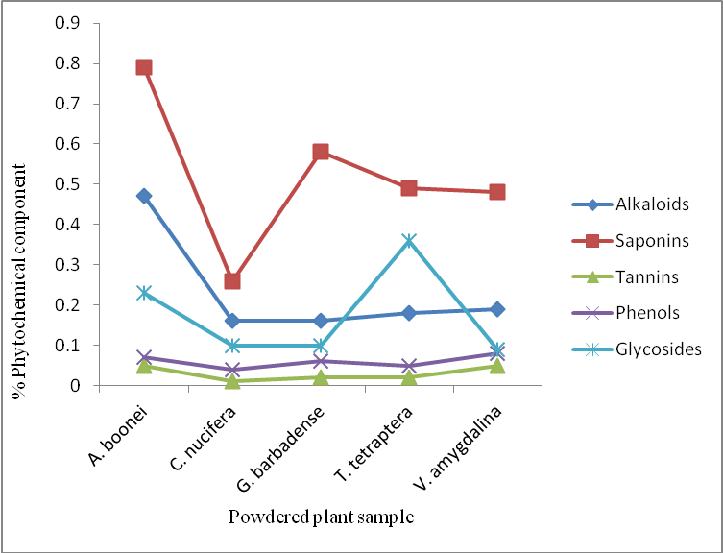
Figure1. Phytochemical components of powdered
plant samples

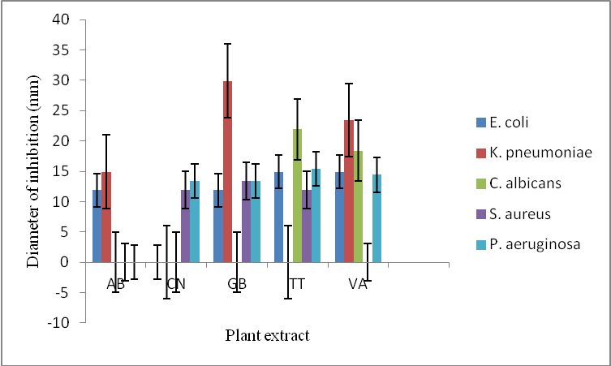

Figure 2. In vitro antimicrobial activities of ethanol extracts of test plants at 1 x 10⁻⁴ cfu/ml inoculum concentration

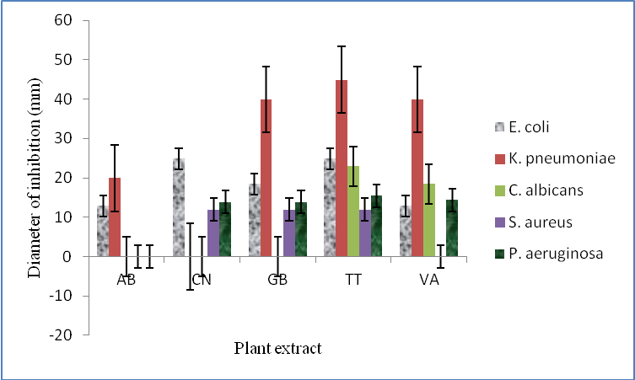

Figure 3. In vitro antimicrobial activities of ethanol extracts of test plants at 1 x 10⁻⁶ cfu/ml inoculum concentration

Conclusion
The test plants contained minerals and secondary metabolites that could be responsible for the observed antimicrobial activity of the plants. A. boonei is a valuable plant in the management of neonatal jaundice because of its high magnesium, copper, zinc and iron contents. Mg and Zn play significant roles in metabolism, copper and iron are essential in red blood formation and function. Enhanced metabolism flushes out bilurubin out of the baby’s system. A decoction of A. boonei is good for the mother as galactogogue as well as for the baby for the treatment of jaundice especially in breast feeding and infections associated neonatal jaundice. Of importance is the significant antimicrobial activities of G. barbadense and V. amygdalina in infections associated neonatal jaundice. The isolation and purification of active components of A. boonei, G. barbadense and V. amygdalina could improve pharmaceutical treatments for neonatal jaundice. Toxicity studies of the three plants will certify their safety in treatments.

Corresponding Author:
Dr. Idayat T. Gbadamosi
Department of Botany
University of Ibadan, Nigeria
E-mail: gita4me2004@yahoo.com

References
- Coleman Ruth, 2011. Newborn Jaundice & Vitamin D. Available at: http://www.livestrong.com/article/532575-newborn-jaundice-vitamin-d/#ixzz2a3FMIuBl. Accessed 24 April 2013.
- Bilgen H, Ozek E, Unver T, Biyikli N, Alpay H, Cebeci D. Urinary tract infection and hyperbilirubinemia. Turkish Journal of Pediatric 2006; 48(1):51-5.
- Kotal P, Vitek L, Fevery J. Fasting-related hyperbilirubinemia in rats: the effect of decreased intestinal motility. Gastroenterology 1996; 111: 217-23.
- Kumral A, Ozkan H, Duman N, Yesilirmak DC, Islekel H, Ozalp Y. Breast milk jaundice correlates with high levels of epidermal growth factor. Pediatric Research 2009; 66: 218–21.
- American Academy of Pediatrics Subcommittee on hyperbilirubinemia. “Management of hyperbilirubinemia in the newborn infant 35 or more weeks of gestation”. Pediatrics 2004; 114(1): 297-316.
- Nelson Melissa, 2013. Neonatal Hyperbilirubinemia. Available at: http://medstation.yale.edu/5A0B783D-40E6-4989-9496-. Accessed 24 April 2013.
- Leung C, Soong WJ, Chen SJ. "[Effect of light on total micro-bilirubin values in vitro]". Zhonghua Yi Xue Za Zhi (Taipei) (in Chinese) 1992; 50(1): 41–5.
- Sofoluwe GO, Gans B. Neonatal jaundice in Lagos. West Africa Journal of Medicine 1960; 9: 145.
- Ransome-Kuti O. The problems of pediatric emergencies in Nigeria. Nigerian Medical Journal 1972; 2: 62.
- Effiong CE, Aimaku VE, Bienzle U, Oyedeji GA, Ikpe DE. Neonatal Jaundice in Ibadan, incidence and aetiologic factors in babies born in Hospital. Journal of the National Medical Association 1975; 67(3): 208-13.
- Ahmed H, Yukubu AM, Hendrickse RG. Neonatal jaundice in Zaria, Nigeria--a second prospective study. West Africa Journal of Medicine 1995; 14(1):15-23.
- Onyearugha CN, Onyire BN, Ugboma HAA. Neonatal jaundice: Prevalence and associated factors as seen in Federal Medical Centre Abakaliki, Southeast, Nigeria. Journal of Clinical Medicine and Research 2011; 3(3): 40-5.
- Fok TF. Neonatal Jaundice — Traditional Chinese Medicine Approach. Journal of Perinatology 2001; 21:S98 – S100.
- Patwardhan SK, Bodas KS, Gundewar SS. Coping with arthritis using safer herbal options. International Journal of Pharmacy and Pharmaceutical Sciences. 2010; 2(1): 1-11.
- Adotey JPK, Adukpo GE, Boahen YO, Armah FA. A Review of the ethnobotany and pharmacological importance of Alstonia boonei DeWild (Apocynaceae). International Scholarly Research Network. 2012; 1-9.
- Moronkola DO, Kunle OF. Essential oil compositions of leaf, stem bark and root of Alstonia boonei De Wild (Apocyanaceae). International Journal of Biological & Pharmaceutical Research. 2012; 3(1): 51-60.
- Todou G, Konsala S. Gossypium barbadense L. [Internet] Record from PROTA4U. Brink, M. & Achigan-Dako, E.G. (Editors). PROTA (Plant Resources of Tropical Africa / Ressources végétales de l’Afrique tropicale), Wageningen, Netherlands. http://www.prota4u.org/search.asp 2011.. Accessed 24 April 2013.
- Lazar MA. East meets West: an herbal tea finds a receptor. Journal of Clinical Investigation 2004; 113:23–5.
- www.prota4.org. PROTE4U-Record display. Accessed 24th April, 2013.
- Sofowora A. Traditional Medicine: Definitions and Terminology. In: Medicinal Plants and Traditional Medicine in Africa. 1st ed. John Wiley Sons; 1982.
- Walsh LM. Instrumental methods for analysis of soils and plant tissue. Soil Science society of America Inc. Madison.Wis., USA; 1971.
- AOAC. Official Methods of Analysis. 18th ed. Association of Official Analytical Chemists, Washington, DC., USA; 2005.
- Afolabi CA, Ibukun EO, Emmanuel Afor BL, Akinrinlola TR, Onibon AO, Akinboboye EMO, Farombi EO. Chemical constituents and antioxidant activity of Alstonia boonei. African Journal of Biotechnology 2007; 6 (10): 1197-201.
- Richter EM, Jesus DP, Muñoz RAA, Lago CL, Angnes L. Determination of anions, cations, and sugars in coconut water by capillary electrophoresis, Journal of Brazilian Chemical Society 2005; 16: 1134-139.
- Uphade BK, Shelke SS, Thorat DG. Studies on some physico-chemical characteristics of coconut water near sugar and chemical factory, Kopergaon (M.S.), International Journal of Chemical Science 2008; 6: 2052–054.
- Apena A, Atole C, Chinweike-Umeh SN, Usigbe UE, Ojekunle MO, Ashiru AW. The nutritive potentials of cotton (Gossypium barbadense) Leaves. Nigerian Food Journal 2004; 22: 160-63.
- Essien EU, Izunwane BC, Aremu CY, Eka OU. Significance for humans of the nutrient contents of the dry fruit of Tetrapleura tetraptera. Plant Foods for Human Nutrition 1994; 45: 47-51.
- Eleyinmi AF, Sporns P, Bressler DC. Nutritional composition of Gongronema latifolium and Vernonia amygdalina. Journal of Nutrition and Food Sciences 2008; 38: 99-109.
- Schauss G. Alexander, 2013. Minerals and Human Health. The Rationale for Optimal and Balanced Trace Element Levels. Accessed 24 April 2013. Available: http://www.traceminerals.com/research/humanhealth.
- Alabi DA, Oyero LA, Jimoh, Amusa NA. Fungitoxic and phytotoxic effect of Vernonia amygdalina Del., Bryophyllum pinnantum Kurz, Ocimum gratissimum (Closium) L. and Ucalypta globules (Caliptos) Labill. water extracts on cowpea and cowpea seedling pathogens in Ago-Iwoye, South Western Nigeria. World Journal Agricultural Science 2005; 1: 70-5.
- Erasto P, Grierson DS, Afolayan AJ. Bioactive sesquiterpene lactones from the leaves of Vernonia amygdalina. Journal of Ethnopharmacology 2006; 106: 117-20.
- Gbadamosi IT, Oyedele TO. The efficacy of seven ethnobotanicals in the treatment of skin infections in Ibadan, Nigeria. African Journal of Biotechnology. 2012; 11(16): 3928-934.
- Singla RK, Jaiswal N, Varadaraj BG, Jagani H. 2011. Antioxidant and Antimicrobial Activities of Cocos nucifera Linn. (Arecaceae) Endocarp Extracts. Indo Global Journal of Pharmaceutical Sciences 2011; 1(4): 354-61.
- Ikobi E, Igwilo CI, Awodele O, Azubuike C. Antibacterial and wound healing properties of methanolic extract of dried fresh Gossypium barbadense leaves. Asian Journal of Biomedical and Pharmaceutical Sciences 2012; 2(13): 32- 7.
- White LB, Foster S. The herbal drugstore. Rodale Inc. 610pp.; 2000.
- Ijeh II, Ejike CECC. Current perspectives on the medicinal potentials of Vernonia amygdalina Del. Journal of Medicinal Plants Research 2011; 5(7): 1051-061.
- Lekana-Douki JB, Liabagui SLO, Bongui JB, Zatra R, Lebibi J, Toure-Ndouo FS. In vitro antiplasmodial activity of crude extracts of Tetrapleura tetraptera and Copaifera religiosa. BMC Research Notes 2011; 4:506 – 10.
- Badu M, Mensah JK, Boadi NO. Antioxidant activity of methanol and ethanol/water extracts of Tetrapleura tetraptera and Parkia biglobosa. International Journal of Pharma and Bio Sciences 2012; 3(3): 312 – 21.
- Gbadamosi IT, Moody JO, Lawal AM. Phytochemical screening and proximate analysis of eight ethnobotanicals used as antimalaria remedies in Ibadan, Nigeria. Journal of Applied Biosciences 2011; 44: 2967 – 971.

9/1/2013

