An Empirical Study of the Main Factors that Positively Influence Broadband Penetration Using International Comparisons

Zenzo Polite Ncube ¹, Nelson Gasela ², Johannes Michiel Hattingh ¹

^{1.} Department of Computer Science, Mafikeng Campus, North West University, Mmabatho 2735, South Africa
^{1.} Department of Computer Science, Potchefstroom Campus, North West University, Potchefstroom 2735, South Africa
Zenzo.Ncube@nwu.ac.za

Abstract: Telecommunications proliferation is seen as an empowering technology by policy makers and other stakeholders in many parts of the world .As a result, many researchers have investigated the main factors that positively influence telecommunications proliferation in the developing world in order to understand how social and economic benefits can be derived from these technologies. This paper is an empirical study of the main factors that positively influence specifically the aspect of broadband penetration using a data set containing a spectrum of developed and developing countries. In the process, the idea is to analyse international data from sources like the World Bank reports, ITU reports etc. to find correlations and relationships and to determine factors that affect the digital divide in order to come up with recommendations that might possibly help to narrow it. The empirical analysis entails some regression studies and applications of the linear response surface analysis technique (LRSA).
[Ncube ZP, Gasela N, Hattingh JM. An Empirical Study of the Main Factors that Positively Influence Broadband Penetration Using International Comparisons. Nat Sci 2013;11(11):1-6]. (ISSN: 1545-0740). http://www.sciencepub.net/nature. 1

Keywords: Telecommunications proliferation; Broadband penetration; Digital divide; Linear Response Surface Analysis (LRSA)

1. Introduction
With telecommunications proliferation seen as an empowering technology by policy makers and other stakeholders in many parts of the world ,many researchers have investigated the main factors that positively influence telecommunications proliferation in the developing world in order to understand how social and economic benefits can be derived from these technologies. The relationship between telecommunication technologies and these factors is poorly understood and remains a challenge especially in the developing world where there is a lack of adequate traditional fixed line telecommunications infrastructure and in these regions people think mobile phones and broadband can help “leapfrog” fixed line infrastructure to newer technology.
Many researchers have found evidence that the lack of fixed line infrastructure and access in developing countries have seriously reduced their opportunities and as a result mobile phones and broadband technologies may be attractive to alleviate some of their problems.
Telecommunications infrastructure offers untold benefits to many countries and the more signals it can transmit with a high bit rate, the more benefits it can bring. A broadband network is one such network and according to Lee and Marcu (2007) and Crandal (2005), broadband is defined as “communication technologies that provide high-speed, dependable connections to the Internet for large numbers of residential and small subscribers. In the same work, the author highlights a number of benefits of affordable broadband development such as encouraging innovation, contribution to productivity and economic growth (ITU,2003).The ITU Standardization Sector in Recommendation 1.113 considers broadband as a transmission capacity that is faster than primary rate Integrated Services Digital Network(ISDN) at 1.5 or 2.0 Megabits per second(Mbits).The common types of broadband include Digital Subscriber Lines (DSL),Cable modems, fibre –optic cable,etc
Through application of multiple regression analyses and the interpretive linear response surface analysis technique, this paper is an empirical study of the main factors that positively influence broadband proliferation using a data set containing a spectrum of developed and developing countries. The data used are from sources like the World Bank reports, ITU reports and others. The paper examines whether and how factors such as innovation , efficiency , competition , availability of fixed line infrastructure, mobile lines , institutional environment, general infrastructure, economic freedom, trade freedom, freedom from corruption, number of mobile operators and gross national income per capita influence broadband proliferation from a global perspective. Policy implications of this empirical analysis will also be explored for effective broadband development strategies.
This paper begins with a brief review of related (background) followed by a description of the research methodology employed, an overview of the linear response surface analysis technique, empirical experiments (illustrative examples and interpretation of findings), conclusions and future work.

2. Background
Broadband penetration, both in fixed form or mobile form is seen as an important enabling factor for reducing the digital divide amongst countries. Empirical studies have become a popular way of investigating the diffusion of this technology.
One of the main differences in the growing body of investigations lies in the interpretation of the findings. Some researchers acknowledge that some factors play an enabling role and are not by themselves sufficient to guarantee broadband adoption and diffusion but play a role as a pre-requisite for adoption and meaningful penetration in a particular country. It is further often unclear whether a factor is a result of diffusion or the cause. The philosophy of this study is more on interpretive issues and for this purpose many of the analyses are based on a form of optimization analysis falling in the broad area of response surface analysis. In this approach ,an estimated function relating broadband diffusion to some of the important factors are investigated using response surface analysis techniques.
In this paper only linear response surfaces are investigated over a certain domain. The first step to identify these relationships is to look at empirical studies in the literature to identify some important significant factors.
Researchers such as Kim et al.(2003),Distaso et al.(2006),Grosso (2006) and Lee et al.(2011) have carried out empirical analyses of the factors that significantly influence fixed broadband adoption while others such as Gruber (2001),Liikanen et al.(2001) and Koski and Kretschmer (2002),etc. have focused their attention on the drivers of mobile broadband diffusion.
Kim et al. (2003) empirically studied broadband adoption factors using data from 30 OECD countries and 30 observations and they discovered that the preparedness of a nation and population density is important drivers of broadband diffusion.
Through an empirical analysis of 14 EU countries and 150 observations over 15 time periods, Distaso et al. (2006) found inter-modal competition and the local loop unbundling price as significant factors in broadband adoption.
Grosso (2006) suggested that competition and unbundling positively influenced broadband diffusion. In the same work, the researcher employed the generalized least squares multiple regression analysis and data from 30 OECD countries over 117 observations for the period 2001 to 2004 to identify these significant factors of broadband penetration.
Local loop unbundling is the process by which incumbent carriers lease wholly or in part, the local segment of their telecommunications network to competitors. Using data from OECD countries and a logistic diffusion model, Lee and Brown (2008) empirically analyzed the factors that affect both fixed and mobile broadband diffusion. In their study, these researchers had different findings in terms of significant factors affecting broadband diffusion. For fixed broadband, the significant factors were found to be LLU, income, population density, education and price while multiple standardization policy and population density were found to be the main drivers of mobile broadband. Their study was based on data from 30 OECD countries for fixed broadband for the period 2002 to 2008 and also 26 OECD countries for mobile broadband for the period 2003 to 2008.
Gruber (2001) used data from 140 countries to do an empirical study of mobile broadband diffusion and identified late mobile adoption, multiple operators, high fixed penetration as well as wait time as the most influential factors.
Gruber and Verboven (2001) attempted to determine the main factors that influence mobile broadband diffusion using a dataset of 140 countries. Their findings were that competition, a single standard, incumbent pre-empt sequential entry were important factors while Koski and Kretschmer (2002) found between and within standards, competition and low user cost to be the drivers of mobile broadband penetration.
Lehr et al. (2006) and Koutroumpis (2009) investigated the relationship between broadband penetration and the economic growth potential of a country. The reader is referred to the literature for a detailed analysis of this relationship. These and other researchers have amongst other findings empirically discovered that there is a strong and positive correlation between broadband diffusion and economic growth. In this paper, our focus is on fixed broadband adoption.

3. Material and Methods
The methodology used in this paper is an empirical investigation of data collected for 160 countries, of which 48 are from Africa. The paper describes some empirical analyses based on information published in World Bank, ITU reports etc. Some of the relationships explored are broadband subscribers per hundred (BSH) relative to factors like total fixed telephone subscribers per hundred inhabitants (FLH) ,freedom from corruption(FC),Institutional reforms (INSTREFS), etc. for this sample of 160 giving the research a global perspective. The empirical analysis entails some regression studies and applications of linear response surface analysis techniques.
The LRSA method (Bruwer and Hattingh ,1985; Terblanche,2001; Ncube et al.,2009) serves to interpret regression findings by looking at the space or region of experience defined as the convex hull of the data points (taking the independent variables).Thereafter, the regression function (linear in this case) is evaluated over this convex hull by linear programming applications. The objective is to find points in the convex hull where the regression function attains a minimum/maximum. These results are then displayed graphically.

3.1 Linear Response Surface Analysis
Linear response surface analysis (LRSA) is a subset of the statistical field Response Surface Methodology (RSM). RSM is a research field dedicated to the optimization and forecasting of linear and non-linear models (Terblanche, 2001). These models are presented in terms of various “independent” variables that influence a dependent (or response) variable. The feature that distinguishes LRSA from RSM in general is that LRSA can be applied to both planned and raw data compared to RSM that is applied mainly to planned data. The terms “planned” and “raw” are used to differentiate between data collected from a planned experiment and data for which the cases are collected randomly (e.g. observational studies) (Terblanche, 2001).
LRSA makes use of mathematical programming techniques to generate graphic representations of linear models and data (Bruwer and Hattingh, 1985; Terblanche, 2001).

3.2 Summary of the LRSA technique

The LRSA technique may be summarized as consisting of the following steps:
•Obtain a regression model that is “satisfactory”.
•Determine the area of experience of the regression model by identifying the convex hull of the available points.
•Identify the variable (often a state variable) for which the influence on the dependent variable has to be investigated.
•Select a specific level for this variable.
•Optimize the regression function over the convex hull where this variable is at a specific level. Obtain maximum and minimum values. Select another level and repeat the procedure.
•Graph the optimum values (maximum and minimum) of the regression function against different levels of the chosen variable.

4. Results
Exploratory models that relate BSH (broadband proliferation) as a response variable to factors like trade freedom, institutional reforms, gross national income per capita and others were investigated.
A hypothetical linear function of the form:
BSH = f (INNOV, FLH, FC, INSTREFS, GNIC) was fitted to the data where the acronyms have the following meaning:
BSH: Broadband subscribers per hundred inhabitants
INNOV: Innovation
FLH: Fixed telephone lines per hundred inhabitants
FC: Freedom from corruption
GNIC: Gross National Income per Capita
INSTREFS: Institutional reforms
INSTREFS = f (Regulatory quality, Rule of law, Government effectiveness, Voice and Accountability, Political stability, Corruption).
A good fit characterized by an R-squared of 80.60% and an adjusted R-squared of 79.90% was obtained.
Applying the LRSA technique, the following graphs (Figure 1 to Figure 5) were obtained.

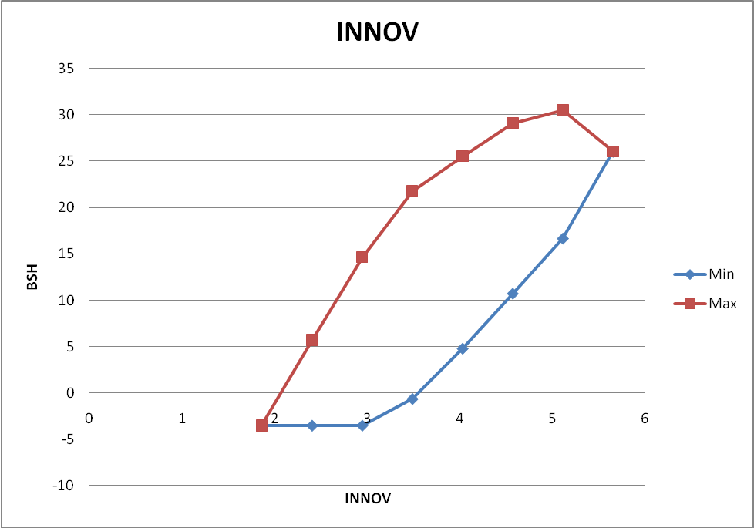
Figure 1 Graph of BSH versus INNOV where INNOV is the state variable

The graph shows the range of expected values of BSH over the range indicated for INNOV. Both the maximum expected values and the minimum expected values are indicated. The difference between the two curves in the graph may be attributed to the other factors in the model.
The graphs indicate a positive strong relationship between INNOV and BSH.
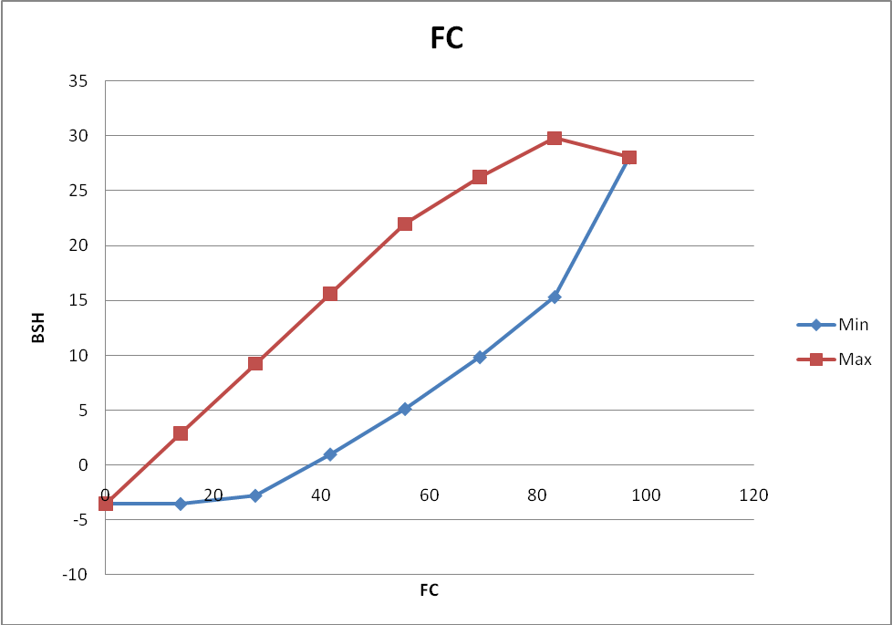
Figure 2 Graph of BSH versus FC where FC is the state variable

The graph shows the range of expected values of BSH over the range indicated for FC. Both the maximum expected values and the minimum expected values are indicated. The difference between the two curves in the graph may be attributed to the other factors in the model.
The graphs indicate a positive strong relationship between FC and BSH.

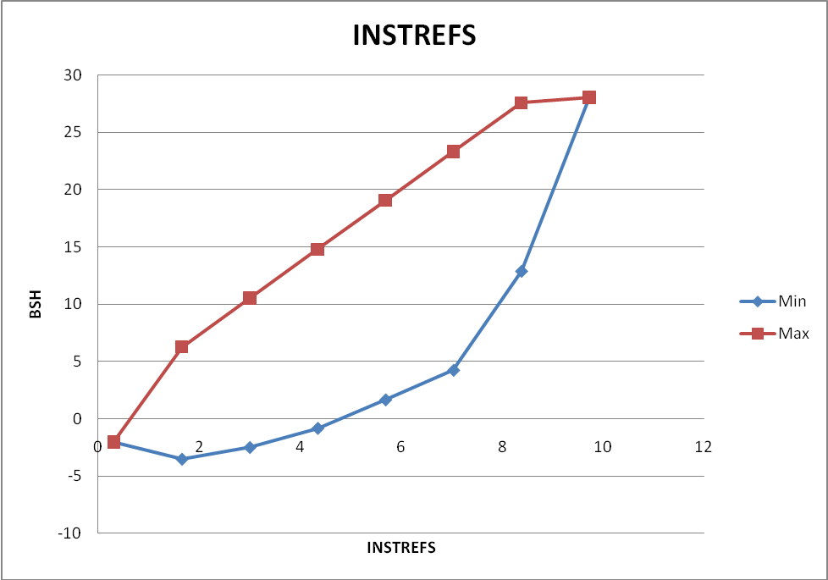
Figure 3 Graph of BSH versus INSTREFS where INSTREFS is the state variable

The graph shows the range of expected values of BSH over the range indicated for INSTREFS. Both the maximum expected values and the minimum expected values are indicated. The difference between the two curves in the graph may be attributed to the other factors in the model. The graphs indicate a positive strong relationship between INSTREFS and BSH.

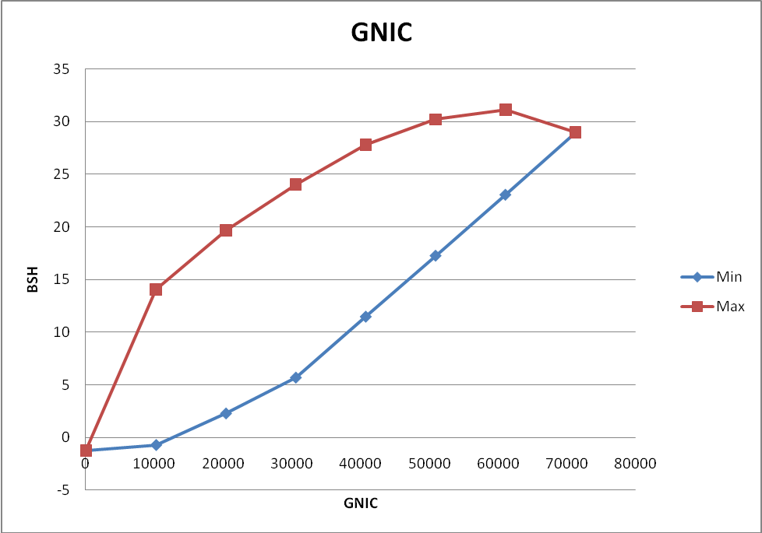
Figure 4 Graph of BSH versus GNIC where GNIC is the state variable

The graph shows the range of expected values of BSH over the range indicated for GINIC. Both the maximum expected values and the minimum expected values are indicated. The difference between the two curves in the graph may be attributed to the other factors in the model.
The graphs indicate a positive strong relationship between GNIC and BSH.

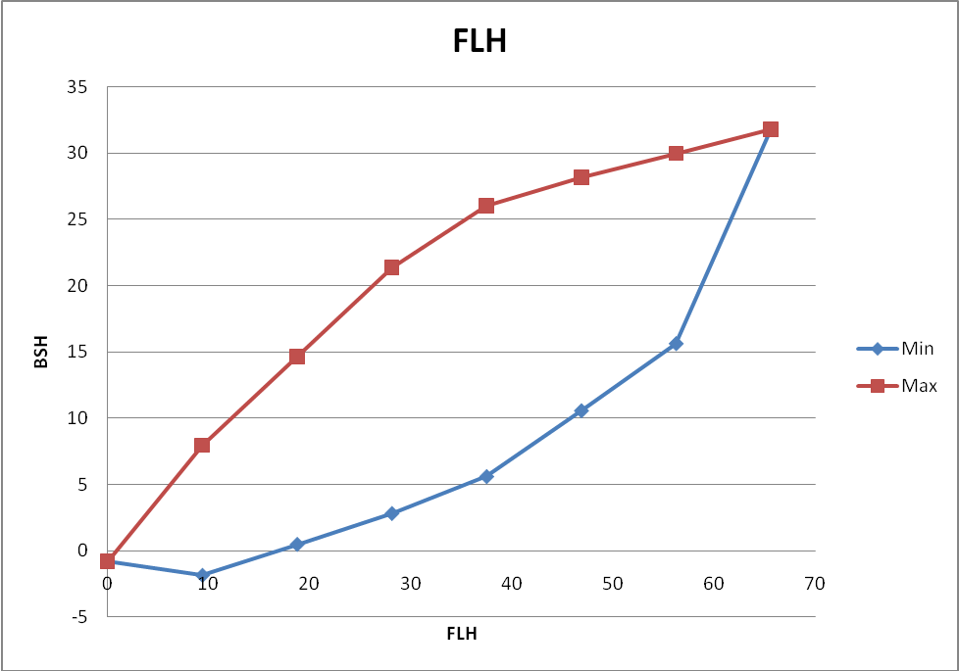
Figure 5 Graph of BSH versus FLH where FLH is the state variable

The graph shows the range of expected values of BSH over the range indicated for FLH. Both the maximum expected values and the minimum expected values are indicated. The difference between the two curves in the graph may be attributed to the other factors in the model.
The graphs indicate a positive strong relationship between FLH and BSH.

5. Interpretation of findings
The factors INNOV, FC, INSTREFS, GNIC and FLH are all important regressors that correlate highly with BSH.
One of the more interesting relationships is that displayed in the LRSA graph for INSTREFS versus BSH. From the shape of the max and min graphs it can be seen that for countries with low values of INSTREFS, broadband penetration (as measured by BSH) levels are relatively low (typical below 15).This suggests that when INSTREFS is at a low level (or absent), broadband penetration is mostly low(or absent).At higher levels of INSTREFS (7 or 8),there are both failures and success stories of broadband penetration suggesting that INSTREFS is an enabling factor but not sufficient for broadband diffusion

6. Conclusions
From the empirical analyses carried out in this research, the main factors in broadband penetration are shown in the diagram below (Figure 6).

Figure 6 Main factors

6.1 Recommendations
The main findings are that developing countries should exercise special care to improve their performance on the following factors: INNOV, FC, INSTREFS, FLH and GNIC
The empirical study carried out in this paper, illustrates that some of the main determinants of broadband penetration are INNOV, FC, INSTREFS, FLH and GNIC. Countries that better manage these factors tend to be more successful than others. The model of high broadband proliferation is characterized by high volumes of these factors.

6.2 Policy implications
There is need to root out corruption to achieve success with broadband diffusion. Although INSTREFS does not guarantee success with broadband penetration diffusion, it is an enabling factor in the sense that very few countries with low levels of INSTREFS manage to have good broadband penetration diffusion.
Generally speaking, countries with better infrastructure are more successful in BB diffusion.

7. Future Work
We are busy with extensions of the interpretive attributes of the methodology to also make it applicable to certain selected no-linear functional relationship classes. Some research to make specific recommendations for units (countries) is under consideration and will be refined in the near future.
There is need to investigate the substitution between fixed and mobile broadband.

Acknowledgements:
Authors are grateful to the Faculty Agriculture, Science and Technology (FAST) Research Committee of the North-West University, Mafikeng Campus for financial support to carry out this work.

Corresponding Author:
Dr. Zenzo Polite Ncube
Department of Computer Science
North West University
Mafikeng Campus
Mmabatho 2735, South Africa
E-mail: Zenzo.Ncube@nwu.ac.za

References
- Lee S, Marcu MI (2007) Fixed and Mobile Broadband Deployment: An empirical Analysis of Adoption Factors Submitted for the 35th Research Conference on Communication, Information and Internet Policy.
- Crandal RW (2005) Broadband Communications”, in Cave, M., Majumdar,S. and Vogelsang,I.(Eds.), Handbook of telecommunications economics, Volume 2: Technology evolution and the Internet , North-Holland, Amsterdam,Netherlands,pp.156-191.
- International Telecommunication Union (ITU) (2003).Promoting broadband: Background paper for workshop on promoting broadband”, available at:http://www.itu.int/osg/spu/ni/promotebroadband/PB03_PromotingBroadBand.pdf.
- Kim, J.H, Bauer, J.M and Wildman, S.S (2003). Broadband uptake in OECD countries: policy lessons from comparative statistical analysis. In: Paper Presented at the 31st Research Conference on Communication, Information and Internet Policy, Arlington, Virginia.
- Distaso W, Lupi P, and Maneti FM (2006). Platform competition and broadband uptake: theory and empirical evidence from the European Union. Information Economics and Policy. 18, pp. 87–106.
- Grosso M (2006). Determinants of broadband penetration in OECD nations. In: Paper Presented to the Australian Communications Policy and Research Forum.
- Lee S, Brown JS (2008).Examining broadband adoption factors: An empirical analysis between countries. info, Vol. 10 Iss: 1, pp.25 – 39.
- Gruber H (2001).Competition and innovation: the diffusion of mobile telecommunications in Central and Eastern Europe. Information Economics and Policy, 13 pp. 19–34.
- Gruber H, Verboven F (2001).The evolution of markets under entry and standards regulation: the case of global mobile telecommunications. International Journal of Industrial Organization, 19, pp. 1189–1212.
- Koski H, Kretschmer T (2005). Entry, standards and competition: firm strategies and the diffusion of mobile telephony. Review of Industrial Organization, 26 (1), pp. 89–113.
- Lehr W, Gillett S, Osorio C and Sirbu M (2006). Measuring broadband’s economic impact. Broadband Properties, 12, p. 24.
- Koutroumpis P (2009). The economic impact of broadband on growth: a simultaneous approach. Telecommunications Policy, 33, pp. 471–485.
- Bruwer PJS, Hattingh JM (1985). Constrained regression models for optimization and forecasting, Orion 1(1), pp. 2-15.
- Terblanche SE (2001). Linear Response Surface Analysis as a Technique for Visualizing Linear Models and Data. Masters dissertation. North West University. (unpublished)
- Ncube ZP, Hattingh JM and Helberg ASJ (2009). Evaluating the effect of Telecommunications Technology and other factors on Economic Growth and Social Development based on International Comparisons. Southern Africa Telecommunication and Applications Conference.
- Liikanen J, Stoneman, P and Toivanen O (2004). Intergenerational effects in the diffusion of new technology: the case of mobile phones. International Journal of Industrial Organization, 22, pp. 1137–1154.

9/9/2013

