**The Impact of Autocorrelation on the Performance of the MEWMA Control Chart with Mild Correlation**

Abbas Umar Farouk * and Ismail Bin Mohamad

Department of Mathematical Sciences, Faculty of Science, Universiti Teknologi Malaysia, 81310, UTM Johor Bahru, Johor Darul Ta’azim, Malaysia

*Corresponding author: ([abbasumar6@gmail.com](mailto:abbasumar6@gmail.com))

**Abstract:** As it is indisputable any time conventional control charts are used you have the suggested assumption that observations are usually independently in addition to identically distributed as time passes. However, in reality, this sort of findings generated through continuous along with discrete production procedures are usually serially correlated, which violates the independence assumption of conventional control charts as well as modify the performance of control charts adversely. In this paper, we investigate the performance of MEWMA control chart with autocorrelated data with mild correlation being controlled. The generated data were applied to MEWMA control chart procedure and showed an in-control state, as the generated observations had been put through normality tests with the assumptions and also sensitivities for departure to normality, and ended up being normal by all standard. Therefore, this provides an alternate for the quality practitioners to consider for the continuous and discrete production processes even the autocorrelation doesn't have impact on the performance of MEWMA control limits once the mild correlation continues to be controlled.

[Abbas, Umar F. Ismail Mohamad. **The Impact of Autocorrelation on the Performance of the MEWMA Control Chart with Mild Correlation.** *Nat Sci* 2013;11(12):82-86]. **(ISSN: 1545-0740**). <http://www.sciencepub.net/nature>. 12

.

***Keywords***: Autocorrelation, MEWMA control chart, Mild correlation, Normality test, Statistical process control.

**1. Introduction**

Statistical process control methods tend to be traditionally used in industry to monitor procedures as well as enhance the quality of products, traditional statistical process control methodology guarantees which process data are statistically independent.

This particular assumption retains within continuous as well as discrete processes, as stated by (D.H., Pignatiello et al. 2000) that many processes such as chemical manufacturing, electricity generation, water quality processing, waste water etc. generate autocorrelated data which violates the assumption of traditional control charts, results in unnecessary large ARL values. Johnson and Bagshaw and Johnson (Bagshaw and Johnson 1975), discussed the effects of autocorrelation on the performance of cumulative sum (CUSUM) control charts. (Harris and Ross 1991) discussed the impact of autocorrelation on CUSUM and exponentially weighted moving average (EWMA) control charts and showed that positive autocorrelation could also adversely impact the performance of these charts. (Woodall and Faltin 1993) discussed the effects of autocorrelation on the performance of control charts and made recommendations on how to deal with autocorrelation. (Zhang 1997) proposed a statistical control chart for stationary processes and compared its performances to some of the charts recommended for autocorrelated data.

The idea associated with independence is not even approximately satisfied in certain manufacturing processes, because the characteristics tend to be measured over time order from the production, which might expose autocorrelation, that may possess a significant effect on the performance of control chart procedure.

In the univariate case, when significant autocorrelation is observed, the overall approach of process monitoring methods would be to fit a time series model to the process data. The residuals, which are independent, are then used to construct the control chart (Alwan and Roberts 1988; Lu and Renolds 1999) have extensively discussed it. Much more, when the model is not sufficient, the residuals might not be independent, consequently, there will be alarms.

Lots of approaches can be found in the literature for dealing with autocorrelation. (Montgomery and Mastrangelo 1991) discussed different model-based approaches, a model- free approach, and an engineering controller, and recommends model-based approaches for eliminating autocorrelated structures.

There are plenty of literatures that talks on the performance of MEWMA control chart, for example, (Lowry, Woodall et al. 1992; Borror, Montgomery et al. 1999; Testik, Runger et al. 2003) and so many other researchers but none yet have discuss the effect of autocorrelation on the performance of MEWMA using the mild level of correlation.

In this article, we are going to investigate the impact of the performance on the control limits for the multivariate exponentially weighted moving average (MEWMA) control procedure when observations are autocorrelated with mild level of correlation being controlled.

The outline of the rest of this article is as follows;

In the next section, we described the Multivariate exponentially weighted moving average and in section 3, we have talked on the materials and methods used in the analysis of data to explain our findings.

Finally, we summarise our findings in section 4.

**2**.**Multivariate Exponentially Weighted Moving Average Control Procedure**

The univariate EWMA chart is based on the values

$Z_{t }=rX_{i}+(1-r)Z_{i-1}$ (2.1)

i= 1,2,..., where Z0 = = 0 and

*0< r*

(Roberts 1959) showed that if X1, X2,... are iid N(0, $σ^{2}$) random variables, then the mean of *Zi* is 0 and the variance is

$σ_{Zi}^{2}=\{r\left[1-{\left(1-r\right)}^{2i} \right]/(2-r)σ^{2},$ i=1,2,...,

Thus, when the in-control value of the mean is 0, the control limits of the EWMA chart are often set at $∓ Lσ_{Zi},$ where *L* and *r* are the parameters of the chart.

(Lucas and Saccucci 1990) discussed the choice of *r* and *L* from the univariate EWMA chart in details.

In the case of multivariate, a natural extension is to define the vectors of EWMA's

$Z_{i}=RX_{i}+ (1-R)Z_{i-1}$ (2.2)

*i=1,2,*..., where *Z0= 0* and *R* = *diag*( *r1,r2,..., rp*) 0< *j =1,2,...,p.*

The MEWMA chart gives an out of control signal as soon as

$T_{i}^{2}= Z_{i}^{'} Σ_{Zi}^{-1} Z_{i }>h_{4}$ (2.3)

when $h_{4}$ (>0) is chosen to achieve a specified in control ARL and $Σ_{zi}$ is the covariance matrix of $Z_{i}$.

The ARL performance of the MEWMA chart depends only on the noncentrality parameter $λ$

In

$λ= {(μ^{'} Σ^{-1}μ)}^{1/2}$ (2.4)

It is then much easier to make ARL comparisons among several multivariate control charts if all of the charts have this property (Lowry, Woodall et al. 1992).

However, as (MacGregor and Harris 1990) suggested for the univariate case, using the exact variance of the EWMA statistic leads to a natural fast initial response (FIR) for the EWMA charts, which is also true with the MEWMA control chart.

That leads to the assumption that for the chart design and the ARL comparisons the asymptotic (as i $→$ $∞$) covariance matrix, then

$Σ_{Zi}=\{r /(2-r)\} Σ$ (2.5)

is used to calculate the MEWMA statistic.

(Lowry, Woodall et al. 1992) gave a table that contains ARL profiles of general MEWMA charts for various values of *r*, smaller values of *r* are more effective in detecting small shifts in the mean vector which is analogous to the univariate case.

This article talks on the application of MEWMA to the autocorrelated with mild level of correlation.

We generated a set of data from a multivariate random process for the 3-quality characteristics of interest by developing a (Mathworks. 2011) Mat lab source codes. As shown in Table 1 below:

3. **Materials and Methods**

Table 1: The MEWMA scheme

|  |
| --- |
| **Observations MEWMA vector MEWMA Statistic**  *i X1 X2 X3* *Z1  Z2 Z3 T­­2i­­­­­* |
| 1 0.61 1.12 3.91 0.06 0.11 0.32 1.24  2 1.57 -1.69 3,95 0.21 -0.07 0.68 2.68  3 0.56 1.92 -3.33 0.25 0.13 0.28 0.61  4 0.40 3.64 -2.38 0.26 0.48 0.02 1.01  5 -0.33 -1.19 0.82 0.20 0.31 0.10 0.38  6 -0.30 1.25 -4.21 0.15 0.41 -0.34 1.54  7 0.79 2.71 2.31 0.22 0.64 -0.08 1.33  8 0.92 -1.93 -2.97 0.29 -1.35 -0.36 0.57  9 0.81 0.35 4.64 0.34 -1.18 0.14 0.28  10 1.39 0.31 -1.08 0.44 -1.03 0.01 0.07 |
| Control Limit *h*4 = 8.66 |

Table 1 present the generated autocorrelated data for the three characteristics (X1,X2, X3) which was used to determine the MEWMA vector as well as the MEWMA statistic using (2.2) and (2.3) respectively.

The multivariate normal distribution is considered with unit variances and a correlation of 0.1, the process mean is on target (0,0,0) for the first 5 observations and then shifts to (1,2,3) for the last 5 observations. (*X1, X2, X3*) are the observations in the table while *Z1, Z2, Z3* are the MEWMA vectors with *r* = 0.1 also the values of $T_{i}^{2}$ were obtained using equation (2.3) with covariance matrix using equation (2.5) which provides the natural (HS) feature for the MEWMA chart. The value of *h4* was obtained using the simulation to provide in-control ARL's of 200. Table 1shows the data used to determined the MEWMA vector as well as the MEWMA statistic. A mat lab codes was developed to generate the desired data for the 3 characteristics of interest. The codes can be obtained from the authors based on request.

As observed by Testik, *et al* that quality practitioners should check the assumptions and the sensitivities to departures from normality before operational use of the multivariate control chart for the individual observations, if a process shows evidence of even moderate departure from the normality, the control limit may be entirely inappropriate. In view of their suggestion that we subject the generated autocorrelated for test of normality using the graphical and statistical methods, since there is not a direct test for multivariate normality, we generally test each variable individually and assume that they are multivariate normal if they are individually normal.

The 3- variables were subjected to normality test so that the data can be fit for the analysis, from the outcome of the test, it was found that the variables are normally distributed as shown in Table 2, the *Shapiro-Wilks's* significance values are all greater than 0.05. Also to support the S-W, the normality plot shows that all the 3- variables are normal as shown in Figures 2-4.

The autocorrelated values were now used to determine the MEWMA control chart with the usual procedures as spelt out by Lowry et al (1991), the control chart and *T2* Statistic were generated as shown in Figure1, which indicates that the control chart has the UCL of 10.81 and all the 10 observations were within the control limit, none is outside or showing an alarm.



Figure 1: The MEWMA control chart of the data

Figure 1 present the MEWMA control with the points/values lying within the control limits, with the upper control limit of 10.81 while the lower control limit being 0.

Table 2: Showing the Results of Normality Test

|  |  |  |  |  |  |  |
| --- | --- | --- | --- | --- | --- | --- |
| **Tests of Normality** | | | | | | |
|  | Kolmogorov-Smirnova | | | Shapiro-Wilk | | |
| Statistic | df | Sig. | Statistic | df | Sig. |
| X1 | .150 | 10 | .200* | .934 | 10 | .493 |
| X2 | .138 | 10 | .200* | .957 | 10 | .753 |
| X3 | .174 | 10 | .200* | .913 | 10 | .302 |
| *. This is a lower bound of the true significance. | | | | | | |
| a. Lilliefors Significance Correction | | | | | | |

Table 2 present the results of the test of normality showing the Kolmogorov-Smirnov and Shapiro-Wilk values, here since our samples is less than 50 we shall consider the Shapiro-Wilk's values instead of K-S value which is for sample size 50 and above. From S-W table all the values for the 3-characteristics on Significance column shows its values greater than 0.05, which is the rule of thumb for a variable to be normally distributed otherwise it is not normal.

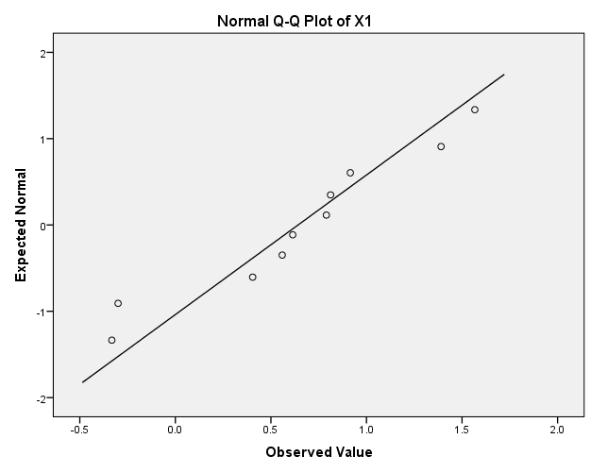

Figure 2: The Q-Q Plot for X1

Figure 2 present the Q-Q plot for the first characteristic (X1), as we can see that the almost all points are attached to the fit line, which indicates the normality of characteristic under consideration.

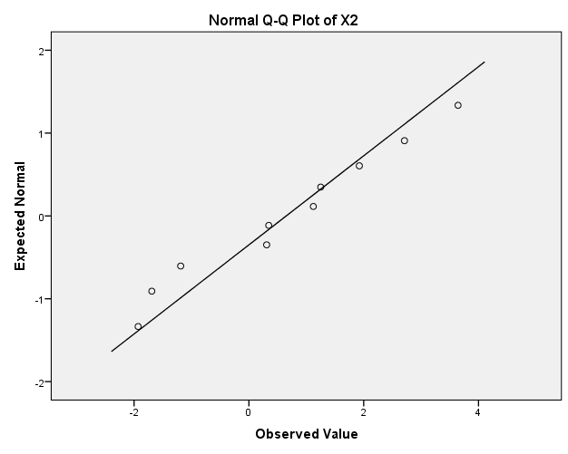

Figure 3: The Q-Q Plot for X2

Figure 3 present the Q-Q plot for (X2), here also the points are almost attached to the fit line, that's indicates the normality of the variable under consideration.

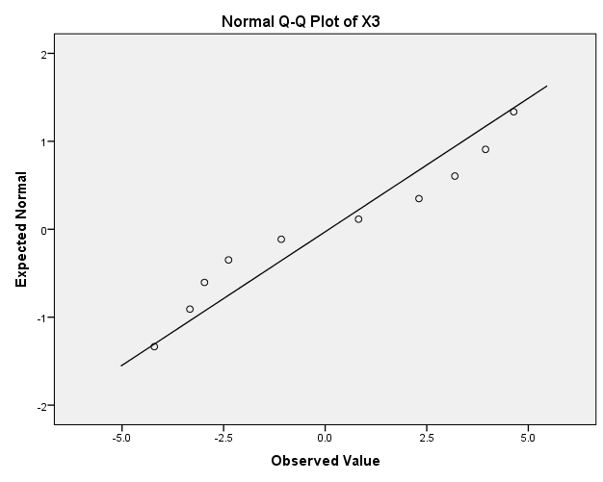

Figure 4: The Q-Q Plot for X3

Figure 4 present also the Q-Q plot for the last characteristics (X3), the points are almost clustered to the fitted line an indication of the normality.

Based on these data generated and plotted, it is observed that the use of autocorrelated data to the MEWMA when the correlated values are being controlled can lead to an in-control and it is a good alternative for the practitioners to use for the continuous data usage.

**4. Conclusion**

From Figure 1, we can see that the generated autocorrelated data with the mild correlation applied on the MEWMA control chart has produced an in-control chart with all its values/points lying within the control limits with no point raising an alarm.

For the quality practitioner to operationally use the multivariate control charts, it has to be check for the assumptions and sensitivities to departures from the normality.

The generated data were subjected to normality test which proves to be normal by all standard. With these results of this article it can be an alternative to other techniques for the quality practitioners to adopt for use in continuous data as well as the discrete data. With this findings its eminent to conclude that the autocorrelation has no effect on the performance of the MEWMA control limits when mild correlation is controlled.

Finally, we conclude the discussion that the autocorrelated data with mild correlation controlled can result into the in-control process on multivariate exponentially weighted moving average, the above method was tested using 3 characteristics of interest but can be extended to higher quality characteristics desired.

We are recommending that the autocorrelated data with mild level of correlation being controlled should be applied to other statistical process control techniques.

**APPENDIX A**: Derivation of the Covariance Matrix for *Zi*

By repeated substitution of (2.2), it can be shown that

$Z_{i}= \sum_{j=1}^{i}{R{(I-R)}^{i-j} X_{j}}$.

Thus

$Σ_{Zi}= \sum_{j=1}^{i}{var[R{(I-R)}^{i-j}} X_{j }]$

= $\sum_{j=1}^{i}{[R{(I-R)}^{i-j}} Σ{(I-R)}^{i-j} R].$

Because *R* and (*I-R*) are diagonal matrices, the (*k,l*)th element of $Σ_{Zi}$ is

*rkrl* [1-(1*-rk*)i(1-*rl)*i]/[*rk + rl-rkrl*], (A.1)

where $σ_{k,l}$ is the (*k,l)*th element of If *r1=r2=...=rp =r,* then the expression in (A.1)

simplifies to {*r*[1-(1-*r*)2i] /(2-*r*)} $σ_{k,l}$, so that

$Σ_{Zi} \{r[1-(1-r)2i] /(2-r)\} Σ.$ (A.2)

The covariance is derived here under the assumption that the control rule is ignored, but it can offers some guidance on the type of control rule to be used.{Lowry, 1992 }

**Acknowledgement**

Authors are grateful to the UTM for financial support to carry out this work.

**Corresponding Author**:

Abbas Umar Farouk

Mathematical Sciences Department,

Faculty of Science,

Universiti Teknologi Malaysia

81310, UTM Johor Bahru

E-mail: [abbasumar6@gmail.com](mailto:abbasumar6@gmail.com)

**References**

1. Alwan, L. C. and H. V. Roberts (1988). "Time-series modeling for statistical process control." Journal of Business and Economic Statistics **6**(1): 87-95.
2. Bagshaw, M. and R. Johnson (1975). "The effect of serial correlation on the performance of CUSUM test II." Technometrics **17**: 73-80.
3. Borror, C., D. Montgomery, et al. (1999). " Robustness of the EWMA control chart to non-normality." JOURNAL OF QUALITY TECHNOLOGY **31**(3): 309-316.
4. D.H., T., J. J. Pignatiello, et al. (2000). "Applying an AR(1) CUSUM control chart to data from a chemical process." Quality Engineering **13**: 107-114.
5. Harris, T. and W. Ross (1991). "SPC procedures for correlated observations." Canadian Journal of Chemical Engineering **69**(1): 48-57.
6. Lowry, C. A., W. H. Woodall, et al. (1992). " A multivariate EWMA control charts." Technometrics. **34**: 46-53.
7. Lu, C. W. and J. Renolds, M.R. (1999). "EWMA control charts for monitoring the mean of autocorrelated processes." Journal of quality Technology **31**(2): 166-188.
8. Lucas, J. and M. Saccucci (1990). "Exponentially weighted moving average control scheme: properties and enhancement." Technometrics **32**: 1-12.
9. MacGregor, J. F. and T. Harris (1990). "Discussion of "Exponentially Weighted Moving Average Schemes: properties and Enhancements"." Technometrics **32**: 23-26.
10. Mathworks. (2011). Global Optimization Toolbox: User's Guide (r2011b).
11. Montgomery, D. C. and C. Mastrangelo (1991). "Some statistical process control methods for autocorrelated data." Quality Technology **23**(3): 179-193.
12. Roberts, S. (1959). "Chart Tests Based on Geometric Moving Averages." Technometrics **1**(3): 239-250.
13. Testik, M. C., G. C. Runger, et al. (2003). "Robustness properties of multivariate EWMA control charts." Quality and Reliability Engineering International **19**(1): 31-38.
14. Woodall, W. H. and F. Faltin (1993). Autocorrelated data and SPC. New York. **13:** 18-21.
15. Zhang, N. F. (1997). "Detection capability of residual control chart for stationary process data." Journal of Applied Statistics **24**(4): 475-492.

11/22/2013