**Water Quality Evaluation of Abu Elgharadig groundwater wells with Assessment of Reverse Osmosis plant**

Ahmed A. Ghareeb1, Maher. H. Helal2, Omnia I. Mohamed2, Mohamed M. Yehia3 and Seleem E. Gaber3

1 Department of Chemical laboratories, Khalda Petroleum Company

2 Department of Chemistry, Faculty of Science, Helwan University, Egypt.

3 Central Laboratory for Environmental Quality Monitoring (CLEQM)

[ghareeb_aa@yahoo.com](mailto:ghareeb_aa@yahoo.com)

**Abstract:** The study area, Abu El Gharadig, is located in western desert is an oil field for a petroleum company, Brackish groundwater in this field is the sole source supply for desalination plant used to treat the brackish groundwater to fresh water, where it is used for human usage in area. The reverse osmosis (RO) technology with polyamide membrane is used in desalination plant for that purpose. The purpose of this paper is to study the quality of brackish groundwater at the studied area and to investigate the efficiency of Reverse Osmosis (RO) desalination plants to produce potable water. Samples have been collected from brackish groundwater represented in three water wells (AG well No.11, AG well No.14 & AG well No.15) in addition to the produced water after desalination process. Physicochemical and microbiological analyses were carried out for all samples. Results show that the source brackish groundwater is free from bacterial contamination & organic pollutant and the produced water comply with WHO drinking standard and acceptable for human usage.

[Ahmed A. Ghareeb, Maher. H. Helal, Omnia I. Mohamed, Mohamed M. Yehiaand Seleem E. Gaber. **Water Quality Evaluation of Abu Elgharadig groundwater wells with Assessment of Reverse Osmosis plant.** *Nat Sci* 2014;12(6):33-39]. (ISSN: 1545-0740). <http://www.sciencepub.net/nature>. 6

**Key words:** Groundwater, Desalination, Abu El Gharadig, Reverse Osmosis.

**1. Introduction**

Almost all available conventional water resources in Egypt are represented by the Nile water and groundwater. On the other hand many integrated development projects such as Oil & Gas facilities are located at a distance from the Nile water where groundwater is the only available source. In many cases the high salinity of groundwater affects its suitability as a source for drinking; in these cases brackish water treatment plants is the solution.

Moghra aquifer is the source of brackish groundwater in Abu Elgharadig basin. This aquifer, dominated by fluvio-marine sands, occupies a wide area located to the west of the Nile Delta. The brackish water in that aquifer occupies a wide belt to the west of Wadi El Farigh and Wadi El Natrun and the water changes to saline and hyper saline further to the west. The water in the Moghra aquifer is fossil water, although there are indications of hydraulic continuity with the Delta aquifer. The estimation of the volume of exploitable brackish water in the Moghra aquifer (>3000 ppm) has not been made, but it can be in excess of 1 billion m3. Associated with El Moghra aquifer, there is a localized aquifer in the Pliocene beds, known as Wadi El Natrun aquifer. It is generally brackish (salinity >l000 ppm) and is fed mainly by lateral seepage from the Delta aquifer and from upward leakage from the Moghra. [1]

Desalination is a general term for the process of removing salt from water to produce fresh water. Fresh water is defined as containing less than 1000 mg/L of salts or total dissolved solids (TDS).[2] The feed water salinity for desalination facilities ranges from approximately 1000 mg/L TDS to 60,000 mg/L TDS.

Reverse osmosis (RO) is a membrane technology widely applied in water desalination, production of potable water and more recently in tertiary wastewater treatment. This technology has the advantages of membrane processes such as modular construction and small footprint, which allow the combination with other treatment processes.[3]

Reverse Osmosis (RO) is a physical process that uses the osmosis phenomenon, i.e., the osmotic pressure difference between the saltwater and the pure water to remove salts from water. In this process, a pressure greater than the osmotic pressure is applied on salt­water (feed water) to reverse the flow, which results in pure water (fresh water) passing through the synthetic membrane pores separated from the salt. A concentrated salt solution is retained for disposal.[4]

The objective of this research is to study the quality of the brackish groundwater at the studied area and investigate the desalination process using polyamide membrane. The study will focus on the groundwater quality (salinity, nutrient, organics…). The study will concern the groundwater wells and RO treatment plant owned by Khalda petroleum Company (KPC) at Abu Elgharadig in the western desert.

**2. Materials and methods**

**2.1 Area of study**

Abu Elgharadig Field (A/G), which lies principally to the east of the Qattara Depression in the central portion of the Northern Western Desert of Egypt. (Lat. 29° 47 ' 29 " N, Long 28° 33 9 ' 19" E) Figure (1). The study will concern the groundwater wells and the RO treatment plant owned by Khalda Petroleum Company (KPC) at Abu El-Gharadig Field in the Western Desert.

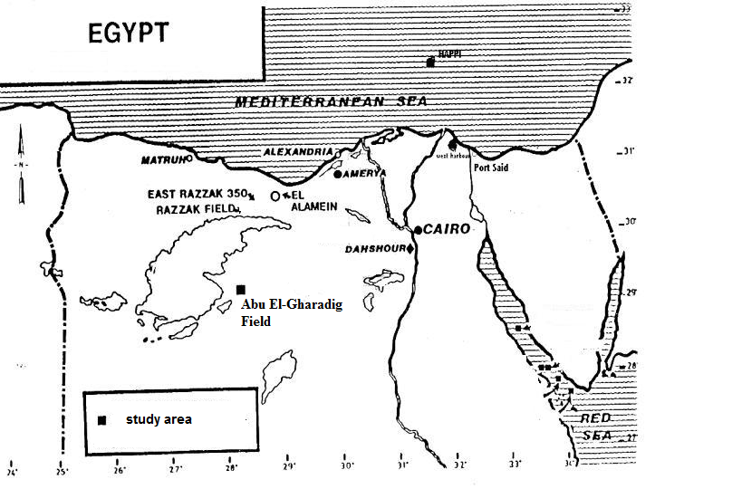

**Figure (1) Location map of the study area**

There are three main water wells were drilled at Abu Elgharadig Field (area of study), perforated at Moghra layer on depth 980 Ft, AG Well No.11, AG Well No.14 & AG Well No.15 (Figure (2)).

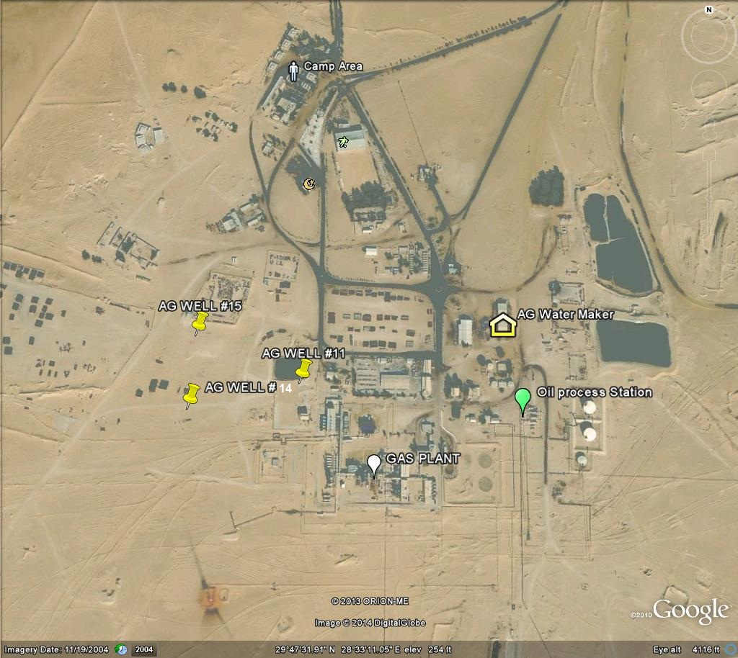

**Figure (2), satellite map of Abu Elgharadig field area**

Water plant has been established at Abu Elgharadig Field for purpose of desalination of Brackish Ground water obtained from 3 main drilled wells AG well No.11, AG well No. 14 & AG well No. 15 and the result is fresh water used as main source for drinking water and different water usage in KPC labour camp.

Figure (3) shows schematic Diagram for water plant, the input (Raw) water from wells and stored in brackish tanks pumped by feed pumps to pretreatment area which consists of two multimedia filters (Normally consists of a variety of different media types such as gravel for the under bed support, garnet, fine sand and Anthracite). Water transferred from multimedia filter into two iron removal filters filled with Manganese Greensand. The filtered water passes through cartridge filters of 5 micron pores filters then introduced to a high pressure pump, which raises the water pressure to 400 Psi that allow the fresh water to be separated into 24 membrane, the rejected water goes to reject saline pond and fresh water is stored in fresh water storage tank.

**2.2 Sampling**

The Water Samples were collected from Abu Elgharadig Field, from three main water source wells AG Well No.11, AG Well No.14 & AG Well No.15 which represent inlet for water Plant in addition to sample collected from the final product after desalination process.

The sampling pump is turned on and the initial ground water field parameters (Temperature,, pH, specific Electric conductance (EC)) are recorded. Field parameters are then periodically recorded in the stabilization form, and when predetermined parameters become stable the well has been adequately purged and sampling may commence.

Conservation is done by adding acid to the sample until the pH is < 2 (0.7 ml of 65 % HNO3 concentration). Acidification stops most bacterial growth, blocks oxidation reaction and prevents adsorption or precipitation of cations. Prior to acidification, the water sample was filtered, using 0.45 µm membranes, to remove suspended materials, which could dissolve when acid is added.[5]

The samples are transferred to the laboratory and preserved at temperature 4 oC at the same day of collection.

**2.3** **Laboratory analysis**

**2.31 Physicochemical Analysis**

Carbonate and bicarbonate are determined by titration against sulfuric acid (0.02N). [6] Determination of Total Dissolved Solids (TDS) was carried out by gravimetric method.[7] Microbial contamination in the water samples were examined by membrane filtration technique through nitrocellulose membranes followed by plating on selective media.[8] Heavy metals (Al, Cd, Pb, Cu, Fe, Mn, Zn, Cr, Ni ) and major Cations (Na+, Ca2+, K+, Mg2+), were carried out using Inductively Coupled Plasma with Optical Emission Spectrometric ICP-OES).[9] Ion Chromatography (IC) is a technique used to measure the concentrations of major anions(F-, Cl-, SO42-, NO3-, PO43-, NO22-).[10]

Total Organic Carbon analyzer from Dohrmann DC-190 was used to measure organic matter in water samples as total organic carbon (TOC).[11]

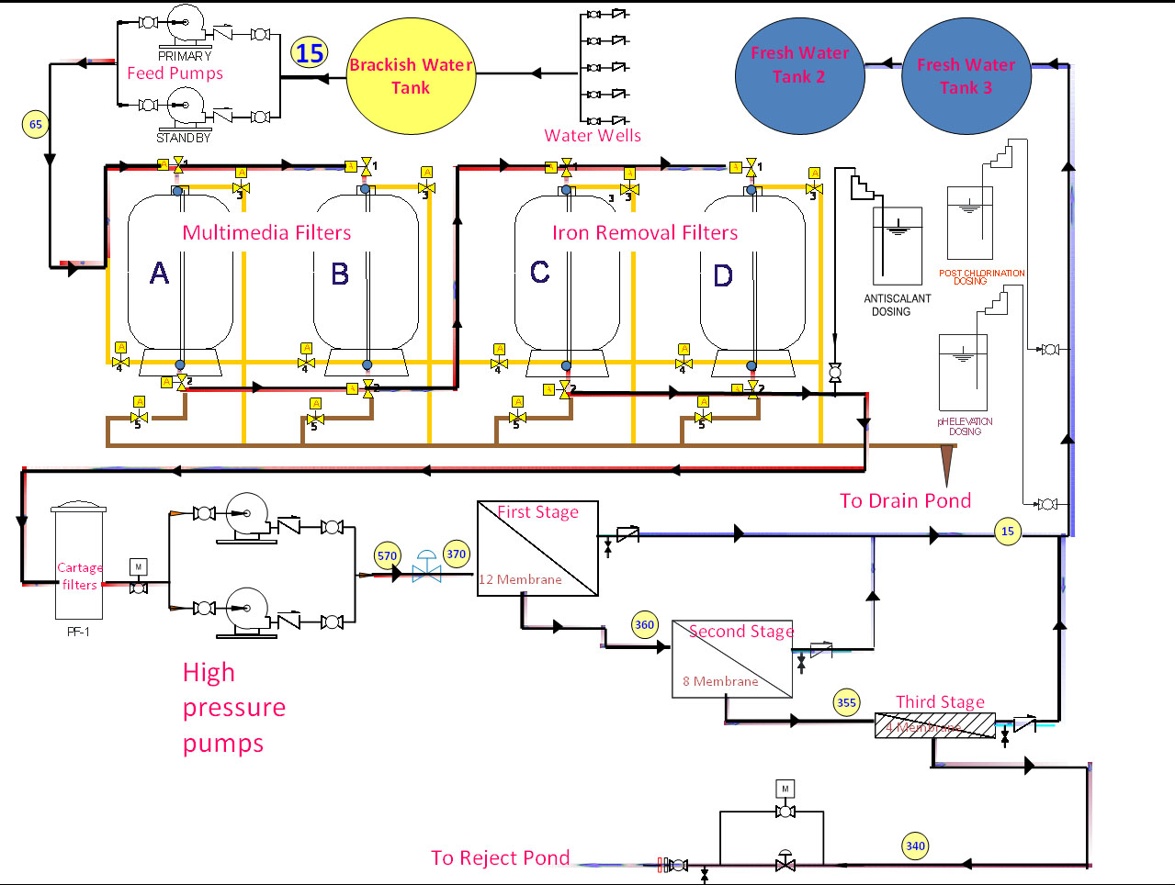

**Figure (3) reverse Osmosis desalination plant schematic flow diagram**

**2.32** **Analysis of Poly Aromatic Hydrocarbons (PAHs)**

The water samples were extracted for PAHs according to **standard method APHA, 2005** [12] using solid phase extraction (SPE) system. The recovery efficiency of the extraction procedure was in the range 68.3 to 103.6% with relative standard deviation (RSD) from 0.9 to 7.1%. PAHs were analyzed using a gas chromatography system with Flam Ionization Detector (GC-FID) (Agitech 7890A series).

**3. Results and Discussion**

Desalination plant in Abu Elgharadig field area is used to supply the area with fresh water for human needs. The plant takes source water from brackish groundwater wells exist in the area and through reverse osmosis desalination (RO) process across polyamide membrane it produce fresh water with daily rate production of 365 m3with recovery percentage 55 %. The quality of source brackish water & produced water were examined and compared by WHO standard guidelines. After the chemical and bacteriological examination, the water was observed to have the following characteristics.

**3.1 Physicochemical Parameters**

The represented data is a result of monthly monitoring program for one year from July 2012 to June 2013. The physicochemical analysis of the studied groundwater wells are presented in Table (1).

PH for the brackish groundwater is in range 6.76 to 7.54 which is in the normal range of natural water pH (6.5-8.5), while for product (RO) water is in the acidic pH range of 5.9 to 6.1. The pH of drinking water is not a health concern; however, acidic water (low pH) can leach metals from plumbing systems, which can cause health problems so a method of neutralizing acidic water is recommended. For high yield water supplies, a method of neutralizing acidic water is to feed a solution of Sodium hydroxide can raise the pH level to 8 or higher.

Table (1) represents physicochemical parameters for inlet brackish source water (AG Well No.11, 14 & 15) and outlet product water obtained from reverse osmosis plant. Brackish groundwater wells represent the source for RO desalination plant; contain a level of salinity between 10770 mg /l to 11850 mg/l TDS which is more than ten times WHO permissible limit. On the other hand the TDS of product (RO) water it is ranged from 166 to 176 mg/l due to the removal of salinity ions Na, K, Ca, Mg, SO4, Cl.

**3.2 Major Cations**

From the results (Table (2)) among major cations, sodium was generally dominated representing on average 69.8 % of all cations. Calcium and magnesium were of secondary important representing in average 23.8% and 5% of all cations, respectively. Potassium ion was almost absent representing on average 1.25% of all cations. The dominant cations in brackish water follow the order Na > Ca > Mg > K, and the same sequence is represented in the three wells no. 11, 14 & 15.

**3.3 Major anions**

Table (4) represents the concentration of anions, chloride was generally dominated representing on average 83.35% of all anions. Sulphate and bicarbonate were of secondary important representing in average 14.84% and 1.52% of all anions, respectively. Nitrate ion was almost absent representing on average 0.29% of all anions. The dominant anions in brackish water follow the order Cl > SO4 > HCO3 > NO3, and the same sequence is represented in the three wells no. 11, 14 & 15.

**Table (1): Physicochemical parameters analysis Result**

|  |  |  |  |  |  |  |  |
| --- | --- | --- | --- | --- | --- | --- | --- |
| **Parameters** | **Type of Water** | **Source** | **Values from collected samples** | | | | **WHO guideline** |
| **Minimum** | **Maximum** | **Average** | **Stdev.** |
| pH | Inlet | AG Well No.11 | 6.76 | 7.5 | 7.2 | 0.4 | 6.5 -8.5 |
| AG Well No.14 | 6.81 | 7.54 | 7.3 | 0.42 |
| AG Well No.15 | 6.84 | 7.49 | 7.3 | 0.37 |
| **outlet** | **Product** | **5.9** | **6.1** | **6** | **0.1** |
| Total Alkalinity mg/l | inlet | AG Well No.11 | 82.9 | 107 | 92.6 | 12.7 | ---- |
| AG Well No.14 | 97 | 112 | 102.1 | 8.57 |
| AG Well No.15 | 86 | 102 | 91.3 | 9.24 |
| **outlet** | **Product** | **49** | **57** | **52.7** | **4.04** |
| Electrical Conductivity (EC) mmhos/cm | inlet | AG Well No.11 | 16.91 | 17.61 | 17.3 | 0.35 | ---- |
| AG Well No.14 | 17.86 | 18.52 | 18.2 | 0.33 |
| AG Well No.15 | 16.83 | 17.5 | 17.1 | 0.34 |
| **outlet** | **Product** | **0.38** | **0.42** | **0.4** | **0.02** |
| Total Dissolved Solids (TDS) mg/l | inlet | AG Well No.11 | 10822 | 11270 | 11044 | 224.03 | 1000 |
| AG Well No.14 | 11430 | 11850 | 11635 | 211.8 |
| AG Well No.15 | 10770 | 11200 | 10965 | 217.33 |
| **outlet** | **Product** | **166** | **176** | **170.7** | **5.03** |

**Table (2): Major Cations analysis results**

|  |  |  |  |  |  |  |
| --- | --- | --- | --- | --- | --- | --- |
| **Parameters** | **Type of Water** | **Source** | **Values from collected samples** | | | |
| **Minimum** | **Maximum** | **Average** | STDEV |
| Calcium  ( Ca) mg/l | inlet | AG Well No. 11 | 840 | 854.1 | 845.7 | 7.43 |
| AG Well No. 14 | 860 | 882 | 873.3 | 11.72 |
| AG Well No. 15 | 832 | 886 | 861.0 | 27.22 |
| **outlet** | **Product** | **21** | **25** | **23.0** | **2.00** |
| Potassium  (K) mg/l | inlet | AG Well No. 11 | 44 | 46 | 44.7 | 1.15 |
| AG Well No. 14 | 46 | 52 | 49.3 | 3.06 |
| AG Well No. 15 | 40 | 43 | 41.7 | 1.53 |
| **outlet** | **Product** | **2.1** | **2.4** | **2.2** | **0.15** |
| Magnesium  ( Mg) mg/l | inlet | AG Well No. 11 | 176 | 196 | 188.8 | 11.11 |
| AG Well No. 14 | 161.1 | 200 | 175.7 | 21.19 |
| AG Well No. 15 | 170 | 195.61 | 183.5 | 12.87 |
| **outlet** | **Product** | **11.9** | **12.5** | **12.1** | **0.32** |
| Sodium  ( Na) mg/l | inlet | AG Well No. 11 | 2450 | 2500 | 2466.7 | 28.87 |
| AG Well No. 14 | 2600 | 2700 | 2633.3 | 57.74 |
| AG Well No. 15 | 2420 | 2500 | 2465.0 | 40.93 |
| **outlet** | **Product** | **41** | **44** | **42.67** | **1.53** |

**3.4 Microbiological Examination**

Microbiological examination results for total coliform and facial coliform bacteria, showed no contamination with bacteria.

**3.5 Organic Matter**

**3.51 Total Organic Carbon (TOC)**

Contamination of groundwater was checked by the analysis of total organic carbon (TOC) as an indicator for organic pollution. Table (3) shows the analysis results of TOC, the results of brackish water indicate that the concentration of organic matter was low. The concentration of TOC in the studied groundwater wells varied from 5.2 mg/l to 9.98 mg/l, while its concentration decreased at permeate water to 1.35 mg/l./l.

**Table(3) Total organic carbon analysis results**

|  |  |  |
| --- | --- | --- |
| **source** | **unit** | **TOC Result** |
| AG Well No. 11 | mg/l | 6.08 |
| AG Well No. 14 | mg/l | 9.98 |
| AG Well No. 15 | mg/l | 5.2 |
| permeate Water | mg/l | 1.35 |

**3.52 Polycyclic Aromatic Hydrocarbons (PAHs)**

PAHs compounds include Naphthalene, Acenaphthylene, Acenaphthene, Phenanthrene, Anthracene, Fluoranthene, Pyrene, Benzo(a)anthracene, Benzo(a)anthracene, Benzo(b)fluoranthene, Benzo(k)fluoranthene & Benzo(a)pyrene concentrations are examined using standard method illustrated in experimental section, the results showed that there is no detection for these compound in two types of water brackish & produced water.

**3.6 Trace metals**

Elemental analysis of water samples from three brackish wells in addition to produced water were Table (5) shows the results, all tested elements are within WHO guide line values.

**Table (4) Major Anions analysis results**

|  |  |  |  |  |  |  |
| --- | --- | --- | --- | --- | --- | --- |
| **Parameters** | **Type of Water** | **Source** | **Values from collected samples** | | | |
| Minimum | Maximum | Average | STDEV |
| Chloride  (Cl) mg/l | inlet | AG Well No. 11 | 5160 | 5200 | 5186.7 | 23.09 |
| AG Well No. 14 | 5180 | 5450 | 5343.3 | 143.64 |
| AG Well No. 15 | 5100 | 5190 | 5146.7 | 45.09 |
| **outlet** | **Product** | **83** | **85** | **84.3** | **1.15** |
| Nitrate  (NO3) mg/l | inlet | AG Well No. 11 | 12 | 26 | 18.3 | 7.09 |
| AG Well No. 14 | 13 | 24 | 19 | 5.57 |
| AG Well No. 15 | 10 | 24 | 17.3 | 7.02 |
| **outlet** | **Product** | **1.6** | **2** | **1.8** | **0.21** |
| Sulfate  (SO4) mg/l | inlet | AG Well No. 11 | 850 | 980 | 923.3 | 66.58 |
| AG Well No. 14 | 900 | 1000 | 956.3 | 51.19 |
| AG Well No. 15 | 800 | 976 | 912 | 97.32 |
| **outlet** | **Product** | **40** | **49** | **44.7** | **4.51** |

**Table (5), Heavy metal analysis results**

|  |  |  |  |  |  |
| --- | --- | --- | --- | --- | --- |
| Parameters | Type of Water | Source | Values from collected samples | | |
| Minimum | Maximum | Average |
| Chromium  ( Cr) µg/l | inlet | AG Well No. 11 | 2 | 3 | 2 |
| AG Well No. 14 | 2 | 3 | 2 |
| AG Well No. 15 | 2 | 4 | 3 |
| **outlet** | **Product** | **<1** | **<1** | **<1** |
| Copper  ( Cu) µg/l | inlet | AG Well No. 11 | 15 | 20 | 18 |
| AG Well No. 14 | 12 | 15 | 13 |
| AG Well No. 15 | 12 | 16 | 13 |
| **outlet** | **Product** | **5** | **10** | **7.3** |
| Iron  (Fe ) µg/l | inlet | AG Well No. 11 | 60 | 140 | 110 |
| AG Well No. 14 | 62 | 95 | 80 |
| AG Well No. 15 | 66 | 190 | 110 |
| **outlet** | **Product** | **10** | **21** | **16** |
| Manganese  (Mn) µg/l | inlet | AG Well No. 11 | 32 | 52 | 44 |
| AG Well No. 14 | 29 | 46 | 39 |
| AG Well No. 15 | 46 | 67 | 58 |
| **outlet** | **Product** | **10** | **15** | **11.5** |
| Nickel  (Ni ) µg/l | inlet | AG Well No. 11 | 6 | 6 | 10 |
| AG Well No. 14 | 5 | 7 | 10 |
| AG Well No. 15 | 5 | 5 | 10 |
| **outlet** | **Product** | **2** | **4** | **3** |
| Zinc  ( Zn) µg/l | inlet | AG Well No. 11 | 62 | 77 | 72 |
| AG Well No. 14 | 47 | 100 | 72.3 |
| AG Well No. 15 | 47 | 65 | 53.3 |
| **outlet** | **Product** | **<1** | **<1** | **<1** |

**3.7 Efficiency of RO membrane**

The efficiency of desalination of brackish groundwater at Abu Elgharadig plant using Reverse Osmosis (RO) was studied by comparing the quality of the product water to the source groundwater from the three wells. The results represented in Figure (4) show that the removal percent of all studied parameters include salinity, major cations and major anions were higher than 90% while only alkalinity removal percent was about 44%. Generally the overall water quality of the produced water is good as potable water according to WHO guideline.

**4. Conclusion**

Overall evaluation with extended analysis of brackish ground water in Abu Elgharadig field area represented from three brackish water source wells showed that the source water are free from bacterial.

Contamination and organic compounds pollutants although the tested wells located at Oil field location for petroleum company.

Trace metals are exist with very minor concentration in brackish source water and presented in neglected figures within WHO’s guideline values in permeate water.

Cations and anions exist in brackish source water where separated in desalination process through polyamide membrane, where the membrane showed high percentage of salt rejection reach to 98 % for Na & Cl. pH of produced water is slightly lower than recommended WHO limit however, it is treated in desalination plant by addition controlled dosage of Sodium Hydroxide solution to raise pH to recommended limits (6.5 to 8.5). Finally overall review for all parameters compared with WHO standard guideline values showed that the produced water comply with WHO drinking standard and acceptable for human usage.

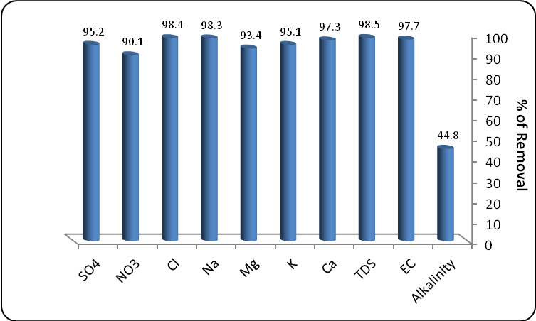

**Figure (4) The removal percent of major ions from brackish groundwater using RO membrane**

**References:-**

1. Allam, A.R., Saaf, E.J.,& Dawoud, M.A., Desalination of brackish groundwater in Egypt*.* Desalination, 2003. 152(1–3): p. 19-26.

2. MILLER, J.E.,&Sandia National Laboratories, Review of Water Resources and Desalination Technologies. 2003: Washington, D.C; Oak Ridge, Tenn.

3. Chelme-Ayala, P., Smith, D.W.,&El-Din, M.G., Membrane concentrate management options: a comprehensive critical review*.* Can. J. Civ. Eng. Canadian Journal of Civil Engineering, 2009. 36(6): p. 1107-1119.

4. Mohsen, M.S.,&Gammoh, S., Performance evaluation of reverse osmosis desalination plant: A case study of Wadi Ma'in, Zara and Mujib Plant*.* Desalination and Water Treatment Desalination and Water Treatment, 2010. 14(1-3): p. 265-272.

5. Laxen, D.P.H., & Chandler, I.M., Comparison of filtration techniques for size distribution in freshwaters*.* Anal. Chem. Analytical Chemistry, 1982. 54(8): p. 1350-1355.

6. EPA, Standard Test method, Alkalinity Test method 310.1. U.S. Environmental Protection Agency.

7. EPA, Standard Test method, Residue, Non-Filterable (Gravimetric, Dried at 103-105°C) Test method 160.2. U.S. Environmental Protection Agency.

8. EPA, Standard Test method,Total Coliforms and Escherichia coli in Water by Membrane Filtration Using a Simultaneous Detection Technique (MI Medium), Method 1604. U.S. Environmental Protection Agency.

9. EPA, Standard Test method, Determination Of Metals And Trace Elements In Water By Ultrasonic Nebulization Inductively Coupled Plasma-Atomic Emissionspectrometry, Test method 200.15. U.S. Environmental Protection Agency.

10. EPA, Standard Test method,Determination Of Inorganic Anions By Ion Chromatography, Test method 300. U.S. Environmental Protection Agency.

11. Eaton, A.D., Franson, M.A.H., American Public Health Association, American Water Works Association,&Water Environment Federation, Standard methods for the examination of water & wastewater, Method 5310B. 2005, American Public Health Association: Washington, DC.

12. Eaton, A.D., Franson, M.A.H., Association, A.P.H., Association, A.W.W., & Federation, W.E., Standard methods for the examination of water & wastewater, Mothod 6440. 2005, American Public Health Association: Washington, DC.

4/26/2014