***Hibiscus Sabdariffa* Calyx Extract Alleviate Hepatotoxicity Induced by Carbon Tetrachloride on Male Albino Rats**

Jamilah M Hashemi

Home Economic Dept., Ministry of Higher Education, King Abdul-Aziz University

**Abstract: Background:** The liver disorders are one of the world problems. Unfortunately, conventional or synthetic drugs used in the pretreatment of liver diseases are inadequate and sometimes can have serious side effects. Roselle (*Hibiscus sabdariffa* L., family Malvaceae) is an annual shrub, it exhibits many biological activities, such as anti-atherosclerosis, anti-carcinogenic, and anti-oxidative properties. **Aim:** The present study aims to determine the hepatoprotective effects of *Hibiscus sabdariffa* extract (HPEEE) against carbon tetrachloride (CCl4) induced liver injury in male rats. **Material and Methods:** Male albino rats (n=30) were intraperitoneally (i.p.) injected with CCl4 (1 mL/kgb.wt., 1:1 v/v mixture of CCl4 and liquid paraffin) every 72 h for 14 days to induce hepatotoxicity. Pretreatment with HPEEE was administered orally at three dosage levels (200, 400 or 600 mg/kg b. wt) daily started two weeks prior to CCl4 injection and continued until the end of the experiment. Serum alanine transaminase (ALT), aspartate transaminase (AST) and alkaline phosphatase (ALP) activities, lipid profile and hepatic malondialdehyde (MDA) and reduced glutathione (GSH) were measured. As well as the liver tissues of different groups were examined. **Results:** The oral administration of HPEEE displayed a strong hepatoprotective effect as it significantly dose-dependent reduced CCl4-induced hepatotoxicity in rats, as judged from the serum activities of ALT, AST, and ALP. As well as it showed a significant decrease in CCl4- induced MDA formation in the liver and increase in hepatic GSH activity. Also HPEEE pretreatment, showed a significant increase in HDL-C concentration and a decrease in the levels of TC, TG, LDL-C, and VLDL-C as compared to untreated CCl4-group. Histopathological examination of the liver tissues of CCl4 group represented the presence of focal hepatic necrosis associated with leucocytic cell infiltration, and apoptosis of hepatocytes, multiple focal areas of hepatic necrosis, and marked congestion of central vein, while the pretreatment with HPEEE overcome most of these changes, the majority of the cells tend to be normal in group received 600 mg/kg b.wt. **Conclusion:** These results suggest that the extract of dried flowers of *Hibiscus sabdariffa* L. Possesses strong antioxidant, hepatoprotective and hypolipidemic effects on CCl4-induced oxidative stress in rats. Therefore, HPEEE could be of potential help as a medicament or food supplement for alleviation of liver toxicity.

[Jamilah M Hashemi. ***Hibiscus Sabdariffa* Calyx Extract Alleviate Hepatotoxicity Induced by Carbon Tetrachloride on Male Albino Rats.** *Nat Sci* 2014;12(6):111-120]. (ISSN: 1545-0740). <http://www.sciencepub.net/nature>. 16

**Key words:** Carbon tetrachloride, *Hibiscus sabdariffa L* extract, male rats, liver enzymes, hepatic antioxidant, hypolipidemic, hepatoprotective.

**1.Introduction**

Liver disorders are one of the world problems. Despite its frequent occurrence, high morbidity and high mortality **(Vinoth *et al.,* 2009)**. Liver damage can be caused by certain xenobiotics and microbial infiltration from ingestion or infection (**Hai *et al.,* 2011).**

Carbon tetrachloride (CCl4) is a well established as xenobiotics. Previous studies showed that both liver and kidneys are the target organs of CCl4. Extensive evidence demonstrated that CCl4 is activated in the liver to a highly reactive trichloromethyl radical which initiates free radical mediated lipid peroxidation of the cytoplasmic membrane phospholipids and causes functional and morphological changes in the cell membrane, which leading to an accumulation of lipid-derived oxidants causing liver injury **(Singh *et al.,* 2008).**

Herbal drugs had been extensively used for the treatment of various disorders since prehistoric times and even today most of the medicinal preparations are derived from plants. The recognition of herbal drugs is escalating worldwide owing to minor side effects in comparison to synthetic drugs **(Srivastava *et al.,* 2006).** Therefore, there has been considerable interest in the role of complementary and alternative medicines for the treatment of liver disease **(Shen *et al.,* 2009).**

*Hibiscus sabdariffa* extract (HPEEE) is one of such important herbal hepatoprotective drug. *Hibiscus sabdariffa* is a natural phenolic rich plant that has been reported to have a wide range of pharmacological properties, such as antioxidant activity and free radical scavenging capacity **(Ali *et al.,* 2005)**. *Hibiscus sabdariffa* extract which is a group of phenolic compounds was isolated from the dried flowers of *H. Sabdariffa*. Previous studies showed that the constituents of the extract of *H. Sabdariffa* have strong antioxidant properties **(Ramirez *et al.,* 2011).** It has been postulated in several studies that effectiveness of plant extracts against many diseases are due to their antioxidant, antigenotoxic and biomodulatory effects on various cells and animals exposed to different agents (**Tsai *et al.*, 2009).** Literature reviews indicated that the hepatoprotective activity of *Hibiscus sabdariffa* has been sparingly evaluated so far. However, it is unclear if HPEEE also has protective effects against CCl4 toxicity.

The present study was designed to investigate the effect of HPEEE *in-vitro* as well as examining its protective effect on the CCl4-induced liver damage in rats.

**2.Material and Methods.**

**Drugs and chemicals.**

Carbon tetrachloride (CCl4) was obtained from Sigma Chemical Co. (St. Louis, MO, USA). Thiobarbituric acid, 1,1,3,3-tetramethoxy-propane, trichloroacetic acid, and diethyl ether were obtained from Sigma-Aldrich (USA). Chemical Kits were obtained from Biodiagnostic Co. All chemicals used were analytical grade of the highest laboratory purity.

**Preparation of *H. Sabdariffa* extract.**

Flowers of *H. Sabdariffa* L. Calyces was obtained from Agricultural Seeds, Spices and Medicinal plants Co., Egypt. Dried powder (100 gm) were extracted three times with 300 mL of ethanol at 50ºC for 3 h, samples were filtered after each extraction and the solvent was removed from the combined extracts with a rotary evaporator at 37ºC, the residue was re-dissolved in 250 ml distilled water, stirred by using a magnetic stirrer at 40° C for 3 h, the supernatant liquid was filtered and the process was repeated for complete extraction. The whole extract was lyophilized, and stored at -20ºC until further use, according to (**Lin *et al.*, 2008).**

**Prepretreatment with *H. sabdariffa* calyces extract.**

*Hibiscus sabdariffa* extract (HPEEE) was dissolved in distilled water and a dose of 200, 400 or 600 mg/kg body weight was administered by gavage (10 ml/kg body weight). The dose of 200 mg/kg was selected based on previous experimental studies according to **(Sandeep *et al*., 2010)**.

**Induction of hepatotoxicity by carbon tetrachloride.**

Animals were intraperitoneally (IP) injected with carbon tetrachloride CCl4 (1 mL/kgb.wt., 1:1 v/v mixture of CCl4 and liquid paraffin) every 72 h for 14 days according to **Karthikeyan and Deepa (2010).**

**Experimental animals and design.**

Thirty adult male albino rats, *Sprague Dawley* strain, weighing (220 ± 15 g) were purchased from the animal house of the National Research Center, Dokki, Egypt. Animals were housed in plastic cages at a controlled temperature of 23± 2 ºC, kept on 12 h light/ 12 h dark regular cycle in partially humid and they were fed on a standard casein diet according to **Reeves *et al*. (1993)** and given tap water *ad libitum*. All rats were handled in accordance with the standard guide for the care and use of laboratory animals.

After the period of adaptation (one week), animals were divided into five groups (each of 6 rats) as follows: **Control (group I):** Rats were orally administered a single daily dose of (1 ml of dist. Water), after two weeks injected IP with liquid paraffin at a dose of 1 ml/kg b.wt. every 72 h for 14 days. **CCl4 (group II):** Rats were orally administered a single daily dose of (1 ml of dist. water), after two weeks were injected i.p. with CCl4 in liquid paraffin (1:1) at a dose of 1 ml/kg b.wt. every 72 h for 14 days. **HPEEE + CCI4 (groups III, IV and V):** Rats were administered orally by gavage with HPEEE at a dose of (200, 400 or 600 mg/kg b.wt., respectively) started two weeks prior to CCl4 injection and continued until the end of the experiment. During the experiment periods (four weeks) animals were weighed twice weekly to monitor changes and to adjust the dosages of HPEEE and CCI4 accordingly.

**Blood collection and serum separation.**

Blood samples were withdrawn from the retro orbital plexu of each animal, 48 h after the last dose of the drug under anesthesia with diethyl ether according to the method of **Cocchetto and Bjornsson (1983)**. Blood was allowed to clot, and then centrifuged at 3000 rpm for 15 min to separate serum, which kept at -20ºC till biochemical analysis. Immediately after blood sampling, animals were sacrificed and the liver of each animal was dissected out, a part of liver was fixed in 10% formalin for histopathological studies and the other part was washed with ice-cold saline to remove as much blood as possible and stored at -20 ºC until assayed.

**Determination of liver enzymes activities.**

Separated serum samples were used for determination of alanine and aspartate aminotransferase activities (ALT&AST) **(Reitman and Frankel, 1957)**, and alkaline phosphatase (ALP) **(Belfied and Goldberg,1971)**.

**Determination of hepatic antioxidant.**

Liver homogenized (10%) was prepared in ice cold saline (0.9%), and the homogenized tissues were centrifuged at 3000 rpm at 4 ºC for 30 min. The obtained supernatants were used for determination of malondialdehyde (MDA) as a measure of lipid peroxidation **(Yoshioka *et al*., 1979)** and reduced glutathione (GSH) **(Beutler *et al*., 1963)**.

**Determination of lipid profile parameters.**

Serum samples were used for determination of total cholesterol (TC) **(Allain *et al*., 1974)**, triacylglycerol (TG) (**Fossati and Prencipe, 1982)**, and high-density lipoprotein cholesterol (HDL-C) **(Demacker *et al*., 1980)**. While, low-density lipoprotein cholesterol (LDL-C) and very low-density lipoprotein cholesterol (VLDL-C) were calculated according to the equation of **(Friedewald *et al*., 1972).**

**Histopathological examination.**

Specimens from liver were fixed immediately in 10% neutral buffered formalin, dehydrated in different grades of alcohol, cleared in xylol, embedded in paraffin wax, sectioned at 4-6 u thick and stained with Haematoxylin and Eosin **(Bancroft *et al*., 1996)** and examined microscopically.

**Statistical analysis.**

Results were expressed as a (mean ± SEM). Data were analyzed statistically by analysis of variance, for statistical significance using L.S.D. test, one way ANOVA, post hoc multiple comparisons according to **Snedecor and Cochron (1989)**. An IBM computer with a software system SPSS version 20 was used for these calculations.

**3.Results**

Effects of HPEEE on body weight gain in normal and hepatotoxic rats are represented in table (1). There were very highly significant decrease (*p* <0.001) in final weight and weight gain in CCl4 untreated group as compared with negative control group. Administration of HPEEE induced significant improvement, especially at a dose level of 400 and 600 mg/kg b.wt, where there were very highly significant increases in final weight and weight gain as compared with untreated group. While there was slightly improved at a dose of 200 mg/kg b.wt, which recorded significant difference as compared with groups treated at a dose level of 400 or 600 mg/kg b.wt in final body weight and weight gain.

**Table 1: Effect of HPEEE on body weight in CCl4-induced hepatoxicity in male rats.**

|  |  |  |  |
| --- | --- | --- | --- |
| **Experimental groups** | **Body weight (g)** | | |
| **Initial** | **Finial** | **Weight gain %** |
| **Group I: Negative control** | 221.01 ± 4.02 | 281.23 ± 4.38 | 60.22 ± 3.60 |
| **Group II: CCl4** | 218.92 ± 3.59 | 250.26 ± 4.84 a*** | 31.34 ± 1.87 a*** |
| **Group III: HPEEE (200 mg/kg) + CCl4** | 219.91 ± 2.96 | 264.78 ± 3.56 a** b* | 44.87 ± 2.16 a*** b** |
| **Group IV: HPEEE (400 mg/kg) + CCl4** | 225.00 ± 3.54 | 277.92 ± 3.36 b*** c* | 52.92 ± 3.49 b*** c* |
| **Group V: HPEEE (600 mg/kg) + CCl4** | 222.80 ± 3.80 | 278.34 ± 3.37 b*** c* | 55.54 ± 1.66 b*** c** |

- HPEEE: *H. sabdariffa* extract. CCl4: carbon tetrachloride

- Each value represents the means ± SEM. n = 6 rats

- a As compared with negative control group. b As compared to CCl4group (*p* < 0.05*, 0.01** and 0.001***).

- c As compared between different doses of HPEEE treated groups (*p* < 0.05*, 0.01** and 0.001***).

Table (2) showed the effect of different doses of HPEEE on liver enzymes activities in CCl4-induced hepatoxicity in male rats. It found that, CCI4 group recorded very highly significant difference (*p*<0.001) on serum aminotransferese (ALT and AST) and ALP activities as compared with negative control group, with the mean values (91.99 ± 2.15, 44.10 ± 1.53 and 70.34 ± 1.38 *vs*192.30 ± 3.2, 96.68 ± 2.37and142.49 ± 2.69for ALT, AST and ALP, respectively). Pretreatment with HPEEE significantly ameliorated the elevation in liver enzyme activities, there were very highly significant reduction in liver enzyme activities (*p*<0.001) in treated groups at all administered doses of HPEEE used as compared with untreated group. The most noticeable improvement was showed at a dose of 400 and 600 mg/kg b.wt, which recorded very highly significant difference (*p*<0.001) as compared with group treated with 200 mg/kg b.wt, at the same time there were non-significant difference when compare the group treated with 400 and 600 mg/kg b.wt.

Effect of HPEEE on hepatic lipid peroxide as (MDA) and reduced glutathione (GSH) is illustrated in Table (3). The levels of MDA was very highly significant elevated (*p* <0.001) in CCI4 group as compared with negative control group with the mean values (246.47 ± 2.36 *vs* 179.82 ± 2.11). Administered HPEEE significantly suppressed the increase in hepatic MDA levels, there were noticeable very highly significant reduction in all treated group comparing with untreated group. The group received HPEEE at a dose level of 200 mg/kg b.wt recorded very high significant difference as compared with the 400 and 600 mg/kg b.wt, while there was non-significant difference when compared the group administered 400 and 600 mg/kg b.wt. Results of hepatic GSH assay indicated that, compared to control, hepatic GSH activity in CCI4 group was very highly significant low (*p* <0.001). Meanwhile HPEEE treated groups induced very highly significant increase in hepatic GSH activity comparing with untreated CCI4 group. The improvement in hepatic GSH activity was dose dependent. With respect to control group, pretreatment with HPEEE induced resettled of hepatic MDA level and GSH activity almost to the control group.

**Table 2: Effect of HPEEE on serum aminotransferase (ALT, AST) and alkaline phophatase (ALP) enzyme activities in CCl4-induced hepatoxicity in male rats.**

|  |  |  |  |
| --- | --- | --- | --- |
| **Experimental groups** | **ALT**  (U/ml) | **AST**  (U/ml) | **ALP**  (U/L) |
| **Group I: Negative control** | 91.99 ± 2.15 | 44.10 ± 1.53 | 70.34 ± 1.38 |
| **Group II: CCl4** | 192.30 ± 3.2a*** | 96.68 ± 2.37 a*** | 142.49 ± 2.69 a*** |
| **Group III: HPEEE (200 mg/kg) + CCl4** | 115.69 ± 1.96a*** b*** | 61.81 ± 1.65 a*** b*** | 96.02 ± 2.80 a*** b*** |
| **Group IV: HPEEE (400 mg/kg) + CCl4** | 101.04 ± 2.62 a* b*** c*** | 51.00 ± 1.62 a* b*** c*** | 78.76 ± 2.21 a*b*** c*** |
| **Group V: HPEEE (600 mg/kg) + CCl4** | 96.41 ± 1.68 b*** c*** | 48.72 ± 2.17 b*** c*** | 73.64 ± 1.78 b*** c*** |

- HPEEE: *H. sabdariffa* extract. CCl4: carbon tetrachloride

- Each value represents the means ± SEM. n = 6 rats

- a As compared with negative control group. b As compared to CCl4group (*p* < 0.05*, 0.01** and 0.001***).

- c As compared between different doses of HPEEE treated groups (*p* < 0.05*, 0.01** and 0.001***).

**Table 3: Effect of HPEEE on hepatic lipid peroxide as (MDA) and reduced glutathione (GSH) in CCl4- induced hepatoxicity in male rats.**

|  |  |  |
| --- | --- | --- |
| **Experimental groups** | **MDA**  (nmol/g tissue) | **GSH**  (mg/g tissue) |
| **Group I: Negative control** | 179.82 ± 2.11 | 24.92 ± 0.77 |
| **Group II: CCl4** | 246.47 ± 2.36 a*** | 14.13 ± 0.71 a*** |
| **Group III: HPEEE (200 mg/kg) +CCl4** | 209.28 ± 2.94 a*** b*** | 19.01 ± 0.68 a*** b*** |
| **Group IV: HPEEE (400 mg/kg) +CCl4** | 190.19 ± 3.07 a** b*** c*** | 21.42 ± 0.82 a** b*** c* |
| **Group V: HPEEE (600 mg/kg) +CCl4** | 184.22 ± 2.66 b*** c*** | 23.21 ± 0.70 b*** c*** |

- HPEEE: *H. sabdariffa* extract. CCl4: carbon tetrachloride

- Each value represents the means ± SEM. n = 6 rats

- a As compared with negative control group. b As compared to CCl4group (*p* < 0.05*, 0.01** and 0.001***).

- c As compared between different doses of HPEEE treated groups (*p* < 0.05*, 0.01** and 0.001***).

Serum lipid profile parameters in CCl4- induced hepatoxicity in treated and untreated groups are presented in Tables (4& 5). The results indicated that, levels of TC, TG, LDL-C and VLDL-C in CCI4 group were very highly significant elevated, while HDL-C level was very highly significant reduced with respect to control group. Administration of HPEEE resulted in a very highly significant diminution of TC, TG, LDL-C and VLDL-C parameters (*p* < 0.001) and elevation in HDL-C in comparison to CCl4-untreated group, there were very highly significant difference in all investigated lipid parameters in CCl4-treated groups at all level doses and CCl4-untreated group(*p* < 0.001). The levels of these parameters in group treated with 600 mg/kg b.wt. were resettled towards to the control level, there were non-significant difference in all tested lipid profile parameters in CCI4 group treated with 600 mg/kg b.wt. and control negative group.

**Table 4: Effect of HPEEE on serum total cholesterol (TC) and triacylglycerol (TG) in CCl4- induced hepatoxicity in male rats.**

|  |  |  |
| --- | --- | --- |
| **Experimental groups** | **TC**  (mg/dl) | **TG**  (mg/dl) |
| **Group I: Negative control** | 90.78 ± 2.47 | 82.54 ± 1.95 |
| **Group II: CCl4** | 142.25 ± 2.62 a*** | 125.49 ± 2.45 a*** |
| **Group III: HPEEE (200 mg/kg) + CCl4** | 106.60 ± 2.29 a** b*** | 94.48 ± 2.32 a** b*** |
| **Group IV: HPEEE (400 mg/kg) + CCl4** | 98.72 ± 1.95 a* b*** c* | 89.34 ± 2.03 a* b*** |
| **Group V: HPEEE (600 mg/kg) + CCl4** | 95.45 ± 2.63 b*** c** | 86.62 ± 1.96 b*** c* |

- HPEEE: *H. sabdariffa* extract. CCl4: carbon tetrachloride

- Each value represents the means ± SEM. n = 6 rats

- a As compared with negative control group. b As compared to CCl4group (*p* < 0.05*, 0.01** and 0.001***).

- c As compared between different doses of HPEEE treated groups (*p* < 0.05*, 0.01** and 0.001***).

**Table 5: Effect of HPEEE on serum high-density lipoprotein cholesterol (HDL-C), low-density lipoprotein cholesterol (LDL-C) and very low-density lipoprotein cholesterol (VLDL-C) in CCl4- induced hepatoxicity in male rats.**

|  |  |  |  |
| --- | --- | --- | --- |
| **Experimental groups** | **HDL-C**  (mg/dl) | **LDL-C**  (mg/dl) | **VLDL-C**  (mg/dl) |
| **Group I: Negative control** | 46.12 ± 1.59 | 28.15 ± 1.41 | 16.51 ± 0.63 |
| **Group II: CCl4** | 31.53 ± 1.79 a*** | 85.63 ± 2.98 a*** | 25.09 ± 0.79 a*** |
| **Group III: HPEEE (200 mg/kg) + CCl4** | 38.70 ± 1.55 a** b*** | 49.01 ± 2.71 a*** b*** | 18.89 ± 0.49 a** b*** |
| **Group IV: HPEEE (400 mg/kg) + CCl4** | 41.29 ± 1.65 a* b*** | 39.56 ± 2.68 a** b*** c* | 17.87 ± 0.41 b*** |
| **Group V: HPEEE (600 mg/kg) + CCl4** | 42.85 ± 1.22 b*** c* | 35.28 ± 2.14 b*** c** | 17.32 ± 0.50 b*** |

- HPEEE: *H. sabdariffa* extract. CCl4: carbon tetrachloride

- Each value represents the means ± SEM. n = 6 rats

- a As compared with negative control group. b As compared to CCl4group (*p* < 0.05*, 0.01** and 0.001***).

- c As compared between different doses of HPEEE treated groups (*p* < 0.05*, 0.01** and 0.001***).

**Histopatholgical results:**

Liver microscopically examination of control rats showed the normal histological structure of hepatic lobule which consists of central vein and hepatocytes arranged in hepatic cords as seen in (Fig 1). Liver sections ofCCl4 intoxicated rats showed focal hepatic necrosis associated with leucocytic cells infiltration, and apoptosis of hepatocytes (Fig 2), multiple focal areas of hepatic necrosis, associated with leucocytic cells infiltration and apoptosis of hepatocytes (Fig 3), and marked congestion of central vein and perivascular mononuclear cells infiltration (Fig 4). Liver section of treated rats at a dose level of (200mg/kg b.wt.) showed kuffer cells activation, and slight dilatation of hepatic sinusoids (Fig 5), whilein group pretreated with HPEEE (400mg/kg b.wt.) showed kuffer cells activation and binucleation of hepatocytes (Fig 6). Concerning liver sections of group pretreated with 600 mg/kg b.wt showed no histopathological changes (Fig 7), except slight kuffer cells activation (Fig 8).

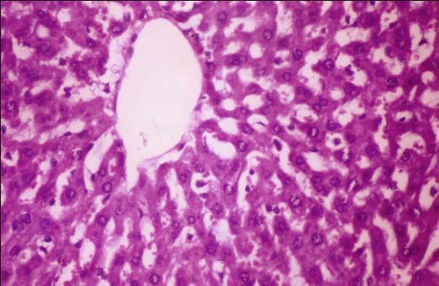

**Fig (1) Liver of control group showing the normal histological structure of hepatic lobule.** (H&E stain x400)

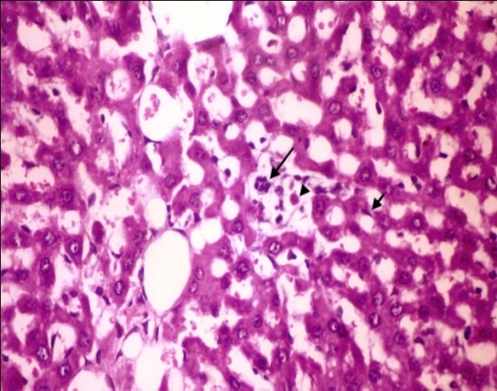

**Fig. (2): Liver section of CCl4-intoxicated rats showing focal hepatic necrosis associated with leucocytic cells infiltration (large arrow), and apoptosis of hepatocytes (arrow head), kupffer cells activation (small arrow).** (H&E stain x400)

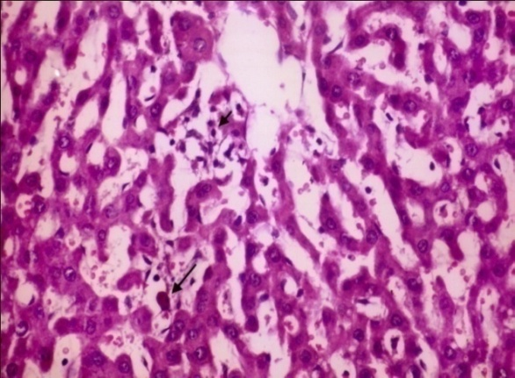

**Fig. (3): Liver section of CCl4-intoxicated rats showing multiple focal areas of hepatic necrosis (small arrow), associated with leucocytic cells infiltration. Note apoptosis of hepatocytes (large arrow).** (H&E stain x400)

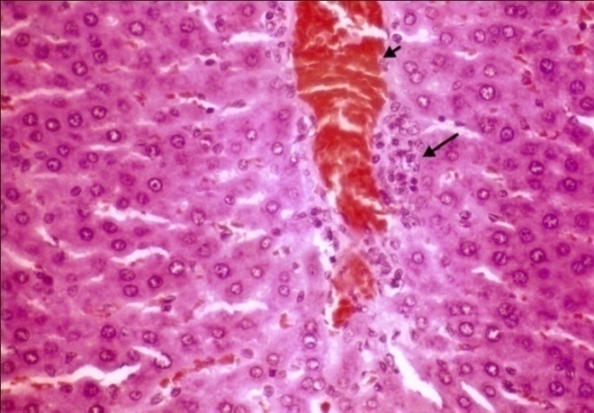

**Fig. (4): Liver section of CCl4-intoxicated rats showing congestion of central vein (small arrow), and perivascular mononuclear cells infiltration (large arrow).** (H&E stain x400)

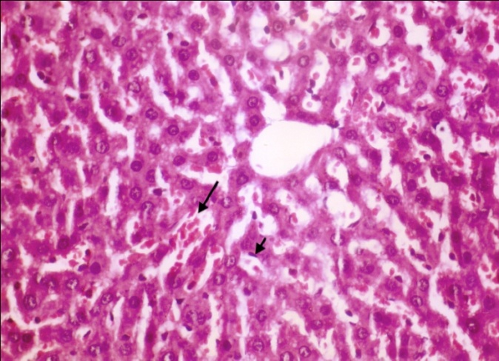

**Fig. (5): Liver section of CCl4- intoxicated rats pretreated with HPEEE (200mg/kg b.wt.) showing kuffer cells activation (small arrow), and slight dilatation of hepatic sinusoids (large arrow).** (H&E stain x400)

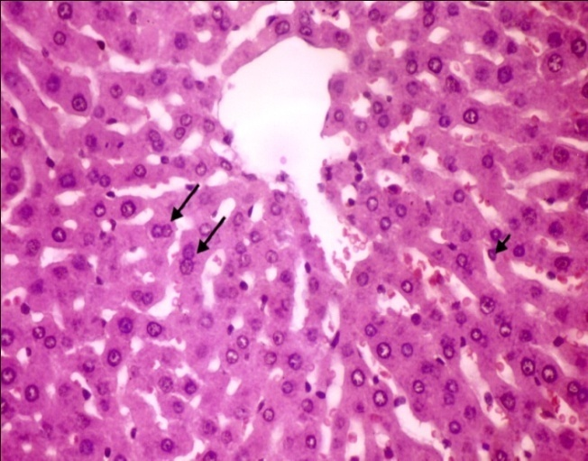

**Fig. (6): Liver section of CCl4- intoxicated rats pretreated with HPEEE (400mg/kg b.wt.) showing kuffer cells activation (small arrow), and binucleation of hepatocytes (large arrow).** (H&E stain x400)

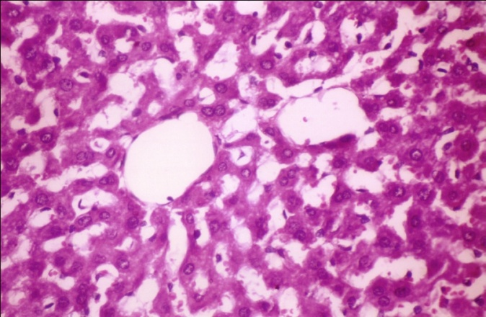

**Fig. (7): Liver section of CCl4- intoxicated rats pretreated with HPEEE (600mg/kg b.wt.) showing no histopathological changes.** (H&E stain x400)

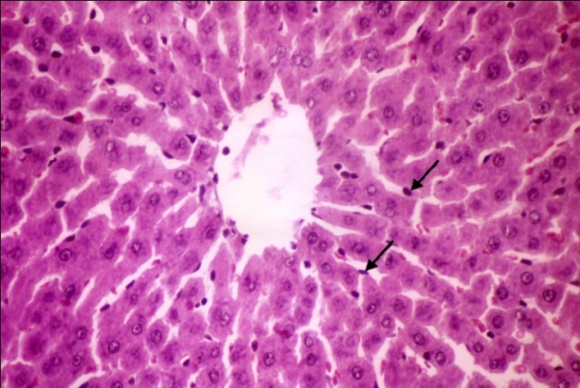

**Fig. (8): Liver section of CCl4- intoxicated rats pretreated with HPEEE (600 mg/kg b.wt.) showing kuffer cells activation (large arrow).** (H&E stain x400)

**4.Disscussion**

Liver diseases reduce people’s quality of life and frequently lead them to death. The occupational exposure to chemical compounds like aliphatic hydrocarbons alters the liver structure and functions **(Jaeschke, 2008).** Carbon tetrachloride is used as a hepatotoxic agent in animal research work to study the hepato-curative agent in plants and other compounds **(Aliyu *et al.,* 1995).** *Hibiscus sabdariffa* Linn. (HPEEE) is a valuable source of traditional medicine **(Ubani *et al*., 2010).** Aqueous extract of HPEEE is enriched in high antioxidant constituents, mainly flavonoids and vitamin C **(Hirunpanich *et al*., 2006)**

The aim of this study was to evaluate the effect of *Hibiscus sabdariffa* Calyx Extract

on body weight, serum levels of liver enzymes and blood lipids, as well as on the activity of liver tissue antioxidant enzymes in hepatotoxic rats.

In this Study, results showed that rat group intoxicated with CCl4 revealed significant decrease in final weight and weight gain percent, as compared to control group. These results were in agreement with (**Venukumar and Latha, 2002, Chang *et al*., 2007 and Balamurugan and Muthusamy, 2008**). Pretreatment of rats with HPEEE showed a significant increase in final weight and weight gain percent as compared to CCl4 intoxicated group. These findings suggested that the extract administration of HPEEE significantly neutralized the toxic effects of CCl4 and helped regeneration of hepatocytes due to its antioxidant activity. These observations were in perfect conformity with **Dahiru *et al***. (2013).

In the present study, serum hepatic biomarkers, AST and ALT activities were greatly increased (*p* < 0.05) in rats with the CCl4 treatment rats compared to control. The increased serum levels of hepatic markers have been attributed to the liver injury, because these enzymes are placed in the cytoplasmic area of the cell and are released into circulation in the case of cellular damage **(Brent and Rumack 1993)**. **Anand *et al*., (2011)** stated that the CCl4 induced increase in serum ALT and AST levels, which cause cell membrane and mitochondrial damages in liver cells. There are many authors’ reports indicating that these enzyme activities were significantly elevated after CCl4 treatment (**Mehmetcik *et al*., 2008; Arici and Cetin 2011 and Yin *et al*., 2011**). The first reports about hepatotoxic effects by CCl4 are lipid peroxidation origin, and are largely due to its active metabolite CCl3 (This metabolite can abstract hydrogen from fatty acids, initiating the lipid peroxidation), lead to cell injury, and finally liver damage (**Park *et al*., 2005**). On the other hand, Decreases in the serum levels of AST, ALT and ALP enzymes with HPEEE is an indication of the stabilization of plasma membrane as well as repair of liver damage caused by CCl4. This observation is in agreement with the view that serum levels of transaminases return to normal with healing of hepatic parenchyma and the regeneration of hepatocytes **(Jaishree and Badami.,2010)**. **Akanya *et al*., (1997)** reported thattheprotective effect of the extract could be due to the rich Vitamin C content of the extractwhich serves as an antioxidant and a reductant, especially in the conversion of any -tocopheroxyl radicals formed, to -tocopherol.**Wang *et al*., (2000**) also concluded that the presence of Hibiscus protocatechuric acid(phenol) and Hibiscus anthocyanins both isolated from the flower had a protective effect against tart butyl hydroperoxide induced hepatic toxicity in rats.

Glutathione is a major non-protein thiol in living organism, which plays a central role of co-ordinating the body’s antioxidant defense process. It is implicated in the cellular defense against xenobiotics and naturally occurring deleterious compounds such as free radicals. Glutathione status is a highly sensitive indicator of cell functionality and viability. Perturbation of the GSH status of biological system has been reported to lead to serious consequences **(Pastore, 2003).** In the present study, a significant decrease in hepatic GSH level was observed in CCl4 intoxicated group as compared to control group. The depletion of hepatic GSH has been shown to be associated with an enhanced toxic to CCl4 **(Hewawasam *et al*., 2003).** On the other hand,there was an increase in hepatic GSH level in the rats treated with HPEEE this may be due to the prevention of GSH depletion and destruction of free radicals **(Adewale and Abiodun, 2013).**

Lipid peroxidation has been postulated to be the destructive process in the liver injury due to toxicant (CCl4) **(Tsai *et al*.,2009)**. In the present study, an elevation in the level of MDA in the liver of animals treated with CCl4 was observed. Enhanced lipid peroxidation expressed in terms of the MDA (malonaldehyde) contents in CCl4 treated rats confirmed hepatic damage by the earlier reports **(Wang *et al*., 2004)**. However, pretreatment with HPEEE substantially reduce the level of lipid peroxidation. HPEEE is known to contain a considerable amount of phenolic content and exhibited strong free radical scavenging property. Phenolics may efficiently reduce the excessive formation of free radical and maintain hepatic membrane integrity **(Guo *et al*., 2009)**. Consequently, the ability of the HPEEE extract to protect the rats against CCl4 induced liver damage may be attributed to the high antioxidant potentials exhibited in this study.

The present results revealed significant elevation in serum TC, TG, LDL-C and VLDL-C levels along with a significant reduction in serum HDL-C levels in CCl4 intoxicated rats, as compared to control rats. These results were in agreement with the previous results of **El**-**Habibi *et al.* (2009)and Al-Dosari (2010).** Pretreatment of rats with HPEEE resulted in significant improvement in the tested lipid profile parameters, that could be attributed to increased inhibition of intestinal absorption of cholesterol, interference with lipoprotein production increased expression of hepatic LDL receptor and their protection, leading to an increased removal of LDL-C from the blood and its increased degradation and catabolism of cholesterol from the body. All these events either individually or in combination lead to decrease in serum LDL-C levels, which reduced serum total cholesterol level during the pretreatment **(Pooja and Priscilla, 2009).**

Histopathological changes indicating liver damage after CCl4 administration. It has been reported by previous findings that CCl4 causes necrosis **(Sun *et al*., 2001),** fibrosis **(Natsume et al., 1999)**,mononuclear cell infiltration **(Natsume *et al*., 1999),** steatosis and degeneration of hepatocytes, increase in mitotic activity **(Teocharis *et al*., 2001)** and cirrhosis (**Zalatnai *et al*., 1991)** in the liver. It has also been reported that CCl4 causes apoptosis in liver (**Sun *et al*., 2001).** Therefore, histopathological findings in the liver due to CCl4 administration are in agreement with previous studies. Pretreatment with HPEEE significantly improved the structure of hepatic cells This protective effect appears due to HPEEE antioxidant properties (**Liu *et al*., 2006).**

In conclusion, the results of this study demonstrate that HPEEE was effective for the prevention of CCl4-induced hepatic damage in rats. Our results show that the hepatoprotective effects of HPEE extract may be due to both an increase in the activity of the antioxidant-defense system and an inhibition of lipid peroxidation.However, the protective, curative and antioxidant qualities of HPEEE need to be confirmed by characterizing the active ingredient(s) of this plant as well as its mechanism(s) of action.

**References:**

1. Adewale, A. and Abiodun,O. (2013): Hepatoprotective and Antioxidant Effect of Hibiscus Polyphenol Rich Extract (HPEEE) Against Carbon Tetrachloride (CCL4) –Induced Damage in Rats. British Journal of Medicine & Medical Research 3(4): 1574-1586.
2. Akanya, H.O., Oyeleke, Jigam, S.B, and Lawal, F.F. (1997): Analysis of sorrel drink (soboroto). Nig. J. Biochem. Mol. Bio. 12:77-82.
3. Al-Dosari, M.S. (2010): The effectiveness of ethanolic extract of *Amaranthus tricolor* L.: A natural hepatoprotective agent. Am. J. Chin. Med., 38(6):1051-1064.
4. Ali, B.H., Al Wabel, N. and Blunden G.(2005): Aspects of *Hibiscus sabdariffa* L. Phytochemical, pharmacological and toxicological: a review. Phytother Res. 19(5):369-375.
5. Aliyu, R., Okoye, Z.S.C., and Shier, W.T. (1995): The hepatoprotective cytochrome P-450 enzyme inhibitor Isolated from Nigerian medicinal plant *Cochlospermum Planchonii* is a zinc salt. J. Ethnopharmacol., 48(2), pp.89-97.
6. Allain, C.A., Poon, L.S., Chan, C.S.G., Richmond, W. and Fu, P. (1974): Enzymatic determination of total serum cholesterol. Clin. Chem., 20:470.
7. Anand, K.V., Anandhi, R., Pakkiyaraj, M. and Geraldine, P. (2011): Protective effect of chrysin on carbon tetrachloride (CCl4)-induced tissue injury in male Wistar rats. Toxicol. Ind. Health, 27(10):923-933.
8. Arici, O.F. and Cetin,N. (2011): Protective role of ghrelin against carbon tetrachloride (CCl4 induced coagulation disturbances in rats. Regul Pept 166:139–142.
9. Balamurugan,G. and Muthusamy, P. (2008): Observation of the hepatoprotective and antioxidant activities of *Trianthema decandra* Linn. (*Vallai sharunnai*) roots on carbon tetrachloride-treated rats. Bangladesh J. Pharmacol., 3(2):83-89.
10. Bancroft, D., Stevens, A. and Turmer, R. (1996): Theory and practice of histological technique, 4th ed., Churchill Living Stone, Edinburgh, London, Melbourne. p: 47-67.
11. Belfied, A. and Goldberg, D.M. (1971): Enzyme, 12,561. C/F: Bio-Merieux, L´Etoile, France.
12. Beutler, E., Duron, O. and Kelly, D.O. (1963): Improved method of determination of blood glutathione. J. Lab. Clin. Med., 61(5):882-888.
13. Brent,J.A. and Rumack, B.H. (1993): Role of free radicals in toxic hepatic injury II. Clin Toxicol 31:173–196.
14. Chang, H.F., Lin,Y.H., Chu,C.C., Wu,S.J., Tsai, Y.H. and Chao, J.C. (2007): Protective effects of *Ginkgo biloba*, *Panax ginseng*, and *Schizandra chinensis* extract on liver injury in rats. The Am. J. of Chinese Medicine, 35 (6): 995-1009
15. Cocchetto, D.M. and Bjornsson, T.D. (1983): Methods for vascular access and collection of body fluids from the laboratory rat. J. Pharm. Sci., 72 (5): 465- 492.
16. Dahiru, D., Umaru, H. A., Vasira, B. and Agama,A. M. (2013): Antioxidant and Antiperoxidative Activities of Aqueous Extract of *Hibiscus sabdariffa* L. Calyx on Alcohol-induced Hepatic Lipid Peroxidation in Rats. American Journal of Biochemistry, 3(2): 62-65.
17. Demacker, P.N.M., Vos-janssen, H.E., Hifman, A.G.M., Vant´s Lear, A. and Jansen, A.P. (1980): Measurement of high density lipoprotein cholesterol in serum. Comparison of sex isolation methods combined with enzymatic cholesterol analysis. Clin. Chem., 26(13):1780.
18. El-Habibi,E.M., Sirag,H.M. and Edrees, G.M. (2009): Comparative effect between Chitosan and Chitosan-cu complex on CCl4 induced liver damage in rats. Egypt J. Hosp. Med., 36:397- 405.
19. Fossati, P. and Prencipe, L. (1982): Enzymatic determination of triglycerides. Clin. Chem., 28:2077.
20. Friedewald, W.T., Levy, R.L. and Fredrickson, D. (1972): Estimation of concentration of low-density lipoprotein cholesterol in plasma without use of the preparative ultracentrifuge. Clin. Chem., 18(6):499.
21. Guo, H., Sun, J., He, H., Yu,G.C.and Du, J. (2009):Antihepatotoxic effect of corn peptides against bacillus calmette-guerin/lipopolysaccharide-induced liver injury in mice. Food Chem.Toxicol. 47:2431–2435.
22. Hewawasam, R.P., Jayatilaka, K.A., Pathirana, C. and Mudduwa, L.K. (2003): Protective effect of *Asteracantha longifolia* extracts in mouse liver injury induced by CCl4 and paracetamol. J. Pharm. Pharmacol., 55(10):1413-1418.
23. Hai, Z. H., Bing,W., Yong, K. L., Yong,Y. B. and Yan, G.u.(2011): Hepatoprotective and Antioxidant Effects of Licorice Extract against CCL4-Induced Oxidative Damage in Rats. Int. J. Mol. Sci. 12, 6529-6543.
24. Hirunpanich, V., Utaipat,A., Morales, N.P., Bunyapraphatsara, N., Sato, H.and Herunsale, A. (2006): Hypocholesterolemic and antioxidant effects of aqueous extracts from the dried calyx of *Hibiscus sabdariffa* L. in hypercholesterolemic rats. J. Ethnopharmacol;103:252-60.
25. Jaeschke,H. (2008): Toxic responses of the liver. In: Klaassen CD (ed) Casarret & Doull’s toxicology. The science of poisons. 7th ed. New York: McGraw-Hill, p:557-582.
26. Jaishree,V. and Badami, S.(2010): Antioxidant and hepatoprotective effect of swertiamarin from *Enicostemm axillare* against D-galactosamine induced acute liver damage in rats. J. Ethnopharmacol. 130:103–106.
27. Karthikeyan, M. and Deepa, K. (2010): Hepatoprotective effect of *Premna* *corymbosa* (Burm. f.) Rottl. & Willd. leaves extract on CCl4 induced hepatic damage in Wistar albino rats. Asian Pacific J. of Tropical Medicine, 3(1): 17-20.
28. Lin, H.M., Tseng, H.C., Wang, C.J., Lin, J.J., L.o., C.W. and Chou, F.P. (2008): Hepatoprotective effects of *Solanum nigrum* Linn extract against CCl4-induced oxidative damage in rats. Chem. Biol. Interact., 171:283–293.
29. [Liu, J.Y](http://www.ncbi.nlm.nih.gov/pubmed?term=Liu%20JY%5BAuthor%5D&cauthor=true&cauthor_uid=16176854)., [Chen, C.C](http://www.ncbi.nlm.nih.gov/pubmed?term=Chen%20CC%5BAuthor%5D&cauthor=true&cauthor_uid=16176854)., [Wang, W.H](http://www.ncbi.nlm.nih.gov/pubmed?term=Wang%20WH%5BAuthor%5D&cauthor=true&cauthor_uid=16176854)., [Hsu,J.D](http://www.ncbi.nlm.nih.gov/pubmed?term=Hsu%20JD%5BAuthor%5D&cauthor=true&cauthor_uid=16176854)., [Yang, M.Y](http://www.ncbi.nlm.nih.gov/pubmed?term=Yang%20MY%5BAuthor%5D&cauthor=true&cauthor_uid=16176854).and [Wang, C.J](http://www.ncbi.nlm.nih.gov/pubmed?term=Wang%20CJ%5BAuthor%5D&cauthor=true&cauthor_uid=16176854).(2006):The protective effects of *Hibiscus sabdariffa* extract on CCl4-induced liver fibrosis in rats. [Food Chem Toxicol.](http://www.ncbi.nlm.nih.gov/pubmed/16176854) Mar;44(3):336-43.
30. Mehmetcik,G., Ozdemirler,G.and Koc, N. (2008): Role of carnosine in preventing thioacetamide-induced liver injury in the rat. Peptides 29:425–429.
31. Natsume, M., Tsuji, H., Harada, A., Akiyama,M., Yano, T. and Ishikura, H.(1999): Attenuated liver fibrosis and depressed serum albumin levels in carbon tetrachloride-treated IL-6- deficient mice. J. Leukoc Biol;66:601-608.
32. Park, W.H., Lee,S.K and Kim, C.H. (2005): A Korean herbal medicine, panax notoginseng, prevents liver fibrosis and hepatic microvascular dysfunction in rats. Life Sci 76:1675–1690.
33. Pastore, Y. (2003): Functional analysis of oxidative stress activated mitogen activated protein kinase cascade in plants. Proc.Natl Acad. Sci. USA 97, 2940-2945.
34. Pooja, C. O. and Priscilla, D.M. (2009): Antioxidant and hyperlipidemic activity of *Hibiscus Sabdariffa* leaves and calyces extracts in rats.Indian J.of Exp.Biol.,47 (3):276-282.
35. Ramirez-Rodrigues, M.M., Plaza, M.L., Azeredo, A., Balaban, O.M. and Marshall, M.R.(2011): Physicochemical and phytochemical properties of cold and hot water extraction from *Hibiscus sabdariffa*. Journal of Food Science. 76(3):C428–C435.
36. Reeves, P.G., Nielsen, F.H. and Fahey, G.C. (1993): AIN-93 purified diets for laboratory rodents: Final report of the American Institute of Nutrition ad hoc writing committee on the reformulation of the AIN-76A rodent diet. J. Nutr., 123(11):1939-1951.
37. Reitman, S. and Frankel, S. (1957): A colorimetric method for the determination of serum oxaloacetic and glutamic pyruvic transaminases. Am. J. Clin. Pathol., 28:56.
38. Sandeep,G., Raghuveer,I., Prabodh,C.S., Suresh, H., Atin, K., Aakash, D. and Tilak, B. (2010): Hypolipidemic effect of ethanolic extract from the leaves of *Hibiscus sabdariffa* L. in hyperlipidemic rats. Acta Poloniae Pharmaceutica-Drug Research, 67 (2):179-184.
39. Shen, X., Tang,Yuping, Y., Ruihui, Y.u., Fang, Taihui, D. and Jin,a.o. (2009): The protective effect of *Zizyphus jujube* fruit on carbon tetrachloride-induced hepatic injury in mice by anti-oxidative activities. Journal of Ethnopharmacology 122: 555–560.
40. Singh, N., Kamath,V., Narasimhamurthy, K., Rajini, P., S. (2008): Protective effect of potato peel extract against carbon tetrachlorideinduced liver injury in rats, Environ Toxicol Pharmacol, 26241-246.
41. Snedecor, G.W. and Cochron, W.G. (1989): Statistical methods. 8thed. Lowa State Univ. Press, Ames, Lowa, USA.
42. Srivastava, S.K., Rai, V., Srivastava, M., Rawat, A.K.S. and Mehrotra, S. (2006): Estimation of heavy metals in different Berberis Species and its Market Samples. Environ. Monit. Assess., 116: 315-320.
43. Sun, F., Hamagawa, E., Tsutsui,C., Ono,Y., Ogiri, Y. and Kojo, S.(2001): Evaluation of oxidative stress during apoptosis and necrosis caused by carbon tetrachloride in rat liver. Biochem. Biophys. Acta. 1535:186-91.
44. Teocharis, S.E., Margeli,A.P., Skaltsas, S.D., Spiliopoulou, C.A. and Koutselinis, A.S.(2001): Induction of metallothionein in the liver of carbon tetrachloride intoxicated rats: an immunohistochemical study. Toxicology. 161:129-38.
45. Tsai,C.F., Hsu, Y.W., Chen, W.K., Chang, W.H., Yen, C.C., Ho, Y.C. and Lu, F.J.(2009): Hepatoprotective effect of electrolyzed reduced water against carbon tetrachloride-induced liver damage in mice. Food Chem. Toxicol.47:2031–2036.
46. Ubani, C.S., Joshua, P.E.and Oraeki, A.N.(2010): Influence of aqueous extract of *Hibiscus sabdariffa* calyces on lipid profile of phenobarbitone induces wistar albino rats. J. Pharm Res;3: 319-24.
47. Venukumar, M.R. and Latha, M.S. (2002): Hepatoprotective effect of the methanolic extract of *Curculigo Orchioides* in CCl4-treated male rats. Indian J. Pharmacol., 34:269-275.
48. Vinoth, K.P., Sivaraj, A., Elumalai, E. K. and Senthil, K.B. (2009):
49. Carbon Tetrachloride – Induced Hepatotoxicity in Rats – Protective Role of Aqueous Leaf Extracts of *Coccinia Grandis*. International Journal of PharmTech Research Vol.1, No.4, pp 1612-1615
50. Wang, C.J., Wang, J.M., Lin, W.L., Chu, C.Y., Chau, F.P. and Tseng, T.H.B. (2000): Protective effect of *Hibiscus anthoyanins* against tert-bult hydroperoxide-induced hepatic toxicity in rats. Food Chem. Toxicol. I38:411-6.
51. Wang, B.J., Liu,C.T., Tseng,C.Y., Wu, C.P. and Yu, Z.R. (2004): Hepatoprotective and antioxidant effects of *Bupleurum kaoi* Liu (Chao et Chuang) extract and its fractions fractionated using supercritical CO2 on CCl4-induced liver damage. Food Chem. Toxicol. 42:609–617.
52. Yin,G., Cao, L., Xu, P., Jeney, G. and Nakao, M. (2011): Hepatoprotective and antioxidant effects of *Hibiscus sabdariffa* extract against carbon tetrachloride-induced hepatocyte damage in Cyprinus carpio. In Vitro Cell Dev Biol Anim.; 47(1):10-5.
53. Yoshioka, T., Kawada, K., Shimada, T. and Mori, M. (1979): Lipid peroxidation in maternal and cord blood and protective mechanism against activated oxygen toxicity in the blood. Am. J. Obstet. Gynecol., 135:372-376.
54. Zalatnai, A.,Sarosi,I., Rot, A. and Lapis,K.(1991): Inhibitory and promoting effects of carbon tetrachloride- induced liver cirrhosis on the diethylnitrosamine hepatocarcinogenesis in rats. Cancer Lett.57:67-73.

5/23/2014