Thermal effects of conductive heat resistant NBR/IIR rubber blends

Abdulkareem A. Redhwan *, A.A. El-Gamel, S.A. Khairy and H.H. Hassan

Physics Department, Faculty of Science, Cairo University, Cairo, Egypt
*abdulkareem.redhwan@yahoo.com

Abstract: Blends of acrylonitrile butadiene/Isoprene-Isobutylene (NBR/IIR) rubber with different ratios were prepared. SEM observations confirmed the usage of BIIR as compatibilizer for NBR/IIR blends. Each rubber blend was loaded with different ratios of N-326 and N-774 carbon blacks. I-V curves, joule heating effects and temperature-dependent electrical conductivity of the prepared blends were investigated. It was found that, the electric and thermal properties of the blends were enhanced upon increasing N-326 content.
[Redhwan Abdulkareem A, El-Gamel AA, Khairy SA and Hassan HH. Thermal effects of conductive heat resistant NBR/IIR rubber blends. Nat Sci 2014;12(6):133-138]. (ISSN: 1545-0740). http://www.sciencepub.net/nature. 19

Keywords: acrylonitrile; butyl rubber; SEM; thermal; electrical conductivity.

1. Introduction
Polymer composites doped with carbon black have attracted growing interest due to their potential use in various applications [1]. They can be utilized for electric heating devices which convert electrical energy into thermal energy. The concentration, particle size, and structure of the carbon black are essential for controlling the electrical and thermal properties [2, 3]. The incorporation of carbon black has been reported to form electric carrier paths throw the insulating rubber matrix [4]. An effective electrical conductivity of carbon black /polymer has been achieved at relatively high concentration of carbon black [5]. The temperature dependence of the electrical properties of conductive rubber composites has been utilized in various polymer applications. The negative temperature coefficient of conductivity (NTCC) of polymer is a parameter determines the efficiency of self-controlled heater and current limiters [6, 7]. However a polymer with positive temperature coefficient of conductivity (PTCC) is needed for electromagnetic radiation shielding [8, 9].
Blends of NBR with polymers have been investigated by Hofmann [10]. The instability of physical properties of butyl rubber (IIR) is a serious obstacle to its use as heating element applications [7]. This problem has been overcome by the addition of uncrosslinked layers of NBR to the IIR. The observed T-peel adhesion between the NBR and IIR is rate and temperature dependent [11]. Sau et al [12] found that rubber blends having differences in polarity are very useful in achieving suitable conductivity since the distribution of carbon black at the interference of two rubbers gives rise to high conductivity. NBR has good electrical properties due to a polar C≡N groups [13], while butyl rubber (IIR) posses good thermal properties. This combination is expected to enhance the thermal resistance of NBR.
In this article, some NBR/IIR rubber blends loaded with N-326 and N- 774 carbon blacks have been prepared, in an attempt to enhance the entire electrical and thermal properties. N-326 and N-774 were selected as dopants because they differ greatly in their particle size, surface area, and surface conditions of carbon particles. This large variation is expected to modify the electric and thermal properties of the blend. These properties are investigated by measuring the current-voltage curves, electric heating behavior, and temperature dependence of electrical conductivity.

2. Experimental
Rubber of acrylonitrile butadiene/butyl (NBR/IIR) blend was prepared with (50/50) ratio. The rubber blend was reinforced with N-326 [High Abrasion Furnace Black (HAF-LS)] and N-774 [Semi Reinforcing Furnace Black (SRF- HS)]. The percentages of N-326 to N-774 were selected as (0:100), (25:75), (50:50), (75:25), and (100:0). The particle size, surface area and PH of the different used carbon black fillers are listed in Table (1) [14]. The ingredients of each blend were listed in Table (2). Mastication and mixing were carried out on a two-roll mill of length 0.3 m, radius 0.15 m, speed of slow roll 18 rev / min, and gear ratio 1.4. The compounded rubbers were compressed into discs of 1 x 10⁻⁴ m² area and 0.01 m thick. The vulcanization process was carried out using special home-made mold and an electrically heated hydraulic press at a fixed temperature of 153 ⁰C under a pressure of 4 MPa for 30 min. For joule effect measurements, samples of rectangular shape of 0.06 m length, 0.05 m width, and 0.01 m thick were used. Two brass electrodes were embedded inside the sample at distance 0.04 m and length 0.025 m during the vulcanization process. Suitable electrical circuit was used for measuring joule heating, DC conductivity and the I-V characteristics. A QUANTAFEG 250 scanning electron microscope (SEM) was used for sample surface investigations.

Table 1. Physical and chemical properties of the carbon black fillers used [14].

Carbon Black | Particle size, nm | Surface area, m²/g | PH
N-326 (HAF-LS) | 29 | 80.0 | 7.0
N-774 (SRF-HS) | 70 | 28.0 | 9.0

Table 2. Compositions of NBR/IIR rubber blends loaded with different types of carbon black.

Ingredients, phrª | Samples
Ingredients, phrª | S₁ | S₂ | S₃ | S₄ | S₅ | S₆
NBR | 50 | 50 | 50 | 50 | 50 | 25
IIR | 50 | 50 | 50 | 50 | 50 | 75
BIIR^{b} | 10 | 10 | 10 | 10 | 10 | 10
Stearic acid | 2 | 2 | 2 | 2 | 2 | 2
Zinc oxide | 5 | 5 | 5 | 5 | 5 | 5
N-326 | 0 | 25 | 50 | 75 | 100 | 50
N-774 | 100 | 75 | 50 | 25 | 0 | 50
DOP^{c} | 3 | 3 | 3 | 3 | 3 | 3
Paraffin oil | 5 | 5 | 5 | 5 | 5 | 5
MBTS^{d} | 2 | 2 | 2 | 2 | 2 | 2
DPG^{e} | 1 | 1 | 1 | 1 | 1 | 1
Sulfur | 3 | 3 | 3 | 3 | 3 | 3
ª Part per hundred parts of rubber by weight ^{b} Bromo Butyle-rubber
^{c} Dioctyl Phythalate ^{d} Dibenzthiazyl Disulphide
^{e} Diphenyl Guanidine

3. Results and Discussion
3.1. Scanning electron microscopy
Pure vulcanized (50/50) NBR/IIR rubber blends without and with compatibilizer are investigated by using QUANTAFEG 250 scanning electron microscope. The surface morphology of the previous blend without compatibilizer is shown in Fig. (1-a). The SEM micrograph shows low degree of compatibility and no enough miscibility between the main components of blend and the sample appears continuous in nature associated with the phase separation. So the SEM micrograph shows two different phases inside the blend as a result of the difference in polarity between the pair rubber components of the blend.
Fig. (1-b) shows the surface morphology of NBR/IIR blend containing 10 phr of BIIR as a compatibilizer. It is evident that the phase separation appears to be diminished to a greater extent and the dispersed IIR phase is seen more evenly dispersed in the NBR phase. So the surface morphology of the prepared blend appears as continuous phase [15].

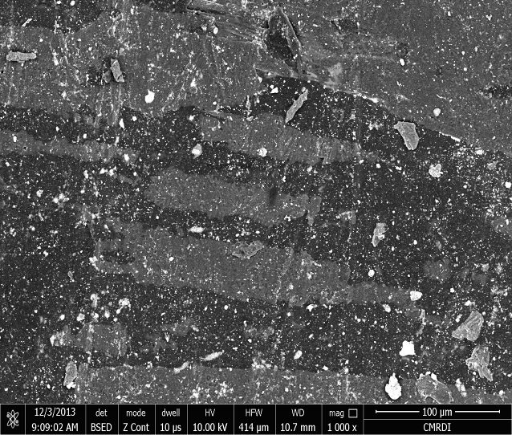

Figure 1-a. SEM micrograph of pure vulcanized NBR/IIR (50/50) rubber blend without compatibilizer (BIIR).

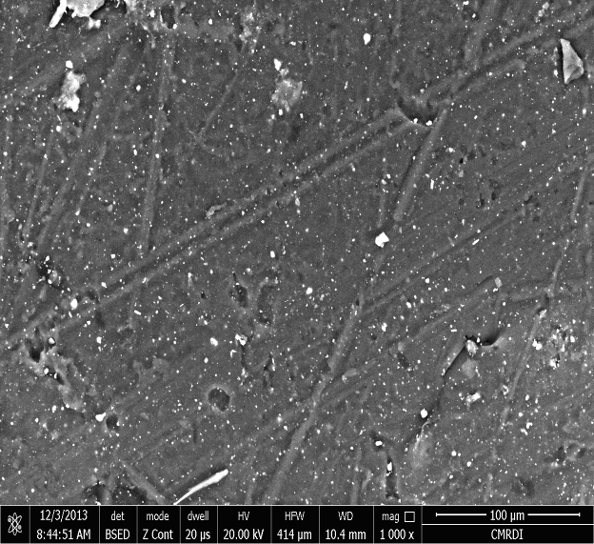

Figure 1-b. SEM micrograph of NBR/IIR (50/50) rubber blend with compatibilizer of 10 phr (BIIR).

3.2. I-V characteristics
Fig. (2) shows the current-voltage characteristics of the rubber blend NBR/IIR (50/50) loaded with different ratios of N-326:N-774 carbon black fillers. It can be seen that, the curves display the ohmic behavior at low field intensities. The current density is controlled by thermally generated electric field, across the gap between the conductive particle agglomerates [7]. By increasing the electric field, the behavior of I-V changes from linear to non-linear one. The non linearity of the curves is attributed to the injection of charge carriers into the conduction band which capable of carrying current; this process is termed space charge limited current (SCLC) [16]. From Fig (2) it is observed that, a low electric current passing through the samples which contains high content of N-774 carbon black, in contrast to the higher current observed in the samples which have higher content of N-326 carbon black fillers. This related to the nature of N-326 carbon black which has higher tendency to form aggregations inside the rubber matrix due to its small particle size. This aggregations form conduction network structure and hence small interspacing distances between carbon black particles resulting in notable increment in electric current.
The non ohmic behavior can be fitted to an empirical formula of the form [6]:

I = k V^{n} (1)

Where k is a constant and n is called the non-linearity coefficient. The values of n were calculated from lnI-lnV characteristics and tabulated in Table (3). It is noticed that, n appears to be deviated slightly from the ohmic behavior. Also from the table, the value of n decreases with increasing N-326 black content, which reflect that N-326 improves the thermal stability of the microstructure core of the rubber matrix.

Figure 2. I-V characteristics for rubber blend (50/50) NBR/IIR loaded with different ratios of N-326:N-774.

Table 3. The calculated values of the non-linearity coefficient (n) for rubber blend (50/50) NBR/IIR loaded with different ratios of N-326:N-774 carbon black.

Samples | the non-linearity coefficient, n
S₁(0:100) | 1.63
S₂(25:75) | 1.57
S₃(50:50) | 1.53
S₄(75:25) | 1.31
S₅(100:0) | 1.21

3.3. Electric heating effect
A constant power of 2 watt was applied on (50/50) NBR/IIR loaded with different ratios of N-326:N-774 carbon black fillers. The change of temperature with time is measured as shown in Fig. (3).
It is noticed that, the temperature of the blend rises slowly with time until an ultimate temperature (T_{m}) is attained and maintained afterwards constant over time. This behavior is linked to the fact that the applied electric power is effectively dissipated as heat. This trend was similarly observed for all composites. The maximum temperature attained at a given power was higher for the blend with higher carbon black filler N-326 content as shown in Fig. (3). The changes of temperature with time can be expressed as [7]:
(T_{t} – T_{o}) = (T_{m} – T_{o}) [1 – exp - ] (2)

Where _{To}, T_{m}, _{Tt}, and τ_{g} are the initial temperature, maximum temperature, an arbitrary temperature at time t, and growth time constant respectively.

Figure 3. Time dependence of temperature changes at constant electric power (P = 2 watt) for conductive NBR/IIR rubber blends.

Fig. (4) represents variations of growth time constant τ_{g} for the studied blends.

Figure 4. The growth time constant (τ_{g}) versus different types of carbon black ratios for (50/50) NBR/IIR blend.

It is clear that, the growth time constant (τ_{g}) increases monotonically with the increase of N-774 content and vice versa. The low value of τ_{g} for samples that contain high ratio of N-326 carbon black fillers means that, the samples have rapid temperature response to the applied power. The ultimate temperature regime, on the other hand, displays a constant temperature because the heating gain by electric power is equal to the heat loss by radiation and convection according to the principle of energy conservation [2].
Fig. (5) displays time-dependent temperature changes at different constant power for (50/50) NBR/IIR blend loaded with (50:50) (N-326:N-774) carbon blacks. It is clear that, as the applied power increases, the maximum temperature increases, consequently a growth time constant will decrease. It was found that, the maximum temperature was quadratically increased with the increment of the applied power, as can be seen in Fig. (5).

Figure 5. Time dependence of temperature changes at different constant power for (50/50) NBR/IIR blend loaded with (50:50) N-326:N-774 carbon black.

3.4. Effect of temperature on electrical conductivity
Fig. (6) illustrates the temperature dependence of electrical conductivity lnσ of (50/50) NBR/IIR rubber blend loaded with different carbon black ratios N-326:N-774. There is a notable increment in the electrical conductivity of blends that contain higher ratio of N-326 carbon black filler in comparison with other blends that contain lower ratio. This is related to the large surface (small particle size) of N-326, which fills the free volume inside the rubber matrix and decreases the conductive inter-spacing distance between aggregate-aggregate. The later creates conductive path channels which lead to an increase in the electrical conductivity [17].

Figure 6. The change of lnσ versus 1000/T for (50/50) NBR/IIR rubber blend loaded with different ratios of N-326:N-774 black.

It is noticed also that, at a relatively low temperature range, the conductivity is slightly dependent on temperature. This may be attributed to the direct contact of conductive aggregates which resist the breakage as the rubber is thermally expanded [16]. The conductivity decreases with increasing temperatures, this is probably a result of breakdown structure of conductive phases due to thermal expansion of the rubber matrix. The rise of temperature will cause an appreciable increase in the separation distance between conductive phases, and so the charge carriers will be scattered at rubber layers between conductive phases which leads to the decrease in conductivity.
It is clear from the figure that, the blend exhibits NTCC behavior, the variation in differential thermal expansion of the polymer matrix and conductive filler leads to destruction of the conductive network. According to the hopping and tunneling effect theory, there is a decrease in conductivity. In other words, the rise of temperature will cause an appreciable increase in the separation distance between conductive phases and the dimensions of continuous conductive paths decrease, resulting in a decrease in conductivity of the blends.
Thereupon, the temperature dependence of conductivity can be expressed by a simple empirical form:
σ = σ_{o} exp (3)
where α is the characteristic parameter, σ_{o} is a constant.
During the experimental work, it was found that, such blends exhibit the NTCC and PTCC behavior at the same time. Fig. (7) shows the temperature dependence of the electric conductivity of (25/75) NBR/IIR rubber blend loaded with (50:50) N-326:N-774 carbon black ratio. This figure shows also that, as the temperature of the sample was increased, the conductivity decreases until certain temperature, namely the critical temperature (T_{C}), then the NTCC behavior changes abruptly to PTCC.
The minimum conductivity behavior shown in Fig. (7) could be explained as a competition of two conduction mechanisms. The first one, at low temperature, which results in a marked decrease of σ by increasing temperature due to the thermal expansion of the hopping and/or tunneling paths between carbon particles or aggregates. The second conduction mechanism which is the predominant one at high temperature region is due to thermal activation of the rubber matrix [18].

Figure 7. NTCC and PTCC behavior of lnσ versus temperature for (25/75) NBR/IIR rubber blend loaded with (50:50) N-326:N-774 carbon black ratio.

4. Conclusion
SEM image supports the evidence for the compatibility of NBR/IIR blend and the homogeneity observed after the addition of 10 phr (BIIR) as a compatibilizer. N-326 (HAF) carbon black improves the thermal stability and microstructure core of the (50/50) NBR/IIR rubber blend. Also, as its ratio increase the electrical conductivity and electric heating behavior is improved. Most of the prepared blends exhibit negative temperature coefficient of conductivity, in comparison with other blend [(25/75) NBR/IIR rubber blend loaded with (50:50) N-326:N-774], that exhibit the combination of positive and negative coefficients. The NTCC behavior of our blend enables it to be employed as efficient heaters.

Corresponding Author:
Abdulkareem A. Redhwan
Physics Department
Faculty of Science
Cairo University, Cairo, Egypt
E-mail: abdulkareem.redhwan@yahoo.com

References
- J.-E. An, and Y. G. Jeong, Eur. Polym. J., 49 (2013) 1322.
- W. Hopark, J. Polym., 28, (5) (1996) 672.
- S. Isaji, Y. Bin, and M. Matsuo, Polymers, 50 (4), (2009) 1064.
- A. T. Ezquerra, M. J. Salazar, and J. F. Caleja, J. Mater. Sci. Lett., 5 (1986) 1065.
- J. K. W. Sandler, J. E. Kirk, I. A. Kinloch, M. S. P. Shaffer, and A. H. Windle, Polymer, 44, (19) (2003) 5893.
- D. Saraydin, E. Karadağ, and O. Güven, J. Polym., 29 (8), (1997) 631.
- F. El-Tantawy, Eur. Polym. J., 37 (2001) 565.
- H. Tagachi, Physica B., 270 (1999) 325.
- P. Ghosh, and A. Chakrabarti, Eur. Polym. J., 36 (2000) 1043.
- W. Hofmann, Kautschuk and Gummi Kunstsoffe, 37, (9), (1984) 753.
- M. H. Chung, and G. R. Hamed, Rubber Chem. Technol., 62, (2), (1989) 367.
- K. P. Sau, T. K. Chaki, and D. Khastgir, J. Mater. Sci., 32 (1997) 5717.
- A. M. Y. El-Lawindy, W. E. Mahmoud, and H. H. Hassan, Egypt. J. Sol., 26 (1), (2003) 43.
- C. M. B low, “Rubber Technology and Manufacture”, Buttenvorths, London (1971).
- M. Yaser, P. singh, K. N. Pandey, V. Verma, and V. Kumar. Indian J. Pure & Appl. Phys., 51, (2013) 621.
- D. A. Seanor, “Polymer Science”, Editted by A. D. Jenkins, North Holland Publ. (1972).
- X. M. Chen, Y. Suzuki, and N. J. Sato, J. Mater. Sci. Electron, 5 (1994) 244.
- F. El-Tantawy, Eur. Polym. J., 38 (2002) 567.

6/13/2014

