The Teratogenic Effects of Carbendazim Compound on Radula of the Different Ages of Land Slug, Arion linnaeus

Soha Mobarak, A. and Randa Kandil, A.

Plant Protection Research Institute – Agricultural Research Center. Giza.
Soha_snails@yahoo.com

Abstract: Effect of carbendazim (fungicide) on radula and feeding activity of different ages of land slug, Arion linnaeus, was studied. Three ages of slug i.e., {(hatching (one month), Juvenile (three months), Adult (nine months)} were treated with different concentrations of carbendazim as contact for one week and the LC₅₀ value was calculated. Results indicated that hatching age was the most susceptible to carbendazim followed by juvenile while the adult age was the lowest susceptible one. On the other hand, the pathological studies showed that the compound caused teratogenic effects and pathological changes in radula of slug whereas all types of teeth were completely absent these effects led animals to refrain feeding bringing death. So, this compound could be used in control programs of land slugs for protecting the plants from this pest.
[Soha Mobarak, A. and Randa Kandil, A. The Teratogenic Effects of Carbendazim Compound on Radula of the Different Ages of Land Slug, Arion linnaeus. Nat Sci 2014; 12(7):138-141]. (ISSN: 1545-0740). http://www.sciencepub.net/nature. 19

Keyword: Teratogenic – Radula – Slug – Carbendazim.

1. Introduction
Terrestrial slugs have proved to be one of the most successful of all groups of molluscs. The reduction of the shell has lessened the need for calcium salts with the results that slug can live in wider range of habitats than most snails. Slugs are tolerant of water loss and its worm – like body allows the individual to squeeze through cervices in the soil for searching shelter (Ali Reham, 2011) Various slug species are among serious pests of cultivated plants. They feed on seeds, seedling and damage different parts of mature plants (Biner and Frank 1998). The knowledge about the Egyptian terrestrial gastropods is still fragmentary and partial information is available about their biology and control. Thus, the present work aims to study the toxic and teratogenic effects of carbendazim fungicide on the different ages of Arion linnaeus which consider the most harmful slug species. Also, studying the compound effect on the feeding activity of slug.

2. Material and Methods

Tested animals:
The individuals of black slug, Arion Linnaeus, were collected from nursery of ministry of agriculture-Dokki, Giza orchards and transported to the laboratory. Animals were reared in plastic boxes according to Godan (1983). The terrarium was examined weekly for egg- laying. After hatching and rearing, animals were divided into 3 groups according to age, hatching (one month), juveniles (three months), and adults (nine months) for treatment. Ten animals of each age were used for each test and another for control.

Tested compound:
The fungicide carbendazim 50% WP was used. It was obtained from Agriphar Co. Belgium.

Treatment:
Contact technique (thin layer film) was used according to Asher and Mirian (1981). Different concentrations of the tested compound were applied using water to the diameter of 5 cm in Petri-dish. Two ml of each concentration was spread on inner surface of Petri-dish by moving the dish gently in circles. Water was evaporated under room condition in a few minutes leaving a thin layer film of compound on the surface of Petri – dish. Animals of each age were exposed to the candidate concentrations for one week in Petri- dish. A parallel control test was conducted using plain water. The killed animals were daily counted and mortality percentages were calculated after one week. LC₅₀ was determined for each age according to Finny (1971).

Antifeedent test:
Serial concentrations of the tested compound were used for each age of slug. Each animal was exposed to 25 cm² green lettuce leaves for 4 successive days before the treatment. The eaten area was daily estimated. This procedure was repeated daily for 4 successive days with lettuce leaves previously dipped in the tested concentration for 3 seconds. The inhibition of feeding activity was calculated using the following equation according to Hussein and El-Wakil (1993).

% inhibition of feeding activity= | Area consumed by control –Area consumed by treatment  Area consumed by control | × 100

+++ = strong antifeeding activity (80 -100 % inhibition). ++ = moderate antifeeding activity (50 - 80 % inhibition).
+ = slight antifeeding activity (30 – 50 % inhibition). - = no antifeeding activity (0.0 – 30% inhibition).

Pathological studies.
The three ages of animals were treated with LC₅₀ of compound for studying the pathological changes in radula of slug comparing with the untreated animal of control. The buccal mass of each age was removed using fine scalpel by cutting the interior part of slug individual and put it in test tube with sodium hydroxide (NaoH 7.5%). Test tubes were heated in water bath for 10-15 min., to clean the stuck tissues around the specimens. Then, the specimens were washed with distilled water for ten min., to remove the sodium hydroxide and passing in ethanol 30, 50, 70, 80, 90, 95 and 100% for ten min., for each concentration to extract all the water from the specimens. Then, transferred to Petri- dish with Xylene for ten min., to remove alcohol. Finally, the specimens were mounted on glass slides in Canda balsam medium and covered with cover slide then microscopically examined for identification and photographed the radula under light microscopy (X40) and compared with those of untreated.

3. Results and Discussions

LC₅₀ Determination
Data shown in Table (1) presented the comparative response of different ages of Arion Linnaeus to carbendazim compound used as a contact treatment. LC₅₀ of carbendazim were 0.15, 0.21 and 0.25 mg/cm² for hatching, juvenile and adult ages of slug, respectively. Results revealed that hatching was the most susceptible age to carbendazim followed by juvenile age while the adults were the lowest susceptible one. These differences in the susceptibility level may be due to the physiological state of the slug which changes from age to another. Our finding are in harmony with those which obtained by El-Deeb et al (2003) they showed that the three months age of Eobania vermiculata was the most susceptible age to diazinon compound followed by one month and the old adult . However, the six month and adult ages appeared more tolerate to diazinon than the other ages.

Antifeeding effect
The results shown in Table (2) indicate the antifeeding activity of the tested compound against the three ages of slug. Results revealed that the concentration of 0.08 mg/cm² caused 65, 30 and 30% inhibition of feeding activity for hatching, juvenile and adult ages of slug, respectively. The second concentration 0.16 mg/cm² of carbendazim induced 80, 50 and 70% inhibition of feeding activity to the same ages of slug, respectively.
Regarding 0.24 mg/cm² concentration, it achieved 100% inhibition of feeding activity to hatching age while it gave 75 and 80% reducing in feeding activity for juvenile and adult ages, respectively. Complete inhibition 100% of feeding activity was occurred for the three ages of slugs by high concentration 0.3 mg/cm² of carbendazim. In spite of this it is clear that hatching age is the most sensitive one. This is clearly evident from the effect of the concentration of 0.24 mg/cm² which caused completely inhibition of feeding activity to hatching age and 75, 80% inhibition against juvenile and adult, respectively. The adult age came in the second rank while the juvenile age came in the last rank. Hussein and El-Wakil (1993) found that the concentration of 0.52 µ/cm² and 1.3 µ/cm² of cardenolide extract gave 100% protection to lettuce leaves against Theba pisana and Hilicella vestalis, respectively.

Pathological changes
The radula consists of many rows of chitinous teeth arranged on a horny membrane on the odontophore or tongue on the floor of the buccal cavity. New rows of teeth are constantly being produced from the floor of the buccal cavity, while older teeth are probably reabsorbed. The teeth in the centre of the radula differ in shape from those on the side: their appearance and shape are taxonomically useful.
The pathological findings of radula of the different ages of slug, Arion Linnaeus, treated with LC₅₀ of carbendazim were showing in Figs. (2, 4, and 6). Concerning hatching age, Fig. (1) Showed that the normal shape of radula (control) is composed of three types of teeth arranged linearly, including central, lateral, and marginal teeth. In the treated hatching slug, Fig. (2) exhibited that there was complete disappearance of all types of teeth, central, lateral and marginal teeth. Also, it is observed that the size of radula was increased.
Regarding juvenile slug, Fig. (3) showed the untreated radula with appearance all the type of teeth. Fig. (4) noticed that the lateral, marginal teeth, and central were absent but no changes in the size of radula. Fig. (5) showed the untreated radula of adult slug it was cleared all type of teeth. Fig. (6) showed the radula of treated adult slug. It obvious that all type of teeth was approximately absent whereas the marginal teeth were complete absences, while central and lateral teeth were observed semi disappearance. Barker (2001) and Smith (2012) mentioned that the radula comprised 80-132 straight transverse rows of 35-57 marginal- lateral teeth either side of a well – developed central tooth.
From the previous results it is clear that carbendazim compound caused teratogenic effect and pathological changes in radula of the all ages of the slugs. These actions caused no feeding and death in all ages of slug, comparing with untreated animals. Also, the hatching and adult ages were more susceptible to compound than juvenile age. The same results were occurred with the antifeeding activity. Also, carbendazim may be caused inhibition to regenerate the radula so, the slugs can't eat and death, because in carnivorous pulmonates, furthermore, if the radula or proboscis are lost, they are immediately regenerated, Godan (1983). Andrew (2009) recorded that carbendazim cause fetotoxic and teratogenic effects in laboratory animals following bolus oral dosing. Also, Mohmoud Maha (2003) found that diflubenzuron compound caused teratogenic effect on jaw of different ages of land slug, Limax flavus, whereas the jaws size were relatively smaller than that of untreated one and beak of jaws for treated slug was longer than that of untreated slug.
Finally, we can conclude that carbendazim compound can protect the plants from slugs attack by unfeeding in addition to control this pest.

Table (1): LC₅₀ of carbendazim compound against three ages of land slug, Arion linnaeus, using contact technique.
Ages | LC₅₀ mg/cm² | Lower mg/cm² | Upper mg/cm²
Hatching  Juvenile  Adult | 0.15  0.21  0.25 | 0.08  0.15  0.15 | 0.2  0.3  0.2

Table (2). Antifeeding activity of carbendazim compound using lettuce leaves dipping in different concentrations on different ages of Arion linnaeus.
Conc. Of compound  mg/cm² | Hatching |  | Juvenile |  | Adult
Conc. Of compound  mg/cm² | % inhibition of Feeding | Antifeeding activity | % inhibition of Feeding | Antifeeding activity | % inhibition of Feeding | Antifeeding activity
0.08 | 65 | ++ | 30 | + | 30 | +
0.16 | 80 | +++ | 50 | ++ | 70 | ++
0.24 | 100 | +++ | 75 | ++ | 80 | +++
0.3 | 100 | +++ | 100 | +++ | 100 | +++

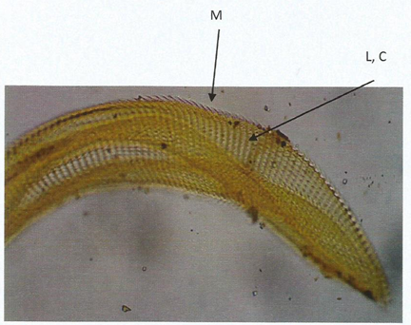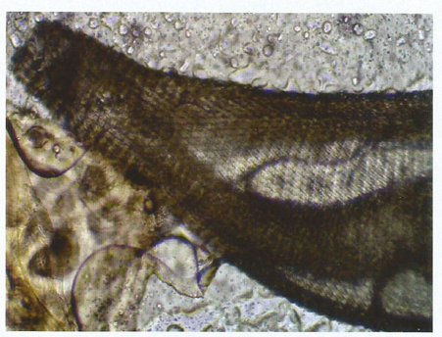

Fig. (1) Untreated hatching Arion linnaeus (control). Showing the normal structure of the radula teeth  L (Lateral), C (Control), M (Marginal) | Fig. (2) Hatching Arion linnaeus Treated with carbendazim showing absent the teeth and changes the size of radula

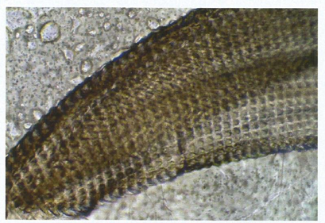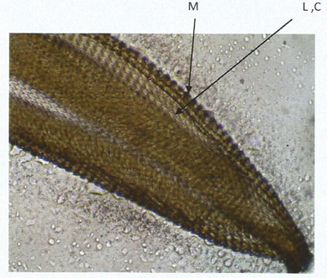
Fig. (3) Untreated Juvenile Arion linnaeus (Control). Showing the normal teeth in radula structure  L (Lateral), C (Control), M (Marginal) | Fig. (4) Juvenile Arion linnaeus Treated with carbendazim. Showing the absent of radula teeth

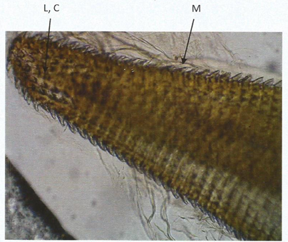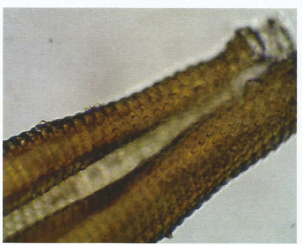
Fig. (5) Untreated Adult Arion linnaeus. Showing the teeth in radula  L (Lateral), C (Control), M (Marginal) | Fig. (6) Adult Arion linnaeus Treated with carbendazim. Showing the absent of all type of teeth radula

References
Ali Reham, F. (2011). Studies on some gastropods. PH.D. Thesis Fac. Agric., Cairo Univ. 133pp.
Andrew, W. (2009). Two headed fish mystery deepens. Stock and land. http://sl.farmonline.com
Asher, R. S. and Marian, F. (1981). The residual contact toxicity of bay sir 8514 to Spodopetera littoralis larva. Phytoparasitica., 9 (2): 133-137.
Barker, G. M. (2001). The biology of terrestrial molluscs. (radular structure and function). CABI Publishing, 213 pp.
Briner, T. and Frank, T. (1998). The palatability of 78 wildflower strip plants to the slug Arion lusitanicus. Ann. Appl. Biol., 133: 123-133.
El-Deeb, H. I.; Eweis, E. A.; Kandil, M. A.; Gabr, W. M. and Mobarak Soha, A (2003) . Toxicity and biochemical studies of methomyl and diazinon on different ages of the land gastropod species Monacha obstructa. J. Agric. Sci. Mansoura Univ., 28 (9): 7011-7023.
Finney, D. J. (1971). Probit analysis. A statistical treatment of the sigmoid response curve. Cambrige Univ.
Godan, D. (1983): Pest Slugs and Snails (biology and control) Springer Verlg Berkin Hidelberg. New York: 345pp.
Hussein, H. I. and El-Wakil, H. B. (1993). A pioneer moluscicidal and antifeeding cardenolide extract from Calotropis procera against economic land snails. J. Pest control Environ. Sci., 20: 136- 142.
Mahmoud Maha, F. (2002). Effect of plant extract and growth regulator on jaw morphology of some terrestrial molluscs. Egypt. J. Agric, Res., 80 (1): 155- 167.

Smith M. R. (2012). Mouthparts of the burgess shale fossils Odontogriphus and Wiwaxia: implications for the ancestral molluscan radula. Royal Society B: Biological Science. 279 (1745): 4287-4295.

6/12/2014

