Measurement of some heterogeneous samples’ characteristics using gamma scanning technique

Z. Ahmed ¹, W.I. Zidan ¹, M.S. EL-Tahawy ¹ and A.G. Mostafa ²*

^{1.} Egyptian Nuclear & Radiological Regulatory Authority,P.O. Box: 7551, Nasr City, 11762 Cairo, Egypt
^{2.} Physics Dept. Faculty of Science, Al-Azhar University, Nasr City, Cairo, Egypt
*drahmedgamal@yahoo.com

Abstract: The performance characteristics of an available and applicable assay system are discussed briefly. The operation of the system is described to measure heterogeneous NM samples in order to determine some characteristics for these samples (length, width, thickness and the targets distribution in the container). The possibility of moving the system to the inspection location should be taken into consideration, the system in the present work is relatively easily transportable and make from this segmented gamma scanner a valid alternative from opening the container of the sample for item verification. The used technique could minimize labor time for verification of such samples, protects them from damage and minimizes radiation exposure during inspection activities. The challenge of assaying NMs does not end with the design of the assay system, much effort has been made to the development of efficient and reliable method of the analysis of the resulting measurements.
[Ahmed Z, Zidan WI, EL-Tahawy MS and Mostafa AG. Measurement of some heterogeneous samples’ characteristics using gamma scanning technique. Nat Sci 2015;13(4):124-131]. (ISSN: 1545-0740). http://www.sciencepub.net/nature. 19

Keywords: Nuclear safeguards, Uranium mass content, Monte Carlo, Calibration of detector, AWCC.

1. Introduction
Non-Destructive Assay (NDA) techniques have been widly used to verify and characterize nuclear materials (NM), but Tomographic and segmented gamma scanning methods are important whenever sealed or heterogeneous NM samples exist. Quantitative isotopic assay is an essential requirement in the safeguarding of NMs. Nuclear safeguards is system of policies and technical measures, developed to ensure that fissionable materials are being used for their intended purposes and are controlled through the implementation of that system. Verification and characterization of NMs necessitate a system capable of measuring all NMs exist in a nuclear fuel cycle.
Non-destructive analysis of radio nuclides in packages containing low level waste (LLW)& medium level waste (MLW) was performed by Suarez et al [1]. The used equipment perform the measurements and calibration has divided into two main parts, gamma spectrometry and mechanical system. Gamma spectrometry consists of Hyper Pure Germanium detector (HPGe) in horizontal laid out connecting to an electronic chain, mechanical system consists of a lift with a turntable in which the drum (220 liters barrel, 185 mm thickness internally shielded with concrete) is placed in order to rotate and elevate it during measurement. They used a program to control both mechanical and detection systems. They concluded that the density of homogeneous packages is high within the range from 1.79 to 1.90 g/cm³.
Segmented Gamma Scanner (SGS) is commonly utilized to assay (208 L) drums containing radioactive waste [2]. Such system comprises a detector, collimator and a transmission source assembly. The detector is a broad-energy HPGe with a 28 cm² crystal surface area and 2.5 cm thickness, on a Cryo-Cycle hybrid liquid nitrogen and electric cryogenic system. The collimator has a fixed opening of 12.7 mm height, 177.8 mm wide and 152.4 mm depth, the opening of the collimator is lined with 3.3 mm thick tungsten.The transmission source assembly is located on the opposite side of the container from the detector and consists of a highly collimated 5 mCi ¹⁵²Eu transmission source, concluded that the SGS technique is a well-accepted NDA technique almostly applicable to containers of any size.
Martz et al have compared the results obtained by two different gamma-ray NDA systems used for imaging waste barrels [3]. The Lawrence Livermore National Laboratory (LLNL) has developed an emerging gamma-ray NDA technology that call active (A) and passive computed tomography (PCT). A and PCT has been used to characterize waste barrels up to 416 liters with weights up to 725 kg, and container up to 92 cm diameter and 122 cm length. A and PCT used a single, highly-collimated HPGe detector and a ¹⁶⁶Ho external radioactive source. The interest of the institute of nnuclear ttechniques (INT) is to employ tomographic imaging principles to assay heterogeneous waste, an economically feasible solution is to build an array of small size, room-temperature detectors to an existing SGS. They concluded that accuracy of measurements depends on the image resolution capability of the scanner.
Tran Quoc Dung has proposed a measuring technique for assaying radioactive materials in waste drums and estimating the source distribution in waste [4]. The mathematical simulation of gamma ray measurement proposed with the segmented gamma scanner calculations, has been also carried out.
Nabil Menaa et al [5] have built and tested a system for non-destructive assay of drummed radioactive waste obtained from nuclear power plants. The system is capable of assaying 208 liter drums and 320 liter over-pack drums in two different modes; a tomographic gamma scanning (TGS) mode and a Segmented Gamma Scanning (SGS) mode. 15 mCi ¹⁵²Eu transmission source is used in this system to determine matrix attenuation. Waste items with matrix densities between 0 and 1 g/cc were assayed in the TGS mode, where its methodology combines low spatial resolution imaging techniques with High Resolution Gamma Spectroscopy (HRGS). In a TGS assay; the waste drum is scanned with three degrees of freedom, i.e., rotation, translation and elevation. In the SGS mode, the waste drum is scanned with two degrees of freedom, rotation and elevation. They concluded that, this system provides the capabilities of automatically select and perform TGS assays, SGS assays with transmission, and/or SGS assays without transmission.
The characterization and performance of TGS systems are discussed in detail for both TGS and SGS modes of operation by Ramkumar et al [6]. The system consists of a 5000 mm² Broad Energy Germanium (BEGe) detector and a 15 mCi ¹⁵²Eu transmission source. The detector was housed inside a cylindrical lead shield of 50 mm annular thickness. The detector and the transmission source are accurately aligned with each other and also with the center of the rotating platform.
Ravazzani et al have designed a SGS system for the verification of large low enrichmed uranium (LEU) oxide powder containers in nuclear fuel fabrication plants [7-8], they used the system to determine the amount of uranium oxide powder and ²³⁵U/U abundance. The measurements are performed by scanning the container axis with a collimated detector. The energy spectrum covered the 1001 keV region to estimate ²³⁸U mass and the 185 keV region to determine the ²³⁵U/U abundance. The gamma spectra taken at different axial positions of the container used to verify the homogeneity of the sample. The filling height of the container and the powder density were also obtained. They showed that this method allows the verification of U mass and enrichment with an accuracy of a few percents, which is sufficient in most inspection conditions.
Traditional gamma- ray methods used to characterize nuclear waste introduce errors that are related to non-uniform measurement response associated with unknown radioactive source and matrix material distribution. These errors were reduced by applying an active and passive tomographic technique (A and PCT) developed at LLNL [9]. A and PCT techniques currently utilizes a single HPGe detector to collect both the A and PCT data. The technology uses an external radioactive source to perform active (A) simultaneously map. The used source is a radioactive gamma-ray source that typically provides multiple mono-energetic peaks from 180-keV to about 1.3 MeV.
One passive and two active neutron assay systems were developed by FiIß et al for fissile material detection in nuclear waste [10]. The passive counter is movable and easy to handle, and can detect 40 mg reactor Pu in cemented 200 l waste drum. The Active assay systems need a suitable neutron source which generates a neutron field in the waste matrix to be investigated. An active assay systems used 200 I drums with Li(p,n)Be neutrons source. They concluded that, for the active neutron interrogation systems, the used Li(p,n)Be neutron source was successfully tested and that system had a detection limit of 0.1 mg ²³⁵U.
In this work, non-destructive method based on SGS was used to measure the characteristics of some heterogeneous nuclear material samples. These characteristics included length, width, thickness and distribution of targets inside container which could be used effectively for nuclear safeguards verification purposes. The main target after the performance of these measurements is to apply an absolute method for estimating the ²³⁵U mass content in the samples and comparing the obtained results with the declared values for verification. A Piece of depleted uranium metal was used for characteristics’ measurements verification. Monte Carlo (MC) has been used for simulating the experimental work for the depleted uranium measurements. All these measurements are performed to support safeguards objectives.

2. Segmented Gamma Scanner (SGS) general description
Figure (1) shows a general view of the used SGS technique with its basic components.
The system is composed of two main subsystems; a mechanical subsystem and a detector subsystem [11].

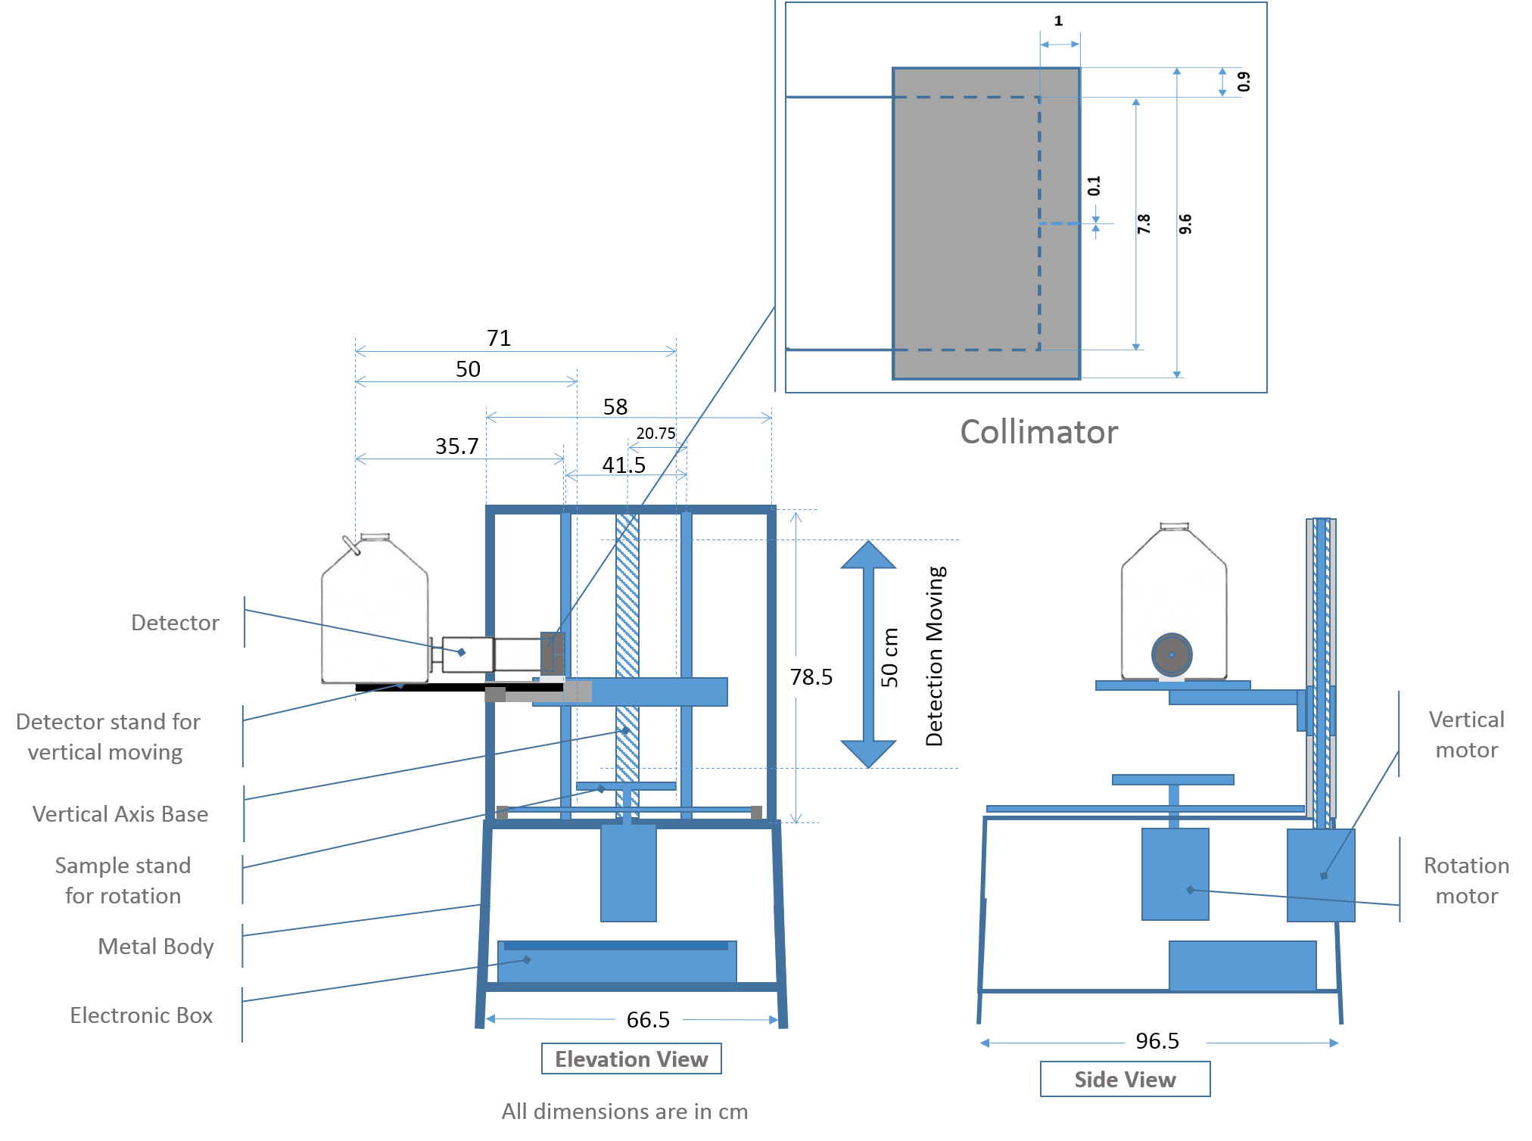

Figure 1. General view of the used SGS system [11]

2.1. Mechanical subsystem
The mechanical subsystem accommodates sample heights up to 50 cm. The detector is mounted on a motor-driven platform supported with a lead collimator around the detector. The sample is positioned on a handle. The angular displacement is controlled by the operator and may be continues or discrete. The handle accommodates sample with diameter 27.5 cm. This subsystem includes two motors: a stepping motor for vertical motion and another one for sample handle rotation. Both motor motions can be controlled via an assay software. Figure (2) illustrates the screen interface which used to insert the movement values; either vertical or rotational.
Mechanical system takes 25 seconds to move vertical distance of 1 cm and it takes 12 seconds to complete the full circle.

2.2. Detector subsystem
This subsystem includes: a high- resolution planar Ge-detector [Canberra; model GL0515R], Pre-Amplifier [model 2002 CPSL], a Cryostat [model 7905 SL-5], a portable Multi-channel Pulse-Height Analyzer and an adjustable high voltage power supply [HV-PS].
The main function of the collimator is to segregate the sample to several horizontal segments. The collimator should also serve as a shield against unwanted background radiation. To ensure maximum detector efficiency, the vertical dimension of the collimator should be at least as large as the actual diameter of the detector crystal.
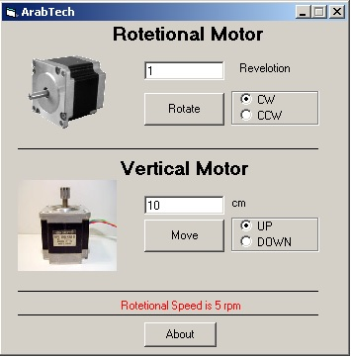

Figure 2. Interface screen for specifying vertical or rotational movement steps [11]

3. Experimental setup and calculations
3.1. Experimental setup
Specific gamma ray energies, which are signature for ²³⁵U isotope, is measured for NM samples contain targets with random distribution inside the container. Each target has uranium aluminide core lined with aluminum cladding ( 7 g U total, 19.75% ± 0.2% U-235). Figure (3) shows the target and uranium core dimensions within it.
The assayed samples are plastic containers (32 cm height and 11.6 cm diameter) having cylindrical shape and containing different number of targets.
The experimental work is performed via two phases for scanning of each sample; the first phase is performed for the upper half of the sample, while the second phase is dedicated to the lower half of the sample. In the upper half of the sample, the Mechanical movement of the system has been made through the following steps: The sample is placed on the mechanical system in three views:
Firstly: cylindrical plastic sample is placed in away that the detector views it from its side along array normal to the sample centerline (sample axis of symmetry is perpendicular to axis of symmetry of the detector as shown in Figure (4a)).
- In order determine the target face, the system is moved irregularly (vertical and rotational) during the value of steps. The target face side is that 90 degree after the side of the least count. Label has been placed to distinguish the target face.
- After the target face has been determined, the system has to be moved vertically in an irregular way ​​from the side of the target fed, to determine the length as a primary value. Two marks have been put to distinguish the beginning and the end of the initial length.
- After determining the primary length, the system movement is increased by 0.01 cm for each step.
- Mechanical system continues to move by 0.01 cm at every step until the mark of beginning of the primary length, and then the system was moved by 0.1 cm till near the end of the primary length. Near the end of the initial length (second mark at the end of the primary length), the movement of the system becomes 0.01 cm in every step and this movement continued to the end of the primary length. After each step, 90 to 100 seconds were waited before the start of the next step to observe the different counts in every step.
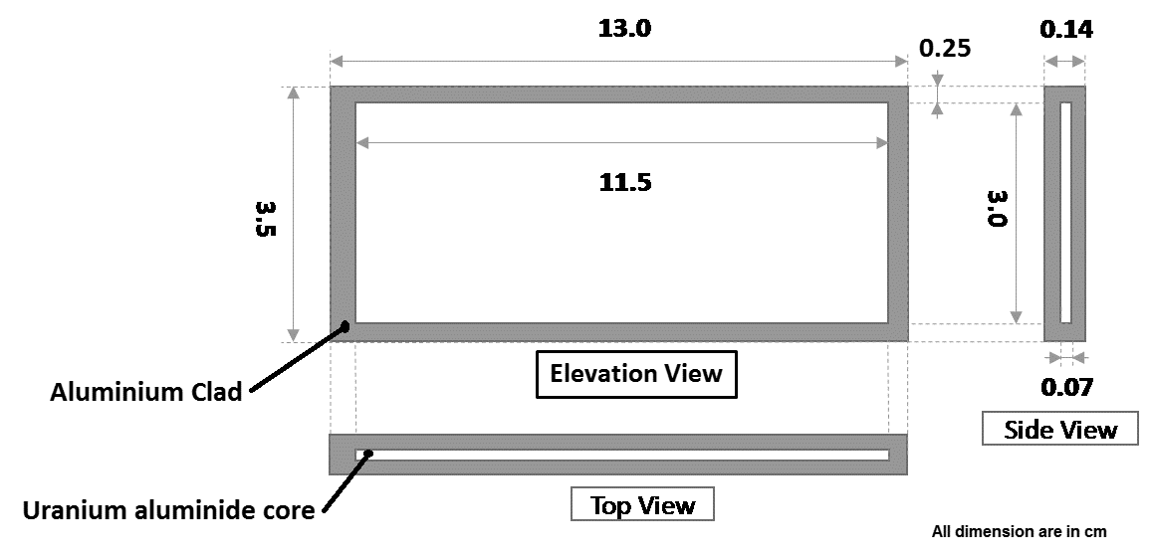

Figure 3. Target and uranium core dimensions

Secondly: the sample is placed in front of the detector so that the axis of symmetry of the sample was adjusted to be in coincidence with the extended axis of symmetry of the detector, as shown in Figure (4b).
System was moved in a systematic way from the bottom to the top and from top to bottom along the diameter of the container to identify each target thickness and determine the space between targets.
Thirdly: the detector views the sample from the side along a ray normal to the sample axis and centered along the sample length as shown in Figure (4c).
- As usual, the mechanical system is moved vertically and irregularly to determine the width in an elementary way. Distinct signs are placed at the beginning and end of the primary width.
- As usual also, the movement of the mechanical system at the beginning and the end of the primary width is increased by 0.01 cm; the movement of the mechanical system is increased by 0.1 cm between the initial width marks.
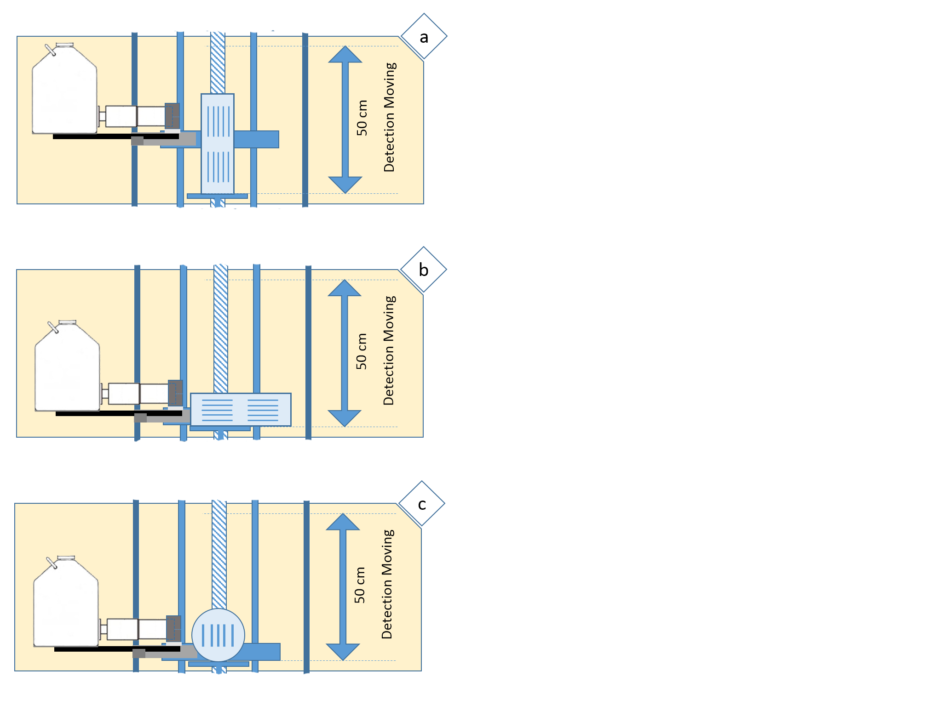

Figure 4. Sample views in the system

In the lower half of the sample, the previous steps are done with the same procedures.
A single piece of depleted uranium metal is used to determine NM samples characteristics. It has a rectangular shape, weighted 69.69 g with 0.2 % enrichment and its dimensions is (6.12 cm as length, 1.92 cm width and 0.32 cm thickness).
At first view, the sample is fixed on SGS in such a way that the axis of symmetry along the sample length was adjusted to be perpendicular with the extended axis of symmetry of the detector and the sample-to-collimator distance was 2.5 cm.
Second view, the detector views the sample from the side along a ray normal to the sample axis and centered along the sample length.
The experiments are performed by adjusting the experimental setup in such a way that errors due to electronic losses are minimized (dead time did not exceed 2 %). Figure (5) shows the experimental setup configuration for measuring depleted NM sample.
In first view, SGS is used to measure the sample at different points along the sample length, the measurements were started from near of the beginning of the sample and the detecting system is moved to lower coaxial points until the end of the sample length. A total measuring life time was about 223.303 hours.
At second view, SGS is used also to measure the depleted NM sample at different points along the sample thickness. The count rate becomes very low, so NaI detector is used for this measurement. This subsystem is composed of a portable scintillation assembly based on a Miniature Multi Channel Analyzer model (MCA-166) with a NaI (Tl) detector model (12S12-3.VD.PA.003) with dimensions (76.2 x76.2 mm) and an Aluminum housing of 1mm thickness. The detector resolution is 6.5% at 662 KeV at (¹³⁷Cs) gamma ray energy. The data acquisition was carried out via gamma spectroscopy software based on ORTEC WinSPEC software. The measuring life time is optimized in two views to achieve good statistics.
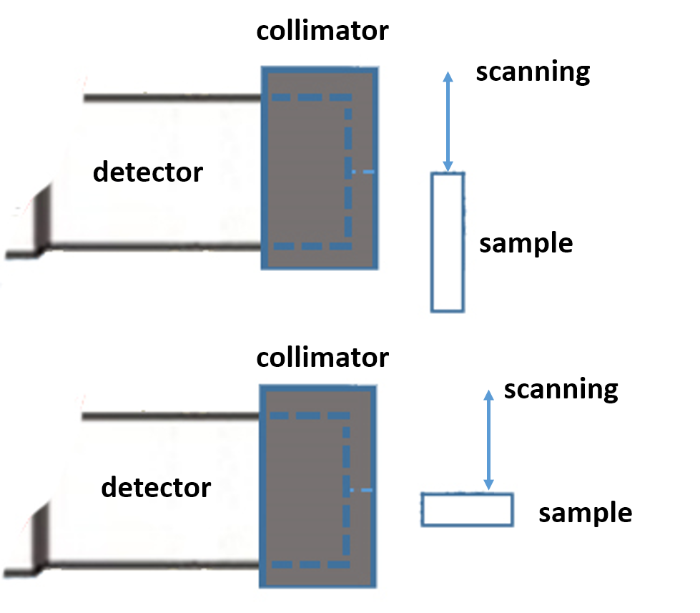

Figure 5. The experimental setup configuration for measuring depleted NM sample

3.2. Calculations
MCNP code is used to perform numerical simulations for depleted NM measurements, taking into consideration the energy of the emitted gamma ray. MCNP input files contain detailed characteristics of the detector's dimensions, sample's dimensions, the experimental setup configuration to calculate the absolute full energy peak efficiency of the detector at a certain sample - detector distance.
The general form of the net counting rate (C_{R}) in a gamma-peak of certain energy due to any radioactive isotope ( if the measuring system is optimized in order to minimize the effects of electronic losses and background) can be given as follows:

C_{R} = M₂₃₈. S_{a}. ε_{ab} (1)

Where:
M₂₃₈ is the mass of ²³⁸U in grams,
ε_{ab} is the absolute full energy peak efficiency of the detector at the measured gamma energy.
S_{a} is the specific activity of the measured gamma-photons with specified energy g⁻¹s⁻¹.
46 and 22 MCNP input files are designed for the first and second view respectively to perform the calculations. Each file contains 13 and 8 cell, 30 and 17 surfaces and 1 tally for first and second views respectively. The number of histories was selected to keep the relative standard deviation due to MCNP calculations less than 2%. The calculations were performed on Pentium (4) 3.00GHz processor. Each run of calculation was performed using 6× 10⁷ numbers of histories and the total time of calculations were about 115 hs for first view and was about 24.20 hs for second view.
4. Results and Discussion
4.1. measured containers
Three scanned containers containing different number of fuel targets with varying distribution in each container. These containers are illustrated in Figures (6).
It can be seen that, the number of fuel target in each container and their target distribution are as follows, sample1 (S1) contains 9 fuel targets, sample2 (S2) contains 6 fuel targets and sample3 (S3) contains 10 fuel targets.

4.2. Measured dimensions of simulated target
For the depleted NM sample used to simulate the fuel target, the results of the scanned sample along its length are given in Figure (7).

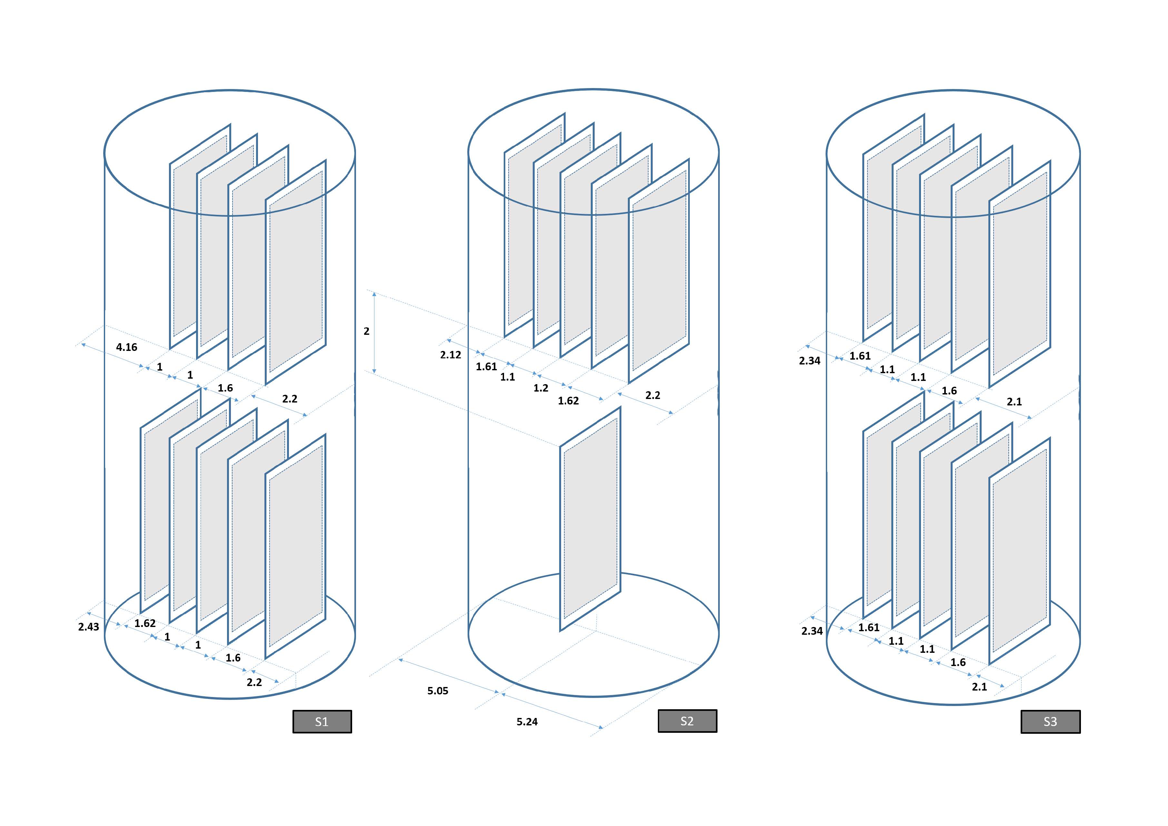

Figure 6. The number and distribution of the Fuel targets in containers
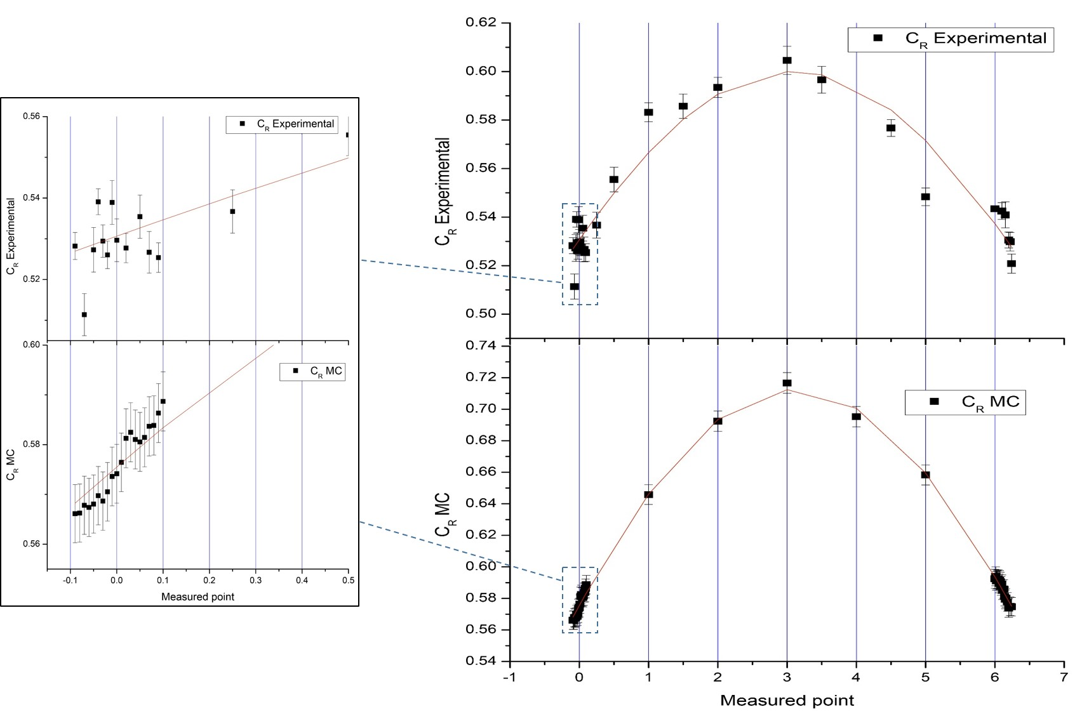

Figure 7. Count rate with the measured points

The absolute full energy peak efficiency of the detector has been calculated using MC simulation. C_{R} for the investigated sample is obtained from equation (1).
Fig (7) illustrates also the calculated count rate with the measured points along the length of the sample.
From MC figure, the start and end points of the sample are known. By comparing the MC figure with the experimental figure, the start and end of the sample can be determined.
As shown in Figure (7), the measured point “-0.05” means that the begin of sample in front of the edge of collimator, after this point the sample starts to enter in the collimator. Measured point “6.22” the end of sample in front of the other edge of collimator and the sample begin to go far away from collimator.
For second view, the absolute full energy peak efficiency of the (NaI) detector that calculated from MC simulation, C_{R} for the investigated sample is obtained from equation (1). The experimental and calculated count rate as function of measured point are illustrated in Figure (8). Also it illustrates the sample position in the measured point “0” (center of collimator), the whole sample inside the collimator.

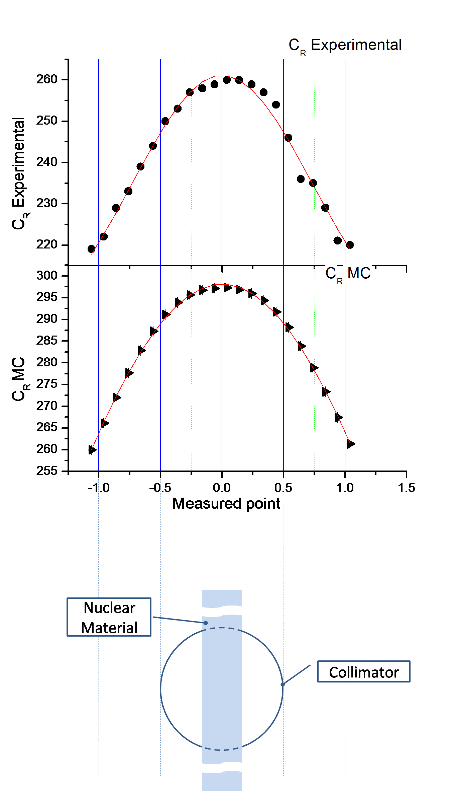

Figure 8. Experimental and calculated count rate as function of measured point and the sample position in collimator

From Figure (8), the measured point “0” means that the half of the sample coincids with the center of the collimator (the whole sample inside collimator). The measured point “ -0.66” means that the upper surface of the sample in front of the lower edge of collimator and below this point the sample starts to go far away from collimator. The measured point “0.34” means that the upper surface of the sample coincids with the upper edge of the collimator (the whole sample inside collimator) and upper this point, the sample starts to go far away from the other side of the collimator.

5. Conclusion
A Tomographic gamma scanning system has been used as a Segmented Gamma Scanner (SGS) to measure the characteristics of some heterogeneous nuclear material (NM) samples. The samples were assayed without recourse to open their containers. The used technique could minimize labor time for verification of such samples, protects them from damage and minimizes radiation exposure during inspections activities.
The sample characteristics could be used in numerical methods (like Monte Carlo calculation) to verify such heterogeneous samples via absolute non destructive techniques.

Corresponding Author:
Prof. Dr. Ahmed G. Mostafa
Faculty of Science
Physics Department
Al-Azhar University, Nasr City, Cairo, Egypt
E-mail: drahmedgamal@yahoo.com

References
- J.A.Suarez, G.Pina, C.Perez and A.Morales , European Safeguards Research & Development Association (ESARDA) symposia,(2003).
- K. E. Morris, S. K. Smith, S. Gailey, D. R. Nakazawa and R. Venkataraman, WM Conference, February 26 – March 1, (2012), Phoenix, Arizona, USA.
- H. E. Martz, D.J. Decman, G. P. Roberson and F. Levai, International Symposium on Safeguards, October 13-17, (1997), Vienna.
- Tran Quoc Dung, Progress in Nuclear Energy, 33, (1998), 403.
- Nabil Menaa, Dante Nakazawa, Haori Yang, Susan Kane Smith, David Petroka and Marcel Villani , WM ’10, March 7- 11, (2010), Phoenix, AZ.
- Ramkumar Venkataraman, Macel Villani, Stephen Croft, Patricia McClay, Robert McElroy, Susan Kane, Wilhelm Muller and Robert Estep, Nuclear Instruments and Methods in Physics Research A ,579, (2007) 375.
- A. Ravazzani, A. Foglio Para, R. Jaime, M. Looman, P. Peerani, P. Schillebeeckx and U. Weng, Journal of Nuclear Material Management, 33, (2005),10.
- A. Ravazzani, A. Foglio Para, R. Jaime, M. Looman, P. Peerani, P. Schillebeeckx and U. Weng, European Safeguards Research & Development Association (ESARDA) symposia, (2003).
- G. Patrick Roberson, Harry E. Martz, Daniel J. Decman, Jessie A. Jackson, DeLynn Clark, Richard T. Bernardi and David C. Camp, 6th nondestructive assay waste characterization conference, November 17-19, (1998), salt lake city.
- P. FiIß, G. Caspary and R. Odoj, European Safeguards Research & Development Association (ESARDA) symposia, (2003).
- M.Darweesh, W. El-Gammal, W.I.Zidan, E.A. Badawi and Atef.E.Ali, international symposium on safeguards; linking strategy implementation and people, October 20-24 (2014), IAEA, Vienna.

2/15/2015

