Effect of transition metals dopants on the Thermoluminescence Properties of Lithium Borate Glass System

H. S. Hafez ¹, H.M. Essa ¹, M.M. Alokr ² and A.M. Moanes ²*

^{1.} Rad. Protection Dept., NRC, AEA, Cairo, Egypt
^{2.} Physics Dept., Faculty of Science, Al-Azhar University, Cairo, Egypt
*drmoneep@yahoo.com

Abstract: The influence of dopants Ti and V on the thermoluminescence (TL) properties of lithium borate glass (LB) is reported in the present article. Glassy system of composition 70 H₃BO₃ – (30-x) Li₂CO₃: x ( TiO₂ or V₂O₅ ) with x ranging from 0.2 to 1.0 (in mol%) for TiO₂ and from 0.1 to 0.5 (in mol%) for V₂O₅ was prepared by convention melt quenching method. The samples were exposed to different γ-ray doses in the range of 1–10 Gy and their thermoluminescence signals (TL) were recorded in the temperature range from 50 to 400 °C. It was observed that the optimum concentration which enhanced the (LB) were 0.6 mol and 0.2 mol of TiO₂ and V₂O₅ respectively. The glow curves of the two series LB:Ti and LB:V have two overlapped peaks at 373, 377 and 375, 377ºC respectively. The TL response of the principal peak exhibited linear increase with the dose. The comparison of TL response of the studied glasses with that of LiF:Mg,Ti (TLD-100) indicates an improvement in the dose response in terms of linearity and low sensitivity for measurement of doses.
[Hafez HS, Essa HM, Alokr MM aand Moanes AM. Effect of transition metals dopants on the Thermoluminescence Properties of Lithium Borate Glass System. Nat Sci 2015;13(5):119-122]. (ISSN: 1545-0740). http://www.sciencepub.net/nature. 16

Keywords: Thermoluminescence; LB glasses; Sensitization

1. Introduction
Generally, thermoluminescent dosimetry (TLD) has become a reliable and promising method used in ionizing radiation-dose measurements [1–5]. Nowadays there are a many materials in use for TLD, among them the glassy matrix structure, which represents a potentially attractive systems due to their outstanding properties such as their good thermal stability, having a tissue equivalent identity, relatively low cost, easily prepared and shaped, good ability to host luminescent activators in elevated concentrations and an increasing possibility of providing optical fibers that are used in manufacturing by dimensional detectors. Many efforts have been devoted to develop tissue equivalent appropriate glassy scintillator materials for the use in ionizing radiation measurements. The interaction of X-and γ-rays with glasses leads to the release of electrons by Compton inelastic scattering. The resulting electrons or holes may be preferentially trapped in the structural defects generated by radiation, where new electronic configurations are resulted and lead to cause selective light absorption due to the color center formation [6–8]. Luminescence studies of undoped and doped borate glasses were discussed in references [9–12].Several attempts to improve TL response were carried out on glass materials by adding different transition and rare earth metal ions to these glasses [13–18]. Many efforts have been devoted to develop tissue equivalent appropriate glassy scintillator materials for the use in ionizing radiation measurements. In the present paper glass system both un-doped and doped with V₂O₅ or TiO₂ were synthesized and studied the thermoluminescence and structural properties.

2. Experimental
Samples were prepared by mixing stoichiometric amounts of boric acid, lithium carbonate and then titanium oxide or vanadium oxide were added to the mixture as a dopant. All the reagents were of high purity (at least 99.99%); they were obtained from Sigma-Aldrich (Germany). To achieve high homogeneity, the components were mixed mechanically for 40 min and then placed into an alumina crucible. The mixture was heated in an electrical furnace at ∼1200 1C for 60 min. This procedure yields high quality glasses of the prepared compositions: 70 H₃BO₃ – (30-x) Li₂CO₃: x ( TiO₂ or V₂O₅ ) with x ranging from 0.2 to 1.0 (in mol%) for TiO₂ and from 0.1 to 0.5 (in mol%) for V₂O₅ is chosen.
The resulted glasses were transparent. Their transparency varied with the dopant concentration. Density was measured by the traditional method using Archimedes principle. Samples in powder form were kept in dark containers to avoid exposure to light before, during and after irradiation. Gamma irradiation was performed in air using a 137Cs gamma source of dose rate13.29Gy/h. The detailed compositions are as show in table 1.
TL measurements were taken with a Harshaw TLD Reader Model 3500 (USA) at the Secondary Standard dosimetery Laboratory (SSDL)

of the Malaysian Nuclear Agency. Thermoluminescence was measured at a heating rate of 5 ºC s⁻¹ and in the temperature range 50–400 ºC. A continuous nitrogen flow was used to reduce chemiluminescence .The dosimeters were in opaque covers before, during and after the irradiation to protect them from light. Measurements were started 24 h after irradiation to eliminate the signals from shallow traps .All the necessary calibrations and quality assurance measurements were performed to obtain precise and consistent results .Each experimental data point below represents the average of three to five measurements .The reader was calibrated with LiF,Mg and Ti(TLD-100) irradiated under the same conditions.

Table 1. Glass compositions Systems
Series 1 | Series 2
T0: 70 H₃BO₃ –30 Li2CO3  T1: 70 H₃BO₃ –29.8 Li₂CO₃ :0.2 TiO₂  T2: 70 H₃BO₃ –29.6 Li₂CO₃:0.4 TiO₂  T3: 70 H₃BO₃ –29.4 Li₂CO₃:0.6 TiO₂  T4: 70 H₃BO₃ –29.2 Li₂CO₃:0.8 TiO₂  T5: 70 H₃BO₃ –29.0 Li₂CO₃:1.0 TiO₂ | V0: 70 H₃BO₃ –30 Li₂CO₃  V1: 70 H₃BO₃ –29.9 Li₂CO₃:0.1 V₂O₅  V2: 70 H₃BO₃ –29.8 Li₂CO₃:0.2 V₂O₅  V3: 70 H₃BO₃ –29.7 Li₂CO₃:0.3 V₂O₅  V4: 70 H₃BO₃ –29.6 Li₂CO₃:0.4 V₂O₅  V5: 70 H₃BO₃ –29.5 Li₂CO₃:0.5 V₂O₅

3. Results and Discussion
Figure (1) shows the TL responses of Li₂CO₃–H₃BO₃ (LB) doped with the transition metals in question and irradiated with test dose 5Gy. The sensitivity of LB:Ti material increased with the increasing Ti concentration until 0.6 mol and start to decrease again. While LB:V sensitivity is increased 0.2 mol and decreased again. For both the modalities, the optimal concentrations for TiO₂ and V₂O₅ was found to be 0.6 mol% and 0.2 mol % respectively The decrease in intensity may be due to the large number of trap energy levels, which is most likely generated by non-radiative events. The luminescence efficiency of a phosphor µ is related to the probability of a luminescence transition Pr and the probability of a non-radiative transition Pnr by
µ = Pr/(Pr + Pnr) [19].
Figure (2) represents the characteristic glow curves of LB glass after exposed to 10Gy of gamma ray, in this figure we can see that LB glass has one peak at (360 °C) but after doping of LB with TiO₂ or V₂O₅ the shape of glow curve and peak position change as shown in Fig 2. In this figure we can see that the characteristic glow curves has two TL peaks appeared at (373 and 377°C) and (370 and 375°C) for LB:Ti and LB:V respectively. From this this figure it is observed the area under curves for doping sample increase than that of sample plank.
Figure (3) shows the effect of changing in LB:Ti or V concentration on the TL-sensitivity of (LB) exposed to different dose of gamma ray . From the figure it can be seen that. as the concentration of Ti and V increase the peak height increase until reach concentration 0.6 mol% of TiO₂ and 0.2 mol % for the V₂O₅ after which the peak height decreases, this mean that the optimum concentration of TiO₂ is 0.6 mol% and 0.2 mol % for the V₂O₅.
Figure (4) represents the effect of titanium and vanadium concentration on the TL-intensity of LB glass after exposed to test dose 5Gy. It can be observed that the optimal concentration of TiO₂ is 0.6mol% and V₂O₅ is 0.2mol%.
Figure (5) shows the linear dependence of TL intensity on γ-dose for both cases. The obtained data were compared with that of TLD-100 Figure. 6 as reference dosimeter. The comparison reveals that the sensitivity of the prepared samples is less than that of TLD -100. On other hand the prepared samples show a linear dependence up to 10Gy which is convenient for measurements.

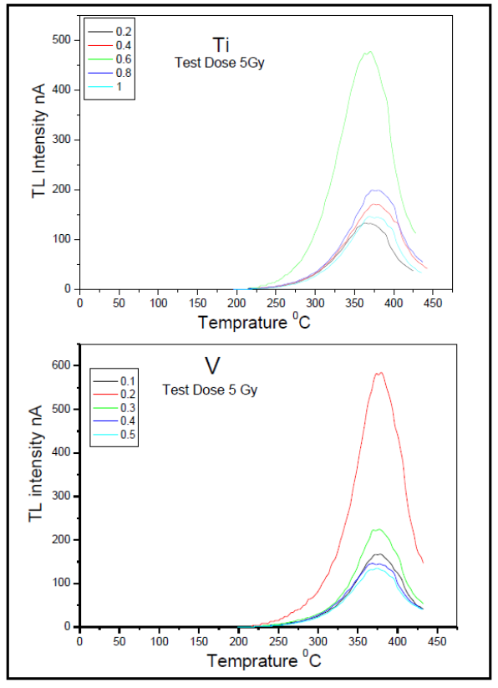

Figure 1. TL glow curves of the doped LB glasses irradiated to 5Gy a (TiO₂) , b (V₂O₅)

Figure 2. The characteristic glow curve of (a) LB:Ti (0.6 mol %) and (b) LB:V (0.2 mol %)

Figure 3. The effect of changing in concentration on the TL-sensitivity of LB:Ti (a) and LB:V (b) exposed to different dose of gamma ray

Figure 4. Effect of concentration ratio of LB:Ti and LB:V on the TL-sensitivity exposed to 10Gy of γ ray
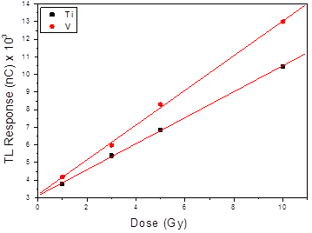

Figure 5. TL response of (a) LB:Ti and (b) LB:V to radiation doses

4. Conclusion
The present study reveales properties of the TL response of the two dosimetric materials, namely, LB:Ti and LB:V. Different concentrations of Ti and V were added to Lithium Borate Glass, the result shown the optimum concentration of system LB:Ti is 0.6 mol% and of system LB:V is 0.2mol% . The responses of both of them depend linearly on the γ-dose range 1 –10 Gy. The sensitivity of LB: V to dose is higher than that the sensitivity of LB:Ti. Respectively the investigated materials hold promise in various fields of radiation dosimetry, TL response of the studied glasses with that of LiF:Mg,Ti (TLD-100) indicated low sensitivity for the measurement of doses.

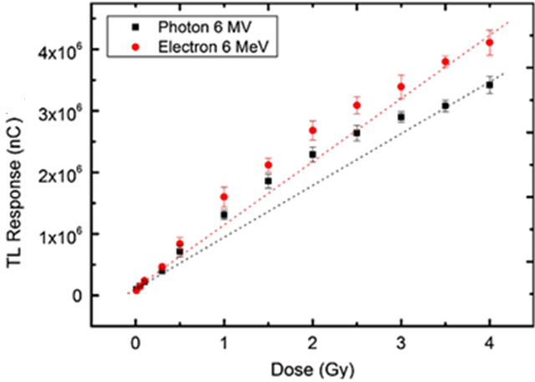

Figure 5. TL response of TLD-100 to radiation doses

Corresponding Author:
Dr. A.M. Moanes l
Physics Department
Faculty of Science
Al-Azhar University, Cairo, Egypt
E-mail: drmoneep@yahoo.com

References
- McKeever, S.W.S., 1989. Thermluminescence of Solids. Cambridge, University Press.
- Hussein, A., Higazy, A.A., Sayed, A., Sharaf, M.M., Mansy, M., 1989. Thermo- luminescence response of magnesium phosphate glass to gamma radiation. Radiat. Eff. Def. Solids 110 (3), 367–374.
- Justus, B.L., Huston, A.L., Johnson, T.L., 1996. Laser-heated radiation dosimetry using transparent thermoluminescent glass. Appl. Phys. Lett. 68 (1), 1463–1468.
- Mansy,M.,Hussein,A.,Higazy, A.A.,Sayed, A.M., Sharaf, M.,1998. The MgO–P2O5 glasses as thermoluminescent gamma dosimeters. Radiat. Eff. Def. Solids 1451,115–121.
- Ranjbar, A.H., Durrani, S.A., Randle, K., 1999. Electron spin resonance and thermoluminescence in powder form of clear fused quartz: effects of grinding. Radiat. Meas. 30, 73–81.
- El-Sersy, A.R., Khaled, N.E., 2004. Use of optical properties of LiF in radiation protection dosimetery. Radiat. Eff. Def. Solids 159, 439–445.
- Bishay, A., 1970. Radiation induced color centers in multicomponent glasses. J. Non- Cryst. Solids 3, 54–114.
- Friebele, E.J., Griscom, D.L., 1979. Treatise on Material Science and Technology. In: Doremus, R.H., Tomozawa, M. (Eds.), Academic Press, New York.
- Srivastava,J.K.,Supe,S.J.,1989.Thermoluminescence characterization of Li2B4O7 doped with Cu. J. Appl. Phys. D22,1537–1543.Moustafa
- Martini, M., Furetta,C., Sanipoli,C., Scacco,A., Somaiah, K., 1995. Spectrally resolved thermoluminescence of Cu and Eu doped Li2B4O7. Radiat. Eff. Def. Solids 135,133–136.
- Pontuschka, W.M., Kanashiro, L.S., Courrol, L.C., 2001. Luminescence mechanisms for borate glasses: the role of local structural units. Glass Phys. Chem. 27, 37–47.
- VenkateswaraRao,G.,Reddy,P.Y.,Veeraiah,N.,2002.Thermoluminescence studies on Li2O–CaF2–B2O3 glasses doped with manganese ions. Mater. Lett. 57, 403–408.
- Takenaga, M., Yamamoto, O., Yamashita, T., 1983. Anew phosphor Li2B4O7: Cu for TLD. HealthPhys. 44,387–393.
- C. Ivascu, I.B. Cozar, L. Daraban, G. Damian, J. Non-Cryst. Solids 359 (2013) 60.
- R. Takam, E. Bezak, G. Liu,L. Marcu, Radiat. Prot. Dosim. 150 (2012) 22.
- Y. Sheng, L. Yang, H. Luan, Z. Liu, Y. Yu, J. Li, N. Dai, J. Nucl. Mater. 427 (2012) 58.
- A. Kutub, M.S. Elmanhawaawy, M.O.Babateen, Solid State Sci. Technol.15 (2007) 191.
- S.S. Rojas, K. Yukimitu, A.C. Hernandes, Nucl. Instrum. Meth. Phys. Res. B 266 (2008) 653. Chem. 27 (2001) 37.
- Mckeever, S., 1985. Thermoluminescence of Solids. Department of Physics, Oklahoma state university, Cambridge University press.

4/4/2015

