Preparation and Characterization of Frick gel dosimeter

M.I. El Gohary ¹, Y.S. Shabban ², E.A. Amin ³, M.H. Abdel Gawad ¹*, O. S. Desouky ²

^{1.} Biophysics Branch, Physics Department, Faculty of Science, Al-Azhar University, Nasr City, Cairo, Egypt
^{2.} National Center for Radiation Research and Technology, Nasr City, Cairo, Egypt
^{3.} Medical Physics Unit, Ain-Shams hospital, Ain-Shams University, El-Abbasia, Cairo, Egypt
*mahmoud.hassan@azhar.educ.eg

Abstract: The gel dosimeter is one of methods that can be used for the measurements of radiation doses in medical uses (radiotherapy and radiodiagnosis). The transition of ferrous Fe²⁺ to ferric Fe³⁺ in Fricke dosimeter after irradiation results in a change of optical density which can be used for the dosimetry of ionizing radiation. The aim of this work is to characterize the Frick gel dosimeter or Ferrous-Xylenol-Gelatin (FXG) by measuring the total mass attenuation coefficient, absorption spectrum, dose response curve, sensitivity, energy dependency and environmental keeping conditions were measured. The FXG readings were evaluated by using the absorption mode of spectrophotometric technique. The results showed that the FXG dosimeter is tissue equivalent and has a linearity behavior in range from 1 to 15Gy, energy independent and stable in temperature less than or equal 10˚C.
[El Gohary MI, Shabban YS, Amin EA, Abdel Gawad MH, Desouky OS. Preparation and Characterization of Frick gel dosimeter. Nat Sci 2015;13(6):139-143]. (ISSN: 1545-0740). http://www.sciencepub.net/nature. 18

Keywords: Radiotherapy, Radiodiagnosis, Frick gel dosimeter Optical density

1. Introduction
Ionizing radiation has been used in medical (diagnosis or therapy) applications. The ionizing radiation with KeV usually used in the diagnosis applications while the beams with MeV are used in the therapy applications. The linear accelerators produced both high mega voltage X-ray (photon) and electron beams while the Cobalt 60 machine is produced only high mega voltage gamma ray. These machines mainly used in the field of radiotherapy to treat the cancer with clinical photon or gamma ray (deeper tumors) and electron (superficial tumors) beams. With the increasing use of treatment machines, a quality assurance (QA) of treatment machines has been required in order to optimize clinical results ^{(R1, R2, R3)}. The Fricke gel dosimeter or Ferrous-Xylenol-Gelatin (FXG) ^{(R4)}, is based on the oxidation of ferrous (Fe2+) to ferric (Fe3+) ions by ionizing radiation^{(R5)}, has been widely studied for application to QA of radiation treatments by allowing the three-dimensional dose distribution verification ^{(R6, R7).} The pioneers of ferrous Gel dosimeter were Fricke and Hart 1966, they discover the matrix of solution with the Xylenol Orange (XO) as an indicator into a gelatin matrix ^{[R8]}. The FXG is a Radiochromic gel and represent as a radiosensitive chemical formula that is used for radiotherapy measurements so that, according to the quantity of radiation, a chemical reaction of an oxidation take place leading to a converting from ferrous ions (Fe²⁺) into ferric ions (Fe³⁺) ^{[R9]}. A complex bond between Fe³⁺ and XO (XO–Fe³⁺) leading a change in color of the transparent gel medium when it is exposed to ionizing radiation ^{[R10]}. This work aims to highlight the preparation of FXG to be used as alternative dosimeter in poor clinical oncology sites. Other aim of this work is to characterize the chemical dosimeter by measuring the spectral analysis to determine the relationship between the optical density and absorbed dose by using absorbance mode of a spectrophotometer system ^{[R11]}. A tissue equivalent wax phantom was used to rise up the absorbed dose in the FXG dosimeter. The dosimetric wavelengths, total mass attenuation coefficient, dose response curve energy and dose dependent response, sensitivity and keeping were evaluated for clinical beams.

2. Material and Methods
2.1. FXG Chemicals
The chemical kits which are used in this study are listed in table (1). As shown in table (1), these chemical kits are the basic concentrations of Frick gel.

2.2. Polymethyl methacrylate (PMMA) cuvettes
The FXG dosimeters were conditioned in disposable Polymethyl methacrylate (PMMA) cuvettes with the following characteristics: two parallel optical faces, 10 mm of optical path length and of dimensions 10×10×45 mm³. The cuvettes were sealed with parafilm and placed in a refrigerator for about 24 hrs, in order to obtain solid and stable gel samples for the spectrophotometric reading; The very important note that the Preparation procedures generally affect the system performance; therefore, a defined protocol for manufacturing the dosimeter material is required to be followed consistently ^{[R12]}.

Table 1. Chemical kits of Frick gel
 | The name | Symbol | Molecular weight [g/mol] | Concentration  [mM]
1 | ferrous ammonium sulphate hexahydrate | Fe(NH4)₂ (SO4)2.6H2O | 312.12 | 1
2 | Gelatin from porcine skin | C₁₇H₃₂N₅O₆ | 402.47 | 124.38
3 | Xylenol Orange | C₃₁H₂₈N₂Na₄O₁₃S | 760.58 | 0.1
4 | Sulphuric acid | H₂SO₄ | 98.07 | 50

2.3. Wax Phantom
The In this study, fabricated phantoms are made from wax to be used in the experimental work. The density of this phantom is 0.982 gm/cm³. Two fabricated phantoms are designed. One is designed as a buildup region to calibrate the gel samples. The dimensions of this phantom is (10x10x10 mm) with two parts, upper and lower, the lower part has a cavity to by suitable to three samples of gel (Fig. 1).

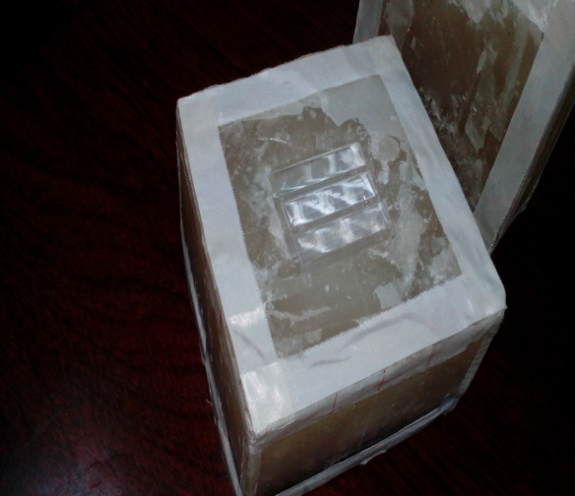

A

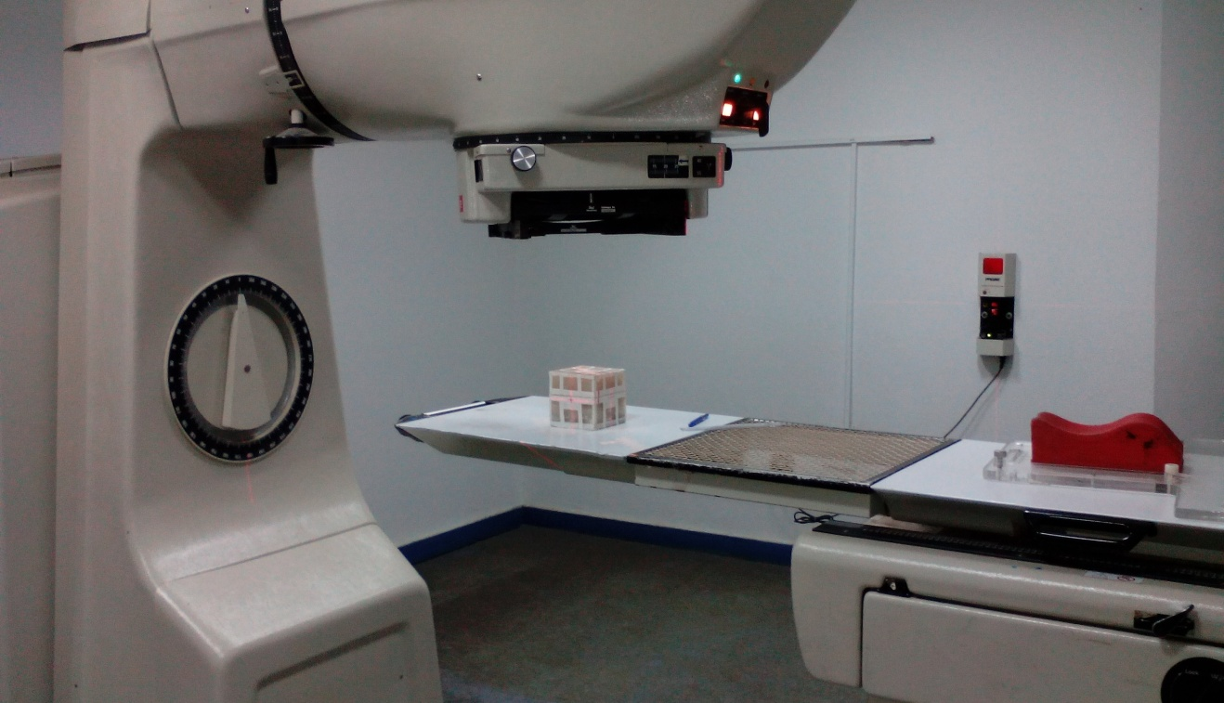
B
Figure 1. The cubic phantom (A) the two parts of wax phantom, (B) the phantom at the top of cobalt60 treatment machine.

2.4. Irradiation sources
The PHOENIX Theratron®, Cobalt-60 radiotherapy machine was used to irradiate the FXG dosimeter to measure the spectral analysis and remaining measurements. Precise Elekta® Linear Accelerator “Linac” (Elekta Oncology System, Crawley, UK) is another treatment machine used to measure the energy dependence for different quality of energies. Both machines were calibrated using IAEA– TRS 398 protocol ^{[R1]}, with a calibrated ionization chamber. The irradiated plan is made to irradiate the FXG by using four fields with four angles (0, 90, 180 and 270), each field has collimator (0 angle) and fixed square field size (10x10 cm²) at Source-to-Axis Distance (SAD) equal 80 and 100 cm for cobalt and linear accelerator respectively. Usually, the irradiation was done after one day or a few hours from the preparation of FXG ^{[R13]}.

2.5. Optical Density measurements
The spectrum analysis and optical density of FXG was measured using double beam SPECORED® spectrophotometer in the wavelength range 300-1100 nm. It was operated in absorbance mode, and changes of optical density in 1 cm path length.

2.6. FXG preparation
There are two major parts in FXG, the gelatin water mixture which provides 80% of the final volume, and the active chemicals that make up the other 20%. The Gelatin powder was mixed with Deionized water and are heated in water bath at 40 ˚C and left for about 15 min to be absorbed. Then the water– gelatin mixture was heated and continuously stirred with a magnetic stirrer until the powder was completely dissolved, giving clear solution at about 45 ˚C. After mixing, the chemicals part are prepared by adding Sulphuric acid (H₂SO₄), then the ferrous ammonium Sulphate hexahydrate [Fe(NH4)₂(SO4)2.6H2O] is dissolved in the acidic water and finally Xylenol orange [C₃₁H₂₈N₂Na₄O₁₃S] is added ^{[R14]}

2.7. Calculation of total mass attenuation coefficient
The recently studies are related to the total mass attenuation coefficient (μ/ρ) curve of multi element materials for multi energetic photon beams ^{[R15], [R16]}. In the present study, the μ/ρ curve for the FXG was calculated for different photon energies. The aim of the calculations is to discover the radiological properties of gel dosimeters by compare its radiobiological parameter (i.e μ/ρ) against the μ/ρ of water to check if it is a tissue equivalent or not. There are many ways to calculate the μ/ρ of the given materials for different radiation sources. Win X-Com computer program is a software program used online to calculate the μ/ρ. In this study the Win X-Com has been used to calculate the μ/ρ of the FXG materials at energies from 1keV to 100 GeV ^{[R17]}.

2.8. Pre-irradiation keeping condition
The FXG was keeping in three different conditions to study the effects of these conditions on the stability of FXG before the irradiation process. These conditions are: (a) Refrigerator condition “Dark room with about 7 to 10 ˚C”, (b) Dark room condition “light isolation with about 22 to 25˚C”, and (c) opening light condition “direct light with about 22 to 25˚C”. The effect is monitoring by evaluate the color change by using the absorption of spectrophotometer at wavelength 580 nm. The aim of this experiment is to determine the best condition of FXG keeping before the irradiation process.

2.9. Dose response and energy dependence
By using the spectrophotometer system, the dose response curve of irradiated FXG was measured. The dose response curve is a relationship between the absorbance change (cm⁻¹) and the absorbed dose (Gy). The sensitivity and the energy dependence were measured for different irradiated energies (Gamma with about 1.25 MeV and Photon with 6 &15 MeV).

3. Results and Discussion
3.1. Total mass attenuation coefficient
By using the Win X-COM program, figure 2 shows the total mass attenuation coefficient μ/ρ for FXG dosimeter.
Figure 2, Illustrates the total mass attenuation coefficient in the FXG using Win X-COM program. The photoelectric absorption and coherent scattering are decreased with the increasing of photon energy, while only the pair production is increasing with the increasing in the photon energy from range 1 till about 800 MeV then the effect appear with almost a saturation effect.
To check if this dosimeter is tissue equivalent or not it must to compare these results with the μ/ρ for irradiated volume of water. The figure 3, illustrate the total mass attenuation coefficient for water.
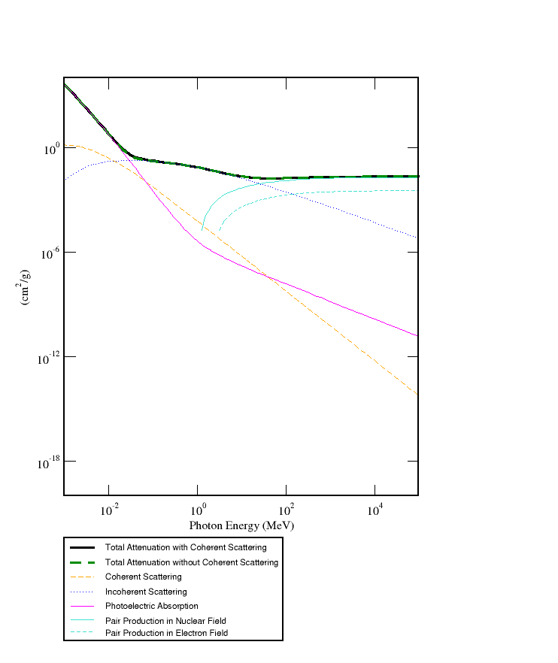
Figure 3, graphically represent that the both coherent scatter and photoelectric effect are decreased with increasing of photon energy while the pair production is increased with photon beam increase from 12 to 1000 MeV. Figure 3 almost similar to figure 2 which indicate that the same μ/ρ behavior of FXG.

Figure 2. The total mass attenuation coefficient of the FXG dosimeter
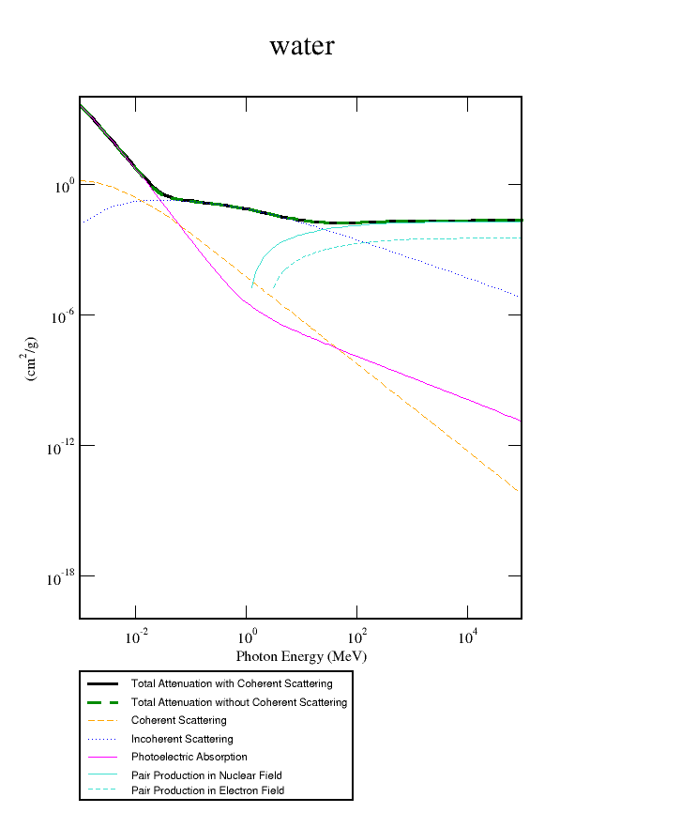

Figure 3. The total mass attenuation coefficient for irradiated volume of water

3.2. Pre-Irradiation keeping conditions of FXG
Figure 4, show the effect of three different environmental keeping conditions. The room temperature with even direct or isolated light has a high effect on the stability of FXG sample (color change reach to 464 and 967 % after 6 days of preparation in the isolated and direct light conditions respectively), while the refrigerator condition “Dark room with about 7 to 10 ˚C” has almost no effect when it is compared with other conditions (color change reach to 90 % after 6 days of preparation).

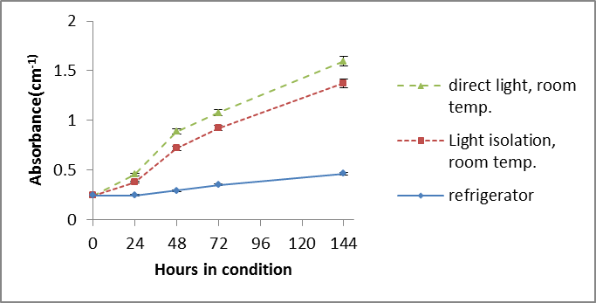

Figure 4. The effect of environmental condition on the stability of pre irradiated FXG samples

3.3. Spectrum of irradiated samples
Figure 5, illustrates the optical absorption spectra for irradiated samples by using Cobalt treatment machine with doses 1, 2.5, 4.5 and 7 Gy respectively and compared with non-irradiated samples. The Frick gel presents two absorption bands as expected: one at range from 435 to 445 nm, corresponding to Fe²⁺ ions initially present in non-irradiated FXG and other at range 575 to 585 nm, corresponding to Fe³⁺ ions generated by radiation induced Fe²⁺ ions oxidation. The band of 435 to 445 nm tends to disappear depending on the irradiated dose as the band of 575 to 585 nm is intensified with increasing dose.
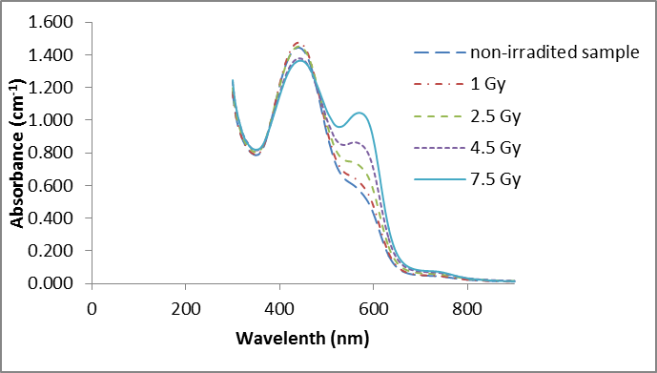

Figure 5. The absorbance spectra for irradiated samples of FXG

3.4. Change in absorbance of FXG
Figure 6, shows the spectrum of absorbance change (net absorbance). The net absorbance means the difference in absorbance (pre and post irradiation). In this figure a broad absorption peak centered around 580 nm, with the optical density increasing in proportion to the dose up to the examined dose (7.5 Gy) and decreasing with dose at about 435 nm.

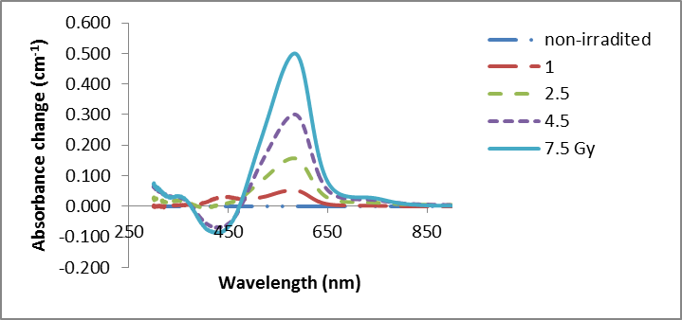

Figure 6. The net absorbance of irradiated FXG

3.5. Dose response and energy dependence
The spectrophotometric dose response curve of the Fricke gel dosimeter irradiated with Co⁶⁰ gamma radiation and absorbed doses between 1 to 15 Gy is presented in Fig.7.
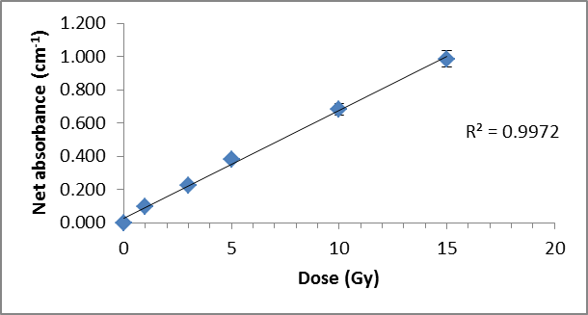

Figure 7. The dose response of FXG for gamma beam

As shown in Fig. 7. The spectrophotometric response presents a linear behavior of absorbed dose in the range from 1 to 15 Gy. The sensitivity of FXG dosimeter can be determined by calculating the slope of linear dose response, which is equal 0.0652 Gy⁻¹ cm⁻¹.
Figure 8, shows the dose response of FXG for the two photon energies (6 & 15 MeV). The absorbance change or the net absorbance presents in the X-ray the sensitivity for both 6 & 15 MeV, are equal to 0.0683 Gy⁻¹cm⁻¹ for range from 1 to 15 Gy. The sensitivity (which is mean the slope of this relations), represent almost the same value even in Gamma or X-ray beams, that is mean the FXG is energy independence.

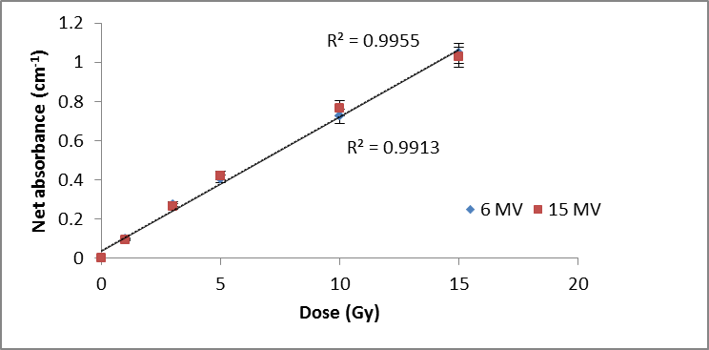

Figure 8. The FXG dose response of 6 & 15 MeV X-ray beams

4. Conclusion
- The FXG dosimeter is a tissue equivalent because the effect of radiation on the FXG is similar to the effect of radiation on the water.
- The better environmental keeping conditions for the FXG is the refrigerator condition which has about ≤ 10 ˚C.
- The peak of absorbance for the FXG was at 575 to 585 which represent the value of maximum absorption in the FXG samples.
- The FXG dosimeter has a linear behavior in range from 1 to 15 Gy.
- FXG is energy independence because the sensitivity of FXG is equal to 0.0652 Gy⁻¹ cm⁻¹ in ~1.25 MeV gamma radiation while equal 0.0683 Gy⁻¹cm⁻¹ in 6 & 15 MeV X-ray radiation.

Acknowledgements:
The authors would like to thank: Dr, Seham El Marakby, National Center for radiation Research and Technology and Moaz Mohamed, Amr hamed, Noha Roshdy, Noha A. Elsalam Medical physicists Medical physics unit, Ain-Shams hospital, Ain-Shams University, for supporting this work.

Corresponding Author:
Dr. Mahmoud Hassan Abdel Gawad
Biophysics Branch, Physics Department
Faculty of Science
Al-Azhar University, Nasr City, Cairo, Egypt
E-mail: mahmoud.hassan@azhar.educ.eg

References
- TRS 398 protocol of INTERNATIONAL ATOMIC ENERGY AGENCY Absorbed Dose Determination in External Beam Radiotherapy: An International Code of Practice for Dosimetry based on Standards of Absorbed Dose to Water. 23 April, 2004;11b.
- PODGORSAK, E.B., “External photon beams: physical aspects”, Radiation Oncology Physics: a Handbook for Teachers and Students, (PODGORSAK, E.B., Ed.), IAEA, Vienna (2005) 161–217.
- STRYDOM, W., PARKER, W., OLIVARES, M., “Electron beams: physical and clinical aspects”, Radiation Oncology Physics: a Handbook for Teachers and Students, (PODGORSAK, E.B., Ed.), IAEA, Vienna (2005) 273–299.
- Khan FH, Physics of Radiation Therapy. Lippincott Williams & Wilkins, 2010; 4th edition: 125-33.
- Davies JB, Baldock C. Sensitivity and stability of the Fricke–gelatin–xylenol orange gel dosimeter. Radiation Physics and Chemistry 2008;77:690-6.
- OLSSON, L.E., et al., Ferrous sulphate gels for determination of absorbed dose distributions using MRI technique: basic studies, Phys. Med. Biol. 34 1 (1989) 43.
- BERO, M.A., GILBOY, W.B., GLOVER, P.M., Radiochromic gel dosemeter for three-dimensional dosimetry, Radiat. Phys. Chem. 61 (2001) 433.
- Doran SJ, The history and principles of chemical dosimetry for 3-D radiation fields. Applied Radiation and Isotopes 2009;67:393-8.
- Davies JB, Baldock C. Sensitivity and stability of the Fricke–gelatin–xylenol orange gel dosimeter. Radiation Physics and Chemistry 2008;77:690-6.
- Bero MA, Gilboy WB, Glover PM. Radiochromic gel dosemeter for three-dimensional dosimetry. Radiat. Phys. Chem. 2001;61:433–435.
- Cavinato C.C., Sakuraba R.K., Cruz J.C., and Campos L.L., “Optical response of the FXG solution to different phantom materials”, Radiation Measurements, 46, 1928-1931, (2011).
- Sampaio F.G., Del Lama L.S., Sato R., de Oliveira D.M., Czelusniak C., Oliveira L.N., de Almeida A., “Quality assurance of a two-dimensional CCD detector system applied in dosimetry”, Trans. Nucl. Sci., 60(2), (2013)b.
- De Oliveira L. N., Zimmerman R. L., Moreira M. V., Ila D., and De Almeida A., “Determination of diffusion coefficient in Fricke Xylenol Gel dosimeter after electron beam bombardment”, J Surf. Coa. Technol., 203, 2367–2369, (2009).
- Davies J.B. and Baldock C., “Temperature dependence on the dose response of the Fricke–gelatin”, Radiation Physics and Chemistry, 79, 660-662, (2010).
- Murat Kurudirek, “Effective atomic numbers and electron densities of some human tissues and dosimetric materials for mean energies of various radiation sources relevant to radiotherapy and medical applications”, Radiation Physics and Chemistry , 102, 139-146, (2014).
- Vishwanath P. Singh and Badiger N.M., “Effective atomic numbers of some tissue substitutes by different methods: A comparative study”, J Med Phys, 39(1). 24-31, (2014).
- Gerward L., Guilbert N., Jensen K.B., and Levring H., “WinXCom a program for calculating X-ray attenuation coefficients”, J Radiat. Phys.Chem.,71, 653–654, (2004).

5/30/2015

