Anatomical Features of the Roots and Leaves of Hibiscus Rosa-Sinensis and Abelmoschus Esculenta

Nwachukwu C.U. *, Mbagwu F.N. **, Iwu Jane Ijeoma ***

* Alvan Ikoku College of Education., Owerri, Imo State, Dept. of Biology.
** Imo State University., Owerri, Imo State, Dept. of Plant Science and Biotechnology.
*** Dept. of Plant Science and Biotechnology, Imo State University
nwachukwucu2005@yahoo.co.uk

ABSTRACT: Roots and leaves anatomical features of Hibiscus rosa sinensis and Abelmoschus esculenta found in different parts of Imo State Nigeria were studied with the aid of a light microscope. The aim is to ascertain the taxonomic importance of roots and leaf anatomical features in establishing intraspecific relationship among these taxa. Result obtained showed presence of long chain and numerous epidermal calls in Hibiscus rosa seninsis while they are short chains small and numerous in Abelmoschus esculenta. Similarly the xylem vessels are numerous and circular in Hibiscus rosa seninsis while they are few and cuboidal in Abelmoschus esculenta. Furthermore in the leaf anatomy of Hibiscus rosa seninsis the central cells are large with dark stained calcium oxalate crystala while in Abelmoschus esculenta the mesophyll layer is made up of 3 – 4 layers of regular shaped cells. An analysis of the root and leave anatomical features studied showed that these taxa possessed vital characteristic that could be attached to other taxonomic information and used in their description hence the biosystematic implication of this finding have been discussed in the light of the current literature. [New York Science Journal. 2008;1(1):27-32]. (ISSN: 1554-0200).

KEYWORDS: Anatomy; Hibiscus rosa sinensis; Abelmoschus esculenta; Malvaceae

INTRODUCTION
The plants Hibiscus rosa sinensis and Abelmoschus esculenta belong to the Subkingdom Tracheobionta (vascular plants); Division magnoliopsida and family malvaceae Tiadak, 1979, Green sill 1976 and stern 2001).
The family malvacaea is one of the most important families consisting of 82 genera and 1,500 species with Hibiscus over 200 species, sida 200 species, ablition 190 species and malva 40 species. The family is world wide in distribution but is mostly represented in the tropical and subtropical region. Members may be herbs, shrubs or trees with mucilage.
Leaves of the family may be simple, alternate, stipulate, petiolate, palmatified (as in cotton) or multifoliate as in silk cotton. Inflorescence is solitary as in cymes though occasional they are in panicle raceme, regular polypetalous, bisexual, hypogynous, conspicuously mycilaginous, with a whorl of bracteoles known as epicalyx except in (Ablition and sida). The pollen grains are large and spiny; placentation is axile with the style passing through the staminal tube.
The fruit could be capsule in the cotton plant or a schizocarp as in Abutilon and Althaea rosea, the seed is endospermic (Vidyarthi and tripathi, 2002).
Hibiscus rosa sinensis is an evergreen shrub growing up to 2.5 inches high. It is a tender perennial plant and it prefers light (sandy) medium (loamy) and heavy (clay) soils. The plant prefers neutral and basic soils and cannot grow in shade (Burkill, 1995). Similarly Abelmoschus esculenta grows best in warm climates with a minimum temperature of 18ºc. The plant is known and called different names in Nigeria such as Okra (Igbo name) Etighi in Efik, Kabewa in Hausa and Ila in Yoruba land (Harpert 1977). It can grow up to 1.8m in height depending on the variety as long as the soil is not water logged. The stem is erect and hairy and leaves are also hairy with long leaf stalk (Azah 1968). Hibiscus rosa sinensis and Abelmoschus esculenta have been found to possess wide range of uses to mankind ranging from economic, medicinal and agronomic. The young leaves Hibiscus rosa sinensis are most times used as substitute for spinach in most parts of eastern Nigeria. The fibre is used for coarse fabrics, nets and paper making (Akroroda 1985). The essential oil in the seed has a strong antispasmodic effect and has been successfully used to ease the pains for intestine pile or kidney colic. The flower extract is used internally in the treatment of excessive and painful menstruation, veneral diseases and to promote hair growth (Burkill 1995). Abelmoschus esculenta on the other hand is also used for variety of purposes e.g., the stem is used as paper manufacturing, the unripe fruits are used as vegetable while the sauces or soup used in active cooking known as palaver in Sireerleone is got from the leaves and fruits of Abelmoschus esculenta (Greenisill, 1976).
Despite the numerous economic, medicinal and agronomic importance of Hibiscus rosa sinensis and Abelmoschus esculenta, there is absence of a clear taxonomic criteria especially in root and leaf anatomy to delineate these two taxa. The probable lack of anatomical (roots and leaf). Information on these two taxa does not make them irrelevant considering the various roles anatomy has played in taxonomic delieanation of species (Schewell 1957). Contributions on the anatomy of plants of various areas includes the works of Nwachukwu and Mbagwu, 2007 in Eight Indigofera species, Mbagwu and Edeoga in Vigna, Okoli in Telfairia. Further contributions of anatomical features in systematics are the works of Curcibitacaea and Metcalfe and chalk 1950 in selected Dicotyledons.
This investigation therefore reports the root and leaf anatomical characters in Hibiscus rosa sinensis and Abelmoschus esculenta as observed with a light microscope. This investigation further assesses the relevance of these anatomical features (root and leaf) in deducing similarities and differences among the taxa studied as well as utilizing the anatomical characters obtained from these two taxa for the systematic grouping and characterization of the two taxa.

Materials and Methods
Section of mature and fresh roots and leaves of Hibiscus rosa sinensis not longer than 1 x0.5cm each of the two taxa colleted from the cultural garden of IMSU and Songhi farms Nekede Owerri-West Local Government in Imo State were put into labeled vials and fixed in FAA (1:1:18). 40% formaldehyde, 70% ethanol v/v for at least 72 hours. These were then rinsed in several changes of distilled water and passed through different alcohol series (30, 50, 95 and 100%). The dehydrated materials were infiltrated with wax by passing through different proportions of alcohol and chloroform gradually replaced the alcohol; pure chloroform and wax were added in the bottles. The idea was to gradually infiltrate the tissues with wax which would be hard enough to microtomy. The metal mould, were later removed and the specimens within the wax cube were trimmed and section on Reichert rotary microtome at 20 – 24cm. The ribbons were placed on clean slides smeared with a film Haupt’s albumen and allowed to dry and drops of water added prior to mounting.
Drops of alcian blue were put on the specimen for five minutes, washed off with water and counter stained with safranin for two minutes, then dehydrated in a series of alcohol 50%, 70%, 80%, 90%, xylene/absolute alcohol solution (i.e. 1:3 and 1:1 v/v) and pure xylene at intervals of a few seconds and mounted in Canada Balsam. Photomicrographs were taken from the slides using a Leitz Wetzlar artholus microscope fitted with a vivitar v-335 cmera.

Result
The anatomical features of the root and leaf of Hibiscus rosa sinensis and Abelmoschus esculenta investigated are summarized in Tables 1 and 2 and illustrated in (Figs 1a – b and 2a – b). The root epidermal layer of the two taxa studied shows that the epidermal cells are in form of short chains (kioned) small and numerous in Hibiscus rosa sinensis while they are of long chains big and numerous in Abelmoschus esculenta (Fig. 1a – b). Similarly the cortex tissue show the presence of small sized parenchyma cells in Hibiscus rosa sinensis while in Abelmoschus esculenta the parenchyma cells are bigger in size. Both taxa show presence of angular collenchyma. The xylem vessels are numerous circular in shape and are radially grouped in Hibiscus rosa sinensis while they are few and cuboidal in shape in Abelmoschus esculenta (Fig. 1a – b). The root anatomy of both taxa studied shows presence of calcium oxalate crystal in the cortex region of the two taxa though the crystal are not stained in Hibiscus rosa sinensis while they are dark stained in Abelmoschus esculenta (Fig. 1a – b).
Furthermore the leaf anatomy (Fig. 2a – b) of both taxa studied show variations in Hibiscus rosa sinensis, the mesophyll which is confined to the center of the lamina is composed of 4 – 6 epidermal layers of cells and are irregular in shape while in Abelmoschus esculenta the mesophyll layer though confined to the centre of the lamina is composed of 3 – 4 epidermal layers of cells and are regular in shape (Fig. 2a – b). There are also well developed selerenchymatous and parenchymatous cells and calcium oxalate crystal in the leaves of the two taxa studied.

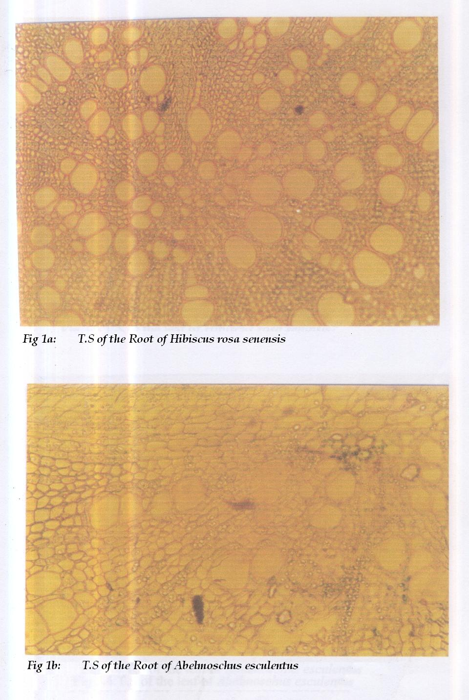

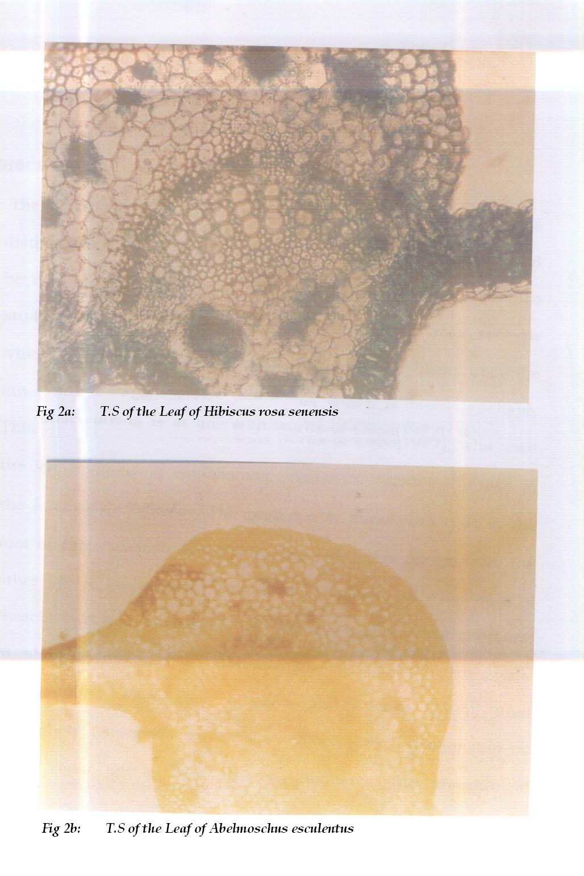

Table 1: Anatomical Characters of the Roots of the two taxa studied.
Characters | Hibiscus rosa senensis | Abelmoschus esculenta
Epidermal cells | Short chains, small | Long chain, big
Parenchyma cells | Small in size | Big in size
Number of crystals | 3 | 2
Xylem vessels | Numerous, circular in shape | Few, cuboidal in shape
Collenchyma cells | Angular | Present Angular
Xylem fibres | Present | Absent
Metaxylem | Many | Few
Pith | Present | Present
Phloem | Present | Present
Stains of Oxalate | No stain of Oxalate | Dark stain of Oxalate

Table 2 Anatomical Characters of the Leaves of the two taxa studied.
Characters | Hibiscus rosa senensis | Abelmoschus esculenta
Nature of central cells | Large with dark stained contents of Calcium Oxalate | Large without stains of Calcium Oxalate
Mesophyll | 4 – 6 layers with irregular shape | 3 – 4 layers with regular shapes
Xylem vessels | Very big and numerous | Very small and few
Sclerenchymatous and Parenchymatous | Well developed | Well developed
Crystals | Present | Present
Crystals | Present | Present
Phloem | Present | Present

Discussion
The Hibiscus rosa sinensis and Abelmoschus taxa investigated possesses features in their root and leaf anatomy that could be vital in their description and in their taxonomy. The variation in the epidermal cells: Short chains, small and numerous in Hibiscus rosa esculentus and long chains, big and numerous in Abelmoschus could be used to separate these two taxa. The mesophyll layer which is irregular comprised of 4 - 6 layers in Hibiscus rosa sinensis and regular with 3 - 4 layer in Abelmoschus esculenta could further strengthen the difference among the two taxa (Fig. 1a - b and Fig. 2a - b) This observation is inline with the work of Okoli (1987), Edeoga and Okoli (1997, 2001) who used both the root and leaf anatomical features in the family Cucurbitaceae and Dioscoraceae in establishing relationship among taxa. The reported small sized paranchyma cells of root anatomy in Hibiscus rosa sinensis and bigger sized cell in Abelmoschus esculenta is not strange since Nwachukwu 2005 had reported that cells of parenchyma vary greatly in size, shape and could also be elongated or lobed. The parenchyma cells are metabolically active and are modified for photosynthetic and secretary function. The nature of xylem vessels in both taxa, are very big, numerous and circular in shape in Hibiscus rosa sinensis further separates it from the very small few and ovoid in shape xylem cells in Abelmoschus esculenta. This observation is equally significant since no previous work has been reported on the root and leaf of the two taxa studied. Hence this variation in vascular bundle types among the taxa could be used to distinguish them (Fig. 1a - b) similarly variations in other features of the roots and leaves of the plants studied Table 1 and 2 could further be used to separate this taxa, while the presence of Protoxylem, Metaxylem, Crystals, Angular collenchyma cells in both taxa studied are typical of most dicot plants. This study is therefore based on the principles that root and leaf anatomy has played a major role in the identification, characterization and delimination of plants. Hence the need to incorporate information from root and leaf anatomy with data derived from other botanical disciplines remains vital when formulating conclusions on the systematic of the taxa investigated.

Corresponding Author:
Nwachukwu C.U.
Dept. of Biology,
Alavan ikoku College of Education,
P.M.B 1033 Owerri, Imo State, Nigeria.
E-mail Address: nwachukwucu2005@yahoo.co.uk

REFERENCES
- Akorod M.O (1985) Edible fruits productivity and harvest duration of Abelmoschus esculenta in Southern Nigeria Nihort, Ibadan, Nigeria Pp. 110 - 113.
- Azah Y.E.A (1968) Applied agronomic research on field food crops in Northern Ghana, Food and Agricultural Organization. NO. 2596:5 - 8.
- Burkill H.M (1995) The useful plants of West Tropical Africa (2nd edition) Royal Botanic Gardens Kew. Pp. 654 - 670.
- Edeoga H.O and Okoli B.E (1997) Anatomy and Systematics in Costus lucanusianus Complex (costaceae) Acta Phytolax Gebot 48:155 - 158.
- Edeoga H.O and Okoli B.E (2001) Midrib anatomy and Systematics in Dioscoreae. J.Econ. Tax. Bot, 23:1 - 5.
- Greensill T.M (1976) Growing better vegetable 4th edition Evans Brothers Ltd. London Pp. 14 - 15.
- Harpert L. (1997) Population biology of plants. London Academic press Pp. 3 - 15.
- Metcafe C.R and Chalk L. (1950) Anatomy of the Dicotylendon 2nd edition Clarendon press, Oxford 2:860 - 900.
- Mbagwu F.N and Edeoga H.O (2000) Anatomical studies on the
- roots of some vigna species (Leguminosae - Papilionoideae) Agric Journal (1) 8 - 10.
- Nwachukwu C.U (2005) Anatomy and Histology of Spermatophytes, (A basic approach) 1st edition Beth Vin Publishers 55 Osuji Street Owerri, Imo State Nigeria.
- Nwachukwu C.U and Mbagwu F.N (2006) Anatomical studies on the petiole of some species of Indigofera. Medwell, Agricultural Journal 1 (2): 55 : 58.

- Okoli B.E (1987) Anatomical studies in the leaf and protract of Telfairia Hoker (Curcurbitaceae) Feddes Repertorium, 98:231 - 236.
- Schewell-Copper W.E (1957) Basic book on vegetable growing (2nd edition) Barrie and Jenkin Ltd London Pp. 19 - 26.
- Stern K.R (2000) Introduction plant Biology, Macgraw-Hill Company Inc. United States of America. 603 Pp.
- Tindale H.O (1979) Commercial Vegetable growing. University Press, London Pp. 14 - 50.
- Vidyard R.D and Tripathi S.C (2002) A test book of Botany, Chand and Company, Ram Nagar. New Delhi Pp. 649 - 650.

