Investigation And The Analysis Of Water Masses At Pakistan Coastal Regions

¹M.Waheed-uz-Zaman and ²M.Ayub Khan Yousuf zai

¹Institute of Space and Planetary Astrophysics and
²Department of Applied Physics, University of Karachi
mwaheed_06@yahoo.com

Abstract: In this communication we have studied the properties of water masses in the coastal regions of Pakistan with seasonal influences. Changes in the coastal are magnified by the proximity of land that does bring with an annual increase in atmospheric temperatures and a concentration of fresh water supply through river run off. This fact makes the characterization of water masses more difficult than in the deep ocean where the most of the water is not in contact with the atmosphere. The Northern Arabian Sea is least known but present studies show the presence of three high salinity features in the upper 500 meters. These masses are identified as Red Sea Water masses, Persian Gulf water and Arabian Sea High salinity water respectively. The Red Sea and Persian Gulf, contribute high salinity waters to the Arabian Sea at depth about 500 meters and 300 meter respectively, while Arabian Sea high salinity water mass is the shallowest of the three high salinity masses and lies at the bottom of the equatorial surface water. The system of water types/ masses in the Arabian Sea is complex, so that several suggestions of the dominating ones can be found. The air-sea interaction and the water exchange with the Indian Ocean control and maintain the major characteristics of the water masses and the circulation in the northern Arabian Sea. Due to the atmospheric forcing there is up-welling all along the Somali Coast that moves northward and divert to open Arabian Sea as Ras Ai – Hadd jet (RAH). The RAH jet adverts significant amounts of up-welled water into the open Arabian Sea during the southwest monsoon and acts as a conduit for Gulf of Oman waters reaching the open Arabian Sea at the end of the southwest monsoon and into the fall inter-monsoon period suggested that of formation of Arabian Sea High Salinity water. [New York Science Journal. 2008;1(3):1-11]. (ISSN: 1554-0200).

I. INTRODUCTION
Description of seawater characteristics and motions are facilitated by using the concept of water masses. This concept is analogous to that employed by meteorologists to describe air manner in weather patterns. Air masses are identified by characteristic combinations of air temperature and moisture content. These characteristics allow meteorologists to identify the past history (air source regions) of the various air masses. Examples of air masses include continental polar (cold dry air formal over high latitude land areas) and maritime tropical (warm, moist air formal over equatorial ocean areas.

Large volumes of seawater move through the oceans as discrete water masses, identifiable by their characteristic temperatures and salinities. These water masses form at the ocean surface, and their temperatures and salinities reflect surface conditions where they formed. If a newly formed water mass is denser than its surrounding waters, it sinks to a level determined by its density relative to the density distribution in the nearby ocean. Below the surface, water masses are moved by subsurface currents, often for thousands of kilometers. After hundreds of years (possibly 1000 years), the deep waters return to the ocean surface, again to exchange gaseous with the atmosphere and to be warmed by heat from the sun. Subsurface water mass movements can be traced by using changes in dissolved gas concentrations, especially dissolved oxygen, and the presence of pollutants from nuclear weapons testing and even atmospheric pollutants, such as chlorinated hydrocarbons. The densest water masses in the ocean form in Polar Regions, where waters of moderately high salinity are intensely cooled at the ocean surface. These processes increase the depth of the pycnocline by the sinking of dense waters from the surface. If dense enough these water masses may sink all the way to the bottom and flow along the ocean floor. A water mass of intermediate density will flow at dense waters of the surface zone. The vertical position of water mass of intermediate density is like the position of a card in a deck of cards, and the ones above have lower densities.

II. WATER MASS FORMATION THEORY
If the surface temperature is very low, convection from cooling can reach deeper than the surface layer. This situation is encountered in the Polar Regions where cold water sinks to the bottom of the ocean. This process replenishes the deeper waters and is responsible for the currents below the upper kilometer of the ocean. Areas of deep winter convection are the Weddell Sea and the Ross Sea in the Southern Ocean and the Greenland Sea and the Labrador Sea in the Arctic region.
In the fig below, 75% of the ocean's water has a temperature and salinity within the dark green region, 99% have a temperature and salinity within the light colored region. The warm water outside the 75% region is confined to the upper 1000 m of the ocean.
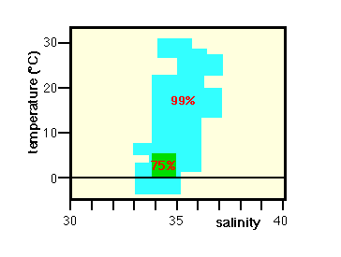
Volumetric temperature-salinity diagram of the world ocean

The average ocean temperature is 3.8°C; even at the equator the average temperature is as low as 4.9°C. The layer where the temperature changes rapidly with depth, which is found in the temperature range 8 - 15°C, is called the permanent thermo cline. It is located at 150 - 400 m depth in the tropics and at 400 - 1000 m depth in the subtropics. Figure below shows the temperature and salinity distribution in a meridional section through the Pacific Ocean as an example. Notice the uniformity of both properties below 1000 m depth. Notice also that in many ocean regions, temperature and salinity both decrease with depth. A decrease in temperature results in an increase of density, so the temperature stratification produces stable density stratification. A decrease in salinity, on the other hand, produces a density decrease. Taken on its own, the salinity stratification would therefore produce unstable density stratification. In the ocean the effect of the temperature decrease is stronger than the effect of the salinity decrease, so the ocean is stably stratified.

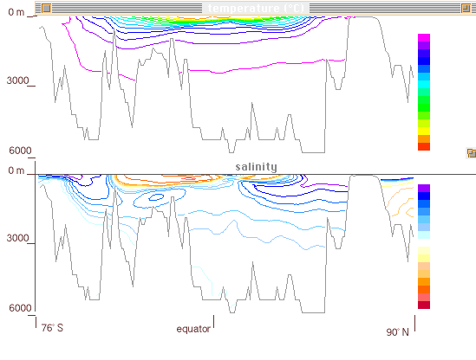
Temperature (top) and salinity (bottom) as functions of latitude and depth in the Pacific Ocean. (The image includes the Arctic Ocean on the extreme right.)

In contrast to the subsurface temperature distribution, the subsurface salinity distribution shows intermediate minima. They are linked with water mass formation at the Polar Fronts where precipitation is high; details will be discussed later in the course. At very great depth, salinity increases again because the water near the ocean bottom originates from Polar Regions where it sinks during the winter; freezing during the process increases its salinity.
In most ocean regions the wind-driven circulation, which was the focus of discussion so far, does not reach below the upper kilometer of the ocean. Water renewal below that depth is achieved by currents that are driven by density differences produced by temperature (thermal) and salinity (haline) effects. The associated circulation is therefore referred to as the thermohaline circulation. Since these movements are so slow, it is unrealistic to measure them directly; they have to be deduced from the distribution of water properties.
The driving force for the thermohaline circulation is water mass formation. Water masses with well-defined temperature and salinity characteristics are created by surface processes in specific locations, which then sink and mix slowly with other water masses as they move along. The two main processes of water mass formation are deep convection and subduction. Both are linked to the dynamics of the mixed layer at the surface of the ocean; so it is necessary to discuss thermohaline aspects of the upper ocean first.
Oceanographers refer to the surface layer with uniform hydrographic properties as the surface mixed layer. This layer is an essential element of heat and freshwater transfer between the atmosphere and the ocean. It usually occupies the uppermost 50 - 150 m or so but can reach much deeper in winter when cooling at the sea surface produces convective overturning of water, releasing heat stored in the ocean to the atmosphere. During spring and summer the mixed layer absorbs heat, moderating the earth's seasonal temperature extremes by storing heat until the following autumn and winter, and the deep mixed layer from the previous winter is covered by a shallow layer of warm, light water. During this time mixing does not reach very deep, being achieved only by the action of wind waves. Below the layer of active mixing is a zone of rapid transition, where (in most situations) temperature decreases rapidly with depth. This transition layer is called the seasonal thermo cline. Being the bottom of the surface mixed layer, it is shallow in spring and summer, deep in autumn, and disappears in winter. In the tropics, winter cooling is not strong enough to destroy the seasonal thermo cline, and a shallow feature sometimes called the tropical thermo cline is maintained throughout the year.

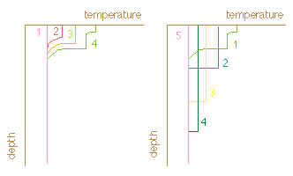
Development of the seasonal thermo cline during the year

The depth range from below the seasonal thermo cline to about 1000 m is known as the permanent or oceanic thermo cline. It is the transition zone from the warm waters of the surface layer to the cold waters of great oceanic depth The temperature at the upper limit of the permanent thermo cline depends on latitude, reaching from well above 20°C in the tropics to just above 15°C in temperate regions; at the lower limit temperatures are rather uniform around 4 - 6°C depending on the particular ocean.
Below the surface layer which is in permanent contact with the atmosphere, temperature and salinity are conservative properties, i.e. they can only be changed by mixing and advection. All other properties of sea water such as oxygen, nutrients etc. are affected by biological and chemical processes and therefore non- conservative. Water masses can therefore be identified by their temperature-salinity (T-S) combinations.

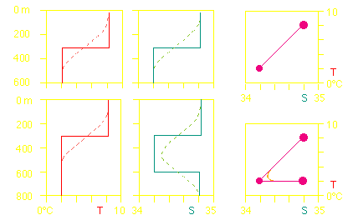
The above diagram shows the distribution of temperature (red) and salinity (cyan) with depth; the diagrams on the right show the corresponding TS-diagrams. Top: layering of warm and saline water mass found at 0 - 300 m depth above cold and fresh water mass found at 300 - 600 m). The full lines show the situation before mixing, the broken lines after mixing. The TS-diagram shows the two water masses as TS points. Before mixing only the two points are seen in the TS-diagram. Mixing connects the two TS-points by a straight line.
Water mass formation by deep convection occurs in regions with little density stratification (i.e. mostly in polar and sub polar regions). When the water in the mixed layer gets denser than the water below, it sinks to great depth, in some regions to the ocean floor. The density increase can be achieved by cooling or an increase in salinity (either through evaporation or through brine concentration during freezing) or both.
Water mass formation by subduction occurs mainly in the subtropics. Water from the bottom of the mixed layer is pumped downward through a convergence in the Ekman transport and sinks slowly along surfaces of constant density.
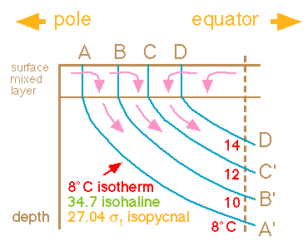

Sketch of water mass formation by subduction. First diagram: Convergence in the Ekman layer (surface mixed layer) forces water downward, where it moves along surfaces of constant density. The 27.04 sigma-t surface, given by the TS-combination 8°C and 34.7 salinity, is identified.

Antarctic Bottom Water is formed by deep convection in the Weddell and Ross Seas and fills all ocean basins below 4000 m depth; in the Pacific and Indian Oceans it is mixed with North Atlantic Deep Water, the mixture being known as Circumpolar Water. North Atlantic Deep Water is the product of a process that involves deep convection in the Arctic Ocean, the Greenland Sea and the Labrador Sea. Most Antarctic Intermediate Water is formed by deep convection east of southern Chile and west of southern Argentina and spreads into all oceans with the Circumpolar Current. Intermediate Water in the northern hemisphere may be formed by convection or subduction. Central Water, the water of the permanent thermo cline, is formed by subduction in the subtropics. Mediterranean and Red Sea waters are intrusions of high temperature; high salinity waters from two Mediterranean seas (see the discussion of Mediterranean seas below).
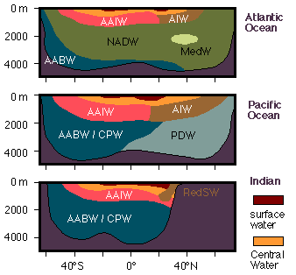
Sketch of the water mass distribution in the world ocean. AABW: Antarctic Bottom Water, CPW: Circumpolar Water, NADW: North Atlantic Deep Water, PDW: Pacific Deep Water, AAIW: Antarctic Intermediate Water, AIW: Arctic Intermediate Water, MedW: Mediterranean Water, RedSW: Red Sea Water, gold: Central Water, brown: surface water.

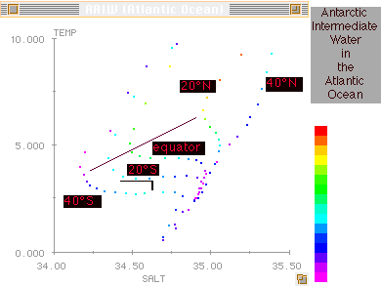

A complete description of water mass movement requires horizontal property distributions as well as vertical sections and TS-diagrams. It is then seen that the path of Antarctic Bottom Water in particular is strongly affected by the topography. For example, the deep basins of the eastern Atlantic Ocean are separated from the Southern Ocean by a sill and cannot be reached by Antarctic Bottom Water directly. They are filled through a gap in the Mid-Atlantic Ridge near the equator; in other words, flow of Antarctic Bottom Water in the eastern South Atlantic Ocean is southward, from the equator toward the pole. In the Pacific Ocean, input is mainly along 170°W (east of New Zealand), followed by spreading east and westward in the northern hemisphere; recirculation into the southern hemisphere occurs in the east. Input into the Indian Ocean is from the west, and in smaller quantities from the east.
III. CIRCULATION IN ARABIAN SEAS
Arabian Seas are small bodies of water characterized by very restricted water exchange with the major ocean basins. This results in different hydrodynamics and sets them apart from the remainder of the world ocean. While the circulation in most of the world ocean is dominated by wind-driven currents, the circulation in Arabian seas is determined by thermohaline processes. Two basic types of circulation can be distinguished, the concentration basin and the dilution basin. Concentration basins occur where evaporation in the region exceeds precipitation.

The circulation in Arabian seas and their water exchange with the remainder of the world ocean differs strikingly between the two types. In concentration basins, evaporation increases the salinity of the surface waters, raising their density and producing convection. Deep water renewal is therefore a nearly continuous process, and the waters of the basin are well ventilated (have relatively high oxygen content) at all depth. In dilution basins, the freshening of the surface waters resulting from excess rain and freshwater input from rivers reduces the density of the surface layer. This prevents the freshened water to reach the deeper layers. The result is the establishment of a fresh upper layer and a strong halocline. Water below the halocline is renewed only very slowly through mixing across the halocline and inflow of oceanic water through the connecting strait. Oxygen content below the halocline is therefore very low. If the basin is large and the exchange with the open ocean very restricted, oxygen levels at depth can fall to zero, preventing the existence of higher marine life.

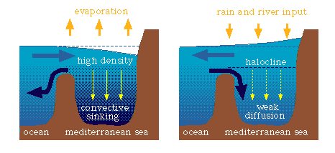

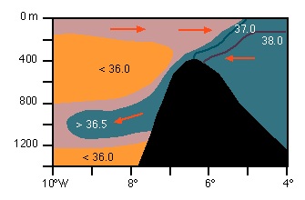
Spreading of Arabian Water in the Indian Ocean, indicated by the salinity where maximum produced by it. The depth of the spreading is typically just below 1000 m.

IV. WATER MASSES OF THE ARABIAN SEA

For study and analysis water masses at Pakistan coastal regions (stations) I selected 10 positions along the coastal zones of Arabian Sea. After study I observed that the basis of water mass analysis in the deep ocean is the derivation of water mass properties in the formation region are small compared to the property differences that are observed between different water masses at some distance from their formation region.

The situation in the coastal ocean is quite different. Many coastal regions are well mixed, so TS- graph which show variations of temperature and salinity with depth, are not often found in the coastal ocean. Even where vertical stratification is present, a large part of the water column is still taken up by the surface mixed layer, which in a TS- graph is represented by single water type. Undergo large changes from season to season. If the TS- Properties of the coastal ocean area averaged over the year, the resulting standard derivation is much larger than any variation that may exist as a result of stratification in the water column at any particular time. Although water properties in the coastal ocean undergo large variation they do not fluctuate in a random fashion but follow a seasonal cycle. It is possible to make use of this and define the water masses of the coastal ocean through the use of the so called TS-time graph. Other than plotting temperature against salinity as both very with depth, we plot the values of both variables in the mixed layer against each other as they very over the year. The sequence of the observation taken over a year defines a TS- relationship in the time that reflects the weekly and secondly changes of the two properties. Establishing a TS- time graph for a particular coastal ocean region requires an observational effort over many years and is therefore much more demanding than the effort required establishing a TS-graph for a deep ocean station.

TS-graph can be produced for all other parts of the coastal ocean. They can, in fact, be a useful tool for the analysis of the hydrography of the surface mixed layer in the open ocean. In the context of coastal oceanography it is worth noting that many shelf seas have been surveyed in great detail over many decades and their data base is suitable for deriving standard deviations on a monthly basis.

T-S graph of Arabian Sea

V. CONCLUSION

In this study an effort is made to understand the properties of the waters in the Pakistan coastal ocean which are constantly changing. Seasonal influences are magnified by the proximity of land, which brings with it an increased annual range in atmospheric temperatures and a concentration of fresh water supply through river runoff. This makes the characterization of water masses more difficult than in the deep ocean, where most of the water is not contact with the atmosphere.

In the absence of air/sea interaction processes, the physical properties of water parcels can only be changed when they mix with water parcels of different origin and therefore different properties. Without mixing, water parcels retain their temperature and salinity unchanged. Temperature and salinity are therefore known as conservative properties, in contrast with non-conservative properties such as oxygen or nutrients which participate in biochemical processes and therefore show changing concentration levels even in the absence of mixing. Temperature and salinity are therefore the most suitable hydrographic properties to define water masses and study their distribution.
`In this study, an attempt is made to understand the physics of water masses formation process. The basic tool for water mass classification and analysis is the temperature-salinity (TS) graph in which the two conservative properties are plotted against each other. A homogeneous water mass is a water mass of uniform temperature and salinity. The best known examples of this kind are the water masses of the permanent thermo cline known as Central Water.

In this we study, the air-sea interaction and the water exchange with the Indian Ocean control and maintain the major characteristics of the water masses and the circulation in the northern Arabian Sea. Due to the atmospheric forcing there is upwelling all along the Somali coast that moves northward and divert to open Arabian Sea. This advects significant amounts of up welled water into the open Arabian Sea during the southwest monsoon and acts as a conduit for Gulf of Oman.

VI. REFERENCES
- Cartwright D E (1999), Tides, Cambridge University Press, Cambridge
- Garrison T (1999), Oceanography: an invitation to marine science, 3/e, Wadsworth Pub. Co., London
- Gershenfeld N (1999), The nature of mathematical modeling, Cambridge University Press, Cambridge
- Glasson J, Therivel R & Chadwick A (1999), Introduction to environmental impact assessment, 2/e, UCL Press, London
- Gurney R J & Browning K A (ed), (1999), Global energy and water cycles, Cambridge University Press, Cambridge
- Garfunkel S et al. (1998), Mathematics: Modeling our world, South-Western Educational, Cincinnati
- Krzanowski W J (1998), An Introduction to statistical modeling, Arnold, London
- McKinney M L & Schoch R M (1998), Environmental science: Systems and solutions, Jones & Bartlett, Sudbury, MA
- Allen P A (1997), Earth surface processes, Blackwell Science, Oxford
- Csiszar I and Michaletzky G Y (1997), Stochastic differential and difference equations, Birkhäuser, Boston
- Katz R W & Murphy A H (ed), (1997), Economic value of weather and climate forecasts, Cambridge University Press, Cambridge
- Laws E (1997), Mathematical methods for oceanographers, John Wiley, New York
- Lowrie W (1997), Fundamentals of geophysics, Cambridge University Press, Cambridge
- Pant G B & Kumar K R (1997), Climates of South Asia, John Wiley, West Sussex
- Paul M S & Warr K (ed), (1991), Global environmental issues, Hodder & Stoughton, London
- Hammond A (1991), Environmental almanac 1992, Houghton Mifflin, Boston
- Couper A (1983), Atlas of the oceans, Times Books, London
- Gillett J (1990), Environmental geography, Longman, Essex, pp. 74-76 & 82
- Thurman H V (1988), Introductory oceanography, 5/e, Merrill, Columbus
- Davis R A & Addison Jr (1972), Principles of oceanography, Addison-Wesley, Reading, Mass.
- Wilhelmy H (1968), Indus delta and Rann of Kutch, Erdkunde, pp. 22 & 177-191
- Snead R E (1976), Recent morphological changes along the coast of West Pakistan, Assoc. Am. Geographers Annuals, pp. 57 & 550-565
- Alen Brown (ed), (1992), The UK Environment, Govt. Statistical Service, London
- Mesa C (1994), in Ocean wave measurement and analysis, edited by O T Magoon and J M Hemsley, American Society of Civil Engineers, New York
- Hsu J R C & Silvester R (1990), J. Waterway, Port, Coastal, Ocean Engineering, ASCE, 116(3), 367-380
- McCormick M E (1993), J. Waterway, Port, Coastal and Ocean Engineering, ASCE, 119(6), 253-267
- Herbich J B (ed), (1992), Handbook of coastal and ocean engineering, vv. 2-3, Gulf, Houston.

3/18/2008

