Synthesis and characterization of Polyaniline/Poly(p-hydroxyaniline)/Fe₃O₄ magnetic nanocomposite

Mohammad Reza Saboktakin*, Abel Maharramov, Mohammad Ali Ramazanov
Department of Chemistry, Baku State University, Baku, Azarbaijan
E-mail: saboktakin123@yahoo.com

Abstract
The several composites have been studied for static dissipationand microwave absorbing materials based on polyaniline with metallic oxides. These composites are conducting polymers have been widely used because of their lower density as well their good environmental stability as in the case of polyaniline (PAN). In the present work , in situ polymerization of aniline was carried out in the presence of Fe₃O₄ nano particles to synthesize polyaniline/Poly(p-hydroxyaniline)/ Fe₃O₄ (PAN/PHAN/Fe₃O₄) composites.The composites,thus synthesized have been characterized by Fourier transfer infrared(FTIR) spectrophotometer and X-ray diffraction . The morphology of these composites was studied by scanning electron microscopy. [New York Science Journal. 2008;1(4):14-18]. (ISSN: 1554-0200).

Keywords: Conductivity, polyaniline ,poly(p-hydroxyaniline), Fe₃O₄ , nanocomposites.

Introduction
Nowdays the conducting polymers offers a great technological application potential in several areas [1-3], can be cited: static films for transparent packaging of electronic components , electromagnetic shielding , rechargeable batteries ,light – emitting diodes , nonlinear optical devices , sensor for medicine and pharmaceutics apparatus , membranes for separation of gas mixture , protection against corrosion ,conducting paint s and glues and others .The most important application of these polymers is like radar(microwave) adsorbing materials[4].These polymers are generally prepared by adding fillers ina polymeric matrix.One very common way, among the several methods fir preparing conducting polymer blends or composites , is by mechanical mixing of the components[5].
Great interest has been focused on polyaniline (PAN) and Poly(p-hydroxyaniline)( PHAN) , within the field of conducting polymers , due to important characteristics that it presents: its conductive form has excellent chemical stability combined with relatively easy ,inexpensive and with high – yield.These blends may combine the desired properties of two components ,the electrical conductivity of polyaniline/poly(p-hydroxyaniline) with the physical and mechanical properties of the polymeric matrix[6-7].
We have been studied some microwave absorption properties of polyaniline / Poly(p-hydroxyaniline)with Fe₃O₄ nanoparticles[8] .

Experiments
Nano particles of Fe₃O₄ were purchased from nanotechnology center of baku state university. The particles have an average of 10 -12 nm. Aniline and 4-aminophenol were purchased from Aldrich chemicals.Aniline was purified by distillation under vacuum.Ammonium persulfate.
The images of nanoparticles were investigated using Philips XL30 scanning electron microscope.The Fourier transfer infrared(FTIR , Bruker )spectroscopy was used to identified the polymer on the Fe₃O₄ nano particles surface.Specta were obtained in the wave number range of 400-4000 cm⁻¹. Spectra of the polyaniline modified Fe₃O₄ nanoparticles were recorded from KBr in 1:10 (wt/wt) ratio.
HCl 1M solution(100 cm³ ) was prepared. Add 0.558 gram of aniline to solution,stir for 4 hours .Dissolve 0.006 mol potassium persulfate (KS₂O₈) with 10 ml distilled water. Mix these two solutions to start the polymerization reaction. The solution turned to dark green.Stir for 24 hours to obtain a homogeneous solution of the polymeric matrix . The polymeric matrix is a dispersion of particle of 100-200 nm in diameter. The infrared absorption spectra of the matrix are consistent with the structure of polyaniline .
Stir Fe₃O₄ dispersive solution with sodium dodecyl sulfate / distillaed water with mechanical stirring . A diluted solution of the PAN polymer is then mixed with Fe₃O₄ solution (25% Fe₃O₄) for 10 minutes . The average molar ratio of the components is PAN:Fe₃O₄ = 1:2 . The dispersion is stable with very small amount of precipitation . 0.012 mole (3.5gr) 4-aminophenol dissolve in the 25cm³ HCl 1M solution. Stir for 2 hours .Then , dissolve 0.01 mol potassium persulfate (KS₂O₈) with 20 ml distilled water. Mix these two solutions to start the polymerization reaction. The solution turned to dark green.Stir for 24 hours to obtain a homogeneous solution of the polymeric matrix.The viscosity of solution is increased.

Results and Discussion
SEM of polyaniline/ Poly(p-hydroxyaniline)/ Fe₃O₄ nanocomposite synthesized by chemical oxidative is shown in Figure 1. PAN/ PHAN / Fe₃O₄ nanocomposite is very sensitive to the temperature . Due to the intractionelectron and sample . Scanning electron micrography images were obtains from a diluted solution of the nanocomposite particle . The white spots are Fe₃O₄ nano particles .The SEM image shows the presence of spherical Fe₃O₄ particles in PAN/ PHAN matrix, which are homogenenously distributed throughout the composites ,which is also confirmed from XRD studies[11]. A very high magnification of SEM image shows the presence of spherical Fe₃O₄ particles(cenospheres ) in PAN/ PHAN , which are homogeneously distributed throughout the composites ,which is also confirmed from XRD studies .It is for the first time such a beautiful distribution of cenospheres is observed which looks as if the beads are floating over the water surface . These ceospheres show a large variation in their dimensions.Since the partices of Fe₃O₄ are spherical in shape ,the observed porosity in these composites is less than the other PAN/ PHAN composites .

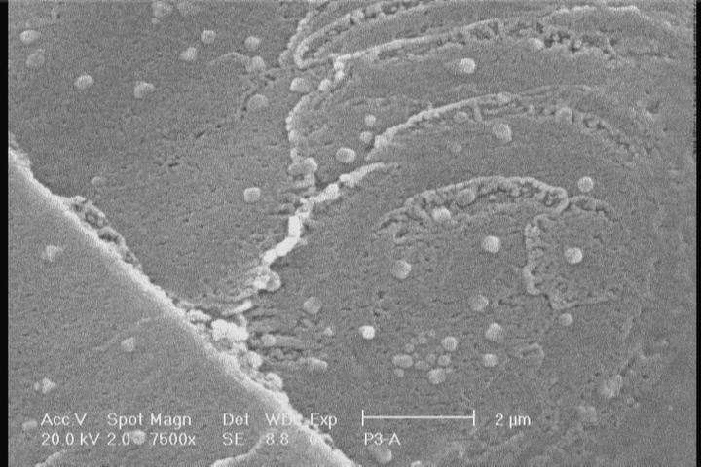
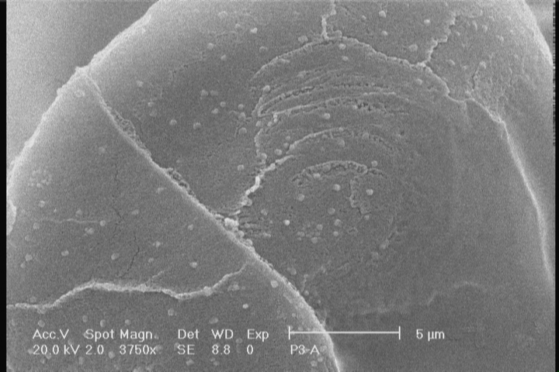

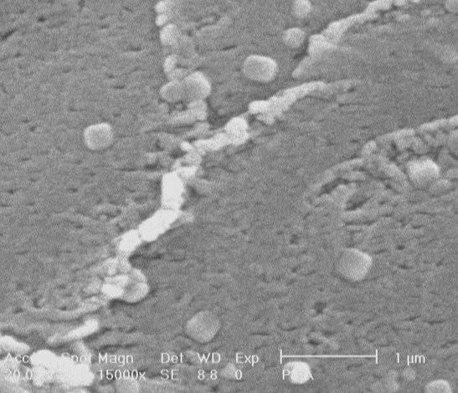
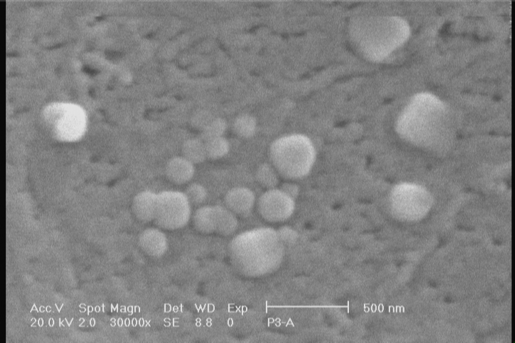

Figure 1. Scanning electron micrograph of PAN: PHAN:Fe₃O₄ nanocomposite

The crystallinity of the formed composites was followed with X-Ray diffraction(XRD) as s function of weight percent inorganic component. Figure 2a shows X-ray diffraction pattern of polyaniline .Diffraction of PAN: PHAN have a broad peak at about 2Ө = 25.92 ˚ , which is a characteristic peak of PAN: PHAN (Wan et al 1994 , Wan and li 1998) . Studies on XRD patterns of PAN: PHAN are scarce in the literature(Rajendra Prasad and Muunichandriah 2002 ) .Figure 2b shows the XRD pattern for PAN: PHAN:Fe₃O₄ (25% ). The diffraction pattern of PAN: PHAN: Fe₃O₄ nanocomposite shows a peak at about 2Ө = 26.89˚[12,13].

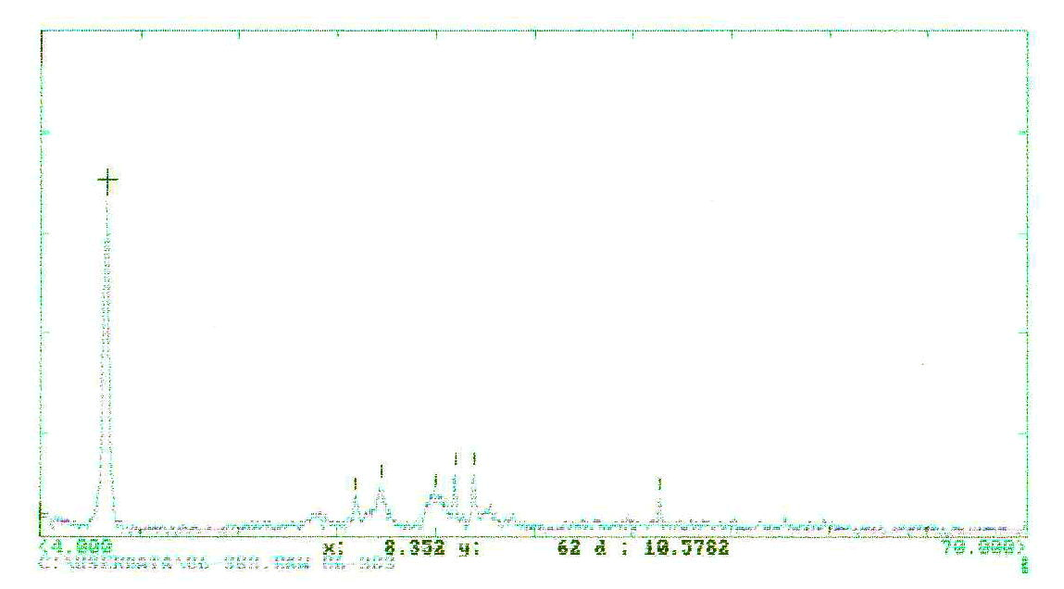

Figure2. XRD spectra of PAN: PHAN: Fe₃O₄ nanocomposite

Figure 3a shows the FT-IR spectrum of pure polyaniline nanopolymer , where the % of transmittance is plotted as a function of wave number (cm⁻¹) . The characteristic FT-IR peak at 1523 and 1485 cm⁻¹ are due to the presence of quinoid and benzenoid rings , respectively and are clear indication of these two states in the polymer chain. Also , The peaks at 1176 cm⁻¹ are due to the C-N bond stretching vibration ,respectively[14] .

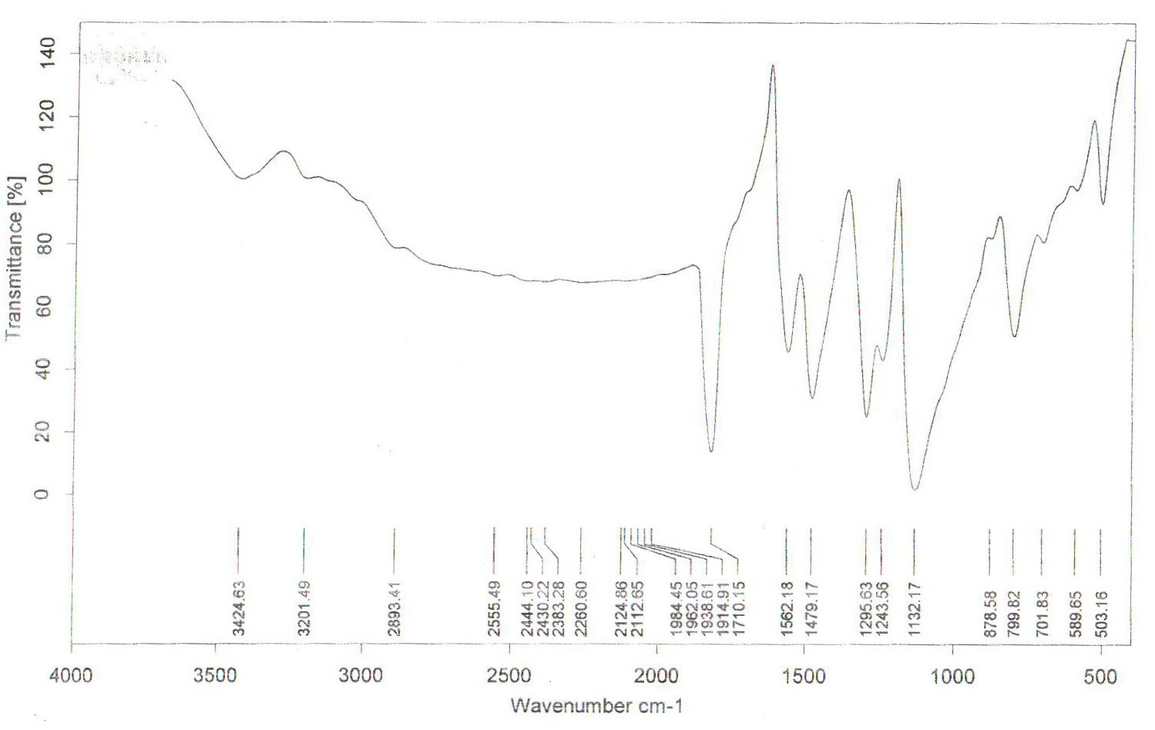

Figure3a. FT-IR spectra of pure polyaniline

Also,figure 3b shows the FT-IR spectrum of polyaniline-poly(4-aminophenol) nanocomposite in presence of Fe₃O₄ as a ferromagnetic material exhibit new absorption peaks distinctly at 1591,1485,1382,1178 and 760 cm⁻¹ which are assignable to the presence of various metal oxides in the composite.The broad peaks at 3200-3500 cm⁻¹ are O-H Phenolic group in the nanocomposite.

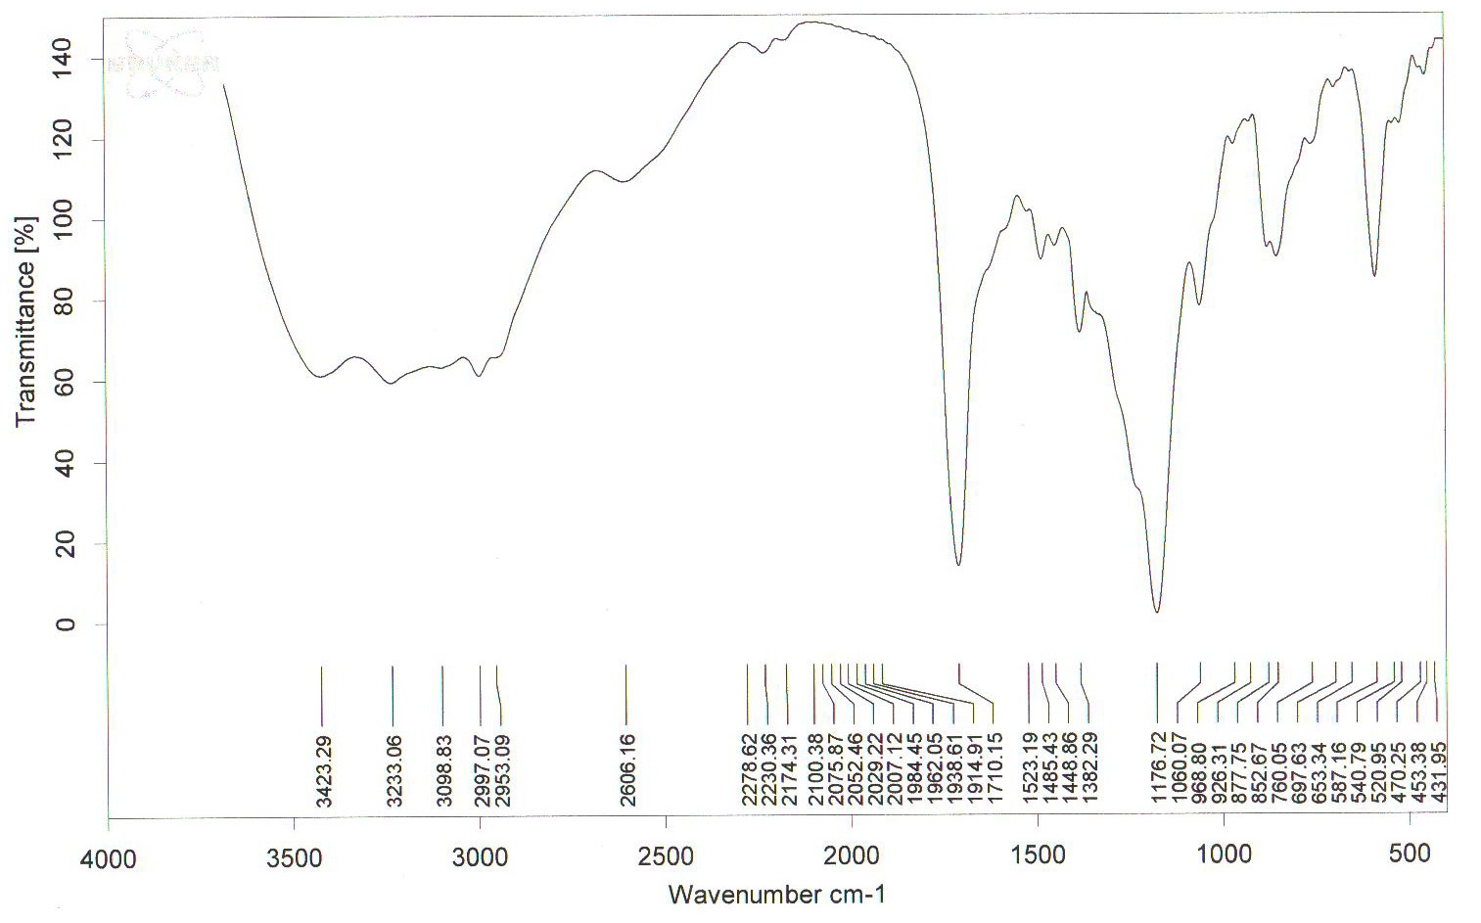

Figure3b. FT-IR spectra of PAN: PHAN: Fe₃O₄ nanocomposite

The effect of Fe₃O₄ particles on the electrical conductivity of PAN/ PHAN / Fe₃O₄ nanocomposites was studied .These data shows the low frequency behaviour of nanocomposite.The absolute conductivity for individual samples increases as a function of frequency except for the nanocomposite with 25 wt% Fe₃O₄ . The electrical conductivity of pure PAN/ PHAN (0 wt% Fe₃O₄ ) has the order of 10⁻⁴ S/cm. For the PAN/ PHAN /Fe₃O₄ nanocomposite the conductivity values change the order of magnitude.(10⁻⁵ S/cm).From FT-IR and XRD studies , the presence of Fe₃O₄ in nanocomposite are confirmed[15].

Conclusions
We have synthesized new polyaniline matrix by in situ polymerization in the presence of Fe₃O₄ nano particles .The PAN/ PHAN / Fe₃O₄ ferromagnetic nanocomposites have been characterized by FT-IR, SEM,and XRD techniques.This nanocomposite show crystalline nature ,whereas the PAN synthezied is amorphous in nature . The SEM photograph of nanocomposite with 25% Fe₃O₄ show the presence of cenospheres. These nanocomposites are suitable materials for high technology industries . The organic component is the hybride material have the dimention of 100-200 nm . One type of the composite is synthesized by preparing a precursor that contains the Fe₃O₄ nano particles.The composites were coated on glass and metal surfaces by the method of layer-by layer coating of self – assembled multi layers.

Acknowledgment
The authors Wish to thank prof. M.Allahverdiev(Baku State University) for Valuable discussions.

References
- P.F.W. Simon, R. Ulrich, H.W. Spiess , U. Wiesner, Cem.Mater,13 , 3464 ,2001.

2. M.R. Saboktakin., A. Maharramov, M.,A.,Ramazanov, Nature and Science

,2007,5(3), 67-71.
- M.R.Saboktakin,A., Maharramov, M.,A.,Ramazanov,Journal of American

Science,2007, 3(4),40-45
- M.R.Saboktakin,A., Maharramov, M.,A.,Ramazanov,Journal of American Science,2007, 3(4),30-34
- B.O’Regan,M.Gratzel, Nature,353,737,1991.
- A.J.Zarur,J.Y.Ying,Nature,403,65,2000.
- J.M.Liu and S.C.Yang, J.Chem.Soc.,Chem.Comm.,1529,1991.
- J.O.Stoffer,T.J.O’Keefe,X.Lin,E.Morris,P.Yu,S.P.Sitaram,US Patent 5,932,083.
- S.P.Sitaram, P.Yu, T.J.O’Keefe and J.O.Stoffer ,Polym.Mater.Sci.Eng.,75,354,1996.
- L.Sun,H.Liu,R.Clark,S.C.Yang,Syn.Met,85,67,1997.
- J.M.Liu,L.Sun,J.H.Hwang and S.C.Tang,H.L.Wang,Mat.Res. Soc.Symposium Proceeding , 247 ,601,1992.
- P.A.McCarthy,J.HuAng,S.C.Yang,H.L.Wang, Langmir,18,259,2002.
- Z.Tang ,N.Alvarez and Sze Yang , Mat.Res. Soc.Symposium Proceeding , 732,601,2003.
- S.C.Raghavendra.S.Khasim,M. Revanasiddappa,M.V.N. Ambika Prasad and A.B.KuKarni,Bull.Mater. Sci,26,7,2003.
- S.P.Armes, J.F. Miller,Synth. Met.22,385,2001.

2/21/2008

