Subsurface Stratigraphic mapping using Geophysics and Its Impact on the Urbanization Development in Arepo Area, Ogun State, Nigeria

Oyedele, K. F. and Bankole, O. O.

Department of Physics (Geophysics Programme)
University of Lagos, Nigeria
kayodeunilag@yahoo.com

Abstract: This article presents the findings of geophysical investigations carried out at Arepo area, Ogun State, Nigeria. The main geophysical methods employed was resistivity sounding, induced polarization and borehole geophysics. The integrated geophysical techniques has demonstrated its ability to be a better approach to resolve the subsurface stratigraphical ambiguities than a single geophysical technique. The method was suitable to distinguish between sand and clay beds in a complex geologic zone. Based on the thickness of sand layer, the area investigated can probably support low to giant engineering structures. [New York Science Journal. 2009;2(2):31-45] (ISSN: 1554-0200).

Keywords: Stratigraphic mapping, lithologic beds, geoelectric sections, resistivity sounding

1. Introduction
Ogun State has witnessed an upsurge in infrastructural development and increased in human population in recent years particularly in those areas that shear borders with Lagos State. The study Area, Arepo falls within this category (Fig.1). On the basis of increasing economic activities and booming construction works coupled with the incidence of collapsed building structures in the country, this investigation was carried out to provide detailed information on the characteristics of the subsurface lithology and ground conditions prior to the commencement of construction works. Since nearly every civil engineering structures – building, bridge, highway, tunnel, wall, tower, canal, and dam – must be founded in or on the surface of the earth (Lambe and Whitman, (1979), it is expedient that detailed information on the strength and the fitness of the host earth materials must be ascertained via pre-construction investigation of the subsurface at the proposed site.

In a simplistic sense, drilled core can be used to map subsurface materials. However, geophysics can provide some of the required information to delineate those materials in subsurface space. Geophysical tools that are routinely used to image the subsurface of the earth in support of mining related geotechnical investigations, include Seismic methods, ground penetrating radar (GPR), Electrical resistivity (ER), Electromagnetic (EM), Induced polarization (IP) and Magnetic method (M) (Gowd 2004, Ward, 1990 and Neil and Ahmed, 2006). This survey, which could be carried out for less than the cost of a single cored drill hole, provides critical insight into the complex subsurface architecture and stratigraphic relationships of buried units (Susan, 2000). To this end, intergrated geographical techniques-via electrical resistivity induced polarization and borehole geophysics have been employed to delineate subsurface stratigraphic relationship or variation of Earth materials of Arepo, area Ogun state, Nigeria as an aid to civil engineer in charge of construction works.

2. Geology and Hydro geology
The geology of the area (fig.1) can be described broadly as a sedimentary basin, which thickens from north to south (down dip) and from East to West. The project area is underlain by the littoral and lagoon deposits of recent sediments. The coastal belt vary in width from about 8km near the republic of Benin boarder to about 24m toward the eastern end of Lagos lagoon (Jones and Hockey, 1964). The recent sediment can be divided into littoral and lagoon sediments of the coastal belt and the alluvial sediments of the major river. The sediments consist of unconsolidated sands, clay and mud with a varying proportion of vegetation matter, along the coastal area while the alluvial deposits consist of coarse, clayey, unsorted sands with clay lenses and occasional beds. Hydro-geologically, Kampsax and Kruger (1987) subdivided the aquifer in the coastal terrain of Lagos and Ogun into four with the first aquifer representing the recent sediments and the second and third aquifers being within the coastal plain sands. The water table aquifer occurs in recent sediments along the coast and within alluvial plains of the river valleys. However the water table is shallow with results of chemical analysis of the water from recent sediments showing higher TDS and conductivity than water from the coastal plain sands aquifer (Oyedele, 2006).

3. Equipment and Field Procedure
Electrical resistivity and Induced polarization measurements were carried out using ABEM terrameter SAS 1000 system. This equipment is reliable and provides adequate spatial resolution and target definition. The data were acquired using the vertical electrical sounding method (VES). A total of thirteen (13) VES wee carried out using the Schlumberger array with a maximum current electrode separation AB/2 of 120m. The essential idea behind the VES is that it assumes conductivity variation with depth only, such that as the distance between the current and potential electrode is increased, the current filament passing across the potential electrode carried a current fraction that has returned to the surface after reaching increasingly deeper depth (Telford et al., 1976). To ensure that geophysical results can be interpreted in a way that is clear and meaningful to all project participants drilled borehole logs were used to correlate with the geophysical data (Fig. 3a to 3c).

4. Data Processing and Presentation
To minimize erroneous interpretation due to human error, the WinGlink software was utilized for the processing of the acquired data. The processed data were presented in the forms of 1-D models resitivity curves, geoelectric sections and maps.

5. Results and Discussion
1-D Models Resistivity Curves
The apparent resitivity values were plotted against the electrode separation (AB/2) in meter on a computer based log-log graph using the WinGlink software for a computer iterated interpretation. These iterations were presented as 1-D iteration models. Figure 2 shows the representative samples of these curves. Visual examination of the 1-D model curves shows a typical 4-layered case. This consists of topsoil (clayey sand), fine sand/medium sand, clay and coarse sand. Table 1 shows the detailed interpreted resistivity measurements of the subsurface sediments.

Geoelectric Sections
The geoelectric sections of the various VES stations in the study area were created to indicate the various geoelectric layers within the subsurface with their characteristic resitivity values and probable geologic connotations (Fig.3a to 3d).

The geoelectric section across A to A¹ is made up of data from VES 1, 2, 5, 7 and 8 correlated with drilled hole (D2) (Fig. 3a). The top geoelectric layer has resistivity values ranging from 74 to 118Ωm with a thickness that varies from 1.56 to 4.11m and is composed of predominantly clayey sand. The second geoelectric layer has resitivity values that vary from 96 to 265Ωm and thickenss values that range from 7.64 to 19.87m. It is predominatntly fine sand. The third geoelectric layer has resistivity values that vary from 34.7 to 62.5Ωm and thickness values of 19.3 to 25.6m and consists of clay. The fourth layer has resistivity values that vary from 318 to 403.6Ωm and with no thickness values because the current terminated in this zone.

The geoelectric section across B to B¹ is made up of data from VES 5, 6 and 10 (Fig. 3b).The first geoelectric layer has resistivity values that vary from 29.4 to 118.0Ωm and thickness values that range from 1.1 to 3.5m and is made up of clayey sand with decomposed organic and inorganic materials. The second geoelectric layer consists of fine sand with resistivity values that vary from 150 to 188Ωm and thickness values that vary from 11.5 to 14.3m. The third layer has resistivity values that vary from 26.3 to 152.3Ωm and thickness values that range from 17.3 to 21.8. This layer is predominantly clay. The last layer is made up of coarse sand with resistivity values that vary from 23.4 to 463.9Ωm with no thickness.

The geoelectric section across C to C¹ is made up of data from VES 7, 6, 11, 12 and 13. The first geoelectric layer is made up of clayey sand with resistivity values that vary from 32 to 118Ωm and thickness values that range from 0.7 to 3.5m. The second layer is made up of fine to medium sand and consists of resistivity values that range from 96.0 to 104.6Ωm and thickness of 1.7 to 6.4m. The third layer has resitivity value that vary from 26.3 to 202.0Ωm and thickness that range from 16.2 to 25.6m. The lithology is predominantly clay. The fourth layer is made up of coarse sand with resistivity values that vary from 26.4 to 464.0Ωm.

Across D to D¹ the geoelectric section is made up of VES 2,4,6 and 9. The first layer is composed of clayey sand with resistivity values that vary from 76 to 118Ωm and thickness values that range from 1.5 to 3.5m. The second layer has resistivity values that vary from 171 to 188.6Ωm and thickness values that vary from 2.5 to 19.5m. This is indicative of fine to medium sand. The third layer has resistivity values that vary from 26.3 to 44.6Ωm and thickness between 6.3 to 32.5m, which is indicative of clay material. The fourth layer has resistivity values that range from 292.2 to 540Ωm and consists of coarse sand.

Contoured Maps
Several maps were produced using SURFFER program to monitor the trend of lithological variations with a view to assessing the subsurface stratigraphic stratum suitable for low, medium and giant engineering structures.

Figure 4 shows the isopach map of thickness of sand layers that vary from 2 to over 18m. Based on the sand thickness, the northern, western southern and south-eastern sections of the area can probably support giant engineering structures while the north-eastern section show an indication of low to medium structures. The depth to sand layers range from 1.1 to 55.0m.

Figure 5 shows the isopach map of depth of clay layers. The depth to clay layers vary from 4 to over 24m. Both the northwestern and southeastern portions of the area investigated have depth to clay layers that range from 9 to over 24m. On the other hand, the northeastern portion has depth to clay layers that vary from 4 to 14m. Figure 6 shows the isopach map of thickness of clay layers and it varies from 6 to over 30m. Over ninety five percent (95%) of the area have thickness values that vary from 12 to over 30m with the exception of VES 9 that has clay thickness value of about 10.2m (Table 1).

The depth to groundwater table (GWT) in the area vary from 0.5 to over 8.5m (Fig.7). With the exception of VES 9, the depth to GWT at all the VES stations range from 2.5 to over 8.5m.

Figures 8,9,10,11 and 12 shows isoresistivity depth-slice maps at 3m, 7m, 10m, 15m and 25m respectively. With the exception of isoresistivity depth-slice map at 25m (Fig.2), in which the resistivity values vary from 200 to over 230Ωm, all the other isoresistivity depth-slice maps have reistivity values that vary from 20 to over 230Ωm (Figs. 8 to 11).

6. Implication of Study Area on Engineering Structures
The results of the geophysical investigation carried out shows that the study area can accommodate probably low to high engineering structures based on the inferred thickness of the sand layers. In the northeastern portion however, low to medium structures are feasible except extensive pilling is done. This is because the sand layer in that area is thin (2.5 to 7.6m) and it is underlain by clay. Beneath all the VES stations, with the exception of VES 8 and 9, the thickness of the sand body ranges from 10.9 to 19.9m with resistivity values ranging from 109.6 – 118.0Ωm. These areas can probably support giant engineering structures.

However, it is important to note that underneath this sand layer is a thick clay body beneath all the VES stations. To ensure the safety of giant engineering structures in the area, adequate pilling is recommended.

7. Conclusion
The subsurface geotechnical investigation using the combination of electrical resistivity, induced polarization and borehole geophysics at Arepo area, Ogun State, Nigeria revealed that the stratigraphy consists basically of four layers which are representative of top soil (clayey sand), fine to medium sand, clay and coarse sand. Based on the qualitative and quantitative interpretation of VES data alongside with borehole data, it is deduced that low to high engineering structures are feasible. However, for massive constructions, structural foundation via pilling is recommended at depth not less than 32m because of the clay beds that directly underlain the sand bodies.

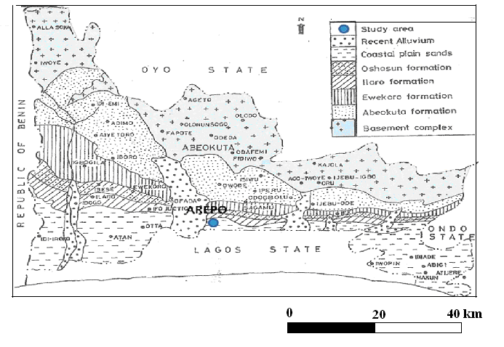
Fig 1: Geological map of Ogun State showing the study area.

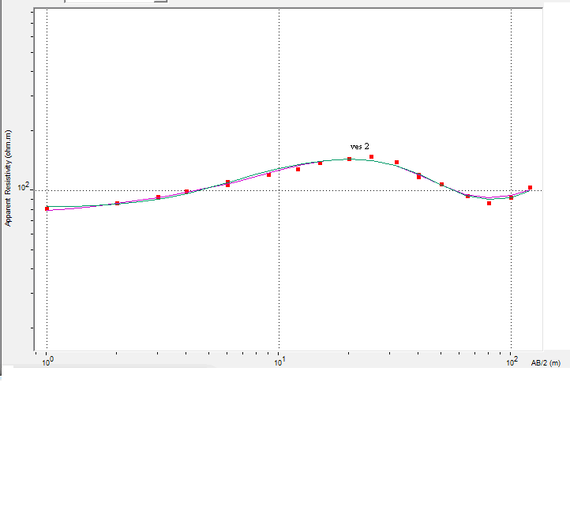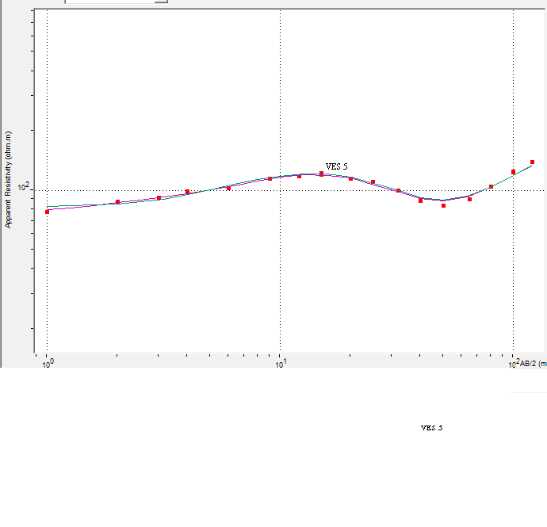
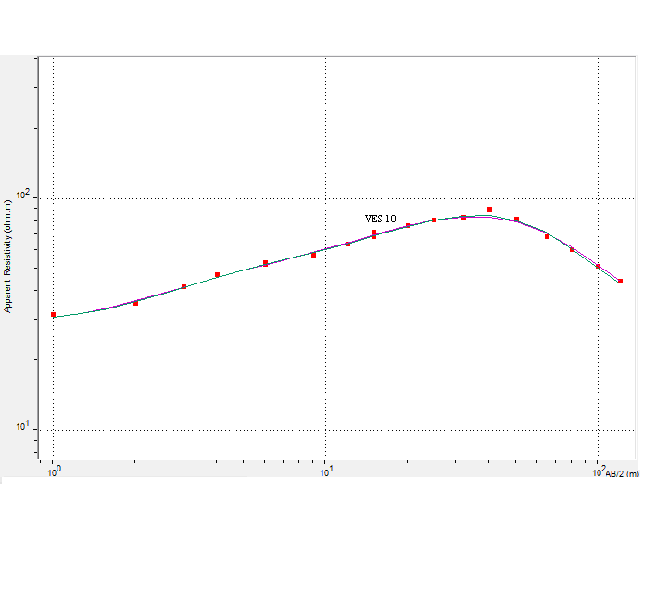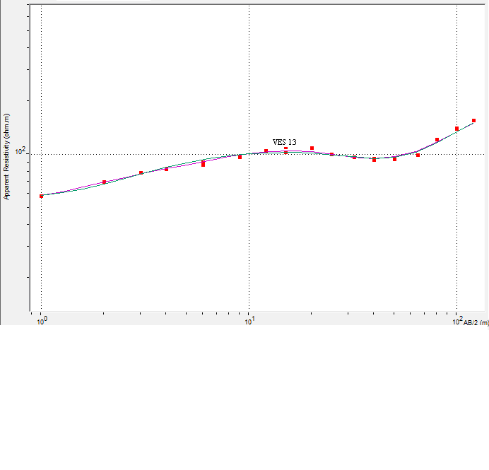

Fig 2: Representative sample of 1D model resistivity curves.

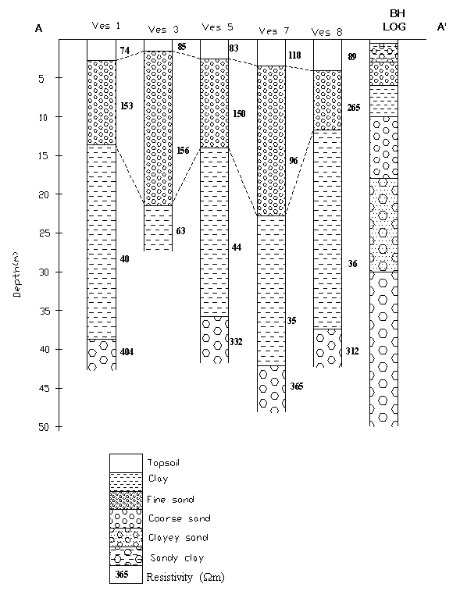
Fig 3a: Geoelectric section across A to A' beneath VES 1, 3,5,7 & 8 correlated with available borehole log.

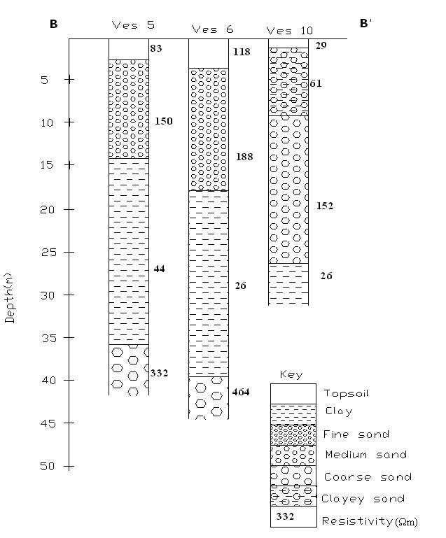

Fig 3b: Geoelectric section across B to B' beneath VES 5, 6 and 10.

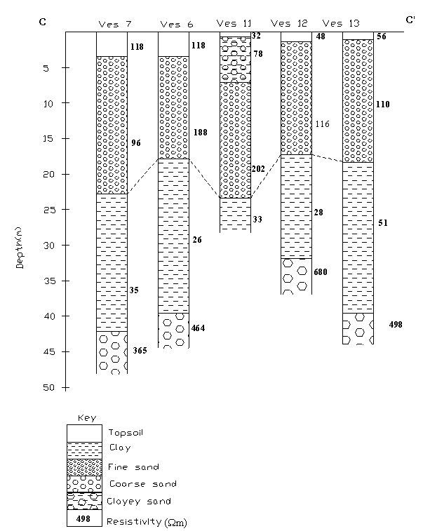
Fig 3c: Geoelectric section across C to C' beneath VES 7, 6, 11, 12 and 13

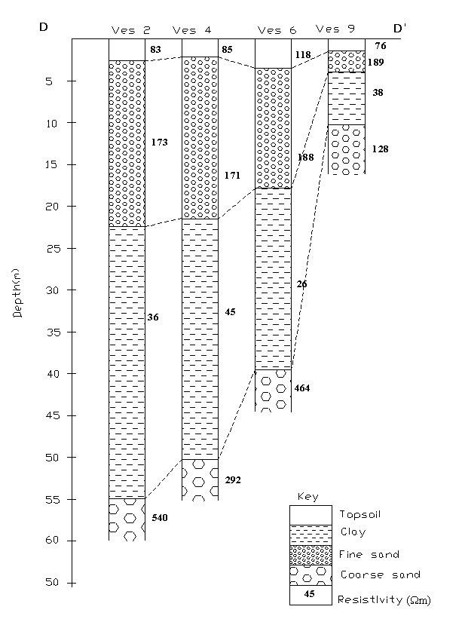

Fig 3d: Geoelectric section across D to D' beneath VES 2, 4, 6 and 9.

Fig 4: Isopach map of sand layers.

Fig 5: Isopach map of depth to clay layers.

Fig 6: Isopach map of thickness of clay layers.

Fig 7: Isopach map of depth to groundwater table.

Fig 8: Isoresistivity depth-slice map at 3m.

Fig 9: Isoresistivity depth-slice map at 7m.

Fig 10: Isoresistivity depth-slice map at 10 m.

Fig 11: Isoresistivity depth-slice map at 15 m.

Fig 12: Isoresistivity depth-slice map at 25 m.

Table 1: Interpreted resistivity measurements.

VES Station | Layer | Resistivity  (Ωm) | Thickness (m) | Depth (m) | Lithology
1 | 1 | 73.54 | 2.78 | 2.78 | Topsoil (clayey sand)
1 | 2 | 153.07 | 10.86 | 13.64 | Fine sand
1 | 3 | 39.68 | 25.06 | 38.7 | Clay
1 | 4 | 403.58 | - |  | Coarse Sand
2 | 1 | 83.17 | 2.63 | 2.63 | Topsoil (clayey sand)
2 | 2 | 173.29 | 19.83 | 22.46 | Fine sand
2 | 3 | 36.06 | 32.49 | 54.95 | Clay
2 | 4 | 539.92 | - | - | Coarse Sand
3 | 1 | 85.13 | 1.56 | 1.56 | Topsoil (clayey sand)
3 | 2 | 155.95 | 19.87 | 21.43 | Fine sand
3 | 3 | 62.54 | - | - | Clay
4 | 1 | 84.81 | 2.19 | 2.19 | Topsoil (clayey sand)
4 | 2 | 170.98 | 19.31 | 21.5 | Fine sand
4 | 3 | 44.6 | 28.73 | 50.23 | Clay
4 | 4 | 292.17 | - | - | Coarse Sand
5 | 1 | 83.17 | 2.51 | 2.51 | Topsoil (clayey sand)
5 | 2 | 149.72 | 11.5 | 14.01 | Fine sand
5 | 3 | 43.82 | 21.79 | 35.8 | Clay
5 | 4 | 332.29 | - | - | Coarse Sand
6 | 1 | 118.42 | 3.5 | 3.5 | Topsoil (clayey sand)
6 | 2 | 187.98 | 14.33 | 17.83 | Fine sand
6 | 3 | 26.34 | 21.71 | 39.54 | Clay
6 | 4 | 463.93 | - | - | Coarse Sand
7 | 1 | 118.22 | 3.45 | 3.45 | Topsoil (clayey sand)
7 | 2 | 95.92 | 19.37 | 22.82 | Fine sand
7 | 3 | 34.73 | 19.29 | 42.11 | Clay
7 | 4 | 364.82 | - | - | Coarse Sand
8 | 1 | 89 | 4.11 | 4.11 | Topsoil (clayey sand)
8 | 2 | 265.24 | 7.64 | 11.75 | Fine sand
8 | 3 | 35.9 | 25.59 | 37.34 | Clay
8 | 4 | 311.76 | - | - | Coarse Sand
9 | 1 | 76.42 | 1.45 | 1.45 | Topsoil (clayey sand)
9 | 2 | 188.58 | 2.53 | 3.98 | Fine sand
9 | 3 | 38.24 | 6.26 | 10.24 | Clay
9 | 4 | 127.53 | - | - | Medium Sand
10 | 1 | 29.43 | 1.14 | 1.14 | Topsoil (clayey sand)
10 | 2 | 61.42 | 7.88 | 9.02 | clayey sand
10 | 3 | 152.25 | 17.27 | 26.29 | Medium sand
10 | 4 | 26.36 | - | - | Clay
11 | 1 | 31.72 | 0.68 | 0.68 | Topsoil (clayey sand)
11 | 2 | 78.05 | 6.44 | 7.12 | Clayey sand
11 | 3 | 201.97 | 16.22 | 23.34 | Fine sand
11 | 4 | 32.87 | - | - | Clay
12 | 1 | 48.29 | 1.4 | 1.4 | Topsoil (clayey sand)
12 | 2 | 115.97 | 15.86 | 17.26 | Fine sand
12 | 3 | 28.31 | 14.59 | 31.85 | Clay
12 | 4 | 679.81 | - | - | Coarse Sand
13 | 1 | 55.98 | 1.09 | 1.09 | Topsoil (clayey sand)
13 | 2 | 109.57 | 17.3 | 18.39 | Fine sand
13 | 3 | 51.23 | 21.18 | 39.57 | Clay
13 | 4 | 497.55 | - | - | Coarse Sand

Correspondence to:
Oyedele, K. F. and Bankole, O. O.
Department of Physics (Geophysics Programme)
University of Lagos, Nigeria
kayodeunilag@yahoo.com

References
Gowd, S.S. (2004). Electrical resistivity surveys to delineate groundwater potential aquifers in Peddavanka watershed, Ananatapur District, Andhra Pradesh, India. Jour. of Environmental Geology. Vol. 46, 118 – 131pp.
Kampsax, K. and Sshued, P.(1987).Hydrogeology of Lagos metropolis, A report submitted to the Ministry of works and Housing. Open File Records. 205pp.
Jones, A.A. and Hockey, R.A. (1964).The geology of part of Southern Nigeria. Geol.Survey, Nigeria. Bull. 31,101pp.
Neil, A. and Ahmed,I. (2006).A generalized protocol for selecting appropriate geophysical techniques. Dept.of Geol. and Geophys.University of Missouri-Rolla, Rolla, Missouri, 19pp.
Lambe, W. T. and Whitman, V. R. (1979). Soil Mechanics, S.I.Version. John Wiley and Sons. 530pp.
Susan, E.P. (2004). The role of geophysics in 3-D mapping. Geol. Survey. Canada. ON, KIA 0E8, Canada 61-65pp.
Oyedele, K. F.(2006). Geoelectric mapping of saline water intrusion into the coastal aquifers of Lagos, Nigeria (Ph.D Thesis), 102pp.
Telford, W. M., Geldart, L. P. and Sheriff, R.E .(1990). Applied geophysics. Cambridge University Press.
Ward, S. P. (1990). Resistivity and induced polarization method. In Ward, S. P. (edition). Geotechincal and Environmental Geophysics vol. 1. Investigation in Geophysics, No.5. SEG; Tulsa Oklahoma.

12/3/2008

