ENHANCEMENT OF THERMAL CAPABILITIES OF A SOLAR CONCENTRATOR

I. O. Ohijeagbon¹, A. S. Adekunle², and O.D. Awolaran
^{1 & 2} Department of Mechanical Engineering, University of Ilrorin, P. M B 1515, Ilorin, Nigeria
¹ idehaiohi@yahoo.com

ABSTRACT
In order to continue to explore the enormous potential of solar energy as a veritable source of energy, physical constraints inherent in science and technological must steadily be converted to advantageous concepts and processes. This study investigates methods for enhancing thermal capabilities of a parabolic dish solar collector or concentrator. Optical lenses of different focal lengths and diameters were utilised to determine various output characteristics of thermal radiation. Convergent temperature (T_{c}), rate of energy emitted ($q$), and intensity of radiation ($i_{n}$) were found to increase with steady increase in ambient temperature (T_{a}). Larger diameter lenses and shorter focal length lenses were more advantageous than smaller diameter lenses and longer focal length lenses in producing higher thermal outputs respectively. It was further observed that actual drop in thermal outputs are obtained with lenses of 15 and 30 cm focal lengths compared with no-lens condition at upward of 31 ⁰C of ambient temperature. Also, the farther away the temperatures measured, the lower the thermal output temperature. This was as a result of radiation effects from the collector which influenced the output temperatures around the lenses. The study therefore concluded that enhanced thermal capabilities of solar energy devices operating on thermal radiations could be achieved by this method.
Key words: thermal capabilities, concentrator, optical lenses, converged temperature, rate of energy emitted, and intensity of radiation.

1. INTRODUCTION
In view of increasing interest of finding enhanced and effective temperature output and thermal capabilities of solar energy radiations, which is described by Adegoke and Bolaji (2000) as the most attractive energy source for the future; this work is intended to further corroborate various existing methods and applications of solar energy devices operating on principles of thermal radiations. Many areas of applications of solar energy devices such as, solar cooker, solar furnaces, cooling of building, solar water and air heating, solar drying, among others, show that obviously, the availability of solar energy that have lend to very useful researches, which have continued to show that it is a safe and environmentally friendly source of energy in enhancing and transforming hitherto traditional techniques to modern scientific methods on energy utilisation and applications (Mc Veigh, 1977, Adegoke, 1998, Pelemo et al., 2002). Solar radiation does not contaminate environment or endanger ecological balance. It avoids major problems like exploration, extraction and transportation (Rajput, 2006). More so that mankind and especially engineering is today facing one of the most severe challenges ever. Present energy engineering leads to resource depletion and environmental destruction. Thus we need to develop energy engineering in harmony with nature (Wall, 2002).
Being a free gift of nature, solar energy is in most abundant supply compared with other naturally existing forms of energy such as fossil fuel, coal, oil and natural gas which are fast depleting due to increased global dependence on energy (Richard, 1984); hence more effective methods of exploring its use should be encouraged. Solar energy is not only inexhaustible, it is non-polluting and therefore can be utilised to provide all our energy needs (Richard, 1977). The finiteness of the fossil-fuel-based sources of energy has brought home to mankind the stark reality of the need to develop other sources of energy. Hence, an upsurge of small and large scale renewable energy programmes all over the world (Bamiro, 1983).
The enormous potential of solar energy as a veritable source of energy is in no doubt, however, its effective exploration and utilisation is determined by the extent and limitations that science and technological advances may allow. Although the total amount of energy is enormous, the collection and conversion of solar energy into useful forms must be carried out over a large area which entails a large capital investment (Rajput, 2006). In the past, the exploitation of solar energy reaching the earth’s surface as a viable alternative energy source has been pursued vigorously through the development of different solar powered systems with varying degrees of efficiencies (Pelemo et al., 2002).
This study therefore is aimed at investigating methods of enhancement of thermal capabilities of a parabolic dish solar collector or concentrator. The process involves the use of optical lenses of different focal lengths and diameters to determine the output characteristics of temperature, rate of energy emitted, and intensity of radiation respectively. Improvements in thermal capabilities as a result of implementation of the optical lenses will lead to very useful information and optimised processes of solar energy devices operating on thermal radiations.

2. THEORETICAL FRAMEWORK
According to Rogers and Mayhew (1992), the framework for establishing the total energy emission per unit time by unit area of a surface and also for the intensity of radiation of a surface is hereby given.
The total energy emitted per unit time by unit area of a black surface is proportional to the 4th power of the absolute temperature T. This relation is expressed by the Stefan-Boltzmann law:
$q_{b}={σT}^{4}$ (1)
where, $σ$ = Stefan-Boltzmann constant = 56.7 x 10⁻¹² KW/m²K⁴
The spatial distribution of energy emission from an element can be represented as follows:
${\text{dQ}}_{\text{bn}}=i_{n}{\text{dw}}_{n}\text{dA}$ (2)
${\text{dQ}}_{bφ}=i_{φ}{\text{dw}}_{φ}\text{dA}$ (3)
where, ${\text{dQ}}_{\text{bn}}$ is the rate of flow of energy through dA₁ and ${\text{dQ}}_{bφ}$ is the rate of flow of energy through dA₂.
i_{n} is the intensity of radiation in the normal direction and i_{φ} is the intensity of radiation in the φ direction.
The spatial distribution of i_{φ} is expressed by Lambert’s cosine law:
$i_{φ}=i_{n}\text{cos}φ$ (4)
Combination of equations (3) and (4) gives:
${\text{dQ}}_{bφ}=i_{n}\text{cos}φ\text{dw}\text{dA}$ (5)
The solution of equation (5) gives:
$Q_{b}=i_{n}π\text{dA}$ (6)
Equation (1) can be re-written as:
$Q_{b}={σT}^{4}\text{dA}$ (7)
Combination of equations (6) and (7) gives:
$i_{n}=\frac{{σT}^{4}}{π}$ (8)
This equation, giving the intensity of normal black radiation, is a consequence of the Stefan-Boltzmann law and Lambert’s law.
Therefore for a grey body the following laws are valid:
$q={εq}_{b}=\text{εσ}T^{4}$ (9)
$i_{n}=\frac{\text{εσ}T^{4}}{π}$ (10)
where $ε$= total hemispherical emissivity or simply emissivity, and is defined as the ratio of the total energy $q$emitted by a surface to the total energy $q_{b}$ emitted by a black surface at the same temperature.
Thus, $ε={\left(\frac{q}{q_{b}}\right)}_{T}$ (11)
The ratio of the total hemispherical emissivity to the normal emissivity $εε_{n}$is equal to unity for a grey body. Assuming a glass as a silver polished surface, its normal emissivity$ε_{n}$ is given as 0.02 (Rogers and Mayhew, 1992). Hence, $ε=ε_{n}$ for a grey body. Equations (9) and (10) are respectively used to analyse the experimental data collected.

3. MATERIALS AND METHODS
3.1 Conditions and Materials
The major equipment used to carry out this research study is a focusing type solar collector or concentrator. This collector was previously constructed by Gbodiyan and modified for better performance by Abiola (Gbodiyan, 2003, Abiola, 2003), and then used by Awolaran for research studies (Awolaran, 2005). The surface area of the collector surface is 1.1314 m² with an estimated focal length of 69 cm, obtained as a cumulative value from the pieces of mirrors attached to the collector surface.
The geographical location of Ilorin, Nigeria where the study was conducted is estimated as Latitude: 8.43 ⁰N, Longitude: 4.5 ⁰E and Altitude: 366m, percentage annual average of actual to theoretical hours of sunshine in a day: $nN$ = 53, where, n = actual hours of sunshine in a day, N = theoretical maximum possible sunshine hours in a day, solar irradiance: 640 (Fagbenle, 1990, NMA, 2005).
Three thermometers were used (0-45)⁰C, (0-100)⁰C and (0-350)⁰C respectively. Four converging lenses with the following specifications were use; 10 cm focal length lens (5 cm in diameter), 15 cm focal length lens (5 cm in diameter), 30 cm focal length lens (5cm in diameter) and 15 cm focal length lens (10 cm in diameter) respectively. The lenses were used to investigate the effects of the lens’ focal length and diameter respectively on the thermal output of the concentrator. A stop watch was used to time and monitor temperature changes within specific time-intervals during the experimental investigation.

3.2 Methods
The concentrator solar device without the use of lenses was positioned to ensure no shading effect and to guarantee a maximum radiation from the sun, between the hours of 12.00 noon and 2.00 pm when the experiment was conducted. During this period it was assumed that the sun radiation is at its peak. The concentrator laced was also placed so that the angle between the rays of the sun and the collector axis is minimised in order to obtain the maximum solar irradiance, that is, the total radiation incident on unit area of surface per unit time (Rogers and Mayhew, 1992). This was accomplished by making sure the shadow of the concentrator on the ground forms approximately a perfect circle and radiation rays approximately at a normal angle to the concentrator surface.
The (0-350)⁰C thermometer was placed at the region of convergence of the concentrator to measure the air temperature (T_{c}) at converging point. The (0-45)⁰C thermometer was placed at a distance of about 3 meters away from the concentrator system in order to measure the ambient air temperature (T_{a}) without undue interference or influences. The setting up of the apparatus was done 30 minutes before the commencement of taking the readings, so that the apparatus will adapt to the ambient state. The readings of T_{a} and T_{c} were taken and recorded at 10 minutes interval between the hours of 12.00 noon and 2.00 pm for Day 1, without the use of any lens. The entire procedure was repeated for Days 2, 3 and 4 respectively, fixing the converging lenses of different focal lengths at the region of convergence of the solar concentrator in order to investigate the effects of focal lengths of lenses on convergent temperatures. Therefore the (0-350)⁰C thermometer was now placed at the new region of convergence of the lenses, to measure the temperature (T_{c}) at the new focal point.
All the above procedure was repeated for 3 more weeks to get a better view of the variations of the parameters over time. Lenses of different surface areas/diameters was then used on the forth week respectively for another 3 days each to study the effects of lenses dimensions on convergent temperatures accordingly.

4. DISCISSION OF RESULTS
4.1 Effects of Lenses Focal Length on Radiation Output Characteristics
Table 1: average ambient and convergent temperatures of concentrator-using lenses with different focal lengths below shows the data collected for the ambient and convergent temperatures of the concentrator (Awolaran, 2005). These being the average values over a 3 weeks period, that is 29th August 2005 to 1st September 2005, 5th September 2005 to 8th September 2005, and 12th September 2005 to 15th September 2005 respectively. The data is for no lens condition and with lenses of 10 cm, 15cm and 30 cm focal lengths respectively with each of the lens been 5 cm in diameter.
The output characteristics of solar radiation indicates a consistent increasing temperature (T_{c}) of converged radiations with time with respect to increasing ambient temperatures (T_{a}) as shown in table 1, and figure 1: variation of energy emitted with time for different focal lengths of lenses respectively. Consequently, the rate of energy emitted ($q$), and intensity of radiation ($i_{n}$) given by equations (9) and (10) would also increase correspondingly with the exception of the ambient values which appears constant.
Figure 1 further reveals that higher thermal output characteristics are achievable with lens of shorter focal length of 10 cm compared with 15 and 30 cm lenses. It should however be noted that actual drop in thermal outputs are obtained with lenses of 15 and 30 cm focal lengths compared with no-lens condition at upward of 31 ⁰C of ambient temperature; this situation further reveals that the farther away the temperatures observed and measured from the primary solar collector at some significant point in the ambient temperature, the lower would be the thermal outputs with further increasing ambient temperatures. Hence, it can be deduced that thermal and radiation measurements through the lenses is also partly influenced by radiation effects from the collector.
4.2 Effects of Lenses Diameter on Radiation Output Characteristics
Table 2: average ambient and convergent temperatures of concentrator-using lenses with different diameters and Focal Lengths = 15 cm as shown below, the data collected is for the ambient and convergent temperatures of the concentrator for lenses of 5 and 10 cm diameter respectively (Awolaran, 2005); with each of the lens been 15 cm focal length. These being the average value of 3 days readings each for each lens. That is 31st August 2005, 7th September 2005 and 14th September 2005 for the 5 cm diameter lens, and 30th September 2005, 1st October 2005 and 3rd October 2005 for the 10 cm diameter lens respectively.
In addition to increasing convergent temperatures with respect time and increasing ambient temperatures as shown in table 2, figure 2: variation of energy emitted with time for different lenses diameters also reveals that appreciable gain can be achieved in the rate of energy emitted ($q$), and intensity of radiation ($i_{n}$) if an increased diameter lens is utilised in solar collector devices. Figure 2 also indicates equivalent values of the rate of energy emitted ($q$) for ambient measurement of both lenses, as their curves overlap one another.

5. CONCLUSION
From the results, the study shows that enhancement of thermal capabilities of a solar concentrator is achievable through the use of converging lenses. Larger diameter lenses should be preferred over smaller diameter ones as this will permit more radiation to be captured. And shorter focal lengths are more advantageous than longer focal lengths, as a result, allowing the converged radiation closer to the collector surface which is also influenced by thermal radiations from the solar collector itself. Hence, improved and optimised output characteristics of temperature, rate of energy emitted, and intensity of radiation respectively could be achieved and employed for better performances of solar energy devices operating on thermal radiations.

Table 1: Average Ambient and Convergent Temperatures of Concentrator-Using Lenses with Different Focal Lengths
Time | Average Ambient Temperature, T_{a} (⁰C) | Average Convergent Temperature, T_{c} (⁰C)
Time | Average Ambient Temperature, T_{a} (⁰C) | With No Lens | With Lenses Diameters = 5 cm
Time | Average Ambient Temperature, T_{a} (⁰C) | With No Lens | 10 cm Focal Length | 15 cm Focal Length | 30 cm Focal Length
12.00 noon | 29.50 | 45.00 | 49.33 | 45.67 | 49.33
12.10 pm | 30.00 | 41.67 | 53.00 | 46.00 | 50.33
12.20 pm | 30.17 | 48.33 | 52.67 | 47.33 | 52.00
12.30 pm | 29.92 | 46.67 | 52.67 | 46.67 | 43.00
12.40 pm | 30.17 | 47.67 | 52.67 | 50.00 | 47.67
12.50 pm | 30.25 | 48.33 | 55.00 | 50.33 | 53.67
1.00 pm | 31.17 | 53.00 | 54.67 | 54.33 | 59.67
1.10 pm | 31.33 | 59.33 | 63.67 | 57.00 | 53.33
1.20 pm | 31.67 | 61.67 | 62.00 | 55.00 | 57.33
1.30 pm | 31.67 | 60.33 | 65.33 | 53.67 | 54.67
1.40 pm | 31.75 | 65.67 | 70.00 | 58.33 | 58.67
1.50 pm | 31.83 | 65.33 | 71.00 | 61.67 | 63.00
2.00 pm | 32.33 | 68.33 | 80.67 | 65.00 | 63.67
Table 2: Average Ambient and Convergent Temperatures of Concentrator-Using Lenses with Different Diameters and Focal Lengths = 15 cm
Time | Average Values of Temperature
Time | 5 cm Diameter Lens |  | 10 cm Diameter Lens
Time | Ambient Temperature, T_{a} (⁰C) | Convergent Temperature, T_{c} (⁰C) | Ambient Temperature, T_{a} (⁰C) | Convergent Temperature, T_{c} (⁰C)
12.00 noon | 29.33 | 45.67 | 31.00 | 47.67
12.10 pm | 30.33 | 46.00 | 31.33 | 49.33
12.20 pm | 29.67 | 47.33 | 31.67 | 55.67
12.30 pm | 29.67 | 46.67 | 32.67 | 56.00
12.40 pm | 30.00 | 50.00 | 31.67 | 54.67
12.50 pm | 30.00 | 50.33 | 33.00 | 61.00
1.00 pm | 31.33 | 54.33 | 32.00 | 61.67
1.10 pm | 31.00 | 57.00 | 33.33 | 66.00
1.20 pm | 31.33 | 55.00 | 33.00 | 66.67
1.30 pm | 32.00 | 53.67 | 33.00 | 65.67
1.40 pm | 31.33 | 58.33 | 32.33 | 77.67
1.50 pm | 31.67 | 61.67 | 33.67 | 86.67
2.00 pm | 32.00 | 65.00 | 33.67 | 82.67

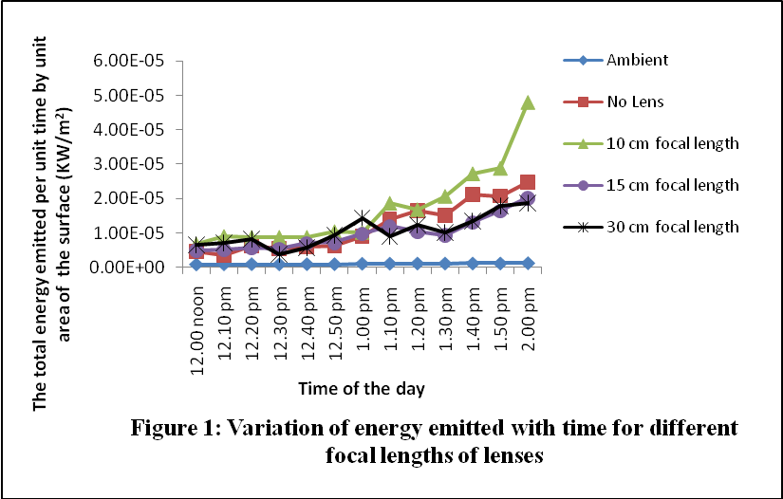
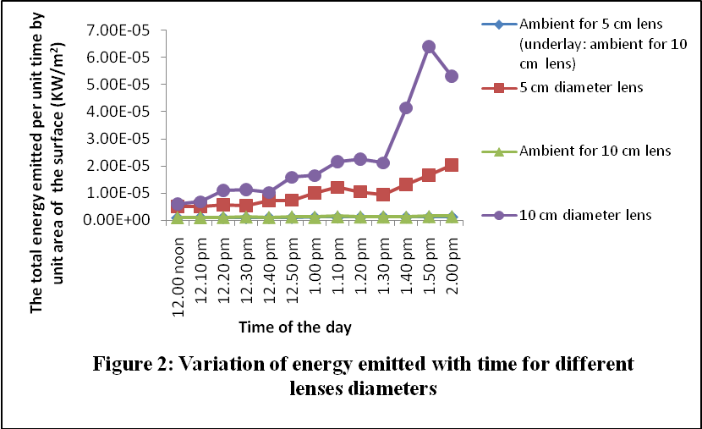

6. REFERENCES
Abiola, A. O. (2003), Temperature Magnification and Applications of a Parabolic Solar Energy Collector, B. Eng. Thesis, Department of Mechanical Engineering, University of Ilorin, Ilorin, Nigeria.
Adegoke, C. O. (1998), Alternative Energy Option for Nigeria as a Reaction to Impending Global Climate Change, Journal of Science, Engineering and Technology, Vol. 5(3), pp1341-1348.
Adegoke, C. O. and Bolaji, B. O. (2000), Performance Evaluation of Solar-Operated Thermosyphon Hot Water System in Akure, International Journal of Engineering and Engineering Technology, School of Engineering and Engineering Technology, Akure, Nigeria, Vol. 5(1), pp35-40.
Awolaran, O. D. (2005), Investigation of Methods of Increasing Temperature of a Parabolic Solar Energy Collector, B. Eng. Thesis, Department of Mechanical Engineering, University of Ilorin, Ilorin, Nigeria.
Bamiro, O. A. (1983), Empirical Relations for the Determination of Solar Radiation in Ibadan, Nigeria, Solar Energy, Pergamon Press Ltd., UK., Vol. 31(1), pp85-94.
Fagbenle, R. L. (1990), Estimation of Total Solar Radiation in Nigeria Using Meteorological Data, Nigerian Journal of Renewable Energy, Vol. 1, pp1-10.
Gbodiyan, M. F. (2003), Design and Construction of a Solar Steam Producer, B. Eng. Thesis, Department of Mechanical Engineering, University of Ilorin, Ilorin, Nigeria.
Mc Veigh, J. C. (1977), Sun Power, An Introduction to Application of Solar Energy, Pergamon Press, London.
Nigerian Meteorological Agency (NMA, @ 2005), Record of Climatic Conditions in Ilorin (September 2002-August 2005), Federal Airport Authority, Ilorin, Nigeria.
Pelemo, D. A., Fasasi, M. K., Owolabi, S. A., and Shaniyi, J. A. (2002), Effective Utilisation of Solar Energy for Cooking, NJEM, Vol. 3(1), pp13-18.
Rajput, R. K. (2006), Thermal Engineering, Laxmi Publications (P) Ltd., New Delhi.
Richard, C. D. (1984), Energy Resources and policies, Academic Press, New York.
Richard, J. W. (1977), Solar Energy Technology and Application, Ann Arbor Science, New York.
Rogers, G. F. C. and Mayhew, Y. R. (1992), Engineering Thermodynamics-Work and Heat Transfer, Longman Group, UK. Ltd.
Wall Goran (2002), Conditions and Tools In the Design of Energy Conversion and Management Systems of a Sustainable Society, Energy Conversion and Management Vol. 43, pp1235–1248, www.elsevier.com/locate/enconman

