An Incidence of Substratum Discolouration in a Tropical West African Lagoon.

Onyema, I.C. and Nwankwo, D.I.
Department of Marine Sciences, University of Lagos, Nigeria.

I.C. ONYEMA Ph.D.
Dept. of Marine Sciences
Faculty of Science
University of Lagos, Akoka.
Lagos, Nigeria.
iconyema@yahoo.com.au, iconyema@gmail.com
+2348023446934, +2348060442323
12/13/2008
Abstract
A greenish discolouration of the lagoon floor at the Bayeku area of the Lagos lagoon was observed in January 2006. We report here an investigation of the area between December, 2005 and Feburary, 2006 as part of a larger study. A total of 19 species from 13 genera were reported. Oscillatoria tenuis (95,800 trichomes per ml) was implicated as the causative organism for the substratum discolouration. Increased insolation, especially reaching the lagoon floor, low salinity, absence of flood conditions, suitable sediment type (fine – medium sand) and high nutrient (PO₄ - P > 0.24 mg/L; NO₃ – N > 4.40mg/L) levels possibly encouraged the algal proliferation and subsequent substratum discoloration. It is suggested that improving water quality indices and salinity after January caused the disappearance of the discolouration on the substratum.

Keywords: algae, water quality indices, substratum.
Corresponding author: iconyema@gmail.com
INTRODUCTION.
Coastal algal blooms respond to nutrient load from anthropogenic sources (Lee, 1999; Onyema, 2007). South-western Nigeria is endowed with an intricate network of rivers, creeks and lagoons, that serve as conduits transferring highly nutrified waters from hinterland to coastal areas. Bloom conditions have been reported in some of these waters (Nwankwo et al., 2003a; Nwankwo et al., 2008). Blooms of Microcystis aureginosa, M. flos-aquae and M. wesenbergii were reported in the Lagos lagoon (Nwankwo, 1993), Ogun river at Iju (Nwankwo, 1993) causing bluish colouration, anoxia, odour, impacting taste to the water (Nwankwo et al., 2003a) and kuramo lagoon (Nwankwo et al., 2008). Blooms of Trichodesmium thiebautii have also been reported off the Lagos coast (Nwankwo, 1993) during thermocline conditions and more recently a bloom of Bellerochea malleus that caused brownish discolouration off the Light house beach, Lagos (Nwankwo et al., 2004) was documented. Blooms of Anabaena flos-aquae, A. spiroides (cyanobacteria), Cerataulina bergoni, Chaetoceros convolutus, Coscinodiscus centralis (diatoms) and Ceratium furca, C. fusus, C. tripos and Noctiluca scntillans (dinoflagellates) are known to induce harmful effects in waters of south-western Nigeria (Nwankwo, 1993; Nwankwo et al., 2003a, b, Onyema, 2008). There is at present a report of substratum discolouration in the Lagos lagoon system (Onyema and Nwankwo, 2006) implicating Beggiatoa alba and Oscillatoria spp as causative species.

Between December, 2005 and Feburary, 2006, a greenish discolouration of the substratum at Bayeku was observed and thoroughly investigated. We report here the composition of the organisms before, during the bloom period and after the collapse. Water quality indices before, during and after the substratum discolouration were also estimated and investigated. This report is part of a larger study that was already ongoing at the time of the occurrence.
MATERIALS AND METHODS.
Description of study area.
The Lagos lagoon opens into the sea via the Lagos habour all through the year. The tidal height is low (<1.5m) and the tidal exchange weak. It is shallow (<2m) and connected to the Epe lagoon to the east. The area investigated was (Fig 1) the Bayeku area of the Lagos lagoon (Latitudes 6⁰ 32^{l}N and 6⁰ 31^{l}N and Longitudes 3⁰ 31^{l}E and 3⁰ 32^{l}E). A greenish, slimy covering of suspected algae on the lagoon floor was observed for the very first time in this area. Nutrient rich water is known to flow from eutrophic creeks and creeklets systems in the area. Furthermore, poor sewerage systems are the common state of the rural dwellers of the immediate area. Hence direct dumping of domestic wastes is carried out in the closet water body.

Collection of samples
Water samples for determining water quality characteristics were collected at the site before substratum sample collection. The boat was anchored throughout sample collections. Water samples were collected in 1L plastic bottles with screw cap from 0.5m depth from the water surface. This was labeled and transported to the laboratory for chemical analysis.

Substratum samples (top 5cm) were collected within a 5cm² quadrat carefully placed on the greenish material / lagoon floor. A spatula was gently used underwater to scrape the topmost part. After carefully scooping up the greenish scum, it was gently spooned into a plastic bag while still underwater. Duplicate samples were collected on each occasion. Out of water and in the boat, samples were transferred to 75cl screw capped plastic containers. Samples were fixed with formalin (4% unbuffered) and labeled appropriately on the field before onward transportation to the laboratory. This process was carried out on each sampling occasion.

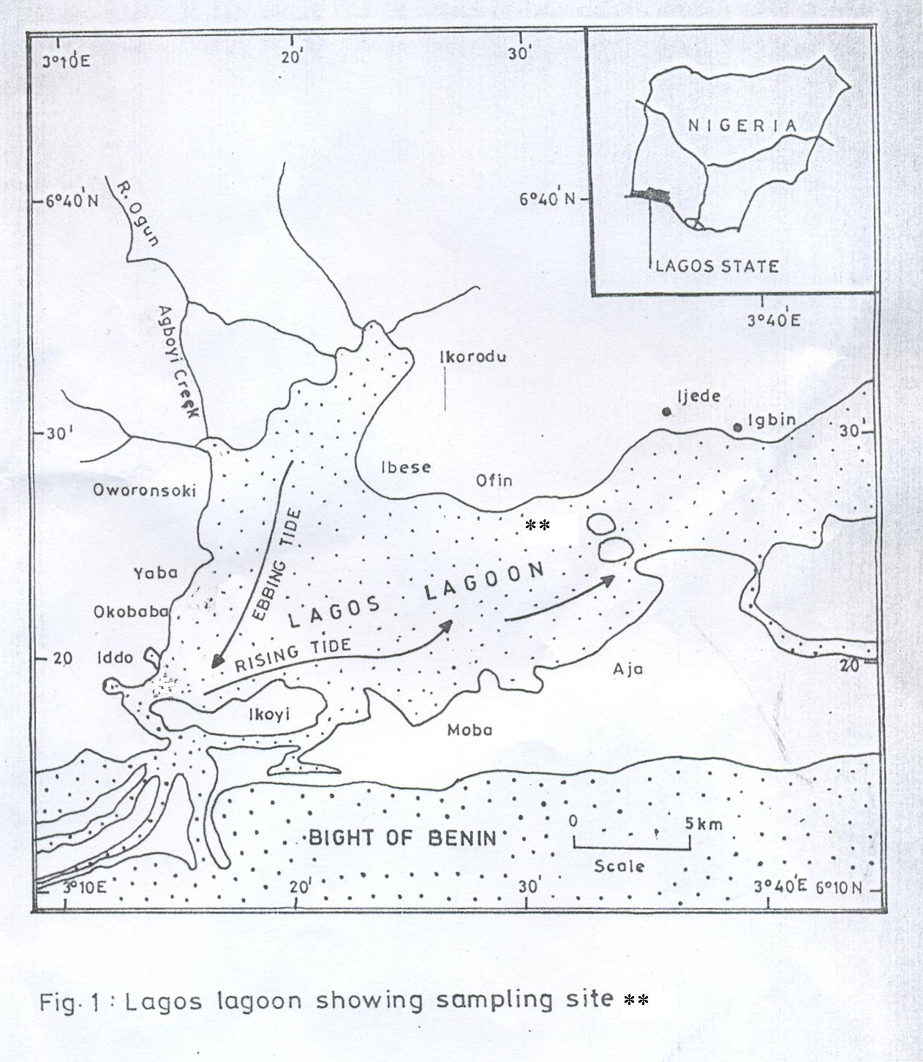

Physico-chemical analysis
Air and surface water temperatures were measured in-situ using a mercury thermometer while water depth was estimated with a calibrated pole. Total dissolved solids was determined by evaporating 100ml aliquot at 105ºC and total suspended solids estimated by filtering 100ml of sample through a pre-weighed filter paper, dried to constant weight and reweigh. Conductivity was measured using the HANNA instrument while salinity was determined using the silver-nitrate chromate method. The surface water pH was determined with a Griffin pH meter (Model 80) while dissolved oxygen was measured using a Griffin oxygen meter (Model 40). Biological and chemical oxygen demands were measured using methods described in APHA (1998) for water analysis. Calorimetric methods using a Lovibond Nesslerier were adopted for the direct determination of phosphate-phosphorus and nitrate-nitrogen values while sulphate levels were measured using the gravimetric method. Calcium and magnesium ions were determined using a 400 single channel, low flame photometer. Concentrations of copper, iron and zinc were determined with an atomic absorption spectrophotometer (A.A.S.) Uni cam 99model.

Biological Analyses
In the laboratory, the drop count microscope analysis method described by Onyema (2007) was used to estimate the substratum algal flora. Microscope analysis was carried out on samples within 48hours of collection. Identification materials were used to assist and confirm identification of species (Smith 1950; Hendey, 1958, 1964; Desikachary, 1959; Wimpenny, 1966; Patrick and Reimer, 1966, 1975; Whitford and Schmacher, 1973; Vanlandingham, 1982; Nwankwo, 1990, 2004a; Bettrons and Castrejon, 1999; Siver, 2003; Rosowski, 2003).
RESULTS.
Physico-chemical.
Air (31 - 32 ºC) and water (30 - 31 ºC) temperatures were high through out the sampling period while the sampling depth was averagely 1.31m. The water remained slightly alkaline throughout the study (7.01 – 7.10). The total dissolved solids (20 - 33 mg/L), salinity (2.30 - 20.60 º/_{oo}), chloride content (770.0 – 6930 mg/L), conductivity (2335 – 12,500 µS/cm), acidity (3.0 - 8.8 mg/L), alkalinity (28.5 - 100.3 mg/L), total hardness (562.5 - 4687.0 mg/L), sulphate (6.1 – 60 mg/L) and cation content (Calcium 111- 500, Magnesium 35.6- 859 mg/L) increased as the dry season progressed, while there was a corresponding decrease in total suspended solids (1590 – 8260 mg/L), nitrate (2.5 - 4.8 mg/L), biological (5 - 11mg/L) and chemical oxygen demands (10 – 49 mg/L) and heavy metals levels (Iron 0.14 - 0.35, Zinc 0.003 - 0.006mg/L) (Table 1).

With regard to the algae, just one species each was recorded for December 2005 (Microcystis aureginosa Kutzing) and January 2006 (Oscillatoria tenuis Agardh), However, 17 species were recorded in February (Table 2). Although, total biomass in terms of cell numbers was high in January (95,800 trichomes per ml) it was for a sole species. This organism (Oscillatoria tenuis Agardh) is the implicated microalgae responsible for the greenish discolouration of the lagoon floor at Bayeku. Furthermore, February recorded 3 cyanobacteria, 8 centric diatoms and 6 pennate diatoms species. Actinophycus splendens Ralfs and Biddulphia laevis Ehrenberg were important diatoms and Oscillatoria limnosa Agardh for the cyanobacteria in terms of numbers in February.
Table 1: Monthly variation in water quality characteristics at Bayeku area of the Lagos lagoon (Dec., 2005 – Feb., 2006).

Physico-chemical parameters | Dec., 2005 | Jan., 2006 | Feb., 2006
Air temperature (ºC) | 32 | 31 | 31
Water temperature (ºC) | 30 | 31 | 30
Depth (m) | 1.42 | 1.24 | 1.41
Total Suspended Solids (mg/L) | 33 | 27 | 20
Total dissolved Solids (mg/L) | 1590 | 5120 | 8260
Salinity (º/_{oo}) | 2.30 | 9.20 | 20.60
Chloride (mg/L) | 770.0 | 3086.0 | 6930
Conductivity (µS/cm) | 2335 | 7877 | 12500
pH | 7.05 | 7.01 | 7.10
Acidity (mg/L) | 3.0 | 8.8 | 8.1
Alkalinity (mg/L) | 28.5 | 30.4 | 100.3
Total Hardness (mg/L) | 562.5 | 360.0 | 4687.0
Nitrate- Nitrogen (mg/L) | 4.4 | 4.8 | 2.5
Sulphate (mg/L) | 6.1 | 10.8 | 60
Phosphate- Phosporus (mg/L) | 0.24 | 0.26 | 0.04
Silica (SiO₂ mg/L) | 1.9 | 2.6 | 2.1
Dissolved Oxygen (mg/L) | 5.5 | 4.2 | 4.3
Biological Oxygen Demand (mg/L) | 11 | 9 | 5
Chemical Oxygen Demand (mg/L) | 49 | 27 | 10
Calcium (mg/L) | 165 | 111 | 500
Magnesium (mg/L) | 35.6 | 50 | 859
Copper (mg/L) | 0.002 | 0.002 | 0.002
Iron (mg/L) | 0.35 | 0.22 | 0.14
Zinc (mg/L) | 0.005 | 0.006 | 0.003

Table 2: Substratum algal composition (before, during and post bloom ) at Bayeku (per ml).
Algal Taxa | Dec., 2005 | (Bloom)  Jan., 2006 | Feb., 2006
Class – Cyanophyceae
Order I – Chrooccocales
Microcystis aureginosa Kutzing | 170 | - | -
Order II – Hormogonales
Lyngbya limnetica Lemm | - | - | 5
Oscillatoria curviceps C.A. Agardh | - | - | 10
Oscillatoria limnosa Agardh | - | - | 60
Oscillatoria tenuis Agardh | - | 95,800 | -
Class – Bacillariophyta
Order I - Centrales
Actinophycus splendens (Sch adbolt) Ralfs | - | - | 205
Biddulphia laevis Ehrenberg | - | - | 125
Coscinodiscus centralis Ehrenberg | - | - | 10
Coscinodiscus eccentricus Ehrenberg | - | - | 10
Coscinodiscus radiatus Ehrenberg | - | - | 5
Cyclotella meneghiniana Kutzing | - | - | 15
Melosira moniliformis (O.F. Muller) Agardh | - | - | 10
Melosira nummuloides Agardh | - | - | 35
Order II – Pennales
Cymbella affinis Kutzing | - | - | 15
Navicula mutica Kutzing | - | - | 5
Nitzschia palea (Kutzing) Wm Smith | - | - | 5
Pleurosigma angulatum (Quekett) Wm Smith | - | - | 55
Pleurosigma elongatum Wm Smith | - | - | 15
Synedra crystallina Kutzing | - | - | 20
Number of species (S) | 1 | 1 | 17
Species abundance (N) | 170 | 95,800 | 605

DISCUSSION.
The water quality status at the site ranged between low and high brackish water conditions. Low brackish condition (S=2.30‰) was experienced in December while high brackish condition (>9.20‰) reflected the dry months. As the rain ceased, turbidity reduced while transparency increased. Furthermore, insolation increased probably reaching the lagoon floor. This coupled with high nutrient levels (PO₃²⁻ > 0.24mg/L, NO₃⁻ > 4.4mg/L, SO₄²⁻ >6.1mg/L), low brackish condition (<9.2⁰/₀₀) and low depth (<1.42m), favorable sediment type (fine – medium sand) and absence of flood conditions probably encouraged the proliferation of the epipelic algal population in January. According to Valangdiham (1982), Oscillatoria tenius, the causative cyanobacterium, in the substratum discolouration, is a saprobiont which can exist either as plankton or as an attached form. Palmer (1969) reported that Oscillatoria tenuis is the second most tolerant Oscillatoria species to organically induced stress. It’s important to note that both sole species in December and January are known pollution tolerant cyanobacteria forms for the region (Nwankwo, 2004b). Importantly, the highest level of nitrate (4.8 mg/L) recorded for this study was in January at the time of the greenish occurrence.

Oscillatoria spp are reported in literature to have wide tolerance limits to pH, salts and organically enriched environments (Valangdiham, 1982; Lee, 1999; Nwankwo, 2004b; Onyema, 2008). In Nigeria, Onyema et al., (2003) has reported Oscillatoria tenius in organically polluted parts of Lagos lagoon. Similarly, Chindah and Pudo (1991) have reported Oscillatoria tenius from the Bonny river associated with oil related effluent. According to Valangdiham (1982) Oscillatoria species are heavily favoured in organically nutrified waters. The existence of high BOD levels in excess of 9mg/L at this site may be pointer to the probably stressed water quality status. According to Hynes (1960), BOD above 8.0mg/L may indicate severe organic pollution.

The disappearance of the bloom in February may be associated with increased salinity (≥20.6⁰/₀₀) and reduced nutrient load (PO₄ – P 0.04mg/L; NO₃-N = 2.05mg/L). Onyema and Nwankwo (2006) reported a high abundance of epipelic algal forms in the dry months at some organically polluted sites of an estuarine creek in Lagos.

This investigation highlights the bane of increasing levels of pollutants from anthropogenic sources in the Lagos lagoon and the role of algal indicators in capturing changes in water quality.

REFERENCES.
American Public Health Association. (1998). Standard Methods for the Examination of Water and Waste Water. 20th ed. APHA New York. 1270pp.
Bettrons, D.A.S. and Castrejon, E.S. (1999). Structure of benthic diatom assemblages from a mangrove environment in a Mexican subtropical lagoon. Biotropica. 31(1): 48 – 70.

Chinda, A.C and Pudo, J. (1991). A preliminary checklist of algae found in plankton of Bonny River
in Niger Delta, Nigeria. Fragm flor. Geobot.36 (1): 112-126.

Desikachary, T.V. (1959). Cyanophyta. Indian Council of Agric. Research, New Delhi. 686pp.
Hendey, N.I. (1958). Marine diatoms from West African Ports. Journal of Royal Microscopic Society. 77: 28-88.

Hendey, N.I. (1964). An introductory account of the smaller algae of British coastal waters. Part
5. Bacillariophyceae (diatoms) London. N.M.S.O. 317pp.
Hynes, H.B. (1960). The biology of polluted waters. Liverpool University Press, Liverpool, 1-202 pp.

Lee, R.E. (1999). Phycology. Cambridge University Press, New York. 614pp.
Nwankwo, D.I. (1993). Cyanobacteria bloom species in coastal waters of South-Western Nigeria. Archiv Hydrobiologie Supplement. 90: 553-542.
Nwankwo, D.I. (1990). Contribution to the Diatom flora of Nigeria. Diatoms of Lagos lagoon and the adjacent sea. Nigerian Journal of Botany. 3: 53-70.

Nwankwo, D.I. (2004a). A Practical Guide to the study of algae. JAS Publishers, Lagos. Nigeria.
84pp.

Nwankwo, D.I. (2004b). The Microalgae: Our indispensable allies in aquatic monitoring and
biodiversity sustainability. University of Lagos Press. Inaugural lecture seris. 44pp.

Nwankwo, D.I., Onyema, I.C. and Adesalu, T.A.(2003a). A survey of harmful algae in coastal
waters of south-western Nigeria. Journal of Nigerian Environmental Society. 1(2). 241 – 246.

Nwankwo, D.I., Onyema, I.C., Adesalu, T.A., Olabode, R.J., Osiegbu, G.O. and Owoseni, T.I.
(2003b). Additions to a Preliminary Checklist of Planktonic Algae in Lagos lagoon, Nigeria. Journal of Science Technology and Environment. 3(1): 8 – 12.

Nwankwo, D.I., Onyema., I.C, Labiran, C.O., Otuorumo, O.A.; Onadipe, E.I.;, Ebulu, M.O. and
Emubaiye, N. (2004). Notes on the observations of brown water discolouration off the light house beach, Lagos, Nigeria. Discovery and Innovation. 16 (3). 111 – 116.

Nwankwo, D.I., Owoseni, T.I., Usilo, D.A., Obinyan I., Uche, A.C. and Onyema, I.C. (2008).
Hydrochemistry and plankton dynamics of Kuramo lagoon. Life Science Journal. 5 (3): 50 – 55.

Onyema, I.C. (2007). Mudflat microalgae of a tropical bay in Lagos, Nigeria. Asian Journal of Microbiology, Biotechnology and Environmental Sciences. 9 (4): 877 – 883.

Onyema, I.C. (2008). Phytoplankton biomass and diversity at the Iyagbe lagoon Lagos, Nigeria.
University of Lagos, Akoka. Department of Marine Sciences. 266pp

Onyema, I.C. and Nwankwo, D.I. (2006). The epipelic assemblage of a polluted estuarine creek in
Lagos, Nigeria. Pollution Research. 25(3): 459 - 468.

Onyema, I.C., Otudeko, O.G. and Nwankwo, D.I. (2003). The distribution and composition of
plankton around a sewage disposal site at Iddo, Nigeria. Journal of Scientific Research Development. 7: 11-24.

Smith, G.M. (1950). The fresh-water algae of the United States. McGraw-Hill, London.719pp

Siver, P.A. (2003). Synurophyte algae. In: Freshwater Algae of North America. Ecology and Classification. Wehr, J.D. and Sheath, R.G. (Eds). Academic Press, New York. pp 523 - 558.

Palmer, C.M. (1969). A composite rating of algae tolerating organic pollution. Journal of Phycology.
5(1): 78 – 82.

Patrick, R. and Reimer, C.W. (1966). The diatoms of the United States exclusive of Alaska and Hawaii (Vol. 1). Monogr. Acad. Nat. Sci. Philadelphia. 686pp.

Patrick, R. and Reimer, C.W. (1975). The diatoms of the United States exclusive of Alaska and Hawaii (Vol. 2, part 1). Monogr. Acad. Nat. Sci. Philadelphia. 213pp.

Rosowski, J.R. (2003). Photosynthetic Euglenoids. In: Freshwater Algae of North America. Ecology and Classification, Wehr, J.D. and Sheath, R.G. (Eds). Academic Press, New York. pp 383 – 422.

Round, F.E. (1953). An investigation of two benthic algal communities in Malham Tarn, Yorkshire.
J. Ecol. 41: 174-187.

Vanlandingham, S.L. (1982). Guide to the identification and environmental requirements and pollution tolerance of freshwater blue-green algae (cyanophyta). U.S. Environmental Protection Agency, EPA – 60.

Whitford, L.A. and Schmacher, G.H. (1973). A manual of freshwater algae. Sparks press Raeigh. 324pp.

Wimpenny, R.S. (1966). The plankton of the sea. Faber and Faber Limited, London. 426pp.

