Differential effects of amitriptyline treatment on testicular and liver functions in adult male rats

Mie Afify ¹, Mohamed Diaa El-dien Abd Elmaksoud¹, Tamer Mosa¹, Marwa Elshaer², Nahla Kotb³

¹Biochemistry Department, National Research Centre, Dokki, Egypt saodiaa@yahoo.com ; mieafify@yahoo.com
²Pathology Department, National Research Centre, Dokki, Egypt
³National Organization for Drug Control and Research (NODCAR), Egypt

Abstract:-
The aim of our study was to investigate the influence of exposure to amitriptyline treatment with different doses on the activity of liver and testicular indices; and examined these organs histopatholgically to confirm the effect of amitriptyline. This study conducted on 80 adult male rats. The 40 rats were divided into two groups according to received dose of amitriptyline (low & high doses) and the third group (20 rats) received toxic dose of cyclophosphamide to serve as a positive control, beside 20 healthy rats as a control group. After 30 days of treatment, the animals were sacrificed and blood & tissue samples were collected. The results showed that there was no significant difference in rats treated by low dose of amitriptyline as regards liver enzymes (ALT, AST & γGT), testicular functions (testosterone & prolactin levels, and spermatic count) and histopatholgically changes in the tissue of these organs. While the high dose showed significant difference in the liver and testicular functions proved by, the changes occurred in the liver and testicular tissue, which is like the toxic effect of cyclophosphamide. In conclusion, high dose of amitriptyline has toxic effects on the metabolic functions of the liver and reduction in the productive functions of the testis beside the toxic histopathological changes in the tissue of these organs. [New York Science Journal 2010;3(3):10-18]. (ISSN: 1554-0200).

Key Words: amitriptyline, liver, testis and cyclophosphamide

- Introduction
It is well known that treatment-emergent sexual dysfunctions occur with many antidepressive compounds. Antidepressants are widely prescribed for the chronic treatment of several anxiety disorders [Feighner, 1999, Zohar and Westenberg, 2000]. Amitriptyline the older tricyclic antidepressant used in the treatment of anxiety disorders [Feighner, 1999].
Amitriptyline hydrochlorate is a tricyclic antidepressant with sedative and analgesic properties [Bryson and Wilde 1996]. The mechanism of the sedation induced by amitriptyline is related to its antihistaminic actions while the analgesic mechanism is not fully understood, although γ2A–adrenoreceptors appear to have significant role [O’zdogan, et al, 2004]. This drug is approximately equally active as an inhibitor of serotonin reuptake and of NE reuptake [Diaz et al, 2008]. Tricyclic may also possess an affinity for muscarinic and histamine H1 receptors to varying degrees. Although the pharmacologic effect occurs immediately, often the patient's symptoms do not respond for 2 to 4 weeks [Thase et al, 2005]. Although norepinephrine and dopamine are generally considered stimulatory neurotransmitters, tricyclic antidepressants also increase the effects H1 histamine, and thus most have sedative effects [Landen et al, 2005].
The antidepressants are among those drugs, which cause toxic effects on much of organ system especially male reproductive system. About 15% of these drugs have adverse effects on hormonal levels and target organ like testes, which secrete hormones and produces male germ cells during spermatogenesis. Studies showed that the effects of antidepressant on sexual dysfunction are more than 60%. Effects of drugs on sexual dysfunction and spermatogenesis appear to be due to changes in hormones level such as testosterone, LH, FSH, prolactin and estrogen [Soghra et al, 2008].
The gonads and adrenals secrete several male sex hormones, called androgens. All are steroid hormones - that is, derived from cholesterol and containing a basic skeleton of four fused carbon rings. Testosterone is the most potent and abundant androgen. Gonadotropin-releasing hormone (GnRH) from the hypothalamus promotes anterior pituitary release of luteinizing hormone (LH) and follicle-stimulating hormone (FSH). LH stimulates the interstitial cells of Leydig in the testes to synthesize and secrete testosterone. Testosterone secretion occurs in pulsatile bursts, about six per day, with a morning peak and an early evening trough, and is regulated through a negative feedback on the hypothalamus and pituitary [Freeman et al, 2001].
Amitriptyline hydrochloride is a prescription medication that is used for the treatment of depression. As with any medicine, there are possible side effects with amitriptyline. Some of these side effects can affect a person's sexual well-being. In the case of amitriptyline, there have been a few sexual side effects reported, a decreased sex drive (libido). The effects of tricyclic antidepressants on the endocrine system can result in sexual dysfunction including libido decrease, impotence, testicular swelling, ejaculation dysfunction, breast enlargement, and galactorrhea in females or gynecomastia in males. The syndrome of inappropriate secretion of antidiuretic hormone (SIADH) has been reported [Taylor, 2006].
Therefore, with the point of view that it might be interesting and possibly fruitful to study the influence of exposure to amitriptyline treatment with pharmacological and toxic doses on the activity of liver and testicular indices in adult male rats. We also examined the hepatic and testicular tissues histopatholgically to confirm the toxic effect of large doses of amitriptyline on these organs.

- Material and methods
  - Experimental design
After approval of the ethical committee of the National Research Center, this study was conducted on 80 adult Wistar male rats (body weight, 250–315 gm.), and standard laboratory conditions were done during experiment. We used amitriptyline tablet (25mg) and dissolved in 125 ml distilled water, for oral administration of the drug, we used a 1-ml syringe (without the needle) directly introducing 0.4 ml of solution into the animal’s mouth.
The rats were divided according to the treatment administered:
- Group I- included 20 rats were treated daily with low dose of amitriptyline 0.4 mg/dl orally taken for 1 month.
- Group II- included 20 rats were treated daily with high dose of amitriptyline 0.4 mg/dl orally taken for 10 days, then 0.8 mg/dl for 10 days, then 1.6 mg/dl for another 10 days.
- Group III- 20 rats were treated by 25 mg/kg body weight of cyclophosphamide intraperitoneally which is a toxic dose for the rats to serve as a positive control group.
Beside 20 normal healthy rats (untreated) served as control group. After 30 days of treatment, the animals were sacrificed and the blood & tissue samples were collected.

2.2- Samples
- Blood samples: Peripheral fasting venous blood samples (3 ml) were drawn from each rat. One ml blood put in a tube containing EDTA to separate the plasma after centrifuging for 10 minutes. The other two ml blood was left to clot at room temperature to separate sera after centrifuging for 10 minutes at 3000 r.p.m. Sera and plasma were separated, divided into several aliquots and stored at – 70°C until assay.
- Tissue samples: Liver and testicular tissue samples were obtained by taking biopsies of the fresh specimen, testis and the liver were dissected, weighted and microscopically analyzed.

2.3- All animals subjected to the following
- Determination of serum aspartate transaminase (AST), serum alanine transaminase (ALT) and serum gamma glutamyle transferase (γGT) by using the method recommended by the Committee on Enzymes of the Scandinavian Society for Clinical Chemistry and Clinical Physiology, the test was performed using already commercially available kit from Boehringer-Mannhiem Company, Germany.
- Detection of prolactin hormone (PL) level by enzyme immunoassay (EIA) using already commercially available Prolactin ELISA kit in a Rat/ Rat plasma which is used for the quantitative measurement of prolactin from the Calbiotech, Inc. (CBI), (Catalog No.: PR063F-100. The CBI prolactin kit is based on a solid phase sandwich ELISA method [Duhau, et al, 1991].
- Detection of testosterone hormone level by enzyme immunoassay using already commercially available kit DRG® Testosterone ELISA (EIA-1559), the DRG® testosterone ELISA Kit is a solid phase enzyme-linked immunosorbent assay (ELISA), based on the principle of competitive binding [Tietz, 1986].
- Evaluation of spermatic count from testicular biopsy. The epididymides were extracted and the sperms were sampled, some drops of the sperm suspension were put on haemocytometer to count the sperm.
- Histopathological analysis: The whole testis and liver biopsy, fixed in 10% formaldehyde solution dehydrated in ethanol and embedded in paraffin wax and sectioned on 5µm thin section and they were stained with haematoxylin and eosin for light microscopic evaluation. For all tissues studied, a blinded microscopic evaluation of the sections was done.
- Statistical analysis:
Statistical analysis was performed using the SPSS software package for Windows [SPSS (UK) Ltd., Surrey, United Kingdom]. ANOVA was used to determine the difference between the means of the groups. Further analysis was carried out using a nonparametric test for two independent samples (Mann-Whitney U test), whereas t-test was used for continuous variables. P value considered significant when it was < 0.05

- Results
In this study, 80 mature male Wistar rats were used and standard laboratory conditions were done during experiment. The 60 rats were divided in three groups, two groups were treated with low (therapeutic) and high (toxic) of amitriptyline for 30 days orally and the third group was treated by high dose (toxic) of cyclophosphamide intraperitoneally to serve as a +ve control group, and 20 rats remained untreated as control.

4.1 Biochemical results:
Table (1) showed the effect of different doses of amitriptyline on the serum levels of liver and testicular functions. In the control group, all rats had normal serum levels of AST, ALT and γGT with mean values of (17.8, 18.8 and 16.2 U/L respectively) as well as normal testosterone and prolactin with means values (6.6 and 13.5 ng/ml respectively).
Group (I): included rats treated by low dose of amitriptyline. The serum levels of liver function tests (AST, ALT and γGT) with a mean values of (19.8, 19.2 and 15.8 U/L respectively), as well as the testicular functions (testosterone and prolactin hormones) with a mean values of (6.3 and 12.9 ng/ml respectively) showed non significant changes (p>0.05) as compared to the control group.
Group (II): included rats treated with high dose of amitriptyline. The serum levels of (AST, ALT and γGT) abruptly increased significantly in all rats with means of (100.2, 64.47 and 57.53 U/L respectively), while the levels of testosterone and prolactin were significantly decreased (P<0.05) with means of (2.4 and 8.8 ng/ml respectively) as compared to the control group and group I.
Group (III): included rats were treated with toxic dose of cyclophosphamide to detect the toxic effect on the liver functions acting as a +ve control group. The serum levels of (AST, ALT and γGT) abruptly increased significantly in all rats with a means of (107.2, 69.9 and 68.53 U/L respectively), while the levels of testosterone and prolactin were significantly decreased (p<0.05) with a means of (2.75 and 8.5 ng/ml respectively), when compared to the control group. While no significant changes (p>0.05) in the levels of all these parameters between groups (II) and (III). This group considered as a confirmatory test to detect the toxic effect of amitriptyline in high dose on the liver and testicular functions.

4.2 Histopathological results
The gonadal weight in the different studied groups showed non-significant changes P>0.05 as compared to the control groups with means of (1.53 gm. for control, 1.54 gm. for group (I), 1.45 gm. for group (II) and 1.51 gm. for group (III).
Table (2) and figure (1) showed the effects of different doses of amitriptyline on spermatic counts in the different studied groups. In the control group, all rats had normal sperm count with a mean of 21.61 x 10^{6/mL}.
Group (I) included rats treated with low dose of amitriptyline, the sperm count showed slightly increased but these increment was non-significant (p>0.05) with a mean of 22.53 x 10^{6/mL} as compared to control group.
Group (II) included rats treated with high dose of amitriptyline, the sperm count was abruptly decreased with a mean of 10.0 x 10^{6/mL} and these decrement was significant (p<0.05) as compared to the control and group (I).
Group (III) rats treated with toxic dose of cyclophosphamide to detect its toxic effect on the sperm counts acting as a +ve control group, the sperm count was abruptly decreased with a mean of 9.59 x 10^{6/mL} and these decrement was significant (p<0.05) as compared to the control and group (I). While no significant changes (p>0.05) in the sperm counts between groups (II) and (III). This considered as a confirmatory test to detect the toxic effect of amitriptyline in high dose on the liver and testicular functions.
Figure (2): showed the histopathology of hepatic tissue of normal adult rats exposed to low and high doses of amitriptyline, besides toxic dose of cyclophosphamide as +ve control.
(A) Normal liver tissue with central vein and surrounding hepatocytes, sinusoids lined with Kupffer cells.
(B) Group I, which showed minimal changes with interlobular inflammatory cellular infiltrations and hepatocytic vacuolation.
(C) Group II, showed marked obliteration of the blood sinusoids, inflammatory cellular infiltration around the hepatic vein and hepatocytic vacuolation.
(D) Group III, showed marked obliteration of the blood sinusoids, marked cytoplasmic degeneration of hepatocytes, focal permeation by lymphoplasmic cells, focal, pyknotic, nectrotic and apoptic nuclei were remarkable
Figure (3): showed the histopathology of testicular tissue of normal adult rat, exposed to high dose of amitriptyline and toxic dose of cyclophosphamide as +ve control by low and high power electron microscope.
(A) Normal testis tissue, ST: Seminiferous tubules; GS: Germ cells; SC: Sertoli cells; and LC: Leydig cells.
(B) Group II showed showing focal pyknosis and damaged spermatogonia lining cells. Absent spermatids were remarkable in most of the seminiferous tubules.
(C) Group III, (+ve control) showed focal pyknotic and damaged spermatids, marked interstitial oedema, intratubular and intraluminal oedema.

Table (1): The influence of amitriptyline in different doses on the liver and testicular functions
 | Controls | Group (I)  Low dose | Group (II)  High dose | Group (III)  +ve control
AST (U/L)  Range  Median  Mean + SD | 16-23  18  17.8 + 2.62 | 17-26  20  19.8 + 3.21 | 85-160  98  100.2 + 9.39*† | 97-179  108  107.2 + 11.39*†
ALT (U/L)  Range  Median  Mean + SD | 15-26  19  18.8 + 3.84 | 15-28  18  19.2 + 4.109 | 45-81  65  64.47 + 5.95*† | 48-91  71  69.9 + 6.91*†
γ GT (U/L)  Range  Median  Mean + SD | 11.0-21  17  16.2 +3.34 | 12.0-21  16  15.8 + 3.321 | 35-85  58  57.53 + 3.52*† | 41-93  69  68.53 + 5.32*†
Testosterone (ng/ml)  Range  Median  Mean + SD | 2.8-9.5  7  6.6 + 1.9 | 2.4 – 9.2  6  6.3 + 1.9 | 0.9 – 3.9  2.5  2.4 + 0.8*† | 1 – 4.2  2.6  2.75 + 0.87*†
Prolactin (ng/ml)  Range  Median  Mean + SD | 6.4 - 22  11.5  13.5 + 4.6 | 6 – 21  12  12.9 + 4.5 | 4 – 14  9  8.8 + 2.6*† | 3.6 – 15  9  8.5 + 2.8*†
Rat weight (g)  Range  Median  Mean + SD | 250 – 310  278  280.8 + 18.4 | 253 – 315  283  282.6 + 19.6 | 250 – 315  276  279.2 + 21.4 | 255- 310  281  280.9 + 18.2
Testicular weight (g)  Range  Median  Mean + SD | 1.3 – 1.8  1.5  1.53 + 0.15 | 1.4 – 1.8  1.51  1.54 + 0.16 | 1.2 – 1.7  1.43  1.45 + 0.18 | 1.3 – 1.7  1.46  1.51 + 0.14
* Significant (p<0.05) as compared to control group,
† Significant (p<0.05) as compared to group (I)

Table (2): Effect of amitriptyline in different doses on sperm counts x 10^{6/mL} in the different studied groups.
Sperm counts x 10^{6/mL} | Control | Group (I)  Low dose | Group (II)  High dose | Group (III)  +ve control
Range | 18 - 25.3 | 18.2 - 25.9 | 8 - 12.8 | 8.1 - 10.5
Mean  + SD | 21.61  + 2.246 | 22.53  + 1.49 | 10.0  + 1.32 | 9.59  + 0.86
P value  Control : group I, II, III  Group I : group II, III  Group II : group III | -----  -----  ----- | 0.055  ------  ------ | 1.2178E-14*  1.4958E-15†  ------ | 3.57537E-16*  1.67707E-15†  0.647
* Significant (p<0.05) compared to the control group.
† Significant (p<0.05) compared to the group (I).

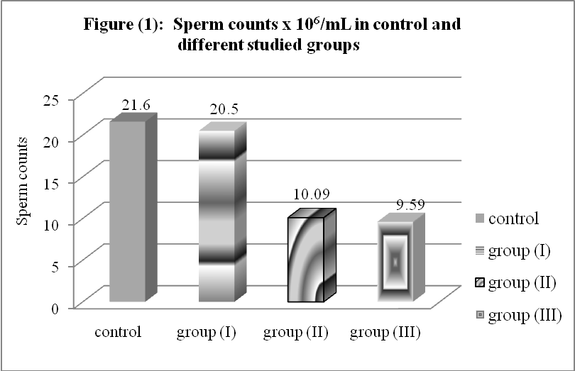

Histopathology of the liver sections stained with haematoxylin and eosin:
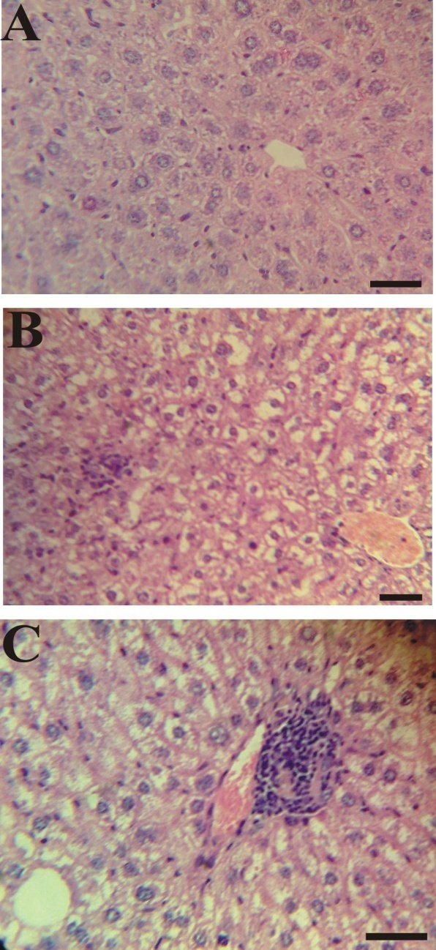
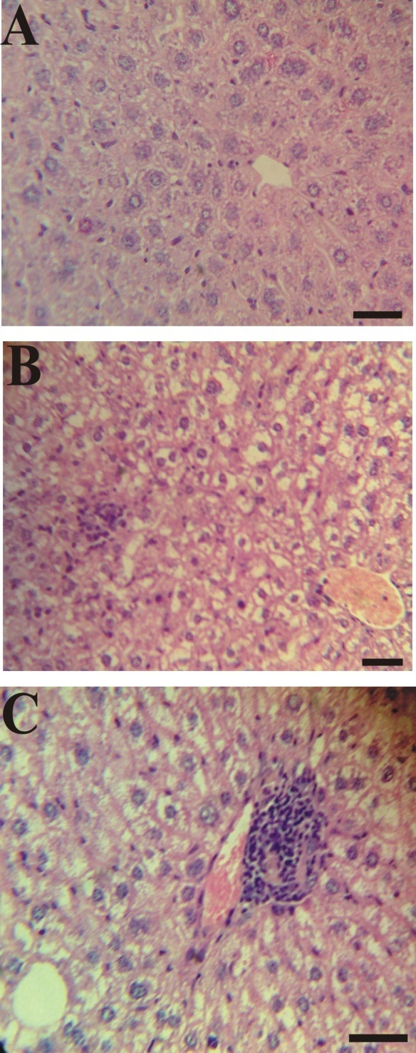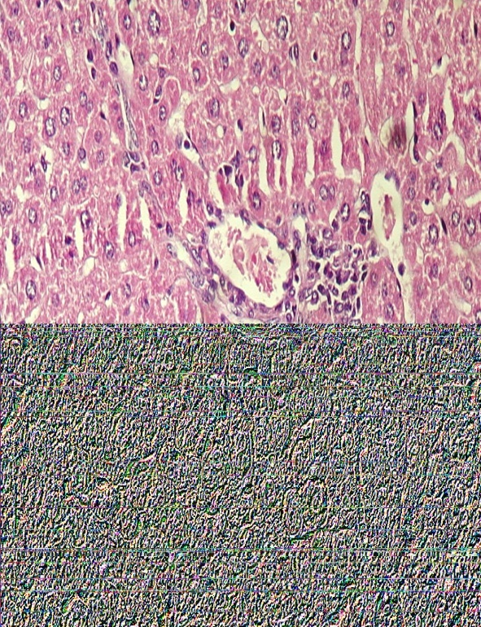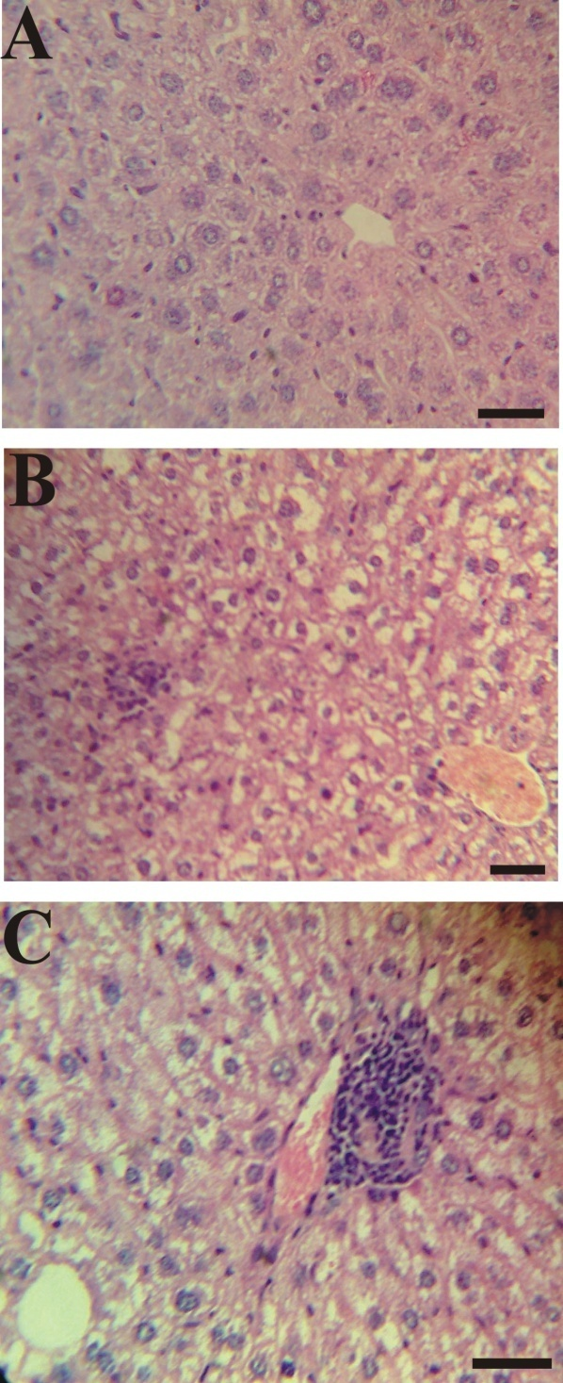
A
B
C
D
Figure 2. Histopathology of hepatic tissue of normal adult rat, exposed to at low and high dose of amitriptyline, and toxic dose of cyclophosphamide as +ve control
(A) Normal liver tissue with central vein surrounding hepatocytes, sinusoids lined with Kupffer cells. (B) Group I, showed minimal changes with interlobular inflammatory cellular infiltrations and hepatocytic vacuolation. (C) Group II, showed marked obliteration of the blood sinusoids, inflammatory cellular infiltration around the hepatic vein and hepatocytic vacuolation. (D) Group III, showed marked obliteration of the blood sinusoids, marked cytoplasmic degeneration of hepatocytes, focal permeation by lymphoplasmic cells, focal pyknotic, nectrotic and apoptic nuclei were remarkable

Histopathology of the testis sections stain with haematoxylin and eosin by low & high power:
Low power High power
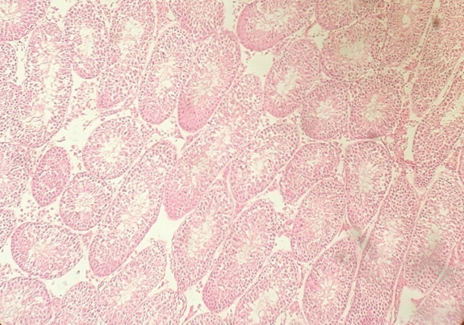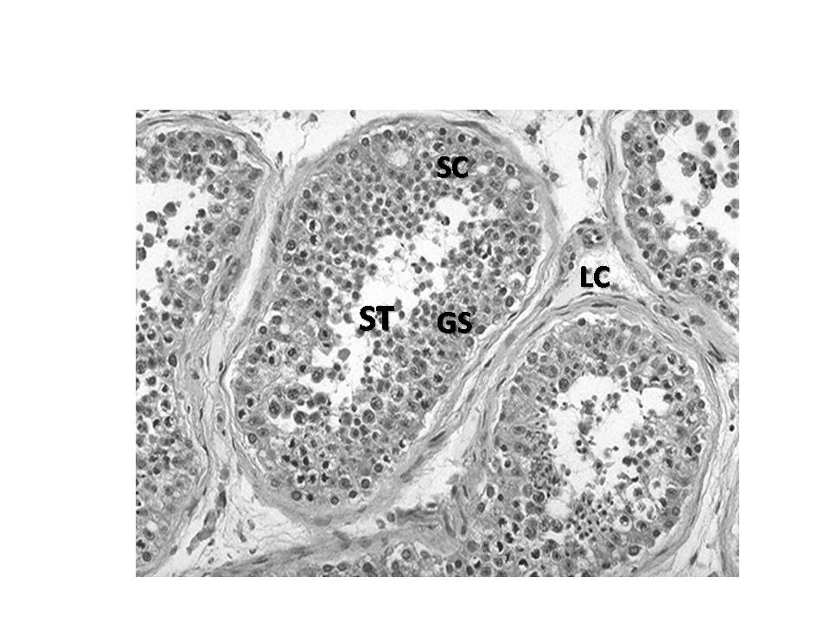
A

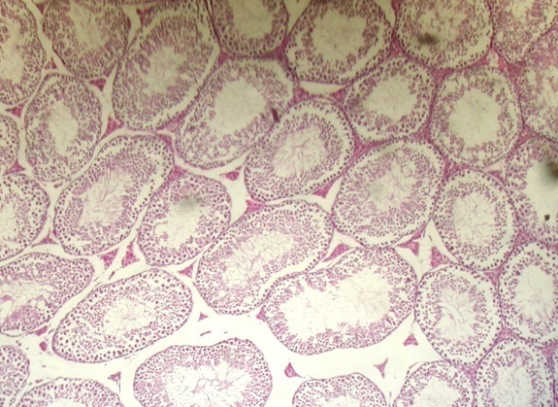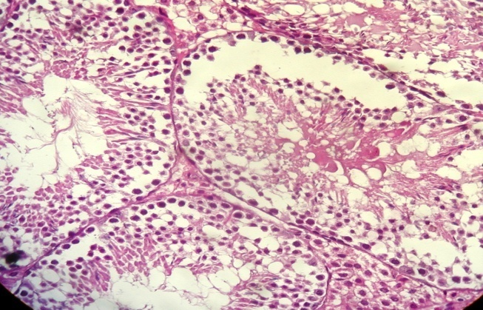
B

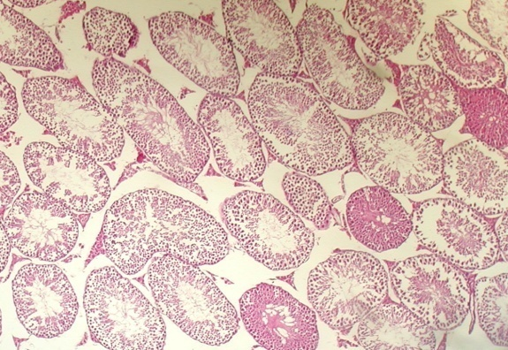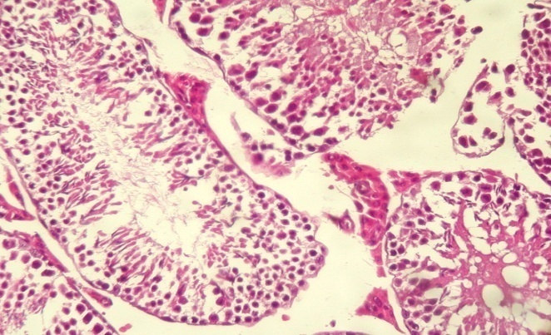
C

Figure 3. Histopathology of testicular tissue of normal adult rat, exposed to high dose of amitriptyline and toxic dose of cyclophosphamide as +ve control (A) Normal testis tissue, ST: Seminiferous tubules; GS: Germ cells; SC: Sertoli cells; and LC: Leydig cells. (B) Group II showed showing focal pyknosis and damaged spermatogonia lining cells. Absent spermatids were remarkable in most of the seminiferous tubules. (C) Group III, (+ve control) showed focal pyknotic and damaged spermatids, marked interstitial oedema, intratubular and intraluminal oedema.

- Discussion
The antidepressants are among those drugs, which cause toxic effects on much of organ system especially male reproductive system. About 15% of these drugs have adverse effects on hormonal levels and target organ like testes, which secrete hormones and produces male germ cells during spermatogenesis. Results showed that the effects of antidepressant on sexual dysfunction are more than 60%. Effects of drugs on sexual dysfunction and spermatogenesis appear to be due to changes in hormones level such as testosterone, LH, FSH, prolactin and estrogen [Clayton and Montejo, 2006]. Using three different experimental models, we searched for the side effect of antidepressant (amitriptyline) drug on the liver or testicular functions. The obtained results indicated that amitriptyline in low dose did not show any side effect on the liver activity as regards the liver enzyme levels (AST, ALT, ALP, and γGT). In addition, there were no significant changes in hepatic morphology between rats treated with low dose of amitriptyline and the control group. While the high dose of amitriptyline affect the liver activity in the form of significant elevation of all liver enzymes compared to controls. Also there were significant morphological changes in the liver tissue including marked obliteration of the blood sinusoids, inflammatory cellular infiltration around the hepatic vein and hepatocytic vacuolation; more confirmatory these changes were matched with the changes that occurred due to the toxic dose of cyclophosphamide which act as +ve control.
On reviewing the literature through several medical databases, we found few studies dealt with the effect of tricyclic antidepressant (amitriptyline) on both hepatic and testicular functions. These results were in accordance of Davila et al, who used primary cell cultures of neonatal hepatocytes to examine the protective effect of flavonoids in the presence of hepatotoxins. The leakage of lactate dehydrogenase (LDH), aspartate aminotransferase (AST) and alanine aminotransferase (ALT), as well as morphological parameters were used as indices of hepatotoxicity of amitriptyline (AT), and nortriptyline (NT) in large dose. These hepatotoxins caused significant LDH, AST, and ALT leakage when compared to untreated control groups. Changes in morphology were evident after 1 h of treatment with the toxicants, including vacuole formation, size deformation and cell necrosis. As the concentration of hepatotoxins was increased, the changes were more pronounced [Davila et al, 1989].
As regards the effect of amitriptyline on the testicular function, the results demonstrated that amitriptyline in low dose did not affect the testicular functions as there were non significant changes in the testosterone and prolactin levels, spermatic counts, and morphologically as compared to the control group. While amitriptyline in high dose produced significant decreased in the testosterone and prolactin levels as well as dramatic decreased in the spermatic count which was evident by morphologically changes in the testicular tissue including focal pyknosis, damaged spermatogonia lining cells and absent spermatids in seminiferous tubules. More confirmatory these changes were matched with the changes that occurred due to the toxic dose of cyclophosphamide, which act as +ve control.
These results were in accordance with Soghra et al, (2008) who showed that the amitriptyline doses have different effects on hormonal levels. The higher dose (25 mg/kg) decreased the testosterone and prolactin levels but increased the FSH levels. Amitriptyline changes the hormonal levels and disrupts the testosterone and estrogens ratio. They concluded that the toxic effects of the amitriptyline caused the disruption of sex hormone and can leads to sexual dysfunction and infertility [Soghra et al, 2008]. It has been demonstrated that repeated application of mild stressors for a period of time produces several symptoms similar to those of depressive patients [Forbes, et al, 1996]. Some of the physiological disruptions that are reflected in laboratory animals submitted to this model include: metabolic dysfunction, reduced locomotive activity, weight loss, decreased sexual behavior and functions [Vollmayr and Henn, 2003].
A repeated oral treatment (twice daily, for 21 consecutive days) with 10 mg/kg of antidepressants imipramine, amitriptyline, citalopram, affects the level of testosterone and its metabolites (5 alpha-dihydrotestosterone and estradiol-17 beta) in the serum and brain structures (cerebral cortex, hypothalamus). Citalopram and mianserin increased significantly the serum testosterone concentration, while imipramine and amitriptyline reduced the concentration of 5 alpha-dihydrotestosterone [Przegalinski, et al, 1987].
On the other hand , a study done by Pardon & Nodarse in which evaluation of the effects of the antidepressive drug amitriptyline on the semen of 20 infertile men with oligoasthenozoospermia was carried out. Quantitative assessment of semen in the whole group showed significantly higher sperm counts, an increased proportion with normal sperm morphology and an increased semen volume after treatment, with a high positive correlation between sperm count before and after treatment. Individual qualitative evaluation showed an increased sperm count in 50% and increased motility in 35% of patients. They concluded that amitriptyline has a beneficial effect on semen in some of these patients [Pardon and Nodarse 1980].

- Conclusion
We concluded from this study that high dose of amitriptyline has toxic effects on the metabolic functions of the liver proved by elevation of the hepatic enzymes and histopathological changes of hepatic tissue. In addition, the use of high dose of amitriptyline led to reduction in the productive functions of the testis proved by decreased of both hormonal levels (testosterone & prolactin) and spermatic count with histopathological changes of the testicular tissue. Therefore, the use of amitriptyline drug should be in the proper pharmacological dose to avoid its toxic effects.

Correspondence to:
Dr. Mohamed Diaa El-Dein Abd El-Maksoud &
Prof. Dr. Mie Afify Mohamed
Biochemistry Department,
Genetic Engineering and Biotechnology Division,
National Research Centre,
Tahrir Street, Dokki, Giza, 12311, Egypt.
Telephone: +2 0103448041
Emails: saodiaa@yahoo.com; mieafify@yahoo.com

References
- Feighner JP. Overview of antidepressants currently used to treat anxiety disorders. J Clin. Psychiatry 1999; 60 (Suppl 22):18–22.
- Zohar J, Westenberg HG.: Anxiety disorders: a review of tricyclic antidepressants and selective serotonin reuptake inhibitors. Acta Psychiatr. Scand. Suppl 2000; 403:39–49.
- Bryson, H.M. and Wilde, M.I.: Amitriptyline. A review of its pharmacological properties and therapeutic use in chronic pain states. Drug Aging 1996; 8, 459–476.
- O’zdogan, U.K., La’hdesma¨ki, J., Mansikka, H., Scheinin, M.: Loss of amitriptyline analgesia in a2A–adrenoreceptor deficient mice. Eur. J. Pharmacol. 2004; 485, 193–196.
- Diaz Luja´n V.E., Castellanos M.M., G. Levin, M.M. Sua´rez.: Amitriptyline: sex-dependent effect on sympathetic response and anxiety in rats submitted to early maternal separation and variable chronic stress in adulthood. Int. J. Devl. Neuroscience 26; 2008, 415–422
- Thase ME, Haight BR, Richard N, et al. Remission rates following antidepressant therapy with bupropion or selective serotonin reuptake inhibitors: a meta-analysis of original data from 7 randomized controlled trials. J. Clin. Psychiatry. 2005; 66:974-981.
- Landen M, Hogberg P, Thase ME.: Incidence of sexual side effects in refractory depression during treatment with citalopram or paroxetine. J. Clin. Psychiatry. 2005; 66:100-106.
- Soghra Bahmanpour, Mohammad Javad Khooshnood, Hamid Kazerroni, Mohammad Reza Namaavar, Amin Basti: Toxicological effects of amitriptyline on sex hormone level of male rats. Abstracts / Toxicology Letters 180S. 2008; S32–S246.
- Freeman E.R., Bloom D.A., and McGuire E.J. "A brief history of testosterone". Journal of Urology 2001; 165: 371–373.
- Taylor MJ. Stratsegies for managing antidepressant -induced sexual dysfunction: a review. Curr. Psychiatry Rep. 2006; 8:431-436.
- Committee on enzymes of the Scandinavian Society for Clinical Chemistry and Clinical physiology. Recommended methods for the determination of four enzymes in blood. Scand. J. Lab. Invest. 1974; 3: 291-309.
- Duhau L, Grassi J, Grouselle D, Enjalbert A, Grognet JM. An enzyme immunoassay for rat prolactin: application to the determination of plasma levels. J. Immunoassay. 1991; 12(2):233-250.
- Tietz NW. In Text book of clinical chemistry. Tietz NW, editor. WB Saunders Company: Philadelphia, London, Toronto; 1986. p. 960-2.
- Clayton AH and Montejo AL. Major depressive disorder, antidepressants, and sexual dysfunction. J. Clin. Psychiatry. 2006; 67:33-37
- Davila JC, Lenherr A, Acosta D. Protective effect of flavonoids on drug-induced hepatotoxicity in vitro. Toxicology. 1989; Aug; 57(3):267-86.
- Forbes, N.F., Stewart, C.A., Matthews, K., Reid, I.: Chronic mild stress and sucrose consumption validity as model of depression. Physiol. Behav. 1996; 60, 1481–1484.
- Vollmayr B. and Henn F.A.: Stress models of depression. Clinical Neuroscience Research 2003; 3 (4-5), pp. 245-251.
- Przegalinski E, Warchol-Kania A, Budziszewska B, Jaworska L.: Effect of repeated administration of antidepressant drugs on the serum and brain concentration of testosterone and its metabolites. Pol. J. Pharmacol. Pharm. 1987, Nov-Dec; 39(6): 683-9.
- Pardon RS and Nodarse M.: Effects of amitriptyline on semen of infertile men. Br. J. Urol. Jun 1980; 52 (3): 226-8.

16/10/2009

