Clinical utility of biomarkers as predictors of lung function in chronic obstructive pulmonary disease

Nervana Samy¹, Abd El-Maksoud M.D¹, Abeer EL Khayyal¹ and Azza Imam²
¹Biochemistry Department, National Research Center, Cairo, Egypt
2Internal medicine Department, Ain Shams University, Cairo, Egypt
E-mail: saodiaa@yahoo.com., nervana91@hotmail.com

Abstract: Background: Recent studies show that chronic obstructive pulmonary disease (COPD) patients exhibit low-grade systemic inflammation, and that plasma endothelin-1(ET-1) and some serum inflammatory markers as hs-CRP, IL-6 and TNF-α are related to faster declines in lung function. We examined correlations between these biomarkers and the decline of lung function in COPD patients. Methods: This study included 96 patients with COPD, besides 20 healthy controls having normal pulmonary lung function. The patients were divided into 4 stages according to lung function measured by spirometer (FEV1 % predicted). All patients were subjected to determination of FEV1 and determination of plasma ET-1, serum hs-CRP, IL-6 and TNF-α. Results: The concentrations of circulating ET-1, hs-CRP, IL-6 and TNF-α, were significantly higher in patients with COPD in comparison to the control group and their levels increased according to the stage of disease. There was a negative correlation between the blood levels of ET-1 with FEV1 in the different stages of COPD. As regards hs-CRP and IL-6 there were significant negative correlation between their levels and FEV1 in stages II and III of COPD but there was no significant correlation between TNF-α and FEV1 in the different stages of COPD. Conclusion: These results suggest that these circulating biomarkers are good candidates as predictors for rapid decline of FEV1 in COPD, although a larger size study with longer term observation is needed to confirm these findings. It is likely that in the future biomarkers will become increasingly required to aid in determining those patients who will benefit from a given drug therapy to improve risk and/or cost benefit, especially since it is becoming more widely considered in COPD. [New York Science Journal 2010;6(3):25-32]. (ISSN: 1554-0200).

Keywords: COPD, ET-1, inflammatory markers

1. Introduction
Chronic obstructive pulmonary disease (COPD) is a major cause of increased morbidity and mortality (Hurd, 2000). The Global Initiative for Chronic Obstructive Lung Diseases (GOLD) guidelines were published in 2001 (Pauwels et al., 2001), and revised in (2004) with the aim of increasing awareness of COPD and of decreasing morbidity and mortality from the disease. COPD is associated with both airway and systemic inflammation (Donaldson et al., 1995).
Endothelin-1 (ET-1) is a peptide with potent vasoconstrictive and broncho-constrictive properties. It is implicated in the pathophysiology of asthma (Hay et al., 1999). ET-1 is raised in the airways of asthmatic subjects and has been shown to stimulate mucus secretion, airway oedema, smooth muscle mitogenesis and bronchial hyper responsiveness (Trakada et al., 2000). It is also thought to have a pro-inflammatory effect in the airways, being both a chemoattractant and upregulator of other inflammatory mediators, such as interleukins, IL-6 and IL-8 (Mullol et al., 1996). ET-1 is produced by bronchial epithelium, pulmonary endothelium and alveolar macrophages. The synthesis of ET-1 is promoted by hypoxia, viruses and several cytokines, including TNF-α, which may act as intermediates in those processes. Ischaemic shock and sepsis induce the synthesis of ET-1 as well. Interestingly, hypoxaemia has been shown to induce airway ET-1 production, which suggests that ET-1 may play an important role in the physiopathology of stable COPD (Trakada et al., 2001).
Airway inflammatory markers are higher in more severe disease and increase during COPD exacerbations. However, despite the widespread use of exhaled biomarkers in patients with asthma and their use in clinical practice (Smith et al, 2005), no exhaled biomarker has been widely used in clinical trials in COPD. In contrast, there is evidence that shows that systemic inflammation is present in stable COPD and that the intensity of the inflammatory process relates to the severity of the underlying disease (Kostikas et al., 2008). Several inflammatory markers such as C-reactive protein (CRP), fibrinogen and IL-6, are increased in patients with COPD in both stable disease and exacerbations, with CRP being the most studied biomarker (Dahl et al., 2007). In recent years, ever increasing attention has been given to studying the role played by systemic markers of the inflammatory response mechanisms observed in COPD. A study has connected elevated CRP levels with increased resting energy expenditure and reduced exercise capacity (Broekhuizen et al., 2006).
In the interest of improving the diagnosis of COPD, several types of biomarker have been measured that are related to disease pathophysiology and the inflammatory and destructive process in the lung. A review of over 600 published studies suggests that few of these biomarkers have been validated, and there is little information about reproducibility and the relationship to disease development, severity, or progression (Franciosi et al., 2006). A meta-analysis covered almost 150,000 patients with COPD, and revealed the poor sensitivity of current biomarkers to define clinical status and quantify the effect of treatment. Only sputum neutrophils and IL-8, as well as serum tumor necrosis factor (TNF-α) and C-reactive protein, showed some trend toward separating different stages of COPD. There is, therefore, clearly a need for more research in this area with repeated measurements in carefully phenotyped patients. With the development of many new drugs that target inflammation in COPD, there is a pressing need to identify reliable biomarkers that may indicate whether an anti inflammatory therapy is likely to have clinical benefit. A major problem is the lack of any gold standard anti inflammatory therapy that is effective in COPD, such as inhaled corticosteroids in asthma, as a yardstick to compare potential therapies (Barnes et al., 2006).
The aim of this study was to evaluate the alterations of plasma endothelin-1(ET-1) in various stages of COPD to determine its value as biomarkers of COPD and as indicator of severity of the disease in patients with chronic obstructive pulmonary disease in comparison to the inflammatory cytokines, C-reactive protein (CRP), tumor necrosis factor-α (TNF-α) and interleukin-6 (IL-6).

2.Patients and methods
A total of 96 patients with stable COPD were recruited from patients seen in the Department of Internal Medicine of Ain Shams Medical University Hospital, their age ranged from 42-65 years (mean age 56.1±6.2). COPD was defined according to the GOLD criteria (Pauwels et al., 2001). COPD was diagnosed when the post-bronchodilator FEV1/FVC (forced vital capacity) ratio was less than 70% (GOLD stages). All subjects were in a clinically stable condition, were not suffering from respiratory tract infections and did not experience disease exacerbation at least 4 weeks prior to blood sampling. Patients were excluded if they had bronchiectasis, tuberculosis or other confounding inflammatory diseases, such as malignancy, arthritis, connective tissue disorders or inflammatory bowel disease. All patients were tobacco smokers. Besides 20 healthy smokers, age matched males with normal pulmonary function were included as controls. The study was approved by the Ethics Committee, and all patients gave informed consent.
The patients were subjected to full history and clinical examination including personal history and x-ray chest and divided into different stages according to lung function measured by spirometry (FEV1 % predicted).
Stage 0: included 27 males (age 42-60, mean age 57.2 ± 6.2), suffering from COPD characterized by chronic cough and sputum production. Lung function is still normal as measured by spirometry.
Stage I (mild): included 20 males (age 55-65, mean age mean age 61.6± 5.3). With mild COPD characterized by mild airflow limitation (FEV1/FVC<70% but FEV1≥80% predicted) and usually but not always characterized by chronic cough and sputum production.
Stage II (moderate): included 25 males (age 47-65, mean age 60.4 ± 6.1) with moderate COPD characterized by worsening airflow limitation (50% ≤FEV<80% predicted) and progression of symptoms, with shortness of breath typically developing on exertion.
Stage III (severe): included 24 males (age 42-62, mean age 59.7 ± 6.2) with severe COPD characterized by severe airflow limitation (FEV1<30% predicted).

2.1.Sampling: Ten ml of fasting blood samples were drawn from each subject. Five ml blood in tubes containing EDTA to separate the plasma after centrifuging for 10 minutes for measuring endothelin-1. The other five ml blood left to clot at room temperature to separate sera after centrifuging for measuring other parameters. The plasma and sera were stored at –70°C till the time of analysis.
2.2.All patients were subjected to the following laboratory assessment:
- Determination of plasma endothelin-1 (ET-1) by use of quantitative enzyme immunoassay technique (ELISA) using kit supplied from (R and D systems, Minneapolis, MN). The ET-1 peptide was first extracted from plasma samples using a centrifugal evaporator after plasma-solvent dilution (water, HCL and acetone). An antibody specific for ET-1 has been pre-coated onto a microplate. Standard, samples, control and conjugate are pipette into the wells and any ET-1 present is sandwiched by the immobilized antibody and the enzyme-linked antibody specific for ET-1, following a wash to remove any unbound substances, substrate is added to the wells and color developed is proportion to the amount of ET-1 bound. The color development is stopped and the intensity is measured (Beatriz et al., 2000).
- Determination of serum interleukin 6 (IL-6) by a solid phase enzyme amplified sensitivity immunoassay (EASIA) performed on micro titer plate using kit supplied by BioSource Europe S.A., Rue de industries, 8 B-1400 Nivelles Belgium (Wedzicha et al.,2000).
- Determination of serum C-reactive protein (hs-CRP) by a high sensitive immunoassay for measuring human CRP which is a two step sandwich ELISA technique using kit supplied by Diagnostic systems laboratories (DSL-10-42100) Webster, Texas, USA (Rifai et al.,1999).
4- Determination of tumor necrosis factor (TNF-α) by enzyme linked immunosorbent assay (ELISA) using sterptavidin-coated microtiter plates (Bienvenu et al., 1993).

3. Statistical analysis
Statistical Package for social science (SPSS) program version 9.0 was used for analysis of data. Data are presented as mean±SD. Comparisons between two groups were performed with unpaired t-tests. Repeated measures one-way analysis of variance (ANOVA) with Bonferroni post hoc correction was used to analyze the variables. Sensitivity and specificity of laboratory data were also done. Pearson’s correlation coefficient was utilized to determine correlations between different parameters. P-value was considered significant if <0.05.

4. Results
The characteristics of patients and controls are summarized in Table (1). The groups were well-matched with respect to age, BMI and smoking history (pack years). By definition, lung function parameters were normal in controls and significantly decreased in patients with COPD.
Table (2,3) and figures (1,2,3,4) show the descriptive statistics and multiple comparison of ET-1 (pg/ml), hs-CRP (mg/l), IL-6 (pg/ml) and TNF-α (pg/ml) levels in the different studied groups. Plasma ET-1 level was increased in stages II and III of COPD and this increment was significant on comparison with control group, while in stage 0 and I there was increase of ET-1 level but this increment was not statistically significant compared to controls. Serum hs-CRP was increased in COPD stages I, II and III and this increment was significant when compared with controls, while in stage 0, there was no significant increase in CRP compared to controls. Serum IL-6 showed significant increase in COPD stages I, II and III compared to the controls , while in stage 0 there was increase of IL-6 level but this increment was not statistically significant compared to controls. Serum TNF-α was also increased in all COPD stages and this increment was statistically significant on comparison with control group, while in stage 0 there was increase of TNF alpha level but this increment was not statistically significant.
Also, the plasma level of ET-1, serum levels of hs-CRP, IL-6 and TNF-α showed significant difference between each stage and stage III.
Table (4) shows the sensitivity and specificity calculated for plasma ET-1, serum hs-CRP, IL-6 and TNF- α. At ET-1value of 1.48 (pg/ml), the sensitivity and specificity were 65.6% and 100% respectively. At hs-CRP value of 2.61 (mg/l), the sensitivity and specificity were 80% and 100% respectively. At IL-6 value of 1.96 (pg/ml), the sensitivity and specificity were 96% and 100% respectively. At TNF-α value of 3.91 (pg/ml), the sensitivity and specificity were 97.6% and 100% respectively.
Table (5) showed the correlation analysis between studied parameters and FEV1, there were significant negative correlation between the serum level of ET-1 and FEV1 in stages I, II and III of COPD (r = - 0.592, - 0.601 and - 0.630 respectively). As regards hs-CRP and IL-6 there were significant negative correlation between their levels and FEV1 in stages II and III of COPD (r = -0.512, -0.554 and -0.542, -0.610 respectively) but there was no significant correlation between TNF-α and FEV1 in the different stages of COPD.

Table (1): Characteristics of patients with COPD and healthy controls involved in the study (the data expressed as mean ± SD)
Variables | Controls  N = 20 | COPD stage 0  N = 27 | COPD  stage I  N = 20 | COPD  stage II  N = 25 | COPD  stage III  N = 24
Age (years)  BMI(Kg/m²) | 58 ± 3.4  25±1.2 | 57.2 ± 6.2  24±2.2 | 61.6± 5.3  25±2.1 | 60.4 ± 6.1  26±1.4 | 59.7 ± 6.2  24±2.3
FEV1 % predicted | 101 ± 8.5 | 97 ± 1.6 | 82.1±3.2 | 67.2± 7.3 | 26.6 ± 5.1
FEV1/FVC % | 100.1 ± 5.9 | 98.3± 2.5 | 66.2 ± 5.2 | 61.7 ± 5.2 | 57.2± 3.2
Pack years | 50±5 | 56±8 | 57±6 | 58±8 | 57±8
FEV1= forced expiratory volume in 1 second, FVC = forced vital capacity

Table (2): Descriptive statistic (mean ± SD) of ET-1(pg/ml), CRP (mg/l), IL-6 (pg/ml) and TNF-α (pg/ml) in patients with different COPD stages and controls

Stage III  N=24 | Stage II N=25 | Stage I N0=20 | 0 Stage N=27 | Control N=20 | Parameters
4.17±2.14 | 2.69±1.70 | 1.87±1.04 | 1.3±0.70 | 0.90±0.25 | ET-1 (pg/ml)
6.96±2.37 | 6.13±2.40 | 2.93±1.11 | 1.19±0.81 | 1.17±0.68 | hs-CRP (mg/l)
11.26±3.22 | 8.32±2.31 | 4.0±1.08 | 1.77±0.63 | 1.48±0.29 | IL-6 (pg/ml)
7.84±1.29 | 7.14±1.21 | 4.46±0.81 | 3.62±0.96 | 3.12±0.42 | TNF-α (pg/ml)

Table (3): Multiple comparison between different groups and parameters

Sig | TNF- α | Sig | IL-6 | Sig | hs-CRP | Sig | ET-1
1.0 | C-S (0) | 1.0 | C-S (0) | 1.0 | C-S (0) | 1.0 | C-S (0)
0.001 | C –S( I) | 0.001 | C –S( I) | 0.001 | C –S( I) | 0.262 | C –S( I)
0.001 | C– S (II) | 0.001 | C– S (II) | 0.001 | C– S (II) | 0.01 | C– S (II)
0.001 | C – S (III) | 0.001 | C – S (III) | 0.001 | C – S (III) | 0.001 | C – S (III)
1.0 | S (0) – S ( I ) | 0.029 | S (0) – S ( I ) | 0.53 | S (0) – S ( I ) | 1.0 | S (0) – S ( I )
0.001 | S (0) – S (II) | 0.001 | S (0) – S (II) | 0.001 | S (0) – S (II) | 0.018 | S (0) – S (II)
0.001 | S( 0) –S( III) | 0.001 | S( 0) –S( III) | 0.001 | S( 0) –S( III) | 0.001 | S( 0) –S( III)
0.001 | S( I) – S( II) | 0.001 | S( I) – S( II) | 0.001 | S( I) – S( II) | 0.582 | S( I) – S( II)
0.001 | S(I) – S(III) | 0.001 | S(I) – S(III) | 0.001 | S(I) – S(III) | 0.001 | S(I) – S(III)
0.267 | S (II)–S-(III) | 0.001 | S (II)–S-(III) | 1.0 | S (II)–S-(III) | 0.008 | S (II)–S-(III)
Significant mean P< 0.05
( C ) mean Control group
( S ) mean Stage

Table (4) Sensitivity and Specificity for studied parameters

TNF-α (pg/ml) | IL-6 (pg/ml) | hs-CRP (mg/l) | ET-1 (pg/ml)
97.6% | 96% | 80% | 65.6% | Sensitivity
100% | 100% | 100% | 100% | Specificity

Table (5) Correlations between studied parameters and FEV1 in patients with different stages COPD (r value)

Stage III | Stage II | Stage I | Stage 0 | Parameters
-0.630٭  -0.554٭  -0.610٭  -0.155 | -0.602٭  -0.512٭  -0.542٭  -0.187 | -0.592٭  -0.223  -0.165  0.032 | 0.162  -0.172  -0.154  0.067 | ET-1(pg/ml)  hs-CRP(mg/l)  IL-6(pg/ml)  TNF-α(pg/ml)
* Significant p<0.05

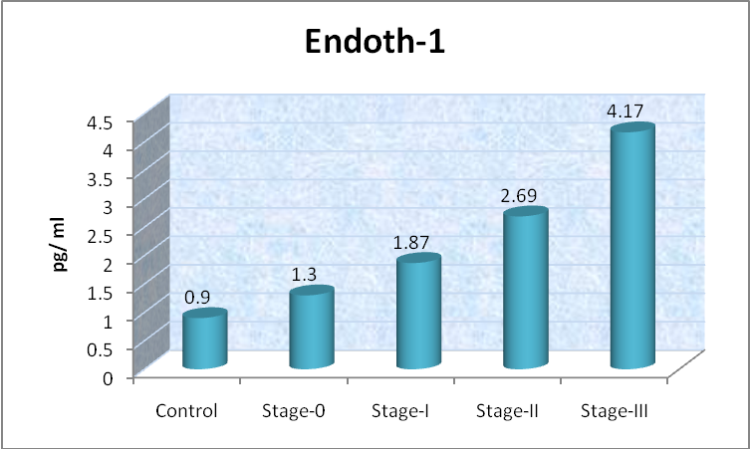

Figure 1: show mean of the Endotheil-1 in different studied groups.

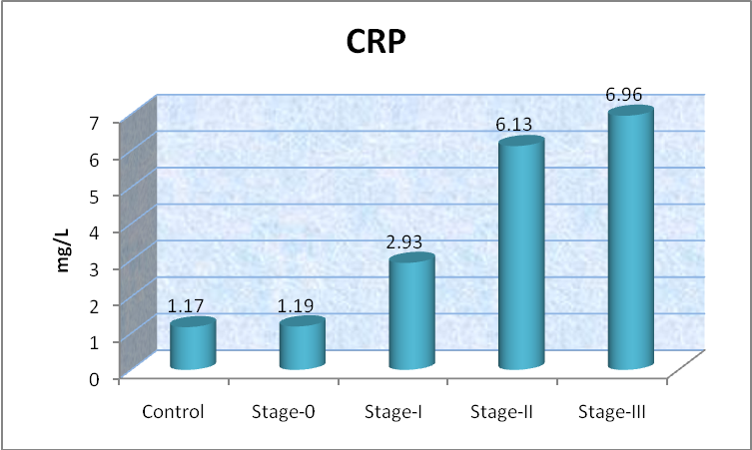

Figure 2: show mean of the CRP in different studied groups

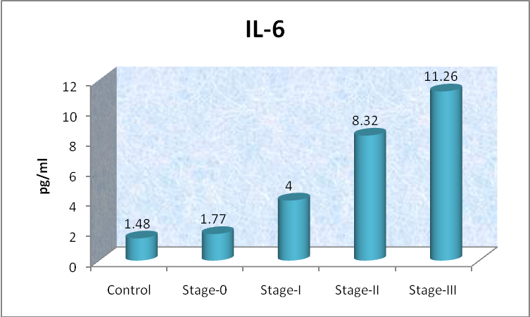

Figure 3: show mean of the IL-6 in different studied groups.

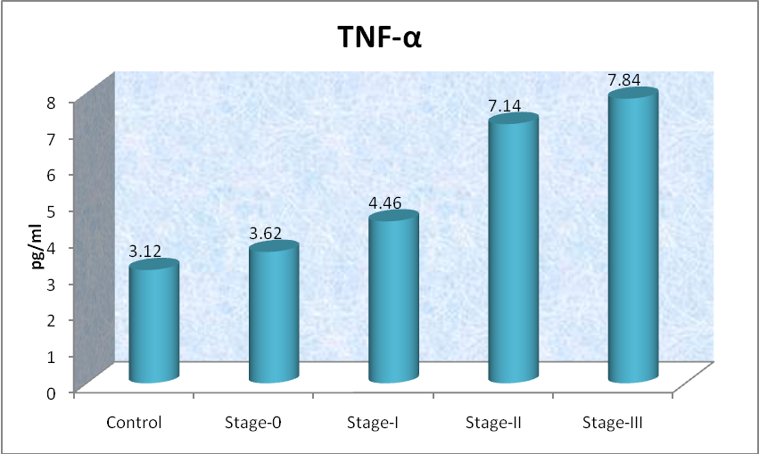

Figure 4: show mean of the TNF-α in different studied groups.

5. Discussion
Chronic obstructive pulmonary disease (COPD) is a slowly progressive disease induced primarily by smoking tobacco. FEV1 is easily measured and is a spirometric predictor of mortality in patients with COPD. Factors that affect the decline of FEV1 are, therefore, of prognostic importance in COPD (Thomason and Strachan, 2000). Biomarker has been defined as a characteristic that is objectively measured and evaluated as an indicator of normal biological processes, pathogenic processes or pharmacologic responses to a therapeutic intervention, which could include, for example, measures of lung function or lung imaging, although the term ‘biomarker’ historically refers to analytes in biological samples (Baker, 2005).
In our study there were significant increase in plasma ET-1 in stage I, II and III COPD and this increment was significantly higher than those of the control group. Also patients with severe COPD (stage III) showed highly significant elevation in of this biomarker in comparison to stage 0, I and II also there was significant negative correlation between ET-1 level and FEV1 of these patients.
These results were in agreement with Carratu et al., 2008 who found that endothelin-1 levels were increased in all COPD patients. In addition, they observed that ET-1 levels were significantly higher in COPD with advanced stage. Several previous studies detected elevated levels of ET-1 in interstitial pulmonary disease and in unstable bronchial asthma, similar to those observed in COPD patients (Zietkowski et al., 2008). Carpagnano and colleagues (2003) hypothesized that ET-1, in pathological pulmonary conditions could be in part produced by airway epithelium itself. However, it appears that ET-1 primary produced by the pulmonary endothelium, could be in part generated by the epithelium, and, in addition, could be partially the result of an uptake into the airway epithelium.
Roland et al., 2001 stated that ET-1 levels are significantly higher in ‘desaturator’ COPD patients and ET-1 levels correlate negatively significant with the degree of the oxyhemoglobin desaturation and with FEV1. They evaluated the role of ET-1 in COPD by examining patients when stable and, for the first time, during periods of exacerbation. Interestingly, rises in both plasma and sputum ET-1 levels were found during exacerbations, with the sputum showing relatively larger changes. Increased ET-1 production within the airway may contribute both to the airway obstruction playing a part in mediating airway inflammatory changes and the increases in sputum production that are a common feature of exacerbations of COPD.
These findings are consistent with the hypothesis that ET-1 plays a very important role in the pathophysiological manifestations of COPD patients. ET-1 was first described as a potent and long-lasting vasoconstrictor derived from endothelial cells (Mattoli et al., 1990). ET-1is produced in the vascular or nonvascular tissues of the lung and in the peripheral circulation (Hay et al., 1993). In the lung, ET-1 is produced by endothelial, tracheal, bronchial and alveolar epithelial cells and tissue macrophages. Stimuli such as hypoxemia, ischemia and shear stress induce the synthesis and secretion of ET-1 within minutes. Once released, the peptide can act locally to elicit bronchoconstriction and sustained pulmonary artery vasoconstriction (Lippton et al., 1989). Accordingly the precise mechanism by which hypoxia induces ET-1 production have not been fully elucidated, although, vasoconstricting peptide may play a relevant role in the pathogenesis of pulmonary hypertension. Increased pulmonary and peripheral blood levels of ET-1 have been described in primary pulmonary hypertension, bronchial asthma, acute lung injury, fibrosing alveolitis, interstitial lung disease and emphysema (Wort et al., 2001).
In our study there were significant increase in serum inflammatory markers hs-CRP, IL-6 and TNF-α in stage I, II and III COPD and this increment was significantly higher than those of the control and stage 0 groups. Also patients with severe COPD (stage III) showed highly significant elevation in of these biomarkers in comparison to stage 0, I and II, also there were significant negative correlation between hs-CRP and IL-6 levels and FEV1 in stages II and III of COPD.
These results were in accordance with Vernooy et al., 2002 who declared that several inflammatory markers and mediators have been shown to be increased in the plasma or serum of COPD patients and that is often associated with significant extra-pulmonary effects, such as cardiovascular abnormalities and skeletal muscle dysfunction. Circulating C-reactive protein (CRP) levels have been shown to be raised in the blood of stable COPD patients and to predict prognosis in terms of hazard ratios for hospitalisation and death from COPD. Stable COPD is associated with low-grade systemic inflammation as demonstrated by an increase in blood leukocytes, acute-phase proteins C-reactive protein (CRP) and fibrinogen and inflammatory cytokines as TNF-α, also, during acute exacerbations of COPD, higher levels of interleukin-6 as well as acute-phase proteins CRP, fibrinogen, and lipopolysaccharide binding protein (LBP) have been demonstrated, declining again during recovery, another study found that CRP levels are not increased in 50% of patients hospitalised with acute exacerbations, but are further elevated in subjects with significant sputum purulence (Weis and Almdal , 2006). In a study done by Gan et al., 2005, they found that decreased FEV1 can independently induce systemic inflammation, they examined the effect of lung function decline on the elevation of inflammatory markers using 7685 patients, they found an additive effect of reduced FEV1 for these markers, suggesting their potential interactions in the pathogenesis of systemic complications observed in patients with poor lung function.
The association of elevated CRP with poor lung function indices was observed a few years ago in population surveys (Kony et al., 2004). Similarly, Man and Sin, 2005 have highlighted CRP in COPD which have been associated with more severe lung function impairment and its reduction by glucocorticosteroids might reduce cardiovascular events, which are frequent in COPD patients. A study has connected elevated CRP levels with increased resting energy expenditure and reduced exercise capacity (Broekhuizen et al., 2006), whereas an epidemiologic study from the Copenhagen City Heart Study has shown that CRP is an independent predictor of COPD hospitalizations and death (Dahl et al., 2007). However, in a prospective cohort study of patients with moderate to very severe COPD followed-up for a median of 36 months, CRP was not significantly associated with survival (de Torres et al., 2008). Despite the fact that COPD is a systemic disease and has recently been suggested to be a part of a chronic systemic inflammatory syndrome, no systemic biomarker can be suggested yet for the routine evaluation of COPD patients, with CRP being the single possible exception for the time being. However, CRP is neither specific nor sensitive for the evaluation of COPD (Fabbri and Rabe et al., 2007).
Clinical and inflammatory changes occurring during COPD have been the subject of a study by Pinto-Plata and colleagues (2007) reporting that in COPD patients the degree of systemic inflammation tends to increase overtime and is, furthermore, up-regulated during acute exacerbations, they stated that several inflammatory markers such as C-reactive protein , fibrinogen and IL-6 were increased in patients with COPD in both stable disease and exacerbations showing inverse correlations between FEV1 and these markers. Airspace inflammation leading to the release of proinflammatory cytokines (e.g. IL-6) from alveolar macrophages may also occur due to subclinical respiratory infection and lead to systemic inflammation (Wilkinson et al.,2006).
Eid et al., 2001 denoted that cachexia and muscle wasting in COPD are associated with systemic inflammation and in particular with TNF-α levels, although TNF-α and IL-6 are increased even in the absence of weight loss. Systemic hypoxia has been proposed as the driver for activation of the TNF-α system. TNF-α receptors are also raised in the circulation of COPD patients (Takabatake et al., 2000). The percentage of CD8+ T cells in the blood producing TNF-α and interferon-gamma is increased in COPD (both ex-smokers and current smokers) compared with smoking and non-smoking controls (Vernooy et al., 2002).

6. Conclusion
These results suggest that these circulating biomarkers are good candidates as predictors for rapid decline of FEV1 in COPD, although a larger size study with longer term observation is needed to confirm these results, as biomarkers represent attractive options but are far from implementation in COPD. It is likely that in the future biomarkers will become increasingly required to aid in determining those patients who will benefit from a given drug therapy to improve risk and/or cost benefit, especially since it is becoming more widely considered in COPD.

Conflict of interest
None of the authors have a conflict of interest to declare in relation to this work

Corresponding author:
Dr. Mohamed Diaa El-Dein Abd El-Maksoud, Biochemistry Department,
Genetic Engineering and Biotechnology Research Division, National Research Centre, Tahrir Street, Dokki, Giza, Egypt.
Tel.: +2033882279;
Mobil : 0103448041 or 0117932321:

References
1- Hurd S: The impact of COPD on lung health worldwide: epidemiology and incidence. Chest 2000, 117:1S-4S.
2- Pauwels RA, Buist AS, Calverley PM, Jenkins CR, Hurd SS: Global strategy for the diagnosis, management, and prevention of chronic obstructive pulmonary disease. NHLBI/WHO Global Initiative for Chronic Obstructive Lung Disease (GOLD) Workshop summary. Am J Respir Crit Care Med 2001, 163:1256-76
3- Donaldson GC, Seemungal TA, Patel IS, Bhowmik A,Wilkinson TM, Hurst JR, et al. Airway and systemic inflammation and decline in lung function in patients with COPD.Chest 2005 Oct;128(4):1995-2004.
4- Hay DW: Putative mediator role of endothelin-1 in asthma and other lung diseases. Clin Exp Pharmacol Physiol 1999;26:168–171.
5- Takabatake N, Nakamura H, Abe S, Inoue S, Hino T, Saito H,Yuki H, Kato S, Tomoike H: The relationship between chronic hypoxemia and activation of the tumor necrosis factor-a system in patients with chronic obstructive pulmonary disease. Am J Respir Crit Care Med 2000,161:1179-1184.
6- Mullol J, Baraniuk JN, Logun C, et al: Endothelin-1 induces GM-CSF, IL-6 and IL-8 but not G-CSF release from a human epithelial cell line (BEAS-ZB). Neuropeptides 1996;30:551– 556.
7- Trakada G, Marangos M, Spiropoulos K: Mechanisms of endothelin-1 elevation in
chronic obstructive pulmonary disease patients with nocturnal oxyhemoglobin desaturation. Respiration 2001;68:134–139.
8- Smith AD, Cowan JO, Brassett KP, Herbison GP, Taylor DR. Use of exhaled nitric oxide measurements to guide treatment in chronic asthma. N Engl J Med 2005 May 26;352(21):2163-73.
9- Kostikas K, Koutsokera A, Papiris S, Gourgoulianis KI, Loukides S. Exhaled breath condensate in patients with asthma: implications for application in clinical practice. Clin Exp Allergy 2008 Apr;38(4):557-65.
10- Dahl M, Vestbo J, Lange P, Bojesen SE, Tybjaerg-Hansen A, Nordestgaard BG. C-reactive protein as a predictor of prognosis in chronic obstructive pulmonary disease. Am J Respir Crit Care Med 2007 Feb 1;175(3):250-5.
11- Broekhuizen R, Wouters EF, Creutzberg EC, Schols AM. Raised CRP levels mark metabolic and functional impairment in advanced COPD. Thorax 2006 Jan;61(1):17-22.
12- Franciosi LG, Page CP, Celli BR, Crazzola m, walker MJ and Danhof M: Markers of disease severity in chronic obstructive pulmonary disease. Pulm Pharmacol Ther.2006, 19:189-199.
13- Barnes PJ, Chowdhury B, Khritonov SA, Magnussen H, Clive P, Page CP, Postma D and Saetta M: Pulmonary Biomarkers in Chronic Obstructive Pulmonary Disease. Am J Respir Crit Care Med. 2006, 174: 6-14.
14- Beatriz GS, Jorge LG, Andrea B, Nadine C and Carisi A: Increased plasma levels of endothelin-1 and Von Willebrand factor in patients with Type 2 diabetes and dyslipidemia. Diabetes Care 2000, Vol. 23, No 9. 1395-99.
15- Wedzicha J, Seemungal T, Maccallum P, Paul E, Donaldson G, Bhowmik A, Jeferies D and Meade T: Acute exacerbations of chronic obstructive pulmonary disease are accompanied by elevations of plasma fibrinogen and serum IL-6 levels. Thromb Haemost.2000, 84:210-215.
16- Rifai N., Tracy R.P., and Ridkar P.M.: Clinical efficacy of an automated high-sensitivity C-reactive protein assay. Clin Chem.1999, 45(12):2136-2141.
17- Bienvenu J, Coulon L, Doche C, Gutowski M and Grau G.: Analytical performances of commercial ELISA-kits for IL-2, IL-6 and TNF-alpha.A WHO study. Eur Cytokine netw 1993, 4(6):447-451.
18- Thomason MJ and Strachan DP. Which spirometric indices best predict subsequent death from chronic obstructive pulmonary disease? Thorax 2000; 55:785-8.
19- Baker M: In biomarkers we trust? Nat Biotechnol 2005, 23:297-304.
20- Carratu P, Scoditti C, Maniscalco M, Maria T, Di Gioia G, Gadaleta F, Cardone R, Dragonieri S, Pierucci P, Spanevello A and Resta O: Exhaled and arterial levels of endothelin-1 are increased and correlate with pulmonary systolic pressure in COPD with pulmonary hypertension. BMC Pulmonary Medicine 2008, 8:20; 2-10.
chronic obstructive pulmonary disease patients with nocturnal oxyhemoglobin desaturation. Respiration 2001;68:134–139.
21- Zietkowski Z, Skiepko R, Tomasiak MM, Bodzenta-Lukaszyk A: Endothelin-1 in exhaled breath condensate of stable and unstable asthma patients. Respir Med 2008, 102(3):470-4.
22- Carpagnano GE, Kharitonov SA, Wells AU, Pantelidis P, Du Bois RM, Barnes PJ: Increased vitronectin and endothelin-1 in the breath condensate of patients with fibrosing lung disease. Respiration 2003, 70(2):154-60.
23- Roland M, Bhowmik A, Sapsford RJ, Seemungal TA, Jeffries DJ,Warner TD, Wedzicha JA: Sputum and plasma endothelin-1levels in exacerbations of chronic obstructive pulmonary disease. Thorax 2001, 56(1):30-5.
24- Mattoli S, Mezzetti G, Riva L, et al: Specific binding of endothelin on human bronchial smooth muscle cells in culture and secretion of endothelin-like material from bronchial epithelial cells. Am J Respir Cell Mol Biol 1990;3: 145–151.
25- Hay DWP, Henry PJ, Goldie RG: Endothelin and the respiratory system. Trends Pharmacol Sci 1993;14:29–32.
26- Lippton HL, Hauth TA, Summer WR, Hyman AL: Endothelin produces pulmonary vasoconstriction and systemic vasodilation. J Appl Physiol 1989;66:1088–1112.
27- Wort SJ, Woods M, Warner TD, Evans TW, Mitchell JA: Endogenously released endothelin-1 from human pulmonary artery smooth muscle promotes cellular proliferation: relevance to pathogenesis of pulmonary hypertension and vascular remodeling. Am J Respir Cell Mol Biol 2001, 25(1):104-10.
28- Vernooy J, Ku¨ c¸u¨ kaycan M, Jacobs J, Chavannes N, Buurman W, Dentener M, Wouters E: Local and systemic inflammation in patients with chronic obstructive pulmonary disease: soluble tumor necrosis factor receptors are increased in sputum. Am J Respir Crit Care Med 2002, 166:1218-1224.
29- Weis N, Almdal T: C-reactive protein—can it be used as a marker of infection in patients with exacerbation of chronic obstructive pulmonary disease? Eur J Intern Med 2006, 17:88-91.
30- Gan WQ, Man SF, Sin DD. The interactions between cigarette smoking and reduced lung function on systemic inflammation. Chest 2005; 127:558-64.
31- Kony S, Zureik M, Driss F, Neukirch C, Leynaert B, Neukirch F: Association of bronchial hyperresponsiveness and lung function with C-reactive protein (CRP): a population based study. Thorax 2004; 59: 892–896.
32- Man S and Sin D. Effects of corticosteroids on systemic inflammation in chronic obstructive pulmonary disease. Proc Am Thorac Soc 2005; 2: 78–82.
33- de Torres JP, Pinto-Plata V, Casanova C, Mullerova H, Cordoba- Lanus E, Muros de Fuentes M, et al. C-reactive protein levels and survival in patients with moderate to very severe COPD. Chest 2008 Jun;133(6):1336-43.
34- Fabbri LM and Rabe KF: From COPD to chronic systemic inflammatory syndrome? Lancet 2007 Sep 1; 370(9589):797-9.
35- Wilkinson T, Donaldson G, Johnson S, Openshaw P and Wedzicha J: Respiratory syncytial virus, airway inflammation, and FEV1 decline in patients with chronic obstructive pulmonary disease. Am J Respir Crit Care Med.2006, 173:871–876.
36- Eid A, Ionescu A, Nixon L, Lewis-Jenkins V, Matthews S,Griffiths T, Shale D: Inflammatory response and body composition in chronic obstructive pulmonary disease. Am J Respir Crit Care Med 2001, 164:1414-1418.
37- Takabatake N, Nakamura H, Abe S, Inoue S, Hino T, Saito H,Yuki H, Kato S, Tomoike H: The relationship between chronic hypoxemia and activation of the tumor necrosis factor-a system in patients with chronic obstructive pulmonary disease. Am J Respir Crit Care Med 2000,161:1179-1184.
38-Pinto-Plata VM, Livnat G, Girish M, et al. Systemic cytokines, clinical and physiological changes in patients hospitalized for exacerbation of COPD. Chest 2007; 131:37-43.

11/8/2009

