Relationship between Fertilization Results after Intracytoplasmic Sperm Injection (ICSI) and Intrafollicular Fluid TNF-α, IL-1 and Serum Progesterone Concentrations

Maha Hashim¹, Nervana Samy¹, Mohamed Diaa el Din¹, Mohamed Said²

¹Biochemistry Department, National Research Center, Cairo, Egypt
dr_mahacp@hotmail.com, nervana91@hotmail.com
²Obstetrics and Gynecology Department, Ain shams University, Cairo, Egypt.

Abstract: There was controversy as regards relationship between intrafollicular TNF-α, IL-1 and serum progesterone and fertilization & pregnancy results after in vitro fertilization IVF/ICSI, as well as the possibility of using TNF-α and IL-1 as markers for the outcome of in vitro fertilization IVF/ICSI. The aim of the present study was to determine the relationship between both follicular fluid TNF-α, IL-1 and serum progesterone levels and fertilization results after ICSI, also to investigate and compare the level of these markers and fertilization results with both the short and the long protocol of controlled ovarian stimulation (COS). Patients and Methods: The study was conducted on 46 infertile women undergoing ICSI, they were divided into 2 groups; group A: 23 women receiving the short protocol and group B: 23 women receiving the long down-regulation protocol. The follicular fluid was collected on the day of oocyte retrieval and serum was taken on the day of human chorionic gonadotrophin (hCG) administration. TNF-α and IL-1 were measured in the follicular fluid (FF) on the day of oocyte retrieval, serum progesterone on the day of hCG administration and serum follicle stimulating hormone (FSH), lutenising hormone (LH) and prolactin levels on day 3 of the previous cycle. Results: There were no significant difference (P>0.05) between the 2 groups as regards, serum progesterone, FSH, LH and prolactin levels. A significant difference (P<0.05) was found in favor of the long protocol as regards follicular TNF-α, IL-1, number of grade 1 embryos and pregnancy rates. A highly significant positive correlation (P<0.05) with long protocol group and a significant positive correlation (P<0.05) with the short protocol group, was present between intrafollicular TNF-α and IL-1 and between both cytokines and number of grade 1 embryos. No significant correlation (P>0.05) was found between serum progesterone levels on day of hCG injection and number of retrieved oocytes or grade 1 embryos, as well as pregnancy rates. A significant negative correlation (P<0.05) was found between intrafollicular TNF-α and serum progesterone in the long protocol group only. Conclusion: This study revealed that the long protocol is better than the short protocol for ovarian stimulation in infertile women. Intrafollicular levels of TNF-α and IL-1 positively correlated with fertilization results, and can therefore be used as reliable markers for ICSI outcome. Serum progesterone levels on the day of hCG have no significant correlation with the number of retrieved oocytes or grade 1 embryos, as well as pregnancy results. So, it cannot predict the fertilization outcome after ICSI.
[New York Science Journal 2010;3(3):33-44]. (ISSN: 1554-0200).

Keywords: ICSI, follicular fluid, TNF-α, IL-1.

1. Introduction
Over the past decade, cytokines have emerged as important components in many biologic processes and have shown to play a significant role throughout the reproductive process. Cytokines are involved in the menstrual cycle, in fertilization and implantation, and in the maternal immunologic responses in early pregnancy. In late gestation, cytokines are important mediators of preterm labor associated with intrauterine infection, and they may also play a role in term labor (Terranova and Rice, 1997). In addition to leucocytes and activated tissue macrophages, that are well known cellular sources, human granulosa cells have been found to express cytokines (Machelon and Emilie, 1997).
Tumor Necrosis Factor-α (TNF-α) is a cytokine that can be directly cytotoxic for tumor cells, can increase immune-mediated cellular cytotoxicity and can activate macrophages and induce secretion of monokines (Smith et al. 2002). TNF-α has previously been detected in human follicular fluid (Roby et al. 1990, Zolti et al, 1990). The ovarian expression of the cytokine is hormonally regulated and reaches a peak in the pre-ovulatory period (Zolti et al. 1990).
Serum progesterone levels during controlled hyperstimulation have been studied. Serum ovarian progesterone level on the day of hCG administration has been under trial as a predictor of pregnancy outcome in IVF (Givens et al. 1994) and in ICSI (Ubaldi et al. 1995; Urman et al. 1999). During the final phase of ovarian follicular development, the oocyte resides in an antral follicle where it is initially associated with specialized granulosa cells (cumulus oophorus and corona radiata cells) and where it is exposed to a particular humoral microenvironment (follicular fluid) whose composition differs from that of blood plasma. The final phase of oocyte meiotic and cytoplasmic maturation, coinciding with the development and growth of antral follicles, is subject to a complex interplay of endocrine, paracrine and autocrine control mechanisms. Hormones and other regulatory substances involved in these mechanisms are either locally secreted within the ovary (steroid hormones, cytokines) or are produced outside and enter the follicles secondarily. The intrafollicular concentration of some of these agents at specific times of antral follicle development is likely to be related to the success or failure of various developmental processes in the oocyte that are necessary for its fertilizability and further developmental competence (Gougeon, 1996).
Studies have attempted to find a relationship between the concentration of cytokines (Barak et al. 1992; Huyser et al. 1994; Cianci et al. 1996,; Branisteanu et al. 1997; Bili etal. 1998) in the follicular fluid, on the one hand, and different parameters of oocyte quality on the other hand. However, all of these studies dealt with classical IVF attempts and were thus unable to determine exactly the oocyte maturity status at the time of recovery. Therefore, oocyte maturity and developmental potential were estimated indirectly, by evaluating the cumulus oophorus and corona radiata morphology and by analysing fertilization results on the day following in-vitro insemination, when the somatic cells surrounding the oocyte were removed. In those conditions, the analysis of fertilization results may be biased by the uncertainty as to the oocyte maturity at the time of in-vitro insemination. In fact, some of the oocytes showing the first polar body on the day after in-vitro insemination may still have been immature at the time when they were exposed to spermatozoa. Moreover, the conditions of ICSI restrict the multifactorial nature of fertilization success and failure, putting ahead those factors that are responsible for oocyte activation and the ensuing developmental processes culminating in the completion of oocyte meiosis and in the development of pronuclei (Mendoza et al. 1999).
Ovarian follicles increase in size under the influence of gonadotrophins, mainly due to an expansion of follicular fluid (FF) volume and an acceleration in granulosa cell mitosis. In a natural cycle, cells forming the cumulus and corona layers, and the granulosa oocyte that they surround, undergo synchronous maturational changes. This synchrony may be disturbed in a gonadotrophin-induced cycle in which interference from endogenous luteinizing hormone (LH) may also cause premature luteinization (Thanki KH and Schmidt, 1990).
In the treatment of infertility, the transient suppression of pituitary function can improve the efficacy of gonadotrophin therapy. The impact of gonadotrophin releasing hormone (GnRH) on the clinical management of infertility and reproductive endocrinology has been widely reported. Clinical application of GnRH and its analogues falls into two broad categories: those dependent upon inhibitory effects on gonadotrophin secretion and those dependent upon stimulatory effects of GnRH on gonadotrophin secretion (Gordon et al. 1993).
Gonadotrophin-releasing hormone agonists (GnRHa) are now used in conjunction with exogenous gonadotrophins as an integral part of most ovulation induction protocols for various forms of assisted reproductive technologies (ART). The principal objective of their use is to reduce the incidence of premature LH surges (and hence reduce the cancellation rate) and, by producing a hypogonadotrophic state, to enable the timing of follicular development to be controlled more precisely, thereby facilitating scheduling of patients for oocyte collection (Gordon et al. 1993).

2. Patients and Methods
This study was conducted on 46 infertile females who were undergoing assisted reproduction attempts using ICSI. The inclusion criteria were age of the female partner (mean age, 30.6 ± 2.6; range, 27–36 yr) and absence of any apparent female pathology. Low responders were not included in this study. Informed consent for use of the follicular fluid (FF) samples obtained during oocyte recovery was provided by all patients.
Two stimulation protocols have been used .The ‘short protocol’ combines endogenous follicle stimulating hormone (FSH)/LH from the initial flare effect with exogenous gonadotrophin. The GnRHa treatment usually begins on menstrual cycle day 1 or 2. The ‘long protocol’ is often begun in the antecedent mid-luteal phase (day 19–23) to minimize the flare effect. Thus, the studied infertile women were divided into two groups: the short protocol group (n = 23) and the long protocol group (n = 23).

2.1 Sample collection
Blood serum samples on the day 3 of the previous cycle for measuring the concentrations FSH, LH and prolactin and on the day of hCG for measuring (measurement of) progesterone. Follicular fluid samples were collected on the day of oocyte retrieval for measurement of the concentrations of TNF- α and IL-1 in the follicles from which mature oocyte were derived. Follicles were aspirated manually with a 10 ml syringe which was changed after the aspiration of each individual follicle. Samples of FF in which an oocyte–cumulus complex was identified were centrifuged for 10 min at 500xg, and the supernatants were stored at –20°C for further analysis. Samples with massive blood contamination (red color) were excluded from further analysis.

2.2 Ovarian stimulation and oocyte collection
The stimulation was made with recombinant FSH (Gonal-F®; Serono International S.A., Geneva, Switzerland) and hMGs (Menogon®; Ferring Arzneimittel GmbH, Kiel, Germany). The total doses of administered gonadotrophins were individualized according to serum 17ß-estradiol (E₂) levels and transvaginal ultrasound measurements of the developing follicles. The pituitary suppression was made with the use of cetrorelix (Cetrotide®; ASTA Medica AG, Frankfurt/Main, Germany and Serono International S.A.) or triptorelin (Decapeptyl Depot®; Ferring Arzneimittel GmbH). The controlled ovarian stimulation (COS) with cetrorelix followed the multidose protocol (Lübeck or short protocol) and the COS with triptorelin followed the long protocol (Diedrich and Felberbaum, 1998; Ludwig et al. 1999; Felberbaum et al. 2000). In all cases, the induction of ovulation was made with 10 000 IU hCG (Choragon®; Ferring Arzneimittel GmbH), when the leading follicle reached a diameter of 18–20 mm measured by transvaginal ultrasound and when E₂ levels indicated a satisfactory follicular response. Transvaginal oocyte retrieval assisted by ultrasound monitoring was performed 36 h later.

2.3 Assessment of oocyte maturity, ICSI and embryo culture
Within 3 h after follicular aspiration the cumulus oophorus and the corona radiata were removed from oocytes by a brief incubation (10–20 s) in a solution of 40 IU/ml of hyaluronidase (Hyase®; Scandinavian IVF Science, Gothenburg, Sweden) followed by repeated aspiration into a finely drawn Pasteur pipette. All these manipulations were carried out at 37°C. Denuded oocytes were assessed for maturity. Only metaphase II oocytes, identified by the presence of the first polar body, were used in this study.
ICSI was performed 3–6 h after oocyte recovery by using techniques of (Tesarik and Sousa, 1995). After ICSI, the injected oocytes were cultured at 37°C in IVF medium equilibrated with 5% CO₂ in air. Fertilization was assessed 16–20 h after ICSI. Only normally fertilized oocytes (two pronuclei and two polar bodies) were considered further for eventual embryo transfer. These were cultured for an additional 24–30 h at 37°C in fresh CO₂-equilibrated IVF medium.

2.4 Embryo grading, selection and transfer
Embryo development was evaluated 2 days after ICSI by determining the number of blastomeres and the relative proportion of embryo volume occupied by anucleate cell fragments. Embryos with <10% fragments, with 10–20% fragments, with 20–30% fragments, and with >30% fragments were referred to as grade 1, 2, 3 and 4 respectively. Two to three embryos with the highest number of blastomeres and with the best morphological grade were selected for transfer in each treatment attempt. All the remaining embryos that had undergone at least one cleavage division and developed from normally fertilized oocytes were cryopreserved on the second day after ICSI. The presence of positive fetal heartbeats was indicative of clinical pregnancies.

2.5 Measurement of hormone and cytokine concentrations
In serum samples, progesterone, FSH, LH, prolactin, levels were measured using the Chrion Diagnostics ACS: 180 Automated Chemiluminescence Systems supplied from Chrion Diagnostics Corporation, USA.
- The ACS: 180 Progesterone assay is a competitive immunoassay using Chemiluminescence technology. Progesterone in the patient sample binds to an acridinium ester-labeled mouse monoclonal anti-progesterone antibody in the Lite Reagent. Unbound antibody binds to a progesterone derivative, covalently coupled to paramagnetic particles in the Solid Phase. An inverse relationship exists between the amount of progesterone present in the patient sample and the amount of relative light unit (RLUs) detected by the system.
- Chrion Diagnostics ACS: 180 FSH assay is a two-site sandwich immunoassay direct, Chemiluminescence technology, which uses constant amounts of two antibodies that have specificity for the intact FSH molecule. The first antibody, in the Lite Reagent, is a polyclonal sheep anti-FSH antibody labeled with acridinium ester. The second antibody, in the Solid Phase, is a monoclonal mouse anti-FSH antibody, which is covalentaly coupled to paramagnetic particles. A direct relationship exists between the amount of FSH present in the patient sample and the amount of relative light units (RLUs) detected by the system.
- Chrion Diagnostics ACS: 180 LH2 assay is a two-site sandwich immunoassay direct, Chemiluminescence technology, which uses constant amounts of two antibodies. The first antibody, in the Lite Reagent, is a polyclonal sheep anti-LH antibody labeled with acridinium ester. The second antibody, in the Solid Phase, is a monoclonal mouse anti-LH antibody, which is covalentaly coupled to paramagnetic particles. A direct relationship exists between the amount of LH present in the patient sample and the amount of relative light units (RLUs) detected by the system.
- Chrion Diagnostics ACS: 180 Prolactin assay is a two-site sandwich immunoassay direct, Chemiluminescence technology, which uses constant amounts of two antibodies. The first antibody, in the Lite Reagent, is a polyclonal sheep anti-prolactin antibody labeled with acridinium ester. The second antibody, in the Solid Phase, is a monoclonal mouse anti-Prolactin antibody, which is covalentaly coupled to paramagnetic particles. A direct relationship exists between the amount of prolactin present in the patient sample and the amount of relative light units (RLUs) detected by the system.
- Follicular fluid concentrations of TNF-α and IL-1 were determined using commercial enzyme immunoassay kits from Boehringer Mannheim, Mannhiem, Germany. The measurements were carried out according to the manufacturers' instructions.

3. Statistical analysis
Statistical analysis was performed using computer statistical software package SPSS 9.02. Descriptive statistics was presented as mean ± standard deviation. Comparative analysis between different groups was applied using ANOVA test for parametric data. To study the relationship between two quantitative variables Pearson´s correlation coefficient (r) was calculated, r-value was considered weak if <0.25, mild if >0.25-<0.50, moderate if >0.50-<0.75 and strong if >0.75. P-value is considered significant if <0.05.

4. Results
Clinical data of the studied groups are presented in table 1. The long and short protocol groups were well-matched regarding women's age and duration of infertility, with no significant difference (P>0.05) as regards these two parameters as well as the number of oocytes retrieved (figure 1).

The difference between the two studied groups as regards the number of grade 1 embryos was statistically significant (P<0.05) in favor of the long protocol group, while numbers of grade 2 and grade 3 embryos showed no significant difference between the two groups (figure 1). There were 9 (39.1%) pregnancies in the long protocol group and two (8.6%) pregnancies in the short protocol group with a statistically significant (P<0.01) difference. The number of retrieved oocytes were positively correlated with (r =0.411, P<0.05) pregnancy rates. While a highly significant correlation (r =0.535, P<0.001) was present between the number of grade 1 embryos and pregnancy rates.
Hormonal and cytokine concentrations in both studied groups are presented in table 2. There were no statistically significant difference (P>0.05) between the two stimulation protocol groups as regards serum FSH, LH and prolactin levels on day 3 of the previous cycle and serum progesterone levels on the day of hCG administration (mean values 3.24 ±2.11ng/dl and 2.31 ±1.64 ng/dl in long and short protocol groups respectively).
There were statistically significant difference (P<0.05) between intrafollicular TNF-α, IL-1 on the day of oocyte retrieval (mean values 11.50±1.79 pg/ml, 6.30±1.60 pg/ml and 11.21±2.71 pg/ml, 7.34±1.82 pg/ml in long and short protocol groups respectively) (figure 2).
Tables 4, 5 and 6 show the correlations of TNF-α, IL-1 and progesterone with other parameters (r-value). No significant correlation (P>0.05) was found between intrafollicular TNF-α levels & IL-1 and serum FSH, LH, prolactin levels on day 3 of the previous cycle, and number of retrieved oocytes. While there was a significant positive correlation (r = 0.472, r = 0.461, P<0.05) between intrafollicular TNF-α and IL-1 concentrations in long and short protocol groups respectively.
As regards the correlation of intrafollicular TNF-α and IL-1 with number of grade 1 embryos, it was highly significant (r=0.630, r=0.601, P<0.05 respectively) with the long protocol group and significant (r=0.467, r=0.444, P<0.05) with the short protocol group. Intrafollicular TNF-α and serum progesterone levels were negatively correlated (r=-0.396, P<0.05) in the long protocol group only.
No significant correlation was found between serum progesterone levels on day of hCG administration and serum FSH, LH and prolactin levels on day 3 of the previous cycle, number of retrieved oocytes, number and quality of embryos, and pregnancy results.
Comparison between parameters of pregnant and non pregnant women is shown in table 3. Regarding the number of retrieved oocytes, grade 1 embryos, concentrations of serum LH, progesterone and intrafollicular levels of TNF-α and IL-1 there were statistically significant difference (P<0.05) between women who achieved a clinical pregnancy and those who failed to do so (figures 3-6). Where significantly lower values were measured in the successful treatment attempts for progesterone and IL-1 and higher values for the number of retrieved oocytes, grade 1 embryos, concentrations of serum LH, and intrafollicular levels of TNF-α. As regard age, serum concentrations of FSH and prolactin there were no statistically significant difference (P>0.05) between women who achieved a clinical pregnancy and those who failed to do so.

Table 1: Clinical data of the two-studied groups
 | Short protocol group (n= 23) | long protocol  group (n= 23)
Age | 30.43±2.74 | 30.80±2.64
Duration of infertility | 8.33±2.10 | 9.56±3.25
Number of retrieved oocyte | 6.09±1.82 | 5.84±1.46
Numder of grade I embryo | 1.72±0.88 | 2.44±0.22*
Numder of grade II embryo | 1.61±0.58 | 1.36±0.48
Numder of grade III embryo | 1.91±0.6 | 0.93±0.51
Number of pregnancies | 2 | 9*
The values expressed as mean ±SD
*P value was significant if <0.05.

Table 2: Hormonal and cytokine concentrations in the two studied groups
 | Short protocol group (n= 23) | long protocol  group (n= 23)
S.FSH (pg/ml) | 5.57±1.92 | 5.94±2.02
S.LH (pg/ml) | 4.77±1.25 | 5.15±1.06
S.Prolactin (pg/ml) | 24.16±4.97 | 23.43±5.10
S.Progestrone (ng/ml) | 3.24 ±2.31 | 2.31 ±1.64
F.IL-1(pg/ml) | 7.34 ±1.82 | 11.21±2.71*
F.TNF-α (pg/ml) | 6.30±1.60 | 11.50±1.79*
The values are given as mean ±SD.
* Significant p<0.05.

Table 3: Clinical data, concentration of selected hormones and cytokines of women who achieved a clinical pregnancy and not
 | Non-pregnant  (n= 35) | pregnant  (n= 11)
Age | 31.03 ±2.87 | 29.55 ±1.04
Duration of infertility | 9.20 ±2.67 | 8.36 ±3.35
Number of retrieved oocyte | 5.60 ±1.72 | 7.18 ±0.60*
Number of grade I embryo | 1.69 ± 0.83 | 3.55 ±0.52*
Number of grade II embryo | 1.49 ±0.56 | 1.45 ±0.52
Number of grade III embryo | 1.49 ±0.61 | 0.96 ±0.67
S.FSH (mIU/ml) | 5.66 ±2.10 | 6.14 ±1.52
S.LH (mIU/ml) | 4.72 ±1.16 | 5.87 ±.0.59*
S.Prolactin (pg/ml) | 22.93 ±6.82 | 21.86 ±5.72
S.Progestrone (ng/ml) | 2.87±0.63 | 1.68±0.72*
F.IL-1 (pg/ml) | 10.18±3.12 | 8.93±2.95*
F.TNF-α (pg/ml) | 6.88 ±3.24 | 9.67±2.77*
The values expressed as mean ±SD.
* Significant p<0.05.
Table 4: Correlations of TNF-α with other parameters (r value)
Correlation of TNF-α with | r value in  short protocol | r value in  long protocol
Age | 0.044 | - 0.044
Duration of infertility | - 0.120 | - 0.135
Number of retrieved oocyte | 0.162 | 0.296
Numder of grade I embryo | 0.467* | 0.630*
Numder of grade II embryo | 0.116 | 0.169
Numder of grade III embryo | 0.153 | 0.207
S.FSH (mIU/ml) | 0.170 | 0.178
S.LH (mIU/ml) | 0.129 | 0.208
S.Prolactin (pg/ml) | - 0.251 | - 0.202
S.Progestrone (ng/ml) | 0.105 | - 0.396*
F.IL-1(pg/ml) | 0.472* | 0.461*
* Significant p<0.05.

Table 5: Correlations of IL-1 with other parameters (r value)
Correlation of IL-1 with | (r) value in  short protocol | (r) value in  long protocol
Age | 0.230 | 0.152
Duration of infertility | 0.071 | 0.068
Number of retrieved oocyte | -0.031 | -0.081
Numder of grade I embryo | 0.444* | 0.601*
Number of grade II embryo | 0.175 | 0.162
Number of grade III embryo | 0.086 | 0.031
S.FSH (mIU/ml) | -0.031 | -0.021
S.LH (mIU/ml) | -0.017 | -0.075
S.prolactin (pg/ml) | -0.104 | -0.100
F.TNF-α (pg/ml)  S. progestrone (ng/ml) | 0.472*  0.067 | 0.461*  0.281
* Significant p<0.05.

Table 6: Correlations of progesterone with other parameters (r-value)
Correlation of progesterone with | r value in  short protocol | r value in  long protocol
Age | 0.132 | 0.152
Duration of infertility | 0.021 | 0.050
Number of retrieved oocyte | 0.201 | 0.130
Numder of grade I embryo | 0.044 | 0.060
Number of grade II embryo | 0.131 | 0.160
Number of grade III embryo | 0.230 | 0.210
S.FSH (mIU/ml) | 0.113 | 0.152
S.LH (mIU/ml) | 0.223 | 0.211
S.prolactin (pg/ml) | 0.207 | 0.218
F.TNF-α (pg/ml) | 0.105 | - 0.396*
F.IL-1(pg/ml) | 0.067 | 0.281
- Significant p<0.05.

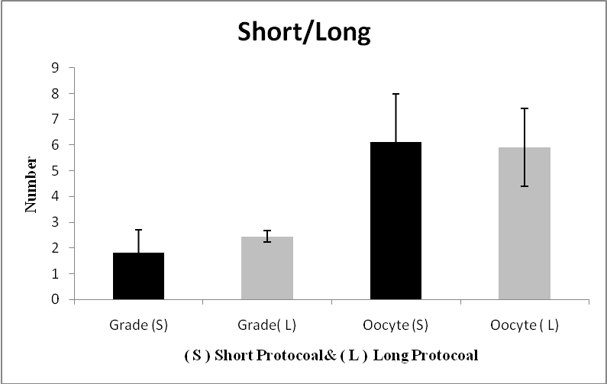
Figure 1. The number of grade -I embryos and retrieved oocytes in the pregnant and non-pregnant women

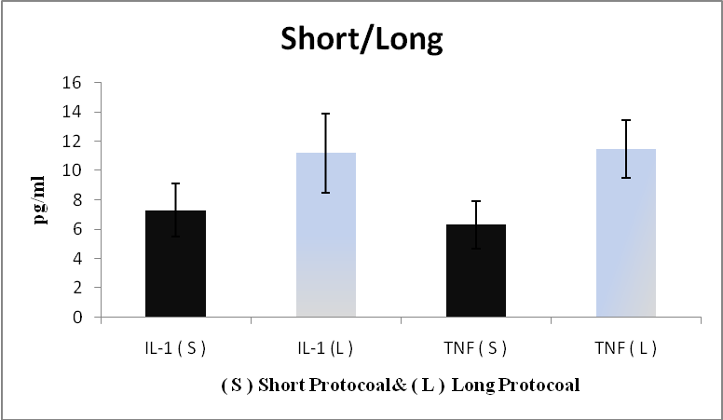
Figure 2. the concentrations of IL-1 and TNF- α in intrafollicular fluid of the in the studied groups.

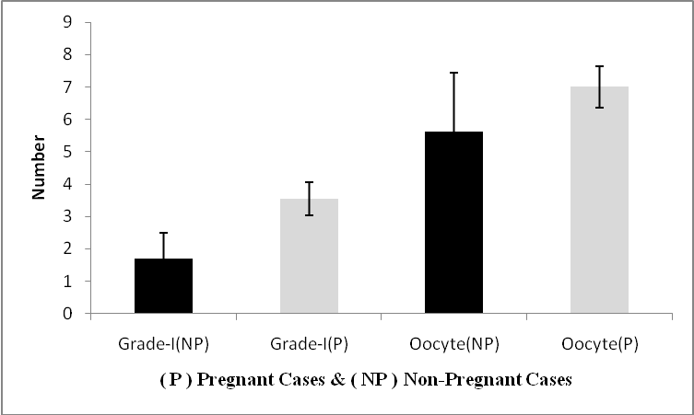
Figure 3. the number of grade -I embryos and retrieved oocytes in the pregnant and non-pregnant women

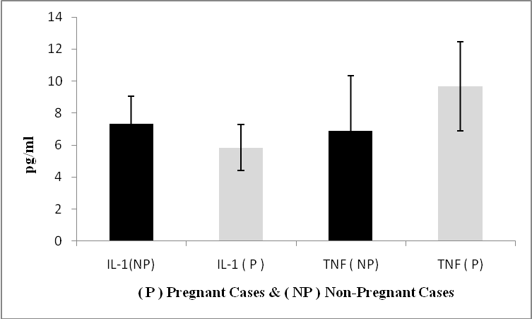
Figure (4): the concentrations of IL-1 and TNF- α in intrafollicular fluid of the pregnant and non-pregnant women.

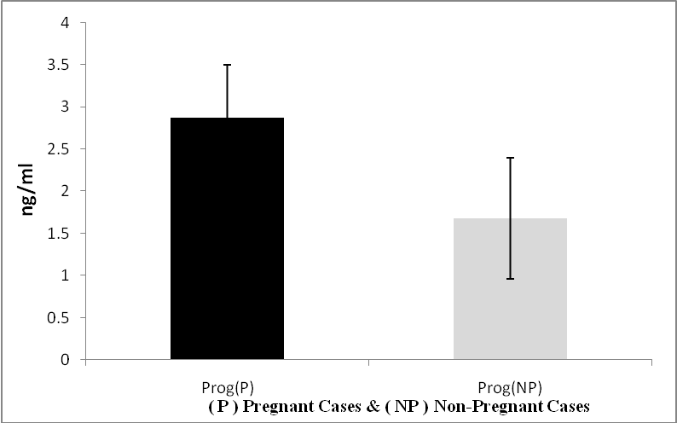
Figure (5): the concentrations of progesterone in the serum of pregnant and non-pregnant women

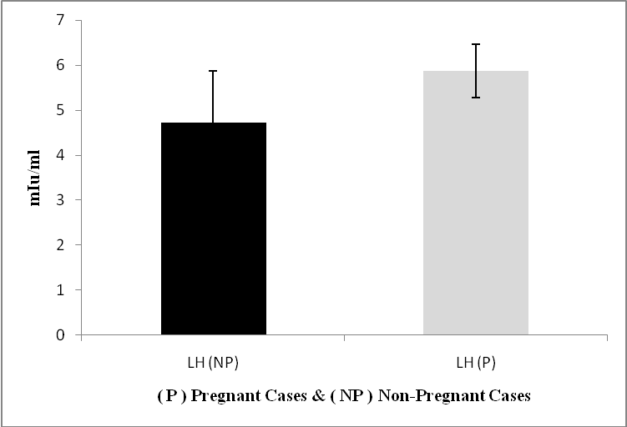
Figure (6): the concentrations of LH in the serum of pregnant and non-pregnant women.

5. Discussion
Fertilization results in human assisted reproduction are influenced by a combination of male and female factors. Thus, fertilization failure in an in-vitro fertilization (IVF) attempt can be due to a sperm abnormality, poor oocyte quality or both. As compared with standard IVF, intracytoplasmic sperm injection (ICSI) into oocytes is mostly indicated in cases of poorer sperm quality, in which the high risk of failure of classical IVF would be expected. Paradoxically, even spermatozoa from such poor quality samples yield high fertilization and pregnancy rates when used in ICSI (Nagy et al. 1995). Fertilization failure after ICSI is thus likely to be mainly due to abnormalities of the oocyte (Mendoza et al. 1999).
The two studied groups of the present study were comparable in terms of several parameters such as age, duration of infertility and the number and quality of transferred embryos. ICSI was applied in all cases, by the same experienced personnel. The inclusion of women with normal reproductive functions and adequate response to ovarian stimulation was imperative, since various infertility disorders seem to be related to elevated cytokine levels, and thus, possible bias in the results was avoided.
According to the results of our study, the difference between the two studied groups as regards the pregnancy rate was statistically significant in favor of the long protocol group. These results were in agreement with a study that used lifetable analysis for calculation of the cumulative conception rates (CCR) and cumulative livebirth rates (CLBR) in relation to ovarian stimulation regimen; they found that the long protocol was significantly better than the short protocol (Tan et al. 1992).
A comparison of long versus ultrashort and short protocols on the basis of clinical pregnancy rate per cycle started, the meta-analysis demonstrated the superiority of the long protocol over the short and ultrashort protocols for GnRH antagonist use in ovarian stimulation (Daya, 2000). According to the results of this study, there were significant differences between the two stimulation protocol groups regarding the intrafollicular concentrations of the TNF-α and IL-1.
Both IL-1 and TNF-α have previously been detected in human follicular fluid (Khan, 1988; Roby et al. 1990; Zolti et al. 1990). In addition to leukocytes and activated tissue macrophages that are well-known cellular sources of the two cytokines, human granulosa cells have been found to express both IL-1ß and TNF-α (Machelon and Emilie, 1997). The ovarian expression of both cytokines is hormonally regulated and reaches a peak in the peri-ovulatory period (Zolti et al. 1990; Hurwitz et al. 1992).
Our results also showed that there was a positive correlation between the intrafollicular TNF-α and IL-1 concentrations. In addition, a positive correlation was found between the concentration of both cytokines and grade I embryo (embryo quality). These results were in agreement with Mendoza et al study (2002) who suggested that infrafollicular concentrations of LH, GH and IL-1 are related to oocyte post- fertilization developmental potential.
Concentrations of IL-1 and TNF-α in human follicular fluid, in relation to IVF results, were analyzed previously by two independent studies (Barak et al. 1992; Bili et al. 1998) in which a positive correlation between IL-1 and TNF-α concentrations, this observation was in agreement with our results but in contrast to our results they found no correlation between the concentration of either cytokine and oocyte fertilization or embryo quality. Similar results had been supported only the former observation because the highest IL-1 and TNF-α concentrations were associated with normally fertilizable oocytes. Moreover, they also found a difference in the concentration of IL-1 between follicles yielding normally fertilizable oocytes and those whose oocytes failed to fertilize or developed an abnormal fertilization pattern (Mendoza et al. 1999).
The fact that follicles yielding normally fertilizable oocytes had the highest concentrations of IL-1 and TNF- α supports the hypothesis that both cytokines are involved in the regulation of processes influencing oocyte quality. Because TNF-α can stimulate angiogenesis (Leibovich, et al. 1987), and IL-1, in addition to stimulating TNF-α secretion, is known to enhance directly vascular permeability (Dinarello, 1988), both cytokines may act in synergy to ensure enhanced entry of circulating pituitary hormones into small antral follicles. Mendoza et al. (1999) found that the category of follicles yielding normally fertilizable oocytes, which showed the highest concentrations of IL-1 and TNF-α, was also that with the highest concentrations of LH, GH and PRL.
On the other hand, a recent study concluded that The intrafollicular concentrations of the estradiol, progesterone, tumor necrosis factor-alpha, interleukin (IL) -1beta, IL-6, vascular endothelial growth factor, leptin, basic fibroblast growth factor, epidermal growth factor, and insulin-like growth factor-I cannot predict the fertilization outcome after ICSI ( Asimakopoulos et al. 2008).
The data of the present study showed that the intrafollicular levels of IL-1 were lower in women who achieved a clinical pregnancy than in those who failed to do so. These results were in agreement with Mendoza et al. (2002) who found that intrafollicular levels of IL-1 were lower in treatment attempts leading to pregnancy as compared with unsuccessful attempts. Higher FF IL-1beta levels were associated with normal fertilization [Mendoza et al, 1999], but surprisingly they were lower in FFs whose oocytes were able to generate better embryos and successful IVF attempts (Mendoza et al, 2002). It is possible that IL-1beta leads to cytoplasmic maturation and normal fertilization, but does not play a role in post-fertilization embryo development (Revelli et al. 2009).
Our results showed that serum progesterone levels measured on the day of hCG administration showed no statistically significant difference between the long and short protocol groups. At the same time, statistically significant lower levels were found in women who became pregnant as compared with those who failed to establish pregnancy. No significant correlation was found between serum progesterone levels on day of hCG administration and number of retrieved oocytes or grade 1 embryos as well as pregnancy results. On the other hand, intrafollicular levels of TNF-α were negatively correlated with serum progesterone levels in the long protocol group only.
These results were in agreement with previous study which concluded that serum progesterone levels before hCG administration do not predict the outcome of assisted reproductive technology (ART) cycles in patients suppressed with GnRH-a before hCG stimulation. Lower fertilization rates observed in the high progesterone cycles did not have an effect on clinical outcome. Also, Huang et al. (1996) concluded that serum progesterone > 0.31 ng/ml during ovulation induction reflects good follicular recruitment, and is not a predictor of IVF outcome.
Many groups have reported significantly declining pregnancy rate with increasing serum progesterone values on the day of hCG administration (Hamori et al.,1987; Edelstein et al.1990; Schoolcraft et al., 1991; Silverberg et al.1991; Kagawa et al.1992; Mio et al., 1992; Fanchin et al.1993; Check et al.1994; Mio and Terakawa 1995; Bosch et al. 2003; Ozcakir et al. 2004). Although a significant inverse relationship between serum progesterone on the day of hCG and the success of IVF is established in many programmes, the involved endocrinologic mechanism is unclear. A number of studies had been suggested that the mechanism of deleterious effect of elevated progesterone was abnormally accelerated endometrial maturation leading to impaired endometrial receptivity. However, several clinical trials have been performed in which progesterone supplementation for luteal phase support was started on the day of hCG administration, without any negative impact on pregnancy rate due to a deleterious effect on the endometrium, suggesting that there is no negative impact of the premature luteinization (PL) on IVF outcome (Howles et al. 1988; Ben-Nun et al. 1990; Hassiakos et al. 1990).
Melo and coworkers (2006) also concluded that the premature elevation of the serum progesterone on the day of HCG administration during controlled ovarian hyperstimulation (COH) does not appear to have a negative impact on pregnancy rate in their oocyte-donation programme. The results of another study showed an association between the presence of detectable levels of TNF-alpha in FF and low 17 beta-estradiol (E2) and progesterone levels in serum, suggesting a role for TNF-alpha in the regulation of human steroidogenesis (Punnonen et al. 1992).

5. Conclusion
Normal women stimulated with either the long or the short protocol of ovarian stimulation have significant difference between TNF-α and IL-1 profiles in the follicular fluids and have similar serum progesterone levels. Women stimulated with the long protocol have higher pregnancy rates, so it may be suggested to use the long protocol regimen of infertile women. The data suggested that intrafollicular levels of TNF-α and IL-1 are related to fertilization results, and can therefore be used as reliable markers for ICSI outcome. Serum progesterone levels on the day of hCG have no significant correlation with the number of retrieved oocytes or grade 1 embryos, as well as pregnancy results. So, it cannot predict the fertilization outcome after ICSI.

Correspondence to: Maha Hashim, Nervana Samy
Biochemistry Department, Genetic Engineering and Biotechnology Research Division, National Research Center, Tahrir Street, Dokki, Giza, 12311, Egypt. Tel.: +2033335451
E.mails: dr_mahacp@hotmail.com, nervana91@hotmail.com

References
(1) Asimakopoulos B, Abu-Hassan D, Metzen E, Al-Hasani S, Diedrich K, Nikolettos N. The levels of steroid hormones and cytokines in individual follicles are not associated with the fertilization outcome after intracytoplasmic sperm injection. Fertil Steril. 2008; 90(1): 60-64.
(2) Barak V, Mordel N, Holzer H. The correlation of interleukin 1 and tumour necrosis factor to oestradiol, progesterone and testosterone levels in periovulatory follicular fluid of in-vitro fertilization patients. Hum Reprod 1992; 7: 462–464.
(3) Ben-Nun I., Ghetler Y., Jaffe R., Siegal A., Kaneti H. and Fejgin M: The effect of preovulatory progesterone administration on the endometrial maturation and implantation rate after in vitro fertilisation and embryo transfer. Fertil Steril 1990; 60:276–281.
(4) Bili H, Tarlatzis BC, Daniilidis M. Cytokines in the human ovary: presence in follicular fluid and correlation with leukotriene B₄. J Assist Reprod Genet 1998; 15: 93–98.

(5) Bosch E, Valencia I, Escudero E, Crespo J, Simon C, Remohí J and Pellicer A: Premature luteinization during gonadotropin-releasing hormone antagonist cycles and its relationship with in vitro fertilisation outcome. Fertil Steril 2003; 80:1444–1449.

(6) Branisteanu I, Pijnenborg R, Spiessens C. Detection of immunoreactive interleukin-11 in human follicular fluid: correlations with ovarian steroid, insulin-like growth factor I levels, and follicular maturity. Fertil. Steril 1996; 67: 1054–1058.

(7) Check JH, Hourahi C., Choe JK, Callan C. and Adelson HG. Pregnancy rates in donors versus recipients according to the serum progesterone level at the time of human chorionic gonadotropin in a shared oocyte program. Fertil Steril 1994; 61: 262–264.

(8) Cianci A, Calogero AE, Palumbo MA. Relationship between tumor necrosis factor and sex steroid concentrations in the follicular fluid of women with immunological infertility. Hum. Reprod 1996;11: 265–268.

(9) Daya S. long versus short gonadotrophin releasing hormone agonist protocols for pituitary desensetisation in asssted reproduction cycles (Cochrane Review). In The Cochrane Library, vol, 2000;Oxford: Update software.
(10) Diedrich K, Felberbaum R. New approaches to ovarian stimulation. Hum Reprod 1998;13:1s–13s
(11) Dinarello CA. Biology of interleukin-1. FASEB J 1988;2: 108–115.
(12) Edelstein MC, Seltman, HJ, Cox, BJ. Progesterone levels on the day of human chononic gonadotrophin administration in cycles with gonadotrophin-releasing hormone agonist suppression are not predictive of pregnancy outcome. FertiL SterL 1990;54: 853-857.

(13) Fanchin R, de Ziegler D, Taieb J, Hazout A and Frydman R: Premature elevation of plasma progesterone alters pregnancy rates of in vitro fertilisation and embryo transfer. Fertil Steril 1993; 59, 1090–1094.
(14) Felberbaum RE, Albano C, Ludwig M, Riethmüller-Winzen H, Grigat M, Devroey P, Diedrich K. Ovarian stimulation for assisted reproduction with HMG and concomitant midcycle administration of the GnRH antagonist cetrorelix according to the multiple dose protocol: a prospective uncontrolled phase III study. Hum Reprod 2000; 15:1015–1020.
(15) Givens CR, Schriock ED, Dandekar PV, Martin MC. Elevated serum progesterone levels on the day of human chorionic gonadotropin administration do not predict outcome in assisted reproduction cycles.Fertil Steril 1994 Nov; 62(5):1011-7.
(16) Gordon K, Irianni F, Hodgen GD. Management of pituitary gonadal function via gonadotrophin releasing hormone (GnRH) antagonists, including ovulation induction by co-administration of either gonadotrophins or pulsatile GnRH. Hum Reprod 1993 Nov; 8 Suppl 2:204-9. Review.

(17) Gougeon, A. Regulation of ovarian follicular development in primates: facts and hypotheses. Endocr. Rev 1996; 17: 121–155.
(18) Hassiakos D, Toner JP, Muasher SJ, Jones HW Jr. Implantation and pregnancy rates in relation to oestradiol and progesterone profiles in cycles with and without the use of gonadotrophin-releasing hormone agonist suppression.Hum Reprod. 1990; 5(8):1004-8.

(19) Howles CM, Macnamee MC and Edwards RG: Progesterone supplementation in the late follicular phase of an in vitro fertilisation cycle: a natural way to time oocyte recovery? Hum Reprod 1988; 3: 409–412
(20) Hamori M, Stuckensen JA, Rumpf D, Kniewald T, Kniewald A, Kurz CS. Premature luteinization of follicles during ovarian stimulation for in-vitro fertilization. Hum Reprod. 1987 Nov;2(8):639-43
(21) Huang JC, Jackson KV, Hornstein MD, Ginsburg ES. The effect of elevated serum progesterone during ovulation induction in in vitro fertilization-embryo transfer. J Assist Reprod Genet. 1996 Sep;13(8):617-24

(22) Hurwitz A, Loukides J, Ricciarelli, E. et al: Human intraovarian interleukin-1 (IL-1) system: highly compartmentalized and hormonally dependent regulation of the genes encoding IL-1, its receptor, and its receptor antagonist. J Clin Invest 1992; 89: 1746–1754.

(23) Huyser C, Fourie FLR, Bosmans E and Levay PF. Interleukin-1ß, interleukin-6, and growth hormone levels in human follicular fluid. J. Assist. Reprod. Genet 1994; 11: 193–202.

(24) Kagawa T., Yamano S., Nishida S., Murayama S. and Aono T: Relationship among serum levels of luteinizing hormone, estradiol, and progesterone during follicle stimulation and results of in vitro fertilisation and embryo transfer (IVF-ET). J Assist Reprod Genet 1992; 9:106–112.

(25) Khan SA, Schmid K, Hallin P. Human testis cytosol and ovarian follicular fluid contain high amounts of interleukin-1-like factor(s). Mol Cell Endocrinol 1988; 58: 221–230.
(26) Leibovich SJ, Ploverini PJ, Shepard HM. et al: Macrophage-induced angiogenesis is mediated by tumor necrosis factor-alpha. Nature 1987; 329: 630–632.
(27) Ludwig M, Felberbaum RE, Diedrich K. Interactions of GnRH analogues and gonadotrophins. In Adashi EY, Baird DT, Crosignani PG (Eds.). Gonadotrophins and Fertility(Christengraf, Rome) 1999;Vol. 1: pp. 125–143.
(28) Machelon V, Emilie D. Production of ovarian cytokines and their role in ovulation in the mammalian ovary. Eur Cytokine Netw 1997; 8: 137–143.

(29) Melo M, Meseguer M, Garrido N, Bosch E, Pellicer A, and Remohí J:The significance of premature luteinization in an oocyte-donation programme. Human Reproduction 2006; 21(6):1503-1507.

(30) Mendoza C, Cremades N, Ruiz-Requena E. Relationship between fertilization results after intracytoplasmic sperm injection, and intrafollicular steroid, pituitary hormone and cytokine concentrations. Hum Reprod 1999; 14: 628–635

(31) Mendoza C, Ruiz-Requena E, Ortega E, Cremades N, Martinez F, Bernabeu R, E Greco E, Tesarik J. Follicular fluid markers of oocyte developmental potential. Human Reproduction 2002; 17 (4): 1017-1022.

(32) Mio Y., Sekijima A., Iwabe T., Onohara Y., Harada T. and Terakawa N: Subtle rise in serum progesterone during the follicular phase as a predictor of the outcome of in vitro fertilisation. Fertil Steril 1992; 58:159–166.

(33) Mio Y, Terakawa N. Reduced implantation rate associated with a subtle rise in serum progesterone concentration during the follicular phase of cycles stimulated with a combination of gonadotrophin-releasing hormone agonist and gonadotrphin. Hum Reprod 1995; 10:1060–1064.

(34) Nagy ZP, Liu J, Joris H. The result of intracytoplasmic sperm injection is not related to any of the three basic sperm parameters. Hum Reprod 1995; 10: 1123–1129.

(35) Ozcakir HT, Levi R, Tavmergen E and Goker EN: Premature luteinization defined as progesterone estradiol ratio >1 on hCG administration day seems to adversely affect clinical outcome in long gonadotropin-releasing hormone agonist cycles. J Obstet Gynaecol Res 2004; 30:100–104.
(36) Punnonen J, Heinonen PK, Teisala K, Kujansuu E, Jansen CT, Punnonen R. Demonstration of tumor necrosis factor-alpha in preovulatory follicular fluid: its association with serum 17 beta-estradiol and progesterone.Gynecol Obstet Invest. 1992; 33(2):80-4.
(37) Revelli A, Piane LD, Casano S, Molinari E, Massobrio M, and Rinaudo P: Follicular fluid content and oocyte quality: from single biochemical markers to metabolomics. Reprod Biol Endocrinol. 2009; 7: 40.
(38) Roby KF, Weed J, Lyles L and Terranova PF. Immunological evidence for a human ovarian tumor necrosis factor. J Clin Endocrinol Metab 1990; 71: 1096–1102.
(39) Schoolcraft W, Sinton E, Schlenker T, Huynh D, Hamilton F, Meldrum DR. Lower pregnancy rate with premature luteinization during pituitary suppression with leuprolide acetate.Fertil Steril. 1991 Mar;55(3):563-6.

(40) Silverberg KM, Burns WN, Olive DL, Riehl RM and Schenken RS: Serum progesterone levels predict success of in vitro fertilisation/embryo transfer in patients stimulated with leuprolide acetate and human menopausal gonadotropins. J Clin Endocrinol Metab 1991; 73:797–803.
(41) Smith S, Francis R, Guilbert L, Baker PN. Growth factor rescue of cytokine mediated trophoblast apoptosis. Placenta 2002; 23(4):322-30.

(42) Tan SL, Kingsland C, Campbell S, Mills C, Bradfield J, Alexander N, Youich J, Jacobs HS. The long protocol of administration of gonadotrophin releasing hormone agonist is superior to the short protocaol for ovarian stimulation for in vitro fertilization .fertil.steril 1992; 57: 810-814.
(43) Tesarik J, Sousa M. Key elements of a highly efficient intracytoplasmic sperm injection technique: Ca²⁺ fluxes and oocyte cytoplasmic dislocation. Ferti Steril 1995; 64: 770–776.
(44) Terranova PF, Rice VM: Review: cytokine involvement in ovarian processes. Am J Reprod Immunol 1997; 37(1):50-63.
(45) Thanki KH, Schmidt CL. Follicular development and oocyte maturation after stimulation with gonadotropins versus leuprolide acetate/ gonadotropins during in vitro fertilization. Fertil Steril 1990; 54(4): 656-60.
(46) Ubaldi F, Smitz J, Wisanto A, Joris H, Schiettecatte J, Derde MP, Borkham E, Van Steirteghem A and Devroey P. Oocyte and embryo quality as well as pregnancy rate in intracytoplasmic sperm injection are not affected by high follicular phase serum progesterone. Hum Reprod 1995 Dec; 10(12):3091-6.

(47) Urman B, Alatas C, Aksoy S, Mercan R, Isiklar A and Balaban B. Elevated serum progesterone level on the day of human chorionic gonadotropin administration does not adversely affect implantation rates after intracytoplasmic sperm injection and embryo transfer.Fertil Steril 1999 Dec; 72(6):975-9.

(48) Zolti M., Meirom R., Shemesh M. Granulosa cells as a source and target organ for tumor necrosis factor-. FEBS Lett 1990; 261: 253–255.

10/22/2009

