Application of Dynamical Analysis to Choose Best Subsoiler’s Shape using ANSYS

Kaveh Mollazade ¹, Ali Jafari ¹, Ebrahim Ebrahimi ²

^{1.} Department of Agricultural Machinery Engineering, Faculty of Agricultural Engineering and Technology, University of Tehran, P.O. Box 4111, Karaj 31587-77871, Iran
^{2.} Department of Mechanical Engineering of Agricultural Machinery, Faculty of Engineering, Islamic Azad University Branch of Kermanshah, Kermanshah, Iran
kaveh.mollazade@gmail.com, mollazade@ut.ac.ir

Abstract: This research presents fatigue analysis of three subsoiler’s shapes, namely C shape, sloping shape, and L shape in order to choose best one of them with maximum working life. After modeling of subsoilers, initial conditions and forces were exerted on the models. Clay loam soil condition was used as a tool to find the value of soil resistance forces. Finally, models were analyzed with ANSYS software. Results showed that C shape subsoiler has biggest value of safety factor (about 5.27) in the fatigue analysis. Results of this research can help the designers of tillage tools to make similar works in their designs and reduce maintenance costs of tillage tools. [New York Science Journal 2010;3(3):93-100]. (ISSN: 1554-0200).

Keywords: Tillage tool; finite element; fatigue analysis; dynamic; shank.

1. Introduction
For thousand of years of recorded history, groups of human beings have been tilling the soil in order to increase the production of food (McKeys, 1985). Tillage has been defined as those mechanical, soil stirring actions carried on for the purpose of nurturing crops. The goal of proper tillage is to provide a suitable environment for seed germination, root growth, weed control, soil-erosion control, and moisture control, avoiding moisture excesses and reducing stress of moisture shortage (Anonymous, 1976).
Nowadays, there are many implement which done primary and secondary tillage operations. But, traffic of heavy agricultural machinery or the action of tillage tools, particularly where the same tool is used at the same cultivating depth in successive operations, lead to soil compaction (Srivastava et al., 2006). According to Guerif (1994), the hard pan induced by mouldboard ploughing, combines smearing in wet conditions and compaction by the furrow wheel of the tractor. Hard pans restrict vertical growth of roots, which reduces extraction of water and nutrients from deeper strata. Crop yield is reduced in situations of moisture shortage. Hard pans also accelerate soil erosion by decreasing inﬁltration and increasing runoff and soil loss (Stafford and Hendrick, 1988).
Subsoiling usually is done to break up impervious soil layers below the normal tillage depth to improve water infiltration, drainage and root penetration. Some outstanding results have been achieved from subsoiling. Yield increase of 50 to 400 percent has been reported from subsoiling under the right soil and moisture conditions and in the right areas. The subsoiler is similar in principle to the chisel, but it is more heavily built and rigid for operation at depths of 40 to 90 cm to loosen deep soil layers for the promotion of water movement and root growth. A tractor of 40 to 60 kW power is needed to pull one subsoiler shank at a depth of 45 cm in heavy soil, while a large track-laying tractor in the order of 50t mass needed for three winged subsoilers operating at 90 cm depth. Subsoilers work best in firm soil where a hard layer prevents adequate root and moisture penetration. If soil is uniformly textured to the depth of subsoiling, or is too wet, subsoiling is usually not as productive. Slope of subsoiler shanks and points affects draft and soil shattering. When shanks are inclined forward, they lift and break the soil much better than if they are vertical, or nearly so. Curved shanks work under hardpan, lifting and shattering the soil ahead of and between shanks (Anonymous, 1976).
Subsoilers work in the very arduous conditions, so they bear heavy dynamic loads. Therefore, proper design of these machines is necessary in order to increase their working life time and reduce the farming costs. Finite Element (FE) is one of those methods which used for evaluation of a structure under static and dynamic loads before making the main model. This leads to improve the strength of our design. ANSYS is a general purpose software package based on the finite element analysis. This allows full three-dimensional simulation without compromising the geometrical details (Hughes 2000; Madenci and Guven 2007).
Finite element method was used by many researchers in order to design the tillage tools or investigate the interaction between soil and tillage implement. Most investigation used a blade as the object studying the interaction between soil and tool, because its geometric simplicity made the corresponding FEM analysis relatively easier (Shen, 1998; Yang and Hanna,1997; , Mouazen and Nemenyi, 1999; Araya and Gao, 1995; Godwin and Spoor, 1977).
In Iran, because of high traffic of agricultural machinery and existing of lime in farm soils, hardpan is a usual problem. Working life time of a subsoiler can be increased by a suitable design according to the soil type and soil condition. Hence, the object of this study was to investigate the fatigue analysis of three different shapes of subsoiler in order to choose best of them by finite element method.

2. Material and Methods

2.1. Material Properties
Considered material for the structure of subsoiler’s shank and blade was St 37-2 which its properties are shown in the Table 1 (Beer et al., 2008).

Table1. Specification of St 37-2
Specification | Value
Yield stress (MPa) | 235
Limit stress (MPa) | 340
Elasticity modulus (GPa) | 200
Poisson’s ratio | 0.3
Density (kg/m³) | 8000

2.2. Modeling and Meshing
The commercial finite element package, ANSYS version 5.4, was used for modeling and analysis of subsoilers. The 3-dimensial Models were created based on bottom-up modeling method. After that, models were meshed by hexahedral three dimensional elements, SOLID 95. Figure 1 shows the created model of subsoilers in the meshing condition. The size of finite models were approximately 19112 elements and 29543 nodes, 23471 elements and 36385 nodes, and 27517 elements and 42061 nodes for C shape, sloping shape, and L shape subsoiler, respectively.

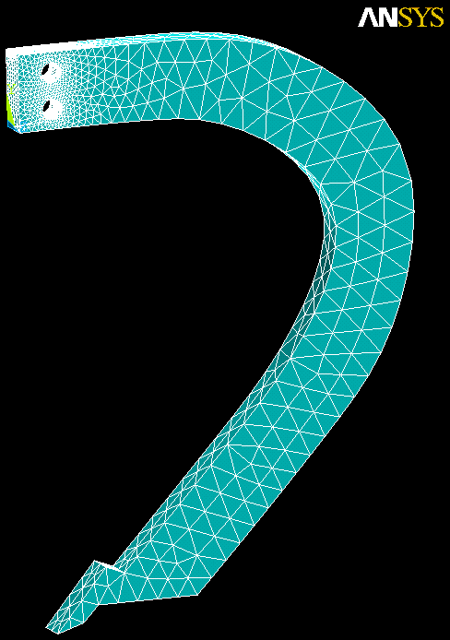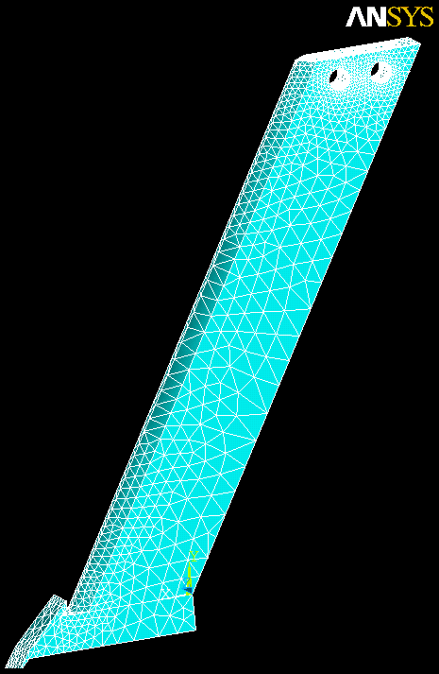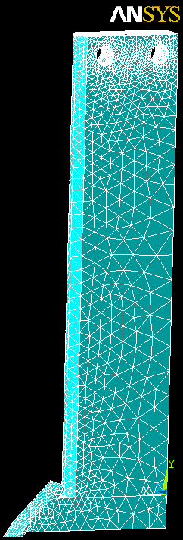
A
B
C
Figure 1. Meshed models of subsoilers; A. C shape, B. sloping shape, C. L shape

2.3. Boundary and Loading Conditions
Boundary conditions were in the holes of the shank which provide the facility to connect the shank to the frame of machine. All of these conditions were constrained in the all degree of freedom. This makes the shanks to not able to move or rotate in any directions.
In order to find the relationship between soil parameters and soil resistance force on the blade and shank of subsoiler, method of McKey (1985) was used as follows:
In the Figure 2, a wedge shaped zone of blade width w is assumed in front of the tool, including an undetermined soil failure angle, β. To each side of the blade is a circular segment with radius r and expending out to a point opposite the lower blade tip. The diameter r and s depend on the angle of the wedge, β. By determining the appropriate wedge angle, as a function of the amount of soil moved, the effects of the slenderness of the tool and the requirement of moving soil to the slides of the blade can affect the value of the critical wedge angle. The angle, β, will of course be a function of also the tool rake angle and the soil strength.

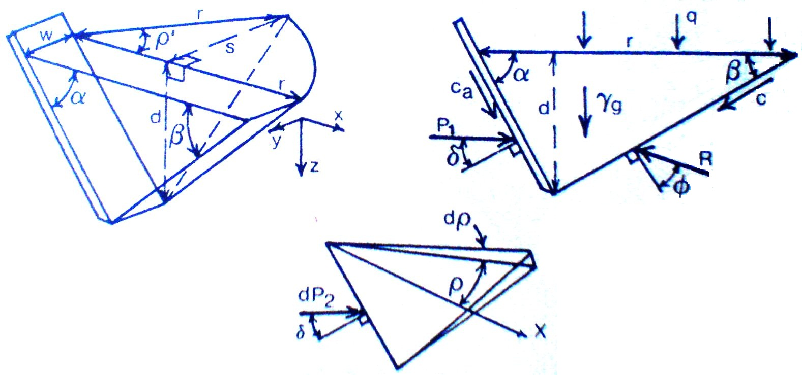
Figure 2. The three dimensional cutting model showing the forces and pressures on the center zone, and an elemental segment of inclined angle dρ in the side crescent

The center zone will require a force P₁ for movement as follows:

$\begin{aligned}P_{1}=\frac{W+Q+\text{cd}[1+\text{cot}β\text{cot}(β+φ)]}{\text{cos}(α+δ)+\text{sin}(α+β)\text{cot}(β+φ)} \\ +\frac{c_{a}d[1−\text{cot}α\text{cot}(β+φ)]}{\text{cos}(α+δ)+\text{sin}(α+β)\text{cot}(β+φ)}\end{aligned}$ (1)

For a uniform soil with a uniform surface pressure loading, q,

$W=γg\frac{d^{2}}{2}(\text{cot}α+\text{cot}β)$,
and

(2)

For each elemental segment of angle dρ, the forces can be resolved to find dP₂ in a similar way. The areas of the top and front of each segment are triangular and have magnitudes of length times half of their maximum width. The volume of the segment is one sixth of a rectangular prism of the same maximum dimensions.

$\begin{aligned}{\text{dP}}_{2}=\frac{[\frac{1}{6}γ{\text{gdr}}^{2}+\frac{1}{2}{\text{qr}}^{2}]dρ}{\text{cos}(α+δ)+\text{sin}(α+δ)\text{cot}(β+φ)} \\ +\frac{[\frac{1}{2}\text{crd}(1+\text{cot}β\text{cot}\left\{β+φ\right\}]dρ}{\text{cos}(α+δ)+\text{sin}(α+δ)\text{cot}(β+φ)}\end{aligned}$ (3)

Resolving all the elemental forces onto the x-z plane, and integrating over the entire included angle ρ’ of each side;

$\begin{aligned}P_{2}=\frac{[\frac{1}{6}γ{\text{gdr}}^{2}+\frac{1}{2}{\text{qr}}^{2}]\text{sin}ρ'}{\text{cos}(α+δ)+\text{sin}(α+δ)\text{cot}(β+φ)} \\ +\frac{[\frac{1}{2}\text{crd}(1+\text{cot}β\text{cot}\left\{β+φ\right\}]\text{sin}ρ'}{\text{cos}(α+δ)+\text{sin}(α+δ)\text{cot}(β+φ)}\end{aligned}$ (4)

The total soil strength force, P, is composed of the force P₁ on the center zone, plus the forces from each side, P₂, in the x-z plane.

$P=(γ{\text{gd}}^{2}N_{γ}+{\text{cdN}}_{c}+{\text{qdN}}_{q}+c_{a}{\text{dN}}_{\text{ca}})w$ (5)

In the above equations γ is the total soil density, c_{a} is soil to tool adhesion strength, Ф is the angle of internal friction of soil, α is the tool angle, δ is the friction angle between tool an soil, g is acceleration due to gravity, d is tool working depth below the soil surface, c is soil cohesion, w is tool width, and N_{γ}, N_{c}, N_{q}, and N_{ca} are factors which depend not only on the soil frictional strength, but also on the tool geometry and tool to soil strength properties.
In this research, in order to find the amount of forces acting on the blade and shank of subsoiler, physical property of clay loam soil was used as shown in Table 2.

Table 2. Clay loam soil properties
Φ, degree | δ, degree | γ, kN/m³ | c, kN/m² | ca, kN/m²
37.3 | 27.3 | 11.8 | 33.5 | 9.4

Using soil properties, i.e. Φ and δ, and N-α curves, values of N_{γ}, N_{c}, N_{q}, and N_{ca} factors were gained as shown in the Table 3 (McKey, 1985).

Table 3. Value of N_{γ}, N_{c}, N_{q}, and N_{ca} factors according to the slope of subsoiler’s part and soil properties
Tool part | N_{y} | N_{c} | N_{q} | N_{ca}
Blades | 34 | 58 | 98 | 2.2
C shape shank | 37 | 62 | 103 | 2.5
Sloping shank | 110 | 280 | 310 | 3.8
L shape shank | 270 | 410 | 450 | 5.6

After finding the soil parameters and N values, and considering 5 cm for working width and 50 cm as working depth, using equation 5, the value of forces acting on the blade and shank of subsoilers were determined.

2.4. Fatigue analysis
Fatigue is the phenomenon in which a repetitively loaded structure fractures at a load level less than its ultimate static strength. The main factors that contribute to fatigue failures include (Shigley and Mischke, 1989):
- Number of load cycles experienced
- Range of stress experienced in each load cycle
- Mean stress experienced in each load cycle
- Presence of local stress concentrations
Fatigue analysis needs to existence of two cyclic forces acting on the structure. To achieve this goal, considering the fact that the soil resistance forces into the structure due to the relative change of soil parameters may be different from the obtained theoretical value, 10 percent of the theoretical force was considered as tolerance. So, there were two forces, one was P+0.1P and the other was P-0.1P. In every phase of loading by entering to the POST1 processor, the Von Misses stresses were activated and the critical nodes were determined. After determination of critical nodes, they were elected as the points for fatigue investigation. Filling the fatigue parameter blanks, the S-N data collected from the fatigue test of the specific alloy into the software should import. 3.2 was taken as the stress concentration factor which was a representative of a difference between the real model and the operating condition with the sample under the test in fatigue test. Eventually a 1500000 force cycle was exerted to the model and partial consumption rate which indicate the number of exerted cycles to allowable ones for each node was obtained.

2.5. Factor of safety
In designing parts to resist failure, it is assured that the internal stresses do not exceed the strength of the material. So, Suderburg’s equation was used for calculation of safety factor as follows (Shigley and Mischke, 1989):
$\frac{1}{F\text{.}S}=\frac{σ_{\text{ave}}}{σ_{y}}+K\frac{σ_{r}}{σ_{e}}$ (6)
where, F.S is fatigue factor of safety, σ_{aver} is mean stress, σ_{e} is yield stress, σ_{r} is cyclic stress, and K is factor of stress concentration. The following equations were used to find the value of σ_{aver} and σ_{r.}
$σ_{\text{ave}}=\frac{σ_{\text{max}}+σ_{\text{min}}}{2}$ (7)
$σ_{r}=\frac{σ_{\text{max}}−σ_{\text{min}}}{2}$ (8)

3. Results
Figures 3 to 5 show the distribution of Von Misses stresses in the C shape, slopping shape, and L shape subsoilers, respectively. The biggest value of stress was occurred in the shank’s holes as 129 MPa in the node 621 for C shape subsoiler, 566 MPa in the node 38 for sloping shape subsoiler, and 801 MPa in the node 1103 for L shape subsoiler. Results showed that fracture probability of subsoiler in the points near to the shank’s holes is higher than the other points and this is due to exist of a bending moment which is produced by the soil resistance force acting on the blades and lower section of shanks.
Based on the results of fatigue analysis (Figure 6), the number of allowable force exertion cycles obtained as 10⁸ cycles. This was because of 0.015 for partial consumption rate which indicate the number of exerted cycles to allowable ones for each node. This can be concluded that the shape of subsoiler has not any effect on the ultimate loading cycle before the fracture of structure.
According to the maximum and minimum stresses in each subsoiler and using equation 6, factor of safety for C shape, sloping shape, and L shape subsoilers was gained as 5.27, 1.2, and 0.85, respectively. This shows that the fracture probability of L shape and sloping shape subsoilers is more than the C shape subsoiler. So, for sloping shape and L shape subsoilers, it is necessary that the body of subsoiler’s shank be strengthen around the holes and this leads to an increase in fabrication costs.

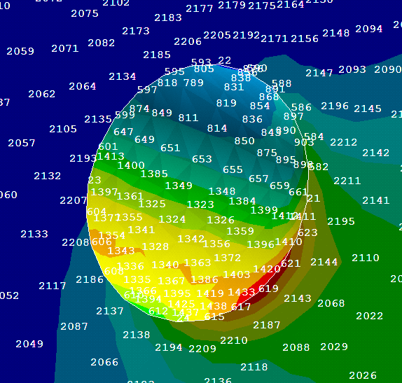
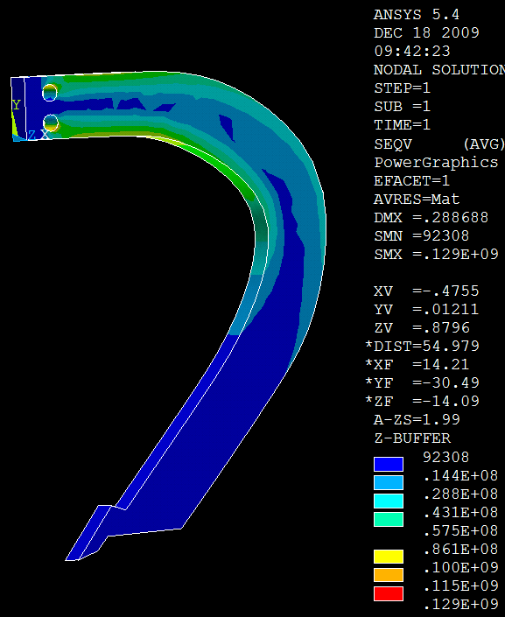
Figure 3. Von Misses stress in C shape subsoiler and corresponding node with biggest stress value (node 621)

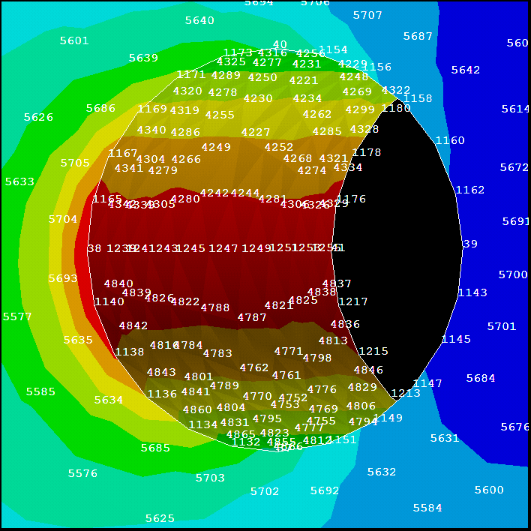
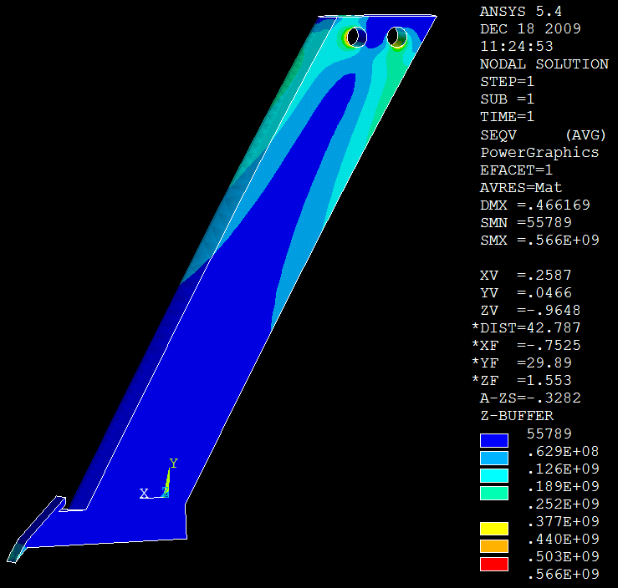
Figure 4. Von Misses stress in sloping shape subsoiler and corresponding node with biggest stress value (node 38)

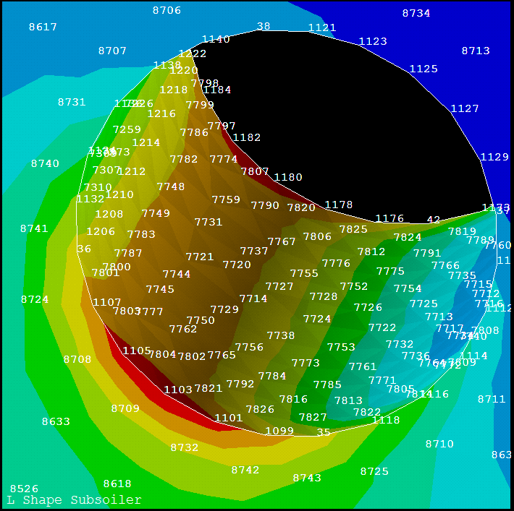
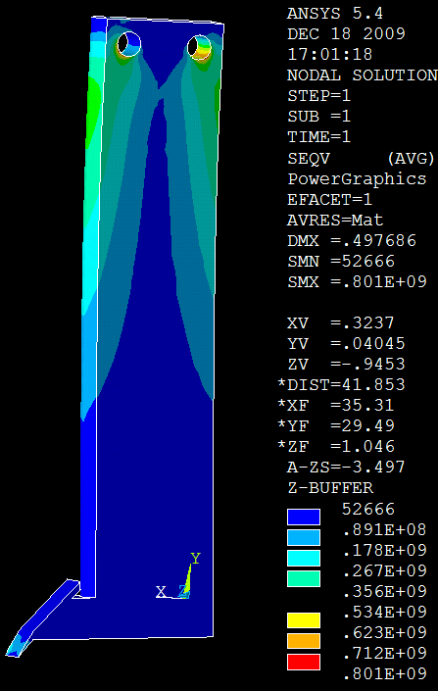
Figure 5. Von Misses stress in L shape subsoiler and corresponding node with biggest stress value (node 1103)

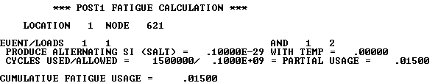
A
B
C

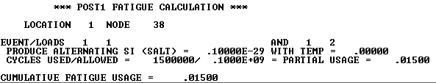
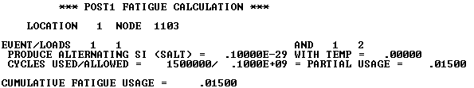

Figure 6. Result of fatigue analysis for A. C shape subsoiler, B. sloping shape subsoiler, and C. L shape subsoiler

4. Discussions
Finite element is an effective tool for investigation of fatigue analysis in structures. Subsoilers are primary tillage tools which used for solving the hardpan problems in the agricultural lands. This research focuses on the dynamical behavior of subsoilers with three different shapes. Results showed that shape of subsoiler has not significant roll in the maximum number of allowable force exertion cycles which caused to fracture of subsoiler’s shank. According to the results, C shape subsoiler bear lower bending moment than the other types. It shows that C shape has better design than the others and this makes the higher factor of safety for C shape subsoiler and consequently makes it’s more working life.

Corresponding Author:
Kaveh Mollazade
Department of Agricultural Machinery Engineering, Faculty of Agricultural Engineering and Technology, University of Tehran, P.O. Box 4111, Karaj 31587-77871, Iran
E-mail: kaveh.mollazade@gmail.com, mollazade@ut.ac.ir

References

- Anonymous. FMO: Fundamental of machine operation- tillage. John Deer Co Publisher. 1976.
- Araya k, Gao R. A Non-linear three-dimensional finite element analysis of subsoiler cutting with pressurized air injection. Journal of Agricultural Engineering Research. 1995: 61:115-128.
- Beer F, Johnston JER, Dewolf J, Maurek D. Mechanics of materials. McGraw Hill Publisher. 2008.
- Godwin RJ, Spoor G. Soil failure with narrow tines. Journal of Agricultural Engineering Research. 1977: 22: 213-218.
- Guerif J. Effects of compaction on soil strength parameters. 1994. In: Soane BD, van Ouwerkerk, C. (Eds.), Soil Compaction in Crop Production, Development in Agricultutal Engineering Series 11. Elsevier Publisher.
- Hughes TJR. The finite element method: linear static and dynamic finite element analysis. Dover Publisher. 2000.
- Madenci E, Guven I. The finite element method and applications in engineering using ANSYS. Springer Publisher. 2007.
- McKyes E. Soil cutting and tillage: development in agricultural engineering 7. Elsevier Press. 1985.
- Mouazen AM, Nemenyi M. Finite element analysis of subsoiler cutting in non-homogeneous sandy loam soil. Soil and Tillage Research. 1999: 51:1–15.
- Shen J. Soil-machine interactions. CRC Publisher. 1998.
- Shigley JE, Mischke, CR. Mechanical engineering design. McGraw-Hill Publisher. 1989.
- Srivastava AK., Georing CE, Rohrbach RP, Buckmaster DR. Engineering principles of agricultural machines. St. Joseph Publisher. 2006.
- Stafford JV, Hendrick JG. Dynamic sensing of soil pans. Transaction of American Society of Agricultural Engineering. 1988: 31(1):9–13.
- Young R, Hanna A. Finite element analysis of plane soil cutting. Journal of Terramechanics. 1977: 14(3): 103-125.

Submission date: 12/21/2009

