New York Science Journal

纽约科学杂志

ISSN 1554-0200

Volume 3 - Number 3 (Cumulated No. 13), March 1, 2010



Marsland Press
Brooklyn, New York, the United States

New York Science Journal

纽约科学杂志

ISSN 1554-0200

Marsland Press

Brooklyn, New York, the United States

http://www.sciencepub.net
http://www.sciencepub.org
sciencepub@gmail.com

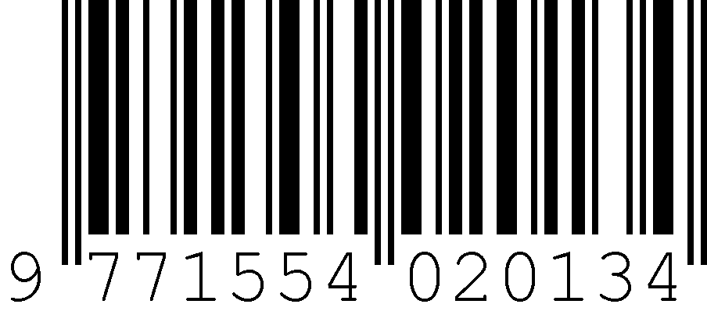
ISSN 1554-0200

