Biochemical Studies on Tilipia Nilotica Exposed to Climate change and Cadmium Sulphate (0.50p.p.m.)

¹Mona S. Zaki, ², ³Olfat M. Fawzi ²Suzan O. Mostafa , ²Isis Awad, ¹Mostafa fawzy
¹Department of Aquaculture, vet. devission National Research Centre, Giza, Egypt.
²Department of Biochemistry, National Research Centre, Giza, Egypt.
dr_mona_zaki@yahoo.co.uk

Abstract: Fourty fish (Tilipia Nilotica) were collected from Abbassa Sharkia government and fed commercial fish diet. Thirty fish were exposed to cadmium Sulphate (0.50p.p.m.) and 30◦ temp. for 21 days. Ten fish were kept without treatment (control). Haematological analysis of the exposed group demonstrated a marked elevation in serum glutamic oxaloacetic transaminase, serum glutamic pyruvic transaminase, serum glucose, urea, creatinine, sodium, potassium and phosphorus, while serum calcium, haemoglobin and PCV were reduced. [New York Science Journal 2010;3(4):90-95]. (ISSN: 1554-0200).

Keywords: Pollution – cadmium, fish, immunity.

1. Introduction
Heavy metals are persistent contaminants in the environment that come to the forefront of dangerous substances such as cadmium, lead, mercury, copper and zinc causing serious health hazard in humans and animals[1-10]. The agricultural and industrial wastes, partially treated or without treatment are being discharged into surface water[11-16]. Such metals are absorbed from polluted water through gills, skin and digestive tract of fish by bio-concentration and bio-magnification. Chronic cadmium toxicity or "itai-itai" disease was recorded [17-20].
Cadmium toxicity was interfered with calcium/phosphorus ratio [21, 22] Suppression of cell mediated and humoral response of mammals exposed to sublethal dose of cadmium has been reported [23-26].
Heavy metals are recognized as cumulative toxic substances causing serious health hazards to man depending on their concentration [13-19].

2. Material and Methods
Experimental design: Total of fourty fish 100-200 gm body weight of each were acclimatized A tized to laboratory conditions for two weeks before use. They were divided into control group (10 fish) and experimental group (30 fish) that was exposed to cadmium Sulphate at a concentration of 0.50 p.p.m. and 30◦ temp. for 21 days.
Blood samples were collected from the caudal vein after 7 and 21 days of exposure. Serum for biochemical analysis and heparinized blood for hematological investigations were obtained from each sample.
Biochemical analysis: Test kits of Bio Merieux (France) were used for evaluation of serum glutamic pyruvic transminase and glutamic oxaloacetic transaminase [20]. Serum glucose was assessed according to Trinder [23]. Serum urea and creatinine were determined using kits of Bio Merieux (France). The concentration of cadmium, sodium, potassium and calcium were detected by using atomic spectrophotometry according to Forstner [13].
Hematological examination: Blood hemoglobin (Rb) was assessed by Drabkin [12]. Hematocrit value was carried out by using microhaematocrit capillary tubes, centrifuged at 1200 r.p.m. for 5 min.
Bacteriological examination: Bacterial isolation was done from skin, liver and kidney of fish on blood tryptose agar, MacConcky agar and tryptic soy agar plates. The plates were incubated aerobically and anaerobically. The bacterial isolates were identified morphologically and biochemically, according to Nomiyama [18].
The serum IgM was measured according to Fuda et. al. [15]. Antisera for fish were prepared by immunizing rabbits as previously described by Fuda et.al [15]. The procedure for labeling antibody fragment with enzyme was performed.
Elisa assay procedure: Assay was carried out in 96-well polystyrene ELISA microtiter plates (Titertex, Horsham, P A). The microtiter plates were coated with rabbit antigrey mullet IgM and was fractionated by DE-52 at a concentration of 40 $μ$g/ml in 0.01 MPBS. A volume of 150$μ$l was dispensed into each well and incubated for 4 hrs at 4°C.
Blocking was achieved after one washing with 200 $μ$l of 0.01 MPBS + 0.1 % 20 $μ$l per well and two washings with 200 $μ$l of PBS +1% PBS. 0.01% thiomerosol was added to each well and incubated for 2 hrs at room temperature.
Incubation of samples and standards after washing was carried out as described above. 100 $μ$l of sample and standard were placed into the appropriate wells in the microtiter plates and incubated at room temperature.
Incubation with peroxidase labeled antibody after washing was done as described above, each well received 150 $μ$l of peroxidase labeled antibody 1:1600 in PBSBSA, followed by incubation for 12 hrs at room temperature.
Statistical analysis: The obtained data were subjected to the student T test.

RESULTS
Serum biochemical analysis: Fish exposed to cadmium Sulphate (0.50 p.p.m) showed a significant increase of SGPT and SGOT activity with pronounced elevation of urea and creatinine by 1st, 2nd, 3rd week of exposure. High level of sodium and potassium in serum of exposure fish was noticed (Table 1). Hyperglycaemia and hypocalcemia were noticed along the experimental period with- marked elevation of serum cadmium (Table 2).
Haematological profile: Reduction of Hb concentration and P.C.V value were observed (Table 2).
Bacteriological examination: Pure culture of Streptococcus spp., Staphylococcus spp. Agrobacterium spp., Flavobacterium spp. were isolated from the internal and external organs of exposed fish (Table 3).
Determination of fish IgM: There was a significant decrease in total protein and IgM level from the first week of exposure until the end of last week (Table 4).
Pathological findings
Macroscopical lesions of exposed fish revealed congestion in all internal organs after 21 days. Liver appeared friable and dark red. Peticheal haemorrhages around the operculum, and abdominal cavity were observed. Congestion and edema of gill lamellae were seen.

Table 1. Effect of cadmium Sulphate .50p.p.m. on kidney and liver function of Tilipia Nilotica.

Exposure time | SGOT  U/L | SGPT U/L | Urea mg/dl | Creatinine  mg/dl | Sodium  Meg | Potassium  Meg
1st week (control) | 91.0$±$0.17 | 21.7$±$1.7-5 | 3.39$±$0.27 | 0.75$±$0.72 | 123$±$0.57 | 4.29$±$0.07
1st week of exposure | 92.00$±$2.40 | 26.5$±$0.73 | 3.80$±$0.34 | 0.82$±$0.01 | 132$±$0.76 | 4.70$±$0.02
2nd^{st} week control) | 91.00$±$0.10 | 23.1$±$1.48 | 3.40$±$0.28 | 0.74$±$30 | 121.3$±$4.8* | 4.23$±$0.58
2nd ^{st} week of exposure | 124$±$0.45* | 28$±$2.1* | 3.81$±$0.13** | 0.91$±$0.19** | 137$±$0.70** | 5.8$±$0.08
3rd week (control) | 91$±$2.2 | 21.00$±$0.05 | 3.30$±$0.27 | 0.73$±$0.27 | 127$±$4.2 | 4.2$±$0.09
3rd week of exposure | 135$±$2.46* | 35$±$1.56* | 4.7$±$24* | 0.98$±$0.18** | 147$±$7.6 | 6.35$±$0.13
* Segnificant P< 0.05 ** highly significant P < 0.01

Table2: Some hematological and biochemical changes in Tilipia Nilotica exposed to cadmium Sulphate.

Exposure time | P.C.V % | Hemoglobin gm/dl | Glucose mg% | Cadmium p.p.m | Calcium mg/dl | Phosphonis mg/dl
1st week (control) | 22.00$±$0.06 | 8.8$±$0.3 | 63$±$1.20 | 0.04$±$0.01 | 5.6$±$0.32 | 4.2$±$0.07
1st week of exposure | 18.9$±$0.05 | 8.2$±$0.01 | 69$±$0.46 | 0.07$±$0.016 | 4.50$±$0.87 | 6.2$±$0.21
2nd^{st} week control) | 23$±$0.29 | 8.3$±$0.36 | 61$±$0.05 | 0.044$±$0.068 | 5.4$±$0.91 | 4.1$±$0.66
2nd week of exposure | 18$±$1.97 | 7.10$±$0.98** | 71$±$1.93** | 0.13$±$1.03* | 4.3$±$0.73* | 6.3$±$0.12*
3rd week (control) | 21.0$±$1.32 | 8.2$±$0.07 | 63.2$±$0.70 | 0.03$±$0.01* | 4.4$±$0.73 | 3.9$±$0.1
3rd week of exposure | 17.9$±$0.8 | 6.81$±$0.23* | 85$±$0.02* | 0.15$±$082* | 3.4$±$0.88* | 6.4$±$0.6*
* Segnificant P< 0.01 ** highly significant P < 0.05

Table 3. Bacteriological recovered in Tilipia Nilotica exposed to cadmium Sulphate (0.50 p.p. m).
Bacterial strain | External surface | Internal organs | Internal organs liver | Gills
Agrobacterium spp. | 3.1x10⁷ | 2.7x10⁶ | 2x10³ | 1x10⁷
FlavobacterIum spp. | 6x10⁷ | 5.2x 10⁶ | 4X10³ | 5.3X10⁸
Staphylococcus spp. | 5x10⁵ | 4x10⁴ | 5.2x10³ | 3.2x10⁶
Streeptococcus SPP. | 5x10⁷ | 9x10⁵ | 7x10⁶ | 3x10⁷

Table 4. Influence of cadmium Sulphate 0.50 p.p.m on 1gM and protein level.
Exposure period | 1gM/old | Total protein/neg/dl
Control | 0.98$±$ 0.10 | 7.84$±$0.20
1st week of exposure | 0.81$±$ 0.23** | 7.30 $±$ 0.69*
2st week of exposure | 0.72$±$ 0.84* | 6.32$±$0.29*
3st week of exposure | 0.62$±$0.44 * | 6.4$±$0.48*
* Segnificant P< 0.01 ** highly significant P < 0.05
$±$ Standard errors

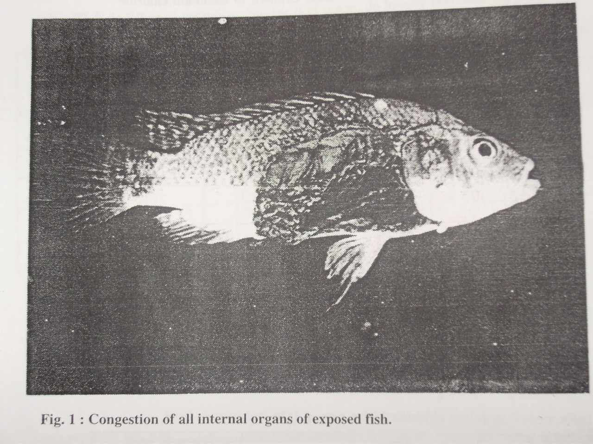

4. Discussions
Aforementioned data of exposed fish to cadmium Sulphate (0.50 p.p.m) for 3 weeks revealed a elevation of serum GPT, GOT, urea and creatinine.
These findings are in agreement with previous results. Elevation of urea and creatinine beside liver enzymes in cadmium-exposed fish may be attributed to liver and kidney injury. Reduction of calcium level in serum may have resulted from its increased excertion in urine through inhibition of calcium ATPase enzyme. On the other hand, increase of the phosphorus level in serum of exposed fish was noticed. Cadmium Sulphate toxicity leads to disturbance in blood electrolytes followed by skeletal changes [23,25]. Hyperglycemia was observed in the present work which coincides with that obtained in Rainbow traut and salmogaidneri [25]. The blood glucose level was affected by the rate of carbohydrate metabolism under hypoxia and stress conditions. Hyperglycemia is attribute to stress stimuli followed by rapid secretion of both glucocorticoids and $α$-techolarnines from the adrenal tissue [2]. Regarding to hematological profile exposed fish, hemoglobin and P.C.V. values were decreased. These results are in agreement with previous findings [17,18]. The erythropenia resulted from reduction of Hb concentration and P.C.V. value in Kwait Mullet due to disturbance of osmoregulatory mechanism accompanied with destruction of gill membrane and failure of gas exchange [19]. Cadmium interfered with sulpha-hydride groups of essentials enzymes [4,25]. Heavy metals are recognized as cumulative substances leading to serious health hazards to man and animals [6-9].
In the present study, a significant decrease of IgM and total protein during the experimental period were observed. Reduction of IgM level indicated that the cadmium Sulphate toxicity leads to suppression of immune system of exposed fish which become susceptible to any infective agents [15,20]. There is a significant decrease in IgM level in fish exposed to cadmium Sulphate if compared with control which may have resulted from high cortisol secretion that was indicated by hyperglycemia in exposed fish.
Macroscopical examination of fish exposed to cadmium Sulphate for 21 days revealed a congestion of all internal organs and friable bloody liver. These findings are in agreement with those mentioned by other authors [1-9].
Necrobiotic changes of epithelial lining of renal tubules were observed especially the proximal convoluted tubules that were reflected on electrolytes reabsorption such as calcium, phosphorus, potassium and sodium. These findings come parallel to those previously reported.
It could be concluded that cadmium Sulphate at 0.50 p.p.m induced deleterious effect in fish such as damage of liver, kidney, spleen and gills, which were reflected on the biochemical and hematological parameters. Heavy metals induced cumulative effect, therefore equivalent lesions of fish may occur in humans. Moreover, immune suppression could play an important role in predisposing for further infections conditions.
Lamellar telangictasis resulted from rupture of pillar cells and capillaries under effect of chronic irritation of cadmium Sulphate and leads to an accu- mulation of erythrocytes in the distal portion of the secondary lamellae [29]. The subepithelial space of the secondary gill lamellae was infiltrated with inflammatory cells. This finding is in agreement with that previously ment- ioned [29,30]. Mucinous metaplasia of lamellar epithelial lining is considered as adaptive mechanism against heavy metal toxicity. These alteration are in agreement with those previously mentioned [31].
It could be concluded that cadmium Sulphate at 0.25 p.p.m induced delet- erious effects in fish such as damage of liver, Kidney, spleen and gills, wh- ich were reflected on the biochemical and hematological parameters. Heavy metals induced cumulative effect, therefore equivalent lesions of fish may occurr in humans. Moreover, immune suppression could play an important role in predisposing for further infections conditions.

References
- Abbas, H.H., K.H. Zaghloul, and M.A. Mousa, 2002. Effect of some heavy metal pollutants on some biochemical and histopathological changes in Blue tilapia, Oreochromis aureus. Egypt. J. Agric. Res., 80(3): 1395-1411.
- Abbas, W.T. 2006. Fish as an indicator for pollutants in aquatic environment. Ph. D. Thesis, Zoology Department, Faculty of Science, Cairo University, Egypt, 144 pp.
- Abdel-Baky, T.E. 2001. Heavy metals concentrations in the catfish, Clarias gariepinus (Burchell, 1822) from River Nile, El-Salam Canal and Lake Manzala and their impacts on cortisol and thyroid hormones. Egypt. J. Aquat. Biol. & Fish., 5(1):79-98.
- Abernthy A. R. and P.M., Cutnbie 1999. Bull Environ. Contoam. Toxicol. 17: 595 (1999).
- Abou El-Gheit, E.N., M.S., Zaki, A.A., Abo El-Ezz, H.A. El-Cherei, 2001. Vertebral column curvature syndrome in common carp Cyprinus Carpio L. fish. J. Egypt. Vet. Med. Ass., 61(5):57-69.
- Abou El-Naga, E. H.; K. M. El-Moselhy, and M. A. Hamed, 2005. Toxicity of cadmium and copper and their effect on some biochemical parameters of marine fish Mugil seheli. Egypt. J. Aquat, Res., 31(2):60-71.
- Ahmed, Y.F.; M.M., Mohamed, I.Z., El-Nemer, K.I. El-Desoky, and S.S. Ibrahim, 1998. Some pathological studies on the effect of cadmium and mercuric Sulphates on the gonads of catfish (Clarias lazera). Egypt. J. Comp. Pathol. Clin. Pathol., 11:72-81.
- Authman, M.M.N. 2008. Oreochromis niloticus as a biomonitor of heavy metal pollution with emphasis on potential risk and relation to some biological aspects. Global Veterenaria, 2(3):104 -109.
- Authman, M.M.N., E.M. Bayoumy, and A.M. Kenawy, 2008. Heavy metal concentrations and liver histopathology of Oreochromis niloticus in relation to aquatic pollution. Global Veterenaria, 2(3):110-116.
- Bahnasawy, M.H. 2001. Levels of heavy metals in catfish, Clarias gariepinus from different habitats and their effects on some biochemical parameters. Egypt. J. Aquat. Biol. & Fish., 5(1):99– 125.
- Burger, J., M. Gochfeld, C., Jeitner, S.Burke, and T. Stamm, 2007. Metal levels in flathead sole (Hippoglossoides elassodon) and great sculpin (Myoxocephalus polyacanthocephalus) from Adak Island, Alaska: Potential risk to predators and fishermen. Environmental Research, 103: 62–69.
- Drabkin, D., l964. Bio Chem., 164, 703.
- Forstner N. and G.T.W., Wittmann 2007. Metal pollution in the aquatic environment. Springer-Verlag, Belin .
- Frolin, L, C. Haux, L., Karkson-Norgren, P. Runn, and A. Larsson 1986. Aquatic Toxicol. 8:51.
- Fuda, H., K., Sayano, F. Yamaji, and Haraj, 1991. Comp Brioche, Physiol, 99 A 637-643.
- Gad, S.C. and C.S., Weil, 1986. Statistics for Toxicologists. In Hayes. A. W. 2nd .
- Matsubara, A., S. Mihara, and R., Kusuda, 1985. Bull Japan Sac, Sic. Fish. 51m 921.
- Nomiyama, K., 1988. "Bacteriological Test Book ". Vol. 2 pp. 15-23. Pergamon
- O'Neill, J.G., 1981. Bull. Env. Contam. Toxico!., 27: 42-48.
- Reitman, S.,and S. A., Frankel, 1957. Am. J. Clin. Pathol. 28, 56 .
- Stephen, W.I. 2004. Zinc, cadmium, mercury and lead. Stephen, W.I. Ed.; Blackwell Scientific Publications.
- Stostiof, M.K. 1993. "Fish Medicine" W.B. Saunders Company, Philadelphia, Lonion, Toronto, Montreal, Sydney, Tokyo (1993).
- Trinder, P., 1960. Ann. CUn Brioche. 6,24.
- Vinodhini, R., and M. Narayanan, 2008. Bioaccumulation of heavy metals in organs of fresh water fish Cyprinus carpio (Common Carp). Int. J. Environ. Sci. Tech., 5 (2):179-182.
- Vosyliene, M. Z. and A. Jankaite, 2006. Effect of heavy metal model mixture on rainbow trout biological parameters. Ekologija., 4:12-17.
- Zaki, M.S., and A.H. Osman, 2003. Clinicopathological and pathological studies on Tilapia nilotica exposed to cadmium Sulphate (0.25 ppm) Bull. NRC, Egypt., 28 (1): 87-100.
- Carleton H., "Carleton's; Histopathological Technique" 4th Ed. London, Oxford University, Press, New York, Toronto. (1979).
- Balah, A.M., El-Bouhy, Z.M. and Easa, M.E.I.S., Histopathlogical studies in the gills of Tilipia nilotica "Oreochromis niloticus" under the effect of some heavy metals. Zagazig Vet. J., Vol. 21, No. 3 pp 351-364. (1993).
- Randi, A.S., Monserrat J. M., Rodrigue E. M and Romano L. A. , J. of fish diseases 19, 311 (1996).
- Pascoe, D., Evans, S. A. and Woodworth, J., Arch. Env. Contam. Toxicol., 15:481. (1986).
- Stostiof, M.K. "Fish Medicine". W.B Saunders Company, Philadelphia, London, Toronto, Montreal, Sydney, Tokyo (1993).

12/4/2009

