Design and Development of the Human Energized Chaff Cutter

Zakiuddin Syed Kazi ¹, Jayant P.Modak ²

^{1.} Department of Mecanical Engineering, Anjuman College of Engineering, Nagpur-44001, India,
^{2.} Priyadarshini College of Engineering, Nagpur-44001, India
qszaki1@rediffmail.com
Abstract:
In the recent past a human-powered process machine has been developed for brick making, wood turning, clothes washing and drying and earthen pot making. The machine consists of a human-powered flywheel motor using a bicycle-drive mechanism with speed-increasing gearing and a flywheel, which drive the process unit though a spiral jaw clutch and torque-increasing gearing. The operator puts energy into the flywheel at a convenient power level for about one minute. After enough energy is stored, pedaling is stopped and the energy in the flywheel is made available to the process unit. Pedal power is the transfer of energy from a human source through the use of a foot pedal and crank system. This technology is most commonly used for transportation and has been used to propel bicycles. Less commonly pedal power is used to power agricultural and hand tools and even to generate electricity. The paper discuss about the applications for pedal power technology. The machine is economically viable, can be used by unskilled workers, save time otherwise spent in traditional mixing and can be adopted for human-powered process units which could have intermittent operation without affecting the end-product. [New York Science Journal 2010;3 (4):104-108].(ISSN:1554-0200).

Keywords: Flywheel, Spiral Jaw Clutch, Chaff Cutter.

1. Introduction
Chaff is hay cut into small pieces for feeding to livestock (Mohan D and Kumar A, 2004); it is a good fodder, and at its best is cleanly and evenly cut, free of dust, of good colour and with a fresh aroma. Chaff can be purchased from commercial chaff cutting mills (Wikipedia, 2009] Cutting chaff can be done by manually operated machine and electric operated one, As far as cutting by manually operated machine is concerned. Traditionally for the operator it is done manually which is physically demanding through it energy and postural requirements and is commonly regarded as source of drudgery (Kumar P, et al 2004); many farmers associated with this task reported back, shoulder and wrist discomfort. It may also cause clinical or anatomical disorders and may affect worker's health.

2. Need for manually energized Chaff Cutter:
The main objective to design and develop a machine, which uses the human powered flywheel motor as an energy source (Modak J and Bapat A, 1987); consisting of a bicycle mechanism, use of non-conventional energy as source. Developing countries of third world like India are facing problems of Power storage due to rapid industrialization, non-availability of power in rural areas and unemployment among semi-skilled workers. In the context of the present condition in India and third world countries the Power shortage and exhaustion of coal reserves and unemployment, it is felt that “Manually energized Chaff Cutter machine” for cutting fodder is very necessary. This machine is environment friendly i.e. non-pollutant. It will bring Innovation & mechanization in agricultural engineering. Unskilled women may also get employment. Development of such an energy source which has tremendous utility in energizing many rural based process machines in places where reliability of availability of electric energy is much low .

3. Concept of manually energized Chaff Cutter:
The average work rate of a man working continuously is equivalent to 0.13 h.p (Modak and Bapat, 1994);. Therefore only continuous manufacturing process requiring less than 0.13 h.p. can be man powered. Any manufacturing process requiring more than 0.13 h.p. and which can be operated intermittently without affecting end product can also be man powered. Such man powered manufacturing process can be based on the following concept. In this processes a flywheel is used as a source of power. Manpower is used to energize the flywheel at an energy input rate, which is convenient for a man. After maximum possible energy is stored in flywheel it is supplied through suitable clutch and gearing system to a shaft, which operates process unit (Modak and Moghe, 1997); the flywheel will decelerate at a rate dependent on load torque. Larger the resisting torque larger will be the deceleration. Thus theoretical a load torque of even infinite magnitude could be overturn by this man-flywheel system. Manually driven chaff cutter machine operates on the basis of above principle.
Figure1.Energy unit and transmission system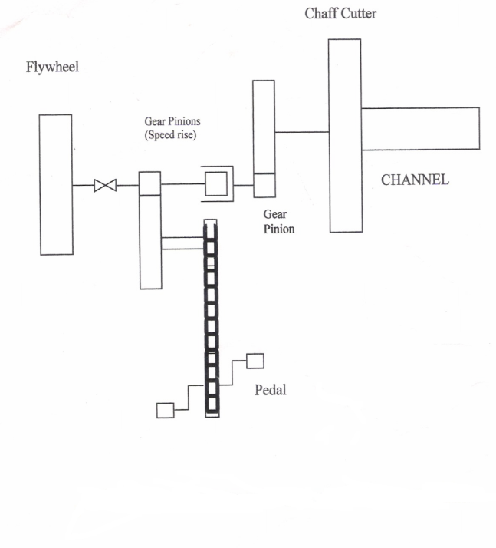

Figure2.Schematics of Human Powered Chaff-cutter machine

4. Working
Figure3. Schematic diagram of Chaff Cutter Machine.
1-Chain Sprocket 2-Pedal 3-Chain 4-Freewheel 5,6-Bearings for bicycle side 7-Gear-I 8-Bearing 9-Tachogenerator for flywheel shaft 10-Pinion-I 11-Bearing for flywheel shaft 12-Flywheel 13-Bearing for flywheel 14-Two jaw clutch 15,15-Bearing of intermediate shaft 17-Pinion II 18-Gear II 19,20-Bearing for process unit shaft 21-Coupling 22-Chaff Cutter blade 23-Tachogenerator for chaff Cutter shaft.
Essentially, the machine consists of three sub-systems: (1) the energy unit (2) transmission mechanism (3) the process unit. The energy unit consists of a conventional bicycle mechanism, the transmission unit consists of a drive train; a chain drive mechanism running over a pair of speed-increasing gears and the process unit. The schematic arrangement of a chaff cutter machine is shown in Figure 3. The operator drives the flywheel (12). The rider accelerates the flywheel to a desired speed in about one minute , through a chain (3) and a pair of gears (7,10) .The chain drive is utilized for first stage transmission because the drive is required to be irreversible, this is achieved by conventional bicycle chain drive with a free wheel (4). A free wheel is used between pedals (2) and the flywheel to prevent the back flow of energy from flywheel to pedals. When flywheel attains desired speed, pedaling is stopped and it is connected to the process unit though torque amplification gears by engaging a two jaw spiral clutch(14). A special jaw clutch is used in this machine in place of conventional friction clutch as friction clutch consumes more energy for its own operation.[7] The energy stored in flywheel is supplied at the required rate to chaff cutter (22) and the chaff is cut to obtain small pieces of fodder.

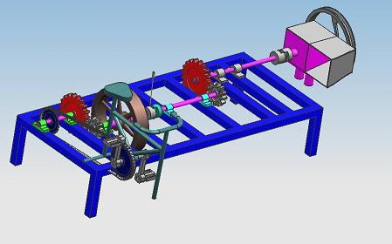
Figure4. Human Power chaff cutter
5. Dimensional Analysis.
Dimensional analysis is the method of dimensions.[8] It is a mathematical technique used in research work for design and for conducting model tests. It deals with the dimensions of the physical quantities involved in the phenomenon. All physical values are measured by comparison, which is made fixed to an arbitrarily fixed value.
Dimensional analysis can be used primarily as experimental tool to combine many experimental variables into one. The main purpose of this technique of is making experimentation shorter without the loss of control.
Applying Releigh’s method the dimensional equation for resistive torque , number of cuts, process time are formulated.[9]
Table 1 - Dimensional Analysis
Sr. No. | Description | Types of variable | Symbol | Dimensions
1 | Tip diameter of blade | I | D | L
2 | Hub diameter | I | d | L
3 | Acceleration due to g | I | g | LT⁻²
4 | No. of blades | Independent | n | -
5 | Young modulus of elasticity of cutting blade | Independent | E | ML⁻²L⁻¹
6 | Width of cutting blade | Independent | W_{b} | L
7 | Thickness of cutting blade | Independent | t_{b} | L
8 | Cutting blade angle | Independent | α | -
9 | Equivalent moment of inertia of flywheel | Independent | I | ML²
10 | Angular velocity of flywheel | Independent | ω | T⁻¹
11 | Gear ratio | Independent | G | -
12 | Sp time instant during cutting operation | Independent | t_{c} | T
13 | Kinetic Energy of flywheel | Independent | e | ML²T⁻²
14 | Instantaneous torque on cutting blade | Dependent | Tc | ML²T⁻²
15 | No. of cuts during cutting | Dependent | Cp | -
16 | Process time for cutting chaff | Dependent | t_{p} | T
M, L and T are the symbols for mass, length and time respectively.
Applying Buckingham π theorem the dimensional equations for resistive torque , number of cuts, process time are formulated as under [10].

Resistive torque:
Tc = f[(d/D), n, (D⁴/gI)E, (W_{b}/D), (t_{b}/D), α, (√(D/g) ω), G] √(g/D) t_{c} ]
(D/gI) Te =f [ (dW_{b} t_{b}/D³), (D⁴/gI)E, α, G, n, (√(D/g) ω) √(g/D) t_{c} ] (1)
Number of cuts :
C = f[(dW_{b} t_{b}/D³), (D⁴/gI)E, α, G, n, (√(D/g) ω)] √(g/D) t_{c} ]
√(D/g) Cp= f[(dW_{b} t_{b}/D³), (D⁴/gI)E, α, G, n, (√(D/g) ω)] √(g/D)t_{c} ] (2)
Process time for cutting(t_{p}) :
t_{p} =f [(dW_{b} t_{b}/D³), (D⁴/gI)E, (√(D/g) ω), G, α, n]
√(g/D) t_{p} = f[(dW_{b} t_{b}/D³), (D⁴/gI)E, (√(D/g) ω), G, α, n] √(g/D) t_{c} ] (3)
In equations 1,2and 3, f stands for “function of ” .
6. Result and Discussions:
Empirical models to predicts the performance of the manually driven chaff cutting machine to cut chaff were established and optimum values of various parameters were arrived at on the basis of experiments involving the manually driven chaff cutting system.
A new theory of cutting of cutting of chaff from the manually driven chaff cutting machine is proposed. This hypothesis states that on engagement of the clutch, the speed of flywheel suddenly falls indicating energy loss. A part of this energy loss is due to developing pressure due to chaff .when this pressure in the chaff stalk crosses yield stress, cutting commences. After sometimes a rise in the pressure in chaff stalk, as available energy decreases and then the rate of cutting falls and consequently cutting stops.
It is further hypothesized that the cutting time is a function of available energy for cutting, resisting torque and average angular speed of the chaff cutter shaft .the proposed fly wheel motor can be used as an energy source for any process unit that can operate with its input element in a transient state of motion.
This Flywheel motor is applied to brick making, low head water pumping and wood turning the performance is found to be functionally satisfactory and economically viable the wheel motor can be used as an energy source for process unit that need have continuous operation and have a upper limit of about 3h.p. In designing the Human energized chaff cutter, the main objective was on cost and ergonomic designed, readily-available materials and we proposed a simplistic design that can deliver productive, efficient, and reliable cutter for rural area. This equipment can adequately replace electric motor-driven chaff cutter in rural areas where there is no or limited supply of electricity, saves cost.
Corresponding Author:
Zakiuddin Syed Kazi
Department of Mechanical Engineering,
Anjuman College of Engineering
Nagpur, 44001, India
qszaki1@rediffmail.com
7. References:
- Mohan D, Kumar A. Development of safer fodder-cutter machines: a case study from north India. Safety Science. 2004; 42(1):43-55.
- Chaff cutter, From Wikipedia, the encyclopedia. http://en.wikipedia.org/wiki/Chaff_cutter. retrieved on 2nd October 2009.
- Kumar P, Nag A, Drudgery P. Accidents and Injuries in Indian Agriculture Industrial Health. 2004; 42 (3): 149–162.
- Modak J, Bapat A. Design of experimentation for establishing generalized experimental model for a manually driven flywheel motor. Proc. International Conference on Modeling and Simulation. New Delhi, India. 1987 8(2): 127-140.
- Modak J, Bapat A. Formulation of Generalised Experimental Model for a Manually Driven Flywheel Motor and its Optimization. Applied Ergonomics. 1994 25 (2): 119-122.
- Modak J, Moghe S. Comparison of some bicycle drive mechanisms designed in the light of transmission angle optimization and J. Papadopoulos Hypothesis, Part II. International Symposium on Machines and Mechanisms (ISMM '97), September 2-5, 1997.
- Gupta J. “Design proposal for new type of clutches essentials for process machines with manually energized flywheel motor as an energy source. Proceedings mechanics Transmission and mechanism (MTM 97) organized by University of Tianjin, China. July 1-4; 1997: 383-388.
- Schenck H. Reduction of variables Dimensional analysis. Theories of Engineering Experimentation. Publisher Mc Graw Hill Book Co., New York, USA. 1961:60-64.
- Schenck H. Experimentation as a subject of study. Theories of Engineering Experimentation. Publisher Mc Graw Hill Book Co., New York, USA. 1961:6.
10. Modak J, Tatwawadi V Modelling of an industrial enterprise using a feedback control system’s approach. Modelling, Measurement and Control Series,D. 2006; 27(1):35-36.

Date of submission: 03/03/2010

------------------------------------------------------------------------------------------

