Immunohistochemical Expression of Heat Shock Protein 70 in Psoriasis Vulgaris

Amina Gamal el Din¹*, Hanan M Saleh², Nermeen Abdel Fattah² and Abdel Maksoud A³

¹.Pathology Department, Medical Research Division, National Research Centre,Dokki, Cairo-12622 (Egypt)*
^{2.}Dermatology & Venereology Department, Faculty of Medicine, Ain Shams University, Abbasia, Cairo-12622 (Egypt).
³Dermatology and Venereology Department, Medical Research Division, National Research Centre, Dokki, Cairo-12622(Egypt).
hassaneinamina@yahoo.com

Abstract: Psoriasis, a common skin disease in Egypt, has drawn much attention to study the potential role of immunity in its pathogenesis.. Exposure of skin to microbial antigens and other stressful stimuli can induce heat shock proteins (HSPs) expression. HSPs comprise a large number of antigens against which immune responses are directed, owing to their cytokine-like effects and immunomodulatory properties. The potential role of HSP70 in pathogenesis of psoriasis is under investigation. We aimed at evaluating the differential immunohistochemical expression of HSP 70 in psoriatic skin and correlating the results with disease severity ; to elucidate its potential role in pathogenesis of psoriasis. Skin biopsies were taken from 20 patients with different severity of untreated chronic plaque-type psoriasis and from 20 healthy volunteers. Antibodies to HSP70 were analyzed immunohistochemically. Immunoreactivity intensity distribution index (IRIDI) scores including the proportion of immunoreactive cells and their staining intensity were calculated in the basal, suprabasal, superficial as well as the whole epidermal layers of patients and controls. Differential and total IRIDI scores for HSP70 expression showed highly significant higher values in psoriatic patients compared to controls. Statistical differences were found between the different groups of patients; according to their disease severity and controls. Positive correlations also existed between IRIDI scores of patients and disease severity. Based on the findings of the present study, HSP70 is suggested to play a role in the pathogenesis of psoriasis and to correlate with disease severity. Further studies on immunotherapeutic intervention are recommended, aiming at inhibiting events in an ongoing immune response which may provide new therapeutic and perhaps preventive approaches for psoriasis. [[ New York Science Journal. 2010;3(4):112-116]. (ISSN: 1554-0200).

Keywords: : psoriasis, heat shock protein 70, immunohistochemistry

1. Introduction
Psoriasis is a common, chronic inflammatory skin disease associated with both genetic and environmental risk factors (Krueger,2002). There is growing interest in the role of innate and adaptive immunity in inflammatory diseases such as psoriasis (Curry et al,2003). The exposure of the skin to microbial pathogens and other stressful stimuli can induce heat shock proteins (HSPs) expression, as a part of the innate immunity (Boucock and Shannan,2001). Autoimmunological mechanisms triggered by microbial agents have been suggested as playing an important role in the pathogenesis of psoriasis (Jones et al,2004; Asea et al, 2000). More recently,
HSPs have become a focus for their role in inflammatory and autoimmune diseases owing to their cytokine-like HSPs play a central role in homeostasis by their ability to bind to other peptides

and to control their effects and immunomodulatory properties (Asea et al,2000). Based on molecular
mass and sequence homology, HSPs are classified into families including ubiquitin, small HSPs of 20 to 28 KDa, HSP60, HSP70 and HSP90 (Curry et al,2003). The antigenic sites of many pathogenic HSPs, particularly HSP70 are immunodominant and are thus the primary targets for B cell and T cell responses (Palleros et al,1991). In the HSP70 family are heat shock cognate protein 70 (HSC70), which is constitutively expressed during normal cell development and differentiation (Curry el al,2003) and the major heat or stress-inducible protein HSP70 (Palleros el al,1991). They are nuclear and cytoplasmic proteins exhibiting approximately 95% sequence homology and forming stable complex in stressed cells. HSP27, HSP60 and HSP70 and their ligands common HSP receptor CD91 have been reported to be increased in lesional psoriatic skin(Boyman et al,2005).
The aim of our study was to evaluate the differential immunohistochemical expression of HSP70 in psoriatic skin in comparison with normal skin to elucidate its potential involvement in the pathogenesis of psoriasis and to correlate the results with the disease severity.

2. Material and Methods
Twenty patients with untreated chronic plaque-type psoriasis and of various degree of severity were participated in the present case- control study. They were randomly selected from those attending the outpatient dermatology clinic at Ain Shams University Hospitals and fulfilling the inclusion criteria of the study. They were 13 males and 7 females with mean age 33.6 years ±12.57 (16-53) and mean disease duration 10.5 years± 6.38 (1-24). Twenty age and sex matched healthy volunteers were included as controls. Inclusion criteria included subjects with no concomitant dermatological and/or systemic diseases that could affect the outcome of the study, subjects who did not use any topical or systemic treatment for at least one month before the study. Prior to initiation of the study, every subject was informed about the aim of the study and gave an informed consent.
All subjects were subjected to the followings:
1. Full history taking.
2. General and dermatological examination.
3. Assessment of psoriasis severity using Psoriasis Area and Severity Index (PASI) score (Fredrickson and Patterson , 1978).
4. Skin biopsy: Formalin-fixed paraffin embedded 5 mm skin punch biopsy specimens were obtained from 20 clinically diagnosed and histopathologically confirmed psoriatic lesions and from 20 normal skin controls.
Immunohistochemical staining procedure was applied to all specimens. Sections, 3-4 µm thick, were cut and mounted on positively charged slides (Menzel-glazer-polysine). Monoclonal mouse antibody to HSP70Ab-2 (clone W27;Neomarkers, Fremont, CA, USA) and Ultravision universal detection kit were used. After deparaffinization of the sections in xylene, rehydrated through graded ethyl alcohol and washed with phosphate-buffered saline, endogenous peroxidase activity was prevented by using hydrogen peroxide 0.86%. Microwave treatment (x4 for 10 minutes; sections in 10 mM citrate buffer, pH 6.0) were used for antigen retrieval. Blocking of non-specific binding was done using a universal blocking reagent (ultra V block; Neomarkers). Prediluted primary monoclonal antibody was applied for 1 hour at room temperature within a humidifying chamber. DAB; Neomarkers were used as chromogen. Mayer's haematoxylin was used for counterstaining (Merck, Germany). Sections were mounted and examined under the light microscope (Olympus CX 41 Japan).
Immunohistochemical evaluation was done on light microscopic examination. Epidermis was divided into 3 layers: basal, suprabasal and superficial (stratum corneum). Each layer was
evaluated for the proportion of immunoreactive cells as well as their staining intensity. The proportion of the immunoreactive cells in each layer was assessed as 0: no immunoreactive cells, 1: less than 25% of the cells are immunoreactive. 2: 25-50% of the cells are immunoreactive. 3: more than 50% of the cells are immunoreactive. As regards the staining intensity of the cells, it was graded as 0: no staining, 1: light staining, 2: moderate staining, 3: intense staining. Immunohistochemical evaluation was performed semiquantitatively according to Chaiyarit et al,1999). An immunoreactivity intensity distribution index (IRIDI) was calculated for every patient and control. IRIDI score of each layer was calculated by multiplying the score of the proportion of immunoreactive cells by the score of their staining intensity. Total IRIDI score was determined by adding the IRIDI scores of the 3 epidermal layers for every patient and control.
Statistical analysis was carried out using the Statistical Package for the Social Sciences (SPSS) version 15. Comparison of quantitative data was carried out using unpaired t-test and Mann Whitney test. ANOVA and Kruskal-Wallis tests were used to compare more than 2 groups as regards quantitative data. Post Hoc test was used to detect the least significant difference in case of significant ANOVA test. Probability (p) values ≤ 0.05 were considered statistically significant and p ≤0.001 were considered statistically highly significant. Correlation between different parameters was assessed using Pearson's correlation coefficient test. Correlation is considered significant at 0.05 level.

3. Results
The study included 20 patients with chronic plaque-type psoriasis. They were 13 males and 7 females with mean age 33.6 years ± 12.57 (16-53). Twenty age and sex-matched healthy volunteers, with mean age 32.3 years ± 12.54 (15-54) were enrolled as controls. According to PASI score, patients were divided into 3 groups:
- Group 1 included patients with mild psoriasis.
Their PASI score ranged from 7 to 13 (mean 10.2 ± 3.03). They were 6 patients (3 males and 3 females) with mean age 33.8 years ± 12.19 (24-53) and mean disease duration 10.17 years ± 6.62 (1-20).
-  Group 2 included patients with moderate psoriasis.
Their PASI score ranged from 17 to 24 (mean 18.4 ± 3.09). They were 7 patients (5 males and 2 females) with mean age 39.86 years ± 10.42 (26-53) and mean disease duration 9.0 years ± 7.77 (2-24).
- Group 3 included 7 patients with severe psoriasis.
Their PASI score ranged from 30 to 65 (mean 50.2 ± 17.41). They were 5 males and 2 females with mean age 41 years ± 12.1 (16-53) and mean disease duration 12.43 years ± 4.99 (4-20).
Immunohistochemical evaluation of HSP70 expression: The mean IRIDI scores of HSP70 expression of psoriasis vulgaris and normal skin in the different epidermal layers (differential IRIDI scores) as well as the whole epidermis (total IRIDI scores) are summarized in Table (1). As regards normal control skin, light HSP70 immunostaining was seen within basal cell layer of the epidermis. Suprabasal cell layer showed light to moderate HSP70 immunostaining in 4 specimens only. Superficial cell layer on the otherhand, showed no HSP70 immunoreactivity. Moreover, HSP70 was not immunohistochemically detected in the dermis of normal skin. The immunohistochemical staining pattern of normal keratinocytes was diffuse; cytoplasmic and nuclear (Fig. 1). In contrast, intense HSP70 immunostaining was found in psoriatic lesions, predominantly in basal and suprabasal epidermal cell layers. In the basal cell layer, keratinocytes tended to be decorated focally and peripherally at basal side of cytoplasm with perinuclear as well as nuclear expression. In the suprabasal cell layer, it was irregularly distributed. Superficial epidermal cell layer showed light HSP70 immunoreactivity as well (Figs. 2 and 3). Only 2 cases from the severe group of psoriasis showed expression of HSP70 within the dermal inflammatory infiltrate as intense perinuclear, granular staining of lymphocytic infiltrate (Fig. 2).
Comparison between patients and controls as regards total and differential IRIDI scores of expressed HSP70 : On comparing psoriatic and normal skin specimens, statistically highly significant differences were found between patients and controls as regards mean IRIDI scores of HSP70 expression in basal, suprabasal as well as superficial epidermal cell layers. Similar results were also noted on comparing patients and controls as regards total IRIDI scores (Table 1).
Comparison between different groups of patients and controls as regards total and differential IRIDI scores of HSP70 expression : Statistically highly significant differences were found between the different groups of patients and controls at all epidermal cell layers as well as regarding total IRIDI scores (Table 2). By using the post Hoc test to detect the least significant difference, statistical differences existed according to the epidermal cell layer. In the basal epidermal cell layer, significant differences were found between groups 1 and 2 (p=0.047) and between groups 1 and 3 (p=0.012). Highly significant differences were found between group 2 and controls as well as between group 3 and controls. No significant differences were however, found between groups 2 and 3 (p=0.540) and between group 1 and controls (p=0.317). In the suprabasal epidermal cell layers, significant differences existed between groups 1 and 2 (p=0.046) as well as between groups 2 and 3 (p=0.003). Statistically highly significant differences were found between groups 1 and 3, group 1 and controls, group 2 and controls and group 3 and controls.
In the superficial epidermal cell layer, significant differences between groups 1 and 2 (p=0.008), groups 1 and 3 (p=0.003) as well as between group 1 and controls (p=0.010) were found. Moreover, statistically highly significant differences existed between group 2 and controls and between group 3 and controls. No significant difference was found between groups 2 and 3 (p=0.688). As regards total IRIDI scores, there were significant differences between groups 1 and 2 (p=0.012) as well as between group 1 and controls (p=0.006). Highly significant differences existed between groups 1 and 3 as well as between group 2 and controls and between group 3 and controls. No significant difference was noted between groups 2 and 3 (p=0.072). Significant positive correlations were also found in the patients between PASI score, total and differential IRIDI scores of HSP70 expression in the basal, suprabasal and superficial epidermal cell layers (r= 0.55, 0.53, 0.61 and 0.28 respectively).

Table 1: Mean Differential and Total IRIDI Scores of HSP70 Expression in Psoriasis Patients Compared to Control

 | Patients | controls | t-test | p-value
Basal cell layer | 4.75± 2.40 | 2.35±1.04 | 4.099 | 0.001
Suprabasal cell layer | 6.35±2.45 | 1.65±0.93 | 8.002 | 0.001
Superficial cell layer | 1.6± 1.04 | 0.0 | 6.839 | 0.001
Whole epidermis | 12.70±5.89 | 4.0±1.97 | 7.165 | 0.001
Table 2: Comparison between Different Groups of Patients and Controls as Regards Differential and Total IRIDI Scores of HSP70 Expression

 | Group 1  Mild psoriasis | Group 2  Moderate psoriasis | Group 3  Severe  psoriasis | controls | F-test | p-value
Basal cell layer | 3.16±1.33 | 5.14±2.73 | 5.14±2.73 | 2.35±1.04 | 8.94 | 0.001
Supra  Basal  cell layer | 4.33±0.82 | 6±2.24 | 6±2.24 | 1.65±0.93 | 43.86 | 0.001
Superficial cell layer | 0.83±0.41 | 1.86±1.22 | 1.86±1.22 | 0.0 | 23.49 | 0.001
Whole epidermis | 8.33±2.56 | 13±6.19 | 13±6.19 | 4.0±1.97 | 31.64 | 0.001

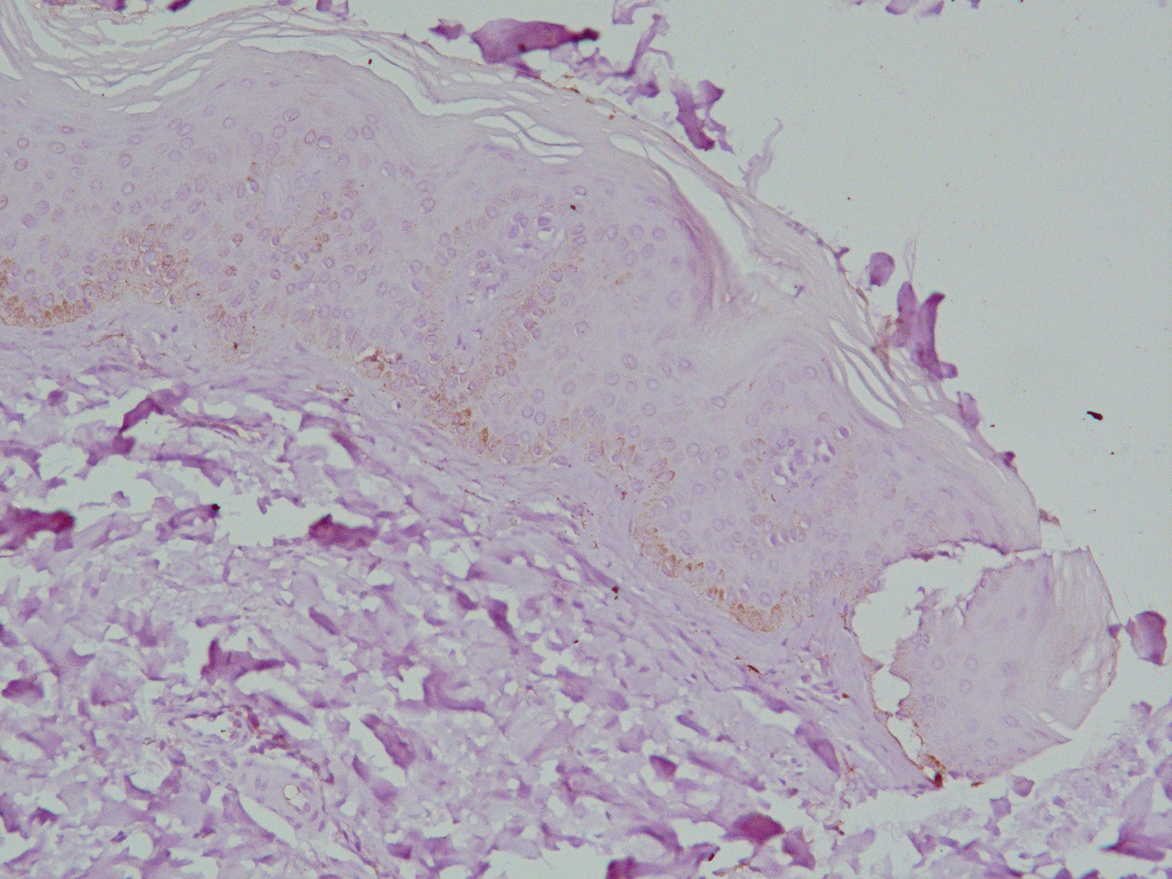
Figure 1: Normal skin: light HSP70 imunostaining in basal epidermal cell layer with negative immunoreactivity in suprabasal and superficial epidermal layers (immunoperoxidase X200)

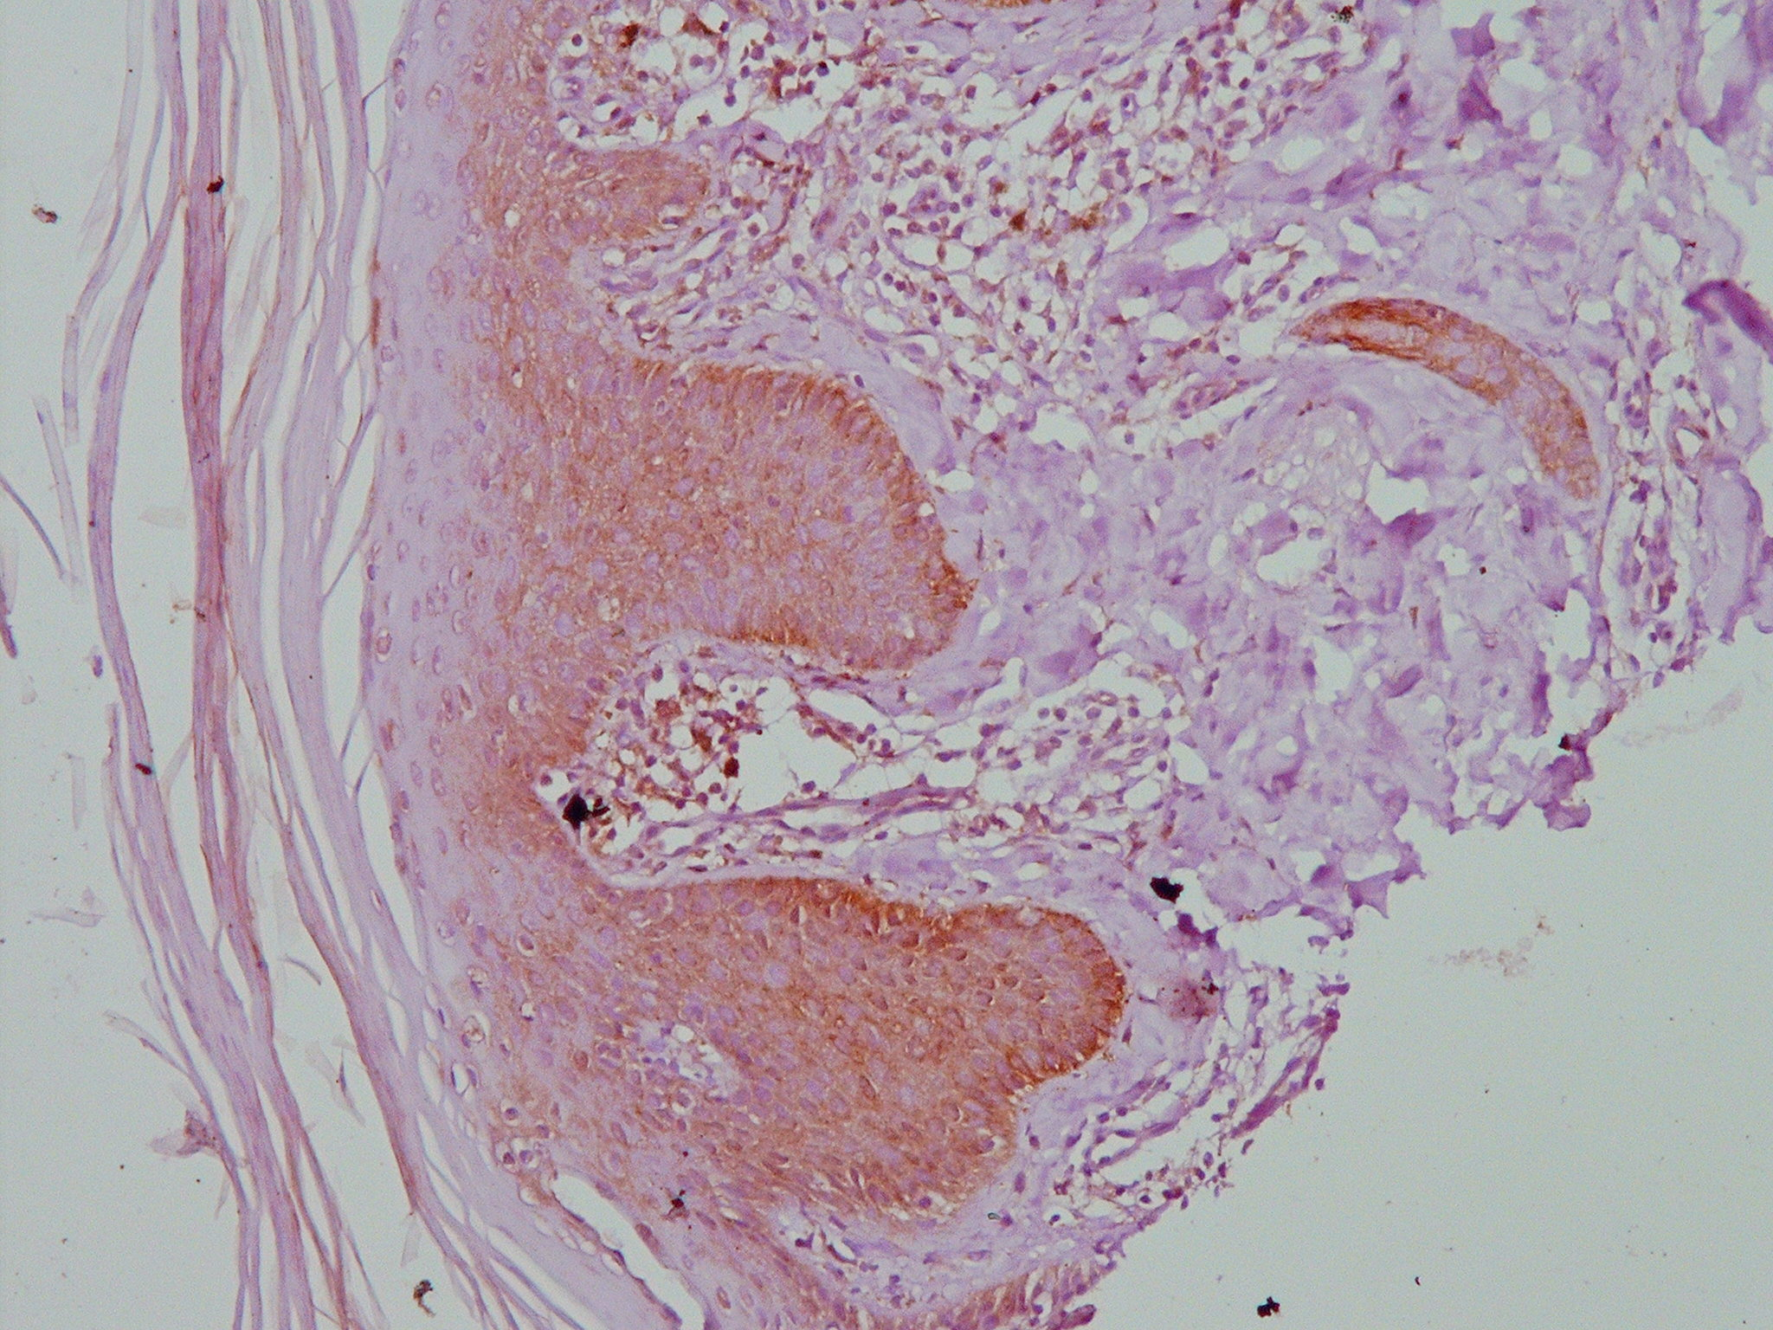

Figure 2. Psoriasis vulgaris: intense HSP70 immunostaining in basal and suprabasal epidermal
cell layers with light superficial layer immunostaining and dermal inflammatory infiltrate immunoreactivity. (immunoperoxidase X 200).
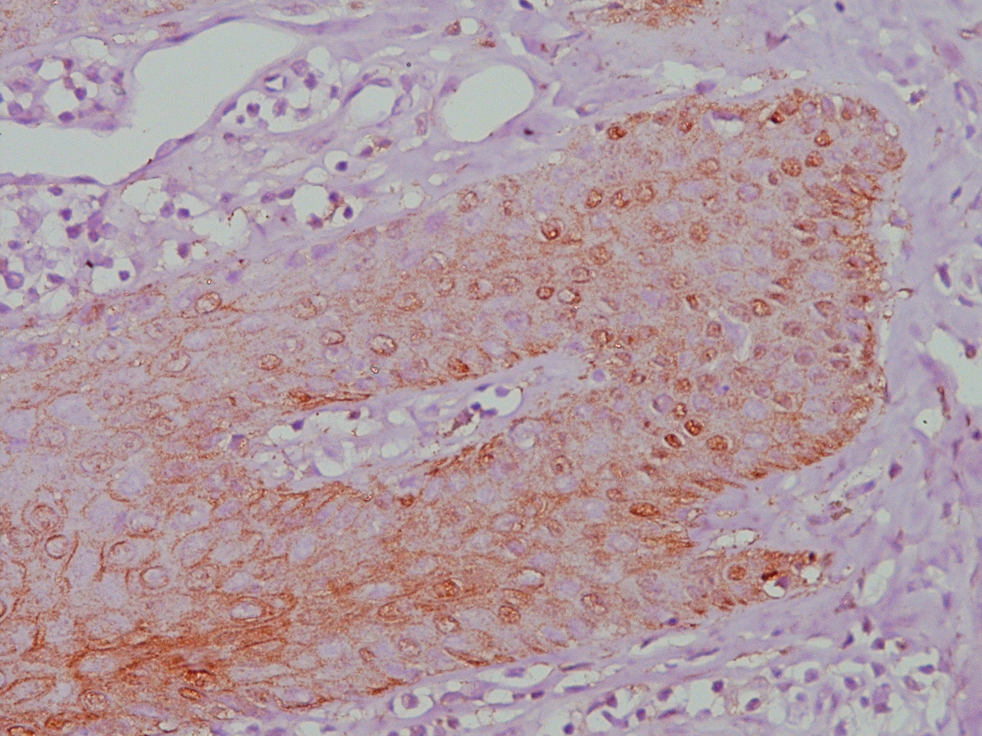
Figure 3. Psoriasis vulgaris: intense HSP70 immunostaining (nuclear and focally cytoplasmic
(immunoperoxidase X 400).

4. Discussions
The differential expression of HSP70 may be related to the different expression of the stress inducible HSP70 depending on the differentiation state of keratinocytes. Expression of HSP70 may be also related to the extent of keratinocytes alteration. The following proposed scenario may explain HSP70 contribution in the development of psoriasis. Minor skin lesion(s) caused by microbial infection or physical stimuli lead(s) to stimulation of keratinocytes and secretion of cytokines, HSP70, (auto-)antigens and HSP-(auto-)antigens complexes.
Dendritic antigen presenting cells (APCs), expressing common HSP receptor CD91, bind HSP and HSP-antigen complexes. This is followed by the activation and translocation of NF-κß into the nucleus leading to the production of proinflammatory cytokines (Basu et al,2001; Boyman et al, 2004). HSP70 also facilitates the activation of dendritic APCs with IL-12 production. Presentation of processed HSP and HSP-antigen complexes, stimulation of T lymphocytes and secretion of TH-1 type cytokines then follow (Nestle et al,1994).. On the basis of this, enhanced epidermal proliferation, aberrant epidermal differentiation, recruitment of more immune cells, new blood vessel formation and finally formation of a psoriatic plaque develop. The potential role of HSP70 in the development of psoriatic lesions may therefore be attributed to its primary effect on innate system through immunomodulatory properties.
Based on the findings of the present study, we conclude that HSP70 may play an important role in the aetiopathogenesis of psoriasis, although one cannot exclude the possibility of its up-regulation secondary to inflammation. It seems that psoriasis represents a genetically determined skin disease probably initiated by hyperactivity of the triggered state of otherwise dormant cutaneous innate immunity. Recognition of the potential contribution of HSP70 in the pathophysiology of psoriasis may help clarify the mechanisms underlying the development and maintenance of psoriatic lesions with its different severity. However, further studies are recommended to determine the interplay between
innate and adaptive immune responses in psoriasis and to search for immunotherapeutic intervention, aiming at inhibiting events in an ongoing immune response which may provide useful therapeutic and
perhaps preventive approaches for psoriasis.

Corresponding Author:
Dr. Amina Gamal el Din
Department of Pathology
Medical Research Division, National Research Centre, Dokki, Cairo, 12622 Egypt
Phone: +202 3371382/3371 433
Mobile: +2 012 34 32 554
Fax: +202 3370931/33478742
E-mail: hassaneinamina@yahoo.com

References
- Asea A, Kraeft SK and Kurtjones FA ( 2000). HSP70 stimulates cytokine production through CD14 dependent pathway, demonstrating its dual role as a chaperone and cytokine. Nat Med; 6: 435-442.
- Basu S, Binder RJ and Ramalingam T (2001). CD91 is a common receptor for heat shock proteins gp96, hsp90, hsp70 and calreticulin. Immunity; 14: 303-313.
- Boucock AM and Shannan W( 2001). Insights into psoriasis and other inflammatory diseases from large scale gene expression studies. Hum Mol Genet; 10: 1793-1805.
- Boyman O, Conrad C, Dudli C, Kielhorm E, Nickoloff BJ and Nestle FO ( 2005). Activation of dendritic antigen-presenting cells expressing common heat shock protein receptor CD91 during induction of psoriasis. Br J Dermatol; 152: 1095-1097.
- Boyman O, Hefti HP and Conrad C, 2004. Spontaneous development of psoriasis in a new animal model shows an essential role for resident T cells and tumour necrosis factor-↑. J Exp Med; 199: 731-6.
- Chaiyarit P, Kafrawy AH and Miles DA ,(1999). Oral lichen planus: an immunohistochemical study of heat shock proteins (HSPs) and cytokeratins (CKs) and a unifying hypothesis of pathogenesis. J Oral Pathol Med; 28: 210-214.
- Curry J, Qin JZ, Bonish B, Carrick R, Bacon P, Panella J, Robinon J and Nickoloff BJ ( 2003). Innate immune-related receptors in normal and psoriatic skin. Arch Pathol Lab Med; 127: 178-186.
- Fredrickson T and Patterson U,(1978). Severe psoriasis, oral therapy with a new retinoid. Dermatologica; 157: 238-242.
- Jones DA, Yawalkar N and Suh KY ( 2004). The identification of autoantigens in psoriatic plaques using expression cloning. J Inv Dermatol; 123: 93-100.
- Krueger JG, (2002). The immunologic basis for the treatment of psoriasis with new biologic agents. J Am Acad Dermatol; 46: 1-23.
- Nestle FO, Turka LA and Nickoloff BJ (1994). Characterization of dermal dendritic cells in psoriasis: Autostimulation of T lymphocytes and induction of Th1 type cytokines. J Clin Invest: 94: 202-209.
- Palleros DR, Welch WJ and Fink AL(1991). Interaction of HSP70 with unfolded proteins: effect of temperature and nucleotides on the kinetics of binding. Proc Natl Acad Sci USA; 88: 5719-5723.

11/30/2009

