HYDROCHEMICAL INVESTIGATION OF GROUNDWATER QUALITY IN SELECTED LOCATIONS IN UYO, AKWA-IBOM STATE OF NIGERIA.

Adetoyinbo Adedeji¹ , Adebo Babatunde ^{1, 2} Alabi Aderemi ³

Department of Appled Sciences, Lead City University Ibadan, oyo –State, +234, Nigeria¹
Department of Physics, University of Ibadan, Oyo State,+234, Nigeria²
Department of Physics, Lagos State University, Lagos, +234, Nigeria³
datewithdestiny2007@yahoo.com

ABSTRACT: Water is a vital component to the development of an area. Human settlement is to a large extent dependent on the availability of reliable sources of water preferably in close proximity to the settled localities. This paper examines the hydrochemical facies of groundwater present in the Uyo, Akwa Ibom of Nigeria. 40 Borehole water samples were carefully collected in 8 different locations in Uyo for various physico – chemical analyses. Calcium, magnesium, iron, zinc, copper, manganese, aluminium, and silver, Nitrate, phosphate, fluoride, chloride, pH, conductivity, total dissolved solid, total suspended solid, hardness, summation of ions as well as the temperature and colour were assessed among the entire samples collected. The results shows that: temperature ranges from 26.3 – 28.3, pH range is 3.19 – 5.18 . This means the borehole water samples fall within the highly acidic range. Conductivity ranges between 10.85 and 181.60 μs/cm, TDS range is 4.7 – 86.8mg/l, TSS is between 1.0 and 12.0 mg/l,Total hardness (2.61 – 31.29 mg/l) and Chloride concentration (5.0 – 9.36mg/l). Results show that some of the water samples considered in this work do compare favourably with WHO (1984) water standard for drinking and domestic usages while some other samples of boreholes water fall short of this standard. [New York Science Journal. 2010;3(4):117-122]. (ISSN: 1554-0200)

Key words: Borehole water, hydrochemical facies, water quality, Uyo, Akwa -Ibom

Introduction

Groundwater is one of the major sources of drinking water all over the world [Bear,
1979]. Water and its management will continue to be a major issue with definite and profund impact on our lives and that of our planet earth (Herschy, 1999). Water is the most important natural resources without which life would be nonexistent
(Adebo and Adetoyinbo, 2009 ) . Availability of safe and reliable source of water is an essential prerequisite for sustainable development.
Deserts are not habitable because of lack of water (Asonye et al., 2007).
Freshwater quality and availability remain one of the most critical environmental and sustainability issues of the twenty-first century (UNEP, 2002). Of all sources of freshwater on the earth, groundwater constitutes over 90% of the world's readily available freshwater resources (Boswinkel, 2000) with remaining 10% in lakes, reservoirs, rivers and wetlands. Water is a vital component to the development of an area. Human settlement is to a large extent dependent on the availability of reliable sources of water preferably in close proximity to the settled localities.
Groundwater is also widely used as a source, for drinking water supply and irrigation in food production (Zekster and Everett, 2004).
However, groundwater is not only a valuable resource for water supply, but also a vital component of the global water cycle and the environment.
As such, groundwater provides water to rivers, lakes, ponds and wetlands helping to maintain water levels and sustain the ecosystems. Moreover, some field investigators indicate groundwater as a surprisingly important source of water and sole input to coastal waters (Lewis, 1987; Moore, 1996; Kim et al., 2003). Scientific findings on how coastal and oceanic chemicals interact with the ecosystem posses challenges to our understanding(Church,1996).
In coastal areas where groundwater is used for potable or agricultural purposes, intrusion can be a serious problem resulting in the shut down of wells or necessitating expensive desalination treatment.
According to A. E. Edet, and C.S. Okereke (2001), the southern part of Akwa Ibom State (Nigeria) which contributes more than 30% of Nigeria’s crude oil is presently experiencing an increase in human and industrial activities. This has resulted in an increase in the rate of potable water abstraction. This action if not checked and properly monitored will in future lead to encroachment of seawater into the coastal aquifers.
It therefore became necessary to put a monitoring criteria in place in order to guide against any future saltwater intrusion into freshwater.
The objective of the present study is basically to create baseline data which will be used as a guide to monitor future contamination of the coastal aquifer. To achieve this water samples were collected and analyzed from different sources and localities. The results are then used as a basis to develop a monitoring scheme for the area.
A lot of studies have shown that increase in ground water abstraction in coastal areas is largely responsible for the encroachment of seawater into coastal groundwater aquifers and therefore the present study cannot be an exception. Example of such work in literature include Anderson and Berkebile, [1976] Vengosh and Rosenthal, [1994] Vengosh and Ben-zvl, [1994] and Petalas and Diamantis, [1999]
Water and its management will continue to be a major issue with definite and profund impact on our lives and that of our planet earth. (Herschy,1999). Water is the most important natural resources without which life would be nonexistent (Adetoyinbo and Adebo2009). Availability of safe and reliable source of water is an essential prerequisite for sustainable development. Deserts are not habitable because of lack of water. ( Asonye, et al, 2007).
Freshwater quality and availability remain one of the most critical environmental and sustainability issues of the twenty-first century (UNEP, 2002). Of all sources of freshwater on the earth, groundwater constitutes over 90% of the world's readily available freshwater resources (Boswinkel, 2000) with remaining 10% in lakes, reservoirs, rivers and wetlands.
Groundwater is also widely used as a source, for drinking water supply and irrigation in food production (Zekster and Everett, 2004). However, groundwater is not only a valuable resource for water supply, but also a vital component of the global water cycle and the environment. As such, groundwater provides water to rivers, lakes, ponds and wetlands helping to maintain water levels and sustain the ecosystems. Moreover, some field investigators indicate groundwater as a surprisingly important source of water and sole input to coastal waters (Lewis, 1987; Moore, 1996; Kim et al., 2003). Scientific findings on how coastal and oceanic chemicals interact with the ecosystem posses challenges to our understanding (Church, 1996). Saline intrusion into coastal aquifers has become a major concern (Batayneh 2006 ) because it constitutes the commonest of all the pollutants to freshwater. Therefore, understanding of saline intrusion is essential for the management of coastal water resources (Ginzburg and Levanon 1976 ).

GEOLOGY OF STUDY AREA
The area under consideration is situated south of latitude 4º45' North and East of Iongitude 7º45' East (Figure1). It is located within the sub-equatorial south climate region [Iloeje 1991].
The area has over 2000mm of rainfall per annum. Mean annual evaporation is about 4.6mm/day and relative humidity is in the range 60 to 90%.
The area is generally flat and lies within thin beach dunes and large valleys. It is characterized by mangroove swamps, tidal creeks and brackish lagoon. The area is subject to constant inundation by saline and brackish water. The study area is situated within the Niger Delta Basin. The major lithologic formations include the Miocene Akata Formation, Moicene-Pliocene Agbada Formation and the Pliocene-Pleistocene Benin formation. The middle and upper sand units [Esu et al 1999] of the Benin Formation forms the major aquiferous units in the area. The static water levels at the time of study varied from 0.20 to 2.00m (mean 0.87m).

METHOD AND ANALYSIS
The methods employed for this study are sampling and laboratory analysis. A detailed field sampling exercise was carried out, while laboratory analyses of the water samples were carried out at Dana’s water laboratory, Ibadan. Samples used for determination of metals, physical properties, SO₄²⁻ and NO₃⁻ were collected in plastic bottles. Samples for NO₃⁻, SO₄ ²⁻ and PO₄ ³⁻ were refrigerated and analyzed within 24 hours. All plastics and glass wares utilized were pre-washed with detergent water solution, rinsed with tap water and soaked for 48 h in 50% HNO3, then rinsed thoroughly with distilled deionized water. They were then air-dried in a dust free environment.

Sample collection
Water samples were procured from Ten Boreholes in different locations in Uyo, Akwa –Ibom State of Nigeria at different distances away from the Ocean and Lagoon. The samples were collected in sterilized white plastic containers.
Samples used for determination of the quality assurance measure taken in carrying out the analysis was the “multiplicity of samples” approach. With all obtained results only very little variation was observed. This implies that the analysis was honestly carried out by the laboratory technologist. Metals, physical properties, SO₄²⁻ and NO₃ ⁻ were collected in plastic bottles.

Water analysis
Water quality parameters analyzed are physical properties such as: pH, colour, temperature, conductivity, total suspended solids (TSS), total dissolved solids (TDS), and hardness. Chemical parameters such as: sodium (Na), calcium (Ca), magnesium (Mg²⁺), iron (Fe²⁺), manganese (Mn⁺), aluminium (Al³⁺), zinc (Zn²⁺), silver (Ag+), copper (Cu²⁺), chloride (Cl-), fluoride (F), nitrate (NO₃ -), sulphate (SO₄ ²⁻) and phosphate (PO₄ ³⁻) were also analysed from each sample. pH was analyzed using a pH meter. Cations were analyzed using an atomic absorption spectrophotometer (Perkin – Elemer AAS3110), while anions were analyzed using the colorimetric
method with UV, spectrophotometer (WPAS110). Total dissolved solids (TDS) were analyzed using the gravimetric method (Adebo and Adetoyinbo, 2009).

Results and Discussions
The temperature ranges between 26.3ºC and 28.3ºC. The PH of all samples taken range between 3.19 and 5.18. This shows that some of the samples collected are all in the acidic range. For save drinking water, the highest desirable level is 7 – 8.5. The mean pH of the samples collected is 7.27. This shows that on the average, it is safe for domestic uses especially for drinking. However samples 1 to 4, namely Omole, Yaba, Magodo and Igando borehole samples fall below the 7.0 desirable PH level. They also fall below the highest permissible range 6.5 – 9.2 (WHO, 1984).
The conductivities ranged between 31.9 μs/cm and 1511 μs/cm. The average conductivity observed in all the borehole water sampled was 462.2 μs/cm. Sample 1 i.e borehole water sample from Omole has the least conductivity while sample 7 i.e borehole water sample from Eti-Osa has the highest conductivity. The least Total disolved solids (TDS) was observed in sample 1 (14.7mg/l) while the highest TDS was observed in sample 7 i.e Eti Osa (751mg/l). The average TDS was 204.73 mg/l.
The chloride concentration was lowest in sample collected from sample 1 and 2 ( i.e omole and Yaba). This value was 15.84mg/l. The highest chloride concentration of 343.20mg/l was observed in sample 7 i.e Eti Osa and the average chloride concentration in all the borehole samples was 81.89mg/l. Total hardness varies between 18.58mg/l and 297mg/l. 33.33% of the water samples are hard, about 55.55% are soft, while 11.11% are moderately hard. These results show a direct relationship between Chloride concentration, conductivity and the Total dissolved solid TDS. These three parameters have their least as well as their highest values of conductivities, TDS as well as chloride concentrations in borehole water samples from Omole and Eti – Osa respectively.
About 22 parameters were considered in this work. Table 1(a) and 1(b) show the results of their analysis. Figure 1 is a graph showing the variations of each of the considered parameters. Figure 3 shows the varition of conductivities in samples, Figure 2 shows the variation of chloride concentration in the samples. Figure 4 is the barchart of the water hardness, Tables 2(a) and 2(b) show the chloride concentrations and conductivities in all the water sample respectively. Table 3 shows general hardness classification as well as the percentage hardness of water samples. Table 5 shows the Range values of physical-chemical parameters standards for drinking water. Table 4 shows the percentage hardness of the water samples.

CONCLUSION
Results show that some of the water samples considered in this work do compare favourably with WHO (1984) water standard for drinking and domestic usages while some other samples of boreholes water fall short of this standard.
We can therefore conclude that the borehole water in the selected locations is not totally portable. All the water samples collected, for example, fall within the acidic range. This may be due to effluence from the refineries as well as other activities of oil companies.
More work need to be done in this area by means of extending the area of research to include the whole geographical location of Uyo, Akwa Ibom State in order to ascertain the extent of the conformity of groundwater to WHO safety standard.

TABLE 1a: Chemical Analysis of borehole samples from Uyo, Akwa –Ibom State.

S/No | pH | Temp.  ºC | odour | Color (ºH) | Ca²⁺  Mg/l | Mg²⁺  Mg/l | Fe²⁺  Mg/l | conductivity  μs/cm /l | TDS  Mg/l | TSS  Mg/l | Zn²⁺  Mg/l
Sp/1 | 4.20 | 26.9 | unojectionable | colorless | 0.49 | 0.96 | 0.05 | 99.70 | 47.3 | 3.0 | 0.01
Sp/2 | 4.52 | 26.6 | unojectionable | colorless | 0.00 | 5.60 | 0.02 | 28.90 | 13.3 | 5.0 | 0.00
Sp/3 | 5.14 | 27.0 | unojectionable | colorless | 0.90 | 7.40 | 0.01 | 10.85 | 4.7 | 1.0 | 0.00
Sp/4 | 4.33 | 27.5 | unojectionable | colorless | 0.92 | 1.57 | 0.02 | 65.20 | 30.1 | 4.0 | 0.01
Sp/5 | 4.23 | 28.3 | unojectionable | colorless | 7.30 | 3.60 | 0.07 | 90.50 | 42.9 | 2.0 | 0.01
Sp/6 | 3.91 | 28.0 | unojectionable | colorless | 12.5 | 9.68 | 0.18 | 181.60 | 86.8 | 8.0 | 0.02
Sp/7 | 4.64 | 27.4 | unojectionable | colorless | 0.00 | 6.30 | 0.01 | 31.10 | 14.3 | 6.0 | 0.00
Sp/8 | 4.03 | 26.5 | unojectionable | colorless | 8.20 | 18.80 | 0.09 | 129.90 | 61.8 | 9.0 | 0.00
Sp/9 | 5.18 | 26.3 | unojectionable | colorless | 1.60 | 5.90 | 0.02 | 16.95 | 7.60 | 1.0 | 0.02
Sp10 | 4.11 | 27.1 | unojectionable | colorless | 8.80 | 22.4 | 0.09 | 137.00 | 65.3 | 12.0 | 0.01

TABLE 1b: Chemical Analysis of borehole samples from Uyo, Akwa –Ibom State.

S/No | Cu²⁺  Mg/l | Mg/l Mn²⁺ | Al³⁺  Mg/l | Na⁺  Mg/l | Ag²⁺  Mg/l | F ⁻  Mg/l |  | Cl ⁻  Mg/l |  | NO₃⁻  Mg/l | SO₄⁼²  Mg/l | T.HMg/l | Cation  Sum | Sum  Anion
Sp1 | 0.3 | 0.0 | 0.001 | 0.00 | 0.006 | 0.01 |  | 8.69 |  | 3.80 | 0.00 | 8.30 | 1.82 | 12.50
Sp2 | 0.22 | 0.1 | 0.000 | 0.00 | 0.005 | 0.00 |  | 7.00 |  | 1.90 | 0.00 | 5.72 | 5.85 | 8.90
Sp3 | 0.18 | 0.0 | 0.000 | 0.00 | 0.009 | 0.00 |  | 5.00 |  | 0.50 | 0.00 | 8.31 | 8.50 | 5.50
Sp4 | 0.31 | 0.1 | 0.002 | 0.00 | 0.011 | 0.01 |  | 8.17 |  | 2.50 | 0.00 | 2.61 | 2.94 | 10.68
Sp5 | 0.38 | 0.0 | 0.000 | 0.00 | 0.013 | 0.00 |  | 5.42 |  | 4.90 | 0.00 | 10.95 | 11.35 | 10.33
Sp6 | 0.42 | 0.3 | 0.004 | 0.10 | 0.015 | 0.03 |  | 9.27 |  | 3.50 | 1.00 | 22.67 | 23.22 | 13.8
Sp7 | 0.21 | 0.0 | 0.001 | 0.00 | 0.000 | 0.00 |  | 7.04 |  | 2.00 | 1.00 | 6.31 | 6.52 | 10.04
Sp8 | 0.39 | 0.2 | 0.001 | 0.10 | 0.012 | 0.02 |  | 6.72 |  | 2.90 | 0.05 | 27.29 | 27.79 | 10.66
Sp9 | 0.20 | 0.0 | 0.000 | 0.00 | 0.000 | 0.00 |  | 5.28 |  | 1.60 | 0.00 | 7.18 | 7.74 | 7.88
Sp10 | 0.32 | 0.0 | 0.000 | 0.01 | 0.014 | 0.03 |  | 9.36 |  | 3.00 | 0.02 | 31.29 | 31.73 | 12.38

Table 2 : Chloride concentrations of the Borehole water samples from Uyo

Location | Sp1 | Sp2 | Sp3 | Sp4 | Sp5 | Sp6 | Sp7 | Sp8 | Sp9 | Sp10
Cl⁻¹ (mg/l) | 8.69 | 7.0 | 5.0 | 8.17 | 5.42 | 9.27 | 7.04 | 6.72 | 5.28 | 9.36

Table 4: Percentage hardness of the water samples (Freeze and Cherry, 1979)

Hardness  (Ca ⁺ Mg CO₃²⁻ ) mg/l | Water Classification | % Result of this Study
0 – 75 | Soft | 100
75 – 150 | Moderately hard | -
150 – 300 | Hard | -
>300 | Very hard | -

Table 5: Range values of physical-chemical parameters WHO (1984) Standards for drinking water

S/No | Concentration level | Highest desirable level | Maximum permissible level
1 | pH | 7 – 8.5 | 6.5 – 9.2
2 | Color (oH) | 5 | 50
3 | Total dissolved solids (TDS) Mg/l | 500 | 1500
4 | Total hardness (T.H) Mg/l | 100 | 500
5 | Na²⁺ Mg/l | - | -
6 | K2+ Mg/l | - | -
7 | Ca²⁺ Mg/l | 75 | 200
8 | Mg²⁺ Mg/l | 50 | 150
9 | Fe²⁺Mg/l | 0.1 | 1.0
10 | PO4- Mg/l | - | -
11 | NO₃⁻ Mg/l | 45 | 50
12 | SO₄²⁻ Mg/l | 200 | 400
13 | Cl⁻ Mg/l | 250 | 600
14 | CO₃²⁻ Mg/l | - | 120
15 | HCO₃⁻ Mg/l | - | -
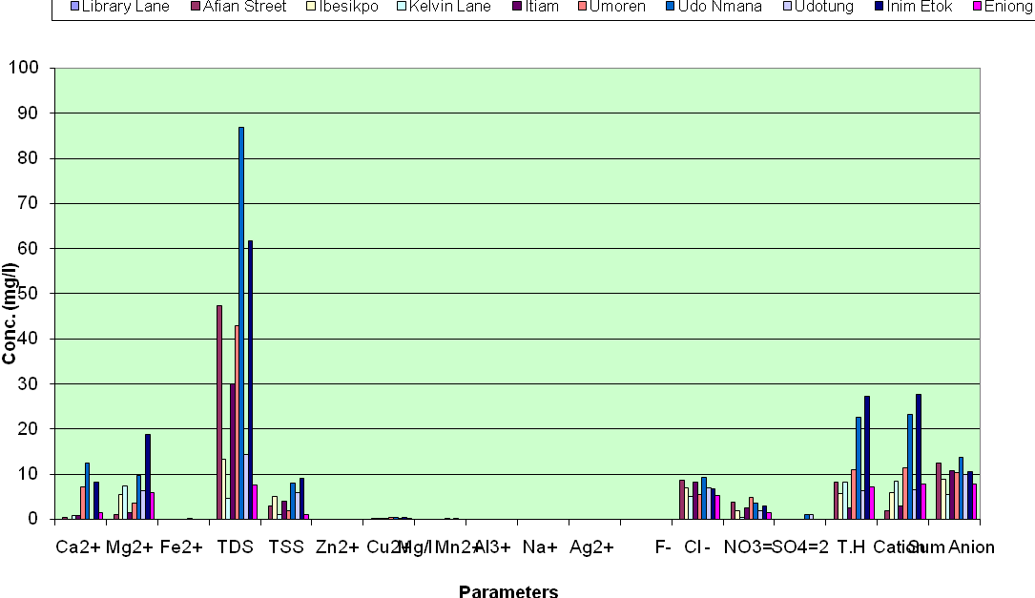
Figure 1: HydroChemical Parameters of Borehole water samples from Uyo, Akwa Ibom State of Nigeria

Figure 2: Chart showing variations of Chloride Concentrations of water Samples in Uyo, Akwa - Ibom

Figure 3: Chart showing variations of Conductivities of water Samples in Uyo, Akwa - Ibom

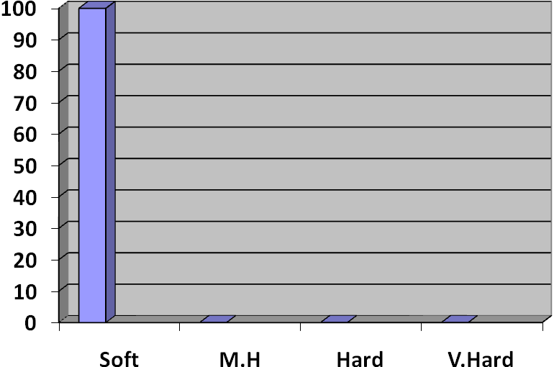
Figure 4: Percentage Hardness of Samples
M.H – Moderately Hard; V. Hard - Very Hard

Correspondence Author
Lead City UniversityIbadan, Ibadan, Oyo State,
+234, Nigeria.
Email: datewithdestiny2007@yahoo.com
Tel: +234-803-502- 2462

REFERENCES
- Adepelumi AA, Ako BD, Ajayi TT, Afolabi O, Omotoso E. J ,Delineation of saltwater intrusion into the freshwater aquifer of Lekki Peninsula, Lagos, Nigeria. Environmental Geology (In press) 2008; with doi: 10.1007/s00254-008-1194-1193.
- Asonye CC, Okolie NP, Okenwa EE,Iwuanyanwu UG . Some Physico- chemical characteristics and heavy metal profile of Nigerian rivers, streams and waterways. Afr. J. Biotechnol. 2007; 6(5): 617-624.
- Batayneh AT . Use of electrical resistivity methods for detecting subsurface fresh and saline water and delineating their interfacial configuration: a case study of the eastern Dead Sea coastal aquifers.
Jordan Hydrogeol. J. 2006; 14: 1277-
1283.
- Boswinkel J.A . Information Note, International Groundwater Resources Assessment Centre (IGRAC), Netherlands Institute of Applied Geoscience, Netherlands. In:
- UNEP (2002), Vital Water Graphics - An Overview of the State of the Wor ld's Fresh and Marine Waters, UNEP, Nairobi, Kenya; 2002
- Church TM . An underground route for the water cycle, Nature, 1996; 380: 579-580.
- Freeze RA, Cherry JK (1979). Table 3: Percentage hardness of the water samples.
- Ginzburg A, Levanon A. Determination of a saltwater interface by electric resistivity depth soundings. Hydrogeol. Sci.1976; 21: 561-568.
- Herschy RW. Hydrometry Principles and and Practices (2nd Edition) John Wiley & Sons, Chicchester.1999
- Kim G, Lee K-K, Park K-S, Hwang D-W, Yang H-S . Large submarine groundwater discharge (SGD) from a volcanic island, Geophys. Res. Lett., 2003; 30(21): 2098,doi:10.1029/2003GL018378.
- Lewis J.B . Measurements of groundwater seepage flux onto a coral reef: Spatial and temporal variations, Limnol. Oceanogr. 1987; 32: 1165-1169.
- Moore WS. Large groundwater inputs to coastal waters revealed by 226Ra enrichments, Nature 1996; 380 : 612-614.
- Ofoma A.E, Onwuka OS, Egbu O.C. Groundwater Quality in Lekwesi Umuchieze Area, South-eastern Nigeria. The Pacific J. Sci. Technol. 1996; 6: 170-176.
- UNEP (United Nations Environment Programme). Global Environment Outlook (GEO-3): 2002; 416.
- Zekster IS, Everett LG (Eds.) . Groundwater resources of the world and their use, IHP-VI, Series on Groundwater No. 6. UNESCO (United Nations Educational, Scientific and Cultural Organisation.

05-02-2010

