Effect of Temperature and Desiccation on Seed Viability of Lepidium sativum L.

Debarati Mukhopadhyay*, S.S. Parihar, J. S. Chauhan¹, Preeti, Sunil Chandra Joshi

Division of Seed Science and Technology, Indian Agricultural Research Institute, New Delhi-110012 India
¹Department of Seed Science & Technology, HNB Garhwal University Srinagar-246174Uttrakhand India
Email: debarati129@gmail.com

Abstract: Lepidium sativum L. is an important medicinal plant of India. Germination studies revealed that seeds do not exhibit dormancy as germination was fastest in 25⁰C compared to 15, 20, 25, 20/30 (alternate temperature of 20and 30⁰C, 20⁰C for 16 hrs and 30⁰C for 8 hrs) and 30⁰C. No significant difference in germination percentage was observed in 15, 20, 25, 20/30⁰C however germination percentage was significantly reduced when incubating temperature exceeded 30⁰C, suggesting thermo inhibition of germination. Seeds with different moisture content viz. 2, 5, 8, 10 and 12% stored under ambient storage and tested for viability at 3 months interval revealed that seeds with 10 and 12% moisture content lost viability within 3 months while no reduction in germination was observed up to 6 months in seeds with moisture content 2, 5 and 8%. [New York Science Journal 2010;3(5):34-36]. (ISSN: 1554-0200).

Keywords: Lepidium sativum; germination; desiccation sensitivity; moisture content.

1 Introduction: Lepidium sativum is a fast-growing, edible herb that is botanically related to watercress and mustard, sharing their peppery, tangy flavor and aroma. In some regions, garden cress is known as garden pepper cress, pepper grass, pepperwort or poor man's pepper.^{[1][2]} Lepidium sativum L. (Brassicaceae), commonly known as Chandrasur in Ayurveda is a Rabi crop predominantly grown in temperate region^{.[3]} The seed of this crop is of medicinal importance and used to prevent post natal complications. The leaves are antiscorbutic, diuretic and stimulant. The plant is administered in cases of asthma, cough with expectoration and bleeding piles. The root is used in the treatment of secondary syphilis and tenesmus. The seeds are galactogogue. They have been boiled with milk and used to procure an abortion, they have been applied as a poultice to pains and hurts and have also been used as an aperients. The seeds are also used for treatment of bacterial and fungal infections. The seeds are reddish in colour and elliptic in shape with spatulate embryos and thousand seed weight varied from 1.545 gm – 1.752 gm.
The objective of the experiment was:
- To study dormancy and effect of different temperature on germination
- To study the effect of desiccation and storage period on seed viability.

Material and Methods: Freshly harvested seeds were procured from Directorate of Medicinal and Aromatic Plant Research (DMAPR) Anand on March 2009[Lot1] and Indian Institute of Horticultural Research (IIHR) Bangalore. [Lot2]. Moisture content was determined and seeds were germinated on top of the paper method in different temperatures. The temperatures used for germination studies were 15ºC, 20ºC, 25ºC, 15/35ºC (alternating temperature of 15/35ºC, 15ºC for 16hours and 35ºC for 8 hours) and 31-33ºC. Observations were recorded daily in all the temperatures. Germination was considered as development of seedlings from seeds with all its essential structures visible. Seeds with different targeted moisture content viz. 2, 5, 8, 10 and 12% were also prepared by keeping the seeds in salt solution with varying e-RH and stored under ambient laboratory condition in hermetically sealed containers. Germination tests were again conducted at 3 months intervals at 25⁰C using TP method.

Results and Discussion: Perusal of the data reveals that seeds do not exhibit dormancy and germination was fastest in 25ºC. It was found that only 4 days were required for the final count in 25ºC whereas it was 8th, 6th, 8th and 7th days required for the final count at 15, 20, 30 and 15~35ºC temperature respectively. There is no significant difference in percent germination in 20, 25 and 15/35ºC. However thermo inhibition of germination was observed beyond 30ºC. First count was earliest in 25ºC on third day while second count was on fourth day. A delay in germination was observed in 15/35ºC, no significant difference in germination and vigour was observed due to desiccation as the germination percentage varied from 88-94% in seeds with different moisture content i.e. 2, 5 and 8%. Subsequent viability test for seeds after 3and 6 months revealed that seeds with 10 and 12% moisture content (on fresh weight basis) lost viability after 3 months storage while seeds with 2, 5 and 8% moisture contents exhibiting no reduction in germination after 6 months. No significant germination was observed in seeds with 2, 5 and 8% moisture content.

Table 1. Germination and vigor at different temperature of Lepidium sativum L.

T (ºC)
Germination % | Days Taken to Germination |  | Root Length (cm) |  | Shoot Length (cm) |  | Seedling Dry Weight (gm)
 | L1 | L2 | L1 | L2 | L1 | L2 | L1 | L2 | L1 | L2
15 | 88 | 85 | 8 | 8 | 1.39 | 2.30 | 2.33 | 2.80 | 0.0050 | 0.0065
20 | 92 | 94 | 6 | 6 | 1.70 | 2.26 | 2.36 | 3.55 | 0.0057 | 0.0070
25 | 93 | 97 | 4 | 4 | 1.91 | 3.00 | 2.82 | 4.65 | 0.0059 | 0.0074
30 | 78 | 80 | 8 | 8 | 1.99 | 2.26 | 2.80 | 4.60 | 0.0055 | 0.0071
15~35 | 94 | 90 | 7 | 7 | 1.90 | 2.00 | 2.86 | 3.55 | 0.0057 | 0.0070

Acronym used: DTG=Days Taken for Germination, T=Temperature, G= Germination, L= Lot, RL= Root Length, SL= Shoot Length, SDW= Seedling Dry Weight

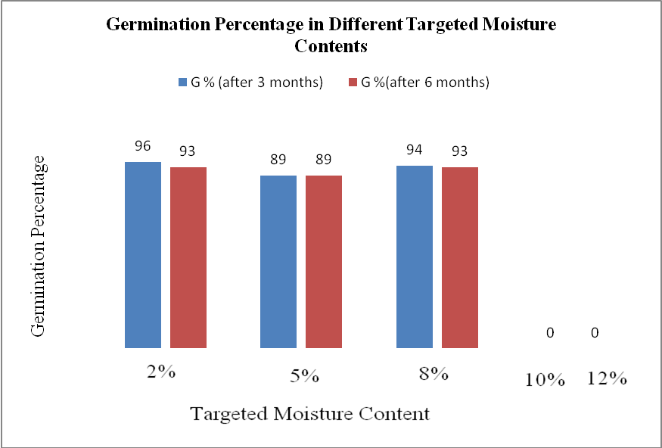

Fig: 1. Effect of storage period on germination of seeds with different moisture content.

Temperature is one of the main environmental factor regulating dormancy and germination (Kruk & Benech-Arnold1998 ^{[3]}, Vleesh & Krof 2000^{[4]}) and seed with less dormancy can germinate over a wide range of temperature condition ( Vleesh et al 1995^{[5]}, Benech- Arnold et al 2000^{[6]}, Vleesh- Bouwmee 2001^{[7]}). Temperature determines germination percentage and germination rate (Ellis et al 1986^{[8]}), besides playing a critical role in the elongation of radcal and shoot, and thus seedling emergence. In Lepidium sativum maximum germination occurred over a wide range of temperature from 15⁰ to 25⁰C and germination declined sharply in 31-32⁰ C. Germination rate usually increases linearly with increasing temperature from a base temperature up to an optimum and decreases linearly to a ceiling temperature. Cardinal temperatures, the minimum the maximum and optimum temperature exist in most species for seed germination (Bewley & Bleek 1994^{[9]}).

Acknowledgements:
Authors are grateful to the Division of Seed Science & Technology IARI, New Delhi for providing the resources essential for conducting all the experiments.

*Corresponding Author:
Debarati Mukhopadhyay
Senior Research Fellow
Division of Seed Science & Technology
Indian Agricultural Research Institute
New Delhi- 110012, India
Mobile: 09871185821
E-mail: debarati129@gmail.com

References:

- Cassidy, Frederic Gomes and Hall, Joan Houston. Dictionary of American regional English, Harvard University Press, 2002. Page 97. ISBN 0674008847
- Staub, Jack E, Buchert, Ellen. 75 Exceptional Herbs for Your Garden Published by Gibbs Smith, 2008. ISBN 142360251X
- Kruk, B. C. & R. L. Benech- Arnold 1998. Functional and quantitative analysis of seed thermal responses in prostrate weed ( Polygonum aviculare) and common purslone ( Portulaca oleracea). Weed Science 46: 83-90.
- Vleeshouwers, L. M and M. J. Kropff 2000. Modeling field emergence patterns in aerable weeds. New Phytologist 148: 445-457.
- Vleeshouwers, L. M, H .J. Bouwmeester and C. M. Karseen 1995. Redefining seed dormancy: An attempt to integrate physiology and ecology. Journal of Ecology 83:1031-1037
- Benech- Arnold, R. L., R. A. Sanchez, F. Forcella, B. C. Kruk and C. M. Ghersa 2000. Environmental Control of Dormancy in weed seed bank in soil. Field Crops Research 67: 105- 122.
- Vleeshouwers, L. M. and H. J. Bouwmeester 2001. A stimulation model for seasonal changes in dormancy and Germination of seeds. Seed Science Research 11: 77- 92.
- Ellis, R. H., S. Covell, E.H. Roberts and R. J. Summerfield 1986. The influence of temperature on seed germination rate in grain legumes. II. Interspecific variation – chickpea at constant temperatures. Journal of Experimental Botany 37: 1503- 1515.
- Bewley, J. D and M. Black 1994. Seeds: Physiology of development and germination. Plenum Press New York.
- International rules for Seed Testing 2009

2/11/2010

