Review of Farm Management Information Systems (FMIS)

Payman Salami *¹, and Hojat Ahmadi¹

- Department of Agricultural Machinery Engineering, Faculty of Biosystems Engineering, University of Tehran, P.O. Box 4111, Karaj 31587-77871, Iran
salami@ut.ac.ir

Abstract: There have been considerable advancements in the field of MIS over the years, and it continues to grow and develop in response to the changing needs of the business and marketing environment. Professionals and academicians are contributing and serving the field of MIS through the dissemination of their knowledge and ideas in professional journals. Thus, changes and trends that likely have an impact on MIS concepts, processes, and implementation can be determined by reviewing the articles published in journals. Content of the articles published in journals can also give us an idea about the types of research and themes that are popular during a given period. To see the evolutionary change in the field of MIS, the present study examined the content of articles published in business and marketing journals. [New York Science Journal 2010;3(5):87-95]. (ISSN 1554 – 0200).

Key words: Farm Management Information Systems; FMIS; GIS; IT; MIS

1. Introduction
In today’s dynamic world everything is changing very radically; and as the 21st century dawns, revolutionary changes are also beginning to challenge the business and marketing world. To cope with the increasing competition and uncertainty, companies need to take advantage of the information technology (IT) and information systems (IS). IS offer firms new ways of improving efficiency. Thus, the need for management of information is becoming the heart of marketing for the firms in order to survive in highly competitive markets. As the significance of management information systems (MIS) has been increasing, marketing and business environments have been revolutionizing through the applications of IT. Hence, the role of MIS in business and marketing has been also changing continuously due to rapid advancements in technology (Nasir, 2005).
Productivity gains in the agricultural industries have historically been driven by the adoption of new technical products and processes. It has been the realm of extension to make sure that farmers hear about these processes and technologies, and usually it has been State governments who have funded the extension effort. With the rapid increase in the complexity of the technology of farming, there is now a recognized need to improve the skills and education of our farmers - the human capital of agriculture. The Internet is changing the way society accesses and processes information. Farmers now have access to a wide range of information about many aspects of their farming systems, but it is often thought by scientists and extension specialists that many lack the skills necessary to use that information to improve their farm profitability and sustainability through technical innovation. (Bell, 2002).
We live in what is being called the "information age", an era in which it is the knowledge and skills of the workforce that will determine our fate in a globally competitive marketplace. Knowledge and skills go hand-in-hand with informed management, and it is in better management that increased productivity will be found.
The managerial tasks for arable farming are currently transforming into a new paradigm, requiring more attention on the interaction with the surroundings (Sigrimis et al., 1999; Dalgaard et al., 2006). Among other things, this managerial change is caused by external entities (government, public) applying increasing pressure on the agricultural sector to change production from a focus on quantity to an alternate focus on quality and sustainability (Halberg, 1999).
This change has been enforced by provisions and restrictions in the use of production input (e.g. fertilizers, agrochemicals, etc.) and with subsidies as an incentive for the farmer to engage in a sustainable production. In general, this change of conditions for the managerial tasks on the farm has necessitated the introduction of more advanced activities monitoring systems and information systems to secure compliance with the restrictions and standards in terms of specific production guidelines, provisions for environmental compliance, management standards as prerequisites for subsidies, etc. Until now, the farmers most often have dealt with this increased managerial load by trying to handle a bulk of information in order to make precise decisions. The increasing use of computers and the dramatic increase in the use of the internet have to some degree improved and eased the task of handling and processing of acquired external information but still, the acquisition and analysis of available information have proven a demanding task, since information can be scattered over many sites and not necessarily interrelated and collaborative. Specific attempts to improve this situation has included the launch of “web-based collaborative information system” developments, combining different information components (models, data, text, graphics) from different but collaborating sources (Jensen et al., 2001). However, such systems still has to be enhanced in terms of collaboration with automated acquisition of operational farm data and integration with the overall Farm Management Information Systems (FMIS).
Information management plays an important role in how well farms are able to deal with increasing demands. In plant production tasks in the field, agricultural machinery now plays a key role in process acquisition and documentation of data. It is important that field tasks are carried out according to plan, and if sudden changes in plan are needed that these follow standards and regulations and help to improve the outcome (Pesonen et al., 2008).
Determination of the technological solutions for the information management system has two dimensions; determining user needs and determining the technological infrastructure. Understanding of user needs in early development state and bringing the knowledge to designing process is important when constructing new systems so, that they will achieve user acceptance efficiently (Kaasinen, 2005). The needs are taken into account when designing the new system architecture and choosing the technology to utilize in the system. Inventory of available technologies gives understanding of technological resources and possibilities that we have as building units of the new system. As a result of the creative designing process the specifications of the new system can be presented.
Management information systems encompass a broad and complex topic. To make this topic more manageable, boundaries will be defined. First, because of the vast number of activities relating to management information systems, a total review is not possible. Those discussed here is only a partial sampling of activities, reflecting the author's viewpoint of the more common and interesting developments. Likewise where there were multiple effects in a similar area of development, only selected ones will be used to illustrate concepts. This is not to imply one effort is more important than another. Also, the main focus of this paper will be on information systems for use at the farm level and to some lesser extent systems used to support researchers addressing farm level problems (e.g., simulation or optimization models, geographic information systems, etc.) and those used to support agribusiness firms that supply goods and services to agricultural producers and the supply chain beyond the production phase (Harsh, 2004).
The MIS manager's objective in IS development is to identify a project's goals, environment, and alternate development strategies, then to evaluate the alternatives and thus select the approach that will best deliver the system. This is a complex problem that influences the procedures and work styles of everyone involved. Also, various people involved have different perceptions of needs and are naturally biased toward familiar approaches (Berrisford et al., 1979; Brousseau, 1988; Naumann, et al., 1982; Willis, 1988).

2. Materials and methods
There have been considerable advancements in the field of MIS over the years, and it continues to grow and develop in response to the changing needs of the business and marketing environment. Professionals and academicians are contributing and serving the field of MIS through the dissemination of their knowledge and ideas in professional journals. Thus, changes and trends that likely have an impact on MIS concepts, processes, and implementation can be determined by reviewing the articles published in journals. Content of the articles published in journals can also give us an idea about the types of research and themes that are popular during a given period. To see the evolutionary change in the field of MIS, the present study examined the content of articles published in business and marketing journals. Specifically, changes and trends in the scope of research topics over time were examined (Nasir, 2005).
A management information system includes internal and external sources of data and allows that data to be modified and structured in different ways as different decisions need different sets of information (Oslon, 1986).
Management information systems (MIS) is an integral part of the overall management system in an Purposeful organization comprising tolls like enterprise resource planning (ERP), overall information systems (IS), etc. ERP is an industry notion for a wide set of management activities which support all essential business processes within the enterprise. The management system support management activities on all levels as well as provide for the identification of key performance indicators (KPI’s) (Folinas, 2007). Typically, ERP is integrated with a database system and will often include applications for the finance and human resources aspects of a business.
Information systems are the software and hardware systems that support data-intensive applications. Especially, information systems provide the possibility to obtain more information in “real-time” enabling a close monitoring of the operations performance and enhance the connection between executed operations and the strategic targets of the enterprise (Lyons, 2005; Folinas, 2007). However, in terms of deriving the requirements for the information system design, often targeted information systems lack a definitive formulation. Different stakeholders have different perspectives on what is and what is not the most important to be included in the design of an information system.
MIS differ from regular information systems because the primary objectives of these systems are to analyze other systems dealing with the operational activities in the organization. In this way, MIS is a subset of the overall planning and control activities covering the application of humans, technologies, and procedures of the organization. Within the field of scientific management, MIS is most of ten tailored to the automation or support of human decision making (O’Brien, 1999). Figure 1 shows the conceptually decomposing of the different management systems in an organization (Sørensen et al., 2009).

Information Systems (IS):
- The application of people, documents, technologies and procedures
- solving business processes comprising related, structured activities or tasks that produce a specific service or product
Management Information System (MIS):
- refer to the group of information management methods tied to the automation or support of human decision making
Enterprise Resource Planning (ERP):
- Enterprise-wide and cross-functional system aimed at coordinating all the resources, information, and activities required to complete business processes

• Decision support system
• Expert system
• Executive decision support
• …

Figure 1. Concept of management information systems.

By following this conceptual framework and notation, a FMIS is depicted as a planned system of the collecting, processing, storing and disseminating of data in the form of information needed to carry out the operations functions of the farm.
Figure 2 shows a sample system architecture as it should be understood by the user of the system. The essential structure that should be understood is the centrality of the FMIS as the system to which all other parties are connected. The arrows, representing communication, are purposely left vague in the sense that they do not specify the protocol or content of the communication. This is because the end user need not know or even care how the communication between the various systems is handled, only that it occurs and that it is possible. The entire system appears to the farmer through a browser interface or the interface provided by the ISO-11783 TC. The TC interface is a special case to the other available interfaces as it acts as the gateway between the FMIS and the ISOBUS enabled tractor-implement combination (Pesonen et al., 007).

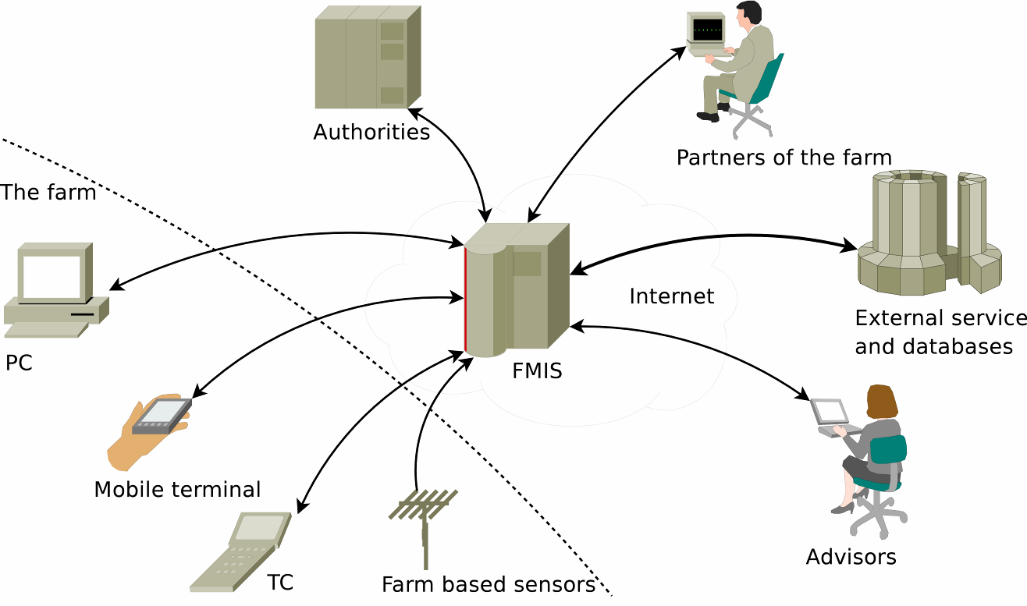

Figure 2. FMIS architecture from the viewpoint of the user.

Figure 3 shows the technical view of the FMIS with the connected systems grouped to four categories. The architecture will be discussed bottom-to-top, starting with the data storage and then moving on to the application logic. The application logic is further divided to class library, data transformation and communication layers. Finally the data transfer and formats to the different systems are considered (Pesonen et al., 2007).
All data within the FMIS are stored to several RDBMS (relational database management system) using the SQL (structured query language) query language for interaction. The three databases of figure 5.2 are:
Authentication database contains the identification and authentication information for all users of the system. Also contained within the authentication database are the access permissions to data that are used when dealing with for example authorities and contractors. The authentication database additionally contains the authentication information to other services; if a mutual trust and agreement exists between the maintainers of the FMIS and some external service, the FMIS can automatically authenticate users for the external service.
General FMIS database contains the same heterogeneous collection of information about the farm that is stored by any commercial FMIS. One difference is that the general FMIS database must also contain information on farm equipment required for precision agriculture. The schema of the general FMIS database is complicated by the amount and diversity of the stored information. However, this complexity requires no novel techniques as the design and implementation of similar databases can be considered routine work in software development.
GIS database contains exclusively data related to precision agriculture. The data need not be stored in a native GIS format though several relational databases have GIS extensions available to provide efficient queries for the stored GIS data. The GIS database is also the first database expected to exhibit performance problems under an increasing load.

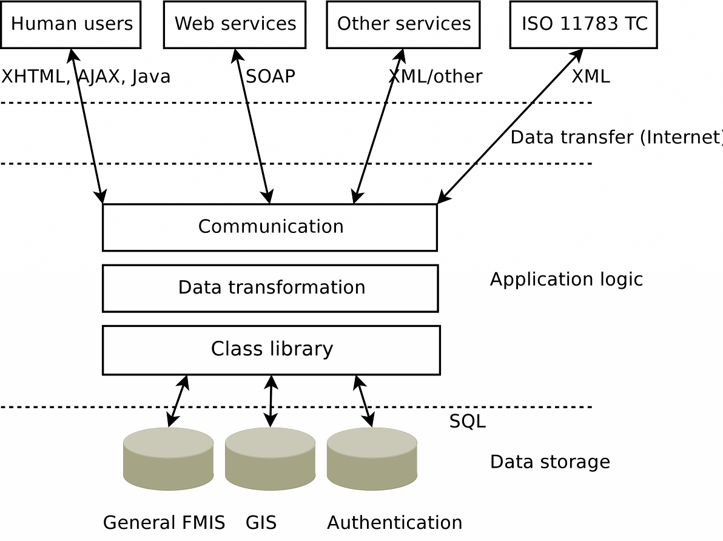
Figure 3. FMIS architecture from the viewpoint of the developer

3. Results and discussion
In terms of information handling, the farmer needs to manage a lot of information in order to make economical and environmental sound decisions. Currently, this process is very labor intensive and for most parts, executed manually. The important concerns and problems voiced by the farm manager include the time consuming tasks of monitoring field operations, manage the finances and application for subsidies which is further complicated by the lack of integrated soft and hardware to manage this work and the lack of coordination when such programs do exists. Also, the farmer voice a need for additional information and advanced technologies to manage monitoring and data acquisition on-line in the field. When looking at the external concerns, it is seen that this mostly concerns the need for sustainable production of farm products, which is further pursued by regulations and the possibility to receive subsidies when more sustainable management practices are abided by. Table 1 lists some of the voiced concerns (Sørensen et al., 2009).
In a study of the use of Farm Management Information Systems (FMIS), Lewis looked at the information sources used by farm decision-makers. He found that, for the majority of farmers, the most important source of management information was other farmers. The most innovative group also rated their own records highly, then came outside advice from accountants and field days. Local and agricultural newspapers also scored highly, well above national newspapers, commercial newsletters or government publications (Lewis, 1997).
Hayes et al. demonstrated a positive association between the on-farm use of a MIS and herd performance. Significant resources are required to implement and use these aids, but improvements in the overall productivity of dairy farms that calve seasonally might be achieved if these technologies were to be more generally adopted (Hayes et al., 1998).
In terms of the "importance" of this information (perhaps synonymous with trustworthiness), family came highest except for the most innovative group, who rated their own records just above family. Other farmers and other professionals such as agricultural consultants, accountants and bookkeepers came next, although the most innovative farmers rated discussion groups higher than these. Agricultural newspapers were next most important, and for the most innovative farmers, farming magazines. Universities, product pamphlets, national newspapers, bankers, solicitors, insurance agents, government publications and television broadcasts were all seen as of low importance. Agricultural and technical colleges were seen of high importance, but only by those farmers who had no FMIS (Bell, 2002).
Another study of a quite different group - grape growers in the Yarra Valley (Almonte, 1998), came to similar conclusions, despite the fact that the target group was very different (e.g. over 70% had tertiary qualifications). The main sources of information were grower groups, other growers, accountants, their own records, field days, and then family. Next came scientific journals, something not seen in other categories of farmers. Lowest came television, radio, local newspapers and salespersons. There was a significant positive correlation between age and using information from families and negative correlations between both level of education and size of farm and the use of information from consultants and grower groups respectively. It seems that the larger the operation, the less the need for outside information.
In a study in Rafsanjan, Iran (Abdollahi Ezzatabadi et al., 2002), the farmer participation in establishing a simple Farm Management Information System investigated. The results showed that the farmers were willing enough to accept the system. Nevertheless, having an accounting system in the first step toward the establishment of an information system, this is used by only 42% of the sampled farmers. The main reason for this is the lack of knowledge about the benefits of such systems.
When considering the Farm Management Information System (FMIS) from the perspective of systems usability presented here, the information management system is more than just data storage and functionalities supporting farm management. It has an important active role in providing on-line support and assistance in everyday farm activities. Thus we suggest that the newly designed information management system concept for automated plant production should be named Active Farm Management Information System, AFMIS (Pesonen et al., 2008).
In a study on the development, change, and transformation of Management Information Systems (Nasir, 2005) the following results Obtained: The results of the content analysis indicate a change in the themes and concepts of IS over the past three decades. Between the years 1970 and 1979, most of the articles have concentrated on the development of IS design and they have underlined critical factors in achieving successful and effective IS design. In the first ten years, IS has been used predominantly to support the managers in their decision making. Besides, it is evident that implementation of IS into sales management has been popular and widespread in this era. However, IS implementations in the sales management have been limited to make forecasting about the sales and to take feedback from the sales persons. However, in the second ten years, IS implementations have disseminated into different domains of business such as maritime industry, industrial markets, motor carrier markets, banking sector, etc.. The roles and responsibilities of the managers in the MIS began to change, and the significance of user involvement (such as involvement of executive managers, managers, and line managers) in the management processes of IS has increased during 1980s. As the need of interaction among executives, users, and IS managers has increased for the success of MIS operations, the decentralization of IS departments has become a dominant issue during the period of 1980–1989. Similarly, the significance of collaboration and interaction among the high-level executives, users, and information system managers has also continued to be mentioned during the period 1990–2002. However, in contrast to the period of 1980–1989, in the period of 1990–2002 the changing role of chief information officers (CIO) has been discussed. Practitioners of the period 1990–2002 have discussed whether CIO is adding value or not. As the firms began to outsource their IS, a discussion of whether to outsource IS or use in-house IS also started at that time.
Naranjo-Gil in a study showed that TMT diversity is an important variable influencing the relationship between MIS sophistication and strategic performance. The issues of management organizational performance are critical problems confronting top managers in public organizations. The findings of this paper provide a fruitful avenue for improving our understanding of strategic performance in hospitals and other organizations (Naranjo-Gil, 2009). Governmental authorities have to design the MIS to provide a broad range of information to health care managers. Thus, top management teams can face the challenge of balances and coordinates patients, financial, organizational and community needs (Fuller-Love & Cooper, 1996; Brittain & Macdougall, 1995; Shortell et al., 1996). A FMIS is depicted as a planned system of the collecting, processing, storing and disseminating of data in the form of information needed to carry out the operations functions of the farm.

4. Conclusions
MIS differ from regular information systems because the primary objectives of these systems are to analyze other systems dealing with the operational activities in the organization. In this way, MIS is a subset of the overall planning and control activities covering the application of humans, technologies, and procedures of the organization. Within the field of scientific management, MIS is most of ten tailored to the automation or support of human decision making. General FMIS database contains the same heterogeneous collection of information about the farm that is stored by any commercial FMIS. One difference is that the general FMIS database must also contain information on farm equipment required for precision agriculture.

Correspondence to:
Payman Salami
Department of Agricultural Machinery Engineering, Faculty of Biosystems Engineering, University of Tehran, P.O. Box 4111, Karaj 31587-77871, Iran
Fax: +98-21-665-93099
Cell phone: +98-918-373-4751
Emails: payman.salami@gmail.com; salami@ut.ac.ir

References
[1] Abdollahi Ezzatabadi, M., Soltani, G. R., Nejati, A. Possibility of farmer participation in establishing a simple Farm Management Information System: A case study in Rafsanjan. J. Sci. & Tech. Agric. & Nat. Resour. 2002; 5(4): 24.
[2] Almonte, E. The Internet as a source of extension information for grape growers in the Yarra Valley region. Honours thesis, La Trobe University, Melbourne. Unpublished 1998.
[3] Bell, C. J. Internet Delivery of Short Courses for Farmers: A case study of a course on Precision Agriculture: A report for the Rural Industries Research and Development Corporation. Canberra, RIRDC 2002. Available online at: http://pandora.nla.gov.au/pan/36436/20030715-0000/www.rirdc.gov.au/reports/HCC/02-085.pdf.
[4] Berrisford, T., and Wetherbe, J. Heuristic Development: A Redesign of Systems Design. MIS Quarterly 1979; 3(1): 11-19.
[5] Brittain, J. M., & Macdougall, J. Information as a resource in the National Health Service. International Journal of Information Management 1995; 15(2): 127-133.
[6] Brousseau, J. Project Management: Look before you leap. Computing Canada 1988; 14(9): 25.
[7] Dalgaard, R., Halberg, N., Kristensen, I. S. & Larsen, I. Modelling representative and coherent Danish farm types based on farm accountancy data for use in environmental assessments. Agriculture, Ecosystems & Environment 2006; 117: 223-237.
[8] Folinas, D. A conceptual framework for business intelligence based on activities monitoring systems. Int. J. Intelligent Enterprise 2007; 1(1): 65-80.
[9] Fuller-Love, N., & Cooper, J. Competition or co-operation? Strategic information management in the National Health Service: A case study of the ceredigion NHS trust. International Journal of Information Management 1996; 16(3): 219–232.
[10] Halberg, N. Indicators of resource use and environmental impact for use in a decision aid for Danish livestock farmers. Agriculture, Ecosystems & Environment 1999; 76: 17-30.
[11] Harsh, S. B. Management information systems 2004. Available online at: http://departments.agri.huji.ac.il/economics/gelb-manag-4.pdf.
[12] Hayes, D. P., Pfeiffer, D. U., and Morris, R. S. Production and Reproductive Responses to Use of DairyMAN: A Management Information System for New Zealand Dairy Herds. Journal of Dairy Science 1998; 81(9): 2362–2368.
[13] Jensen, A. L.; Boll, P. S.; Thysen, I. & Pathak, B. K. A web-based system for personalized decision support in crop management. Computers and Electronics in Agriculture 2001; 25(3): 271-293.
[14] Lewis, A. V. Factors Influencing the Adoption of Computer Based Management Information and Decision Support Systems by Australian Farmers. PhD Thesis, Swinburne University of Technology, Melbourne 1997.
[15] Lyons, M. H. Future ICT systems - understanding the business drivers. BT Technology Journal 2005; 23(3): 11-23.
[16] Naranjo-Gil, D. Management information systems and strategic performances: The role of top team composition. International Journal of Information Management 2009; 29: 104–110.
[17] Nasir, S. The development, change, and transformation of Management Information Systems (MIS): A content analysis of articles published in business and marketing journals. International Journal of Information Management 2005; 25: 442–457.
[18] Naumann, J. D., and Palvia, S. A selection model for systems development tools. MIS Quarterly 1982; 6(1): 39-48.
[19] O’Brien, J. A. Management Information Systems: Managing Information Technology in the Internetworked Enterprise. Boston: Irwin McGraw-Hill 1999.
[20] Oslon, K. D. Introduction to farm records and accounting. University of Minnesota, Institute of Agriculture, Forestry and Home Economics, St. Paul, Minnesota 55108. 1986. Available online at: http://ageconsearch.umn.edu/bitstream/14051/1/p86-52.pdf.
[21] Pesonen, L., Koskinen, H., Rydberg, A. InfoXT - User-centric mobile information management in automated plant production. Nordic Innovation Centre, Stensberggata 25, NO-0170 Oslo, Norway. 2008. Available online at: http://www.nordicinnovation.net/_img/infoxt_finalreport.pdf.
[22] Pesonen, L., Nikkilä, R., Kaivosoja, J., Olsson, J., Norros, L. Rydberg, A. Technological solutions for the information management system. 2007. Available online at: https://portal.mtt.fi/portal/page/portal/www_en/Projects/InfoXT/Publications/WP2.pdf.
[23] Shortell, S. M., Gillies, R. R., Anderson, D. A., Erickson, K. M., & Mitchell, J. B. Remaking Heath Care in America: Building organized delivery systems. San Francisco, CA: Jossey Bass 1996.
[24] Sigrimis, N., Hashimoto, Y., Munack, A. & De Baerdemaeker, J. Prospects in Agricultural Engineering in the Information Age: Technological Developments for the Producer and the Consumer. CIGR-Ejour., I 1999; 1-20.
[25] Sørensen, C., Bildsøe, P., Fountas, S., Pesonen, Pedersen, S., Basso, B., Nash, E. Integration of Farm Management Information Systems to support real-time management decisions and compliance of management standards. Center for research & technology, Thessaly, Greece. 2009. Available online at: http://www.futurefarm.eu.
[26] Willis, T. H., Huston, C. R., d'Ouville, E. E. Project manager's responsibilities in a prototyping systems analysis and design environment. Project Management Journal 1988; 19(1): 56-60.

11/9/2009


Payman Salami was born in 1979 in Kurdistan/Iran, received his B.Sc. degree in Agricultural Machinery Engineering from the Bu-Ali Sina University, Iran, in 2003. He is now M.Sc. student in Agricultural Mechanization Engineering in the University of Tehran under supervision of Dr Hojat Ahmadi. His research fields include Analytics of input output and waste energies in agriculture production, Information Systems, Application of GIS and RS systems in agriculture, Condition Monitoring, and Mechanization Indices.


Hojat Ahmadi was born in Shiraz/Iran in 1969, received B.Sc. degree in Agricultural Machinery Engineering from the University of Shiraz, Iran, in 1992, M.Sc. and Ph.D. degrees in Mechanical Engineering of Agricultural Machinery from the University of Tehran, Iran, in 1996 and 2001, respectively. He is currently assistant professor in Department of Mechanical Engineering of Agricultural Machinery at University of Tehran. His current research interests are Machinery Fault Detection, Vibration & Oil Monitoring, Signal Processing, Precision Agriculture and System Maintenance.

