EFFECT ON BRINNING ON THE MICROBIAL QUALITY AND SAFETY OF SMOKED CATFISH

Omojowo, Funso Samuel;* Omojasola, Patricia Folake,**, Kolawole Matthew Olatunji** Ngwu Emmanuel onyebuchi*, Oluborode Gabriel Bayode*; Adetunji Charles Oluwaseun***

jowosam@yahoo.com ; folakejasola@yahoo.co.uk ; tomak74@yahoo.com; ngwuemma@yahoo.com, tkayode2007@yahoo.com, charliguitar@yahoo.com

*NIFFR, P.M.B. 6006, NEW-BUSSA, NIGER STATE, NIGERIA.
** DEPT. OF MICROBIOLOGY, UNIVERSITY OF ILORIN, ILORIN. NIGERIA
***NIGERIAN STORED PRODUCTS RESEARCH INSTITUTE, ILORIN, KWARA STATE, NIGERIA.

ABSTRACT
This study was carried out to assess the microbial quality and safety of smoked catfish (Clarias gariepinus) treated with Sodium chloride (table salt) during 8-week storage at room temperature. Raw catfish steaks were subjected to the following treatments for 5 minutes prior to smoking: 5-25% table salt. The non-treated catfish served as control. The control and the fresh fish treated samples showed diverse microbial load. All treated smoked sample were negative for E. coli and Streptococcus sp. The treatment effectively reduced the TVC, Coliform, Staphylococcus and fungi after smoking and these low microbial counts was maintained until the end of the 8 weeks storage. Treatments with 20 and 25% salt proved best in terms of microbial reduction but organoleptically 5% treatments are acceptable to consumers. [New York Science Journal 2010;3(6):20-26]. (ISSN 1554 – 0200).

Key words: Table salt, storage, microbial load and smoked catfish

INTRODUCTION
Smoking of fish and/or meat products is one of the most ancient processing technologies. It has been for centuries used for preservation, and is still widely used for this purpose among several communities in the third world where up to 70% of the catch is smoked for preservation (Ward, 1995). Hard curing by salting and smoking permits lengthy preservation by removing moisture, which is essential for bacteriological and enzymatic spoilage. Consumers are rediscovering the good taste of smoked seafood, including smoked catfish. To satisfy the consumer demand, it is necessary to produce good quality and safe smoked seafood products. Fish and fisheries products are among the most perishable commodities worldwide mainly due to microbial spoilage. About one-third of the world’s food production is lost annually as a result of microbial spoilage. In fact, microbial activity is responsible for spoilage of most fresh and of several lightly preserved seafoods (Lund et al., 2000). Smoked fish and shellfish products can be a source of microbial hazards including Listeria monocytogenes, Salmonella spp., and Clostridium botulinum (Heintz and Johnson, 1998). Omojowo and Ihuahi (2006) reported that smoked fish samples from 4 local Markets in Kainji Lake area of Nigeria were dominated by gram-positive bacteria, Potential pathogens, coagulase-positive Staphylococcus, and Escherichia coli. Delay or prevention of microbial spoilage of fish may be achieved by different preservative methods that include the use of smoking and brining. In certain instances, sodium chloride is added mainly as a flavoring and functional ingredient and hence in these cases the effect could be “indirect.” Another reason that the antimicrobial effect of sodium chloride may be called indirect is that it reduces the water activity in many foods and thereby indirectly prevents microbial growth (Ravishankar and Juneja, 2000). The objectives of this study were to evaluate the effect of different concentration of table salt on the microbial, physical, organoleptic and nutritional quality of smoked catfish during 8-week storage at room temperature.

MATERIAL AND METHODS
Sample - Treatment
Fresh catfish (Clarias gariepinus) were obtained from a private Fish pond in National Institute for Freshwater Fisheries Research (NIFFR) Housing Estate, New Bussa, Niger State. The fish samples measuring 17-28cm in length and weighing 180-250g were transferred within 30 minutes to the laboratory in a sterile polythene bags and then killed by severing the spinal cord with a sterile scalpel and aseptically eviscerated, washed and rinsed in sterile water. The fish samples were randomly chosen and divided into 6 groups of 5 fish samples and subjected to treatments. The treatments were as follows; (1) control (untreated samples); (2, 3, 4, 5, 6) with 5,10, 15, 20, and 25% Sodium chloride (table salt) for 5 minutes. A sample from each group were separated from each treatment and smoked. Smoking was done according to the methods described by Omojowo and Ibitoye (2005). After smoking and the fish were allowed to cool down and stored in different boxes. This was done to mimic commercial practices. The samples were drawn after two, four, six and eight weeks of storage; then subjected to analysis.

Microbiological and other Analysis
Total viable count (TVC), Coliform, Staphylococci and Fungi count were evaluated according to the methods described by Harrigan and McCance 1976; Speck 1984 and Sneath et. al., 1986). Moisture contents, fat and Crude protein were estimated as per AOAC (1980). All samples were done in duplicates. Sensory evaluation was carried out according to the method of Afolabi et. al. (1984). Statistical analysis was according to SAS, Institute, Inc, (1992) at P < 0.05.

RESULTS AND DISCUSSION
Microbial Analysis
A study for the absence and presence of the target food borne pathogens such as Salmonella, Staphylococcus, and E. coli is required to evaluate microbial safety of smoked catfish. The Total Viable count (TVC), Coliform, Staphylococci and Fungi count in log CFU/g of fresh and smoked samples plated on selective and non-selective media are shown in Tables 1. The total viable count (TVC) of the fresh non-treated (control) Catfish was 6.60 log CFU/g but after the sample were subjected to treatments with table salt the TVC reduction was highest in 25% (5.02 log CFU/g and least in 5% (5.54 log CFU/g). Similarly, Coliform count was reduced from 4.60 log CFU/g in the control to 3.34 log CFU/g in 25% and least was 4.11 log CFU/g in 5% salt concentration. In the same vein, Staphylococci count was reduced from 4.55 log CFU/g in the control to 3.0 log CFU/g in 25% and least in 5% (4.0 log CFU/g). In addition, Fungi count was reduced from 4.52 log CFU/g (control) to 3.62 log CFU/g in 25% and least in 5% (4.21 log CFU/g. Smoking sharply reduced the total viable count in all samples but the sample treated with treated with 25% concentration had the best reduction of 2.13 and 4.60 log CFU/g on day 0 and at the end of eighth week of storage. The TVC of smoked control (untreated) samples were the highest throughout the period of storage and the sample were even completely covered by mold after the 6th week of storage; therefore, no further microbial analysis was conducted. The results obtained were similar to those reported by Goktepe and Moody (1998) where aerobic plate counts in raw catfish fillets were 4.03 log CFU/g prior to brining and 3.61 log CFU/g after brining. Similar to TVC, the coliform count as shown in (Table 1) of the smoked samples treated with 25% sodium chloride had the best output of 0.98 log CFU/g on day 0. This results is comparable with synthetic antimicrobial agents like Potassium sorbate, Citric acid and Sodium metabisulphite which microbiological properties were reported earlier (Omojowo et. al., 2009a, Omojowo et. al., 2009b).
Significant increases in coliform population of all samples occurred after 4 weeks of storage. Coliform count of all treated samples was less than 3.0 log CFU/g throughout the 8-week storage. In the control samples, the Coliform population of the control sample showed 5.17 log CFU/g on the 6th week while the sample was completely covered by mold on the 8th week of storage. This result was similar to that reported by Virginia, (2002) where the Coliform in the control sample showed 2.6 log CFU/g on the 4th week and the sample was completely covered by mold on the 6th week of storage hence the sample was not analyzed on the 6th week. The high coliform count recorded in this report may be due to contamination from the animal manure used in fertilizing the ponds at one time or the other. In the Staphylococcus population, the smoked sample treated 20-25% Sodium chloride reduced the Staphylococcus count to 0 and remained 0 until the end of 8th week storage (Table1). The isolation of Staphylococcus in smoked samples on day 0 may be attributed to post processing contamination. The population of the Fungi reduced in all the treatments and at the end of the 8-week storage time however, the control samples were high throughout the period of storage and were even completely covered by mold at the end of the 8-week storage. It is of interest to observe that in spite of the slightly reduced moisture contents (from 2nd to 6th week) in almost all the samples microbial load still increases dramatically. This suggests that one single factor may not account for these microbial changes. Cross contamination, pH, purity of preservatives are among other factors that can influence microbial changes.
The TVC of the most of the treated samples were all below 5x10⁵ CFU/g to the 6th week which is below m in a three-class attribute plan and signifies good quality. Low levels of coliform bacteria were detected and the pathogens Staphylococcus aureus counts were below 10³ in all the treated samples till the 6th week. The control however, has TVC higher than 5x10⁵ CFU/g in the second week and higher than the recommended limit 7.0 log CFU/g (ICMSF, 1986) after the 4th week. In addition the Coliform count already exceeded 10³ even immediately after smoking. This finding is of concern as a result of the associated public health implications. For example, generally, hot smoked fish are consumed in the tropics with little or no further processing/cooking; thus, they fall into the high-risk category of foods (ICMSF, 1986). Hence there is a need for the use of appropriate percentage of choice antimicrobial agent.

Visual Observation
The actual external colour of smoked Catfish varied from dark to very dark grayish brown. There were generally, no major difference between the control and most of the treated samples except for the sample treated samples appear slightly darker than the control in this other; 25% > 20% > 15% > 10% > 5%. Generally, the external colour of the treated samples did not change during the eighth week of storage. However, in the 8th week there was profuse growth of moulds in the control.

TABLE 1: MICROBIAL LOAD OF CATFISH TREATED WITH SODIUM CHLORIDE (Log10)
 | Microbial group | Control | 5% | 10% | 15% | 20% | 25%
B/4 Smoking | TVC | 6.60 ª | 5.54 ^{b} | 5.50 ^{b} | 5.48 ^{bc} | 5.32 ^{c} | 5.02 ^{d}
After ,, | TVC | 4.59 ^{b} | 4.16 ^{c} | 3.48 ^{d} | 2.30 e | 2.21 ^{ef} | 2.13 ^{f}
2nd week | TVC | 6.04 ^{c} | 4.58 ^{d} | 3.92 e | 3.45 ^{f} | 3.21 ^{g} | 2.02^{g}
4th ,, | TVC | 6.52 ª | 5.02 ^{b} | 5.00^{b} | 4.21 ^{c} | 4.06 ^{c} | 3.00 ^{d}
6th ,, | TVC | 7.35 ^{b} | 6.07 ^{c} | 5.80 ^{d} | 5.52 e | 5.28 ^{f} | 4.11 ^{g}
8th ,, | TVC | Mouldy | 7.05 ª | 6.94 ª | 6.77 ^{b} | 6.20 ^{c} | 4.60 ^{d}
B/4 smoking | Coliform | 4.60 ª | 4.11 ^{b} | 4.04 ^{b} | 4.00 ^{bc} | 3.84 ^{c} | 3.35 ^{d}
After ,, | Coliform | 3.54 ^{b} | 1.95 ^{c} | 1.80 ^{c} | 1.61 ^{d} | 1.02 e | 0.98 e
2nd week | Coliform | 4.10 ^{c} | 1.97 ^{d} | 1.70 e | 1.71 e | 1.24 ^{f} | 1.12 ^{f}
4th ,, | Coliform | 4.43 ª | 2.03 ^{b} | 1.94 ^{bc} | 1.86 ^{c} | 1.59 ^{d} | 1.30 e
6th ,, | Coliform | 5.17 ^{b} | 2.48 ^{c} | 2.31 ^{d} | 2.20 de | 2.07 e | 1.97 e
8th ,, | Coliform | Mouldy | 2.91 ª | 2.86 ^{ab} | 2.71 ^{b} | 2.46 ^{c} | 2.27 ^{d}
B/4 smoking | Staph. | 4.55 ª | 4.00 ^{b} | 4.00 ^{b} | 3.95 ^{b} | 3.88 ^{b} | 3.00 ^{c}
After ,, | Staph. | 3.17 ^{b} | 1.60 ^{c} | 1.70 ^{d} | 0.92 e | 0.0 ^{f} | 0.0 ^{g}
2nd week | Staph. | 5.06 ^{c} | 1.47 ^{d} | 1.30 e | 1.10 ^{f} | 0.0 ^{g} | 0.0 ^{g}
4th ,, | Staph. | 5.32 ^{d} | 2.46 e | 1.52 ^{f} | 1.30 ^{g} | 0.0 ^{h} | 0.0 ^{h}
6th ,, | Staph. | 5.52 ^{d} | 3.60 e | 3.20 ^{f} | 1.70 ^{g} | 0.0 ^{h} | 0.0 ^{h}
8th ,, | Staph. | Mouldy | 4.20 ª | 3.30 ^{b} | 2.30 ^{c} | 0.0 e | 0.0 e
B/4 smoking | Fungi | 4.52 ª | 4.21 ^{b} | 4.20 ^{b} | 4.17 ^{b} | 3.90 ^{c} | 3.62 ^{d}
After ,, | Fungi | 3.11 ^{b} | 2.00 ^{c} | 1.65 ^{d} | 0.60 e | 0.51 e | 0.48 e
2nd week | Fungi | 5.28 ^{c} | 2.75 ^{c} | 2.70 ^{c} | 1.80 ^{d} | 1.54 e | 1.50 ^{f}
4th ,, | Fungi | 5.41 ^{c} | 3.14 ^{c} | 3.08 ^{c} | 2.90 ^{d} | 2.78 ^{d} | 2.57 e
6th ,, | Fungi | 5.70 ^{d} | 3.56 e | 3.40 ^{ef} | 3.26 ^{fg} | 3.12 ^{gh} | 3.05 ^{h}
8th ,, | Fungi | Mouldy | 4.13 ª | 4.05 ^{ab} | 3.91 ^{bc} | 3.80 ^{c} | 3.62 ^{d}
Means in the same rows with different superscript are significantly different (p < 0.05).

BACTERIAL ISOLATES

All treated smoked sample were negative for E. coli and Streptococcus sp.
The control and the fresh fish treated samples showed the following bacteria flora Bacillus coagulans, B. cereus, Klebsiella ozanae, Proteus vulgaris, Escherichia coli, Staphylococcus aureus, and Streptococcus sp, while the fungi isolated include Penicillium verrucosum, Aspergillus niger, A. candidus, A. flavus and A. nidulan while the smoked untreated catfish sample (control) were dominated by the following organisms B. coagulans, (about 70% of the isolates) while the remaining being S. aureus, and Streptococcus sp. Smoked untreated sample also showed bacteria load above except that Streptococcus sp was not isolated in the sample. The treated sample showed the microbial load in the following pattern; 5% and 10% Sodium chloride (salt) contains the following isolates B. coagulans, S. aureus, K. ozanae, A. candidus, Sporendonema epizoum, and P. verrucosum while 15% have the isolates of 5 and 10% above except A. candidus while 20-25% salt treated sample have B. coagulans, K. ozanae and S. epizoum.

Proximate Analysis
The proximate analysis of raw and smoked samples are presented in Figure 1-4. There were no significant (p0.05) differences in Protein (17.8 - 18.6%), Fat (3.9 – 4.30%), and Moisture contents (78.2 - 79.4%) of fresh samples respectively subjected to different
treatments. The moisture content of the fish samples decreased sharply after the smoking. This decrease was due to loss of water during smoking (Asiedu et al., 1991). The fat content of raw fish samples increased significantly due to loss of moisture and an increase in the dry matter content per unit of weight following sample dehydration. There was an inverse relationship between the moisture and protein content in the smoked samples. There was increase in the protein contents till the 4th week and later began to decline throughout the storage period. The initial increase in protein content in smoked fish till the 4th week may be due an increase in the dry matter content per unit of weight following sample dehydration during smoking and reduction in the moisture contents during the early part of the storage before autolysis becomes pronounced. However, this result shows that storage time causes a decrease in the protein content of smoked catfish which agreed with earlier work of Ufodike and Obureke (1989) where there was decrease in crude protein of preserved Oreochromis niloticus. These workers attributed the decrease to hydrolysis of protein during the process of autolysis in the fish muscle. However, the treated samples show some corresponding higher value of protein more than the control especially as the concentration of the preservatives increases from 5-25%. This increase may be due to the effects of the salt preservatives effects which slow down autolysis in the fish muscles and consequently slow down the protein break down.

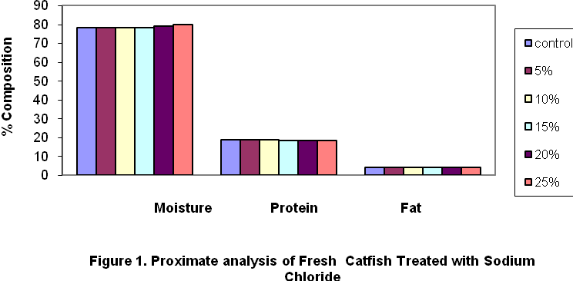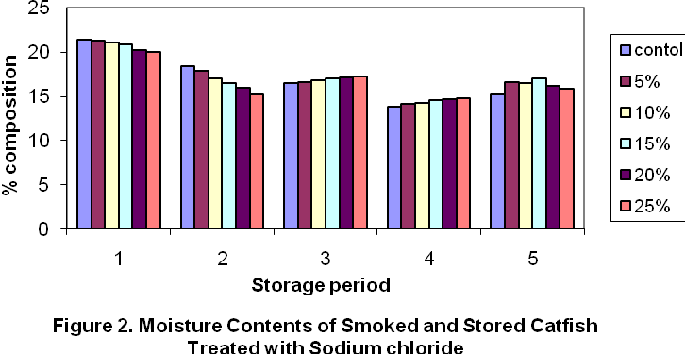

Note, in x-axis 1= Day 1, 2= 2^{n d} Wk, 3 = 4th Wk, 4= 6th Wk and 5= 8th Wk
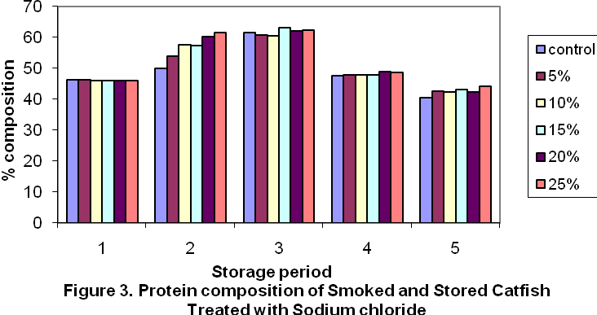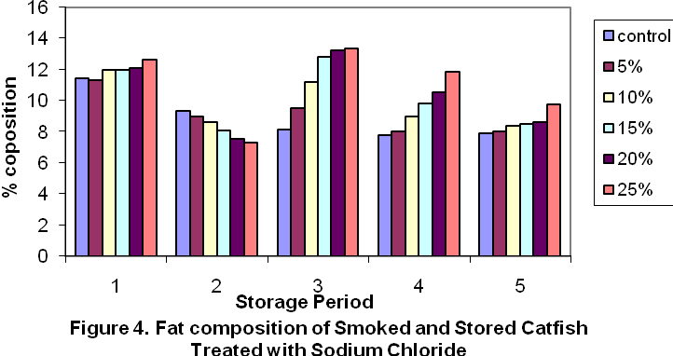
Note, in x-axis 1= Day 1, 2= 2^{n d} Wk, 3 = 4th Wk, 4= 6th Wk and 5= 8th Wk

ORGANOLEPTIC ASSESSMENT
The quality of the smoked fish (both treated and untreated) was evaluated immediately after smoking and after storage for 8th week on taste, flavour, texture, appearance and overall acceptability. The fish flesh overall score was given to both untreated (control) and the one of various treatment using a hedonic scale of 1- 5 fish scoring less than 2 being regarded as unacceptable. Table 2 summarizes the taste panel results. From the result, the trend of scores, for the overall acceptability of freshly smoked catfish was scored as follows: 5 > C > 10% > 15% > 20 % > 25% while on the 8th week the trend is 5% > 10% > 15%> 20 % = 25% while the control were not tasted since it was covered with mould indicated by the asterisk (**).
N.B. The panelist were made of people with no formal training in fish assessment representing the ordinary consumers outside that needs no training before deciding the acceptability of fish in the markets.

TABLE 2. ORGANOLEPTIC ATTRIBUTES OF FRESHLY SMOKED
AND 8TH WEEK STORED CATFISH TREATED WITH SALT

Treatment | Taste | Flavour | Texture | Appearance | Overall-acceptability
CONTROL | 4.6 | 4.3 | 4.6 | 4.7 | 4.6
FRESHLY SMOKED - 5 % | 5.0 | 4.9 | 4.9 | 5.0 | 5.0
10 % | 2.9 | 3.4 | 3.6 | 3.7 | 4.0
15 % | 2.2 | 2.3 | 3.0 | 2.7 | 2.4
20 % | 1.9 | 1.9 | 1.8 | 1.7 | 1.9
25 % | 1.2 | 1.3 | 1.5 | 1.6 | 1.2
CONTROL (8TH WK) | ** | ** | ** | ** | **
8TH WEEK OLD 5% | 4.3 | 4.5 | 4.1 | 4.0 | 4.4
10% | 4.0 | 3.6 | 3.8 | 3.8 | 3.3
15% | 2.0 | 3.0 | 2.2 | 2.9 | 2.0
20% | 1.0 | 1.0 | 1.0 | 1.0 | 1.0
25% | 1.0 | 1.0 | 1.0 | 1.0 | 1.0

CONCLUSION AND RECOMMENDATION
Though, 25% concentration of Sodium chloride (table salt) showed the greatest reduction of TVC, Fungi, and even Staphylococcus population to 0. However, organoleptic study has reveals that the samples treated with 5% and 10% Salt are preferred by the consumers. On the 8th week 5% preference is on the category of LIKE and above and thus preferred above 10% concentration. This 5% concentration was able keep the fish to ICMSF (1986) standard of good quality till the 6th week by reducing the TVC from 7.35 in the control to 6.07 log CFU/g. It also reduced the coliform in the control from 5.17 log CFU/g to 2.48 log CFU/g. Also in the staphylococcus count the reduction is from 5.52 log CFU/g in the control to 3.60 CFU/g. Also the Fungi count was reduced from 5.70 log CFU/g in the control to 3.56 log CFU/g. The Control samples were covered with moulds on the 8th week. Hence no further analysis was carried out on it. Hence, 5% Sodium chloride (Salt) may be used as a preservative in smoked fish without adversely affecting quality in terms of color and organoleptic quality for a period of 6 weeks.

Acknowledgement.
The author is grateful to the Executive director of NIFFR, New-Bussa, Niger-state, Nigeria for sponsoring this research work.

Correspondence to:
Omojowo Funso Samuel,
National Institute for freshwater Fisheries Research (NIFFR). P.M.B. 6006, New-Bussa, Niger-State, Nigeria.

E-mail: jowosam@yahoo.com, G.S.M:08073536126

REFERENCES
[1] Afolabi OA, Arawomo OA. Oke, L.O.
Quality changes of Nigerian Traditionally
Processed freshwater fish species. I.
Nutritive and organoleptic changes. Journal
of Food Technology. 1984. 19, 333-340.

[2] AOAC. Official methods of analysis of the
AOAC (W. Hortwitz E.d.), 13th ed. AOAC,
Washington D.C., U.S.A 1980. 858pp.

[3] Asiedu MS, Julsham k, Lie O. Effect of local
processing methods on three fish species
from Ghana: Part I, Proximate composition,
fatty acids, minerals, trace elements, and
vitamins. Food Chem 1991. 40: 309-321.

[4] Austin B, Austin DA. General introduction.
In Methods for the Microbiological
Examination of fish and Shellfish, B. Austin
and D.A. Austin (Ed.) Ellis Horwood
Limited, England 1989, p19-24.

[5] Bennet RW. Bacteriological Analytical
Manual 6th edn., Association of Official
Analytical Chemists. Arlington, U.S.A 1984.

[7] Efivuvwevwere BJO, Ajiboye MO. Control
of Microbiological quality and shelf-life of
catfish (Clarias gariepinus) by chemical
preservative and smoking. Journal of Applied
Bacteriology 1996. 80: 465-470.

[8] FDA, Department of Health and Human
Services. FDA & EPA Safety levels in
regulations and Guidance. In Fish and
fisheries Products, Hazards & controls
guidance: Third Ed. Appendix 5 2001. p. 285.

[9] Harrigan WF, McCance MF. Laboratory
Methods in Food and Dairy Microbiology,
2nd Edn. London: Academic Press 1976.

[10] Heintz ML, Johnson JM. The Incidence of Listeria spp., Salmonella spp., and Clostridium botulinum in smoked fish and shellfish. Journal of Food Protection, 1998; 61 (3): 318-323.

[11] ICMSF (International Commission on
Microbiological Specifications for Foods
Micro organisms in Foods 2, Sampling for
Microbiological Analysis. Principles and
Specific Applications, 2nd edn. Oxford:
Blackwell Science 1986.

[12] Lund BM, Baird-Parker AC, Gould GW. The Microbiological Safety and Quality of Foods. 2000. Aspen Publishers, Inc. Maryland, USA, 1885 p.

[13] Ojobe TO, Omoregie, E, Ofojekwu, PC. Effects of smoking on Protein and Amino acid contents of preserved Clarias gariepinus muscle. J. Inland Fish. Soc. India. 1992; 24: 15-19.

[14] Omojowo FS, Ibitoye A. Comparisons of
the Microbial qualities of smoked Clarias
gariepinus using four different kilns. In
Fison proceeding, Port Harcourt 14th-18th
Nov. 2005.

[15] Omojowo F.S. and Ihuahi J.A. (2006). Microbiological Quality and Safety of smoked fish from Kainji Lake area. In African Scientist, Vol. 7, No. 4, Dec 31, 2006.

[16] Omojowo FS, Omojasola PF, Idris GL, Ihuahi JA. Evaluation of Citric Acid and Potassium Sorbate as Preservatives on the Safety and Shelf-Life of Smoked Catfish. In: Nature and Science Journal, 2009a Vol. 7(11):1-8.

[17] Omojowo FS, Idris GL, Ihuahi JA. Comparative Assessment of potassium sorbate and Sodium metabisulphite on the safety and shelf life of Catfish. In: Nature and Science Journal, 2009b: Vol. 7(10):10-17.

[18] Ravishankar S, Juneja VK. Sodium chloride. In Natural Food Antimicrobial Systems. 2000. Edited by A.S. Naidu. CRC Press LLC. N.W. Corporate Blvd., Boca Raton, Florida.

[19] Pigott GM, Tuckker BW. Seafood Effects
of Technology on Nutrition, Marcel
Deckker Inc. N.Y.1990: 155-170.

[20] Ward AR. Fish smoking in the tropics. A
review. Trop. Sci. 1995:35, 103 – 112.

[21] SAS Institute, Inc. SAS User’s Guide:
SAS Institute Inc., Cary, NC 1992.

[22] Sofos JN. Sorbate Food Preservatives. Boca
Raton, FL: CRC Press 1989.

[23] Sofos JN. Sorbic acid. In Natural Food
Antimicrobial Systems, ed. A.S. Naidu
2000: 637-659. Boca Raton, FL: CRC
Press.

[24] Sneath PHA, Mair NS, Sharpe ME. Holt JG.
Bergey’s Manual of Systemic Bacteriology
1986. Vol. 2. Baltimore: Williams and
Wilkins.

[25] Speck ML. Compendium of Methods for
the Microbiological Examination s of
Foods 1984. 2nd edn. Washington, D.C:
American Public Health Association.

[26] Ufodike EBC, Obureke JU. Effects of
preservation techniques on quality of
Oreochromis niloticus muscle. J. Aqua. Sci.
1989. 4: 1-5.

[27] United States Food and Drug
Administration. Compliance policy guide,
No 7108. 24. Washington D.C 1978. Food
and Drug Administration.

[28] Virginia LTA. Hazard Analysis and Critical
Control Point (HACCP), Microbial safety
and Shelf life of Smoked Blue catfish
(Ictalurus furcatus) 2000. M.sc Thesis
submitted to the Graduate Faculty of the
Louisiana State University

08/03/2010

