Cesarean Section Scar Depiction By Transvaginal Ultrasound in Non Pregnant State

Ghada M. Mansour, MD, Sherif F. El -Mekkawy, MD, Yasser G.M. Albahaie, MD, Asmaa H. Ali, MsC.
Department of Obstetrics and Gynecology Ain Shams University.
gourmansour@hotmail.com

Abstract: The number of deliveries by Cesarean section has been increasing steadily worldwide in recent decades. The aim of this study was to find whether the trans-vaginal ultrasound is able to detect Cesarean section scars and their defects in the non pregnant state. A number of two hundred parous women were included in the study. After taking a full history, general and local examination, a transvaginal ultrasound was done for all of them detecting scars and dehiscence, blinded to their modes of delivery. Number of vaginal deliveries among the cases was 94 while caesarean sections were 106. Number of caesarean deliveries ranged from 1- 4 (2 +/- 1). 47.2 % of those cases delivered once, while 3.8% of them delivered 4 times. Ultrasound prediction of caesarean section (positive cases) was 84, while negative for scar cases were 116. Statistically significant association between real results and expected results was proved using chi-square test. Sensitivity was 79.2 %, Specificity 100, positive predictive value, 100%, and negative predictive value of 81.3%. Prediction of dehiscence in non gravid uterus was not proved in this study. [New York Science Journal 2010; 3(6):32-39]. (ISSN 1554 – 0200).

Key Words: Transvaginal ultrasound, cesarean section scar, dehiscence of scar.

Introduction:
The number of deliveries by Cesarean section has been increasing steadily worldwide in recent decades. Although it is often assumed that Cesarean section improves neonatal outcomes, there is no hard scientific evidence to support this. The safety of Cesarean section, however, has increased owing to improvements in surgical and anesthetic techniques, increased safety of blood transfusion and routine use of antibiotics and thromboprophylaxis (Jolly et al., 1999).
Cesarean section is also associated with long-term risks such as postoperative pelvic adhesions, uterine scar rupture, and placental complications such as placenta previa and accreta (Miller et al., 1994). The latter two complications are likely to be associated with the poor uterine scar healing following Cesarean section.
Complications during a previous Cesarean section may be predicted by ultrasound in non pregnant state and that is to guard against any possible future complications in the next deliveries.
Uterine scar dehiscence may present as an acute event in the antenatal or intra-partum period, leading to significant fetal and maternal morbidity (Castenada et al., 2000).
Cesarean sections are usually performed by incision of the lower uterine segment. Songoraphic studies have revealed various changes in the anterior uterine wall following the operation (Michaels et al., 1998 and Jarvela et al., 2002). It has been suggested that uterine rupture is more common in cases with a songraphically thin uterine wall (Suzuki et al., 2000).
Transvaginal ultrasound examination is a highly accurate method for detecting Cesarean scar defects (Armstrong et al., 2003), for example in association with abnormal bleeding (Thurmond et al., 1999) or thinning of the residual myometrium (Regnard et al., 2004), which may increase the risk of uterine rupture.
Aim Of Work:
The aim of this study was to find whether the trans-vaginal ultrasound is able to detect Cesarean section scars and their defects in the non pregnant state.
Subjects and Methods :
A number of two hundred parous women were included in the study.
After taking a full history, general , local examination and transvaginal ultrasound were done for all of them.
Time of examination was postmenstrual.
None of them was on hormonal therapy, none had a previous history of endometriosis .
Cases with uterine operations rather than cesarean section were excluded from the study, pregnant ladies, or recent deliveries less than six months and those who delivered since more than 5 years, all were excluded from the study.
All the women participating in this study were informed about its content, value and absence of expected complications
All transvaginal ultrasound scans were done by one person, the first author.
Scan included comment on the uterine longitudinal, antero-posterior, and transverse diameters, myometrium, endometrium, any abnormalities in the ovaries, adnexae and Douglas Pouch and diagnosis of the scar, blinded to their mode of deliveries.
Voluson pro 730 machine was used, with transvaginal probe (7.5 MHz).
Detection of a cesarean scar by sonography depended on visualization of a hyperechoic, linear density through the stroma near the level of the internal os extending to the vesico-uterine interface in the sagittal plane. Importantly, a scar defect will display a fluid collection along this line and in continuity with the endocervical canal. Cesarean scars were recorded as either present or absent.
Ultrasonographic prediction of the scars was recorded and later compared with self-reported obstetric history. After tabulation, all data were analyzed using SPSS software, version 11.0 (SPSS, Chicago, IL, USA). The Pearson χ2 test was used for nominal values and the paired t test and analysis of variance were used for numerical values. P<0.05 indicated statistical significance.

Results:
Mean age was 30.3 +/- 5.6 (18 – 44) years. Vaginal deliveries ranged from (1-6) ( 2 +/- 1).
Number of vaginal deliveries among the cases was 94 while caesarean sections were 106. ( Table 1).
Table (1): Distribution of the studied group as regard CS delivery.
% | No | CS delivery
47% | 94 | No
53% | 106 | Yes

Number of caesarean deliveries ranged from 1- 4 ( 2 +/- 1). 47.2 % of those cases delivered once , while 3.8% of them delivered 4times. (Table 2).

Table (2): Distribution of the studied group as regard number of CS delivery.
% | No | Number of CS delivery
47.2% | 50 | 1
27.4% | 29 | 2
21.7% | 23 | 3
3.8% | 4 | 4
(1-6) | 2+1 | Mean +SD (range)
Ultrasound prediction of caeseran section (positive cases) was 84, while negative for scar cases were 116. Statistically significant association between real results and expected results was proved using chi-square test. (Table 3, 4,5).
Table (3): Distribution of the studied group as regard U/S results.
% | No | U/S results
58% | 116 | Negative
42% | 84 | Positive
Table (4): Relation between real sonographic results and expected results.

P | X² | Real  Negative Positive |  | Expected U/S results
<0.01  HS | 128 | 22(20.8%) | 94(100%) | Negative
<0.01  HS | 128 | 84(79.2%) | 0 | Positive

Table (5): Relation between real sonographic results and expected results.
% | No | Variables
42% | 84 | True +ve
47% | 94 | True –ve
0 | 0 | False +ve
11% | 22 | False –ve

Results revealed that 11% of the real sonographic results were false negative and 0% were false positive.
Sensitivity was 79.2 %, Specificity 100, positive predictive value, 100%, and negative predictive value of 81.3%.
According to the results of this study, ultrasound proved to be a good negative screening test than positive due to higher specificity than sensitivity.
It was noticed that the prediction of scar was accurate in all cases of recurrent scars, while false prediction was among the group of one previous scar. (Table 6)
Table (6): Relation between real sonogrphic results and number of previous CS
P | X² | U/S  Negative Positive |  | CS number
<0.01  HS | 33 | 28(33.7%) | 22(100%) | 1
<0.01  HS | 33 | 29(34.5%) | 0 | 2
<0.01  HS | 33 | 23(27.7%) | 0 | 3
<0.01  HS | 33 | 4(4.8%) | 0 | 4

Figures 1, 2 are showing cases of scar defect by ultrasound, and figures 3,4 are showing cases with no previous scars. None of the positive cases revealed scar dehiscence in this study.

./ 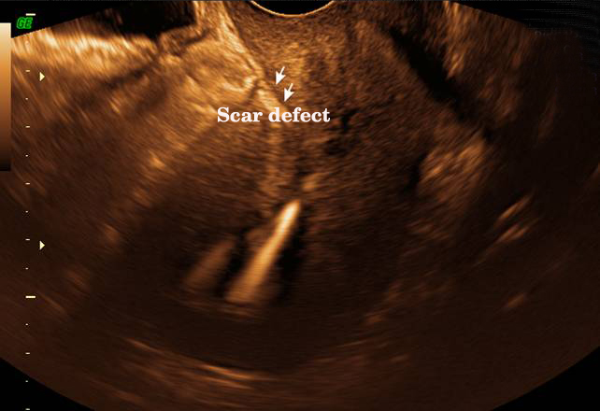

Fig. (1): Scar defect, and IUCD is settled intrauterine.
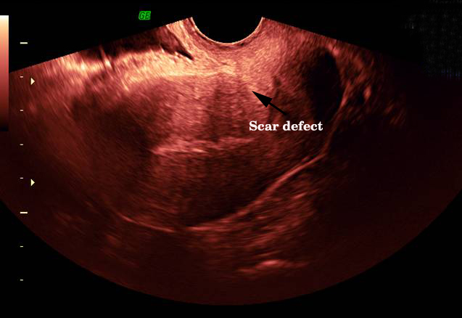
Fig. (2): Scar defect.
:
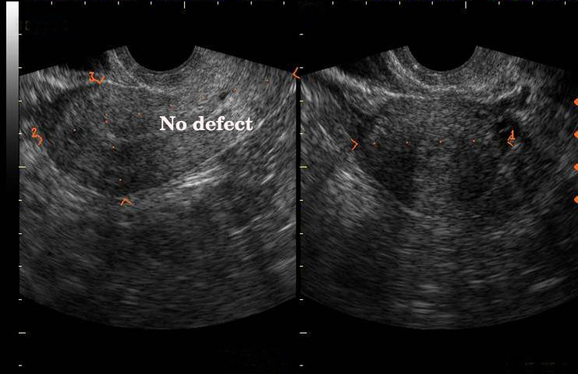
Fig. (3): No scar defect.
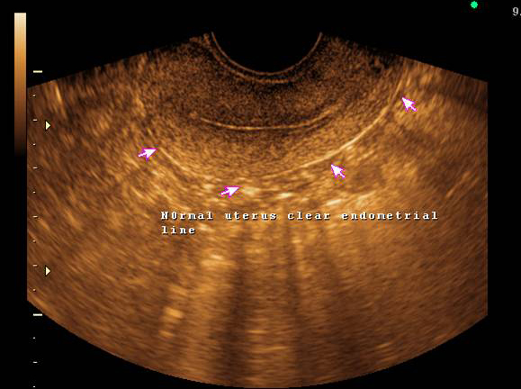

Fig. (4): Normal uterus clear endometrial line

Discussion :
Cesarean section is one of the most frequent surgical interventions worldwide (Katz and Cefalo, 1988).
Cesarean section rates increased over 40 years from about 5% to above 20% and kept going up after a short period of decline in the late 80's to mid 90"s. The cesarean section rate exceeds the recommended rate of 15% in most countries worldwide (Belizan JM et al., 1999).
It seems it will be even increasing as it mounted to 29.1% in the USA in the year 2004 (Hamilton et al., 2005).
Little information has been gained from studies of cesarean section scar healing. It was believed that it heals by regeneration of the muscular fibers and by scar tissue formation (Washington, 1998). The scar may be composed entirely of fibrous tissue and may be a thin linear scar or a wide one, or it may contain a few regenerated muscle fibers.
Further, the scar may extend through the whole thickness of the wound from the serosal surface to mucosal surface, or it may be confined to a part of it so that a gutter is apparent on one or both aspects of the anterior wall of the uterus (Brown, 1993).
Vaginal birth after caeseran section, (VBAC) is still controversial. Investigations to assess the scar integrity in between pregnancies included hystrography, hysteroscopy , Saline Contrast Sonohysterography and ultrasonography
A non invasive non expensive investigation for predicting the integrity of the scar is ideal in determining cases fit for VBAC.
Due to some technical difficulties with abdominal sonography (such as the need of full bladder and less resolution, and problem of effect of obesity on proper depiction), trans-vaginal ultrasonography. with its higher frequency and proximity to the pelvic structures has took the upper hand as it offered a powerful tool for observing the uterine scar of a previous Cesarean section with a more clear view and improved accuracy of measurement (Asakura et al., 2000).
This study aimed to detect the importance of vaginal ultrasound in detecting CS scars in non pregnant uterus and if it can detect their dehiscence aiming finally to know weather the lady planning for a next pregnancy after a ceaserean section can determine the route of next delivery by the condition of the current scar in non pregnant state or not.
Detection of a cesarean scar by sonography began with visualization of a hyperechoic, linear density through the stroma near the level of the internal os extending to the vesico-uterine interface in the sagittal plane.

Mean age was 30.3 +/- 5.6 (18 – 44) years. Vaginal deliveries ranged from (1-6) ( 2 +/- 1).
Number of vaginal deliveries among the cases was 94 while caesarean sections were 106.
Number of caesarean deliveries ranged from 1- 4 ( 2 +/- 1).
47.2 % of those cases delivered once , while 3.8% of them delivered 4times.
Post menstrual phase was preferred for the time of examination because of thr the cycle because of the thin and homogeneous endometrium in the proliferative phase which allows much more definitive evaluation of endometrial and not masking the scar in the myometrium.
Ultrasound prediction of caeseran section (positive cases ) was 84 , while negative for scar cases were 116. Statistically significant association between real results and expected results was proved using chi-square test.
Results revealed that 11% of the real sonographic results were false negative and 0% were false positive.
Sensitivity was 79.2 %, Specificity 100, positive predictive value, 100%, and negative predictive value of 81.3%.
According to the results of this study, ultrasound proved to be a good negative screening test than positive due to higher specificity than sensitivity.
It was noticed that the prediction of scar was accurate in all cases of recurrent scars, while false prediction was among the group of one previous scar.
Rozenberg et al. (1996) published a prospective, observational study of 642 women with a previous cesarean delivery undergoing ultrasound measurement of the lower uterine segment thickness between 36 and 38 weeks' gestation. Their objective was to evaluate the relationship between lower uterine thickness and risk of uterine rupture or dehiscence. The managing obstetrician was blinded to the measurement. They found an overall frequency of defective scars of 4.0% . The frequency of defects rose significantly as the thickness decreased. Using a cutoff value of 3.5 mm, a sensitivity of 88%. a. specificity of 73.2%, a positive predictive value of 11.8%. and a negative predictive value of 99,3% were achieved.
Armstrong et al. (2003) Fluid was visualized within the scars of 13 of 31 subjects (42%) with a prior cesarean delivery. All 13 were found among the 23 subjects (56%) who had labored prior to cesarean delivery. Moreover, women with cesarean scar defects had a greater number of cesarean deliveries (P <0.04) than women without scar defects.
These results are similar to that obtained by Armstrong et al. (2003) Real-time trans-vaginal ultrasound proved 100% sensitive (exact 95% confidence interval [CI] 88.3, 100) and 100% specific (exact 95% CI 90.7, 100) Stored image review had a. sensitivity of 87% (exact 95% CI 70.2, 96.4) and a specificity of 100% (exact 95% CI 90.7, 100).
Detection of severe scar deficiency may be helpful in identifying women at risk as rupture uterus (Rozenberg et al., 1996), abnormally adherent placenta (Gilliam et al., 2002) Cesarean scar ectopic pregnancy in the future. This is also a rare complication of Cesarean sections that occurs. However none of the scar detected in the current study showed dehiscence. That can be augmented by the study of (Castenada et al., 2000) who stated that the uterine scar dehiscence may present as an acute event in the antenatal or intrapartum period, leading to significant fetal and maternal morbidity.
Cheung (2005) reported 2% defective scar. Sen et al (2004) reported 2.82%. However some authors reported slightly higher results Rosenberg et al (1996) reported 15 cases (4.0%) of uterine rupture and stated that the frequency of defects rose as the thickness of the lower uterine segment decreased. Asakura et al. (2000) had a 4.7 % of scar gaping. While Shipp et al. (1999) reported a slightly lower incidence of scar defects.
According to the results of this study, detection of caesarean section scar in non pregnant state was significantly possible , but detection of dehiscence in non gravid uterus was proved in this study and is of debate.
More studies with larger numbers can be done with correlation to the different materials of sutures, surgical technique in suturing the uterine scar, their relations to the ultraosongraphic depiction and corroborated with this study findings.
Corresponding author:
Ghada M. Mansour, MD
Associate consultant of Obstetrics and Gynecology,
Ob/Gyn ultrasound consultant, Ain Shams University Cairo, Egypt.
5th EL Gahez street, Seventh area, Nasr city,
Cairo, Egypt.
Tel, 202/0101459924
202/22614358
Email: gmansour@hotmail.com

References:
Armstrong V, Hansen WF, Van Voorhis BJ and Syrop CH:
Detection of cesarean scars by transvaginal
ultrasound. Obstet & Gynecol 2003; 101:61-65.
Asakura H, Nakai A, Ishikawa G, Suzuki S, Araki T: Prediction of uterine dehiscence by measuring lower uterine segment thickness prior to the onset of labor: evaluation by transvaginal ultrasonography. J Nippon Med Sch 2000; 67:352-6.
Belizan JM, Althabe F, Barros FC and Alexander S: Rates and implications of cesarean sections in Latin America: ecological study. BMJ 1999; 319: 1397.
Brown Mculre JC: Cesarean section: Rupture uterus. Post graduates Obstet Gynecol, 4th ed. Butter worth and CO. Great Britain 1993.
Castenada S, Karrison T, Ciblis L: Peripartum hysterectomy. J Perinat Med 2000; 28: 472-481.
Cheung VY: Sonographic measurement of the lower uterine segment thickness in women with previous cesarean section. J Obstet Gynaecol Can 2005; 27(7):674-81.
Hamilton BE, Martin JA, Ventura SJ, Sutton PD and Menacker F: Births: preliminary data for 2004. Natl Vital Stat Rep 2005; 54(8):l-17.
Hamilton BE, Martin JA, Ventura SJ: Births: preliminary data for 2005. Natl Vital Stat Rep 2005; 55:1–19.
Jarvela IY, Sladkevicius P, Kelly S, Ojha K, Campbell S, Nargund G: Cesarean delivery scar. Ultrasound Obstet Gynecol 2002; 19: 632-633.
Jolly J, Walker J, Bhabra K: subsequent obstetrics performance related to primary mode of delivery. Br J Obstet Gynaecol 1999; 106: 227-232.
Katz VL and Cefalo RC: History and evolution of cesarean delivery. In: Phelan JP, Clark SL, eds. Cesarean Delivery. New York: Elsevier Science 1988; 1-18.
Michaels WH, Thompson HO, Boutt A, Schreiber FR, Michaels SL and Karo J: Ultrasound diagnosis of defects in the scarred lower uterine segment during pregnancy. Obstet Gynecol; 1988: 71:112-120.
Miller DA, Dias FG and Paul RH: Vaginal birth after cesarean; a 10-year experience. Obstet Gynecol 1994; 84; 255-258.
Ofili-Yebovi D, Ben-Nagi J, Sawyer E et al.: Deficient lower-segment cesarean section scars: prevalence and risk factors. Ultrasound Obstet Gyencol 2008; 31: 72-77.
Regnard C, Nosbusch M, Fellemans C, Benali N, Van Rysselberghe M, Barlow P and Rozenberg S: Cesarean section scar evaluation by saline contrast sonohysterography. Ultrasound Obstet Gynecol 2004; 23(3):289-92.
Rozenberg P, Goffinet F, Phillippe HJ, Nisand I: Ultrasonographic measurement of lower uterine segment to assess risk of defects of scarred uterus. Lancet 1996; 347: 281-4.
Sen S, Malik S, Salhan S: Ultrasonographic evaluation of lower uterine segment thickness in patients of previous cesarean section. Int J Gynaecol Obstet. 2004 Dec; 87(3):215-9.
Shipp TD, Zelop CM, Repke JT, Cohen A, Caughey AB and Lieberman E: Intrapartum uterine rupture and dehiscence in patients with prior lower uterine segment vertical and transverse incisions. Obstet Gynecol 1999; 94(5 Pt 1):735-40.
Suzuki S, Sawa R, Yoneyama Y, Asakura H, Araki T: Preoperative diagnosis of dehiscence of the lower uterine segment in patients with a single previous Caesarean section. Aust NZJ Obstet Gynaecol 2000; 40: 402-404.
Thurmond AS, Harvey WJ, Smith SA: Cesarean section scar as a cause of abnormal vaginal bleeding: diagnosis by S sonohysterography. J Ultrasound Med. 1999; 18:13-6.
Washington D: Repeat cesarean Birth .Us Government Printing Office 1998; 351-374.

3/8/2010

