Studies on the Post-Mortem Changes in African Catfish (Clarias angullaris) During Ice –Storage
*Ihuahi Josiah Adoga; **Egila Joseph; and *Omojowo Funso Samuel
*National Institute for Freshwater Fisheries Research (NIFFR), P.M.B. 6006, New Bussa, Niger-State, Nigeria.
**University of Jos, P.M.B. 2084, Jos, Nigeria.
joeihua@yahoo.co.uk, egilajn@yahoo.com, jowosam@yahoo.com
Abstract: Studies were conducted to evaluate the post-mortem changes in African Catfish (Clarias angullaris) during 18 days of ice-storage. Rigor started within 1hr, 30 min after spiking, increased gradually with the lapse of storage time. Maximum rigor index (78%) was attained within 5 hrs, which continued for about 2 hrs 30 min and did not attain full rigor (100%) and then started to relax from rigor. Almost complete relaxation (35%) occurred within 12 hrs after death without showing any sign of spoilage. Initial pH of the muscle immediately after death was 7.10, which decreased to 6.00 within 4 days, and then gradually increased to 7.25 at the lapse of 18 days storage period, when the fish was organoleptically unacceptable. The initial TVB-N and peroxide values were 7.21 mg/100 g and 4.0 meq/kg of oil respectively, which continuously increased with the lapse of the storage period. TVB-N value was 25.42 mg/100 g at the end of 12 days which was within the recommended limit for fresh fish. Values of TVB-N after 12 days exceeded recommended limit. Results of peroxide value did not support those of sensory evaluation since all values were within limit of acceptability throughout the experiment, even when other results indicated unacceptability. The organoleptic acceptability of Clarias angullaris assessed on the basis of quality attributes such as general appearance, odor, color, eyes, slime and consistency of flesh was limited to 12 days. Initial total viable count was 3.2 x 10³ cfu/g which increased to 1.6 x 10⁶ cfu/g on day 12. At this stage the fish were within accepted recommended limit. After 12days, the values exceeded acceptable limit reaching 5.7 x 10⁸cfu/g at the end of 18days. Total coliform count was lower than total viable count throughout the experiment. The overall results indicated that Clarias angullaris was found in acceptable conditions for 12 days of ice-storage in the insulated ice box. [New York Science Journal 2010; 3(6):96-101]. (ISSN 1554 – 0200).
Key words: Clarias angullaris, post-mortem, rigor-mortis, ice-storage, quality.

INTRODUCTION
Studies have shown that post harvest losses in Nigeria are related to poor fish handling, lack of preservation, quality deterioration and spoilage (Eyo, 2001, Daramola, 2007). The high ambient temperature of Nigeria favors the spoilage rate of fish. Clarias angullaris is a valuable fish in Nigeria due to its high market demand, fast growth rate and lucrative size. During icing, chemical changes are known to take place in fish (Huss, 1995). The quality of fish is influenced by a number of factors of which one of the most important is the post-mortem changes and the development of rigor-mortis soon after death (Yasmin et al., 2001). The time a fish takes to go into, and pass through rigor depends on: the species, its physical condition, the degree of exhaustion before death, its size, catching method, the nature of handling during rigor, the temperature at which it’s kept and glycogen content of the fish (Eyo, 2001, Stroud, 2001). The state of rigor in association with other biochemical changes influences the meat quality of fish and higher animals.
Chilling fish in ice or in the refrigerator slows down the destructive processes of enzymes and bacteria, the shelf-life of fish can therefore be extended by many days. Using ice boxes, it has been reported that Tilapia and Catfish will remain edible for 25 to 30 days and 16 to 20 days respectively if buried in ice. Even better results are obtained if the fish are gutted and wrapped (Eyo, 2001, Ola and Oladipo, 2004). In Nigeria, this type of fish preservation is hardly used in the artisanal fishery sector due to unavailability in rural fishing communities and the cost of ice. The artisanal sector in spite of its low technological development remains the backbone of fish production in the country (Tobor, 1990). Considerable information is available on the keeping qualities of most of the species from temperate region; however, few studies have been carried out on the post-mortem changes of freshwater fish in storage condition in contrast to the lot of information that is available for marine fish species. This is what prompted this study
MATERIALS AND METHODS
Fish sampling and preparation: Live samples of Clarias angullaris were obtained from fishermen during early hours (7.00-8.00 am) at Jebba Lake Area of Nigeria and quickly transported to the laboratory of the National Institute for Freshwater Fisheries Research, New Bussa.. Five samples were randomly selected and after cranial spiking, the fish were stored in ice in an insulated box (fish: ice ratio 1:1) in a lot. The treatment was triplicated. The box had 6 holes at the bottom to drain out the melted water. Samples were obtained from the ice box at selected time intervals (0, 2, 4, 8, 10, 12, 14, 16, and 18 days) and used for organoleptic, biochemical and microbiological assessment.
Determination of rigor index: For rigor-mortis study, only fish with a total length (snout-tail) 20 - 30cm were used for this experiment. This is necessary to be able to adequately determine the deflection length during the measurement of rigor-index. Rigor-index was measured at selected time intervals from each treatment according to Bito et al. (1983), modified by Margaret and Kasiga (2005). To measure the rigor-index, the fish sample was placed on a table with half of its body (tail part) kept out of the table. At designated intervals, rigor-index (ratio of tail deflection to total fish length) was calculated by the following equation:
Rigor index = D –Do x 100
D
Where, Do and D represent the distances of the base of caudal fin from horizontal line of the table at the start of the experiment, i.e. in pre-rigor, and at subsequent storage periods respectively.
pH Measurement: pH determination was performed using a pH meter (Corning Model 250). Ten grams of each fish sample was blended with 30ml of distilled water in a warring blender for 1 min, and the sample homogenate was allowed to stay for 5 min, before taking a reading
Determination of Total Volatile Basic Nitrogen (TVB-N): Perchloric acid (PCA) extract of the fish were prepared and analyzed for TVB-N levels using the EC reference (EU 1995). All the samples were headed, eviscerated, washed thoroughly of blood. 10g of fish sample were blended with 90 ml of 6% PCA and filtered. Macro-Kjeldhal distillation apparatus was heated so that the liquid boils in exactly 10 min and, using the same rate of heating, 50 ml of the filtrate that has been made alkaline with 20% sodium hydroxide was distilled for exactly 25 min. The condenser was washed down with distilled water and the distillate titrated with 0.05 M (0.1 N) sulphuric acid. The titre value (less blank) was multiplied by 14 to obtain the TVN as mg N per 100 g flesh. Each analysis was repeated twice.
Peroxide Value (PV) Determination: Measurement of peroxide value was carried out using titrimetric method according to the standard methods described by AOAC (1990).
Microbial analysis: A 15 g of whole fish was well blended using a warring blender and used to prepare serial dilution using peptone water (0.1% w/v) as diluents. Ten fold serial dilution of the suspension was made and 0.1ml of the diluted suspension was plated on triplicate plates. Total viable count (TVC) expressed as colony forming units per gram of fish muscle (cfu/g) of the representative samples were determined by standard plate count methods on Nutrient agar. MacConkey agar was used for Coliform counts determination (Sneath et al., 1986, Omojowo et al., 2010).
Sensory Evaluation: Quality of the fish was determined using organoleptic acceptability as the main criterion. Acceptability was evaluated by ten taste panelists (5 trained sensory experts and 5 fairly trained). Raw samples were washed using potable water and presented whole to the taste panel. Whole fish samples were examined physically for general appearance of skin, consistency of flesh, odor, color of the gills, color and form of eyes and slime formation. Changes in quality of chilled fish during storage were assessed at chosen time interval. The grading of the fish was done following EC (1995) freshness grade for fishery products as shown in tables 1 and 2.

Table 1: Grading of fresh fish
Grade Points Degree of freshness
A <2 Excellent/Acceptable
B 2 to <5 Good/Acceptable
C 5 Bad/Rejected

Table 2: Determination of defect points
Characteristics
of whole fish Defect characteristics Defect points Grade
Odor of neck a) Natural odor 2 Acceptable
when broken b) Faint or sour odor 5 Rejected

Odor of gills a) Natural odor 1 Excellent
b) Faint sour odor 2 Acceptable
c) Slight moderate sour odor 3 Acceptable
d) Moderate to strong sour odor 5 Rejected

Color of gills a) Slight pinkish red 1 Excellent
b) Pinkish red, or brown red, some mucus may be present 2 Acceptable
c) Brown or gray color covered with mucus 3 Acceptable
d) Bleached, thick yellow slime 5 Rejected

General a) Full bloom, bright, shining, iridescent 1 Excellent
Appearance b) Slight dullness and loss of bloom 2 Acceptable
c) Definite dullness and loss of bloom 3 Acceptable
d) Reddish lateral line, dull, no bloom 5 Rejected

Eyes a) Bulging with protruding lens; transparent eye cap 1 Excellent
b) Slight clouding of lens and sunken 2 Acceptable
c) Dull; sunken; cloudy 3 Acceptable
d) Sunken eye covered with yellow slime 5 Rejected

Slime a) Usually clear, transparent and uniformly spread,
but occasionally may be slightly opaque or milky 1 Excellent
b) Becoming turbid, opaque and milky, with marked
increase in amount of slime present in skin 2 Acceptable
c) Thick, sticky, yellowish greenish color 5 Rejected

Consistency a) Firm and elastic 1 Excellent
of flesh b) Moderately soft and some loss of elasticity 2 Acceptable
c) Some softening 3 Acceptable
d) Limp and floppy 5 Rejected

RESULTS AND DISCUSSION
Progress of rigor-mortis: To study the post mortem quality in Clarias angullaris during ice- storage the earliest changes were observed by determining the progress of rigor-mortis in the samples. The most dramatic change in fish post mortem is the onset of rigor mortis. The rigor index of Clarias angullaris stored in ice is shown in fig. 1. In ice-stored Clarias angullaris, rigor started within 1hr, 30min after spiking, increased gradually with the lapse of storage time, highest rigor (78%) was attained within 5hrs, which continued for about 2hrs 30min and then started to relax from rigor. Almost complete relaxation (35%) occurred within 12 hrs after death without showing any sign of spoilage. Further relaxation was not observed after this (see fig 1). The results obtained in the present study are similar to those of Yasmin et al., (2001) and Hossain et al., (2005) who reported short pre-rigor periods in Oreochromis niloticus; a freshwater fish, and Pangasius sutchi respectively. It has been reported that the progress of rigor mortis is influenced by various factors such as species, size, holding temperature, handling practice, fishing method, physical condition, chemical composition and season of the year (Bruce et al., 1983; Regenstein and Regenstein, 1991; Huss, 1995; Cappelin and Jessen,
1997; Stroud, 2001). In the present study, however, a small range of variation in rigor mortis progress was observed within the same species. In this study, Clarias angullaris samples did not reach full rigor state (100%). However, several fishes such as Tialpia and Migral have been reported to reach full rigor mortis (100%) (Yasmin et al., 2001 and Hossain et al., 2005). Abe and Okuma (1991) found full rigor mortis in carp after 24h in ice. In a similar study carried out on Oreochromis niloticus by Margaret and Kasiga (2005), it was recorded that temperature is perhaps the most important factor governing the onset, duration and resolution of rigor.

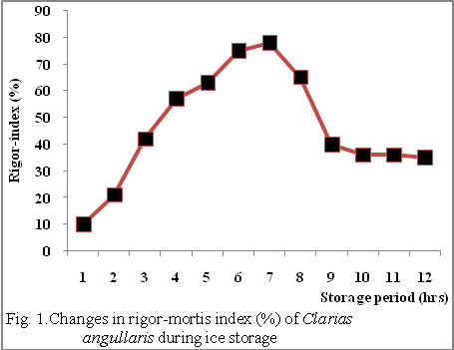
Changes in muscle pH: Initial pH of the muscle immediately after death was 7.10, which decreased to 6.00 within 4days, and then gradually increased to 7.25 at the lapse of 18days storage period when the fish was organoleptically unacceptable. The initial reduction in pH could be attributed to post-mortem glycolysis which led to accumulation of lactic acid, which in turn lowered the pH of the muscle (Huss, 1995). In a related study by El-Marrakchi et al., (1990) on the pH value of sardine (Sardina pilchardus) in ice, it was observed that the pH of the sample gradually reduced from an initial value of 7.2 when fresh to 5.8 within 24hrs, and rose to 6.57 at day 18. Autolytic changes, such as breakdown of proteins, provide an optimum condition for growth and reproduction of spoilage microflora, which produce basic compounds such as amines raising the product pH. Hossain et al., (2005) reported a similar observation in which the initial pH value of Thai pangas (Pangasius sutchi) was 7.0, which decreased to 5.98 during 14 days of storage period and then increased until the experiment was terminated. Thus, rise in product pH during latter days of storage in the present study could be attributed to autolytic changes (Parkin and Brown, 1983).
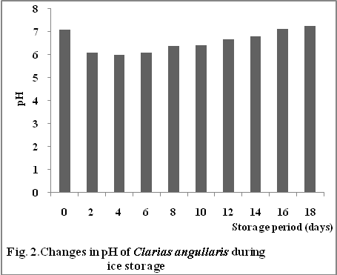
According to Huss (1995), the post mortem pH for most fish is 7 or slightly lower than 7 immediately after catch. The nutritional status of fish affects the levels of stored glycogen and consequently on the ultimate post-mortem pH. It is worthy of note that, well-rested, well-fed less-stressed fish contain more glycogen than exhausted fish (Chiba et al., 1991).
Changes in TVB-N and peroxide value: The initial TVB-N value of Clarias angullaris in ice was 7.21 mg/100g; at the end of the 12th day of ice storage TVB-N value increased to 25.42 mg/100g, which is within the range of recommended value of 30-35mg TVB-N/100g for fresh fish (Huss, 1988, Connell, 1995). These results corroborate those of organoleptic assessment in which Clarias angullaris, were in acceptable condition for 12 days. As from day 14 to 18 the values were within the range of 35.72 – 40.45 mg/100g, exceeding the range of acceptability for fresh fish. TVB-N is a term that includes the measurement of trimethylamine, dimethylamine, ammonia and other basic compounds.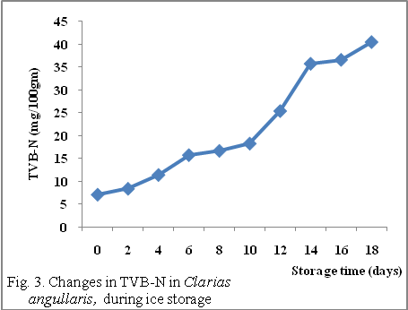
Increase in TVB-N with the lapse of storage may be attributed to bacterial spoilage after the bacterial population has grown (Hossain et al., 2005). TVB-N is normally low during the edible storage period, increasing levels are found in fish near rejection levels. TVB-N might be considered a good indicator of freshness in ice in the present study since the results support those of organoleptic assessment in which acceptability was limited to 12 days in ice.
Peroxide value in Clarias angullaris in ice was 4.00meq/kg of oil at day 0, 4.75 meq/kg of oil at day 4 and 8.78 meq/kg of oil at day 10. At the end of the 18 days storage period the value increased to 15.92 meq/kg of oil which is within recommended values of 10-20 meq/kg of oil as suggested by Connell (1995).
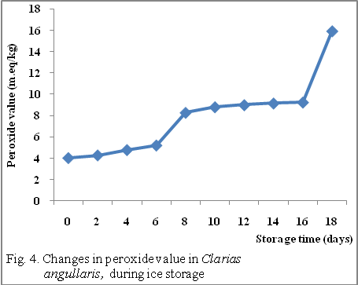
It was observed in this study that changes in peroxide value of the sample were initially very low indicating a low level oxidation in this fish. Peroxide value might not be considered a good indicator of freshness in this study as values were within the range of acceptability throughout the storage period, even when other results indicated rejection. This may be attributed to the low level of oil in this fish. According to (Hossain et al., 2005), lipid oxidation limits the shelf life of oily fish.
Changes in organoleptic qualities: The results of changes in organoleptic quality in Clarias angullaris during ice storage in an insulated box are presented in table 3. The quality of fish was graded using the score from 1-5. The score points less than 2 were considered as excellent. The points from 2 to less than 5 were judged as good or acceptable, while 5 and above were considered as bad or rejected. On the basis of the scores, the fishes were found in acceptable conditions for 12days in ice storage before they became inedible. During this period, changes in quality can roughly be divided into 4 phases corresponding to 0 to 4, 5 to 8, 9 to 12 and 13 to 18 days. Little or no changes occurred in phase 1 without loss of natural flavour and odour, but in phase 2 there was little deterioration without showing definite signs of spoilage and off-flavour. There were signs of early spoilage with slight off-flavour in phase 3; however, in phase 4 the fish begins to have sour to bitter taste, its texture begins to soften showing signs of spoilage and sour odour.
Table 3: Changes in organolpetic qualities of Clarias angullaris during ice storage in an insulated box.
Days of storage Defect Points Grade Overall qualities
0 1.35 A Excellent
4 1.82 B Excellent
8 3.45 B Acceptable
12 4.42 B Acceptable
16 5.00 C Rejected
18 5.00 C Rejected

Changes in bacterial load: The results of changes in bacterial population in muscle (with skin) of Clarias angullaris during ice storage are shown in fig. 5. The initial total viable count was 3.2 x 10³cfu/g which increased to 1.6 x 10⁶cfu/g on day 12. At this stage the fish were in acceptable condition according to International Commission for Microbiological Safety of Foods (ICMSF, 1986), i.e. not exceeding 10⁶cfu/g. This corroborates the results of organoleptic evaluation and TVB-N in which acceptability of Clarias angullaris was about 12 days in ice. The value was 4.2 x 10⁷cfu/g on day 15, and 5.7 x 10⁸cfu/g on day 18 exceeding the acceptable recommended limit. Total coliform counts were generally lower than total viable counts throughout the period of the experiment. However, the presence of coliform bacteria is indicative of faecal contamination of the samples.
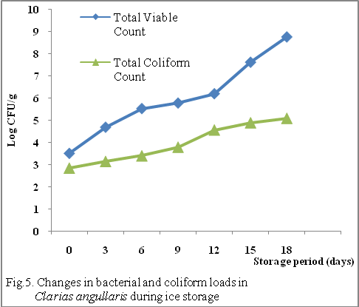
In conclusion, the results of the above studies revealed that Clarias angullaris was found in acceptable condition sensorially up to 12 days in ice storage condition in an insulated ice box. Results of TVB-N and microbial analysis equally supported those of sensory evaluation, in which values were within recommended limit of acceptability within 12 days. Results of peroxide value, however, did not support other results, which may be attributed to the low oil content of the fish sample. The present study suggests that Clarias angullaris has a shelf life up to 12 days in ice storage in an insulted box.
Acknowledgement.
The author is grateful to Dr. Aminu Raji, the
Executive Director of NIFFR, New-Bussa, Niger State, Nigeria, for sponsoring this research work.

Correspondence to:
Ihuahi, Josiah Adoga
National Institute for freshwater Fisheries Research
(NIFFR), P.M.B. 6006, New-Bussa, Niger-State,
Nigeria.
E-mail: joeihua@yahoo.co.uk
G.S.M:08057083162
REFERENCES
- A.A. Eyo. (Fish Processing Technology in the Tropics, 2001. University of Ilorin Press, Nigeria.
- Abe, H. and E. Okuma. Rigor mortis progress of carp acclimated to different water temperatures. Nippon Suisan Gakkaishi, 1991, 57:2095-2100.
- AOAC (Association of Official Analytical Chemists). Official methods of analysis of the Association of Official analytical Chemists, AOAC, 1990 (13th edition), Washington, D.C.
- Bito, M., Yamada, K., Milkumo, Y. and Amono, K. Studies on rigor mortis of fish-1. Differences in the mode of rigor mortis among some varieties of fish by odified cuttings method. Bull. Tokai Reg. Fish. Res. Lab, 1983. 109: 89-96.
- Bruce, A., Bray, D., Lewis, J., Raff, M., Roberts, K. and Watson, J.D. Molecular Biology of the cell. New York and London, Garland Publishing Inc. 1983.
- Cappelin and Jenssen, F. The potential for thaw rigor in frozen industrial Cod blocks, Foredrag ved 27th WEFTA meeting in Madrid, 1997.
- Chiba, A., Hamaguchi, M., Kosaka, M., Tokuno, T., Asai, T. and Chichibu, S. Quality evaluation of fish meat by “Phosphorus-nuclear magnetic resonance”. J. Food Sci. 1991. 56: 660-664.
- Connell, J.J. Quality deterioration and extrinsic quality defects in raw material, 1995. In: Control of Fish Quality, Fishing News Books Ltd. Surrey, England. 31-35.
- El-Marrakchi, A., M. Bennour, N. Bouchriti, A. Hamama and H. Tagafatit. Sensory, chemical and microbiological assessments of Moroccan Sardine (Sardina pilchardus) stored in ice. J. Food Protect. 1990. 53: 600-605
- European Communities (EC). Determination of the concentration of volatile nitrogenous bases (TVB-N) in fish and fish products, 1995. A reference procedure. Official Journal of European Communities. Commission Decision. 15p.
- Huss, H. H. Quality and quality changes in fresh fish. FAO Fisheries Technical Paper 348, 1995. Sub-committee on Fish Trade, Food and Agriculture Organization of the United Nations.
- Huss, H.H. Fresh fish quality and quality changes. FAO/DANIDA. A training manual, FAO Fisheries Series No. 29, 1988.
- ICMSF (International Commission on Microbiological Specifications for Foods, 1986. Micro organisms in Foods 2, Sampling for Microbiological Analysis. Principles and Specific Applications, 2nd edn. Oxford: Blackwell Science.
- J.A. Daramola, E.A. Fasakin and E.O. Adepurasi. Changes in physicochemical and sensory characteristics of smoke-dried fish species stored at ambient temperature. African Journal of Food Agriculture Nutrition and Development. Vol. 7 (6) 2007. 1-14.
- M.I. Hossain, M.S. Islam, F.H. Shikha, M. Kamal, and M.N. Islam. Physicochemical changes in Thai Pangas (Pangasius sutchi) muscle during ice-storage in an insulated ice box. Pakistan Journal of Biological Sciences, 2005. 8(6): 798-804.
- Margaret Masette and Tom Kasiga. The effect of size and holding temperatures on rigor mortis phenomenon in Nile Tilapia (Oreochromis niloticus), 2005. 17-25.
- Ola, Joseph Babajide and Oladipo, Adnes Etanuoma. Storage life of Croaker (Pseudotholitus senegalensis) in ice and ambient temperature. African Journal of Biomedical Research, vol. 7 (2004): 13-17.
- Omojowo Funso Samuel, Olokor Julius Oghenekaro, Ihuahi Josiah Adoga, Adelowo Ezekiel, Idris Garba Libata, Omojowo Taiwo Mary. Preliminary report on the effects of differents sauces on pouched tilapia products. New York Science Journal, 2010; 3(5). 83-86.
- Parkin, K.L., and W.D. Brown. Modified atmosphere storage of Dungeness Crab (Cancermagister). J. Food Sci. 48, 1983. 370-374.
- Regenstein, M.J. and Regenstein, C.E. Introduction to Fish Technology, 1991. New York, an Osprey book published by Van Rostrand Reinhold.
- Sneath PHA, Mair NS, Sharpe ME, Holt JG. Bergey’s Manual of Systemic Bacteriology, 1986, Vol. 2. Baltimore: Williams and Wilkins.
- Stroud, G. D. Rigor in Fish – the Effect on Quality. Ministry of Agriculture, Fisheries and Food. 2001, Torry Advisory Note 36, Torry Research Station, Aberdeen, Scotland.
- Tobor, J.S. The fishing industry in Nigeria. Status and potential fish sufficiency in fish production. NIOMR Technical Paper No. 54, 1990.
- Yasmin, L., K. Ahmed, M. Kamal and Y. Ochiai. Changes in ATPase activity and solubility of myofibrillar proteins from Indian major carps during ice-storage. Bull. Fac. Edu. Ibaraki Univ. (Natl Sci.), 2001. 49: 131-137.

3/9/2010

