Erosion of Biodiversity knowledge between younger and older generation regarding plant identification and their uses in oak and pine dominated zone of Garhwal Himalaya.

Dhani Arya* Ashish Tewari ** Shruti Shah**

* Department of Botany HNB Garhwal University Srinagar Garhwal UK (india)
** Department of Forestry DSB Campus Kumaun University Nainital UK (India)

ABSTRACT-The present study deals with the erosion of biodiversity knowledge between young and older generation regarding the plant identification and use such as fodder, fuel, timber, edible, religious and medicinal plants. The knowledge have been analyzed with both group and result have been shows the erosion of knowledge in younger group 21.64% in oak and 34.06% in pine zone in compare to the older group (male and female). [New York Science Journal 2010; 3(6):108-111]. (ISSN 1554 – 0200).

Key words- Garhwal Himalaya, young and older generation

Introduction:
The Himalayan Mountains (27.38° N latitude and 72.98° E longitude) are the greatest and youngest among the major mountain series of the world extending nearly 3000 km from east to west. Formation of the Himalaya began subsequent to the collision of the Indian plate with the Asian plate at least 40 million before the present (Molnar, 1986). Extending for about 2500 km from east to west, the Himalayan arc covers more than ten degrees of latitudinal expanse between about 27-38º N. Altitude varies considerably and locally exceeds 5000-6000 m, resulting in highly diverse ecological conditions. A mountain range of this dimension encompasses ecological ranges corresponding to a latitude displacement of over 5000 km. Tropical and alpine communities may occur within a distance of two to three hundred kilometres. The Indian Himalaya is the home of biological and cultural diversity. It supports about 18,440 plant species, of which 25.3% are endemic to Himalaya (Samant et al. 1998c). The rich biodiversity of Indian Himalaya is utilized by the native communities in various forms like fodder, timber, house building, religious purposes and including medicine and edible (food). The 1748 species of medicinal plants (Samant et al. 1998) and 675 of wild edible (Samant & Dhar 1997) have been reported to Indian Himalaya.
The inhabitants use plants resources as medicine food, fuel, house building, timber, religious activities and various other purposes (Samant et al. 1996a). This area has great potential of biological diversity and the older generation of this area (male &female) has huge knowledge about their identification and various uses at local level from hundreds and thousand years. But the knowledge of your generation has been decreasing from 20-30 years regarding to plant identifications and their various uses. Therefore the present study has been done filling this corridor in present and future.

MATERIAL AND METHODS:
Rudraprayag district (79°-79° 30’ E-Longitude and 30° 30’-30° 42 N-Latitude) is located in northern part of western Himalaya with great faunal and floral diversity. The region is also the home of India’s most sacred places, which attract hundreds of thousands of pilgrims every year. The main occupations of the people of this region are agriculture, animal husbandry which based on forest and labor work. The geographical area of the district is around 2328kms. For the present study total 6 villages, three in oak (Quercus leucotrichophora) dominated zone and three in pine (Pinus roxburghii) dominated zone were selected.
PRA technique was used to assess the erosion of biodiversity knowledge on plant identification and their uses, between four groups. These four groups include younger male, younger female (age 20-40 years) and older male and older female (age above 45 years). The listing of plant was recorded after long session and discussion with all the groups separately.

RESULTS
Oak dominated zone: The present study shows that the older group of both males and females (age above 45 years) showed high response about plant identification and their uses. They identify total 134 plant species which include 65 trees, 19 shrubs, 19 herbs, 18 grasses, 9 climber and 4 epiphytes, with their respective uses. On the other hand the younger group of both males and females (age 20-30 years old) identify only 105 plant species which include 50 trees, 13 shrubs, 15 herbs, 15 grasses, 8 climbers and 4 epiphytes (Table 1). Besides this they were unaware about some kind of uses of these species in the daily life.
Thus the erosion in plant identification and their used in younger generation was very significant about 29 plants (15 trees, 6 shrubs, 4 herbs, 3 grasses, 1 climber and no loss epiphytes) were disappearing from their identity.

Pine dominated zone
Like the oak dominated zone, in pine dominated zone also the older group of both males and females (age above 45 years) showed high response about plant identification and their uses. They identify total 91 plant species which include 49 trees, 12 shrubs, 10 herbs, 13 grasses, 5 climbers and 2 epiphytes, with their respective uses. On the other hand the younger group of both males and females (age 20-30 years old) identify only 60 plant species which include 36 trees, 6 shrubs, 6 herbs, 5 grasses, 5 climbers and 2 epiphytes. Both wild and cultivated plants were included in the records.
Thus the erosion of plant identification and their uses in younger generation was about 31 plants (13 trees, 6 shrubs, 4 herbs and 8 grasses).
Discussion
Plants have a close relationship with man in whole life, as fire wood, vegetables, fruits, oils, medicines, timber wood and medicine. Thus the knowledge of identifications of plants and their traditional uses are of immense importance for the future generation. Present study showed that the older generation (age above 45 years) was familiar with 134 plant species in oak dominated forest and 91 plant species in pine dominated zone where as in the younger generation (age 20-30 years) the identification and traditional knowledge of plant species if restricted to 105 plant species in oak dominated forest and 60 to oak dominated forest. In both the zones same numbers of epiphytes were identified by both the age groups.
Thus the results had shows the erosion of knowledge in younger group was 21.64% in oak dominated and 34.06% in pine dominated forest in comparison to the older group. Recognizing the ecological importance of Himalayan forest in terms of their intrinsic values as life support system for the local people and as repository of regional biodiversity. So the need of the hour is to conserve the plants and their traditional knowledge.

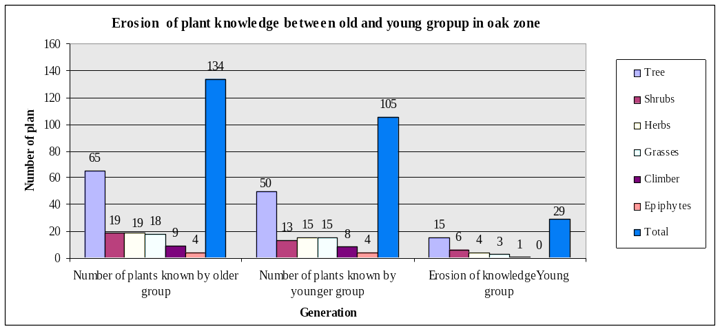
Figure 1. Graphical analysis for erosion of biodiversity knowledge between younger and older generation in oak dominated zone of Garhwal Himalaya

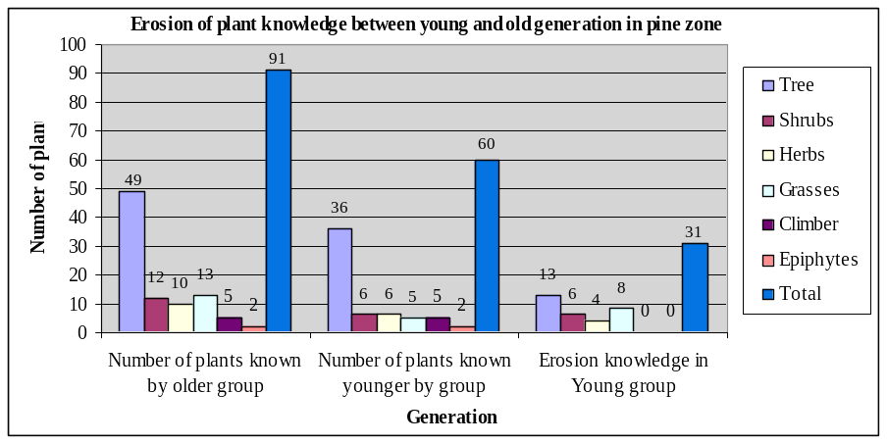
Figure 2. Graphical analysis for erosion of biodiversity knowledge between younger and older generation in pine dominated zone of Garhwal Himalaya

Table-1.1. Erosion of between young and older generation (male and female) in oak and pine dominated zone of Garhwal Himalaya
Plant species | Oak zone |  | Erosion of plant identifications in Young group | Pine zone |  | Erosion of plant identifications in Young group
Plant species | Number of plants known by older group | Number of plants known by younger group | Erosion of plant identifications in Young group | Number of plants known by older group | Number of plants known younger by group | Erosion of plant identifications in Young group
Tree | 65 | 50 | 15 | 49 | 36 | 13
Shrubs | 19 | 13 | 06 | 12 | 6 | 06
Herbs | 19 | 15 | 04 | 10 | 6 | 04
Grasses | 18 | 15 | 03 | 13 | 5 | 08
Climber | 9 | 8 | 01 | 5 | 5 | 0
Epiphytes | 4 | 4 | 0 | 2 | 2 | 0
Total | 134 | 105 | 29 | 91 | 60 | 31

Acknowledgments
The authors are thankful to Mr. Mukul Prakash Executive Director Appropriate Technology India Ukhimath Rudraprayag for providing facilities to work.

Correspondence to:
Dr. Shruti Shah,
Department of Forestry,
Kumaun University, Nainital
Phone: 91-05942-231457
Cellular phone: 91-09412982532
Email: shrutisah@indiatimes.com

References
[1] Samant, S.S.,Dhar, U. & Rawal, R.S. Natural resources use by natives within Nanda Devi Biodphere Reserve in Western Himalaya. Ethnobotany 1996 a; 8: 40-50.

[2] Samant, S.S. & Dhar, U.. Diversity, endemism and economic potential of wild edible plants of Indian Himalaya. International Journal of Sustainable Development & World Ecology 1997; 4: 179-191.

[3] Samant, S.S. Rawal, R.S., Adhikari, B.S. & Dhar, U. Establishment and Maintenance of a Functional Arboretum at Kosi-Katarmal, Almora, Kumaun Himalaya. In Research for Mountain Development: Some Initiatives and Accomplishments (ed. Anonymous). Gyanodaya Prakashan Nainintal. 1998c: Pp.289-318.

[4] Molnar, P. The geologic history and structure of the Himalaya. American Scientist, 1986 vol. 74.
[5] Samant, S.S., Dhar,U. & Palani, L.M.S. Medicinal plants of Indian Himalaya: diversity, distribution, potential values.1998.

Date 3/3/2010

