New Records of Coccinellid Beetles (Coccinellidae: Coleoptera) from District Dehradun, (Uttarakhand), India

*Pushpendra K. Sharma and Prakash C. Joshi

*Department of Zoology, D.A.V. (P.G.) College, Dehradun-248001 (U.K.), India
Department of Zoology and Environment Science, Gurukul Kangri University, Hardwar249404,U.K., India
------------------------------------------------------------------------------------------------------------
*Corresponding author. E. mail <pushp_phd@yahoo.com> Phone- +919410164962, 91-135-2743555

Abstract: An extensive survey of predatory and mycophagous Coccinellid beetles (Coleoptera: Coccinellidae) was conducted in the Dehradun District, India, over a period of two years (July 2005 to June 2007). A total of 4382 specimens of Coccinellids were collected at four different sites representing four different ecosystems having altitudes from 310m to 640m within the Dehradun. Twenty five species were identified and 14 species were recorded for the first time from district Dehradun. These 14 newly recorded species belong to 11 genera of 4 tribes and 3 sub-families. The following 14 species belonged to sub-family Coccinellinae and tribe Coccinellini: Anegleis cardoni (Weise), Cheilomenes sexmaculata var undulata (Fabricius), Harmonia dimidiata (Fabricius), Hippodamia variegata (Goeze), Hippodamia sp., Illeis cincta (Fabricius), Megalocaria dilatata (Fabricius), Micraspis discolor (Fabricius), Micraspis vincta (Fabricius), Micraspis sp., and Psyllobora bisoctonata (Mulsant). Two species occurred from sub-family Chilocorinae and tribe Chilocirini: Brumoides suturalis (Fabricius) and Chilocorus nigrita (Fabricius). Only one species namely Rodolia sexnotata (Mulsant) represented tribe Noviini of the subfamily Coccidulinae. [New York Science Journal 2010; 3(6):112-120]. (ISSN 1554 – 0200).

Keywords: New record, Coccinellid beetles, Coccinellidae, Coleoptera, Predatory

1. Introduction
The predaceous insects of family Coccinellidae are commonly known variously as ladybirds (English English, Australian English, and South African English), ladybugs (North American English), lady beetles or coccinellid beetles (preferred by scientists). The family name comes from its type genus, Coccinella. Most of them are of bright shining colors with a pattern of spots or patches against a contrasting background. Many appear to be distasteful to birds and their conspicuous appearance is an example of warning coloration (Moreton, 1969). These beetles are of extremely diverse habits. The majority of beetles are useful because of their predaceous nature; but some are harmful, being polyphagous. The other coccinellids are predators of a variety of pests viz., aphids, leaf-hoppers, scale insects, mealybugs, mites and other softbodied insects (Omkar and Bind, 1996). Some are specific in their food choice, while many are polyphagous. The introduction of the vedalia ladybird, Rodolia cardinalis Mulsant, from Australia into California in 1888 to control cottony cushion scale, Icerya purchasi, which threatened the citrus industry, is widely regarded the most successful instances of biological pest control by coccinellids (Majerus, 1994).
The family Coccinellidae comprises 5,200 described species worldwide (Hawkeswood, 1987). Khan et al., (2007) have recorded 12 species of coccinellid beetles from Chitral district, Pakistan. A survey of the available literature (Table 1) revealed only a few studies on the species composition of coccinellid beetles in India with no specific mention about the previous records from, Dehradun region. However, Poorani (2002) have listed 400 species of Coccinellids from Indian subregion, which includes the erstwhile state of Uttar Pradesh including Uttarakhand. Singh and Singh (1990) have reported 4 new species of genus Epilachna Chevrolet from Himachal Pradesh, India. Singh and Singh (1991) have reported 16 species of aphidophagous coccinellids from Mizoram state, a north eastern state of India. Omkar and Bind (1993) have reported 6 species of coccinellids from Lucknow region of central U.P. Omkar and Pervez (1999, 2000, 2002) have also reported 17 more species of coccinellids from the same region. Poorani (2003) have reported a new species Telsimia flavomaculata from Karnataka, India. Joshi and Sharma (2008) recently have reported 31 species of coccinellid beetles with 19 new records from district Haridwar, India. The coccinellid fauna of the Indian subcontinent is rich and diverse, but very poorly studied as compared to those from other zoogeographical regions of the world. After the pioneering efforts of Mulsant, Crotch, Weise and Gorham, most of the work on the subcontinent fauna was carried out by the late A.P. Kapur, the former Director of the Zoological Survey of India, in a series of publications. The objective of this study was to investigate the species composition of coccinellid beetles from district Dehradun, Uttarakhand, India.

Table 1. Earlier reports on coccinellid predators from India.
S.  No. | Author | No. of species reported | Area
1.  2.  3.  4.  5.  6.  7.  8.  9.  10.  11.  12.  13  14.  15.  16.  17.  18.  19.  20.  21.  22.  23. | Subramaniam. T.V., 1923  Aiyar, T.V.R., 1942  Kapur. A.P., 1948  Puttarudriah, M. and Channabasavanna, G.P., 1953  Usman, S. and Puttarudriah, M., 1955  Kapur, A.P., 1972  Pajni, H.R. and Singh, J., 1982  Pajni, H.R. and Varma, S., 1985  Canepari, C., 1986  Bhagat and Masoodi, 1988  Singh, T. and Singh, V.K., 1990  Omkar and Bind, R.B., 1993  Singh, K.C. and Singh, T.K., 1991  Singh, T. and Singh, V.K., 1990  Omkar and Bind, R.B., 1995  Omkar and Parvez., A., 1999  Omkar and Parvez., A., 2000  Sathe and Bhosale, 2001  Poorani, J., 2002a  Poorani, J., 2002b  Poorani, J., 2003  Kandibane, M., Rahuraman, S. and Ganapathy, N., 2005  Joshi, P.C. and Sharma, Pushpendra K., 2008 | 01  01  12  53  48  17  30  25  36  04  04  06  15  04  07  10  07  21  01  400  01  07  31 | South India  South India  North India  Mysore State, India  Mysore State, India  Goa, India  Chandigarh, India  Chandigarh, India  India and Nepal  Kashmir, India  Himachal Pradesh, India  Uttar Pradesh, India  Mizoram, North Eastern State, India  Himachal Pradesh, India  Uttar Pradesh, India  Lucknow region, (U.P.), India  Lucknow region, (U.P.), India  Maharashtra State, India  Karnataka, India  Indian subregion  Karnataka, India  Madurai, Tamil Nadu, India  Haridwar region, Uttarakhand State, India

2. Materials and Methods
2.1 Study area: The present study was carried out in the Dehradun district, which is situated at 28⁰ 53' 24" to 31⁰ 27' 50" N latitude and 77⁰ 34' 27" to 81⁰ 02' 22" E longitude. This district, covering an area of about 3088 Km² is in the western part of Uttarakhand state of India. The study area shows three distinct seasons winter, summer and monsoon. Winter season continues from November to February and the days are moderate and nights are very cold with freezing frost during winter months. The summers season continues from March to June with maximum temperature noticed was 40 ⁰C and minimum temperature was 4 ⁰C during the day and night time, respectively. The monsoon season starts from July and Continues till second werek of October. The maximum rainfall occurs during this period and correspondingly high humidity was noticed. During our study period, 2157 mm rainfall was recorded, which was the average of rainfall recorded across all the four sample sites during study period, the maximum of which was during the monsoon season. The collection of adult coccinellids were carried out from different types of ecosystems viz., mixed orchards, agriculture field, herbal garden and forest of Rajaji National Park located at different altitudes. These ecosystems with their locality and altitudes are shown in Figure 1 & Table 2.

2.2 Sampling Method: Sampling of adult coccinellid beetles was conducted at an interval of 30 days from July 2005 to June 2007. The insects were collected by “Sweep sampling Method”, as per Gadakar et al., (1990). Other methods based upon visual encounters, like aspiration and hand picking were also used depending upon the type of habitats sampled.

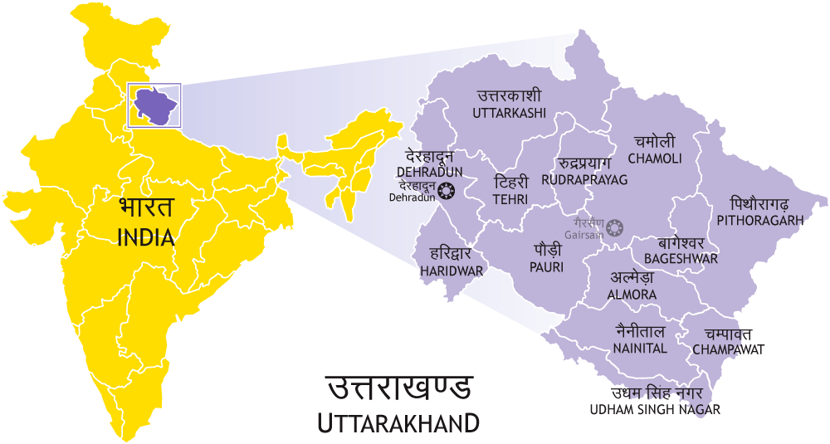

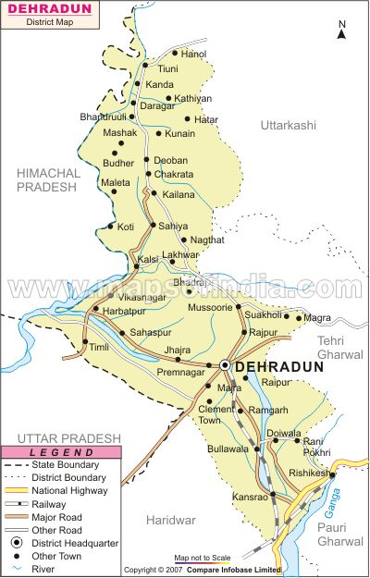
Raiwala
Rishikesh
F.R.I.
Doiwala

FIGURE 1. Map of district Dehradun, Uttarakhand, India showing the location of different study sites.

Table 2. Locations and altitudes of collection sites.
S.No. | Ecosystems | Locations | Altitude
1. | Mixed Orchards | Raiwala | 310.0m
2. | Agriculture | Rishikesh | 356.0m
3. | Garden | F.R.I., Dehradun | 640.0m
4. | Forest | Doiwala | 500.0m

2.3 Preservation and identification of specimens:
The collected insects were transferred into jars containing ethyl acetate soaked cotton. These jars were brought to the laboratory and the insects were stretched and pinned. These were oven dried at 60 C for 72 hours in order to preserve them and then set into wooden boxes and labeled according to their systematic position. Each specimen was tagged with the information about host plants, locality and date. To protect the specimens from the insect pests, naphthalene tablets were added to collection boxes.
The adult specimens of each species were carefully studied for all details under binocular microscope. The insects were separated into different species with the help of available keys (Singh and Singh, 1991; Omkar and Bind, 1993, 1995, 1996; Omkar and Pervez, 1999, 2000; Poorani, 2002b). The insects, which could not be identified in the laboratory, were sent to Northern Regional Station of Zoological Survey India, Dehradun and Entomological Section of Forest Research Institute, Dehradun. Whenever necessary, help of the scientists from Entomology Division of IARI, New Delhi, were also taken.

3. Results
From a total of 3502 samples collected and examined, a total of 25 species of coccinellid beetles were recorded from different study sites in the Dehradun district (Uttrarakhand state), India. Out of these 25 species, 14 species of coccinellid beetles have been recorded for the first time from this particular region of India (Table-3).

Species Composition: During the study period, we recorded 9 species from orchards ecosystem, 16 from agricultural ecosystem, 23 from garden ecosystem and 14 from forest ecosystem. Micraspis discolor (Fab.) and Illeis cincta (Fab.) were the most common species and were found in all study sites. The other commoner species recorded during the study period included Brumoides suturalis Fab., Rodolia sexnotata Mul., Anegleis cardoni Weise, Hippodamia sp. and Micraspis vincta Fab. Eight species of coccinellid beetles viz., Chilocorus nigritus Fab., Adalia decempunctata Linn., Cheilomenes sexmaculata ab rufafasciata (Fabricius), Coelophora 9-maculata (Mul.), Hippodamia variegata (Goeze), Propylea dissecta (Muls.), Halyzia sanscrita (Muls.), Psyllobora bisoctonotata (Muls.) recorded from only two study sites. Four species of coccinellid beetles viz., Coelophora ramosa (Olivier), Harmonia dimidiata (Fab.), Megalocaria dilatata (Fab.) and Phrynocaria sp. recorded from only one study sites. The descriptions of these 14 species are given below:

Sub family: Chilocorinae
Tribe: Chilocorini

1. Brumoides (=Brumus) suturalis (Fabricius)
The adult beetle is oval in shape, about 4.0 mm long and 2.6 mm broad across the mid elytra. The head is brown in colour with a pair of prominent black eyes. The eyes are slight covered by pronotum when the head is retracted. The elytra are brownish yellow except at their apical, basal and lateral margins. There is a median longitudinal black stripe at the apex of the elytra. Besides, there is a lateral longitudinal black stripe on each elytra starting from the humoral angle and ending. The adult beetles were found feeding on the colonies of certain aphids viz., Aphis gossypii, A. craccivora and Lipaphis erysimi.

2. Chilocorus nigrita (Fabricius)
The bright black coloured and medium sized beetle about 5.0 mm long and 3.9 mm broad across the middle elytra. The adults of the beetle have been found inhabiting and feeding of colonies of aphids, L. erysimi, Brevicoryne brassicae, Myzus persicae and Aphis nerii inhabiting on different crop plants.

Sub family: Coccidulinae
Tribe: Noviini

3. Rodolia sexnotata (Mulsant)
This is an oval shaped medium sized ladybeetle, measuring about 5.0-5.5 mm in length and 4.0-4.5 mm in width. The colour of the ladybeetle is dark brownish with the rough elytra. The adults have been found feeding on mango mealybugs.

Sub family: Coccinellinae
Tribe: Coccinellinae

4. Anegleis (or Micraspis) cardoni (Weise)
It is oval in shape and measures about 4.0-5.0 mm in length and 3.5-4.5 mm in width. The elytra are bright pinkish yellow in color with one black median stripe at the joint of both the elytra and two linear markings on each electron; the anterior end of outer one is inwardly curved whereas the inner one is outwardly curved posteriorly. Besides, there is one small rounded black spot towards the posterior end of each elytron. The adult beetles were found feeding on the colonies A. gossypii and A. craccivora.

5. Micraspis sp.
Medium sized beetle, about 4.2 mm in length and 3.0 mm in width across the middle elytra. The head is brown in colour with a pair of prominent black eyes. The elytra are reddish brown and bear tiny silky hairs all over. The specimens of Micraspis sp. do not bear spots over elytra and thus are distinctly different from the other species of genus Micraspis viz., M. discolor and M. cardoni recorded by authors earlier. The adults have been found feeding on aphids and mealybugs.

6. Harmonia dimidiata (Fabricius)
The beetle is oval, large sized about 7.5-8.0 mm in length and 7.0-7.5 mm in width across middle of the elytra. The head bears two small black colored spot. The two third parts of elytra is black in colour posteriorly, while one third elytra is dark reddish in colour anteriorly. The adults have also been found feeding on aphids.

7. Hippodamia (=Adonia) variegata (Goeze)
The adult beetle is oval in shape, about 4.0-4.5 mm in length and 2.5-3.0 mm in width across the middle elytra. The body colour of this beetle is creamish red. The brown head bears a pair of prominent black eyes. Two spots are present towards the anterior portion of the elytra; one is located on the anterior part of each elytron and both the spots are connected with each other by a black horizontal strip which swells in the middle at the joint of two elytra to form another black spot at the junction. This middle black spot at junction is extended by a black line anteriorly upto the thorax and posteriorly upto a spot situated at the junction of both the elytra toward posterior extremity. Besides, these markings two more black spots (one on each elytron) are situated on dorsolateral aspect towards posterior portion of elytra. The adults were found feeding on the colonies of M. persicae and A. craccivora.

8. Hippodamia sp.
The adult beetle is oval in shape, about 4.0 mm in length and 2.5 mm in width across the middle elytra. The body colour of this beetle is creamish orange. The brown head bears a pair of prominent black eyes. Two spots are present towards the anterior portion of the elytra; one is located on the anterior part of each elytron and both the spots are connected with each other by a black horizontal strip which swells in the middle at the joint of two elytra to form another black spot at the junction. This middle black spot at junction is extended by a black line anteriorly upto the thorax. Besides, these markings two more black spots are situated on dorsolateral aspect on middle portion of each elytron. A spot is situated in the end of both the elytra toward posterior extremity. The adults were found feeding on the colonies of aphids.

9. Illeis (= Thea) cincta (Fabricius)
The adult beetle is about 5.2 mm long and 4.0 mm broad across the middle elytra. The head is yellowish in colour with a pair of prominent black eyes. Two spots are situated on the dorsolateral aspects of posterior margin of the thorax. The thorax and elytra are shiny yellowish in colour. The adult were found feeding on the colonies A. nerii.

10. Megalocaria dilatata (Fabricius)
This ladybeetle is oval in shape, giant one measuring about 11.0 mm in length and 10.5 mm in width. The beetle is bright brown in colour and ten black spots are present on its elytra. Thus, five spots are present on each elytron, which are arranged in three rows i.e., 1:2:2 fashion.

11. Micraspis (=Verania) discolor (Fabricius)
It measures about 4.5 mm in length and 3.0 mm in width. The color of elytra is yellowish red with to small rounded black spots on each elytron; one toward the proximal end and the other toward the distal end. The adults were found feeding on the colonies of A. gossypii and L. erysimi.

Table 3. Taxonomic composition of Coccinellidae in four study sites of district Dehradun during 2005-07.
(Species with * are new records)
S.No. | Coccinellidae Species | District Dehradun
S.No. | Coccinellidae Species | S-1 | S-2 | S-3 | S-4
(A). | Subfamily: CHILOCORINAE
(I) | Tribe: Chilocorini
1. | Brumoides suturalis (Fabricius)* | - | 57 | 45 | 24
2. | Chilocorus nigrita (Fabricius)* | - | - | 223 | 208
(B). | Subfamily: COCCIDULINAE
(II) | Tribe Noviini
3. | Rodolia sexnotata (Mulsant) * | 261 | - | 74 | 61
4. | Rodolia sp. | 34 | - | 14 | 12
(C) | Subfamily: COCCINELLINAE
(III) | Tribe Coccinellini
5. | Anegleis cardoni (Weise) * | 112 | - | 38 | -
6. | Cheilomenes sexmaculata (Fabricius) | 15 | 278 | 131 | 39
7. | Cheilomenes sexmaculata var undulata(Fabricius)* | - | - | 45 | -
8. | Coccinella septumpunctata (Linnaeus) | 19 | 302 | 112 | 45
9. | Coccinella septumpunctata var divaricata (Olivier) | 11 | 33 | 26 | 17
10. | Coccinella sp. | 10 | 16 | 12 | 8
11. | Coccinella transversalis (Fabricius) | 17 | 184 | 105 | 52
12. | Harmonia dimidiata (Fabricius) * | - | - | 84 | 26
13. | Hippodamia variegata (Goeze) * | - | - | 98 | 52
14. | Hippodamia sp. * | - | - | 18 | 19
15. | Illeis cincta (Fabricius) * | 19 | 107 | 26 | 24
16. | Megalocaria dilatata (Fabricius) * | - | - | - | 89
17. | Micraspis discolor (Fabricius) * | 19 | 216 | 93 | 44
18. | Micraspis vincta (Gorham) * | 13 | 122 | 47 | -
19. | Micraspis sp. * | - | 31 | 23 | -
20. | Oenopia sauzeti (Mulsant) | - | 68 | 30 | -
(IV) | Tribe Psylloborini
21. | Psyllobora bisoctonotata (Mulsant) * | - | 120 | 72 | -
(D). | Subfamily: EPILACHNINAE
(V) | Tribe Epilachnini
22. | Epilachna sp. | - | 173 | 41 | 19
23. | Epilachna vigintiopunctata (Fabricius) | - | 107 | 30 | -
24. | Henosepilachna vigintiopunctata (Li) | - | 48 | 24 | -
25. | Henosepilachna sp. | - | 17 | - | 19
 | TOTAL | 488 | 1879 | 1411 | 604
S-1 = Site no. 1 (Mixed orchards), S-2 = Site no. 2 (Agricultural Field), S-3 = Site no. 3 (Garden),
S-4 = Site no. 4 (Forests)

12. Micraspis vincta (Gorham)
It is an oval ladybeetle, measuring about 4.5-5.0 mm in length and 3.5-4.0 mm in width. The creamish white pronotum bear distinct black patches; two dot shaped patches toward the proximal end and two almost triangular toward the distal end. There is a triangular curved line, almost across the mid-dorsal line on each red coloured elytron, starting approximately from proximal end and continuing upto the distal end. It has a close morphological resemblance with M. discolor (Fabricius) with respect to the patches over pronotum and colour of elytra. The adult beetles were also found feeding on the colonies aphids and mealybugs.

13. Cheilomenes (=Menochilus) sexmaculata var undulata (Fabricius)
The adult beetle is about 4.5 mm in length and 3.5 mm in width across the middle elytra. Head is dark brown with a pair each of black eyes and brown antennae. The elytra are dark yellow with two thin and black transverse wavy lines towards proximal and one small rounded black spot towards distal end of each elytron. C. sexmaculata var undulata is a predator of aphids. The adults have been found feeding on cotton mustard aphids L. erysimi.

Tribe: Psylloborini
14. Psyllobora bisoctonotata (Mulsant)
This ladybeetle is oval in shape, measuring about 3.0-3.5 mm in length and 2.4-3.0 mm in width. The beetle is white or creamish in colour and sixteen black spots are present on its elytra. Thus, eight spots are present on each elytron, which are arranged in four rows i.e., 2:3:2:1 fashion. It was found feeding on the aphids and mealybugs that confirm the earlier report of Omkar and Pervez (1999).

4. Discussions and Conclusion
The results of this study suggest that the coccinellid community structure in four study sites with different ecosystems and altitudes differs greatly. The number of species found in orchards is much lower compared to agricultural, garden and forest ecosystem. In Indian subcontinent, following workers have worked on the biodiversity aspects of coccinellids. Subramaniam (1923) listed some coccinellids from South India along with the description of hosts. Aiyar (1924) added on taxonomical description of Scymnus coccivora predating on neem scales. While Kapur (1948) described 12 new species of coccinellids and revised the Indian species of Rodolia Mulsant by adding 3 more new species under this genus. Later, Puttarudriah and Channbasavanna (1953) contributed 53 species belonging to 23 genera of 8 tribes and 5 subfamilies. Similarly, Usman and Puttarudriah (1955) recorded 48 species of predaceous coccinellids from Mysore state. Kapur (1972) added 17 species of coccinellids to this family.
Pajni and Singh (1982) recorded 30 species of coccinellids from Chandigarh, which belong to 18 genera. Pajni and Verma (1985) described male genitalia in 25 coccinellids scattered in 15 genera from Chandigarh region. Likely, Canepari (1986) studied 36 species of coccinellids from Northern India and Nepal. During the study period of two years, a total of 31 species of coccinellids beetles were recorded from different study sites of district Haridwar. Bhagat and Masoodi (1988) have reported 4 species of coccinellids viz., Coccinella undecimpunctata L., Adalia tetraspilota H., Hippodamia variegata G. and Scymnus gracilis M. from Kashmir, India. Singh and Singh (1990) have reported four new species of genus Epilachna Chevrolat viz., Epilachna shilliensis, E. convextata, E. septemocellata and E. crecentomaculata from Shilli Himachal Pradesh.
Out of 19 species, 9 species viz., Brumoides suturalis (Fabr.), Chilocorus nigrita (Fabr.), Anegleis cardoni (Weise), Coelophora ramosa (Olivier), Hippodamia variegata (Goeze), Illeis cincta (Fabr.), Micraspis discolor (Fabr.), Micraspis vincta (Gorham) and Psyllobora bisoctonata (Muls.) have been reported by Omkar and Bind (1993, 95 and 96) and Omkar and Pervez (1999 and 2000) from Lucknow region of Central U.P., India. Hippodamia variegata (Goeze) was also reported by Bhagat and Masoodi (1988) from Kashmir region, India. In this study, it was also found that Illeis cincta (Fab.) and Micraspis discolor (Fab.) are the species that are found in all study sites of district Haridwar.
Sathe and Bhosale (2001) gave detailed historical account of coccinellids of the world and described 21 species of coccinellid beetles feeding on aphids and several soft-bodied homopterous pests of agricultural and forest plants from Maharashtra. Poorani (2002) have also reported a new species of genus Oenopia viz., Oenopia adelgivora P. from Karnataka, India. Poorani (2003) have reported a new species of coccinellid beetles viz., Telsimia flavomaculata P. from Karnataka, India. Kandibane et al., (2005) recorded 7 species of predatory coccinellids in an irrigated rice ecosystem, Madurai, Tamil- Nadu. Recently, Joshi and Sharma (2008) reported 31 species of coccinellid beetles with 19 new records from the Haridwar, Uttarakhand, India.
The presence of 14 species of coccinellid beetles in four different study sites in just two years study suggests that District Dehradun have diverse and rich fauna of coccinellid beetles. A clear gradation in the species composition of coccinellid beetles along the altitudes was quite evident. The chances of disturbances in natural habitats of Dehradun district are high, because it is a gateway for most of the very popular center of tourism and a lot of anthropogenic activities have been noticed in all the four study sites. Any change and interference in all the four study sites may cause the disappearance or migration of coccinellids species. As a result, the size of coccinellid community may be reduced. Regardless, due to tremendous increase of population pressure in the natural areas of the Dehradun district, specially during last eight years with increasing industrialization, the chances of disturbances and loss of natural habitats in this districts are high, which may result in changes in the species composition and abundance of the coccinellid community. Further survey is needed of those areas that were not covered in this study to fully explore predatory and phytophagous coccinellids fauna of district Dehradun.

Acknowledgements
We would like to express our gratitude to Prof. B.D. Joshi, Principal, Science College and Prof. Dinesh Bhatt, Head, Department of Zoology and Environmental Science, Gurukul Kangri University, Haridwar, India, for providing the necessary facilities. We are highly thankful to Dr. V.V. Ramamurthy, Principal Scientist, Division of Entomology, I.A.R.I., New Delhi and Dr. J. Poorani, Principal Scientist, Bangalore, India for helping in taxonomic identification.

Corresponding Author:
Dr. Pushpendra K. Sharma
Department of Zoology
D.A.V. (P.G.) College, Dehradun
Uttarakhand 248001, India
E. mail <pushp_phd@yahoo.com

References
1. Aiyar, T.V.R. An undescribed Coccinellid beetle of economic importance. J. Bombay Nat. Hist. Soc. (1924);30:491-493.
2. Bhagat, K.C. and Masood, M.A. Natural enemies of mealy plum aphid, Hyalopterus arundinis Fab. (Aphididae: Homoptera) in Kashmir. J. Adv. Zool. (1988);9(2):145-147.
3. Canepari, C. On some coccinellids of Northern India and Nepal in the Geneva Museum of Natural History (Coleoptera, Coccinellidae). Revue Suisse Zool. (1986);93:21-36.
4. Gadagkar, R., Chandrashaekara, K. and Nair, P. Insect species diversity in the tropics: sampling method and case study. J. Bomb. Nat. Hist. Soc. (1990);87(3): 328-353.
5. Hawkeswood, T. Beetles of Australia. Augus and Robertson, Sydney, Australia. (1987).
6. Hodek, I. and Honek, A. Ecology of Coccinellidae. Dordrecht: Kluwer Acad. Publ. (1996); 464.
7. Joshi, P.C. and Sharma, P.K. First records of coccinellid beetles (Coccinellidae) from the Haridwar, Uttarakhand, India. The Nat. Hist. Jr. of Chulalongkorn University (2008);8 (2):157-167.
8. Kandibane, M., Rahuraman, S. and Ganapathy, N. Diversity, relative and rank abundances of predatory coccinellids in an irrigated rice ecosystem, Madurai, Tamil Nadu. Indian J. Environ. & Ecoplan. (2005);10(2): 297-300.
9. Kapur, A.P. On the old world species of the genus Stethorus Weise (Coleoptera: Coccinellidae). Bull. Ent. Res. (1948);39:297-320.
10. Kapur, A.P. The Coccinellidae (Coleoptera) of Goa. Rec. Zool. Survey, India (1972);66:309-320.
11. Khan, I., Din, S., Khalil, S.K. and Rafi, M.A. Survey of predatory coccinellids (Coleoptera: Coccinellidae) in the Chitral district, Pakistan. Jr. of Insect Sci. (2007);7(7):1-7.
12. Majerus, M.E.N. Ladybirds. Harper Collins London (1994);359.
13. Moreton, B.D. Ladybirds and spider mites. In: Beneficial insects and mites. Her Majesty, Stationary Office London. Ministry of Agri., Fisheries and Food. Bulletin (1969);20:15-20.
14. Omkar and Bind, R.B. Records of aphid natural enemies complex of Uttar Pradesh. II. The coccinellids. J. Adv. Zool. (1993);14(2):96-99.
15. Omkar and Bind, R.B. Records of aphid natural enemies complex of Uttar Pradesh. IV. The coccinellids. J. Adv. Zool. (1995);6(2):67-71.
16. Omkar and Bind, R.B. Record of aphid natural enemies complex of Uttar Pradesh. V. The coccinellids. J. Adv. Zool. (1996);17(1):44-48.
17. Omkar and Pervez, A. New Record of coccinellids from Uttar Pradesh. I. J. Adv. Zool. (1999);20(2): 106-112.
18. Omkar and Pervez, A. New Record of coccinellids from Uttar Pradesh. II. J. Adv. Zool. (2000); 21(1): 43-47.
19. Omkar and Pervez, A. New Record of coccinellids from Uttar Pradesh. III. J. Adv. Zool., (2002);23(1): 63-65.
20. Pajni, H.R. and Singh, J. A report on the family Coccinellidae of Chandigarh and its surrounding area (Coleo.). Res. Bull. Punjab Univ. Sci. (1982);33:79-86.
21. Pajni, H.R. and Verma, S. Studies on the structure of the male genetalia in some Indian Coccinellidae (Coleo.).Res. Bull. Punjab Univ. Sci. (1985);36:195-201.
22. Poorani, J. A review of the genus Oenopia Mulsant (Coleoptera: Coccinellidae) of the Indian subcontinent with description of a new species. Oriental Insects (2002a);36:97-116.
23. Poorani, J. An annolated checklist of the Coccinellidae (Coleoptera) (excluding Epilachninae) of the Indian subregion. Oriental Insects (2002b);36:307-383.
24. Poorani, J. A new species of Telsimia Casey (Coleoptera: Coccinellidae) predatory on arecanut scale from Karnataka, India. Entomon (2003);28(1):51-53.
25. Putarudraih, M. and Channabasavanna, G.P. Beneficial coccinellids of Mysore-I. Indian J. Eng. (1953). 15:87-96. (W.L. 22997).
26. Sathe, T.V. and Bhosale, Y.A. Insect pest predators. Daya Publishing House, Delhi. (2001);1-169.
27. Singh, K.C. and Singh, T.K. Aphidophagous coccinellids of Northeastern India: Mizoram II. J. Adv. Zool. (1991);12 (2):131-134.
28. Singh, Tarlok and Singh, V.K. Four new species of genus Epilachna Chevrolat (Epilachninae: Coccinellidae: Coleoptera) from India. Entomon (1990);15(1&2):27-35.
29. Subramaniam, T.V. A note on colour variations in a common ladybird beetle, Chilomenes sexmaculata Fb. In Fletcher (ed.): Report of the Proceedings of the Fifth Entomological Meeting held at Pusa (1923);363-36.
30. Usman, S. and Puttarudriah, M. A list of the insects of Mysore including the mites. pp. 194. Ent. Ser. Bull. Dept. Agric. (1955);16

Date of Submission- 09-03-2010

Date of Resubmission after revision- 30-04-2010

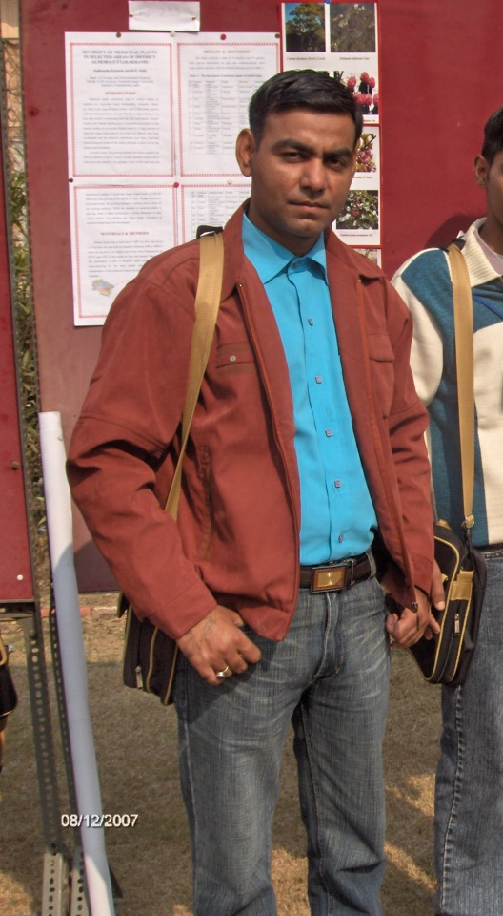
Photo- Dr. Pushpendra Kr. Sharma
M.Sc., NET, M.Phil., Ph.D.
Assistant Professor
D.A.V. P.G. College, Dehradun
Affiliated to
(H.N.B. Garhwal University, Srinagar Garhwal)

