Soil Properties as Affected by Different Land Management Practices in the Sohag Region, South Egypt

M.S. Ibrahim*, M. H. M. Ali** & M.M. Kotb***

* Soils & Water Department, Faculty of Agriculture, Sohag University, Egypt
** Geology Department, Faculty of Sciences, Sohag University, Egypt
*** Soils & Water Use Department, National Research Centre, Cairo Egypt
E.mail: kotbmostafa2003@yahoo.com

Abstract: In Egypt, there is a growing need for information relating to soil condition, its current status, and the nature and direction of change in response to management pressures. This information are required by land managers, and regional, state and national agencies to inform modified management and land-use practices and investment to maintain and improve the soil resource. The aim of the present investigation was to monitor the changes of some important soil properties caused by different management practices and using Geochemical Maps and Box Whisker Graph to demonstrate the results. Four soil types were selected to carry out this study, which are namely; cultivated floodplain soils, newly reclaimed soil, wastewater disposal soils and uncultivated Wadi disposal desert soil. The obtained results show that the reclamation practices lead to increase the silt and clay contents in the reclaimed soils specially in the surface layers, but did not change appreciably by the wastewater disposal practice. The CaCO₃ content increases away from the Nile stream toward the desert areas on both the eastern and western sides. The CaCO₃ content in the sites subjected to wastewater disposal is negatively affected by such practice particularly in the surface layers. The pH values of wastewater disposal soils in El-Dair sites are greatly decreased by two to three units and consequently can affect the forms and availability of nutrients and biological activity. The high levels of OM were reported in the newly reclaimed sites situated very close to the lands applied for wastewater disposal. Levels of OM in the topsoil layers of the wastewater farmlands at El-Dair range between 0.5 and 23.1%, whereas those of the subsoil layers vary between 0.03 and 1.02%. The surface layer of the reclaimed lands have relatively higher EC values than the surface layers of the cultivated lands have. The cultivated floodplain soils are non-sodic soils where the ESP values are less than 15. The exchangeable Na+, in median values, of the reclaimed lands is more than those of the cultivated soils by about three times. Moreover, about 47% of the uncultivated Wadi disposal desert soil sites have ESP values of more than 15 and Ca⁺⁺ is the dominant exchangeable cation. The exchangeable cations maintain a descending complex as follows: Ca²⁺> Na⁺> Mg²⁺> K⁺. The application of wastewater in both sites at El-Kola and El-Dair doesn't induce an increase in the sodicity of soils. The CEC values of the flood plain soils vary between 35 and 80 meq/100g and more than ones of the NRL soils which are 11 - 58 meq/100g. In the NRL about 53% of the soil samples have CEC values less than 10 meq/100g, whereas in the lands undergo the application of wastewater disposal, The CEC values vary between 8 and 95 meq/100g. [New York Science Journal 2010;3(7):8-19]. (ISSN: 1554-0200).

Key words: land management, low quality water, soil properties, Sohag, Egypt.

1. Introduction
The physical and chemical properties of the soils play an essential role in controlling their fertility status. Therefore, the investigations related to study the relation between management and changes in the soil properties are extremely important. Abd El-Hady, et al. (2007) stated that in some new reclaimed areas East of the Nile Valley, the soil characteristics are highly affected by different management.
In Sohag area, the distribution of the soils were differentiated into four main sectors of soils. The cultivated floodplain soils (CF) cover the areas next to the Nile River on both the sides and extends eastward and westward toward the desert. The Nile floodplain forms a relatively wide strip along the western side of the Nile Valley extending from the Nile course to the western desert areas. Contrarily, it constitutes only a very narrow strip along the eastern side and, frequently disappears. The Nile floodplain oftenly ranges in thickness from 6 to 10 km in the western side of the Nile River, but it becomes thinner close to the surrounding desert areas reaching down to about 2 km in the eastern side of the Nile River. The floodplain soils were accumulated during the annual inundation of the Nile water causing deposition of the fine materials before the construction of the High Dam. These sediments are composed of Holocene fluviatile deposits consisting mainly of the silt and clay. The new reclaimed lands (NRL) are located in some areas of the desert fringes, which extend between the Nile floodplain and the Eocene limestone plateau on both the eastern and western sides. In order to improve the fertility of these lands and their suitability for reclamation purpose, a layer of 20 to 40 cm thick is usually transported from the more fertile floodplain sediments to be spreaded on the land surface. Thus, the reclaimed lands include two different layers; the topsoil layers and the subsoil layers. The two layers are compositionally and texturally different. Wadi deposits, are the uncultivated desert areas between the Nile floodplain and the Eocene limestone plateau and they occupied by sediments, mainly clastics, accumulated within the Nile canyon since its initiation during Miocene time. These soils range in age from Pliocene to Recent. However, the surface layers of these soils are mostly covered by thin layers of wadi deposits ranging in thickness from few centimeters up to about 30 m. These deposits are composed from the disintegrated products of the Eocene carbonate on both two sides. Also, a significant portion of these soils is reworked from the nearby Neogene and Quaternary clastics. Hence, the wadi deposits are of local source and accumulated during successive stages of the local flash floods. These soils are mainly sand in nature and contain abundant content of calcareous materials. Because of the various difficulties facing the reclamation practice in this zone, as a result of the prevailing arid climatic conditions and the high cost of water supply, the reclamation process is getting slow. However, other developing activities including the urbanization and industrial projects are being currently established through this desert zone.
The fourth group of soils is the wastewater disposal soils (WWD) at El-Dair site lie in the desert zone bordered by the Eocene limestone plateau from the west and the cultivated floodplain from the east. The land surface shows a general eastward slope toward the cultivated floodplain. The area is occupied by a thick succession of sandy and gravelly Pleistocene sediments covered with a thin layer of recent wadi deposits (sandy gravel) ranging in thickness from 1.0 m, to more than 10.0 m (Omer, 1996). The subsurface soils are highly porous and permeable, (El-Haddad and El-Shater, 1988). The source of effluent disposed into this site is the western division of the Sohag City. The other sit is the WWD at El-Kola, which lies about 13 km east of the Sohag City in the desert area enclosed between the Eocene limestone plateau from the east and the Nile River from the west. Raw wastewater is currently disposed of into El-Kola from the part of the Sohag City locating on the eastern side of the Nile. The land surface is steeply sloping westward toward the Nile River.
For the past several years, the growers have been worried by the continuing fall in crop productions (Personal communication). The decline in production is attributed to the land degradation resulting from the effects of modern agricultural practices. However, the data on the status of the soil quality is lacking. This study was therefore initiated in an area representative of the Sohag Governorate soils. Our objective was to determine changes in soil properties resulting from different land management practices in the Sohag region of South Egypt

2. Material and Methods
Soils
The study area is represented by the Nile basin stretch extending between Latitudes 26° 24′ 16′′ and 26° 36′ 16′′ N and Longitudes 31° 30′ 00′′and 31° 55′ 00′′E and bordered from both the east and west by the higher relief Eocene limestone plateau. The Sohag City is situated in the middle of the area. Although various management types are reported in the study area, the four main management types considered in the current study will be discussed. Accordingly, a semi systematic sampling scenario, with an interval of about 5 km, was used to cover the whole area. A well-constrained Global Positioning System (GPS) was used for navigation to locate the sampling sites accurately. The geographic distribution of the sampling sites is displayed in figure (1):

Soil Analysis
The collected soil samples were air-dried and then gently crushed to pass through a 2mm sieve. Each sample was thoroughly homogenized and subjected to the subsequently mentioned physical and chemical estimations. The mechanical analysis of the soil samples was carried out using pipette method as described by USDA (1996). The soil pH was measured by means of a digital pH meter (Cole Parmer) in water suspension (1 : 2.5), Calcium carbonate (CaCO₃) was estimated by Collins Calcimeter according to Jackson (1973) and USDA (1996). Organic matter (OM) was determined according to the modified Walkely and Black method (USDA, 1996). The cation exchange capacity CEC and exchangeable cations were determined by ammonium acetate-sodium acetate procedure (Hesse, 1998).

Statistical Analysis
The obtained data have been statistically analyzed for the various statistical parameters and graphic presentations using the STATISTICA 5 for windows (1995) computer program distributed by Stat Soft Inc. In addition, the different geochemical maps have been constructed by means of the SURFER 8 Program (2002) distributed by Golden Software Inc. However, analysis of variance (ANOVA) was performed to quantify the similarity and dissimilarity of variables among the sample groups. The significant values were considered to meet confidence level of 95%; this corresponds to the probability of 0.05 (i.e. the p-value should be <0.05 at the significant difference).

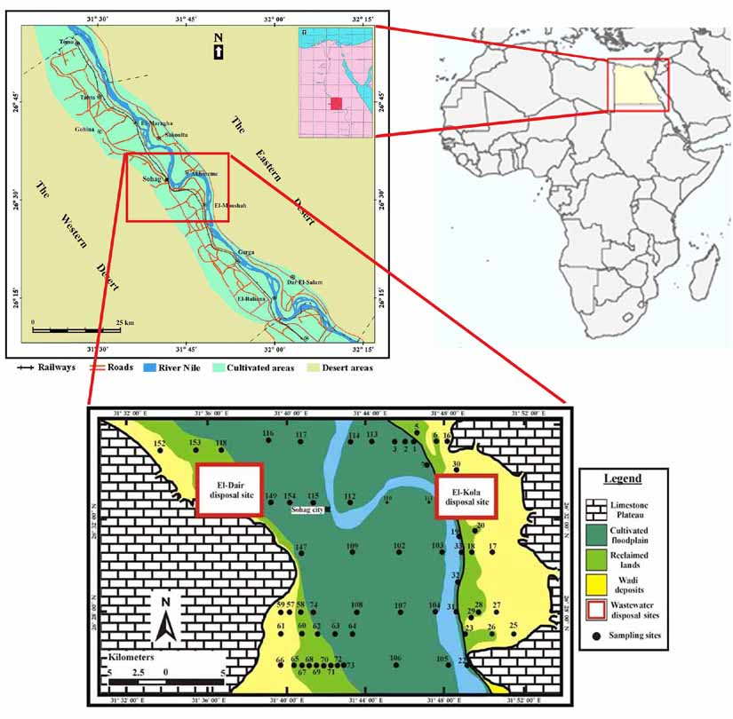

Fig. (1): Location of the study area and soil profiles

3. Results and Discussions

Textural Characteristics:
The data presented in figure (2) show that, the major part of the CF are silty in nature where the silt fraction is prevailed over the other fractions followed by clay then sand. The silt fraction ranges between 26 and 77% in the topsoil layers, the clay fraction varies from 7 to 44% and the sand content fluctuates between 3 and 63%. On the other hand, the subsoil layers shows more variable content of the silt fraction ranging from 14 to 84% and the clay fraction content is relatively higher in the subsoil layers compared

with the topsoil one being fluctuate between 7 and 54% referring to the migration of such fine particles with the percolating irrigation water following the agricultural practice (Figures 2-4). Although the sand fraction content in the subsoil layers covers nearly the same range (3-67%) as the topsoil layers, its average content is relatively low. No significant difference was found in the textural class of the ACF through the eastern and western sides of the Nile River. Meanwhile, the sand fraction of the topsoil layers increases adjacent to the Nile stream and also toward the desert fringes on both sides of the Nile River. The higher content of sand fraction near the Nile course is controlled by the natural sedimentation process. During the Nile flooding, the coarse particles are deposited close to the Nile course whereas the finer ones are accumulated far away. On the other hand, the high content of sand fraction near the desert fringes may originate from the neighboring desert zone through the wind action. The NRL include two contrasted layers texturally dissimilar, the subsoil layers is markedly coarser than the top soil, that is a transported layer. No significant difference was observed in the textural characteristics of the topsoil layers through the eastern and western sides of the Nile Valley. A pronounced variability was noticed in the texture of the subsoil layers between the eastern and western sides, where high content of silt and clay fractions is reported in the former. Such higher level of the fine fraction in the subsurface layers along the eastern side of the valley may be attributed to the effect of the nearby finely textured Pliocene clay. Regarding the textural characteristics of the WD, they are described as coarse textured where the sand fraction is predominant being ranged from 35 to 95%. The silt content varies from 3 to 55% whereas the clay ranges between 1 and 10%. The amount of silt fraction in the WD along the eastern desert considerably higher than that of the western desert, which referred to the influence of the adjacent Pliocene fine grained sediments. With respect to the particle size distribution in the WWD at El-Kola, the sand fraction is prevailed over the other fractions in most samples being fluctuated between 15 and 94%. The silt fraction is the second in abundance and it ranges between 5 and 81%.
lay fraction, the least fraction, ranges between 1 and 14%. The obtained results are strongly similar to those of the adjacent WD where both are coarsely textured grade and include considerable content of the silt fraction. This indicates that the wastewater disposal practice had no important effect on the soil texture grade. Only few samples display high content of fine fraction reflecting accumulation of fine particles carried by the disposal wastewater; these samples represent waterlogged sites.
The topsoil layers of the WWD at El-Dair possesses textural properties very akin to that of the wastewater ponds. The sand and silt fraction ranges between 5 and 98% and from 1 to 90% respectively, whereas the clay content ranges from 1 to 20%. The textural characteristics of sediments in the wastewater disposal sites at El-Dair and El-Kola did not change appreciably by the wastewater disposal practice; the matter which may need longer time. El-Shabassy et al. (1971), reported that no marked change in soil texture was reported as a result of sewage effluent practice for 50 years in the El-Gabal El-Asfar farm, northeast of Cairo. Also, comparable results were reported by Bayoumi et al. (1993) to indicate that the variation in soil mechanical fractions from wastewater application is considered to be extremely limited. These results come in agreement with that of El-Wakeel and Abd El-Naim (1986).

Soil pH
The pH values indicate that the CF and the NRL are slightly alkaline to alkaline in nature with an average pH value fluctuated around 8 (Fig 5). Generally, the pH values do not vary greatly throughout the studied land management types, with some exceptions. The pH values of the WD are slightly higher reflecting the effect of the CaCO₃ fraction. Similar results were obtained by Abd El-Aziz (1998), Amira and Ibrahim (2000), Faragallah (2001), Ibrahim et al. (2001); Abd El-Aziz and Ghallab (2002).
Although most soil samples of the WWD at El-Kola are slightly alkaline to alkaline, some samples tend to be slightly acidic (pH<7). The mean value of pH for the whole site is still close to its value in the native (WD) reflecting the short period (about one year at beginning of sampling protocol) of wastewater disposal; the high CaCO₃ content at this site is another factor. On the other hand, most samples of the WWD at El-Dair show markedly lower pH values reaching down to 5.5 to be acidic in nature. Such depleted levels of pH are principally controlled by the application of organic matter-rich wastewater through the long-term practice (about 15 year). The decomposition of organic matter is the main factor responsible for increasing acidity. In addition, nitrification of ammonia associated with wastewater is another parameter (Schirado et al., 1986). These result comes in harmony with several others reported that the pH values decrease with the application of sewage effluent (Aboulroos et al., 1989; Chen and Barber, 1990; El-Shafei and El-Koumey, 1994; Abou Hussien and El-Koumey, 1997; Amira, 1997). The slight higher pH value in some samples from the subsoil layers of El-Dair farmlands follows the high CaCO₃ content.

Calcium Carbonate Content (CaCO₃)
The CaCO₃ content of the CF, ranging from 0.31 to 10.3 %, 1.1 to 7.4% for the topsoil and subsoil layers, respectively. The difference through the topsoil and subsoil layers was insignificant (p=0.628), (El-Toukhy, 1987). An important trend was observed in the topsoil layers, where the CaCO₃ content increases away from the Nile stream toward the desert areas on both the eastern and western sides, reflecting the effect of the adjacent calcareous desert zone through the wind action. Although it is statistically insignificant (p=0.504), a slight higher CaCO₃ content is recorded along the eastern bank of the valley relative to the western one. This may be attributed to the flash floods, which are more common along the eastern higher relief limestone plateau; so the calcareous disintegration products are more dispersed east of the Nile Valley (Fig. 6). Regarding the NRL, the total CaCO₃ content of the topsoil covers a wide range varying from 3.3 to 39.3%. The subsoil layers shows a significantly high content (p= 0.011) ranging between 5.9 and 59.8%. On the other hand, the topsoil layers of the NRL possesses significantly higher CaCO₃ content (p= <0.001) relative to that of the cultivated floodplains. This can be ascribed to the continuous mixing and reworking with the underneath calcareous subsoil layers as a result of the farming practice.
Worthwhile to mention that, the NRL along the eastern side of the Nile Valley are significantly enriched with the CaCO₃ content compared with those of the western side (p=0.003 and 0.016 for the topsoil and subsoil layers, respectively). Generally, the variable CaCO₃ content of the NRL is controlled principally by the relative abundance of the detrital sediments and the disintegration products from the carbonate terrains. The CaCO₃ in WD ranges from 6.3-58.4%. and the soils of eastern side of the Nile Valley are significantly enriched with carbonate compared with the western one (p=0.011). The high CaCO₃ content east of the Nile Valley may be attributed to the intense disintegration of the high relief Eocene limestone plateau during the flooding periods. In addition, erosion of the nearby lacustrine Plio-Pleistocene calcareous rocks may play a significant role. The CaCO₃ content of the studied soil samples of wastewater farmlands at El-Dair ranges between 0.6 and 9.9% , 0.2 and 15.2% for the topsoil and subsoil layers, respectively. It is obvious that the topsoil and subsoil layers of the farmlands are very similar in their total CaCO₃ contents, which is statistically confirmed by the resulted insignificant variability (p=0.976). It is clear that the CaCO₃ content in the sites applied for wastewater disposal is negatively affected by such practice particularly in the surface layers. This result comes in contradiction with some studies reported slight increase in the CaCO₃ content as the soil treated by wastewater, (Bayoumi et al., 1993; Abd El-Aziz, 1998; El-Desoky et al. 2000; Abd El-Maksoud et al. 2000; Ibrahim et al. 2001; Negim, 2003).

Organic Matter Content (OM)
The mean OM content in the samples from CF soils was 1.68% ±0.46 and 0.83 ±0.20 for surface and subsurface layers, respectively. The relative higher content of OM in the topsoil layers compared with the deeper ones is attributed to the continuous vegetation practice. No significant differences are reported in the OM content throughout the cultivated floodplain along the eastern and western sides of the Nile Valley. The NRL contain OM range from 0.09 to 8.6%, 0.03 to 1.24% in the topsoil and subsoil layers, respectively. Generally, the OM of the topsoil layers is lower than that of the cultivated floodplain and showed a significant enrichment (p<0.001) in the topsoil compared with the subsoil layers (Fig. 7).
The abnormal high levels of OM were reported in NRL sites situated very close to the lands applied for wastewater disposal. The OM content in the subsoil layers, on the average, is closely akin to that of the adjacent WD. The OM content is extremely depleted throughout the WD where, it ranges between 0.02 and 2.46%. An exceptional case was observed (site No. 29), where it shows a comparatively high content of OM. This site is located within the Issawia grave; so decay of the buried human bodies is the most probable source of the enhanced organic matter content. With respect to the WWD at El-Kola, the OM content varies widely covering the range between 0.01 and 13.7%. About 62% of samples have organic matter less than 0.5%. The much high levels of OM (3.99-13.70%) are recorded in the most contaminated sites. Such wide range of OM content reflects different grades of contamination with raw wastewater effluent. Sites with high levels of OM are those characterized by high accumulation of biosolids at the wastewater dumps. However, sites having low OM content are those negligibly affected by wastewater; so, their OM content reflects its pristine level to be comparable with the surrounding wadi deposits, (Alaily, 1979; Aboulroos et al., 1989; El-Gendi et al., 1997; Pouyat et al. 2007). Levels of OM in the topsoil layers of the WWD farmlands at El-Dair range between 0.5 and 23.1%, whereas those of the subsoil layers vary between 0.03 and 1.02%. In general, the OM content in the WWD site at El-Dair is markedly higher, on the average, than that reported at El-Kola reflecting the longer term of wastewater disposal. Decau et al. (1963), pointed out that the OM content of the irrigated soils in the arid regions is generally depleted due to their rapid decomposition. Ibrahim and Omer (2004) reported that organic matter content in the Nile floodplain within Sohag area is fluctuated in the range 1-3%. Ibrahim et al. (2001), studied some soils in Sohag and found that organic matter content ranges between 0.1 and 2.6%;. Labib et al. (1992), stated that the continuous use of sewage water contributed to tremendous addition of OM to the soil. In their studies on El-Gabal El-Asfar farm near Cairo City, El-Shabassy et al. (1971), found that after 55 years from using sewage effluent, the soil organic matter content increased to a stable value of 6.2% in the topsoil and 2% in the subsoil layers. Bayoumi et al. (1993), postulated that soils irrigated with wastewater exhibit a remarkable increase in the organic matter content. These results are in agreement with those of Shende et al. (1985), El-Wakeel and Abd El-Naim (1986) and Amira (1997). Many other studies indicated that, the application of sewage wastes to soil generally increases organic matter content (Alaily, 1979; El-Gendi et al., 1997).

Soil Salinity and sodicity
The CF soil, have EC values do not exceed 3.21 dSm⁻¹ except site no. 149 which exhibits a very high EC value (124.96 dSm⁻¹). This increase in EC value could be attributed to the predominant irrigation by saline ground water, (Table 1). This means that, the groundwater plays an important role in the salinization of this site and the surrounding areas. However, in most sites the EC values seemed to be constant and low in each layers. In addition, there was a general tendency towards decrease in EC values with depth, which could be due to accumulation of soluble salts at the surface layers (Iskandar, 1967). As far as the individual cations are concerned, the data show that the dominant cation in most sites is Na⁺ followed by Ca²⁺, K⁺ then Mg²⁺ in the surface layer. Moreover, HCO₃ are the dominate soluble anion in most of the studied soil samples, followed by SO₄ then Cl⁻, while the soluble CO₃ in all soil samples are nil. Exception was found at site no. 149 which exhibits a strong saline soil where the dominant soluble anion is the SO₄ followed by Cl⁻ ions then HCO₃. As a general, we can noticed that, the surface layer samples of NRL have a relatively high EC value with regard to surface layer samples of the cultivated lands. The salinity of upper layers varies from 0.74 to 116.62 dSm⁻¹ (Table 1). The relatively higher EC values of the surface layers of this land management type than that of the cultivated land, may be due to the irrigation by groundwater mostly with salinity values higher than 1.0 dSm⁻¹. The highest EC values were recorded in the sites nos. 11 and 54, which considered as salt-affected soils. In case of site no. 11 which represent the newly reclaimed soil near the river terraces (mainly of Pliocene Clay) at the east. The farmers used the exposed bentonite as soil conditioners to improve the properties of their fields for agricultural purposes. This cover subjected to leaching by the available water where the salty leached either migrate downward to deeper depths or migrate to surrounding low lands causing accumulation of the salts at the surface of these soils. As arid climate keeps salts from being leached away, the salts return again to the surface by capillary rising to form what is called salt crust. In case of site no. 54, it also represents the newly reclaimed soil that affected by wastewater overflow from the adjacent uncontrolled ponds. This wastewater acts as a source of salts either by itself or by washing the surface layer during the migration to the low laying land. Salts may come also from underground flow where water evaporates, leaving the salts behind.
The values of ESP indicate that the CF soils were non-sodic soils except the site No. 149 where the values is more than 15. On the other hand, only 13% of the NRL sites could be considered as sodic soils (Table 1). Also, the amount of exchangeable Na+, in median values, of the reclaimed lands is more than those of the cultivated soils by about three times. Moreover, 47% of the WD soils sites have ESP more than 15 and Ca⁺⁺ is the dominant exchangeable cation. Generally, the exchangeable cations maintain a descending complex as follows: Ca²⁺> Na⁺> Mg²⁺> K⁺. The application of wastewater in both the sites at El-Kola and El-Dair don’t increase the soil sodicity. This could be attributed to the neutrality of the soils which considered sandy and the exchangeable sites is very low.

Cation Exchange Capacity (CEC)
The CEC values in the CF vary between 35 and 80 meq/100g and display no pronounced spatial trend throughout the study area (Fig. 8). The CEC values of the NRL are relatively less than those of the CF (Fig. 8); which may be due to their high content of CaCO₃ and low content of clay fraction and organic matter. The measured values of CEC in the reclaimed lands vary between 11 and 58 meq/100g. The CEC values in the WD vary between 6 and 31 meq/100g. About 53% of the soil samples have CEC values less than 10 meq/100g. The CEC values of the lands applied for wastewater disposal at El-Kola vary between 8 and 95. Most of samples (about 75%) have CEC values less than 35 meq/100g, whereas the highest values exceeding 60 meq/100g were occasionally recorded. The values of the CEC of El-Kola site are higher than that of the adjacent wadi deposits. The CEC values in the wastewater ponds at El-Dair vary between 5 and 61 meq/100g,whereas the CEC values of the studied samples from the WWD at El-Dair vary between 5 and 38 meq/100g, where most samples (~87%) have CEC values less than 22 meq/100g. In general, the CEC values are extremely fluctuated in the lands applied for wastewater disposal. This reflects the variability of CaCO₃ contents, clay minerals and organic matter in these sediments (Wilson et al. 2008).

Fig. (2): A box-whisker graph of the sand and silt fraction contents (%) throughout the studied soils.

Fig. (3): A box-whisker graph of the clay fraction content (%) and distribution of the clay content in the surface layers throughout the study area. See figure (2) for explanation.

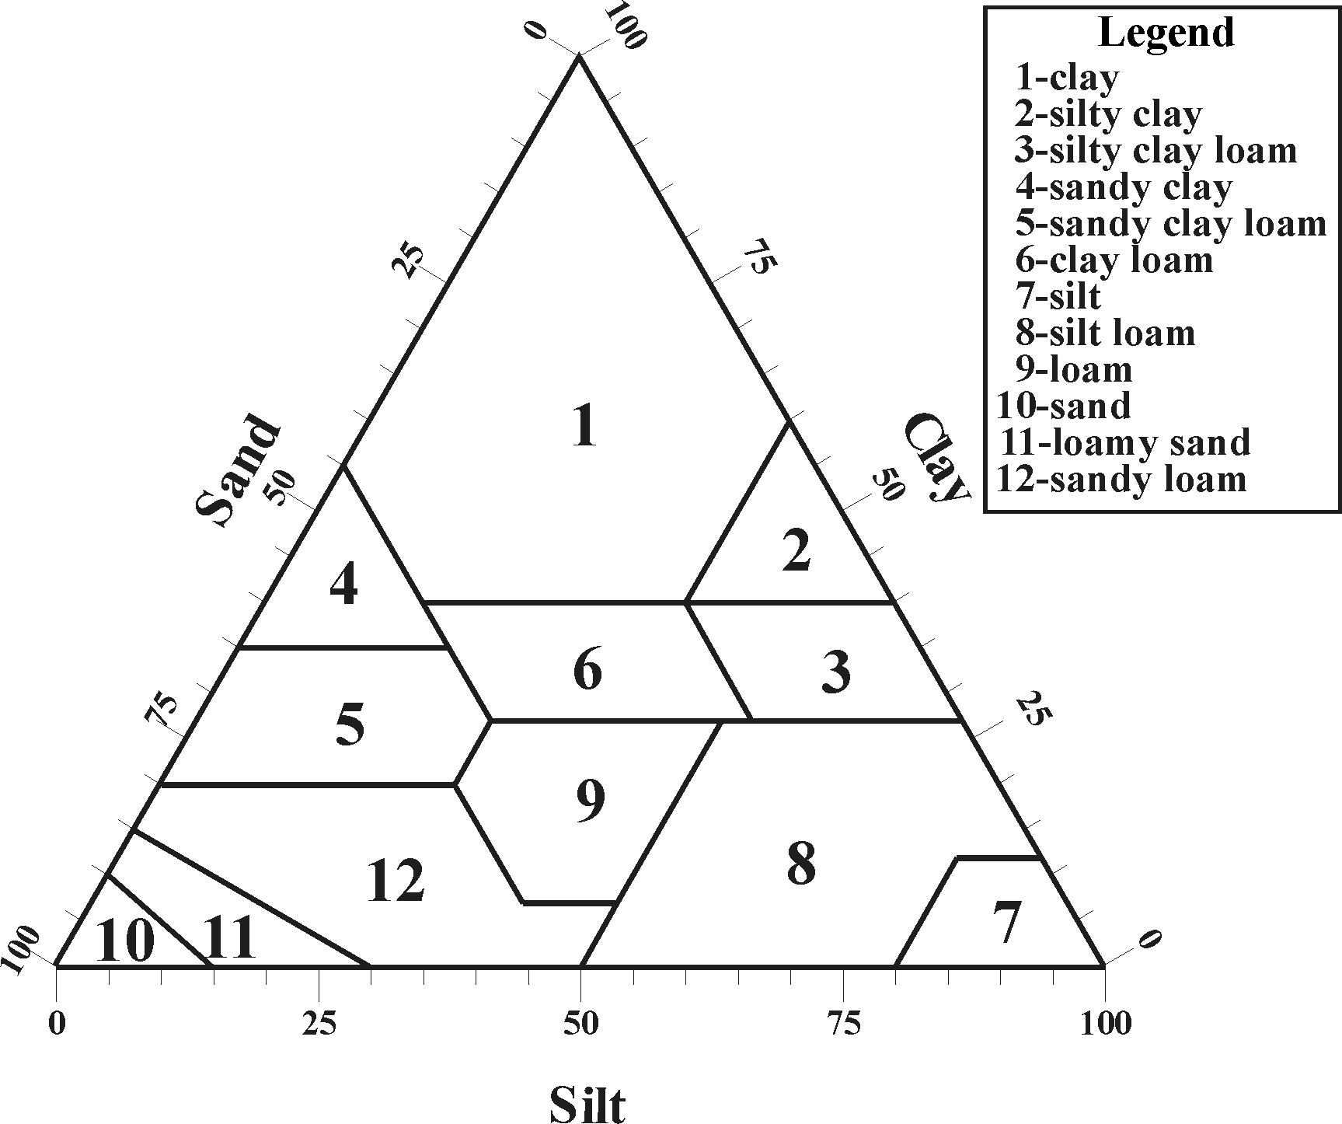
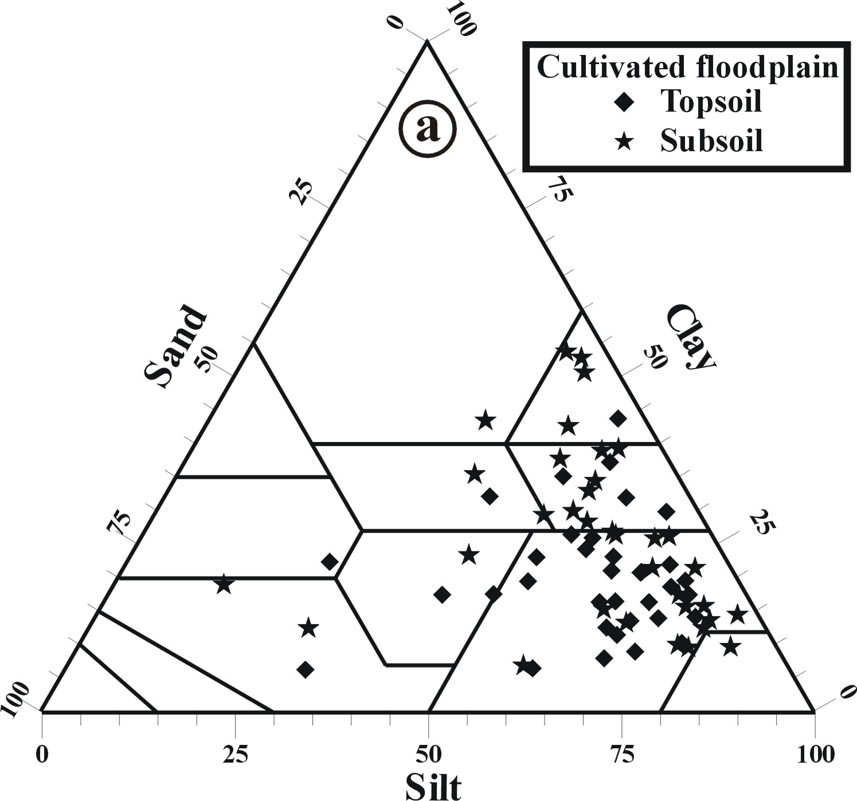 | 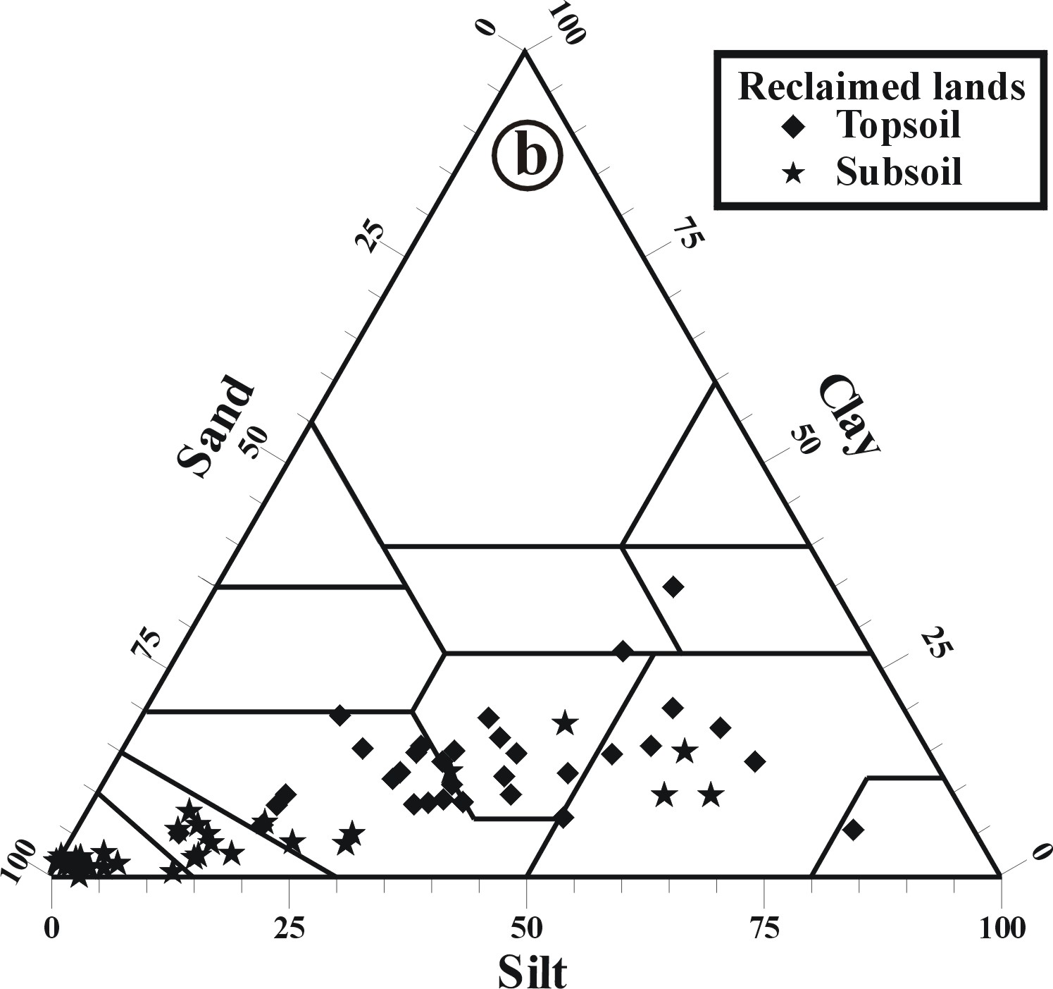
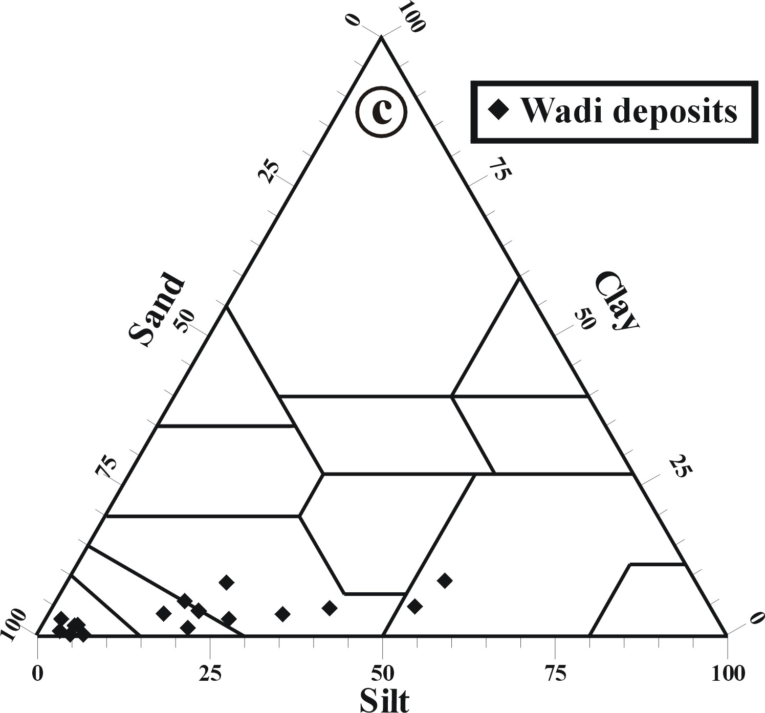 | 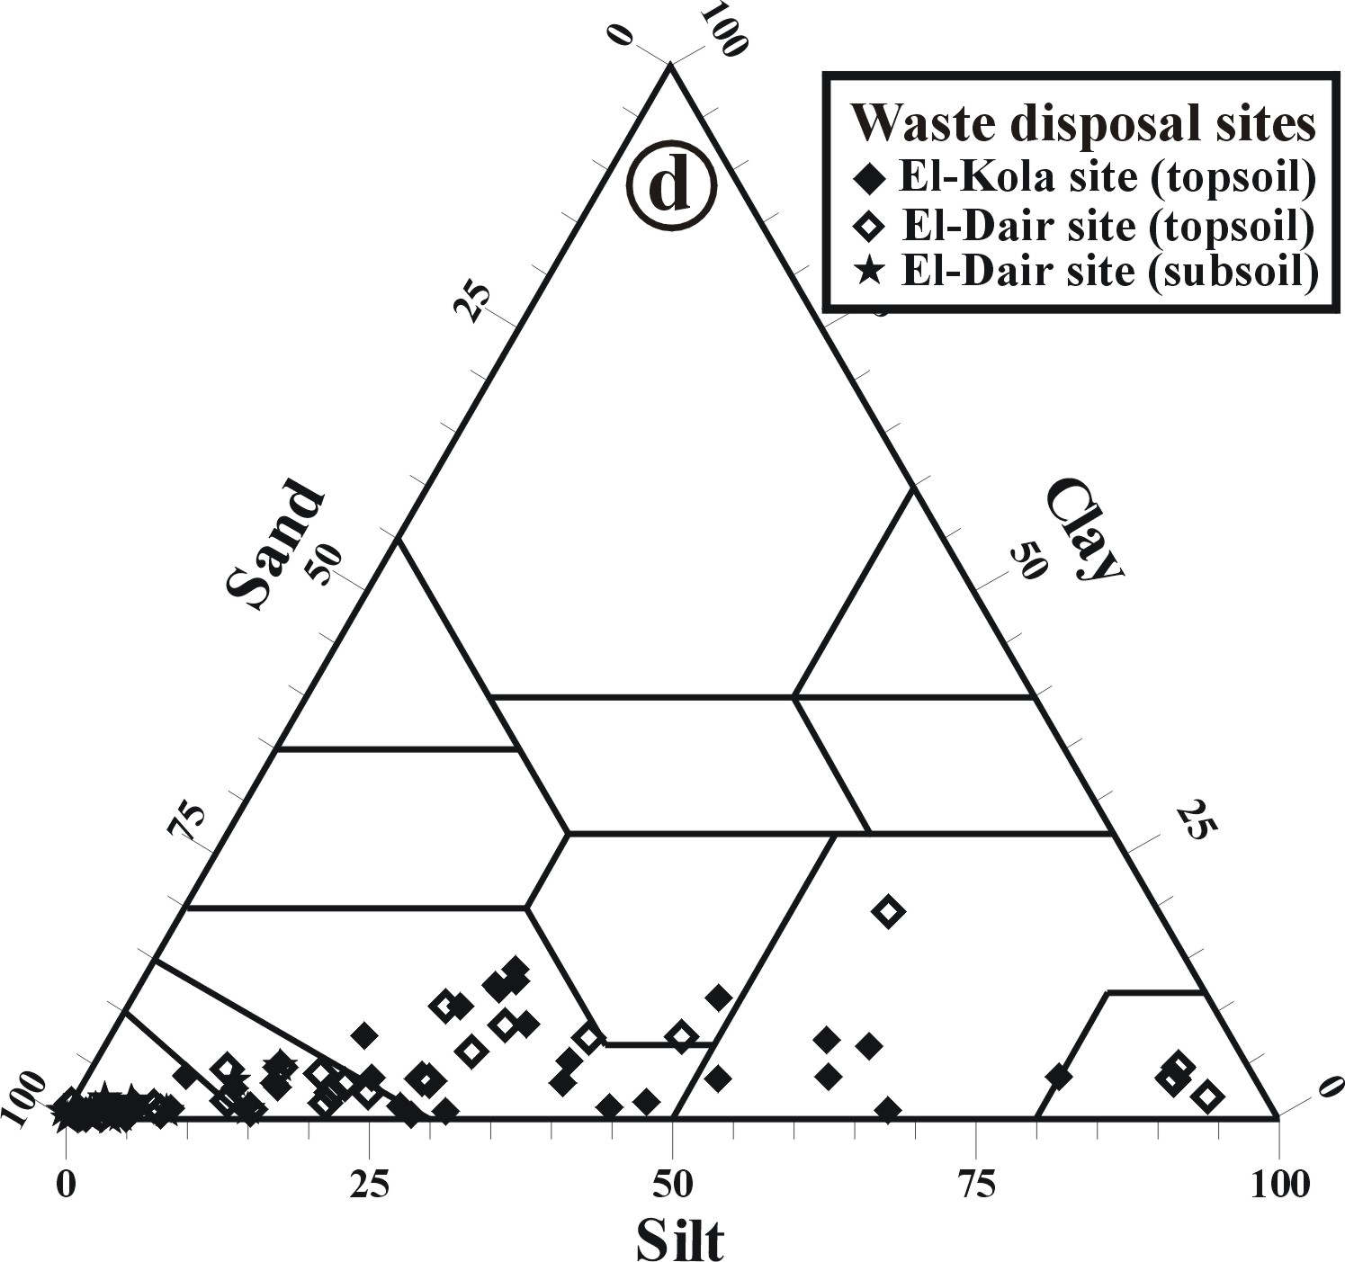
Fig. (4): Textural characteristics of the studied soils (gravel-free) throughout the different sites (USDA, 1993).

Fig. (5): A box-whisker graph of the pH values and the distribution of the pH values in the surface layers throughout the study area.

Fig. (6) A box-whisker graph of the CaCO₃ content and distribution of its total in the surface layers throughout the study area.

Fig. (7): A box-whisker graph of the organic matter content (%) and its distribution in the surface soil throughout the study area.
Fig. (8): The Cation exchange capacity (meq/100g) and its distribution in the surface layers throughout the study area

Table (1) The EC values, soluble ions and ESP of the soils under different management practices (surface layers).
 | Max | Min | Aver. | Max | Min | Aver. | Max | Min | Aver. | Max | Min | Aver. | Max | Min | Aver.
 | ACF |  |  | NRL |  |  | WD |  |  | WWD at El-Kola |  |  | WWD at El-Dair
EC | 125.00 | 0.85 | 4.96 | 116.60 | 0.74 | 9.94 | 245.40 | 1.14 | 36.23 | 121.20 | 1.70 | 17.09 | 15.62 | 0.90 | 4.74
Ca²⁺ | 15.15 | 0.14 | 0.79 | 83.38 | 0.06 | 4.82 | 118.06 | 0.25 | 18.56 | 15.80 | 0.29 | 5.01 | 12.01 | 0.40 | 2.41
Mg²⁺ | 13.54 | 0.13 | 0.65 | 18.73 | 0.03 | 1.55 | 31.90 | 0.06 | 3.74 | 6.16 | 0.16 | 1.79 | 3.11 | 0.09 | 0.74
K⁺ | 0.66 | 0.03 | 0.11 | 1.75 | 0.03 | 0.19 | 5.91 | 0.09 | 0.67 | 0.64 | 0.02 | 0.23 | 0.79 | 0.05 | 0.29
Na⁺ | 109.13 | 0.14 | 3.65 | 44.35 | 0.18 | 4.39 | 150.00 | 0.63 | 18.34 | 120.46 | 0.78 | 11.06 | 1.95 | 0.16 | 0.78
HCO3⁻ | 1.03 | 0.38 | 0.63 | 3.66 | 0.24 | 0.69 | 2.28 | 0.17 | 0.49 | 1.63 | 0.15 | 0.44 | 5.48 | 0.24 | 1.67
Cl⁻ | 64.61 | 0.05 | 2.06 | 120.17 | 0.08 | 7.15 | 253.08 | 0.38 | 30.56 | 116.90 | 0.09 | 10.46 | 2.01 | 0.06 | 0.28
SO4⁻² | 55.79 | 0.06 | 1.95 | 15.05 | 0.09 | 2.12 | 14.6 | 0.14 | 5.97 | 20.93 | 0.22 | 6.47 | 14.26 | 0.09 | 2.19
ESP | 15.02 | 0.60 | 2.15 | 34.18 | 0.73 | 7.29 | 53.61 | 0.79 | 16.32 | 42.71 | 0.22 | 9.46 | 29.97 | 0.55 | 5.31

4. Conclusion
The variation in the land managements could be change the various characteristics of the soils. The dominant texture is silty in most of the floodplain and surface layers of reclaimed soils whereas the sandy texture is the dominant in wadi deposit. The application of wastewater to wadi deposit don’t change the texture of the soils and this may be attributed to the short time of disposal (maximum 15 yr.). The wastewater disposal in El-Dair site greatly decreased the soil pH by two to three units and consequently can affect on the forms and availability of nutrients and biological activity. The organic matter content in wastewater ponds at El-Dair ranges between 0.10 and 53.7% exhibiting the highest content throughout the study area. The abnormal accumulation of organic matter follows the long-term application of the raw wastewater in this site (~15 years). The reclamation practice leads to increase silt and clay contents in the reclaimed soils specially in the surface layers. The reclaimed lands along the eastern side of the Nile Valley are significantly enriched with the CaCO₃ content compared with those of the western side.

Corresponding Author:
M.M. Kotb
Soils & Water Use Department, National Research Centre, Cairo Egypt
E.mail: kotbmostafa2003@yahoo.com

6. References
- Abd El-Aziz, S.H. 1998. Pedological studies on some soils of wadi El-Assiuti, Assiut, Egypt. Ph.D. Thesis, Fac. Agric., Assiut Univ., Egypt.
- Abd El-Aziz, S.H. and A. Ghallab 2002. Land classification, evaluation and use of some soils in Atmur El-Nuqra valley, Kom Ombo, Aswan, Egypt. Assiut J. Agric. Sci. 33:.221-239.
- Abd El-Hady, A.A., M.M. Kotb and H.H. Khater (2007). Soil characteristics Under Different Management of a New Reclaimed Area, East of the Nile Valley, Giza Governorate Egypt. Egypt. J. Soil Sci. Vol. 47, No. 2, pp. 155 -180.
- Abd El-Maksoud, M.M.R., A.O. Abdel-Nabi, H.K. Zaki, and M.Z. Salem 2000.Using of field morphological rating system to estimate the development of wadi Qena soils. Mansoura J. Agric. Sci., 25:1845-1864.
- Abou Hussien, E.A. and B.Y. El-Koumey, 1997. Influence of wastewater on some soils and plant in Menofiya Governorate. Menofiya J. Agric. Res. 22,:.1733-1748.
- Aboulroos, S.A., Sh.Sh. Holah, and S.H. Badawy, 1989. Influence of prolonged use of sewage effluent in irrigation on heavy metal accumulation in soils and plants. Z. Pflanzenearnahr. Bodenken. 152:.51-55.
- Alaily, F. 1979. Changes in phosphorus content in soil during irrigation with sewage effluent. Mitteilungen der Deutschen Bodenkundlichen Geselleschaft., .29: 917-920.
- Amira, M.S. 1997. Effect of long term irrigation with polluted water on morphological, micromoropholigical and chemical properties of some soils of the Nile Delta, Menofiya. J. Agric. Res.22:.1749-1765.
- Amira, M.S. and Ibrahim, M.A.M. (2000): Pedology, clay mineralogy and classifications of some soils representing the western desert fringes of the Nile valley in middle Egypt. Menofiya J. Agric. Res., V.25, No.1, pp.217-235.
- Bayoumi, N.A., A.E. El-Wakeel, R.G. Kerlous, and M.G. Rehan, 1993. Waters of low quality and cultivation in a sandy soil: I. Effects on soil properties and drainage water Composition. Menofiya. J. Agric. Res.18:.1731-1755.
- Chen, J. and S.A. Barber, 1990. Soil pH and phosphorous and potassium uptake by maize evaluated with an uptake model. Soil Sci. Soc. Am. J. 54:1032-1036.
- Decau, J.; Fioramanti, S. and Malterre, H. (1963): The organic matter content of soils of the Haute Garonne. Soils and Fert., V.26, pp.52.
- El-Desoky, M.A., E.M. Khalifa and Abd S.H. El-Aziz, 2000. Clay mineralogy of some soils of wadi El-Assiuti, Assiut, Egypt. Assiut J. Agric. Sci., 29:111-130.
- El-Gendi, S.A., S.H. Badawy and M.I.D. Helal, 1997. Mobility of some heavy metals nutrients in sandy soils irrigated with sewage sludge effluent. J. Agric. Sci. Mansoura Univ., .22,: .3535-3553.
- El-Haddad, A. and A. El-Shater, 1988. Sediments characteristics as a controlling factor of pollution of the groundwater from disposed of wastes, Sohag, Egypt. Sohag Pure & Appl. Sci. Bull. Fac. Sci., 4:.145-162
- El-Shabassy, A.I.; Mitkees; Zikrie, Bis.; Abd El-Malik, S.H.; Hassan, H.M.; Nayroos, F. I. and Abd El-Naim, E. M. 1971 .effects of sewage water on the properties of sandy soils. Agric. Res. Rev. Cairo, March, V.49, pp.97-116.
- El-Shafei, F.S. and El-Koumy, B.Y. (1994): Influence of use of sewage effluent in irrigation on soil and plants. Menofiya J. Agric. Res., V.19, No.5, pp.2521-2534.
- El-Toukhy, M.M. 1987. Studies on the status of some nutrient elements in the soils adjacent to Idko Lake, Beheira Governorate. M.Sc. Thesis, Fac. Agric. Cairo Univ.
- El-Wakeel, A.F. and E.M. Abd El-Naim, 1986. The characteristics of Abu Rawash sewage effluents and their effects on some chemical and physical properties of sandy soil and minerals contents of citrus varieties. Menofiya J. Agric. Res., 11:.1131-1151.
- Faragallah, M.E.A. 2001. Relative distribution of certain nutrients in soils of the Nile Valley-Desert interference zone, east of Assiut City. M.Sc. Thesis, Fac. Agric., Assiut Univ., Egypt.
- Hesse, P.R. 1998. A textbook of soil chemical analysis. CBS Publ., India.
- Ibrahim, M. and A. Omer, 2004. Heavy metals contamination in soils of the major roadway sides and its environmental impact, Sohag, Egypt. The Sec. Int. Conf. For Develop. and the Env. In the Arab World, p.101-120.
- Ibrahim, M.S.. A. Abd Al-galil and M.M. Kotb 2001. Total and available Fe, Mn, Zn and Cu in some soils of Sohag Governorate and their association with some soil properties. Assiut J. Agric. Sci..32:.71-86.
- Jackson, M.L. 1973. Soil chemical analysis. Prentice-Hall, Inc., Englewood Cliffs, N. J.
- Labib, M.T., A.S. El-Hassanin, and A.T. Dobal 1992. Changes in some soil characteristics due to recent and long-term sewage water irrigation. Water Sci. 11th Issue. April. 1992.
- Negim, O.E.A. 2003. Some studies on soils of the college of Agriculture Farm, South Valley University. M.Sc. Thesis, Fac. Agric., Assiut Univ., Egypt.
- Omer, A.A.M. 1996. Geological, mineralogical and geochemical studies on the Neogene and Quaternary Nile basin deposits, Qena-Assiut stretch, Egypt.
- Pouyat, R. V.; I. D. Yesilonis; J. Russell-Anelli and N. K. Neerchal 2007. Soil chemical and physical properties that differentiate urban land-use and cover types, Soil Sci. Soc. Am. J. 71:1010-1019.
- Schirado, Vergara, I.; Schalscha, E.B. and Patt, P.F. (1986): Evidence of movement of heavy metals in a soil irrigated with untreated wastewater. Journal of Environemetal Quallity: 15 (1986), pp. 9-12.
- Shende, G.B., C. Chakrabarti, R.P. Rai, V.J. Nashikkar, D.G. Kshirsagar, P.B. De Shbhratar, and A.S. Juwarkar, 1985. In “Treatment and use of sewage effluent for irrigation”. (Pescod, M. B. and Arar, A. Eds., p.185-209. Butterworths, London).
- STATISTICA 5 FOR WINDOWS (1995): Advanced statistical package. Statsoft, Inc. Tusla, U.S.A. (www.statsoft.com)
- SURFER 8 FOR WINDOWS 2002. Surface mapping system package. Golden Software Inc., U.S.A. (www.goldensoftware.com)
- USDA, (Soil Survey Laboratory Methods Manual) 1996. Soil Survey Investigations. Report No.42, V.3, Washington, D. C.
- Wilson B. R., Ivor Growns and J. Lemon, 2008. Land-use effects on soil properties on the north-western slopes of New South Wales: Implications for soil condition assessment, Australian Journal of Soil Research 46(4) 359–367.

5/5/2010

