Finite Element Analysis of the Preheat Effect on Laser Induced Nano and Micro Phase Transition

Adel Mohamed EI-NADI¹, Mahmoud Fathy Mahmoud² , Hebatalrahman. A^{*3}

Faculty of Engineering, Cairo University¹, Egypt. Benha High Institute of Technology², Egypt.
Housing & Building National Research Centre (HBRC)³, Egypt
*Hebatalrahman@naseej.com
*Hebatalrahman11@yahoo.com

Abstract: In this research the differential equation for the heat transfer through metal as a result of laser metal interaction and the associated boundary and initial conditions are generally discussed. The laser intensity is considered as heat source for material processing. The phase transition process and Stefan boundary conditions are explained. A model for laser metal interaction is specified and the conditions for solution are discussed. Preheating of the solid metal is also considered while neglecting the reflected rays between two melted layers. The solution of the problem is done by finite element method under MATLAB environment. The purpose of this study is to analyze the preheating processes corresponding to laser-metal interactions and their parameters which are important in controlling metal processing. [New York Science Journal 2010;3(7):47-53]. (ISSN: 1554-0200).
Keywords: Finite Element Analysis; Laser; Nano; Micro Phase Transition

Introduction
The finite element method is a very powerful, modern computational tool for partial differential equations. The method has been used almost universally during the past 15 years to solve very complex structural engineering problems, particularly in the aircraft industry. It is now gaining wide acceptance in other disciplines such as thermal analysis, fluid mechanics, and electromagnetic. The method requires the use of a digital computer because of the large number of computation involved ^{(1):(8)}.
It should be obvious that it is not possible to obtain closed-form, analytical solutions to complex problems. Complexities may arise because of the irregular and varied geometry, mixed boundary conditions, nonlinear material behavior, and non uniform material composition. The finite element method is particularly well suited to handle these and other complications ⁽⁹⁾.

Advantages and disadvantages of the finite element method
One of the main advantages of FEM over most other approximate solution method, including the popular finite-difference method, is the fact that
FEM can handle irregular geometries routinely. The triangular element in two-dimensional applications is used with no special considerations. Of course, closed form analytical solutions are invariably nonexistent when irregular geometries are present ^{(10),(11)}.
Another significant advantages of FEM is that a variable spacing of the nodes is also routinely handled. When a body is discredited using finite
elements, the nodes are said to form a mesh. Typical two-dimensional meshes. When the nodes are not equally spaced, the mesh is said to be graded. The finite element method lends itself to the use of graded meshes, special subroutines can be written that will automatically or semi automatically generate unequally spaced nodes, thereby reducing the amount of input required by the user of such a
computer program^{(13):(15)}.
Another advantages of FEM, again over FDM and especially over analytical solution techniques (as opposed to numerical techniques) is the ease with which non homogeneous and anisotropic materials may be handled. Materials whose properties are not position dependent and said to be homogeneous, whereas materials with position dependent properties are heterogeneous. A special case of a heterogeneous material in a thermal analysis is one for which thermal conductivity is temperature -dependent. This method is valid in the case of isotropic and anisotropic materials. Very little extra effort is required in the FEM formulation when heterogeneous and/or anisotropic materials are to be modeled even when some parts of the body are made of one material and other parts are made of different materials ^{(16):(19)}.
All the various types of boundary conditions that we may encounter in a typical FEM applications except those that require prescribed values of the field variables themselves, are automatically including in the formulation. Recall that typical field variables are displacements in structural and stress analysis, temperature in thermal analysis, fluid velocities and pressures in fluid flow analysis, etc. In other words, prescribed displacements, temperatures, velocities, pressures, etc., are not automatically included in the FEM formulation and solution. They are systematically enforced just before the solution for the nodal values of the unknown field variables is obtained. Among the boundary conditions that are automatically included in thermal analysis (heat conduction) which are Convection, Radiation, Applied heat fluxes, and Insulation ^{(20), (21)}.
In all cases, these conditions need not be constant. When these boundary conditions or other properties are a function of the unknown field variables, the problem becomes nonlinear. The basic finite element method is applicable, however, for both linear and nonlinear problems. Another advantage is that higher-order elements may be implemented with relative ease. Higher order elements Higher order elements require the use of higher order interpolating polynomials and additional nodes are introduced along the sides of the two-dimension elements and between the two end nodes of the one-dimension element, curved sides may actually be used thereby allowing very close fits to essentially all irregular geometry^{(22),(23)}.
Among the disadvantages of FEM is the necessity for a digital computer and fairly extensive software. A couple of obvious questions have probably arisen. The first is whether or not the finite element method is more accurate than the finite-difference method. We cannot answer this question without a significant number of qualifications, but FEM seems to be more accurate when curved boundaries are present, the finite element method can usually include the curved boundary more precisely than the finite difference method can ⁽¹⁷⁾.
The second question that may be asked pertains to the relative execution times of typical and comparable Finite Element Method FDM and FEM models. Once again it is difficult to make comparison, but FEM seems to have longer execution times. However, it must be said that FDM models will generally require more hours of computer input preparation by people than will FEM, many of the tedious calculations in FEM are related to the computer. For example, in a thermal application, internal conductance need not be calculated in FEM models because they are inherently included in the computer software. On the other hand, FDM thermal models quite frequently require the user to calculate many of the internal conductances by hand. This will become an even more significant advantaged of FEM as engineering labor costs rise and computational costs decline ^{(20), (7)}.

Theoretical analysis (Galerkin Approach)
The finite element procedure using Galerkin method can be described by the following steps

Step l: Divide the domain V into E finite elements of p nodes each.

Step2: Assume a suitable form of variation of T in each finite element and express
Te(x,y,z,t)-[N(x,y,z)]Te (1)

Step3: in Galerkin method, the integral of the weighted residue over the domain of the element is set equal to zero by taking the weights same as the
interpolation functions N;. Since the solution of equation (1) is not exact, substitution of equation (1) into the differential equations (2)
∂/∂x (Kx∂T/∂x)+ ∂/∂y (Ky∂T/∂y) +∂/∂z(kz∂T/∂z)+qg= ⍴C ∂T/∂t (2)
and equation (3) gives a nonzero value which will be the residue. Hence the criterion to be satisfied at any instant of time is
-Kz ∂T/∂z Lz=I(1-R) (3) ∫∫∫ Ni [∂/∂x(Kx ∂Te /∂x)+ ∂/∂y(Ky ∂Te /∂y)+∂/∂z(Kz ∂Te/∂z)+q-⍴C ∂Te/∂t]
Ve
dV=0, (4)
i=1,2,3..........M
by noting that the first integral term of eq.(4) can be written as
∫∫∫ Ni[∂/∂x(Kx ∂Te/∂x) .dV=-∫∫∫ ∂Ni/∂x (Kx .∂Te/∂x).dV+∫∫ Ni Kx ∂Te/∂x.ℓx.dS
Ve Ve se (5)
Where ℓx is the x-direction cosine of the outward drawn normal, and with similar expressions for the second and third integral terms so eq. (4) can be stated as
-∫∫∫ [Kx . ∂Ni/∂x . ∂Te/∂x + Ky . ∂Ni/∂y . ∂Te/∂y +Kz ∂Ni/∂z . ∂Te /∂z].dV+
Ve
∫∫ Ni[Kx . ∂Te/∂x .ℓx + Ky . ∂Te/∂y. ℓy + Kz. ∂Te/∂z. ℓz]ds+∫∫∫ Ni(q-⍴C∂Te/∂t].dV=0
se Ve (6)
i=l,2,3..........M
Since the boundary of the element Se is composed of S1e, S2e and S3e the surface integral over S1e would be zero (since Te is prescribed to be a constant To on S1e,the derivatives of Te with respect to x,y and z would be zero ) on the surfaces S2e and S3e,the boundary conditions is
Kx ∂T/∂x Lx+ Ky∂T∂y Ly+ Kz ∂T∂z Lz+q=0 (7)
On S2 for t>0

The rate of heat flow is specified on the boundary S₂, where q is a specified heat fluxes which may be a time dependent. This heat flux is caused by an external source of heat, which absorbed radiation when the laser impinges on the surface of the body. L_{x},L_{y},L_{z} are the direction cosines of the outward drawn normal to the boundary
In case of surface convection, then
K_{x}∂T/∂x L_{x}+ K_{y}∂T∂y L_{y}+ K_{z} ∂T∂z L_{z}+h(T-T∞) =0 (8)
On S ₃ for t>0
Where h(T-T∞) is the rate of convective heat loss, h is the coefficient of surface heat transfer and T∞ is the ambient temperature are to be satisfied. For this, the surface integral over S_{2e} and S_{3e} are written in equivalent form as
∫∫N_{i} [K_{x} . ∂T_{e}/∂x .ℓ_{x} + K_{y} . ∂Te /∂y. ℓ_{y} + K_{z}. ∂T /∂ z. ℓ_{z}].dS
_{S2(e)+S3(e)}
=- ∫∫ N_{i}. q . dS₂ -∫∫ h(T_{e}-T∞).dS₃ (9)
_{S2e} _{S3e}
Eq.(9) can be expressed in matrix form as
[K_{ie}] T_{e} + [K_{3e}]T_{e} + [K_{3e}]T_{e}-P_{e}=0 (10)
where the elements of the matrices [K_{ie}] ,[K_{2e}] ,[K_{3e}] and P_{e} are same as those given by
K_{1eij} = ∫∫∫ (K_{x} ∂N_{i/}∂x. ∂N_{j/}∂x+K_{y}∂N_{i}/∂y. ∂N_{j}/∂y + K_{z}∂N_{i}/ ∂z. ∂N_{j/} ∂z).dV (11)
_{ve}

K_{2ije}= ∫∫ h N_{i} N_{j} dS₃ (12)
_{S3e}
K_{3ije}= ∫∫ ⍴ C N_{i} N_{j} dV (13)
_{ve}

P_{ie} = ∫∫∫ qN_{i}dV-∫∫ qN_{i} dS₂ + ∫∫ hT∞ N_{i} dS₃ (14)
ve s2e s3e
Step 4: The element equations (10) can be assembled in the usual manner to obtain the over all equations as
[K₃]T+[K]T=P (15)

Step 5: the final equation have to be solved after incorporation the boundary conditions specified over S₁ and the initial conditions. In matrix notation, we have to solve the linear, large and sparse ordinary differential equations (ODE) system Eq.(15), solving the ODE with the initial value T_{i}(0)=T_{o}(z_{i}), yields the solution to the PDE at each node z_{i} and time t. The K and P matrix are the stiffness matrix and the right hand side of Eq.(15), K₃ is called the mass matrix.
The numerical integration of the ODE system is performed by the MATLAB ODE suite functions ⁽²¹⁾. The time step is controlled to satisfy tolerance on the error, and factorizations of coefficient matrices are performed only when necessary, when coefficients are time dependent, the necessity of re-evaluating are re-factorizing the matrices each time step may still make the solution time consuming, although parabolic re-evaluates only that which varies with time.

The finite element procedure for laser metal interaction
(1) Divide solid region into 34 nodes and elements and liquid region into nodes and element (2) Express trial function T(x) (3) Use Galerkin approach for determination of the heat conduction equation, boundary and initial condition in the element (4) Assembling the elements together to solve the matrix equation for the heat conduction in solid and liquid regions

Error estimation
Now, we indicate the results obtained when we construct the spaces from finite element families of the type that we have described .In each case ,we successively indicate knowledge of the order of error estimate is very important when making the following choices:

1-Refinement of the mesh
Knowing that ||U-Uh|| ≤ Ch^{K} we immediately derive that a subdivision of every element. Of course this increase in precision is obtained at the expense of the size of the system, which we have to solve. Since each element is replaced by group of elements, this increase the total number of degree of freedom ⁽¹⁷⁾.

2-Choice of interpolation
Another way to improve the precision is to use better interpolation for the same mesh, instead of refining the mesh. This amounts to increase the number of degree of freedom. Thus, the user can use two parameters h and k to improve the precision of the finite element method. The behavior of the error as a function of
- The number of degree of freedom
- The interpolation method used.

3-Choice of the numerical integration scheme
The total interpolation error depends on the different types of approximations used. The basic idea is to observe a good coherence between the different approximations: it is not useful to numerically very precisely, if at the same time the interpolation error is small enough ^{(8),(9)}. In general ,we first determine the interpolation error ,then select the numerical integration scheme so that the interpolation errors have the same order as the integration scheme ^{(23),(20)}.

Steps of the numerical solution.

State thermal conduction equation for phase transition
↓
Define the thermal coefficient at the transition condition
Under study as a function of temperature
↓
Define phase transition at the temperature range under
Consideration
↓
State the boundary condition equations
↓
State the control equations and define the physical
Coefficient as a function of temperature
↓
State equation into matrix form to be solved
↓
Apply diffusion theory and turn integration to summation

The try and error method is used and the following sequence will be used

Assuming ∆z ←
___________________________↓__________________________________
↓ ↓ ↓ ↓
Get ∆t calculate RHS get∆T(ℓ ) get∆T(s)
│__________________│____________________│______________│ → →
↓ ↑ ↑
Test if ↑
RHS=LHS ↑
__or___________________↓________________________
yes ←__if_→_____________ No ↑
↓ ↓
Ok retry another ∆z ↑
↓____↑

Results and Discussion
Laser Induced Melting for Preheated Solid Samples
A numerical solution has been performed for Aluminum (Al) samples heated to the melting temperature 934K. Laser radiation is incident on one end of the sample rod and melting starts. At the beginning of the process, the heat energy induced by laser radiation converted to the latent heat of melting in the sample. As the process continues the interface between liquid and solid moves and the heat is conducted through the liquid metal. Stefan condition is now simply stated that the heat conducted through liquid is equal to the latent heat of melting. The problem is solved by the finite element method described in the previous section under MATLAB environment
Fig (1)shows the distribution of temperature along the melted region of Aluminum (Al) sample at different times. The temperature gradient at various times shows a very slight difference. From the curves, the time required for certain position in the

solid sample to reach melting can be estimated. For example, the position at z=17.5 µm melts and reaches a temperature of 1080K after a time of 3 µs.

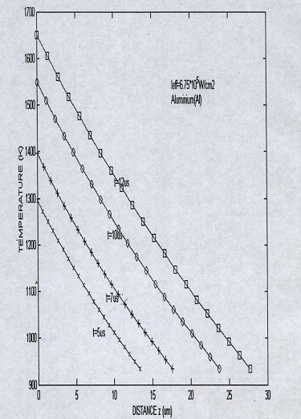
Fig (1): The variation of temperature with distance at different times along the melted region (The original solid at 934K) Aluminum (Al)

Fig (2) shows the variation of surface temperature with time. The surface temperature of the molten metal increases as the time increase. For example, it increases to 1650° in 12 µs, comparing preheated of the molten metal with un-preheated one ⁽¹³⁾, it is noted that the time required to reach the same temperature is reduced for the preheated sample compared with the un-preheated one.

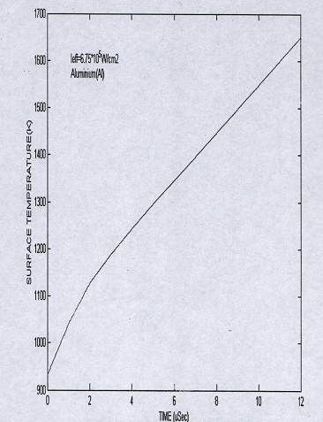

Fig (2): The variation of temperature with time for pure Aluminum (Al) preheated to934K

Fig (3) shows the variation of melt depth with time for preheated samples. It show that preheating reduce time required to reach a certain melt depth. This appears clearly when comparing the melt depth with the values of un-preheated sample after 8 µs from the beginning of phase transition. The preheated sample records 10.75 µm while the un-preheated sample records only 1.7 µm during the same time ⁽¹⁾.

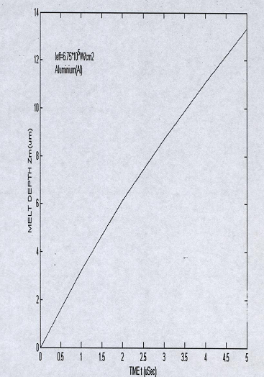

Fig (3): the variation of melt depth with time for pure Aluminum (Al) preheated to 934K

Fig (4) and Fig (5) shows the variation of velocity at the solid liquid interface with time for preheated specimen.

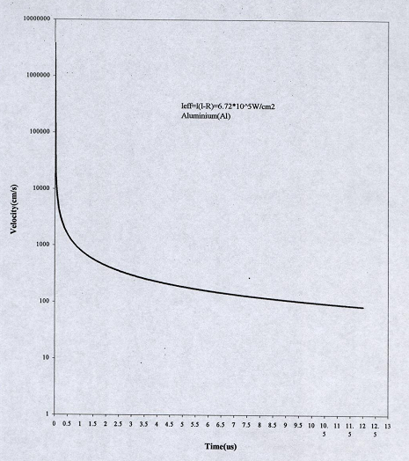

Fig (4) the variation of velocity at the solid liquid interface with time preheated to 934k Aluminum (Al)

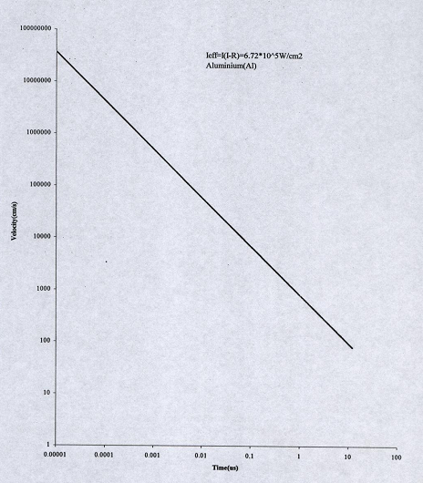

Fig (5): the variation of velocity at the solid liquid interface with time preheated to 934K Aluminum (Al)

Fig (6) shows the variation of surface temperature with time for pulsed operation. The incident laser radiation consists of square pulses of duration 12 µs and intensity l.68MW/cm²The sample is preheated to 934K. During the laser illumination, the radiation is converted into heat and melts the sample. The temperature increases from 934K to 1651K during 12µs. As the laser is switched off, the surface temperature starts to decrease first at a high rate during the first 5µs and then the temperature decreases at a slow rate afterwards. When Comparing our results with previous published results the deviation between different methods of solution was about 4:6%, Our work lay within the acceptable range and have a good agreement with these results within the experimental error

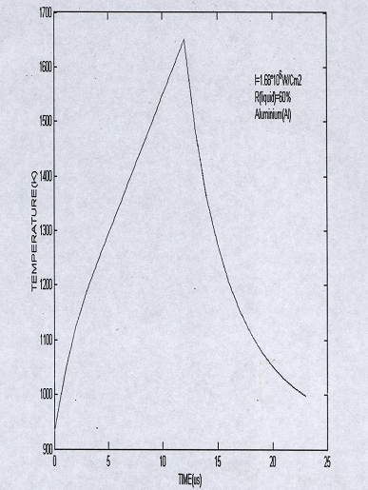

Fig (6): The variation of temperature with time when preheated 934K Aluminum (Al) is processed to laser pulse

Conclusions

1-The preheat of the specimen to melting temperatures (934k) before laser irradiation reduces the time required to raise the surface temperature to melting point. Preheating reduce time required to reach a certain melt depth. The preheated sample records a melt depth of 10.75µm while the un-preheated sample records only 1.7 µm at the same time interval. The variation of surface temperature of liquid Aluminum (Al) with time, shows the increase of the liquid surface temperature at a rate of 1.5*10⁷ K/s.
2-The accuracy for numerical modeling was found to be within± 0.5K, for temperature and ± 0.05*10⁻⁶ for melting depth. The computing time for every state on the curves that evaluates both the temperature and melt depth is within 5 - 20min.

Corresponding Author:
Hebatalrahman. A
Egypt.Housing & Building National Research Centre (HBRC), Egypt
Hebatalrahman@naseej.com
Hebatalrahman11@yahoo.com

References
- G.Cominin, S.Delguidice, "Finite element solution of nonlinear heat
conduction problems with special reference to phase change" IJNME, vol8 no3, pp613:624, 1974.
- J.Padovan "Semi analytical finite element method applied to heatconduction in solids with non-linear boundary condition" IJNME, vol8, no2,andpp295:310,1974.
- D.H Norris "Non structural applications of finite element method" U.S Jap3, pp511:539, 1985.
- J.Glynee "The finite element analysis of engineering systems"Apl Math, vol5, nol, pp65: 79, 1975.
- A.J wills "The applications of finite element to heat conduction problems involving latent heat" Rock mechanics, vol5, no2 , pp65: 76,
1973.
- A.F.Emery Carson "An evaluation of the use of finite element method in the computation of temperature" Jhe.Tra ,vol93 ,no2 , ppl36: 145, 1971.
- R.E.Beckett "Finite element method applied to heat conduction in solids
with nonlinear boundary condition" J.He Tra,vol95, nol ,1973.
- J.Donna "Finite element analysis of steady state nonlinear heat transfer
problems", Nuc. Ede, vol30, no2, 1974.
- A.V.Luikov, "Heat and mass transfer",Mir publisher ,Moscow ,1980.
- N.R.Ykalin, A.Ugiov, I.Zuev, A.Kokora, "laser and electron beam
material processing". Handbook, Mir publisher, Moscow, 1988.
- E.N.Yeremin, "Fundamental of chemical thermodynamics", Mir publisher, Moscow ,1 981.
- S. S Rao, "The finite element method in engineering", second edition, Pergamon Press, N. Y., 1989.
- Mathworks, "Partial differential equation toolbox for use with Matlab" MathWorks,mc.,MA, 1997.
- Hadley W.01son,and William C.Swope, "Laser drilling with focused
Gaussian beam", Appl. Phys. 27(8) ,American Institute of Physics, October
1992.
- J.P Holman, "Heat and mass transfer", metric edition, McGraw-Hill book company, N.Y., 1989.
- S.M.Zubair and MAchaudhry, "Heat conduction in a semi-infinite
solid when subjected to spatially decaying instantaneous laser source", Appl. Phy. A, vol 28, 1993.
- N.Amold, N.Bityurin, "Model for laser induced thermal degradation
and ablation" ,Appl. Phy. A, vol 68, 1999.

- F.A.Houle, and W.D.Hinsberg, "Stochastic simulation of heat flow with application to laser sold interactions" ,Appl.Phy. A, vol 66, 1998.
- B.Hopp,M.Csete,G.S.Zaba,Z.Bor "Time resolved study of Ar-F excimer laser ablation processes",Appl Phy A, vol6, 1995.
- C.Chaleard,V.Detalle,S.Koco,J.L Lacouv "Experimental investigation of laser ablation efficiency of metals" , Spie, vol3404, 1998.
- C.Chaleard,V.Detalle,S.Koco,J.L Lacouv "Influence of laser pulse duration on the ablation efficiency of metals", Spie, vol3404,1998.

5/5/2010

- Murray R.Spiegel "Advanced mathematics for engineering and scientist" SI edition , Schaum's outlines series theory and problems, pp98:130,1987.
- J.Donna "On the accuracy of finite element solution to the transient heat
conduction equation" IJNME, vol8 nol pp 103: 110, 1974.

