One Dimension Model for Laser Interactions in Micro and Nano Scale

Adel Mohamed EI-NADI¹, Mahmoud Fathy Mahmoud² , Hebatalrahman.A*³

Faculty of Engineering, Cairo University¹, Egypt. Benha High Institute of Technology², Egypt.
Housing & Building National Research Centre (HBRC)³, Egypt
*Hebatalrahman11@yahoo.com
*Hebatalrahman@naseej.com

Abstract: In this research a theoretical study for the laser-metal interactions allowing heat conduction and melting of the metal are presented. The metal studied is pure aluminum. The heating of the surface of Aluminum target and the phase transition during melting are studied under continuous and pulsed laser operation. The metal is in the form of an insulated thin rod so that the model is treated as one-dimensional. The heat equation in one dimension and the initial and boundary conditions are formulated. The solid metal is considered semi-infinite, although the solution is restricted to the interaction zone where there are variations with temperature. The incident laser power is considered as a heat source that affects one boundary, while the other boundary is kept at room temperature. During melting, the Stefan boundary condition at the solid liquid interface is applied. Both the laser and the target are assumed to be stationary. The laser beam is parallel, uniform power density and azimuthally symmetry. The model could also be used to study other metals. The purpose of this study is to analyze the processes occurring in laser-metal interactions and their parameters which are important in controlling metal processing. [New York Science Journal 2010;3(7):54-58]. (ISSN: 1554-0200).
Keyword: One Dimension Model; Laser; Interaction; Micro; Nano Scal

Introduction
Laser-Metal Interaction
Metals have a large number of electrons that are not bound to individual atoms but are free to travel within the material, and many of the electrical, thermal and optical properties of metals are determined by the behavior of these electrons. Clearly these free electrons account for the high electrical conductivity of metals. They also conduct heat very well and since there vibration frequencies are not quantified by their being bound to atoms, they absorb all wavelengths of visible and infrared light (1),(2).
If free electrons are broadband absorbers of visible and infrared light, it seems strange that metals should have high reflectivity with the electron absorbing light of all wavelengths. This is certainly the case in transmission (metals are quite opaque). The intensity of light entering a metal drops to near zero in a fraction of a wavelength(3).
Metals are good reflectors because the electrons oscillate at the frequency of the incoming light but do not convert much of the energy to heat since little energy is lost, oscillation of electrons generate light of an intensity comparable to the source(4): (7).

Laser heating of solids
The laser beam for material processing is considerable energy concentrated in a small area. If we allow such a beam to impinge on meta surface, some light will be reflected, some will be absorbed and some will be transmitted. With a metal target, almost all the light will be reflected, a little will be absorbed, and none will be transmitted. To increase the amount of material absorbed, the highly reflective metal surface may be covered with an absorbing dielectric coating that heats up and transfers the heat to the metal. This works well except that the coatings tend to change their properties at heat-treating temperature, affecting the coupling. Another approach is to use a plan-polarized light that is incident on the surface at Brewster's angle, maximizing the coupling (8) :( 14).
Whatever method is used, lasers heat only the surface of metals. All subsurface heating is accomplished by conduction. This makes it easy to model, since the mechanism is easily defined, although the values for thermal properties as a function of temperature are considered. For example Nd:YAG laser beam penetrates several microns into metal surface and is absorbed throughout that layer. As it heats, the number of conduction electrons increases the absorption (9):(15).

Laser melting of materials.
When the heating process continues, the solid being heated will change its phase and start melting. The surface of the molten metal interacts with light much like a solid one. Liquid have larger numbers of free electrons so they behave like metals and absorption of light increase because the increasing of the degree of disorder which causing more interaction between atomic vibrations and electrons. Reflectivity drops from over 90% to about 50% for common metals. While the interaction mechanism is similar to that for solid metal, there are some differences in heat transfer and convection is now possible and can be driven by changes in surface tension arising from temperature gradient (16):(19).

II. Model for Laser Metal Interaction in One Dimension Allowing for Melting
The problem of laser induced melting is studied of a single material in the form of semi infinite thin insulated rod of pure metal. The thermal properties of the metal are assumed to be independent of temperature. A high power laser of intensity I is focused into one end of the rod. The process of heat transfer through the rod is modeled by the one-dimensional heat equation and the associated boundary conditions. The metal rod has thermal conductivity Ks, density ρs and specific
heat Cs, with boundary at z=0 and at z=B where B—∞ (is very large compared to interaction zone).
The boundary at z=0 is subjected to laser with absorbed intensity I(l-R)where R is the reflectivity of the metal surface, the boundary at z=B
is left at constant tb.
The liquid phase has thermal conductivity kℓ, density ρℓ and specific heat Cℓ.
The densities of solid and liquid are assumed equal ρs= ρℓ =ρ.

One dimension heat equation
In considering the laser as heat source, which affects the surface of thematerial the boundary conditions, is such surface is given by
-Kz∂T/∂ZLz=I(l-R)
where the heat flux q=I(l-R)
I is the incident laser intensity
R is the reflectivity of the surface
The solid phase
The heat equation:
Ks∂Ts2/∂Z2 = ρC (∂Ts/∂t) Zm<z<B , t>0
The boundary conditions:
-Ks∂Ts/∂t=I(l-R) Z=0 T(B)=To
The initial conditions
Ts(z,t) =To at t=0
The liquid phase
The heat equation:
k ℓ ∂T ℓ 2/∂z2= ρC ℓ (∂T ℓ /∂t) 0<z<Zm, t>0
The boundary condition:
-K ℓ ∂T ℓ /∂t = I (l-R) z=0, Zm>0
The Stefan interface conditions
T ℓ (Zm,t)=Ts(Zm,t) Z=Zm, t>0
-K ℓ ∂T ℓ /∂z + Ks ∂Ts./∂ z= ρHm (∂Zm/ ∂ t) z=zm, t>0
The velocity of the liquid solid interface
Vm= ∂zm/∂ t
We follow the assumption that the maximum velocity Vm(max) at the beginning of phase transition at Zm=0, and the velocity decreases with increasing the melt depth and tend to be Vm(min)=0 when the melt depth Zm→∞ as the rod is insulated.

Results and Discussion
Heating Stage of The Metal
The process of metal heating by laser is first analyzed as it is a prior process before the phase change begins. In addition, the heating stage is the main
stage in a number of material processing such as heat treatment, annealing. The process of heating begins by absorbing the laser energy and converted it into heat. This heat source is considered as a plan surface heat source. The absorbed energy heats up the surface layer and the heat propagates into the metal by conduction.
The heating of a semi-infinite insulated rod pure Aluminum (Al) sample by laser radiation of intensity (1.68*10⁶) W/cm² is analyzed in one dimension using the heat transfer differential equation. The boundary conditions include the heat flux at one end and room temperature of 300K at the other end. The initial condition of the sample is the room temperature 300K. Since the sample is semi-infinite, while the interactions zone, where there is a sensible temperature variation, is of the order sub-millimeter in length-The metal. The solution region in the metal is considered bounded at the other end by a temperature equal to the room temperature. This end is taken long enough that the metal sample is considered semi-infinite.
Fig (1) shows the variation of temperature with time at different positions in the metal sample. The temperature increases with increasing time and the rate of increase depends on the distance from the surface. Fig (2) shows the temperature distribution inside the metal at different times. The temperature at the surface reaches the melting point after 16.6μs. The heat penetration into the metal is found to be at an average rate of 3.56*10⁷ K/s. For Example at a depth of 0.05mm, the temperature reaches 340K after 8μs and 475K after 16.6μs.
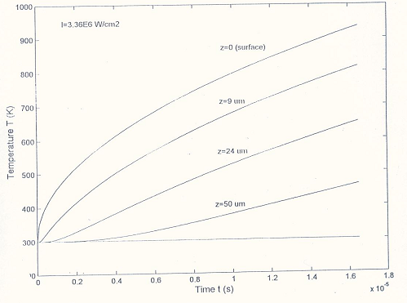
Fig (1): the variation of temperature with time for pure Aluminum (Al) at different positions during laser heating

Laser Induced Melting
As the surface of the metal reaches it's melting temperature, melting starts at the surface. There is now a liquid layer over the solid. The processes of heating and melting are now analyzed using the heat transfer equation in both the liquid region and the solid region. The outer boundary of the liquid region is the laser flux, while the outer boundary of the solid region is at room temperature. The position of the solid –liquid interface is controlled by the Stefan condition for which the heat conducted
through the liquid is equal to the absorbed latent heat for melting and the heat conducted through the solid. The initial condition for the solution is taken to be the temperature distribution inside the solid as shown in Fig. (2)(Upper curve) where the temperature of the surface reaches the melting point. The problem of heat transfer is solved by the finite element method under MATLAB environment. The melt depth and the position of the solid - liquid interface are determined iteratively ^{(20) :( 32)}.
Fig (3) shows the temperature distribution inside the liquid and the solid regions at different instances. From the figure, the temperature gradient in the liquid region is different from that in the solid region because of the difference in their physical and thermal properties and due to the latent heat term in Stefan condition.
Fig(4) shows the increase of melt depth of liquid Aluminum (Al) with time .The rate of increase of melt depth varies with time and so the velocity of the solid -liquid interface varies with times. The velocity of the solid -liquid interface has its maximum value at the surface where the phase transition starts. The rate of developing the melt depth is then decreases with time. Fig (4) show the beginning of phase transition and the linear relation coexist till 4μs from the beginning of phase transition and show the melt depth after 8μs from the beginning of phase transition. The behavior change and also the rate of the process vary. Fig(5) shows the plot of melt depth against time (log-log) which is a straight line of slope 0.51 that is typically the same as that found in the published results ⁽²⁵⁾.
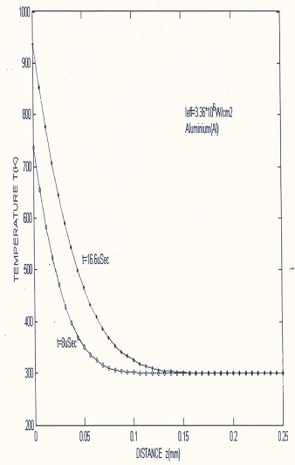
Fig (2): The variation of temperature with distance during heating

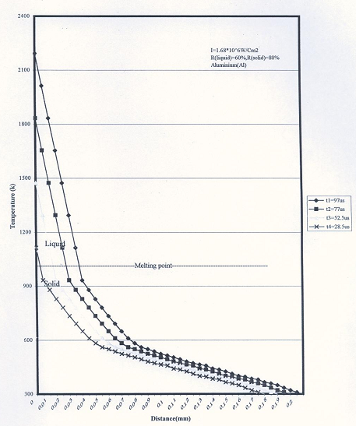
Fig (3): The variation of temperature with distance when phase transition occur

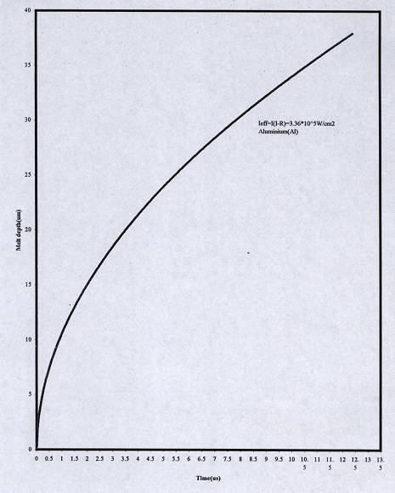
Fig (4): The variation of melt depth with time

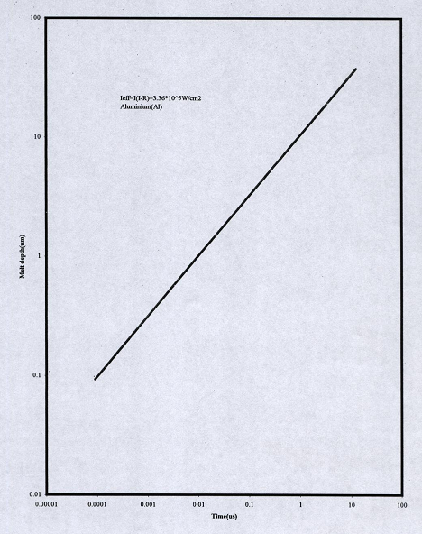
Fig (5): The variation of melt depth with time (log-scale)
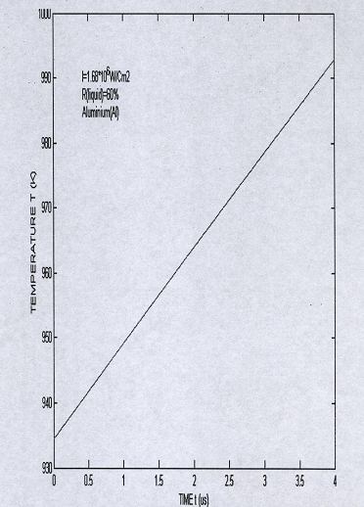
Fig (6): The variation of surface temperature of Aluminum (Al) with time after phase transition to liquid state during melting

Fig (6) shows the variation of surface temperature of liquid Aluminum (Al) with time, during a time interval of 4μs. Although this time interval is short, it reveals the increase of the liquid surface temperature at a rate of l.5*10⁷K/s.

Conclusions
1-The numerical solution model discussed above shows that the present approach enables us to describe the phase transition process in laser melting.
2-An important property of the metal surface, which affects the laser-metal interaction, is its reflectivity. The laser power absorbed by the metal is less than incident power because of the reflectivity of the metal surface, which depends on the metal temperature in case of pure aluminum. It is about (80%) for solid at room temperature and dropped to about (60%) for liquid metal at the melting point.
3-The variation of the physical and thermal properties as a function of temperature is different from the region to another and cause change in the rate of heating or phase transition. This difference causes the movement of the interface between solid and liquid region.
4- The variation of temperature with distance depends on the instant of time. The temperature at surface reaches the melting point after 16.5ns. The heat penetrate into the metal is found to be at an average rate of 3.56* 10⁷ K/s. At a depth of 0.05mm, the temperature reaches 340K after 8μs and reaches 475K after 16.5ns.
5-The variation of temperature with time depends on the position. The temperature increase with increasing time and rate of increase depends on the position distance from the surface.
6-The melt depth for pure aluminum (Al) under the laser exposure of 1.68*10⁶ w/cm² is in the range of (12.6μm) that is corresponding to velocity at the solid liquid interface in the range (877.98cm/s). The variation of velocity decrease with increasing both time and melt depth. The variation of surface temperature of liquid Aluminum (Al) with time shows the increase of the liquid surface temperature at a rate of 1.5*10⁷ K/s.
7-Comparing the above results with the published results by plotting logarithm velocity against logarithm time and finding the slope of the resulting straight line. A slope of (0.5) was found, it means the velocity -time relation is the same in the published result ⁽¹⁹⁾.
The melt depth increase with time with a rate that decrease with time. By plotting logarithm melt depth with logarithm time show that the results agree with published results ⁽²⁹⁾.

Corresponding Author:
Hebatalrahman.A
Egypt.Housing & Building National Research Centre (HBRC)³, Egypt
*Hebatalrahman@naseej.com

6. References
- R. Cartoon, Trans. AFS vol. 71, P. 638, 1963
- J.Okans,Hottori,Y.Nakai and N.Itoh.Surf SCI pp258:267,1991.
- J.Kanasaki,Aokans and N Itoch,Phys,rev Lett,70,2495,1993.
- K.Hattori,A.Okans and Y Nakai.Phys Condones Matter,3,7001,1991.
- D.Amold and E Comer.Phys rev B45,1477, 1992.
- D.Amold and D.J.Marria, Phys rev B46.15102, 1992.
- R.Ebeckett Jhe Tra ,vol 95 no 1,1973.
- A.F.Emery Jhe Tra, vol 93 no2, 1971.
- D.Blier"Laser processing and chemistry "Springer-Verlag Berlim Heidelberg, New-York, 1996.
- E.N sobal "Phase transformation and ablation in laser treated solids", A Wiley Inter Science publication,New York ,1996.
- A.Zhao, and C.W.Ong, Appl.Phys. Lett.66(20),2652:2654,1995.
- Rykalin.N,Uglov.A, and KokoraA, "Laser machining and welding" English translation Ed.by O.Glebov, Moscow, Mir Publishers, 1978.
- Ready.J.F,"Industrial applications of Lasers". Academic Press, N. Y., 1978.
- Dabby.F.W, IEEE J.Quantum Electronics QE-8(2), ppl06: 111, 1972.
- Blackwell,B.F:.ASME J.Heat Transfer 112, pp567:571, 1999.
- Grigull,U.; Sander.H "Heat conduction" English Translation Ed.by J.Kestin).Berlm Heidelberg ,New York: Springer, 1984.
- Blackwell,B.F 'Temperature profile in Semi-infinite body with exponential source and convective boundary condition", Moscow: Mir Publishers, 1978.
- Peak.U, "High-intensity laser-induced vaporization and explosion of solid material". Springer-Verlag, Berlin, 1996.
- Beck.J.V, Cole.K.D.Haji-Sheikh, A.; litkouhi. B "Heat conduction using Green's functions". New York:, Hemisphere Publishing Corporation,1992.
- Gradshteyn.I,Ryzhik.I.M"Table of integrals, series and products" English Translation Ed. by AJef&ey. New York: Academic Press, 1980.
- K.M.Lu,M.L.Cohen, E.E Haller.W.L. Hansen and I.C.Wu,Phys.Rev.B49,5034, 1994.
- A.Bousetta, and A.Schultz, Appl. Phys. Lett. 65(6), pp 696:698, 1994.
- S. R. P. Silva, J. Schwan, D. F. Franceschini and G. Mariotto, J. Appl.
Phys. 81(6), pp2626: 2634 ,1997.
- Z. Zhang, Y. Li, S. Xie, and G. Yang, J. Mater. Sci. Lett. 14, ppl742:1744, 1995.
- M.Barber, J.A.Connor, M.F.Guest, I.H.Hillier, M.Schwarz, and M.Stacey, J.Chem.Soc.Faraday Trans.II 69, 551, 1973.
- P.W.Atkins "Physical chemistry" 2nd edition, Oxford University press, 1998.
- Fan Gang, Guan Yhong and Zhang Jiatao, SPIE, vol. 3550, pp357, 1997.
- Yunys .A Cengel, "Heat transfer" International edition, McGraw-Hill book company. Applied mathematics science, N. Y., 1998.
- N.B.Colthup,L.H.Daly,and S.E Wiberley "Introduction to infrared and Raman Spectroscopy" 3rd ed.(Academic Press,Inc.,San Diego, CA.1990.
- A.Mansour and D.Ugolini.Phys.Rev.B 47(16) pp 10201:10209, 1993.
- S. Souto, and F. Alvarez.Appl.Phys.Lett. , 70(12), ppl539:1541, 1997.
- M. Tabbal, P. Merel, S. Moisan, M. Chaker, A. Ricard, and M. Moisan, Appl. Phys. Lett., 69(12), ppl698:1700, 1996.

5/5/2010

