Study of the Micro and Nano Solidification Process of Pure Aluminum (Al) During Laser Interaction

Adel Mohamed EI-NADI¹, Mahmoud Fathy Mahmoud² , Hebatalrahman.A*³

Faculty of Engineering, Cairo University¹, Egypt. Benha High Institute of Technology², Egypt.
Housing & Building National Research Centre (HBRC)³, Egypt
*Hebatalrahman@naseej.com
*Hebatalrahman11@yahoo.com

Abstract: In this work, a model for laser metal interaction including heating and melting of metals is presented. The solidification process as a result of laser switch off is considered. These processes are important in laser annealing, welding, and cutting with removal of melt, machining, pulsed laser deposition, coating, and hardening. The interaction processes are first considered physically and the governing equations are formulated in three dimension. These equations include the heat equation, boundary conditions, initial condition and Stefan interface conditions. A numerical technique using the finite element method is used for solving this problem in one dimension. The solidification rate and the solidified layer thickness are calculated. The relation between solidification velocity and solidified layer thickness is mentioned An algorithm for solution of the problem under MATLAB environment is carried out. The results are then compared with published results. [New York Science Journal 2010;3(7):59-63]. (ISSN: 1554-0200).
Keywords: micro; Nano; Aluminum; Laser Interaction

Introduction
The Applications of Laser Material Interaction Include Phase Transition
There is a lot of applications of the laser material interactions which involves phase transition like cutting, welding, drilling, trimming, scripting, pulsed laser deposition, surface treating, and cladding ^{(1),(2)}.

Interaction during drilling.
A laser drilling needs a focused Gaussian beam with high power densities. As the power density of a laser on a metal surface approaches l0⁷W/cm², a greater fraction of the metal is vaporized than at lower power densities. This may be undesirable for welding but is exactly what is required for drilling. A vapor keyhole surrounded by liquid forms plasma interactions in the keyhole generating detonation waves. The high vapor pressure resulting from heating at high power densities ejects the liquid from the hole^{(3),(4)}. After the beam is focused to irradiant levels in the range of 10⁶ -10⁷ W/cm² melting occurs in less than a microsecond. Two interactions appear at these power densities ^{(5),(6)}.
First:
Radiation pressure becomes appreciable. The pressure associated with a beam of light having a power density S is simply S/c where c is the speed of light. Power density of 10⁶ W/cm² is then equal to a pressure of 33Pa or 3*10⁻⁴ atmosphere. This may not seem like much but a high power density like l0⁷W/cm² can cause radiation ^{(7):(9)}.
Next:
The molten liquid generally has an appreciable vapor pressure. The atmosphere above the liquid then contains metal atoms. Some of the atoms ionize as the temperature increases. The metal vapor now interacts with light through the process of inverse (breamsstrahlung), where electrons in the field of an ion may be accelerated by electromagnetic radiation ^{(10):(13)}. This heats up the vapor, increasing the number of ions and hence the absorption. We now have plasma, which is a very hot ionized gas that absorbs laser light and emits black body radiation. As long as the power density is sufficient to sustain it, the plasma will act as an efficient absorber ^{(14):(19)}. The steps of the drilling action and keyhole formation can be stated as follow:
1-Laser energy impinges on the surface. Most is reflected, but the portion absorbed is sufficient to heat the material to its melting point ^{(20),(21)}.
2-The molten material has a higher absorption than the solid, increasing the power going into the material. This melts a larger volume of the metal and causes some to vaporize. The molten pool forms into a cup under the radiation pressure of the laser and the vapor pressure of the metal ⁽²²⁾.
3-The cup deepens into a keyhole, which traps the beam. The metal vapor in the keyhole efficiently absorbs the laser light and re-emits it as black body radiation heating the liquid surrounding the keyhole. Conduction and convection in the liquid transfer heat to the material, increasing the molten volume ⁽²³⁾.
4-Relative motion of the work and the beam sends the keyhole through the work, leaving a fused zone behind ⁽²⁴⁾.
The vapor column is of great importance; it is the medium that transfers energy from the laser beam to the work. Its vapor pressure keeps the keyhole open, allowing the beam to penetrate the material being drilled. At high power densities, the vapor column leaves the keyhole, forming a cloud over its opening. Unfortunately the vapor outside the keyhole absorbs light, decreasing the energy entering the work and
reducing penetration ⁽¹⁵⁾.

Interaction during welding
From the early days of laser welding model development until recently, it was commonly assumed that the recoil pressure could not reach significant values. Consequently, high-velocity volumetric motion of the melted material cannot occur in the weld pool and only a flow generated within a thin near-surface layer by the temperature gradient of surface tension is capable of reaching high velocities. Thus, insofar as melt hydrodynamics is concerned, laser welding was considered to be a
process quite different from laser drilling or cutting. This approach gives a good coincidence of numerical results and experimental observations for the case of shallow spot welding when the penetration depth does not exceed the spot radius. Both for the case of deep penetration spot welding and for the case of moving beam welding, when the keyhole is formed, simple estimations show that the absorbed laser intensity can be comparable to that in drilling case⁽¹⁰⁾.

Interaction during surface alloying
The possibility to obtain surface alloying is a direct consequence of steering in liquid. The heat flow induced by laser irradiation during surface melting has great importance from both practical and theoretical point of view. It allows to mix the elements of the substrate with that of pre-deposited coating to be alloyed, thus producing a homogeneous surface layer with specified microstructure and chemical composition⁽²⁵⁾ ⁽²⁶⁾.

The formulation of the problem
The heat transfer by conduction through a body is determined by theconservation of energy principle. The input thermal energy E_{in} and the
energy generated in the body E_{g} are equal to the heat flow out of the body E_{out} and the thermal energy stored in the body E_{ie}. The energy balance
equation can be written as
E_{in} + E_{g} = E_{out} + E_{ie} (1)
The rate of heat flow q by conduction through a body is given by
q = - K A .∇ T (2)
where T(x, y, z, and t) is the temperature inside the body at position (x,y,and z) and at time t. K is the thermal conductivity of the material of the body and A is its cross-sectional area. The energy generated in a solid when any form of energy is converted into thermal energy⁽³⁾
E_{g}=q_{g}V (3)
where V is the volume of the body and q_{g} is the heat energy per unit volume.
When the temperature of a solid body increases the thermal energy will be stored and is given by
E_{ie} =⍴C V (∂T/∂t) (4)
where p is the density of the body and C its specific heat.
Consider an element in Cartesian coordinate of volume dV = dx dy dz. The heat transferred through the element during time dt is obtained by substituting equations (2), (3) and (4) in Eq.( l) which yields

[q(x) + q(y) + q(z)] dt + q_{g} dx dy dz =
[q(x + dx) + q(y + dy) + q(z + dz) ] dt +⍴C dT dx dy dz (5)
The heat inflow rate q(x) into the face located at x is given by Eq.( 2) which reads
q(x) = - K_{x} A_{x} (∂T/∂x)
=-K_{x} (∂T/∂x) dy dz (6)
The heat outflow rate q (x + dx) from the face located at x+dx is
q(x + dx) = q (x)+(∂q(x)/∂x) dx
= - Kx Ax ∂T/∂x - ∂/∂x(Kx Ax ∂T/∂x) dx
= - Kx (∂T/∂x) dy dz - ∂/∂x(Kx ∂T/∂x) dx dy dz (7)
where Kx is thermal conductivity of the material in the x-direction. Similar expressions for q(y), q(y + dy) and q(z) and q(z + dz) can be obtained.
Substituting Eq.(6) and Eq.(7) into Eq.(5) and dividing each term by dx dy dz dt one gets
∂/∂x(K_{x} ∂T/∂x)+∂/∂y(K_{y} ∂T/∂y)+∂/∂z(K_{z} ∂T/∂z)+q_{g} = ⍴C ∂T/∂t (8)
Equation (8) is the differential equation covering the heat conduction in orthotropic solid body. For isotropic body the thermal conductivities in x,
y, z directions are equal K_{x} = K_{y} = K_{z} =K. The heat conduction equation is then
∂T²/∂x²+∂T²/∂y²+∂T²/∂z²+q_{g}/K=1/D (∂T/∂t) (9)
where D = K/⍴C is the thermal diffusivity in an isotropic solid

Special cases
1-If the heat sources are absent in the body (q_{g} =0), then
∂T²/∂x² + ∂T²/∂y² + ∂T²/∂z²+q_{g}/K=1/D (∂T/∂t) (10)
2- If the heat conduction is in a steady state (heat source present), then
∂T²/∂x² + ∂T²/∂y² + ∂T²/∂z²+ q_{g}/ K=0 (11)
3- The steady state (without heat source)
∂T²/∂x² + ∂T²/∂y² + ∂T²/∂z²=0 (12)
Boundary and initial conditions
There are two different boundary conditions needed to be specified where q is a specified heat fluxes which may be a time dependent ⁽⁹⁾. This
heat flux is caused by an external source of heat, which in our case is theabsorbed radiation when the laser impinges on the surface of the body. L_{x},
L_{y}, L_{z} are the direction cosines of the outward drawn normal to the boundary.
In case of surface convection, then
K_{x} ∂T/∂x L_{x}+K_{y} ∂T/∂y L_{y}+K_{z} ∂T/∂z L_{z} + h (T – T∞) =0
on S3 for t > 0 (13)
where h (T - T∞ ) is the rate of convective heat loss, h is the coefficient of surface heat transfer and T∞ is the ambient temperature.
Since Eq.(9) is of the first order in time t, hence it requires oneinitial condition. The commonly used initial condition
T (x,y,z,t=0) =T_{o} (x, y, z) in V (14)
T_{o}(x, y, z) represents the specified temperature distribution at time zero. ⁽⁵⁾.
In the case if the laser is off for a long period of time solidification may occur. The solidified layer thickness is calculated from the relation and the Stephan boundary conditions becomes in the following form
ρ_{m}V_{m}H_{m}= k_{(s)} ∂T/ ∂Z- k _{(ℓ )} ∂T/∂Z (15)
In Case of solidification
The initial condition
T_{s}=(z,0)=T_{o} t=0 (16)
Z_{m} (0)=0 (17)
V*=dz*/dt
Z* solidified layer thickness
V* velocity of solidification

Results and Discussion
Solidification.
The liquid metal begin to cool to the lower temperatures, after the laser source is turned off. Solidification will not begin until the temperature decrease to the melting point depending on the properties of the material and the rate at which the heat escape from the material. In general the solidification rate is less than the melting rate for the same material and this will be shown clearly from the following curves.
Fig (1) shows The Variation of solidified layers thickness with time. The minimum solidified layers thickness is 4.6µm and the solidified layers thickness increase with increasing time,
Fig (2) shows the variation of velocity at the liquid-solid interface with time. The maximum velocity reaches and then decreases with increasing time.
Fig (3) shows the variation of velocity at the liquid-solid interface with solidified layers thickness. The maximum velocity achieved at the minimum solidified layer thickness and after that the velocity decreased as the solidified layer thickness increase. The maximum velocity which is mentioned to be 140*10-3cm/s corresponds to a minimum solidified layer thickness of 4.6µm. The main application of this work is in drilling by melting and ejection, the required depth is used to determine the following parameters time, temperature, velocity of melting, power required and the velocity of ejection by gas or air jet which must be faster than the solidification speed to avoid reverse reaction.
To compare our results with the published results fig (4) and fig (5) show mathematical relation which prove that plot of logarithm solidified layer thickness against logarithm time and plot logarithm solidification velocity against logarithm time produce straight line. Such behaviors were the same as recorded in the published results (24): (26). Fig(4)show a linear relation with slope 76.7 µm/s.

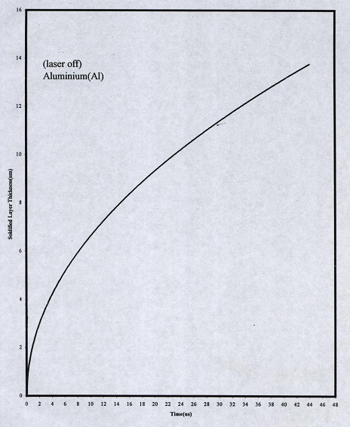
Fig (1): The variation of solidified layer thickness with time for Aluminum (Al)

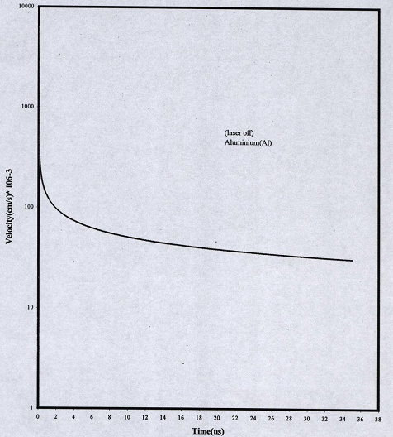

Fig (2): The variation of velocity at the solidified interface with time for Aluminum (Al)
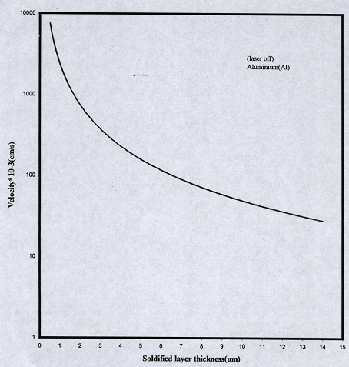

Fig (3): The variation of velocity at L-S solidified interface with the solidified layer thickness for Aluminum (Al)

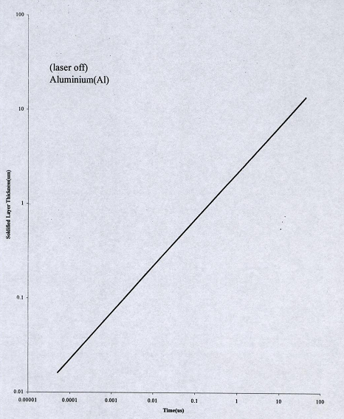

Fig (4): The variation of solidified layer thickness with time for Aluminum (Al)
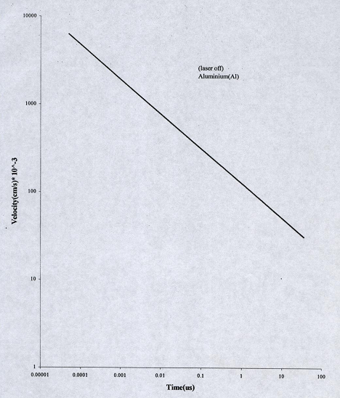
Fig (5) The variation of velocity at the solidified interface with time for Aluminum (Al)

Conclusions
The solidification velocity at the liquid solid interface and the solidified layer thickness are (140*10-3cm/s) and (4.6µm), respectively. The solidification velocity is slower than the velocity at the solid liquid interface.
The main application of this work is in drilling by melting and ejection, the required depth is used to determine the following parameters time, temperature, velocity of melting, power required and the velocity of ejection by gas or air jet which must be faster than the solidification speed to avoid reverse reaction.
During melting, the rate of heat flow by conduction through liquid is equal to the rate of heat absorbed by phase transition from solid to liquid plus the rate of heat flow by conduction through solid. In the case of solidification where the rate of heat flow by conduction through liquid plus the rate of heat liberated by phase transition from liquid to solid is equal to the rate of heat flow by conduction through solid.

Corresponding Author:
Hebatalrahman.A
Egypt.Housing & Building National Research Centre (HBRC)³, Egypt
*Hebatalrahman@naseej.com

6. References
- Murray R.Spiegel "Advanced mathematics for engineering and scientist" SI edition, Schaum's outlines series theory and problems, pp98: 130, 1987.
- J.Peng, P.Zhang, Y.P.Guo, andG.H.Chen, Matt.Lett.29, ppl91:194, 1996.
- G. Dparkes, M. Andel, and D.Phil ."Modem inorganic chemistry", 2nd Edition, edited by G.Dparke,westem printing services Ltd .Bristol, 1956.
- W.Guo and A.Kar, J laser application,vol. 11, no. 4, 1999.
- A.Kar and J.Mazumder J.appl.phys.61, 2465-2655, 1987.
- M.G.Cohen and R.A Webb J.appl.phys.34, 245-249, 1971.
- R.C.Reed, J. M. Robenson, T. Akboy, and Z.Chin, J. Mater. Sci. Lett. 24, ppl742:1744, 1999.
- F. Falk, C. Muhlig, and A. Koba, Optics and laser technology, vol, 32, no. 4 June, 1998.
- J. M. Poates, "Surface modification and alloying", NATO Plenum press, scientific affair division, 1983.
- Dahotre, "Lasers in surface engineering". Material society, Emplet me presses, N. Y., 1998.
- S. S Rao, "The finite element method in engineering", second edition, Pergamon Press, N. Y., 1989.
- Mathworks, "Partial differential equation toolbox for use with Matlab" Math Works, mc. MA, 1997.
- Milonni Peter,Eberly Joseph "Lasers"John Wiley and sons, 1988.
- J.C.Miller "Laser ablation principles and applications" Springer-verlag-Spring series in material science, printed in Germany, 1994.
- Sigemon.A, "Lasers", University Science books. Mill valley, CA, p 563, 1986.
- Heinz, Z. Wang, P. Schwab, and L. SchulzJ, Appl.phys. ,vol 68, pp 2512:2514, 1990.
- B.Walff,Rottke,J.Ihlem and A.Scholl.appI phys.vol.a60,ppl3-17,1995.
- R.Kelly and Amiotells, phys rev,volB91, pp682:691,1994
- Rykalin.N,Uglov.A, and KokoraA, "Laser machining and welding"
English translation Ed.by O.Glebov, Moscow, Mir Publishers, 1978.
- Ready.J.F,"Industrial applications of Lasers" .Academic Press, N. Y., 1978.
- Hadley W.01son, and William C.Swope, "Laser drilling with focused
Gaussian beam", Appl. Phys. 27(8), American Institute of Physics, October
1992.
- F.A.Houle, and W.D.Hinsberg, "Stochastic simulation of heat flow with application to laser sold interactions", Appl.Phy. A, vol 66, 1998.
- Peak. U, "High-intensity laser-induced vaporization and explosion of
solid material". Springer-Verlag, Berlin, 1996.
- Peak.U, "High-intensity laser-induced vaporization and explosion of solid material". Springer-Verlag, Berlin, 1996.
- Beck.J.V, "Heat conduction using Green's functions". New York:, Hemisphere Publishing Corporation,1992.

5/5/2010

