The Effect of Physical Parameters on the Laser Micro and Nano Melting of Pure Metals

Adel Mohamed EI-NADI¹, Mahmoud Fathy Mahmoud² , Hebatalrahman.A^{*3}
Faculty of Engineering, Cairo University¹, Egypt. Benha High Institute of Technology², Egypt.
Housing & Building National Research Centre (HBRC)³, Egypt
*Hebatalrahman@naseej.com
*Hebatalrahman11@yahoo.com

Abstract: In this research, the ability of the laser beam to melt a small amount (nano or micro layer) of material when focused into the surface of absorbing material was studied. The technique has a lot of applications in micro and nano machining. Laser irradiation techniques for two different pure metals in nano and micro scale were calculated, the change in physical parameters such as thermal conductivity, thermal diffusivity, specific heat, between two metals are considered. The change in surface reflection coefficient and absorption coefficient in the liquid phases were taken into account during calculation. The variation of the melt depth and the velocity at the solid -liquid interface with time are evaluated. The results were compared with published results. All the above calculations are repeated for Copper (Cu). The variation of temperature with time is different from that in Aluminum (Al) due to the change in thermal characteristics between the two metals. The change in the velocity at solid liquid interface was studied and there is a significant difference between the two metals. The velocity of the solid-liquid interface and the melt depth are evaluated for both of them to show the effect of change in physical coefficient and properties of material upon these values. [New York Science Journal 2010;3(7):64-69]. (ISSN: 1554-0200).
Keywords: Effect; Physical Parameter; Laser; Micro; Nano; Metals

Introduction
Shortly after the invention of the laser in 1960, research workers found that the beam from a laser could melt and vaporize small amounts of material especially when the beam was focused into the surface of an absorbing material. In the early 1970 laser processing advanced further with the development of multi kilowatt CO2 lasers, which lead to deep penetration mode of operation. Almost at the same time in 1971 M.G
Cohen and R.A Webb(1) showed that the application of laser processing increased steadily and describe the current status of material processing with lasers, before 1971(1): (3).
In 1978 John F Ready (4),(5), emphasized the fundamental physical phenomena behind laser material processing and discussed a broad over- view of the field of operation and the effect of different types of lasers and mode of operation on the parameters of laser material processing. On the other side N.Rykalin, Auglov, I.zuev and A. Kokra in 1978(6),(7) in USSP- published number of books and articles in the problem of interaction of laser with material. These publications reported the achievements in this domain of science and described the applications of laser in different areas (8).
Since focusing is important in laser material processing, Hadly W.Olson and William.C (4), (9) in 1992 presented a computational model for drilling holes with focused Gaussian laser beam and compared their results with experimental results. Unlike earlier models the beam divergence near the focus was taken into account and was shown to affect the whole profile strongly (10). The model included the effect of moving beam waist away from the sample surface and the dependence of the whole profile on the beam divergence (11) :( 14). It also demonstrated the optical conditions needed to drill cylindrical or conical holes. The heat conduction in a semi-infinite solid subjected to a laser sources were modeled by S.M.Zubair and Chandhry(15) in 1993. A closed form model for the computation of temperature and heat flux distribution in a semi-infinite solid when subjected to spatially decaying instantaneous laser source was investigated. The appropriate dimensionless parameters were identified and the reduced temperature and heat fluxes as a function of these parameters were presented in the graphic form (16): (19). Some special cases of practical interest were also discussed. It was demonstrated that the present analysis covered the classical case of no heat generation in the solid as well as some new solutions. They
include the phase transition term in the heat equation and this technique is used commonly by another author (6),(20)
In 1996, Peak.U (7) described a two-stage laser ablation process, which initially generates a laser light-absorbing image at UV exposure step. For this purpose in a combination with laser ablation the power and pulse duration required for the process are also indicated(21):(23).
In 1998 F. A. Houle, and W. D. Hinsberg (8),(24) were developed a general method for calculating time dependent temperature distributions in materials. They used stochastic methods for simulating chemical kinetics in order to model heat flow (25). The algorithm was applied to the particular problem of laser heating of solids. Simulated temperature distributions were compared with conventional calculations and to experimental results for heating of silicon and pulsed IR laser heating of silver(26):(28). The accuracy was demonstrated over a wide dynamic range of illumination conditions. The results were in agreement within the error limits of theory and experiment, indicating that less well characterized system could be treated with confidence. The main advantages of the method were their computational simplicity and extensibility. In the same year G. Andra, F. Falk, C. Muhlig and A. Koba (29):(30) studied experimentally and theoretically the crystallization process of amorphous silicon induced by high repetition rates scanning copper vapor laser (31). The theoretical model employed the concept of explosive crystallization in both basic directions parallel and normal to the laser beam and deal with the crystallization from the melt pool as well. A computational model was developed on the basis of this concept that simplified the original 3-D problem into a set of 1-D solutions. Experimental results gave evidence of an explosive crystallization in the direction of the laser beam. This process could be observed in a wide range of laser energy densities (32):(33).
In 1999, R. C. Reed, Z. Chin, J. M. Robenson and T. Akboy (10),(3) carried out laser transformation hardening experiments on three model steel alloys of nominal composition using CW laser with a near Gaussian beam. It had been proved possible to isolate the effects of alloy chemistry and beam mode on the kinetics of the hardening process (3). The dimensions of the hardened zones had been characterized and the result was compared with calculations made using process models. It was shown that the result from experiment and theory were in broad agreement. Hardened
zones resulting from the uniform source had already a large width to depth ratio than that resulting from the Gaussian source but the effect was
not enhanced as suggested by the theory (31),(17).

Theoretical Modeling of laser metal interaction
Theoretical Modeling of laser metal interaction including phase transition is the base of any laser material processing to be compatible with the experimental work. The models are able to detect the phases related to the processes and the temperature distribution variations that may not be detected experimentally. Modeling of the various physical processes involved in the laser material interaction helps us to optimize the parameters such as the power required, the wavelength of the laser,
and the duration in pulsed operation. Theoretical treatment allowing for phase transitions includes different mechanisms such as melting, evaporation, and plasma formation (11) :( 18).
Assumptions of theoretical model
1-The model considers the laser induced phase transition of a pure metal of semi-infinite sample dimensions. The treated work pieces are considered to consist of two regions, liquid and solid, of nearly the same density.
2-Laser power is absorbed on the sample surface (no volumetric heat generation) pressure and viscose dissipation terms are neglected and the liquid is incompressible.
3-The surface layer is heated by a constant and uniform flux.
4-The first melt layer is a thin boundary layer formed when the latent heat of melting is supplied by laser, further heating melt further layer.
5-The zone of liquid metal is superheated.
6-The influence of surface tension and gravity on the melt flow is insignificant.
Stefan boundary condition at the solid-liquid interface.
When the incident laser radiation causes melting of the metal, liquid and solid phases coexist. The problem with the coexistence of two phases and
the existence of a moving boundary between them is referred as "the problem of Stephan". One way to track the propagation of the melting
front is to specify a boundary condition on the surface of separation S(x, y, z). If the subscripts s and ℓ correspond to solid and liquid phases, Tm
the melting temperature, Hm the latent heat of melting, and Vm is the melt front velocity, then Stefan conditions are
T(x, y, z, t) = Tm, on S(x,y,z) (1)
and
⍴Vm Hm=Ks(∂T/ ∂n)-kℓ( ∂T/∂n)on S(x,y,z) (2)
Where
Vm = dz/dt (3)
and n is the unit normal to the interface S.
Equation (2) shows that, during melting, the rate of heat flow by conduction through liquid is equal to the rate of heat absorbed by phase transition from solid to liquid plus the rate of heat flow by conduction
through solid. Equation (2) applies as well in the case of solidification where the rate of heat flow by conduction through liquid plus the rate of
heat liberated by phase transition from liquid to solid is equal to the rate ofheat flow by conduction through solid.

Evaluating solution steps of the melt depth increment Δz
(1)Assume an increment of melting Δz during certain time Δt.
(2)Solve heat equation for liquid and solid phases with appropriate boundary conditions, during time interval Δt.
(3)Find the temperature in the liquid phase tℓ and the solid state Ts at distance Δz from the interface which is at temperature Tm.
(4)Calculate the new value for Δz which satisfies Stefan boundary condition. Tℓ (zm,t)=Ts(zm,t) z=zm, t>0 (4)
-Kℓ (Ts-Tℓ)/Δz + Ks (Ts-Tℓ/ Δz =⍴ℓ Hm (Δz/Δt) (5)
Where
-Kℓ ∂Tℓ/∂z+ Ks∂Ts/∂z = ⍴ℓ Hm (Δz/Δt) (6)

Δz=sqrt[Δt/ ⍴ℓHm[-Kℓ( (Tm-Tℓ)+Ks(Ts-Tm] (7)
(5) Assume Δz (l)= Δz
(6)Repeat steps 2,3,4 and get a new value for Δz
(7) Follow the interactive procedure from step 2 to step 6 until ⏐Δz(p) -Δz(p-1)⏐≤ 0.002 (8)
Vm = ∂zm/∂t (9)
We follow the assumption that the maximum velocity Vm (max) at the beginning of phase transition at zm =0, and the velocity decreases with increasing the melt depth and tend to be Vm(min) = 0, when the melt depth zm →∞ as the rod is insulated

Results and Discussion
The Investigated Metals
In material processing, several metals have been employed such as Aluminum, and Copper. The properties of each metal as well as the properties of the used laser affect the laser material interaction. In this work, Aluminum (Al) and Copper(Cu) have been chosen, as an example for characterizing the laser-metal interaction. They have the same FCC structure and lattice size 4.049ºA and 3.615º A respectively.

Table (1) Thermal and physical properties of Aluminum (Al) and Copper (Cu) (14:16)
Metal | Aluminum(Al) | Cupper (Cu)
Ks(kW/cm.K) | 2.37 | 4.01
Cps(J/g.K) | 0.974 | 1.178
Ds (cm2/s) | 0.9 | 0.38
⍴ (g/cm3) | 2.7 | 8.96
Tm.(K) | 934 | 1358
Tv(K) | 2793 | 2836
Hm (kJ/mol) | 10.79 | 13
Hv(kJ/mol) | 293.4 | 300.3
Kℓ (kW/cm.K) | 0.94492 | 1.574
cpℓ ( (J/g.K) | 1.15 | 0.4938
dℓ (cm2/s) | 0.3026 | 0.3558

The most important optical properties of Aluminium (Al) for the interaction are its reflectivity "R". The reflectivity of a polished surface is 97% at 10.6µm wavelength and 93% at 1.06µm wavelength(2) since the surface of the work piece usually unpolished, the reflectivity is therefore dropped to be 60% at the liquid interface (8),(11). The absorbed intensity that is transformed into heat is given by the equation
I(1-R)= useful power W/cm2
The reflectivity also varies with temperature of the surface. But when using CO2 laser at 10.6µm, the reflectivity of Aluminum (Al) and Copper (Cu) is nearly constant in the range from 300K to 1000K; which is the case in this investigation .
Table (1) shows that there is a significant difference in physical and thermodynamic properties between the melting point of both Aluminum (Al) 933k and Cupper (Cu) 1358K both of them heated with the laser source, the main feature of the laser beam is its

ability to deliver high power per unit area to local regions on metal work piece and thus rapidly change the target temperature. The intensity of the laser commonly used in material processing is in the range 106 to 109 W/cm2. In this study, the focused laser beam of intensity 1.68*106 W/cm2 is considered, this laser radiation could be obtained by a laser power of 190W focused to a spot of 60µm at the metal surface. Although the laser beam has a spatial distribution of intensity across its cross section, the beam is assumed to be uniformly distributed at the metal surface. The laser can be operated in pulsed mode of operation with pulse width 12µm.
Fig (1) shows the variation of melt velocity at the solid liquid interface with time for Aluminum (Al), the melt depth begin at the minimum value 12µm and increase rapidly, when laser power held at 3.36*105 W/cm2. Fig (2) shows the time variation of velocity of the solid –liquid interface for Aluminum (Al). At the beginning stage the velocity reach a maximum value of 877.98cm/s and begin to decrease with increasing time in approximately linear relation.
Fig (3) shows the variation of velocity at the solid liquid interface with melt depth for Aluminum (Al). The maximum velocity is achieved at the minimum melt depth, and after that the velocity decreased as the melt depth increase. The maximum velocity is equal to be 877.98cm/s which corresponding to minimum melt depth of 12.6µm. The slope of the curve at thel2.6µm melt depth is calculated to be -38* l06s-1.
The velocity at the solid-liquid interface and melt depth is calculated for Cupper sample and compared with the values recorded for Aluminum and the effect of physical and thermodynamic parameters is appear clearly.
Fig (4) shows the variation of melt depth with time for Cupper (Cu). The minimum melt depth is at beginning 7.35 µm and the melt depth increase with increasing time. Fig (5) shows the variation of velocity at the solid liquid interface with time for Cupper (Cu). The maximum velocity is 3250cm/s and begins to decrease with increasing time.
Fig (6) shows the variation of velocity at the solid liquid interface with melt depth for Cupper (Cu). The maximum velocity achieved at the minimum melt depth and after that the velocity decreased as the melt depth increase. The maximum velocity which is 3250cm/s corresponds to minimum melt depth of 7.35 µm.
To compare with published results for the variation of velocity at the solid liquid interface with time, the velocity is plotted against time (log-log) as shown in Fig (7) and Fig (8) for Aluminum(Al) and Cupper(Cu) respectively . The plot produces a linear relation and the slope of the straight line is found to be not equal to 0.5 and this is because of the difference in boundary conditions with the published results which show mathematical relation prove that plot of logarithm velocity at the solid liquid interface against time produce straight line with slop 0.5. Our work produces similar behavior. There is little difference on slopes because our work uses (Al) and (Cu). Our work exactly achieves the same results explained the cooling rates of pure metals in liquid and in solid states, Our work exactly achieves similar behavior, the heating rate is expected to be different as the physical parameters are different for both Aluminum(Al) and Cupper(Cu).

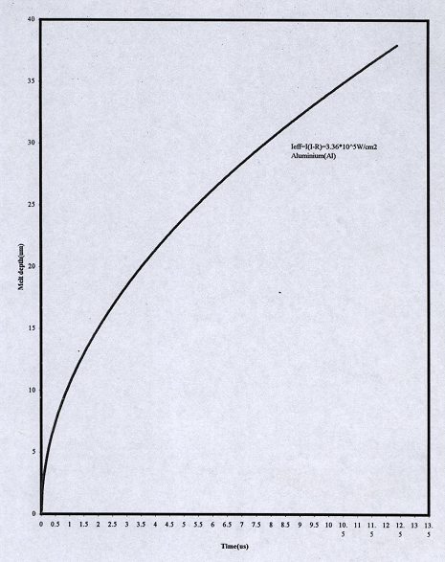
Fig (1) the variation of melt depth with time for Aluminum (Al)

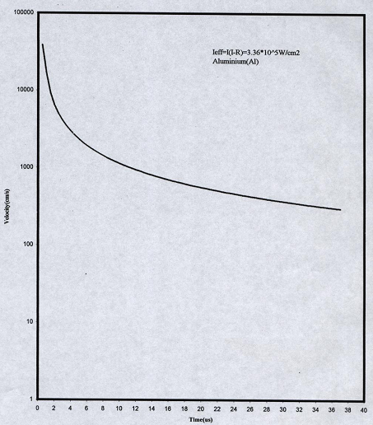
Fig (2) the variation of velocity at the solid liquid interface with time for Aluminum (Al)

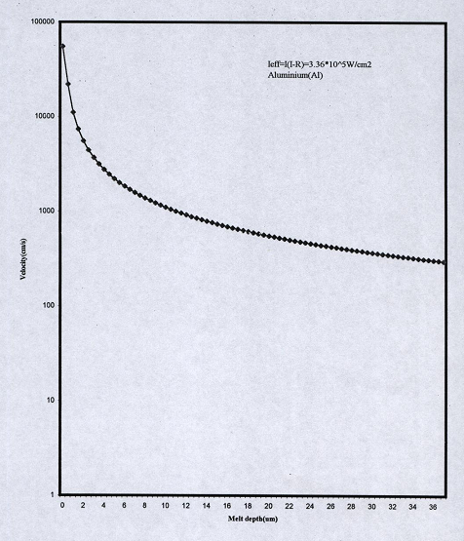
Fig (3) the variation of velocity at the solid liquid interface with melt depth for Aluminum (Al)

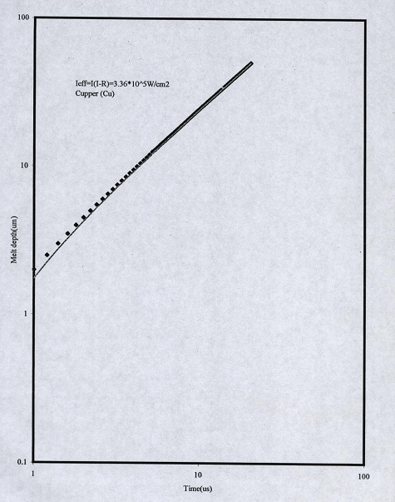
Fig (4) the variation of melt depth with time for cupper (Cu)
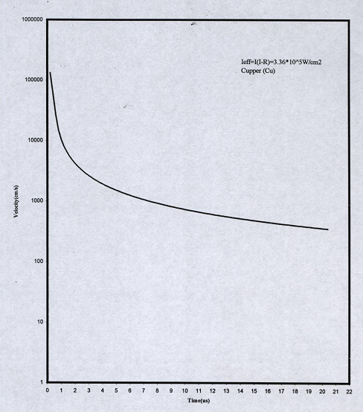
Fig (5) the variation of velocity at the solid liquid interface with time for cupper (Cu)

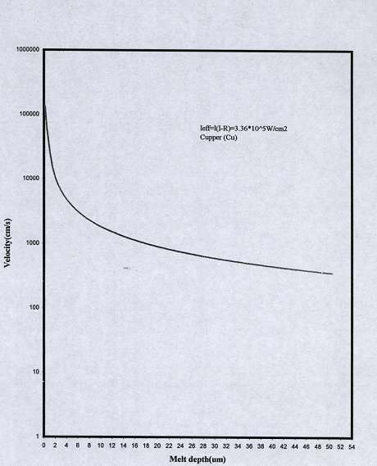
Fig (6) the variation of velocity at the solid liquid interface with melt depth for cupper (Cu)

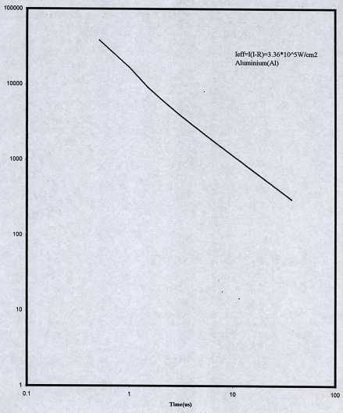
Velocity(cm/s)

Fig (7) the variation of velocity at the solid liquid interface with time(log-log) for Aluminum (Al)

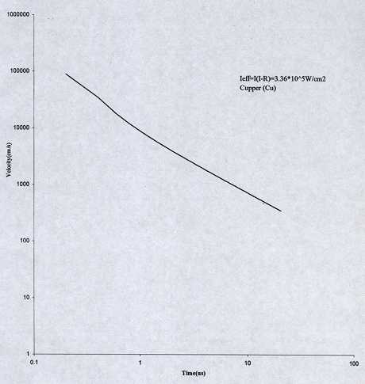
Fig (8) the variation of velocity at the solid liquid interface with time (log scale) for Cupper (Cu)

Conclusions
The change in the thermal characteristic such as thermal conductivity diffusivity, specific heat and density between Aluminum and copper, which relatively considered as similar metals cause change in the temperature distribution with distance and with time which leads to variation in melt depth and melt velocity at the solid liquid interface.
The melt depth for pure aluminum (Al) under the laser exposure of
1.68*106 w/cm2 is in the range of (12.6µm) that is corresponding to velocity at the solid liquid interface in the range (877.98cm/s). The variation of velocity decrease with increasing both time and melt depth.
The velocity at solid liquid interface for pure Cu (copper) is (2420.58 cm/s) which are more than the velocity of pure Aluminum (Al) at the same conditions. The melt depth for copper is (7.35µm) which is smaller than that of Aluminum (Al) (12µm) because of the change in the thermal properties of the two metals, which causes this shift in the value of the minimum depth.
Comparing the above results with the published results by plotting logarithm velocity against logarithm time and finding the slope of the resulting straight line, a slope of (0.5) was found, it means the velocity-time relation is the same in the published result.

Corresponding Author:
Hebatalrahman.A
Egypt.Housing & Building National Research Centre (HBRC), Egypt
Hebatalrahman@naseej.com

6. References
- Peak.U, "High-intensity laser-induced vaporization and explosion of solid material". Springer-Verlag, Berlin, 1996.
- Beck.J.V, Cole.K.D.Haji-Sheikh, A.;litkouhi. B "Heat conduction using Green's functions". New York :,Hemisphere Publishing Corporation,1992.
- Gradshteyn.I,Ryzhik.I.M"Table of integrals, series and products" English Translation Ed.by AJef&ey. New York: Academic Press ,1980.
- K.M.Lu,M.L.Cohen, E.E Haller.W.L. Hansen and I.C.Wu, Phys.Rev.B49,5034, 1994.
- A.Bousetta, and A.Schultz, Appl. Phys. Lett. 65(6), pp 696:698, 1994.
- S. R. P. Silva, J. Schwan, D. F. Franceschini and G. Mariotto, J. Appl. Phys. 81(6), pp2626: 2634 ,1997.
- Z. Zhang, Y. Li, S. Xie, and G. Yang, J. Mater. Sci. Lett. 14, ppl742:1744, 1995.
- M.Barber, J.A.Connor, M.F.Guest, I.H.Hillier, M.Schwarz, and M.Stacey, J.Chem.Soc.Faraday Trans.II 69,551,1973.
- P.W.Atkins "Physical chemistry" 2nd edition, oxford university press, 1998.
- Fan Gang, Guan Yhong and Zhang Jiatao, SPIE, vol. 3550, pp357,1997.
- Yunys .A Cengel, "Heat transfer" International edition, McGraw-Hill book company. Applied mathematics science, N. Y., 1998.
- N.B.Colthup,L.H.Daly,and S.E Wiberley "Introduction to infrared and Raman Spectroscopy" 3rd ed.(Academic Press,Inc.,San Diego, CA.1990.
- A.Mansour and D.Ugolini.Phys.Rev.B 47( 16)pp 10201:10209, 1993.
- S. Souto, and F. Alvarez.Appl.Phys.Lett. , 70(12), ppl539:1541, 1997.
- M. Tabbal, P. Merel, S. Moisan, M. Chaker, A. Ricard, and M. Moisan, Appl. Phys. Lett., 69(12), ppl698:1700, 1996.
- Y.Zhang and H.Li, Appl.Phys. Lett.68(5)pp634:636 ,1996.
- P.Hammer,M.A.Baker,C.Lenardi,and W.GisslerJ.Vac.Sci.Technol.A 15(l),ppl07:112,1997.
- J.Peng,P.Zhang,Y.P.Guo,andG.H.Chen,Matt.Lett.29,ppl91:194,1996.
- G. Dparkes, M. Andel, and D.Phil ."Modem inorganic chemistry", 2nd edition, edited by G.Dparke,westem printing services Ltd. Bristol, 1956.
- W.Guo and A.Kar, J laser application,vol. 11, no. 4, 1999.
- A.Kar and J.Mazumder J.appl.phys.61,2465-2655,1987.
- M.G.Cohen and R.A Webb J. ِppl. phys. 34,245-249,1971.
- R.C.Reed, J. M. Robenson, T. Akboy, and Z.Chin, J. Mater. Sci. Lett. 24, ppl742:1744, 1999.
- F. Falk, C. Muhlig, and A. Koba, Optics and laser technology, vol, 32,no. 4 June, 1998.
- J. M. Poates, "Surface modification and alloying", NATO Plenum press, scientific affair division, 1983.
- Dahotre, "Lasers in surface engineering". Material society, Emplet me presses, N. Y., 1998.
- S. S Rao, "The finite element method in engineering", second edition, Pergamon Press, N. Y., 1989.
- Mathworks, "Partial differential equation toolbox for use with Matlab" MathWorks,mc.,MA, 1997.

5/5/2010

