Maximization of vanillin production by standardizing different cultural conditions for ferulic acid degradation

Prakash Kumar Sarangi^{1,}*, Sonil Nanda², Haraprasad Sahoo¹
¹ PG Department of Botany and Biotechnology, Ravenshaw University, Cuttack 753 003, India
² School of Bio Sciences and Technology, VIT University, Vellore 632 014, India
* Author for correspondence. E-mail: sarangi77@yahoo.co.in

Abstract: Different cultural conditions were standardized during the biotransformation of ferulic acid into vanillin using Staphylococcus aureus. Three major parameters such as substrate concentration, temperature and supplementation of other carbon source (glucose) were taken into consideration. Ferulate concentrations of 5 mM and temperature of 35°C were standardized for optimization. The addition of glucose in to the culture medium gave more than four-fold increase in vanillin production. [New York Science Journal 2010;3(7):77-79]. (ISSN: 1554-0200).

Key-words: ferulic acid, biotransformation, Staphylococcus aureus, vanillin

1. Introduction

Ferulic acid (4-hydroxy-3-methoxycinnamic acid), is an ubiquitous phenolic acid in the plant kingdom. It is mainly conjugated with mono- and oligosaccharides, polyamines, lipids and polysaccharides and seldom occurs in a free state in plants. It is found to be extensively ester linked to lignin or polysaccharide (Hartley and Harris, 1981; MacAdam and Grabber, 2002). It is usually found as ester cross-links with polysaccharides in the cell wall such as arabinoxylans in grasses, pectin in spinach and sugar beet and xyloglucans in bamboo (Iiyama et al., 1994) It also can cross-link with proteins (Figueroa-Espinoza et al., 1999) The cross-linking property of ferulic acid with both polysaccharides and proteins suggests that it can be used in the preparation of complex gels in food applications. It is one of the most abundant phenolic acids in plants, varying from 5 g kg⁻¹ in wheat bran to 9 g kg⁻¹ in sugar-beet pulp and 50 g kg⁻¹ in corn kernel (Kroon et al., 1997). It is a phenolic acid of low toxicity and can be absorbed and easily metabolized in the human body. Ferulic acid has been reported to have many physiological functions including antioxidant (Graf, 1992), antimicrobial, anti-inflammatory, anti-thrombosis, anti-cancer activities and antibiotic properties (Beschia et al., 1982). Many species of microorganisms are able to degrade plant aromatic compounds, thus releasing a vast amount of carbon which otherwise would be locked away in plant secondary metabolites such as lignin (Rosazza et al., 1995).
Microorganisms are able to transform hydroxycinnamic acids to their corresponding hydroxybenzoates. These benzoates are important components of natural flavors and fragrances. Various industrial and food applications have been reported for ferulic acid, especially based on its microbial degradation to biovanillin and its anti-oxidant properties. Vanillin displays anti-oxidation and anti-microbial properties, hence has the potential for use as a food preservative (Burri et al., 1989). Moreover, there is a growing interest in the potential use of ferulic acid as feedstock for the biocatalytic conversion into other valuable molecules such as styrenes, polymers, epoxides, alkylbenzenes, biovanillin and vanillic acid derivatives, protocatechuic acid related catechols, guaiacol and catechol (Rosazza et al., 1995). Vanillin is the world’s most highly prized natural flavor. It is one of the most important aromatic flavor compounds used in foods, beverages, perfumes and pharmaceuticals (Clark, 1990).
In the current study of biotransformation, vanillin was the major degradation product. Various parameters such as substrate concentration, temperature and supplementation of other carbon source (glucose) were analyzed for maximum vanillin production.

2. Material and Methods

2.1. Microorganism

Staphylococcus aureus was isolated from garden soil on the basis of its ability to grow in ferulic acid containing medium. Pure cultures of this strain were maintained on a mixed medium containing both beef extract and peptone as sources of carbon.

2.2. Medium and culture conditions

After growth on a mixed broth medium containing
both beef extract and peptone for 5 days, 1 ml cell suspension was transferred into the 100 ml flask each containing 25 ml of the minimal medium (Muheim and Lerch, 1999) along with ferulic acid as a sole carbon source. The pH of the media was adjusted to 7.2. The cultures were incubated at 35ºC and analysed on day-to-day basis up to 8 days of incubation to detect the degradation product of ferulic acid. Each experiment was carried out in triplicate. The standard deviations of the analyses were less than 5%.

2.3. Extraction and detection of metabolites from the culture media

For the extraction of ferulic acid and its degradation products from the culture media, culture supernatants were collected by centrifugation. These were acidified (pH 1-2) and extracted with equal volume of ethyl acetate. The ethyl acetate was evaporated in vacuum and the residue was re-dissolved in 50% methanol. This processed culture filtrate was subjected to thin layer chromatography (TLC) and high pressure liquid chromatography (HPLC).

2.4. Standardization of culture conditions for maximum vanillin production

For optimization of conditions for maximum vanillin accumulation, effects of substrate concentration (ferulic acid), temperature and additional carbon sources were studied.

2.4.1. Substrate concentration
Effect of various concentrations of ferulic acid on vanillin formation was examined by flask experiments. S. aureus was grown anaerobically in minimal media containing various concentrations (1.0, 2.5, 5.0, 7.5, 10.0 mM) of ferulic acid as a sole carbon source

2.4.2. Temperature
Cultures were incubated at various temperatures (28ºC and 35ºC). Daily basis analysis was performed by sampling the cultures for 8 days.

2.4.3. Supplementation of other carbon sources (glucose)
In order to make high density microbial culture, S. aureus was allowed to grow in minimal media supplemented with glucose (0.1% w/v) as the chief carbon source. After completely consumption of glucose by the microorganism, ferulic acid (5.0 mM) was added into the minimal medium.

3. Results

The study was undertaken to standardize the culture conditions such as substrate concentration, optimum temperature and supplementation of carbon sources in the medium to maximize the vanillin production by S. aureus. In this research, 5mM concentration of ferulic acid was found to be optimum for maximum vanillin production (Fig. 1).

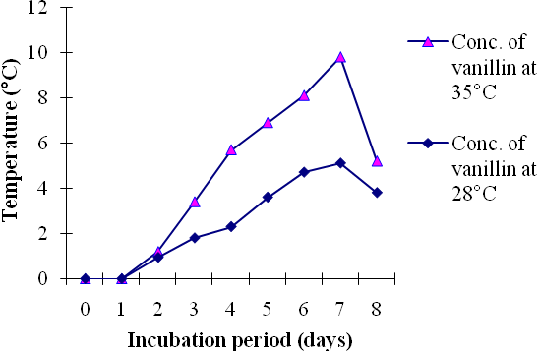

Fig1. Concentration of vanillin at two different temperatures (28 ºC and 35ºC)

There was an increase in product (vanillin) accumulation with increase in concentration of ferulic acid up to 5mM concentration. With further increase in concentration (7.5 mM and 10 mM), there was a decrease in the product formation. It was observed that a maximum amount of vanillin (9.8 mg/l) was obtained on day 7 of incubation at 35ºC as compared to 6.1 mg/l of vanillin at 28ºC (Fig 2).

Fig 2. Vanillin accumulation at various concentration of ferulic acid.

Supplementation of other carbon source (glucose) at 0.1% (w/v) concentration along with ferulic acid was tested as another cultural condition for maximum amount of vanillin production. It was reported earlier that the use of additional carbon source helped in the formation of high density cultures (Oddou et al., 1999) which helps in the formation of product in a shorter period of incubation period. Microorganism consumed ferulic acid very quickly with maximum accumulation of vanillin (45.7 mg/l) after 48 h (Fig 3).

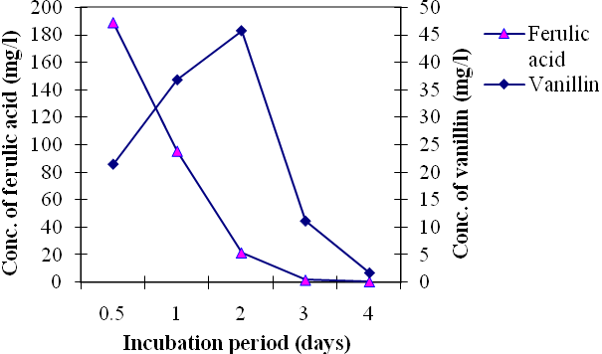
Fig 3. Biodegradation of ferulic acid in presence of glucose.

S. aureus metabolized ferulic acid rapidly with more than four-fold accumulation of vanillin. It is therefore assumed that the amount of vanillin that accumulated in the culture medium was probably toxic for the microorganism at its higher concentration.

Corresponding Author:
Mr. Prakash Kumar Sarangi
PG Department of Botany and Biotechnology
Ravenshaw University, Cuttack 753 003,
Orissa, India.
Telephone: 00 91-674-2471284, 00 91-9437305796
E-mail: sarangi77@yahoo.co.in

References
- Beschia M, Leonte A, Oancea I. Phenolic components with biological activity in vegetable extracts. Bull. Univ. Galati. 1982:6:59-63.
- Burri J, Graf M, Lambelet P, Loliger J. Vanillin: more than a flavouring agent-a potent antioxidant. J. Sci. Food Agric. 1989:48:49-56.
- Clark GS. Vanillin. Perfumer Flavorist 1990:15:45-54.
- Figueroa-Espinoza MC, Morel MH, Surget A, Asther M, Moukha S, Sigoillot JC, Rouau X, Attempt to cross-link feruloylated arabinoxylans and proteins with a fungal laccase. Food Hydrocolloids. 1999:13:65-71.
- Graf E. Antioxidant potential of ferulic acid. Free Rad.. Biol. Med. 1992:13:435-448.
- Hartley RD, Harris PJ. Phenolic constituents of the cell wall of dicotyledons. Biochem. Syst. Ecol.1981:9:189-203.
- Iiyama K, Lam TBT, Stone BA. Covalent cross-links in the cell wall. Plant Physiol. 1994:104:315-320.
- Kroon PA, Faulds CB, Ryden P, Robertson JA, Williamson G. Release of covalently bound ferulic acid from fiber in the human colon. J. Agric. Food Chem. 1997:45:661-667.
- MacAdam JW, Grabber JH. Relationship of growth cessation with the formation of diferulate cross-links and p-coumaroylated lignins in tall fescue leaf blades. Planta. 2002:215:783-793.
- Muheim A, Lerch K. Towards a high-yield bioconversion of ferulic acid to vanillin. Appl. Microbiol. Biotechnol. 1999:51:456-461.
- Oddou J, Stentelaire C, Lesage-Meessen L, Asther M, Colonna Ceccaldi B. Improvement of ferulic acid bioconversion into vanillin by use of high-density cultures of Pycnoporus cinnabarinus. Appl. Microbiol. Biotechnol. 1999:53:1-6.
- Rosazza JPN, Huang Z, Dostal L, Volm T, Rousseau B. Biocatalytic transformation of ferulic acid: an abundant aromatic natural product. J. Indus. Microbiol. 1995:15:457-471.

Submitted on 04/May/2010

