Biodegradability of polyethylene by Brevibacillus, Pseudomonas, and Rhodococcus spp.

Sonil Nanda^{1,}*, Smiti Snigdha Sahu²

¹ Orissa University of Agriculture and Technology, Bhubaneswar 751 003, Orissa, India
² VIT University, Vellore 632 014, Tamil Nadu, India
* Corresponding author. Email: isonil@yahoo.co.in

Abstract: The current article investigates the biodegradation ability of Brevibacillus, Pseudomonas, and Rhodococcus spp. in degrading polyethylene. Shake-flask incubation for 3 weeks was performed for the purpose of biodegradation. The initial and final dry weights of polyethylene before and after incubation in the culture medium were compared and the percentage of degradation was calculated. Pseudomonas was found most efficient in degrading polyethylene with its biodegradability of 40.5% followed by Brevibacillus with 37.5% and Rhodococcus with 33% biodegradability, respectively. [New York Science Journal 2010;3(7):95-98]. (ISSN: 1554-0200).

Keywords: Polyethylene; Brevibacillus; Pseudomonas; Rhodococcus; Shake-flask incubation; Biodegradation

1. Introduction

Polyethylene is a polymer made of long chain monomers of ethylene. It is a thermoplastic commodity mostly used for packaging. The worldwide utility of polyethylene is expanding at a rate of 12% per annum and approximately 140 million tonnes of synthetic polymers are produced worldwide each year (Shimao, 2001). With such huge amounts of polyethylene getting accumulated in the environment, their disposal evokes a big ecological issue. It takes thousand years for their efficient degradation. The durability, light weight, and processability of polyethylene causes it to linger in the nature for centuries and end up in landfills and/or natural water resources (Jang et al., 2002). Although there has always been a search for efficient disposal of polyethylene yet the biological means holds certain concern other than the chemical modes. Some possible measures employed for the purpose are biodegradation and biorecycling (Yang et al., 2005). Recycling is not economically feasible due to the cost factor and loss of mechanical properties (Yang et al., 2004). However, biodegradation serves a tangible alternative.
Amongst the biological ways, microbial biodegradation is widely accepted and is still underway for its enhanced efficiency. Microbial degradation of plastics is caused by certain enzymatic activities that lead to a chain cleavage of the polymer into oligomers and monomers. These water soluble enzymatically cleaved products are further absorbed by the microbial cells where they are metabolized. Aerobic metabolism results in carbon dioxide and water (Starnecker and Menner, 1996), whereas anaerobic metabolism results in carbon dioxide, water, and methane as the end products, respectively (Gu et al., 2000). The degradation leads to breaking down of polymers to monomers creating an ease of accumulation by the microbial cells for further degradation. The depolymerisation results due to various physical and biological forces (Swift, 1997). The physical forces such as temperature, moisture, pressure etc. deal with causing mechanical damage to the polymer so that the biological forces like the enzymes catalyze the process.
The present research focuses on the biodegradation of polyethylene by Brevibacillus, Pseudomonas, and Rhodococcus spp. by pure culture shake-flask incubation method. The percentage of biodegradation was evaluated by comparing the initial and final dry weights of polyethylene before and after incubation. The hypothesis of the study was microorganisms will utilize polyethylene as the sole source of carbon and energy when the rest of the nutrients in the broth are limited.

2. Material and Methods

  - Isolation of Polyethylene Degrading Bacteria

The soil sample was collected from a waste disposal site dumped with polyethylene bags and plastic products (Figure 1). The soil was analysed for its indigenous bacterial population responsible for biodegradation. Bacterial enumeration and isolation were performed.
Selective isolation of the three experimental bacteria i.e. Brevibacillus, Pseudomonas, and Rhodococcus spp. was achieved and the isolates were obtained in pure culture to be used as the inoculum in degrading polyethylene. The cultures were maintained at ambient temperature and frequently revived to sustain their viability profile.
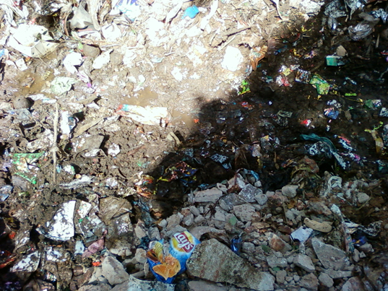

Figure 1. Image showing the site for soil sample collection.

  - Pre-treatment of Polyethylene

General grade polyethylene employed for commercial grocery carriage purpose was used to investigate its biodegradability nature. The polyethylene was cut in small and fine pieces, washed with ethanol (to remove any organic matter adhering to the surface), distilled water, and air-dried. The pieces were crushed by grinding in a mortar pestle along with sufficient amount of crystalline NaCl till they get minced in form of fine ruptured threads. The mixture was transferred into a conical flask with distilled water and mixed well in a shaker for 1 hour.
Crystalline NaCl was chosen for the purpose because the crystals would help in easy grinding and rupturing the polyethylene and its solution would wash away all impurities and organic matter adhering to it. The solution was passed through Whatman no. 41 filter paper. Polyethylene particles were recovered from over the filter paper gently and air-dried.

  - Treatment of Polyethylene

The isolated Brevibacillus, Pseudomonas, and Rhodococcus spp. were individually inoculated in 100 ml of nutrient broth in respective conical flasks except the control. 0.2 g of polyethylene was amended to each flask except the blank. The following were the experimental designs for treatments: T1 (polyethylene + Brevibacillus), T2 (polyethylene + Pseudomonas), and T3 (polyethylene + Rhodococcus). All the treatments were incubated in an incubator shaker at 150 rpm for 3 weeks but due to variation in growth temperatures, T1 was incubated at 50°C where as T2 and T3 at 40°C, respectively. The analyses were conducted in triplicates with a control and blank for each treatment. Blanks were used to examine the viability of the bacteria.

  - Dry Weight Determination of Recovered Polyethylene

The residual polyethylene particles were recovered from the broth cultures by passing though a course filter paper. The bacterial biofilm adhering to the polyethylene surface was washed by a 2% (v/v) aqueous sodium dodecyl sulphate solution for 2 to 3 hours and finally with distilled water. The washed polyethylene particles were air-dried and weighed. The dry weights of recovered polyethylene from the culture media were taken in weekly intervals (i.e. day 0, day 7, day 14, and day 21) for accounting the rate of biodegradation.

- Results and Discussion

After incubation, the culture flasks were removed from the incubator shaker and tested for the viability of microorganisms and any contamination in the medium. The test results indicated a good stability of the three bacteria in the medium with no sign of contamination. Biofilm formation by the three bacteria was clearly visible in the broth cultures and that of Pseudomonas was too viscous and slimy.

Table 1. Comparative analysis of the polyethylene weights in different treatments before and after incubation

Treatment | Weight of PE*  (g)  Initial Final |  | Weight of PE degraded  (g) | Percent of PE degradation
Blank | 0 | 0 | 0 |  | 0
Control | 0.2 | 0.2 | 0 |  | 0
T1 | 0.2 | 0.125 | 0.075 |  | 37.5
T2 | 0.2 | 0.119 | 0.081 |  | 40.5
T3 | 0.2 | 0.134 | 0.066 |  | 33.0
* Polyethylene

A comparative analysis of polyethylene biodegradation within the treatments has been shown in Table 1. Out of the three treatments, T2 (polyethylene + Pseudomonas) gave the best biodegradability of 40.5% followed by T1 (polyethylene + Brevibacillus) which gave 37.5%, and 33% by T3 (polyethylene + Rhodococcus), respectively.
During the 3 weeks incubation, the system was maintained undisturbed with no addition or removal of nutrients to and from the medium. Hence, it might be assumed that when the basal nutrients from the media were entirely utilized by the bacteria, polyethylene acted as the readily available source of carbon and energy. Figure 2 shows the rate of biodegradation by Brevibacillus, Pseudomonas, and Rhodococcus taken in weekly intervals for 3 weeks. The trend for T2 appeared slightly meander because initially in the first week Pseudomonas had a long lag phase in adapting to the changing environment but during the second and the third week a boost in the biodegradation rate was found which would have been possible for the enhanced biofilm formation and enzyme activities on polyethylene particles. The biofilm helped the bacteria to act collectively and produce sufficient metabolites to degrade the polymer and utilize it as the carbon source.

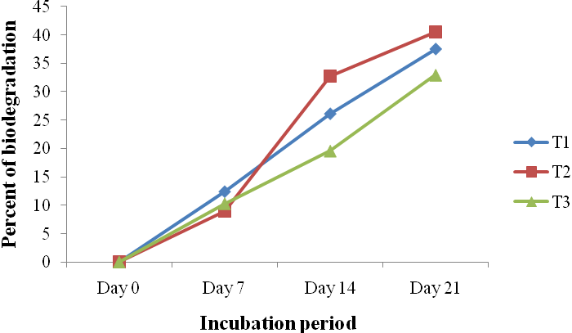

Figure 2. Trend of polyethylene biodegradation in different treatments

Biodegradation depends upon polymer characteristics, organism type and nature of pre-treatment (Shah et al., 2008). The pre-treatment of polyethylene is very significant for its biodegradation. Physical rupturing of the polyethylene and chemical washing by ethanol might have added value to its degradability. To support this, Volke-Sepulveda et al. (2002) showed that addition of ethanol to fungal cultures containing polyethylene improved the biodegradation rate of the polymer. Despite the fact that the isolated bacteria were native to the site of polyethylene disposal and might show some degradability in natural conditions, yet they also exhibited biodegradation in laboratory conditions on synthetic media. This gives some clue that these bacteria can be used in both natural and artificial conditions for the purpose of degradation of polymers.
Although there have been numerous investigations in degrading polyethylene, yet the fate of these organic polymers in the environment and the time required for their complete mineralization to carbon dioxide needs to be fully understood (El-Shafei et al., 1998). There is a growing interest in examining the activity of a consortium of microorganisms to expedite the biodegradation rate.

Corresponding author:
Sonil Nanda
Orissa University of Agriculture and Technology
Bhubaneswar 751 003, Orissa, India
Tel.: +91 9937444333
Email: isonil@yahoo.co.in

References

- El-Shafei HA, El-Nasser NHA, Kansoh AL, Ali AM. Biodegradation of disposable polyethylene by fungi and Streptomyces species. Polymer Degradation and Stability 1998;62:361-365.
- Gu JD, Ford TE, Mitton DB, Mitchell R. Microbial corrosion of metals. The Uhlig Corrosion Handbook. 2nd Edition. Wiley, New York, USA 2000:915-927.
- Jang J-C, Shin P-K, Yoon J-S, Lee I-M, Lee H-S, Kim M-N. Glucose effects on the biodegradation of plastics by compost from food garbage. Polymer Degradation and Stability 2002;76:155-159.
- Shah AA, Hasan F, Hameed A, Ahmed S. Biological degradation of plastics: A Comprehensive review. Biotechnology Advances 2008;26:246-265.
- Shimao M. Biodegradation of plastics. Current Opinion in Biotechnology 2001;12:242-247.
- Starnecker A, Menner M. Assessment of biodegradability of plastics under stimulated composting conditions in a laboratory test system. International Biodeterioration and Biodegradation 1996;85-92.
- Swift G. Non - medical biodegradable polymers: environmentally degradable polymers. Handbook of biodegradable polymers. Harwood Acedemic, Amsterdam. 1997:473-511.
- Volke-Sepulveda T, Saucedo-Castaneda G, Gutierrez-Rojas M, Manzur A, Favela-Torres E. Thermally treated low density polyethylene biodegradation by Penicillium pinophilum and Aspergillus niger. Journal of Applied Polymer Science 2002;83,305-314.
- Yang H-S, Yoon J-S, Kim M-N. Dependence of biodegradability of plastics in compost on the shape of specimens. Polymer Degradation and Stability 2005;87:131-135.
- Yang H-S, Yoon J-S, Kim M-N. Effects of storage of a mature compost on its potential for biodegradation of plastics. Polymer Degradation and Stability 2004;84:411-417.

Submitted 6 June 2010

