Production of Potato Spindle Tuber Viroid-Free Potato Plant Materials in Vitro

Sherin A. Mahfouze ^{*1}; Kh. A. El-Dougdoug² and E. K. Allam²

¹Genetic Engineering and Biotechnology Division, Genetic and Cytology Department, National Research Center, El-Beehoth street, 12622, Dokki, Giza, Egypt .
²Microbiology Department (Virology lab.), Faculty of Agricultue, Ain Shams University, Shoubra, El-Kheima, Cairo, Egypt.
Sherinmahfouze@yahoo.com

Abstract: PSTVd-_{EG} strain was isolated from infected potato plants cv. Diamond during autumn season. The PSTVd-_{EG} was eliminated from these plants by different methods. The meristem-tip culture with size (0.25 mm) gave the high percentage of plantlets PSTVd-_{EG}-free was 83.33%. The chemotherapy with ASA, 2-TU and Virazole was applied in culture media with concentrations 10, 20, 30, 40 and 50 ppm. It was found that, the percentage of PSTVd-_{EG}-free plantlets was increased by increasing chemical concentrations. The thermotherapy of plantlets in jars (21, 3-4, 5, 8 and 21 ºC /4 mon. due to PSTVd-_{EG} elimination). In addition to, the combination cold treatment of tubers plus meristem-tip culture is more effective for PSTVd-elimination in Vitro. As well as, the exposure of the tubers for electricity 5/5, 5/10, 10/5, 10/10, 15/5 and 15/10 mA/min. due to PSTVd-_{EG} elimination particularly the exposure at 10/10; 15/5 and 15/10 mA/min. The results were confirmed by dot-blot hybridization assay. [New York Science Journal 2010;3(8):60-67]. (ISSN: 1554-0200).

Key words: Potato, PSTVd, Meristem-tip, Chemotherapy, Thermotherapy, Electrotherapy

Abbreviation
2-TU= 2-Thiouracil, ASA =Acetyl salicylic acid, GA₃= Gibberillic acid, IAA= Indol acetic acid.
MS= Murashiage and Skoog, NAA= Nephthaline acetic acid, NASH= Nucleic Acid Spot Hybridization.
PSTVd-_{EG} = Potato Spindle Tuber Viroid (Egyptian Strain).

1. Introduction
Potato Spindle Tuber Viroid (PSTVd) is the type member of the genus Pospiviroid (Family Pospiviroidae) (ICTV, 2008). It is a circular single-stranded, RNA molecule, measuring between 356-361 nt. in length and un-encapsidated (Schnöelzer et al. 1985). Higher percentage of PSTVd-free was obtained from apical domes, followed by meristem and lower percentage from shoot tips (Lizárraga et al. 1982 and Salazer et al. 1985).Lower temperature (cold therapy) due to reduce or stopping viroid replication and translocation through phloem tissue (Helms & Wardlaw 1976). Whenever, PSTVd-_{EG} was not detected in plantlets grown at 5ºC for 3 and 6 mon. and low light intensity but viroid was present in tissue when plantlets was transferred to 25ºC for 1 mon. (Lizárraga et al. 1980).
There are many antiviroid chemicals such as piperonyl butoxide (Singh, 1977); Silver nitrate and ethylene (Conejero, 1982); Ribavirin (Belles et al., 1986); ethephon against Citrus exocortis viroid (CEVd) infection (Belles et al., 1990). In addition to, Chitosan (1-4 glucosamine polymers) has been shown to stimulate different responses in plants (Ryan, 1988). Amantadine, Ribavirin and Thiouracil used to eliminate viroids from infected plants (Kryczyński 1992). Potato Virus X was eliminated by exposure potato stems to 5, 10 or 15 mA for 5 or 10 min. followed by immediate planting the axillary buds tips in vitro. The highest TE values were obtained at 15 mA for 5 min. under these conditions, 40% to 80% of the buds regenerated and 60% to 100% of the regenerated plantlets tested virus negative Lozoya et al. (1996).
The first concern of the present study was production of PSTVd-_{EG}-free potato plantlets from infected tuber potato through applied meristem-tip, chemotherapy, thermotherapy electrotherapy techniques and combination with them.

2. Materias and Methods
Two-month-old PSTVd-_{EG} infected potato plants (Solanum tuberosum L.) cv. Diamond growing under greenhouse conditions were used for PSTVd elimination by meristem culture, chemical anti-viroid, thermotherapy and electrotherapy.
Detection of Potato viruses and viroid
DAS-ELISA technique was applied for detection potato viruses (PVX, PVY, PLRV, PVS, PVA, CMV and TRV) as described by Clark and Adams (1977) using an ELISA kits (completely ready for use supplied by Sanofi, Sante Animals, Paris, France).
Dot-blot hybridization for detection PSTVd was done according to (Owens et al., 1986).

Sterilization of stem nodes
The stem nodes were cut from PSTVd-_{EG} infected potato plants cv. Diamond. Nodal cutting and sprouts were washed in running tap water for 1 h. and then transferred to 5% solution of commercial bleach (sodium hypochlorite 5.25% active ingredient) containing 0.1% tween-20, Then were rinsed 3 times with sterile dsH₂O at 2, 5 and 15 min. sequently.

Meristem-tip culture
Twenty-five shoots (2-3 cm length) under the steromicroscope (CETI WF 10X) the outer leaves and leaf primordia until the youngest leaves (2 primordia) were removed. The dome with two leaf primordia was excised with 0.25 mm length by scalpel. Excised the dome meristems were cultivated on MS-medium containing (0.1 mg/L NAA + 0.5 mg/L kinetin + 2.25 gm/L phytagel) (Edriss et al., 1996) then incubated at 25ºC and light intensity 2.000 Lux for 16 h. lightday. After 21 days, the plantlets were transferred to MS propagation medium until rooting.

Chemotherapy
Stem cuttings with one leaf node were cut from potato plants cv. Diamond (6 wks-old) infected with PSTVd-_{EG} and healthy. The stem cuttings were cultured on MS medium solidified with agar (8 gm/L) in jar (250 ml vol.). Jars were incubated at 18ºC/16 h. daylight. The plantlets were multiplied in vitro as nodal cuttings in jars vol. 500 ml (5 subcultures). The nodal cuttings were transferred on MS media containing three antiviroid separated [1-β-D Ribofuranosyl- 1, 2, 4-triazole-3-carboxamide (Ribavirin or virazole), (ASA) and 2-TU]. Thirty nodal cuttings were cultivated on Paper Bridge in jars (500 ml) for each concentration. The jars were incubated on the same mentioned conditions. Percentage of survival cuttings were counted for each conc. after 30 days. The survival nodal cuttings were transferred in anti-viroid free media. After 4 wks. plantlets were detected by dot-blot hybridization against PSTVd-_{EG}.

Thermotherapy
Fivety-six PSTVd-_{EG} infected tubers of cultivar Diamond and PVX, PVY and PLRV virus tested as well as four healthy ones was used in this study. Tubers were storaged at different temperatures and periods (3-4, 5, 7-8 ºC/4 mons. in refrigerators and 21±0.2ºC/4 mons. in incubator. Fourteen tubers/treatment from each temperature. The tuber sprouts were separated and meristems with two leaves primordia were excised. The sprout and meristem tips were cultured on MS media and were incubated as above mentioned. The percentages of survival and PSTVd-_{EG}-free plantlets were counted post storage for 4 mons.

Electrotherapy
Seventy-two PSTVd-_{EG} infected tubers cultivar Diamond were exposed to electrictherapy treatment (Lozoya-Saldaña, 1996) The tubers were treated as following: current intensity-time combinations: 5, 10 or 15 (mA) for 5 or 10 min. Electricity was applied by an electrophoresis power supply (consort 600V-500 mA E865). Immediately after treatment 12 sprouts per treatment were removed from tubers. Sprouts were excised and were planted in vitro in a semi-solid MS medium. Then growing tips 1.9 mm long were excised and were planted in medium consisting of basic MS salts and supplemented with 0.25 ppm GA₃, 2.0 ppm calcium pantothenate (B₅), 3% sucrose and 2.25 mg/L phytagel (Espinoza et al., 1985). After 30 days the plantlets were transferred to shoot differentiation medium containing the basic MS salts supplemented with 0.3 ppm IAA, 0.3 ppm kinetin, 4% sucrose and 2.25 gm/L phytagel (Lozoya and Dawson 1982). The plantlets were incubated at 16 h. daylight/18ºC, for 30 days in the shoot differentiation medium. The percentages of survival and PSTVd-_{EG}-free plantlets were recorded.

Viroid detection by Dot-blot hybridization
Dot-blot hybridization was used for PSTVd-_{EG} indexing of plantlets arised from tissue culture experiment after micropropagation reindexing was performed after meristem-tip, chemotherapy, thermotherapy and electrotherapy treaments.

3. Results
Dot-blot hybridization assay was used to detect PSTVd-_{EG} in potato plants and tubers cv. Diamond virus tested which used to produce PSTVd-_{EG} -free plants as well as micropropagated plantlets. These plants were divided into three groups. Group one: was used for excised meristem-tip, Group two: for treated chemotherapy of plantlets micropropagated in vitro and Group three: PSTVd-_{EG}- infected tubers were treated with cold and electrotherapy treatments.
Meristem-tips size 0.25 mm was excised from PSTVd-_{EG} potato plants cv. Diamond under stereomicroscope. They were cultivated on MS medium and incubated under convenient conditions. After four subcultures the meristems were developed to shoot (Figure 1), the survival of potato plantlets was 75% and percentage of PSTVd-_{EG}-free plantlets was 83.33%. These results were confirmed by dot-blot hybridization (Table 1).
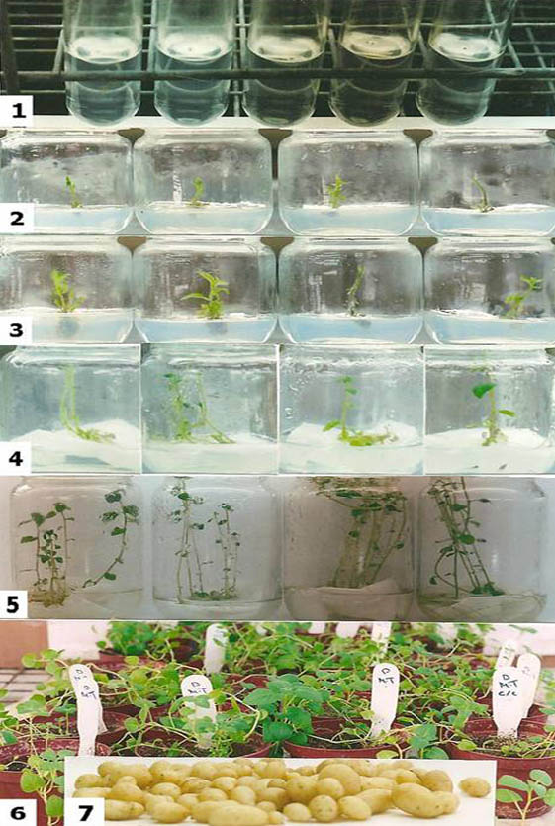

Figure 1. Micropropagation of PSTVd -free potato plantlets by meristem tip on MS-media.
1- Meristem-tip (0.25 mm size), 2, 3- Establishment stage. 4- Multiplication stage, 5- Rooting stage, 6- Adaptation, 7- Minitubers.

The plantlets were cultured on MS media treated with three different anti-viroid compounds. These compounds [Ribavirin (Virazole), 2-TU and ASA were incorporated individually into MS medium with concentrations 10, 20, 30, 40 and 50 ppm. The plantlets were incubated for 30 days. Incorporation of anti-viroid virazole, 2-TU and ASA in culture medium at conc. of 10, 20, 30, 40 and 50 ppm progressively increased the percentages of viroid-free plantlets to 57; 71.4; 77.7; 87.5 and 87.5 for virazole, 50, 63.63, 66.6, 77.7 and 85.7 for 2-TU and 42.8, 50, 71.42, 75 and 83.3 for ASA respectively. In addition, the percentage of survival decreased with increment conc. of the chemical antiviroid (Table 1). On the contrary, the effect of chemical antiviroid on the development plantlets was different such as virazole proved to be somewhat phytotoxic in highest concs. 40 and 50 ppm causes severe stunting in plantlets, thin stem and stunted leaflets.

Table 1: Effect of chemotherapy and meristem-tip on production of PSTVd-_{EG} -free plantlets in vitro.
Chemotherapy treatments | % survival* |  | % viroid elimination
Chemotherapy treatments | H | I | % viroid elimination
Meristem-Tip••(0.25 mm) | 75.0 | 75.0 | 83.3
Chemotherapy •
10 mg/L virazole | 100 | 100 | 57.0
20 mg/L virazole | 87.7 | 73.3 | 71.4
30 mg/L virazole | 80.0 | 73.3 | 77.7
40 mg/L virazole | 76.6 | 54.0 | 87.5
50 mg/L virazole | 76.6 | 42.0 | 87.5
10 mg/L Thiouracil | 93.3 | 66.6 | 50.0
20 mg/L Thiouracil | 70.0 | 63.3 | 63.6
30 mg/L Thiouracil | 36.6 | 30.0 | 66.6
40 mg/L Thiouracil | 35.0 | 28.3 | 77.7
50 mg/L Thiouracil | 33.3 | 25.3 | 85.7
10 mg/L Salicylic | 95.0 | 100 | 42.8
20 mg/L Salicylic | 90.0 | 84.4 | 50.0
30 mg/L Salicylic | 88.3 | 72.2 | 71.4
40 mg/L Salicylic | 78.3 | 61.6 | 75.0
50 mg/L Salicylic | 65.5 | 33.3 | 83.3
* Jar contaiing 30 plantlets. •Total number of tested plantlets 240 (8 jars x 30 plantlets), ••Total number of tested plantlets 25 (one meristem per tube).
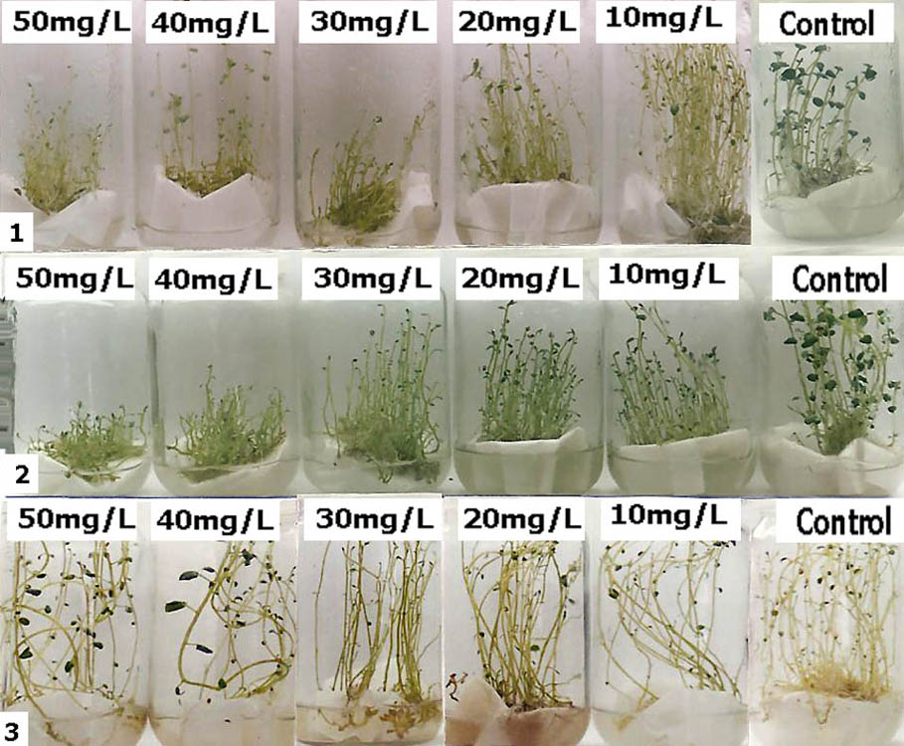

Figure 2. Micropropagation of plantlets on MS media treated with different concentrations of virazole. 1- Healthy plantlets treated with different concentrations of virazole, 2- PSTVd infected plantlets treated with different concentrations of virazole., 3- Re-subculture of plantlets on fresh media without virazole.

Whereas, concentrations 30, 40, 50 ppm from 2-TU cause deleterious effects on growth of potato shoots, and concentrations 20, 30 and 40 ppm from ASA cause stunting of plantlets and concs 30, 40 and 50 ppm encourage formation of callus in some plantlets, while conc. 50 ppm induced formation of microtuber in vitro. But this phytotoxic effect was removed when subcultured on fresh medium without antiviroid-compunds. These results were confirmed by NASH (Table 1) and (Figures. 2, 3 and 4).
Potato tubers cv. Diamond infected with PSTVd-_{EG} isolate were exposed to low-temperatures and cold therapy in refrigerators at 3-4; 5, 8ºC/4 mon. and incubator 21ºC/4 mon. (Table 2). Sprouts were excised with 0.5 mm buds. As well as, meristem-tip (0.25 mm) separated from sprout then micropropagated on MS media. It was found that percentage of sprout survival was 100%. Whenever, PSTVd-_{EG} elemination percentages from sprouts were 61.50, 71.4, 71.4 and 64.2 at temperatures 21,
3-4, 5 and 8ºC respectively. On the other hand,
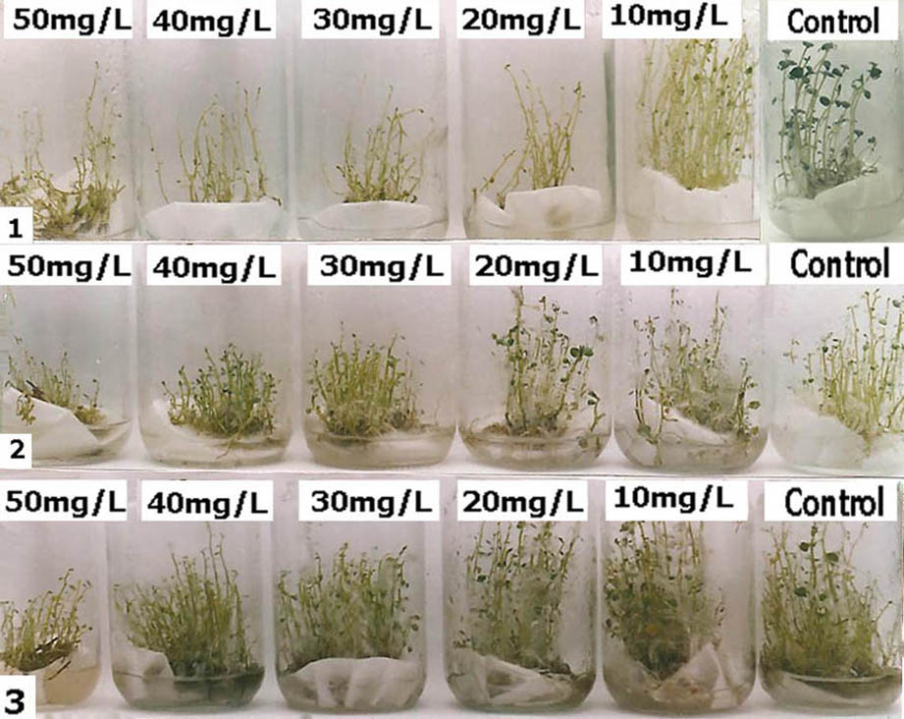
meristem-tip excised from sprouts exposured for low-temperatures 3-4, 5, 8ºC for 4 mon. were the best treatments for viroid elimination which gave 100%, whereas 21ºC/4 mon. gave 77.7 %. However, survival rate of meristem-tip was 85.7; 71.4, 57.1 and 57.1% for temperatures 21, 3-4, 5, 8ºC for 4 mon. respectively (Table 2). These plantlets were indexed for PSTVd isolate by dot-blot hybridization assay.

Figure 3. Micropropagation of plantlets on MS-media treated with different concentrations of 2-TU.
1-Healthy plantlets treated with different concentrations of 2-TU, 2- PSTVd infected plantlets treated with Different concentrations of 2-TU, 3- Re-subculture of plantlets on fresh media without 2-TU.

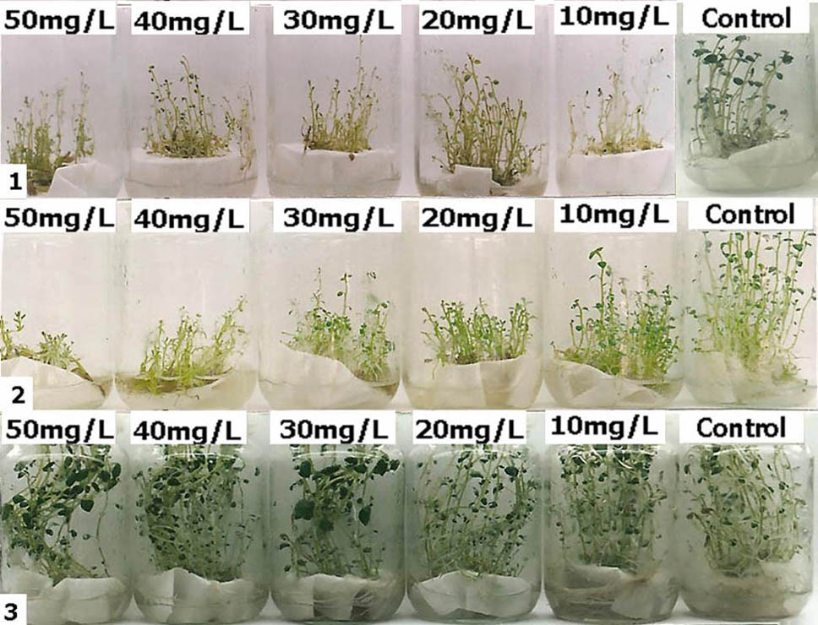

Figure 4. Micropropagation of plantlets on MS media treated with different concentrations of ASA.
1- Healthy plantlets treated with different concentrations of ASA., 2- PSTVd infected plantlets treated with different concentrations of ASA., 3- Re-subculture of plantlets on fresh media without ASA.
Each 12 potato tubers cv. Diamond infected with PSTVd-_{EG} isolate were exposed to 5, 10 and 15 mA for 5, 10 min. The sprouts of these tubers were excised and cuttings with 0.5 mm (explant). The explants were planting on MS media. The shoot-tips of plantlets were excised from plantlets and planting on MS media. It was found that treatments 10/10; 15/5 and 15/10 mA/min were the more effective for PSTVd-_{EG} elimination (100 %) (Table 2). While, 5/5; 5/10 and 10/5 mA/min treatments gave 66.7; 0 and 0 % respectively. On the other hand, it was observed that regeneration Increased in treated sprouts with electrically compared with untreated electrotherapy ones. On the contrary, the survival rate decreases with increase electricity and treatment time (Figure 5 and Table 2). These results were confirmed by NASH.
4. Discussion
The size 0.25 mm of meristem-tips was excised from PSTVd-_{EG} infected potato plants cv. Diamond under stereomicroscope and was cultured on meristem-tip media. The meristem- tip was developed of complete plantlets with 75% the survival of potato plantlets.
Table 2: Elimination of PSTVd from infected tubers by thermotherapy and electrotherapy.

Treatment | Explant treated | % of survival plantlets | % of  PSTVd elimination**
Thermotherapy.  21ْْْْ C / 4mon.  3-4ْْْْ C / 4mon.  5ْْْْ C / 4mon.  8ْْْْ C / 4mon.  Electrotherapy.  (mA/min)  5/5  5/10  10/5  10/10  15/5  15/10 | Sprout  Meristem-tip  Sprout  Meristem-tip  Sprout  M Meristem-tip  Sprout  M Meristem-tip  Shoot-tip | 14/14 (100%)  12/14 (85.74%)  14/14 (100%)  10/14 (71.4%)  14/14 (100%)  8/14 (57.1)  14/14 (100%)  8/14 (57.1)  (6/12) 50.0  (8/12) 66.6  (8/12) 66.6  (6/12) 50.0  (5/12) 42.0  (6/12) 50.0 | 61.50  77.7  71.4  100  71.4  100  64.2  100  (4/6) 66.7  (8/8) 0  (8/8) 0  (0/6) 100  (0/5) 100  (0/6) 100
*Plantlets survived/Total of treated samples.
** Plantlets PSTVd–free/Total Plantlets survived.
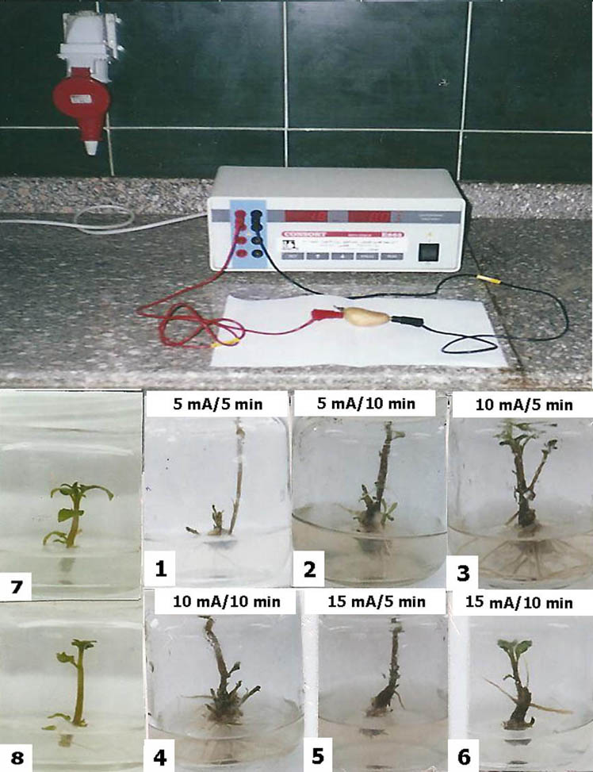

Figure 5. The electrotherapy procedure of PSTVd infected tubers and micropropagation of sprouts on MS media, 1-6) Sprouts of treated tubers cultured on MS media, 7) Sprout of untreated healthy tuber, 8) Sprout of untreated PSTVd- infected tuber.
As well as, the plantlets survived PSTVd-_{EG}-free were 83.33%, where as gave negative result against PSTVd-_{EG} by dot-blot hybridization. The same results were obtained by (Stace-Smith, 1989 and Edriss et al., 1996) who mentioned that viroids were eliminated from shoot apical meristems with ranging size 0.2 to 0.5 mm long, but not obtained from longer ones. Lizáraga et al. (1982) and Salazar et al. (1985) showed that eradication of PSTVd was higher in the smaller tissue reactions and the higher percentage of eradication PSTVd was obtained from apical domes, followed by meristem-tip and in lower percentage from shoot-tips. They discussed this result where PSTVd no infection meristem cells since no phloem elements are found in apical domes and phloem elements disconnected from the rest of the plant vascular system are present in meristem-tips larger portions of apical tissue (like shoot-tips) already contain sieve tubes which are connected to the vascular system of the plant.
Three different anti-viroid compounds namely virazole (Ribavirin), 2-TU and ASA were incorporated individually into MS-medium with 10, 20, 30, 40 and 50 ppm. Potato explants (Nodal cuttings) were taken from PSTVd-_{EG} infected potato plants cv. Diamond and were cultured on media. It was found that, using concentrations of 10, 20, 30, 40, and 50 ppm progressively increased the percentage of PSTVd-_{EG}-free plantlets for three compounds. But on the contrary, the percentage of survival decreased with increment concentration compared to the control. Thus, was found that Virazole proved to be somewhat phytotoxic in highest concentrations (40 and 50 ppm) and it causes stunting in plantlets, thin stem and stunted leaflets. The same results were obtained by many authors Kryczyński (1992) explained that the virazole inhibited viroid multiplication by RNA breaking. Also, they found that Ribavirin has been successful in reducing PSTVd concentration in Scopolia sinensis plants, but in shoot-tip culture or cuttings grown from Ribavirin-treated plants, viroid conc. rapidly reappears. Belles et al. (1986) showed that Ribavirin has been tested against viroids; it was active in eliminating Citrus exocortis viroid from Gynura aurantiaca as foliar applications. They found that concentrations. The lower than 30 mg L⁻¹ was not effective, while phytotoxicity occurred at concentrations of 1600-2000 mgL⁻¹.
It was found that the highest concentrations 30, 40 and 50 ppm of 2-TU cause deleterious effects on growth of potato shoots. These results were similar with Commoner and Mercer (1951) who reported that 2-TU (Pyrimidine analogue) is a powerful inhibitor of virus synthesis and replication. Also, Clerence & Agrawal (1972) mentioned that 2-TU affect on the metabolism of the plant itself; the young leaves become pale and apical growth is arrested. Kryczyński (1992) mentioned that amantadine, ribavirine and thiouracil used to eliminate viroids from infected plants.
In related to, ASA it was found that concentrations 20, 30, 40 and 50 ppm cause stunting of plantlets and concentrations 30, 40 and 50 ppm encourage formation of calli in some plantlets, while concentration 50 ppm induce formation of microtubers in vitro. These results agreed with those reported by Malamy and Klessig (1992) who observed that ASA improve callus growth and/or regeneration in some culture media. Yu et al. (1997) found that ASA induce systemic acquired resistance (SAR). It has been proposed that SAR is mediated by an endogenous signal that is produced in the infected leaf and translocated in the phloem to other plant parts where it activates resistance mechaisms SAR is often induced by avirulent pathogens carrying an avirulence (avr.) gene. The production of an avr gene is recognized by the production of a resistance R-gene in plants (gene-for-gene recognition). In the case of viroid infection, however, involvement of R-genes is unlikely since viroids do not encode proteins. Therefore it will be of great interest to elucidate the PSTVd-activated pathway that is cross-linked with a SAR pathway to activate common down-strain genes encoding PR-1 and β 1, 3 glucanse (Itaya et al., 2002). Our results indicate that PSTVd-_{EG} can be more successfully eliminated by treated PSTVd-infected plants cv. Diamond under conditions of low temperature and more efficiency when used a combination of low temperature treatment and subsequent meristem-tip culture. Thus showed that PSTVd-_{EG} elimination percentage from sprouts were 61.50; 71.4; 71.4 and 64.2 at temperatures 21; 3-4; 5 and 8ºC respectively. On the other hand, meristem-tip excised from sprouts exposured for low temperatures 3-4; 5; 8ºC for 4 mons. were more efficiency for viroid elimination (100%) than in those at 21ºC/4 mon. (77.7%). Whenever, the percentage of sprout survival was 100% for meristem-tip was 85.7; 71.4; 57.1 and 57.1% for 21, 3-4; 5 and 8ºC/4 mons. The same result was obtained by (Lizàrraga et al., 1980). Hadidi et al. (2003) who mentioned that cold treatment of tubers, cuttings and plants must be pronged, even for mons. to increase the percentage of viroid-free plantlets, propably, the length of the treatment could be reduced when applied to in vitro cultured germplasm. The reduced size and tenderness of plant tissue could increase the effect of temperature allowing it to reduce the time of exposure. Also, the percentage of viroid elimination differed according to the isolate. Paduch-Cichel and Kryczński (1987) reported that prolonged a low temperature therapy (longer than 3 mon.) in eradication of PSTVd. The PSTVd-free plants were obtained from meristem-tips of sprouts from infected tubers after 6 months of therapy at 6 to 7ºC in the dark. The efficiency of 6 mon. therapy varied from 18.5 to 80% depending on viroid and plant material. A 3 mon therapy period at the same temperature proved to be too short.
Potato tubers cv. Diamond infected with PSTVd-_{EG} were exposed to 5, 10 and 15 mA for 5; 10 min. followed by immediate planting the sprout in vitro then shoot-tips were excised and cultured on MS media. Temperature was increased from 4 to 10ºC in the tissue during the exposure to the electricity. After a 40 days growing period, electricity was influenced by the severity of treatment since organogenesis and viroid elimination were both stimulated by the electricity. The highest PSTVd-_{EG}-free values were obtained at 10/10; 15/15 and 15/10 mA/min. On the contrary, the survival rate decreases with increase electricity and treatment time. These results were compatible with that found by. Hadidi et al. (2003) mentioned that the viroids also may be eliminated if plants are treated simultaneously at low (2-5ºC) or high (37-38ºC) temperatures, especially if plants are exposed simultaneously to low irradiance lighting followed by shoot-tip culture. Also, Lozoya-Saldaña et al., (1996) who observed that Potato Virus X was eliminated by exposure potato stems to 5, 10 or 15 mA for 5 or 10 min. followed by immediate planting the axillary buds tips in vitro. Temperature increased from 4 to 10ºC in the tissues during the exposure to the electricity. After 60 days growing period, therapy efficiency (TE = % plant regeneration X % virus-free resulting plants) was influenced by the severity of treatment, since organogenesis and virus elimination were both stimulated by the electricity. The highest TE values were obtained at 15 mA for 5 min. under these conditions, 40% to 80% of the buds regenerated and 60% to 100% of the regenerated plantlets tested virus negative.

Corresponding Author:
Dr. Sherin Amin Mahfouze
Genetic Engineering and Biotechnology Division, Genetic and Cytology Department,
National Research Center,
El-Beehoth street, 12622, Dokki, Giza, Egypt
E-mail: Sherinmahfouze@yahoo.com

References
[1] Belles, J.M., Hansen A.J., Granell, A., Conejero, V. 1986. Antiviroid effects of ribavirin on citrus exocortis viroid infection in Gynura aurantiaca. DC. Physiology Molecular Plant Pathology 28: 61-65.
[2] Belles, J.M., Granell A., Conejero, V. 1990. Impairment of viroid infection in Gynura aurantiaca plants by treatment with 2-chloroethylphonic acid (ethephon). Canadian Journal of Plant Pathology 12: 175-179.
[3] Clarence, I. Kado, Hari, O. Agrawal 1972. Principles and Techniques in Plant Virology, Van Nostrand Reinhold Company, New York, pp. 32-41.
[4] Clark, M.F., Adams, S.A.N. 1977. Characteristics of the microplate method of enzyme-linked immunosorbent assay for the detection of Plant Viruses. Journal of General Virology 34: 475-483.
[5] Commoner, B., Mercer, F. 1951. Inhibition of the biosynthesis of tobacco mosaic virus by thiouracil. Nature 168:113-114.
[6] Conejero, V. 1982. Do viroid elicit host pre-existing mechanisms of response? IV International Conference on Comparative Virology. Control of Viral Diseases. Banff. Alberta, Canad, Abstract W 12-1.
[7] Edriss, M.H., Badawy, M.A., Fathi, S., El-Barkouki, T.M. 1996. Propagation of potato using tissue culture technique. Acta Horticulture 434: 413-418.
[8] Epinoza, N., Estrada, R., Tovar, P., Bryan, J.H 1985. Cultivo de Tejidos: Micropropagación, Conservación y Exportación de germoplasma de papa. Documento de Tecnologia Especializada 1. CIP, Lima, Peru. 18 pp.
[9] Hadidi, A., Flores, R., John Randles, W., Joseph, S. Semancik 2003. Viroids-Casiro, Australia 370 pp.
[10] Helms, K., Wardlaw, I.F. 1976. Movement of viruses in plants: long distance movement of tobacco mosaic virus in Nicotiana glutinosa. In: Transport and transfer processes in plants ,eds. Wardlaw, I.F. and J.B. Passiour,:PP. 283-294. Academic Press, New York.
[11] ICTV, (2008) (http://tak.ictvonline.org).
[12] Itaya, A., Matsuda, Y., Gonzales, R.A., Nelson, R.S., Ding, B. 2002. Potato spindle tuber viroid strains of different pathogenicity induces and suppresses expression of common and unique genes in infected tomato. Molecular plant microbe Interactions15 (10): 990-999.
[13] Kryczyński, S. 1992 Plant viroids in Plant. In: Plant disease of viral, viroid, mycoplasma and uncertain etiology. Published in India by Mohan Primlani for Oxford & IBH, pp. 45-65.
[14] Lizárraga, R.E., Salazar, L.F., Roca, W.M., Schilde-Rentschler, L. 1980. Elimination of potato spindle tuber viroid by low temperature and meristem culture. Phytopathology 70: 754-755.
[15] Lizárraga, R.E., Salazar, L.F., Shilde-Rentschler, L. 1982. Effect of meristem size on eradication of potato spindle tuber viroid. In: Research for the potato in the year 2000. Proc. Int. Congress 10th Anniv, ed. Hooker, W.J. 1982:PP. 118-119. Int. Potato Center, February, Lima, Peru.
[16] Lozoya Saldăna, H., Dawson, W.O.1982. Effect of alternating temperature regimes on reduction or elimination of viruses in plant tissue. Phytopathology 72: 1059-1064.
[17] Lozoya Saldăna, J., Albelló, F.H., Garciá de la, R.G.1996. Electrotherapy and shoot tip culture eliminate potato virus X in potatoes. American Potato Journal 73:149-154.
[18] Malamy, C., Klessig, D.F. 1992. Salicylic acid and plant disease resistance. The Plant Journal 2(5): 643-654.
[19] Owens, R.A., Hammond, R.W., Gardner, R.C., Kiefer, C.M., Thompson, S.M., Cross, D.E. 1986. Site-specific mutagenesis of potato spindle tuber viroid cDNA. Plant Molecular Biology 6: 179-192.
[20] Paduch, C., Kryczyński, S. 1987. A low temperature therapy and meristem tip culture for eliminating four viroids from infected plants. Journal of Phytopathology 118(4): 341-346.
[21] Ryan, C.A.1988. Oligosaccharides as recognition signals for the expression of defensive genes in plants. Biochemistry 27: 8879-8883.
[22] Salazar, L.F., Schilde-Rentschler, L. Lizarraga, R.1985. Elimination of potato spindle tuber viroid from potato by cold treatment and meristem culture. In: Subviral pathogens of plants and animals: Viroids and prions. The international potato center lima, peru. pp. 137-150.
[23] Schnöelzer, M., Hass, B., Ramm, K., Hofmann, H., Saenger, L. 1985. Correlation between structure and pathogenicity of potato spindle tuber viroid (PSTVd). EMBO Journal 4(9): 2181-2190.
[24] Singh, K.P.1977. Piperonyl butoxide as a protectant against potato spindle tuber viroid infection. Phytopathology 67 933-935.
[25] Stace-Smith, R.1989. Tissue culture. In: Plant viruses, Volume II Pathology CRC Press. Inc. United State.
[26] Yu, D., Liu, Y., Fan, B., Klessing, D.F. and Chen, Z. 1997. Is the high basal level salicylic acid important for disease resistance in potato?. Plant Physiology 115, 343-349.

30/5/2010

