Comparative study on the protective effect of Biphenyl Dimethyl Dicarboxylate (DDB) and Silymarin in Hepatitis induced by carbon tetrachloride (CCl₄) in rats

Hoda. A. Megahed¹, Hanan G. Zahran ², Mahmoud. S. Arbid³,
A. Osman⁴ and Soha M.Kandil⁵
^{1.}Medical Biochemistry Department ,^{2.} Thraputical Chemistry Department ,^{3.} Pharmacology Department ,^{4.} Vet. Medicine C.U. and ⁵ Kaser El Ainy new Hospitals C.U (C.U = Cairo University) , ^{1,2,3.} National Reacher center.
drhodamegahed@yahoo.com

Abstract: Study on the possible protective effect of (DDB) and Silymarin on Hepatitis induced by CCl₄ was carried out. Injection of CCl₄ daily orally administered to rats in a dose of 2.5ml/kg for three days significantly increase the activity of AST, ALT, ALK. Ph. Bilirubin and GGT by several folds of increase, also urea and creatinin were elevated by CCl₄ given orally. Administration of DDB and Silymarin orally seven day after administration of CCl₄ for three days Significantly decrease liver and kidney enzyme DDB and Silymarin administered before CCl₄ to rats also significantly decrease the activity of liver and kidney enzymes. Histopathological investigation of this study show good confirmation to biochemical analysis. [New York Science Journal 2010;3(9):1-11]. (ISSN: 1554-0200).
Keywords: Hepatitis, DDB, Silymarin, rats.

1. Introduction
Among the several infections that might affect the humn liver are hepatitis viruses A, B, C and D Alter and Mast (1994). Because of its unique metabolism and its intimate relationship to the gastro-intestinal tract, the liver is considered as an important target of toxicity by drugs and xenobiotics.
The degree of hepatotoxicity results from an imbalance between the generation of toxic metabolites and its detoxification processes occurring in the human liver Pineiro-Carrero et al., (2004).
The use of carbon tetrachloride (CCl₄) for induction of liver hepatitis in rat's model was well established (Janakat and Al-Merie 2002; El-Shenawy, 2003).
DDB is synthetic analogue of schizandrin C, one of the active components isolated from Fructus schizandra, a traditional oriental medicinal plant, chemically termed dimethyl 4,4`- dimethoxy- 5,6,5`,6` dimethylene- dioxybiphenyl -2,2` dicaboxylate. This compound (DDB) was shown to protect against liver injury induced by CCl₄ (Oh et al.,2000) . In addition, DDB was used successfully for treatment of cases of chemically induced hepatitis (Kim et al.,2000; El Sawy et al.,2002) , and has a beneficial effect on liver enzymes and the resulting histopatholagical changes Xu et al.,(1997) .
Silybum marianum (Milk thistle) contains silymarin, a mixture of flavanolignans chiefly consisting of silibin, silydiamin, and silychristine (Wagner,1986). Silybum marianum extracts (usually standardized to contain 70% silymarin) have been shown to protect the liver from wide range of toxins including CCl₄ Vogel et al., (1975).
Silymarin is a well-known plant product, which have hepatoprotective activities that mostly explained by antioxidative properties, inhibition of phosphatidylcholine synthesis or stimulation of hepatic RNA and protein synthesis (Li et al. ; Schumann et al., 2003).
The present study aimed to investigate the protective effect of each of DDB and Silymarin on rats model affected by hepatitis induced by CCl₄.

2. Materials and methods:
1- Materials
1-1 Drugs
Dimethyl Dicarboxylate (DDB) and Silymarin pure materials obtained from Arabic company of medicinal plants (Mebaco, Egypt).

1.2 Chemicals
Carbon teterachloride (CCl4) obtained from Egyptian company for chemicals and pharmaceuticals (ADWIA).

1.3 Diagnostic kits
1- For the determination of transaminases (AST, ALT) obtained from Bio merieux, France.
2- For determination of alkaline phosphates, blood urea nitrogen, creatinine and bilirubin obtained from Biodiagnostic, Egypt.
3-Gamma Glutamic transaminase (GGT) obtained from Quimica Clinica Aplicada S.A, Spain.

1.4 Animals
Forty-eight Sprague dawley albino rats of both six weighting 100g b.wt used through the experiments all animals were obtained from animal house unit national research centre, Dokki Giza, Egypt. The animals allowed free access to water and fed on uniform stander diet formula Rogers (1979).

2- Methods:
2.1- Experimental design
Forty – eight rats were divided into eight groups of six animals each as following:
Group 1- Normal control group received a daily oral dose of 1 ml saline.
Group 2- Received a daily oral dose of DDB 300mg/kg for seven days.
Group 3- Received a daily oral dose of Silymarin 22 mg/kg for seven days.
Group 4- Received a daily oral dose of CCl₄ 2.5 ml/kg for three days.
Group 5- Received a daily oral dose of CCl₄ 2.5 ml/kg for three days followed by given a single oral dose of DDB 300mg/kg for seven days.
Group 6- Received a daily oral dose of CCl₄ 2.5ml/kg for three days followed by given a single oral dose of 22mg/kg for seven days.
Group 7- Received a daily oral dose of DDB 300ml/kg for seven days followed by given a single oral dose of CCl₄ 25 ml/ kg for three days.
Group 8- Received a daily oral of Silymarin 22 mg/kg for seven days followed by given a single oral dose of CCl4 2.5 mg/kg for three days.

2.2 Assessment of liver and kidney functions :
The blood was obtained from all groups of rats by puncturing rato-orbital plexus Sanford (1954), the blood was allowed to flow into clean dry centrifuge tube and left to stand, and the serum was separated by centrifugation and examined for:
- AST and ALT were done according to colorimetric method after Reitman and Frnakel (1957).
- Alkaline phosphates was done calorimetrically after Belfied and Goldberg (1971).
- Blood urea nitrogen was done according to Henry et al.(1974).
- Creatinine was done according to colorimetric method (Bartles et al, 1972).
- Blirubin was done according to Walter and Gerade colorimetric method (1970).
- Gamma- Glutamic transminase (GGT) was done according to Szasz (1969).

2.3- Histopathological investigation
Tissue specimens form liver and kidney of treated and control rats were fixed in 10% neutral buffered formalin solution. The fixed specimens were trimmed, washed and dehydrated in ascending grades of alcohol, cleaned in xylene, embedded in paraffin then sectioned (4-6 micron) and stained with hematoxyline and eosin.

2.4. Statistical analysis
All results were expressed as mean ± SE comparison between groups were performed by ANOVA followed by Duncan test. P<0.05 was considered statistically significant.
According to (Bancroft et al., 1996), the degree of hepatic injury was estimated using an ordinal scale modified from Plaa and Charbonneau (1994).

Table (1): Histological grading of liver injury
Grade | Description
O | No apparent injury by light microscopy
I | Swelling of hepatocytes
II | Ballooning of hepatocyes
III | Lipid droplets in hepatocytes
IV | Necrosis of hepatocytes

3. Results
Results in table (2) shows that CCl₄ significantly increase the activity of AST, ALT, ALK ph., Bilirubin and GGT by several folds of increase. The same effect was observed in case of urea and creatinine.

Table (2): Comparative effect of silymarin (Sy) or biphyenyl dimethyl dicarboxilate (DDB) on liver and kidney toxicity induced by carbon tetrachloride (CCl₄) in rats.
Groups | AST (IU/L) | ALT (IU/L) | ALK PH (IU/L) | Urea (mg/dl) | Creatinine (mg/dl) | Bilirubin (mg/dl | GGT (U/L)
Control | 9±0.34ª | 4.02±0.063ª | 166.293±7.43^{b} | 19.22±5.3ª | 0.64±0.033ª | 0.056±0.016ª | 13.5±5.7ª
DDB | 7±0.9ª | 2.2±0.75ª | 154.59±4.09^{b} | 24.47±2.12^{c} | 0.56±0.035ª | 0.23±0.008^{c} | 17.6±13.11ª
Sy | 14.3 ±3.84ª | 8.5±4.86ª | 155.366±10.32^{b} | 26.92±1.3^{c} | 0.6±0.023ª | 0.03±0.009ª | 16.4±5.97ª
CCl₄ | 29.2±2.5^{b} | 51.2±5.10^{b} | 229.267±5.83^{b} | 35.04±3.17^{b} | 4.46±0.018^{b} | 1.55±0.034^{b} | 35.36±7.49^{v}
CCl₄+DDB | 6.33±0.88ª | 2.33±0.67ª | 176.676±2.16^{c} | 29.65±2.16^{c} | 0.54±0.04ª | 0.042±0.016ª | 18.4±5.8ª
CCl₄+Sy | 8±0.81ª | 2.6±0.76ª | 156.466±6.98^{b} | 32.47±4.03^{bc} | 0.48±0.05^{c} | 0.06±0.029ª | 24.9±6.44^{C}
DDB(7) + CCl₄ | 18.5±1.76^{ac} | 18.5±6.22ª | 121.875±6.22ª | 14.65±0.94ª | 0.65±0.02ª | 0.36±0.095^{Cd} | 28.8±9.03^{bC}
Cy (7) +CCl₄ | 19.8±1.24^{ac} | 39±3.38^{b} | 103.384±5.45ª | 15.31±2.18ª | 0.58±0.036ª | 0.43±0.06E
a-c: Means with different letters in the same column differs significantly (P<0.05).

DDB and Silymarin significantly decrease the activity of ALT, AST and ALK ph. before and after administration CCL4.
Meanwhile the decrease was more prominent if the rats pretreated by DDB and Silymarin. The results also in table (2) show that DDB was more effective than Silymarin. From the results shown in table (2) it was a quite obvious that DDB had a significant effect more than Silymarin particularly in case of AST, ALT, urea bilirubin and GGT.
Comparison between the effect of DDB and Silymarin on the activity of liver and kidney enzymes befor injection of CCl₄ was shown table (3).
The same trend was observed in urea and creatinine activities. Figures from 1-7 give more evidence that DDB and Silymarin had a curative and protective effect against liver and kidney damage induced by CCl₄.

Table (3): The differences of the rats affected by DDB and Silymarin before administration of CCl₄.
Parameters | CCl₄ | CCl₄ +DDB | CCl₄+ SY
AST (IU/L) | 30.5 ± 2.5^{b} | 6.82 ± 0.88ª | 8.7 ± 0.4ª
ALT (IU/L) | 58.2 ± 5.10^{b} | 2.51 ± 0.67ª | 3.1 ± 0.76ª
ALK Ph. (IU/L) | 240.5 ± 3.28^{c} | 180.33 ± 5.83^{b} | 160.4 ± 0.98^{b}
Urea (mg/dl) | 37.3 ± 3.17^{b} | 30.63 ± 2.16^{c} | 29.42 ± 4.03^{bc}
Creatinine (mg/dl) | 4.82 ± 0.02^{b} | 0.51 ± 0.04ª | 0.53 ± 0.05^{c}
Bilirubin (mg/dl | 1.49 ± 0.03^{b} | 0.03 ± 0.02ª | 0.07 ± 0.03ª
GGT (U/L) | 36.2 ± 7.49^{b} | 17.5 ± 5.80ª | 22.8 ± 6.44^{c}
a-c: Means with different letters in the same raw differs significantly (P<0.05).

2- Histopatholgical investigation
- The 1st group (control):
The animals were apparently normal. Histological examination of liver revealed grade (0) and kidney of this group showed normal structure picture (1,2&3).
- The 2st group (Received –CCl₄):
Liver of CCl₄ exposed group showed necrobiotic change of hepatocytes including vacuolar degeneration, nuclear pyknosis and necrosis, the hepatic injury appeared as grade (III, IV). Narrowing of hepatic sinusoids and hyperplasia of Kupper cells were also noticed picture (4). Portal triads showed fibrous connective tissue proliferation and hyperplasia of bile duct picture (5).
Kidney of the same group showed swelling of tubular epithelial ling especially the proximal convoluted tubules. Coagulative necrosis of some renal tubules was also seen picture (6).
- The 3st group (Received – CCl₄ and Silymarin):
Liver of animal received- CCl₄ and Silymarin showed ballooning degeneration of hepatocytes and single cell necrosis. Silymarin produced less pronounced hepatoprotective effect and the hepatic injury resembling to grade (II) picture (7). On the other side hyperplasia of bile duct in for m of numerous number of newly formed bile ductless picture (8).
Kidney of the same group revealed mid swelling of tubular epithelial lining in compression with the 2nd group picture (9).
- The 4st group (Received- CCl₄ and DDB):
Liver of animals received – CCl₄ and DDB showed mild swelling of hepatocytes and narrowing of hepatic sinusoids. DDB induced more hepatoprotection than Silymarin and the tissue injury appeared as grade (1) picture (10). Portal triads showed normal histological structure as well as kidney in compression with the 1st group (control) pictures (11, 12).

4. Discussion
This study shows that, in rats, treatment with Biphyenyl Dimethyl Dicarboxylate (DDB) and Silymarin inhibited CCl₄ induced hepatic and kidney damage. Liver damage was evaluated by measurement of ALT, AST, ALK ph., Bilirubin and GGT activities and kidney damage was evaluated by measurement of urea and creatinine activities. Moreover treatment of CCl₄ injected rats with DDB and Silymarin before and after the administration of CCl₄ improve the activities of liver and kidney enzymes.
In the present study, intoxication with CCl₄ caused drastic increase in the activities of liver and kidney enzymes. But the rats orally administered with DDB and Silymarin for three days after administration of CCl₄ was more effective if administered before CCl₄ injection.
Vogal et al. (1975) showed that Silymarin in the most potent protecting substance it cause marked reduction in the activities of several liver enzyme sin experimental animals. Li et al.(2003) stated that Silymarin is able to reduce ALT elevation in animals exposed to CCl₄. Schumann et al.,(2003) stated that silibinine is the major pharmacologically active compound of Silymarin marianum fruit extracts Silymarin its well known hepatoprotecitve activities are mostly explained by antioxidative properties, inhibition of phosphatidycholine synthesis or stimulation of hepatic RNA and protein synthesis. This exemplifies the heapatoprotective potential of Silibinine as an immune modifier in T-cell dependent hepatitis in vivo.
Concerning the protective effect of DDB (Xu et al., 1997 ) reported that DDB efficiently protected the hepatocytes against CCl₄ induced damage. Wagner (1986) stated the DDB- dependently decreased the levels of ALT and AST compared with CCl₄ intoxication only.
Also he stated that DDB cause significant decrease in the elevated liver enzymes in chemically injured rats.
The results of histopathological investigation of the present study show good confirmation of the biochemical analysis.

Conclusion
The results in the presented study indicate that DDB and Silymarin improve the activates of liver and kidney enzymes of both normal and CCl₄ intoxicated rats meanwhile it was observed that DDB was more effective than Silymarin.
Moreover this study showed that the curative effects of these compounds are a little more effective than its protective effect against CCl₄ induced liver toxicity.

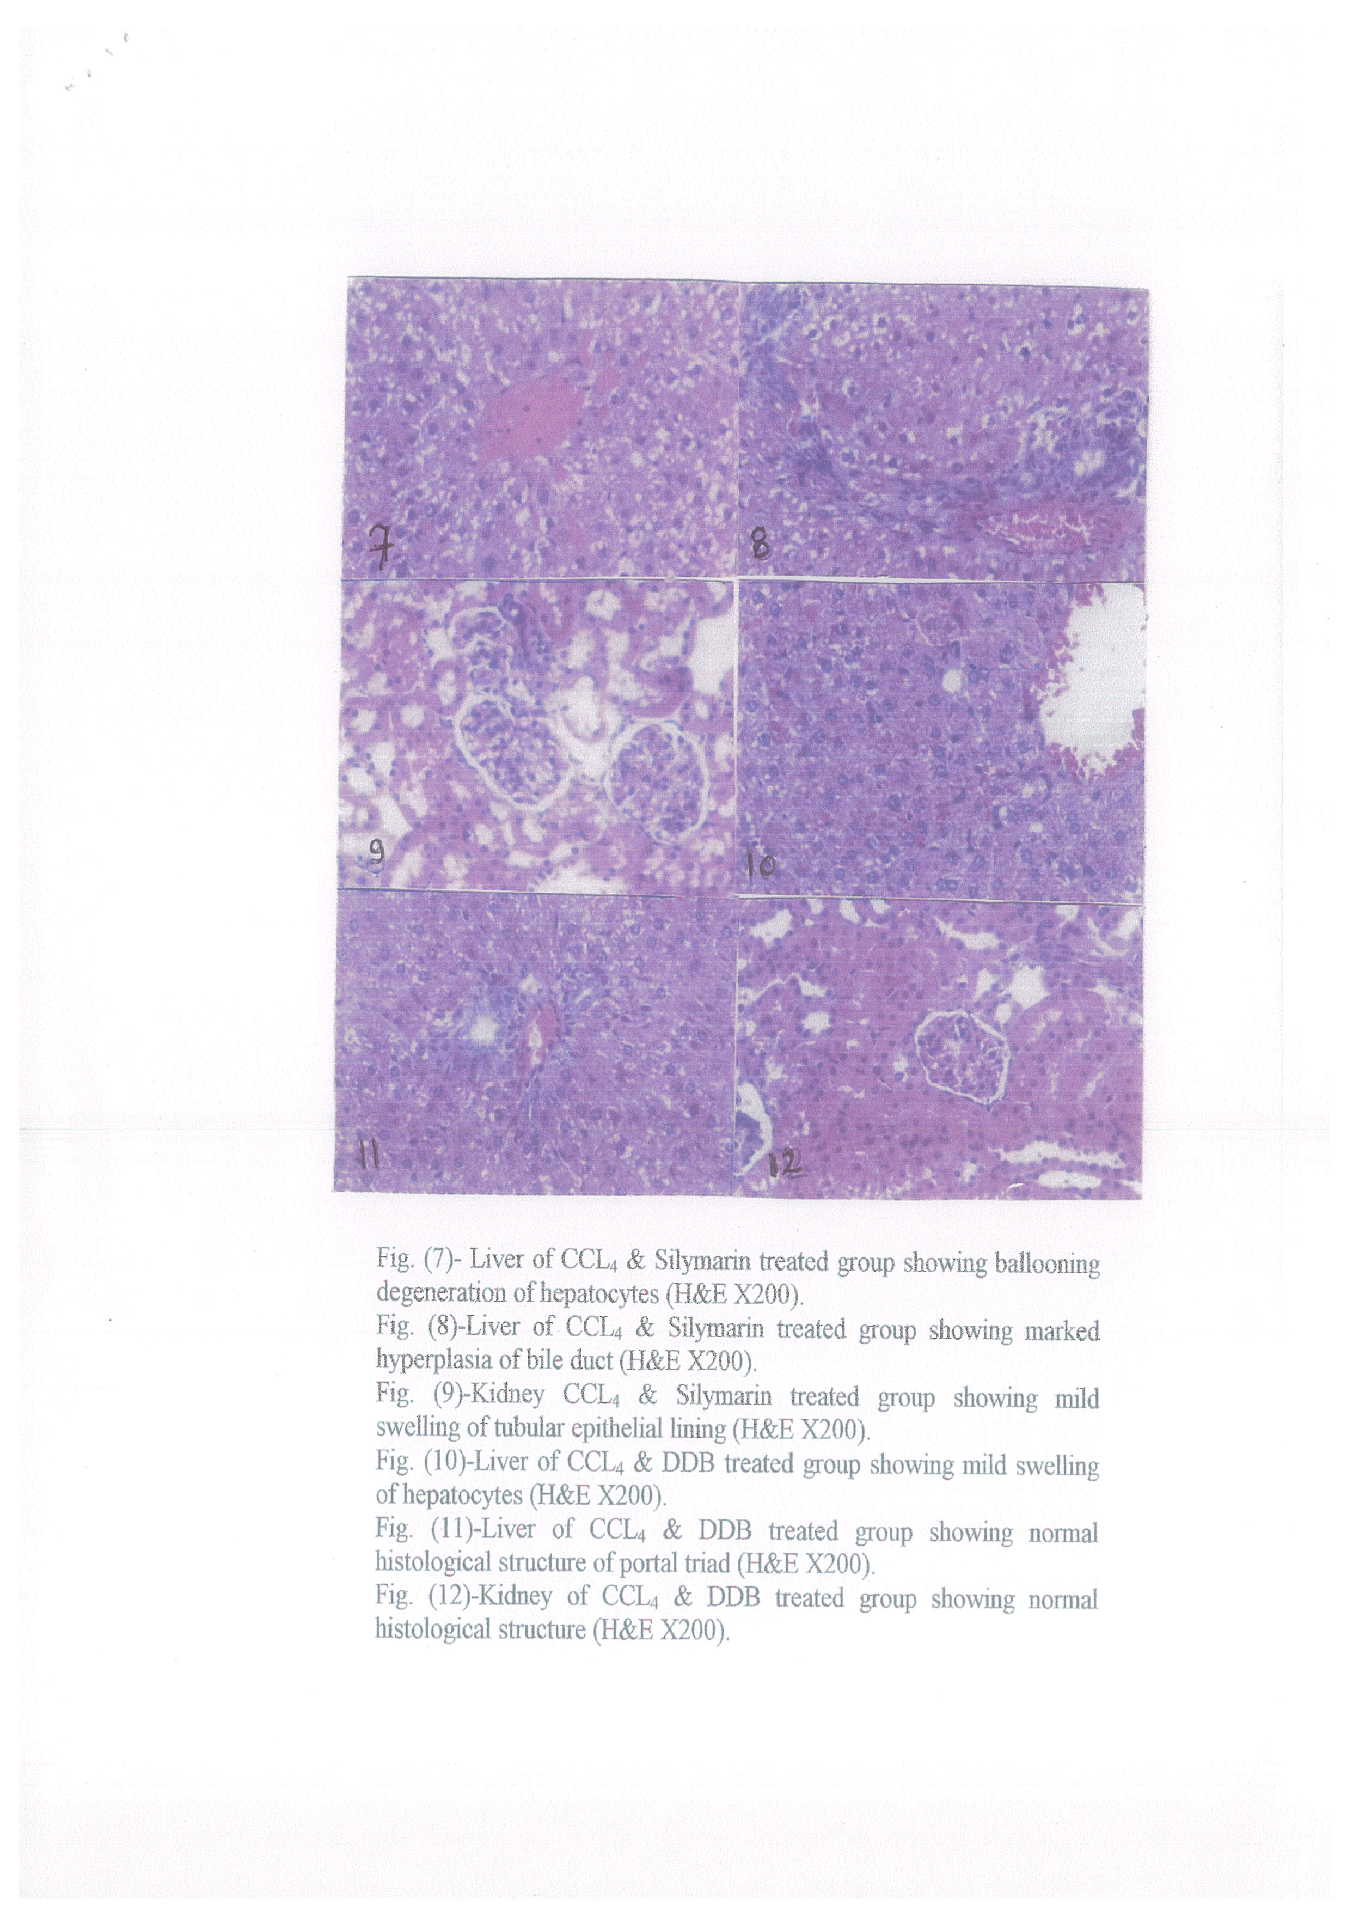

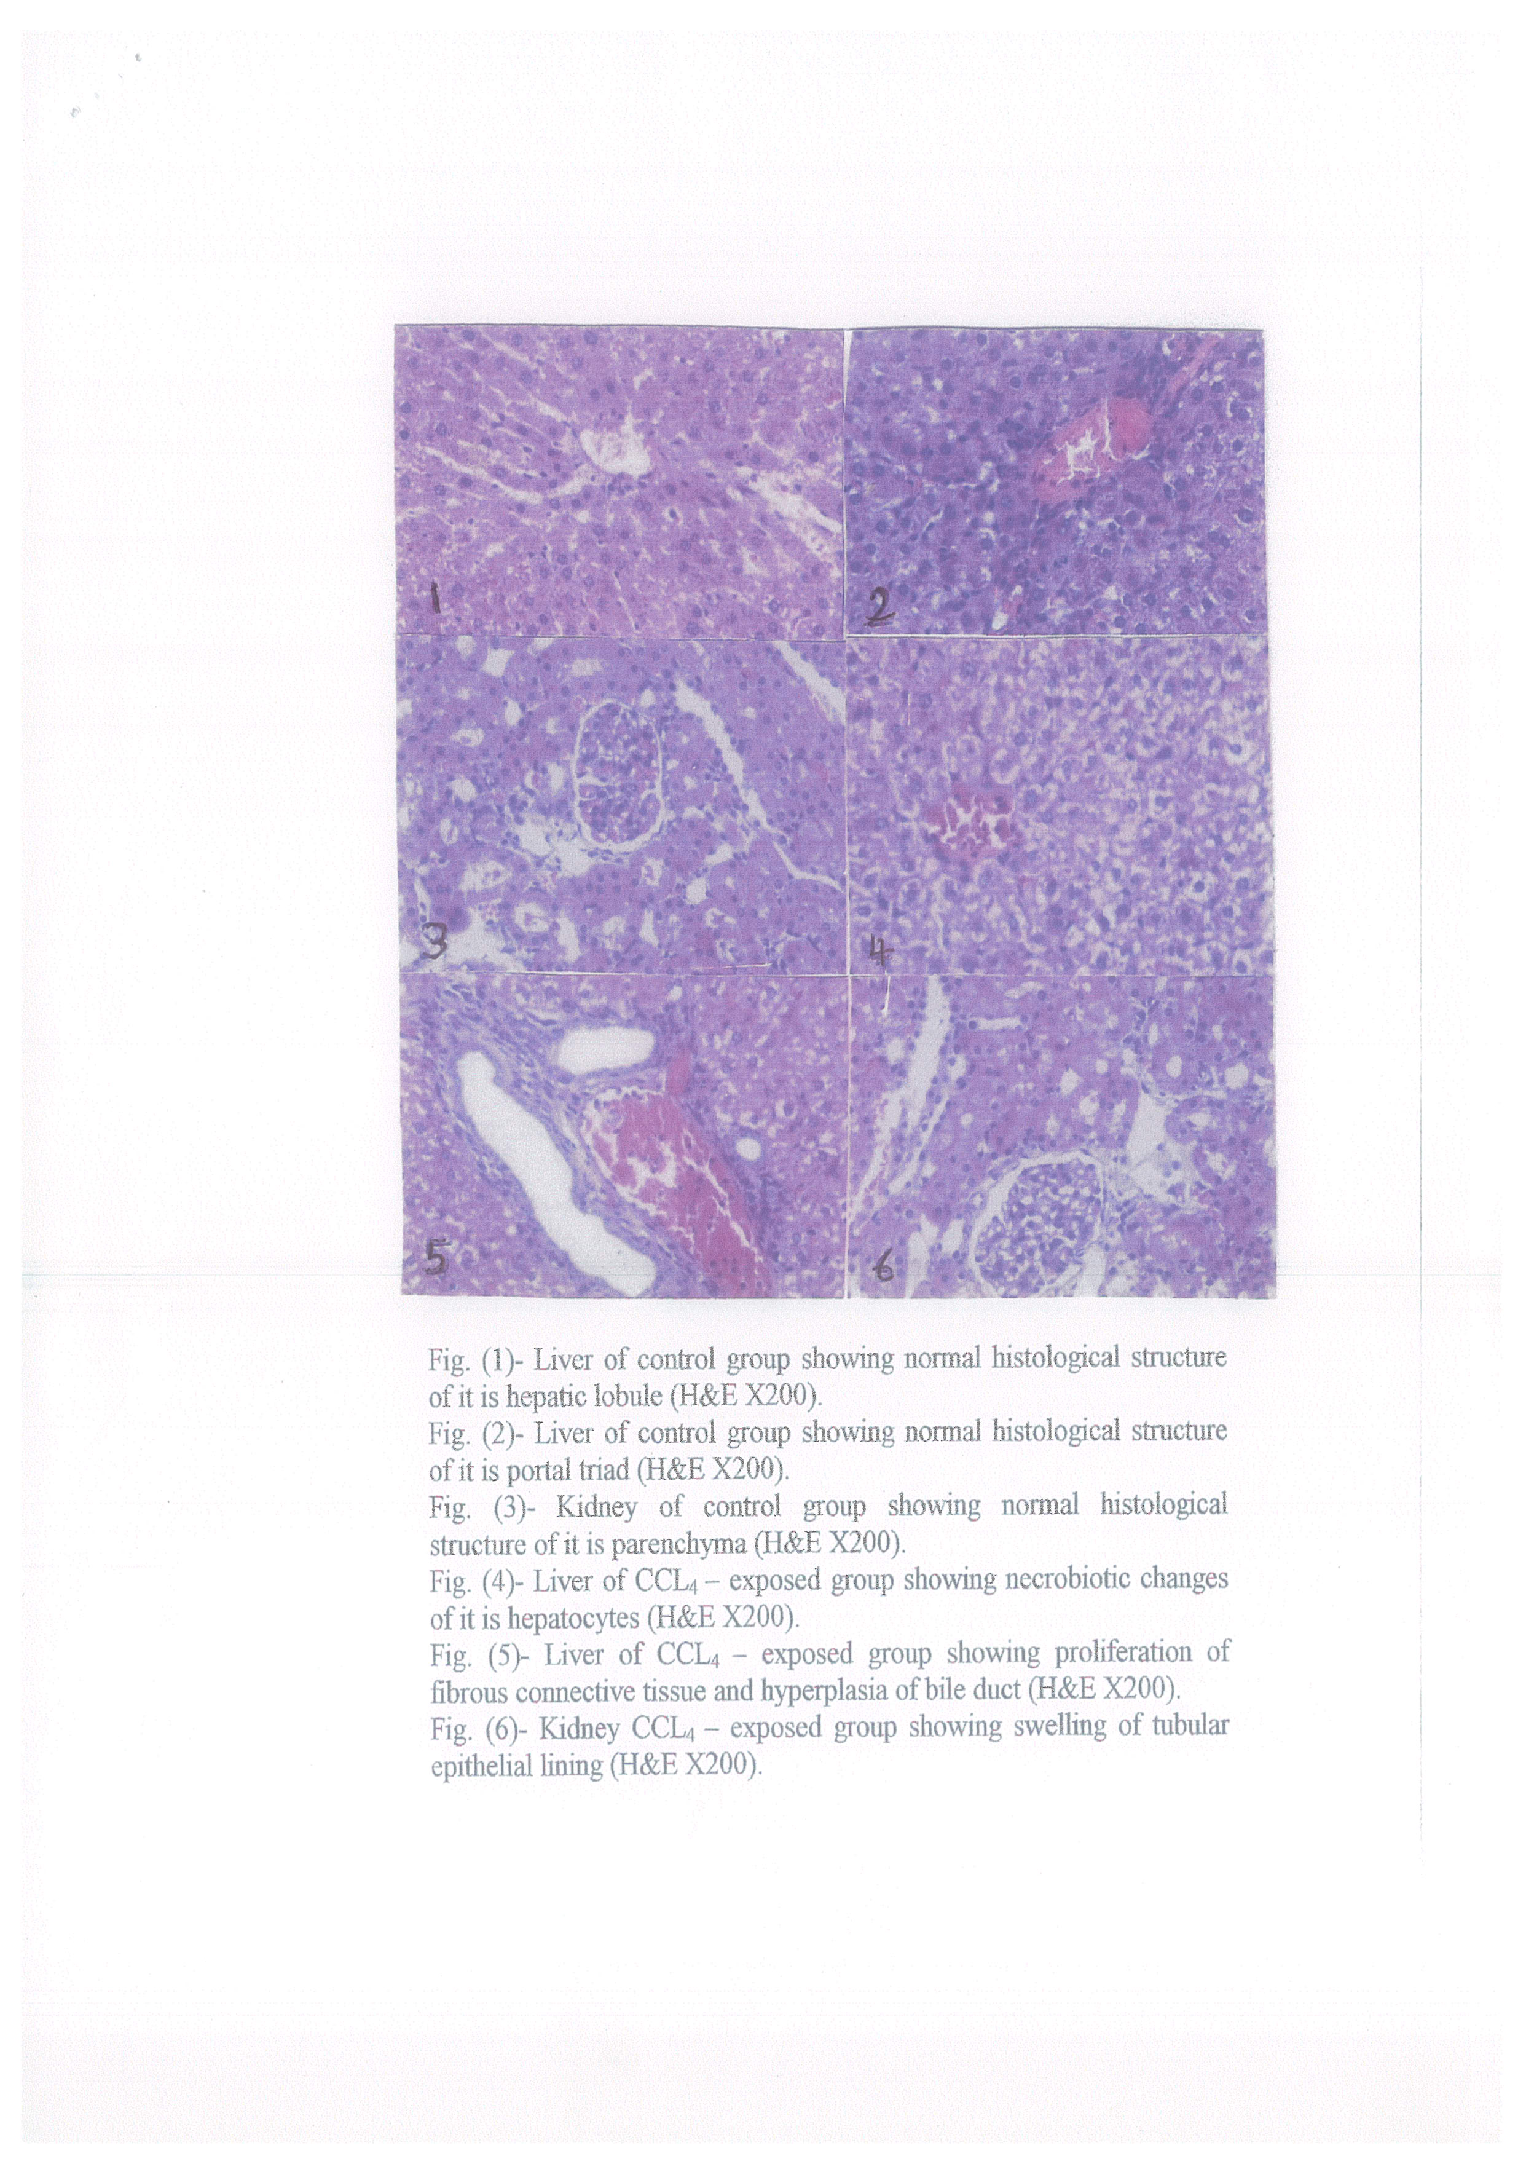

Con.(IU/l)
Fig (1): Effect of Sy and DDB on the activity of AST on heptatotoxicity induced by CCl₄ in rats (n -6).
Con.(IU/l)
Fig (2): Effect of Sy and DDB on the activity of ALT on heptatotoxicity induced by CCl₄ in rats (n -6).

Con.(IU/l)
Fig (3): Effect of Sy and DDB on the activity of Alkaline phosphatase on heptatotoxicity induced by CCl₄ in rats (n -6).

Con.(mg/dl)
Fig (4): Effect of Sy and DDB on the activity of urea on heptatotoxicity induced by CCl₄ in rats (n -6).

Con.(mg/dl)
Fig (5): Effect of Sy and DDB on the activity of creatinine on heptatotoxicity induced by CCl₄ in rats (n -6).

Con.(mg/dl)
Fig (6): Effect of Sy and DDB on the activity of bilirubin on heptatotoxicity induced by CCl₄ in rats (n -6).
Con.(IU/l)
Fig (7): Effect of Sy and DDB on the activity of GGT on heptatotoxicity induced by CCl₄ in rats (n -6).

Reference:
- Alter M. J. and Mast E.E. The epidemiology of viral hepatitis in the United States. Gastroenterol. Clin. North Am.1994; 23: 437-442.
- Pineiro-Carrero, V.M. and Pineiro, E.O. Liver. Pediatrics.2004; 113(4): 1097-1106.
- Janakat S. And Al-Merie H. Optimization of the dose and route of injection, and characterization of the time course of carbon tetrachloride induced hepatotoxicity in the rat. J. Phrmacol. Toxicol. Methods. 2002; 48: 41-44.
- Siham M. El-Shenawy . The protective effect of melatonin, silymarin and their combination in experiment induced acute hepatotoxicity. J. Egypt. Soc. Pharmacol. Exp. Ther. 2003; 23( 2): 229-245.
- Oh, S.Y.; Lee C.H. and Ku, Y.S. Pharmacokinetics and hepatoprotective effects of 2-methylaminoethyl-4-4`-dimethoxy-5,6,5`,6`dimethylenedioxybiphenyl-2-carboxylic acid-2`-carboxylate monohydrochloride in rats with CCl₄-induced acute hepatic failure. J-Pharm-Pharmacol. 2000; 52( 9): 1099-1103.
- Kim, J.H.; Mun, Y.J; Chun, H.J.; Jeon, K.S; Kim, Y.O; Woo, W.H. Effect of biphenyl dimethyl dicarboxylate on the humoral immunosuppression by ethanol. Int. J. Immunopharmacol. 2000; 22 (11): 905-913.
- El-Sawy, S.A; El-Shafey, A.M. and El-Bahrawy, H.A. (2002). Effect of dimethyl diphenyl bicarboxylate on normal and chemically-injured liver. East-Mediterr-Health J. 8, 95-104.
- Xu, O; Lu, J; Wang, R; Wu, F; Cao, J. And Chen, X . Liver injury model induced in mice by a cellular immunologic mechanism – study for use in immunopharmacological evaluations. Pharmacol- Res. 1997; 35( 4): 273-278.
- Wagner H. Antithepatotoxic flavonoids. In: Cody V, Middleton E, Harbourne JB, eds. Plant flavonoids in biology and medicine: biochemical, pharmacological, and structure-activity relationships. New York, NY: Alan R. Liss. 1986 P: 545-558.
- Vogel G., Trost W. and Braatz R. Studies in pharmacodynamics site and mechanism of action of silymarin, the antihepatotoxic principle from Silybum marianum (L.) Gaert. Arzneim- Forsch. 1975 25: 179-185.
- Li, M.Y.; Ryan P. and Batey, R.G. Traditional Chinese medicine prevents inflammation in CCl₄-related liver injury in mice. Am J. Chin. Med. 2003; 31 (1): 119-127.
- Schumann, J.: Prockl, J.; Kiemer, A.K.; Volmar, A.M.; Bang, R. and Tiegs, G. Silibinin protects mice from T cell –dependent liver injury. J. Hpeatol. 2003; 39(3): 333-340.
- Rogers, A.E. "Nutrition , in the laboratory rats (Ed. Boker, H.J., Linsy, JR. and Weisbroth S.H) Pl, 123 Academic press, New York 1979.
- Sanford,H.S. Method for obtaining venous blood from orbital sinus of the rat or mouse.science. 1954; 119: 100 – 102.
- Reitman, S., and Frankel. A Colorimetric method for the determination of serum glutamic oxaloacetic and glutamic pyruvic transaminases. Am. J. Clin. Path. 1957; 28: 26-63.
- Belfield A. and Goldberg D.M. Enzyme. 1971; 12: 561-573.
- Henry J.B., and todd (1974). Clinical diagnosis and measurement by laboratory methods., 16th e., W.B. Saunders and Co., Philadelphia PA. p260.
- Bartles H., Bohmer M. and Heirli C. Clin. Chem. Acta. 1972; 37: 193-196.
- Walter M. and Gerade H. Microchem J.1970; 15: 231-235.
- Szasz G. Clin. Chem. 1969; 15: 124-136.
- Bancroft, J.D; Stevans A. And Turner D.R. Theory and practice of histological techniques. 4th Ed. Churchill Livinigstone, Edinburgh, London, Melbourne, New York.1996.
- Plaa, G.L. and Charbonneau M. Detection and evalution of chemically induced liver injury: In Hayes, A.W. (ed.) Principles and methods of toxicology. 3rdEd., Raven press, New York.1994.

6/1/2010

