Determination of Capsaicin Content and Pungency Level of Five Different Peppers Grown in Nigeria.
¹C.O. Nwokem*, ²E.B. Agbaji, ²J.A. Kagbu, ²E.J. Ekanem
¹National Research Institute for Chemical Technology, Zaria, Nigeria.
²Department of Chemistry, Ahmadu Bello University, Zaria, Nigeria.
onyenwokem@yahoo.com
Abstract: The determination of capsaicin content in five different peppers grown in Nigeria without the need for a derivatization step is here presented. Extraction of capsaicin was done using methanol as solvent and capillary Gas Chromatography-Mass Spectrometry used for quantitation. “Nsukka” Yellow pepper (Capsicum chinense) had the highest concentration of capsaicin (9.177 ± 0.268mg/g) and pungency level (146,823.20 SHU), whereas, “Zaria tatashe” (Capsicum annuum) had the lowest concentration (1.189 ± 0.073mg/g) and pungency level (19,015.20 SHU). All the peppers analyzed in this study can be classified as very highly pungent as the Scoville Heat Unit (SHU) values exceed 80,000, except the tatase, Zaria (Capsicum annuum) which has a mean SHU value of 19,015.20. [New York Science Journal 2010;3(9):17-21]. (ISSN: 1554-0200).
Keywords: Pepper, Capsaicin, Gas Chromatography-Mass Spectrometry

Introduction
Peppers belong to the family Solanaceae, genus Capsicum and species annuum, frutescens or chinense. They are widely used in many parts of the world as a result of their valued sensory attributes; colour, purgency and aroma. Pungency, a commercially important attribute of peppers, is due to the presence of six chemically related compounds; capsaicin, dihydrocapsaicin, norcapsaicin, nordihydrocapsaicin, homocapsaicin and homodihydrocapsaicin which constitute the “capsaicinoids” group (Perucka and Materska, 2001). The two most abundant capsaicinoids in peppers are capsaicin and dihydrocapsaicin, both constituting 90%, with capsaicin accounting for ~71% of the total capsaicinoids in most of the pungent varieties (Kosuge and Furuta, 1970). Capsaicin content of peppers is one of the major parameters that determine its commercial quality.
Capsaicin is the active principle which accounts for the pharmaceutical properties of peppers. It has been used as an analgesic against arthritis pain and inflammation (Deal et al., 1991). It has been reported to show anticancer effect (Moore and Moore, 2003) and neurogenic inflammation (burning and stinging of hands, mouth and eyes) (Szolcsanyi, 2004). The latter property is the basis for the use of capsaicin as defensive pepper sprays. Capsaicin has also been reported to show protective
*Corresponding author

effects against cholesterol and obesity (Kempaiah et al., 2005).
Pepper pungency is measured in Scoville Heat Units (SHU) and Scoville organoleptic test was used initially for measuring SHU (Scoville, 1912). There are five levels of pungency classified using Scoville Heat Units (SHU):
- non-pungent (0-700 SHU),
- mildly pungent (700-3,000 SHU),
- moderately pungent (3,000-25,000 SHU),
- highly pungent (25,000-70,000 SHU) and;
- very highly pungent ( ˃80,000 SHU) (Weiss, 2002)
However, the Scoville organoleptic test has been replaced with chromatographic methods which are considered more reliable and accurate. High Performance Liquid Chromatography has been the method of choice as most workers have reported the need for derivatization when using Gas Chromatography.
The aim of this work was to devise a simple method for the determination of the capsaicin content in five commonly consumed peppers in Nigeria using Gas Chromatography-Mass Spectrometry without the need for a derivatization step.

Materials and Methods
Peppers used for this study were purchased from local retail markets in the region where they are grown. The peppers used in the study are “Atarugu”, Zaria (Capsicum annuum var), “Tatase” Zaria (Capsicum annuum), Yellow pepper, Nsukka (Capsicum chinense), “Atarugu”, Miango (Capsicum annuum var) and “Atarugu”, Makurdi (Capsicum annuum var). Extraction of capsaicin from the pepper samples was done using the method described by Collins et al., (1995) with slight modifications.
GCMS Analysis Conditions
Injections were performed by AOC-20i Auto injector (Shimadzu, Japan). A Rtx-5MS column (5% diphenyl, 95% dimethylpolysiloxane stationary phase), 30m × 0.25mm i.d. (Restek, USA) was used. The column temperature program is as follows 60 °C for 5min, 15 °C/min to 140 °C for 0min, 25 °C/min to 280 °C for 10min (25.93 min total). The carrier gas used was helium with a flow rate of 1.61ml/min. While the detector was a quadrupole mass spectrometer (MS) with EI ionization at 70eV in full scan mode.
Standard Curve
The following standard solutions were prepared from a stock solution of capsaicin using serial dilution: 20, 40, 60, 80 and 100mg/dm³. The standard solutions were run on the Gas Chromatograph Mass Spectrometer (GCMS) and the standard curve plot of peak area against concentration obtained.
Capsaicin Quantitation
The major capsaicinoid, capsaicin, in the peppers was determined by reference to an external capsaicin standard (Sigma, USA). Identification and quantitation of capsaicin in the peppers analyzed were made by comparing the peak retention time and area with those of the external standard analyzed under identical GC-MS conditions.
Scoville Heat Unit Conversions
Capsaicin contents were converted to Scoville Heat Units by multiplying the pepper dry weight capsaicin content in grammes of capsaicin per gramme of pepper by the coefficient of the heat value for capsaicin; which from literature is, 1.6 × 10⁷ (Todd et al., 1977).
Results and Discussion
Methanol was chosen as extraction solvent because it is non-toxic and has been reported to give high extraction efficiency with reduced amounts of pigments and oils extracted with capsaicin as compared to other suitable solvents like acetone (Attuquayefio and Buckle, 1987; Collins et al., 1995). Extraction and quantitation was carried-out in duplicate for each variety.
The standards used for the standard curve were injected at intervals during sample injection to confirm retention time. The chromatograms in figures 1 and 2 reveal that capsaicin with a molecular ion [M] = 305, eluted at between 18.9 and 19.0min. In all chromatograms obtained for the peppers analyzed, the peak of interest was identified upon search with the GCMS as capsaicin.
Effective separation of the various components of the pepper extracts and identification of capsaicin was possible by capillary GCMS. The pepper contents obtained in mg/dm³ were converted to Scoville Heat Units (Table 2) in order to classify them into the various pungency levels.
Results obtained showed varied capsaicin content in the peppers used for this study. The Capsicum annuum pepper had the lowest capsaicin content and was the least pungent as compared to the Capsicum annuum var. and Capsicum chinense peppers. Similar variation in Capsaicin content of different peppers has been previously reported (Sanathombi and Sharma, 2008).
^{Table 1.} Capsaicin content of the whole peppersa
Pepper variety | Mean values
“Zaria atarugu”  “Makurdi”  “Miango”  “Zaria tatase”  “Nsukka Yellow” | 0.546 ± 0.014  0.642 ± 0.015  0.670 ± 0.023  0.116 ± 0.007  0.810 ± 0.024
ª values in mg/g ± SD on fresh weight basis, n = 2

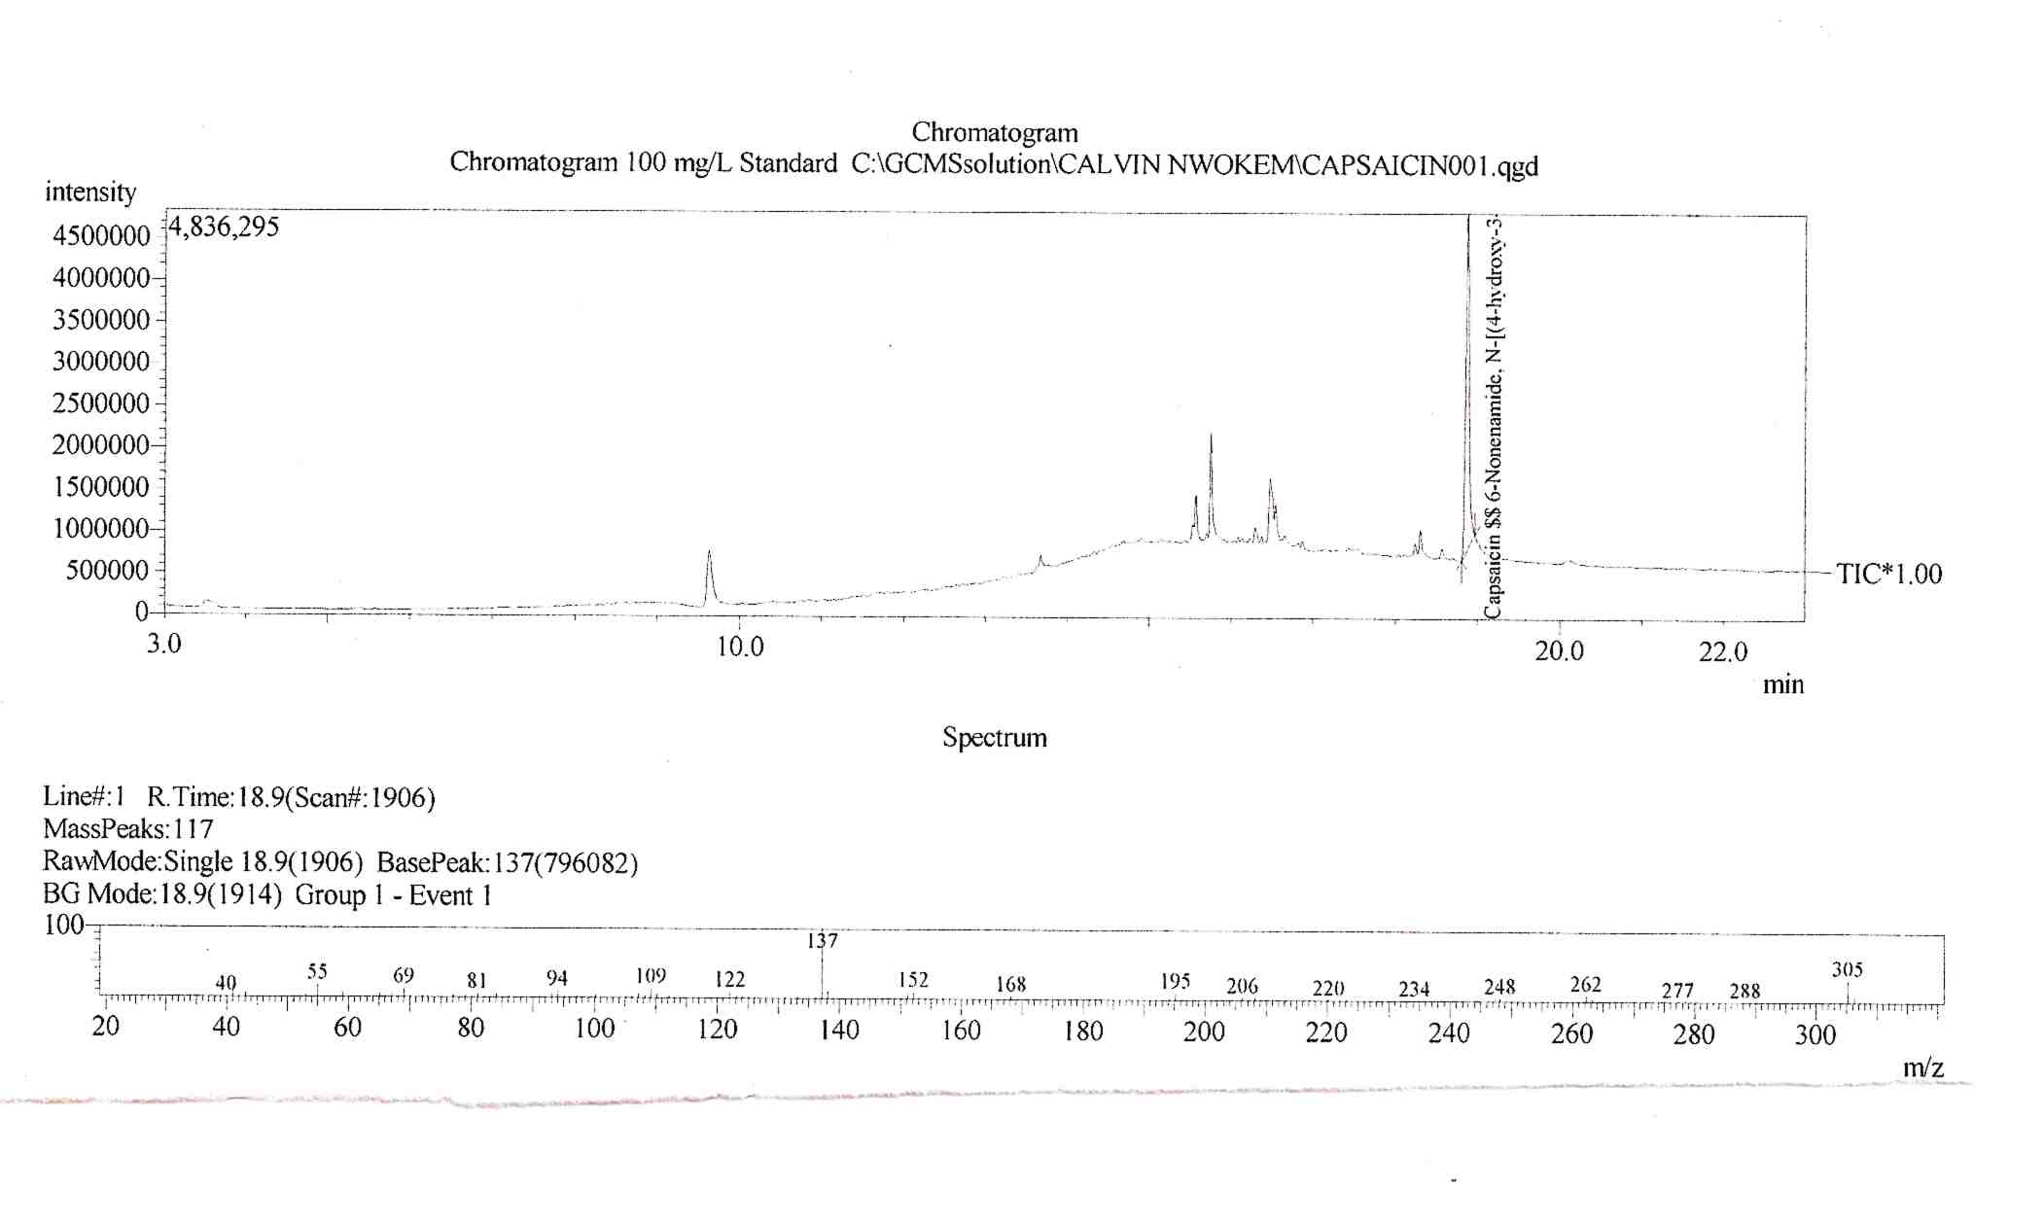

Figure 1. Chromatogram and mass spectrum for 100 mg/dm³ standard capsaicin.

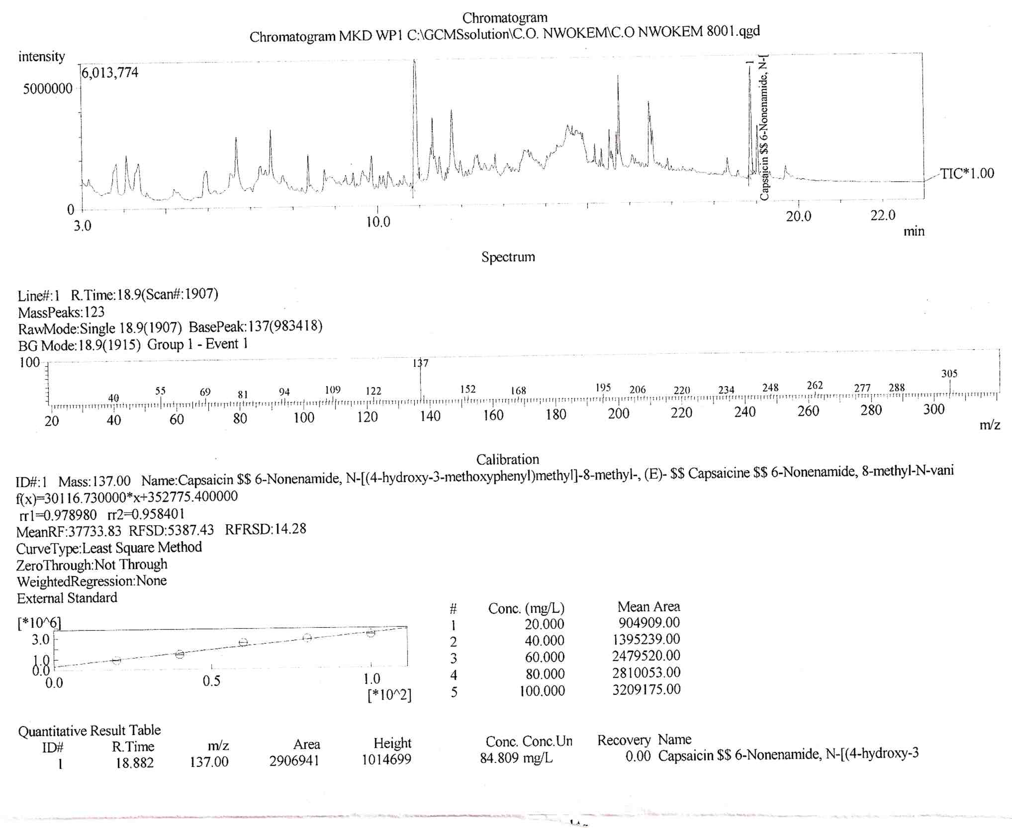

Figure 2. Chromatogram, mass spectrum and quantitative results for “atarugu” Makurdi pepper.

^{Table 2.} Capsaicin content of the dry whole peppersb
Pepper variety | Mean values | SHU | % Capsaicin
“Zaria atarugu”  “Makurdi”  “Miango”  “Zaria tatase”  “Nsukka Yellow” | 5.960 ± 0.153  6.264 ± 0.142  7.172 ± 0.242  1.189 ± 0.073  9.177 ± 0.268 | 95,364.00  100,228.80  114,744.00  19,015.20  146,823.20 | 0.596  0.626  0.717  0.119  0.918
^{b} values in mg/g ± SD of dry weight, n = 2

The use of SHU is the traditional method for pepper evaluation as it provides a better indicator of the pungency level, but is considered less precise (Collin et al.,1995).
All the pepper varieties except for “Zaria tatase” were classified as very highly pungent, with their pungency above ˃ 80,000 SHU (Table 2). “Nsukka yellow” has the highest pungency level (146,823.20 SHU).
All peppers used in this study, with the exception of “Zaria tatase” fall within the pungency limit (0.5-0.9%) presented by the BPC, hence are recommended for Oleoresin production, which is used in the formulation of certain pharmaceuticals.
On the basis of capsaicin content, all the pepper varieties except “Zaria tatase” can serve as potential sources of capsaicin for use in the pharmaceutical industry.
The concentration capsaicin would expectedly have been higher if only the placenta of the pepper varieties were used for analysis as capsaicin is produced in the placental glands.

Conclusion
Yellow pepper (Capsicum chinense), obtained from Nsukka, the South Eastern part of Nigeria is the most pungent of the peppers studied. All the peppers analyzed in this study can be classified as very highly pungent as the Scoville Heat Unit (SHU) values exceed 80,000, except the tatase, Zaria (Capsicum annuum) which has a mean SHU value of 19,015.20. This implies that all the pepper varieties studied, with the exception of the tatase, Zaria (Capsicum annuum) can serve as potential sources of capsaicin.
Acknowledgements:
Authors are grateful to the National Research Institute for Chemical Technology, Zaria, Nigeria for access to the Shimadzu QP-2010 GCMS in the course of this work.
References
- Attuquayefio V., Buckle K. Rapid Sample Preparation Method for HPLC Analysis of Capsaicinoids in Capsicum Fruits and Oleoresins. Journal of Agricultural and Food Chemistry1987; 35: 777-779.
- British Pharmaceutical Codex. The Pharmaceutical Press, London, 1973.

- Collins M.D., Mayer-Wasmund L., Bosland P.W. Improved Method for Quantifying Capsaicinoids in Capsicum using High-Performance Liquid Chromatography. HortScience 1995; 30: 137-139.
- Deal C.L., Schnitzer T.J., Lipstein E., Seibold J. R., Stevens R.M., Levy M.D., Albert D., Renold F. Treatment of Arthritis with Topical Capsaicin: A Double-blind Trial. Clinical Therapy1991; 13(3), 383-395.
- Kempaiah R. K., Manjunatha H., Srinivasan K. Protective Effect of Dietary Capsaicin on Induced Oxidation of Low-Density Lipoprotein in Rats. Journal of Molecular and Cellular Biochemistry 2005; 275: 7-13.

- Kosuge S., Furuta M. Studies on the Pungent Principle of Capsicum. Part XIV: Chemical Constitution of the Pungent Principle. Journal of Agricultural and Biological Chemistry 1970; 34: 248-256.

- Moore D. J., Moore .D. M. Synergistic Capsicum-Tea Mixtures with Anticancer Activity. Journal of Pharmacy and Pharmacology 2003; 55(7): 987-994.

- Perucka I., Materska M. Phenylalanine Ammonia-lyase and Antioxidant Activities of Lipophilic Fraction of Fresh Pepper Fruits Capsicum annuum L. Journal of Innovative Food Science and Emerging Technologies 2001; 2:189–192.

- Sanatombi, K., and Sharma, G. J. Capsaicin Content and Pungency of Different Capsicum spp. Cultivars. Notulae Botanicae Horti Agrobotanici Cluj-Napoca 2008; 36(2), 89-90.

- Scoville W.L. Note on capsicum. Journal of the American Pharmaceutical Association 1912; 1:453.

- Szolcsanyi .J. Forty years in Capsaicin Research for Sensory Pharmacology and Physiology. Neuropeptides 2004; 38: 377-384.

- Todd, P., Bensinger, M., and Biftu, T. Determination of Pungency due to Capsicum by Gas-Liquid Chromatography. Journal of Food Science 1977; 42: 660-665.

- Weiss E.A. (2002). Spice Crops. CABI Publishing International, New York, 2002; 411.

6/29/2010

