Residual Response of the Sulfidic Material on the Yield of Tomato and Onion Grown in Two Sulfur Deficient Soils in Bangladesh

Farook Ahmed¹ and Md. Harunor Rashid Khan²

¹Graduate School of Environmental Science, Okayama University, Okayama, Japan
²Department of Soil, Water and Environment, University of Dhaka, Bangladesh
farookahmed12@yahoo.com, duharun@yahoo.com

Abstract: The residual response of sulfidic materials (SM) and gypsum (G) on the yield of Onio and Tomato grown in two sulfur deficient soils of Kamarkhond series ( Sirajgonj soil) and Kalma series (Gazipur soil) of Bangladesh were evaluated in a greenhouse study. The crops were grown on the residual soil after the immediate growth of rice (Oryza sativa L. Var: BR-26 Sraboni). The best yield performance of Tomato were recorded by SM45 treatment in both Kamarkhond series (Sirajgonj soil) and Kalma series (Gazipur soil) the followed by the SM30>G45 treatments. The application of SM increased the tomato yield by 49.3% (increased over control: IOC) for Sirajgonj soil and 126.4% for Gazipur Soil. The best yield performance of Onion were recorded by SM45 treatment in both Kamarkhond series (Sirajgonj soil) and Kalma series (Gazipur soil) the followed by the SM30>SM15>G45 treatments. The application of SM increased the Onion yield by 123% (increased over control: IOC) for Sirajgonj soil and 112.1% for Gazipur Soil. That indicating SM is potentially more effective than gypsum as a source of sulfur fertilizer in the growth of Tomato and Onion production. [New York Science Journal 2010;3(9):28-33]. (ISSN: 1554-0200).

Keywords: Sulfidic material, Residual response, Yield performance.

1. Introduction
Intensive cropping has been resulting in higher removal of sulfur among the other nutrients. But its replenishment through natural process has been very low compared with the other major nutrients (Balsa et al. 1996). Bangladesh is not free from this threat. About 7 M ha (about 52%) of agricultural lands are reported to consists of sulfur deficient soils in the northern region of Bangladesh (SRDI 1999). The current intensive use of agricultural land for crop production has extended the sulfur deficient areas to about 80% in the northern region (Khan et al. 2007; Shamim and Farook 2010). Poor crop production as a result of acute sulfur deficiency has frequently been reported by many scientists in different regions of India (Tiwari et al. 1985) and Bangladesh (Khan2000). The current use of gypsum, ammonium sulfate, znic sulfate, etc as sulfur fertilizer for the soils can instantly supply sulfur to crops but the fertilization has to be done for each crop every year, which is both uneconomic and inconvenient for farmers. A suitable and sustainable source of sulfur is therefore essential. The use of sulfidic materials (SM) or layers obtained from Acid Sulfate Soils (ASSs) as sulfur fertilizer for crop production is very scanty, Khan et al (2002) reported that high organic matter (2-9%), total sulfur(3-7%) and micronutrients in the ASSs or SM deserve consideration for use in the reclamation of alkaline, calcarious or sulfur deficient soils for the amendment os ASss themselves by the removal of SM from the soils. Shamim and Farook (2010) reported that acid sulfate soils can be used as fertilizer. Khan et al (1994) also reported that the ASSs contained high Mg (1.3 to 2.6 cmol/kg) and Al (1-2 cmol/kg), but the use of ASSs or Sm containing high Al did not show any harmful effects when applied to soils. Khan et al. (2007) reported that the application of SM at the rate of 75 kg S /ha for sulfur deficient soils had no negative effect on soil pH, nutrient status in the soils and sunflower production. They suggested that the application of SM was not only effective as sulfur fertilizer but also enriched the organic matter in the soils. Specialized literature such as Andrew F Smith's "The Tomato in America" states that tomatoes probably originated in the highlands of the west coast of south America. It was used by the Aztecs as early as 500 b.C., in southern Mexico and adjacent areas, and they preferred the smaller cherry-like tomatoes. The larger, lumpy variant is believed to have been selected in Central America after a spontaneous mutation, and it's probably the ancestor of all the modern cultivars.Today's varieties of tomatoes originate from two main predecessors: currant tomatoes and "Matt's Wild Cherry" varieties. They both originate from the native tomato plants in eastern Mexico. After the american colonization by the Spaniards, tomatoes were quickly spread to all their caribbean colonies, and were later moved to the Philippines, where they spread to many different regions in Asia. By 1540, there are the first reported cultivations in Europe, where the Mediterranean climate was ideal. In Bangladesh this crop is being cultivated many years in winter season. Onions are difficult for archaeologists to track because they are too small and their tissues leave little, if any, trace. Some food historians place the earliest onion cultivation at the edges of the Mediterranean as long ago as 5,000 years. Others believe that onions originated in central Asia. The National Onion Association says onions were first grown in Iran and Pakistan. It's difficult to say in which area onions originated as several hundred varieties of onions grow wild in temperate climates all around the world. This crop is also very common and useful in Bangladesh. As Bangladesh has a problem of sulfur deficiency Against this background, the residual effect of sulfidic material was investigated on tomato and onion production on two s-deficient soils in Bangladesh.
2. Material and Methods

2.1 Soil collection and analyses:
Bulk samples of two sulfur deficient soils (surface soil at depth of 0-20 cm) of Kamarkhond series (Sirajgong soil) and Kalma series (Gazipur soil) were collected, respectively from the district of Sirajgonj and Gazipur in Bangladesh. The sulfidic materials (SM: Acid sulfate soil) used for this study was obtained from the surface soil (depth: 0-20 cm) of the Cox’ Bazar district of Bangladesh. This SM contained high organic matter. Selected physical and chemical properties of the initial soils, SM and the average of soil data of all the treatments are given in Table 1. The soil used for onion and tomato production ( post harvesting of rice) residual soil are presented in Table: 1. At each sampling time, soils (0-20 cm depth) were collected from each replicated pot using Cork borer (2 cm diameter), then air-dried and screened by 1 mm sieve. The soils were oven dried (105ºC) before analysis. After treatment with 1 M CH₃COONH₄ (pH 5.0) and with 30 % H₂O₂ to remove free salts and organic matter respectively. Particle size distribution of the initial soils was determined by the pipette method (Day 1965). Soil pH was measured in the field by the soil-water ratio of 1:2.5 and for the oven dried (105ºC) soil – 0.02M CaCl₂ (1:2.5) suspension (Jackson 1973) using a Corning pH meter Model-7. The electrical conductivity (soil solution was extracted from saturated soil paste through vacuum pump: Richards 1954), Organic matter content was determined (Nelson and Sommers 1982) by wet combustion with K₂Cr₂O₇. Available N (1.3 M KCl extraction, Jackson 1973), available P (0.002 N H₂SO₄, pH 3 extraction, Olsen et al., 1954) and available S (BaCl₂ turbidity, Sakai 1978) were determined. Cation exchange capacity was determined by saturation with 1 M CH₃COONH₄ (pH 7.0), ethanol washing. NH4⁺displacement with acidified 10 % NaCl, and subsequent analysis by steam (Kjeldhal method) distillation (Chapman 1965). Exchangeable Na⁺, K⁺, Ca²⁺ and Mg²⁺ were extracted with 1 M CH₃COONH₄ (pH 7.0) and determined by flame photometry (Na⁺, K⁺) and atomic absorption spectrometry. Total S was obtained by digestion with a mixture of concentrated HCl /HNO₃ (1:3) and determined by the turbidity method (Sakai 1978). The bulk samples obtained from each soil were stored for a couple of days under field- moist conditions ( by putting the soil samples and the SM into polyethylene bags in an air-tight box) just prior to laboratory analysis, when the sub-samples were air-dried and crushed to 2 mm before analysis.



Fig 1: Showing the area of sulfur deficient soil in Bangladesh where tomato and onion were grown.

2.2 Pot Experiment:
A pot experiment was conducted in the greenhouse at the premises of the Department of Soil, Water and Environment, University of Dhaka, during the period of November-February, to evaluate the effectiveness of SM compared with gypsum (G) as a residual sulfur fertilizer in relation to yield performance of onion and tomato grown in two sulfur deficient soils. It is mentionable that the onion and tomato were grown on the same pot just after the rice harvesting. Two sets of experiments were set up in a completely randomized design with 3 replications and three sampling times for each treatment. The doses of SM and gypsum were selected according to the sulfur requirement (20-40 kg S ha⁻¹) of the country as reported by BARC (1997). The experimental treatments on the basis of furrow slices of the soils were: control (no application of G and SM); G15, G30 and G45, (G15, 30 and 45 kg S ha⁻¹); SM15, SM30 and SM45 (SM15, 30 and 45 kg S ha⁻¹). Ten kg of air-dried and screened (5 mm sieve) soil was placed in each earthen pot (size: 36 cm height/28 cm diameter). The soil in each pot was fertilized with N, P, and K at the rates of 60, 30 and 20 mg kg⁻¹ as urea, triple super phosphate (TSP) and muriate of potash (MP), respectively for the previous rice production. As per treatments, the soils in the pots were also subjected to the application of SM and gypsum at the rates of SM and gypsum at the rates of 0, 15, 30 and 45 kg S ha⁻¹ during pot preparation. But after the harvesting of rice no sulfur fertilizer was added. Only N, P, and K at the rates of 60, 30 and 20 mg kg⁻¹ as urea, triple super phosphate (TSP) and muriate of potash (MP), respectively was added as basal dose. Both the SM and gypsum were dried, milled and sieved by 1 mm sieve. Then the residual soil was mixed well and made suitable for the production of onion and tomato.

2.3 Yield parameter:
Only the yield of tomato and onion were determined during the experiment at the maturity stage. It was recorded by gm/pot. The level of significance of the different treatments was determined at at maturity stage using Duncan’s New Multiple Range Test (DMRT) and least significant difference (LSD) techniques (Zaman et al. 1982).

3. Results and Discussions
3.1 Tomato:
The results of tomato are given in Figure 2. In control pot of Gazipur soil the yields of tomato was 57.55 g/pot. By the application of gypsum at the rate of 15, 30 and 45 kg S ha⁻¹ the yields were 58.41, 63.12 and 78.07 g/pot whereas the yields were 77.06, 117.0 and 130.31 g/pot for sulfidic materials respectively. From the IOC (increase over control) it was observed that tomato yield was highest in the doses of 45 kg S ha⁻¹ from sulfidic material and the increase was 126.4 % over control pot whereas in the 45 S ha⁻¹ from gypsum the increase was only 36.65% over control pot in Gazipur soil. The yield performance for tomato in Gazipur soil followed the doses SM45> SM30> G45> SM15> G30> G15 respectively. In control pot of Sirajgong soil the values were 50.28 g/pot whereas the values were 110.12, 135.21 and 140.0 g/pot by gypsum application and 122.34, 141.31 and 149.72 g/pot by sulfidic material application. From the IOC (increase over control) it was observed that tomato yield was highest in the doses of 45 kg S ha⁻¹ from sulfidic material and the increase was 197.0 % over control pot whereas in the 45 S ha⁻¹ from gypsum the increase was only 178.0 % over control pot. The yield performance for tomato in Sirajgong soil followed the doses SM45> SM30> G45> G30> SM15> G15 respectively.

3.2 Onion:
The results of onion are given in Figure 3. In control pot of Gazipur soil the yields of tomato was 30.46 g/pot. By the application of gypsum at the rate of 15, 30 and 45 kg S ha⁻¹ the yields were 41.6, 42.22 and 46.6 g/pot whereas the yields were 45.6, 54.94 and 65.67 g/pot for sulfidic materials respectively. From the IOC (increase over control) it was observed that onion yield was highest in the doses of 45 kg S ha⁻¹ from sulfidic material and the increase was 155.5 % over control pot whereas in the 45 S ha⁻¹ from gypsum the increase was only 52.98% over control pot in Gazipur soil. The yield performance for onion in Gazipur soil followed the doses SM45> SM30> G45> SM15> G30> G15 respectively. In control pot of Sirajgong soil the values were 30.1 g/pot whereas the values were 39.10, 41.68 and 51.0 g/pot by gypsum application and 54.47, 60.40 and 62.0 g/pot by sulfidic material application. From the IOC (increase over control) it was observed that onion yield was highest in the doses of 45 kg S ha⁻¹ from sulfidic material and the increase was 105.9 % over control pot whereas in the 45 S ha⁻¹ from gypsum the increase was only 69.43 % over control pot. The yield performance for onion in Sirajgong soil followed the doses SM45> SM30> SM15> G45> G30> G15 respectively.

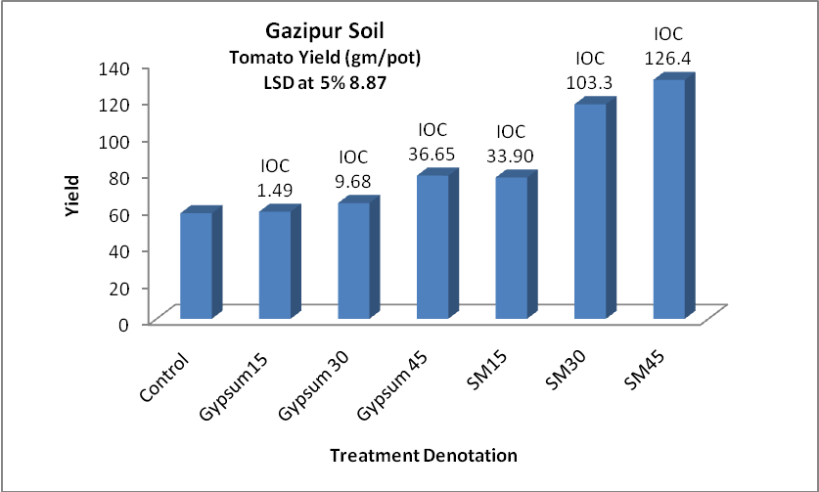

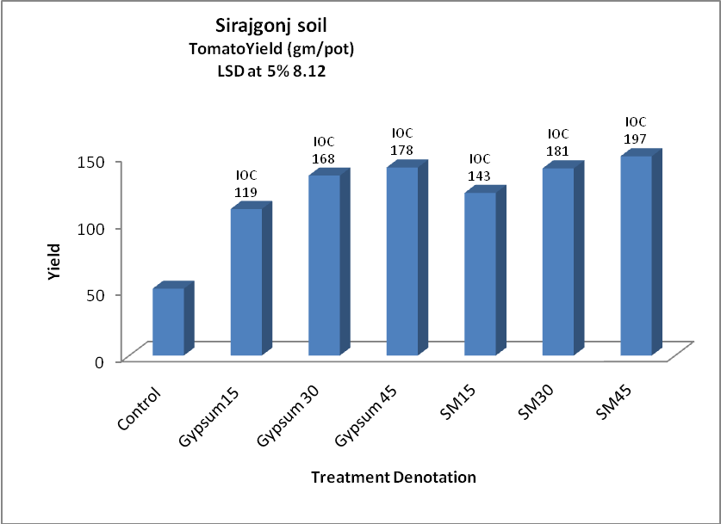
Figure 2: The residual response of sulfidic material on the yield of tomato. IOC= Increase over control (in %).

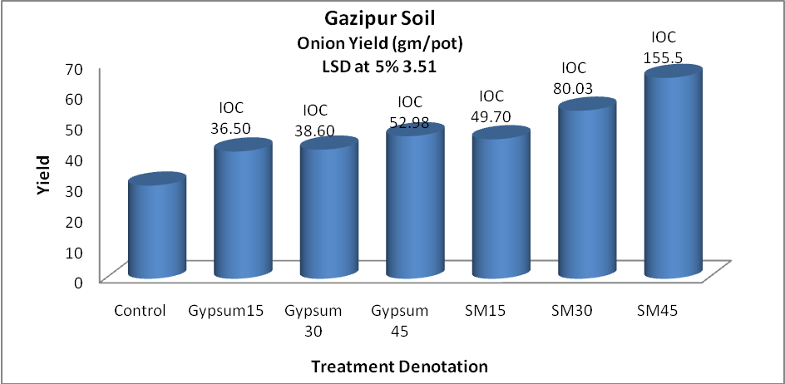

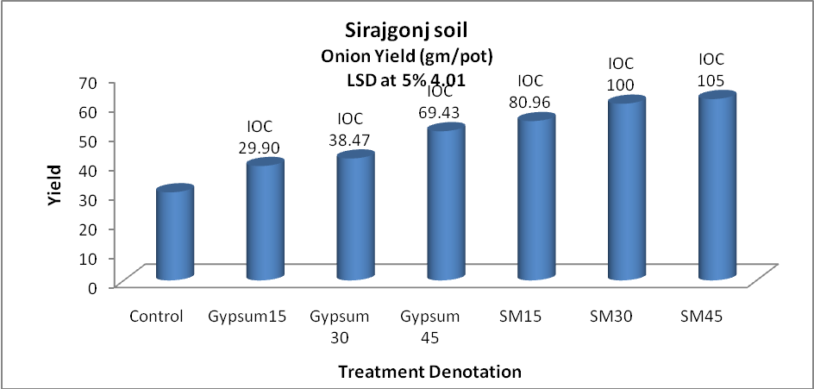
Figure 3: The residual response of sulfidic material on the yield of onion.IOC=Increase over control (in %).

4. Conclusions:
The residual response of sulfidic materials (SM) and gypsum(G) on the yield of Onio and Tomato grown sulfur deficient soils of Kamarkhond series ( Sirajgonj soil) and Kalma series (Gazipur soil) of Bangladesh were investigated in a greenhouse study. The crops were grown on the residual soil after the immediate growth of rice (Oryza sativa L. Var: BR-26 Sraboni). The best yield performance of Tomato were recorded by SM45 treatment in both Kamarkhond series (Sirajgonj soil) and Kalma series (Gazipur soil) the followed by the SM30 treatments. The application of SM increased the tomato yield by 197% (increased over control: IOC) for Sirajgonj soil and 126.4% for Gazipur Soil. The best yield performance of Onion were recorded by SM45 treatment in both Kamarkhond series (Sirajgonj soil) and Kalma series (Gazipur soil) the followed by the SM30>SM15>G45 treatments. The application of SM increased the Onion yield by 123% (increased over control: IOC) for Sirajgonj soil and 112.1% for Gazipur Soil. The results indicated that SM is potentially more effective than gypsum as a source of sulfur fertilizer in the growth of Tomato and Onion production especially in sulfur deficient soils of Bangladesh.

Acknowledgements:
Authors are grateful to the Department of Soil, water and Environment, University of Dhaka, Bangladesh; to the Ministry of Education, Culture, Sports, Science and Technology, Japan and to Prof. Dr. Munehide Ishiguro, Graduate School of Environmental Science, Okayama University, Okayama, Japan.

Corresponding Author:
Farook Ahmed
Graduate School of Environmental Science
Faculty of Environmental Science & Technology
Okayama University
700-8530, Okayama, Japan
Email: farookahmed12@yahoo.com

References
- Abul Hasnat Md Shamim and Farook Ahmed. Response to Sulfur and Organic Matter Status by the Application of Sulfidic Materials in S-Deficient Soils in Bangladesh: Possibilities and Opportunities. Report and Opinion, 2010: 2(1).Smith MD, Wilcox JC, Kelly T, Knapp AK. Dominance not richness determines invasibility of tallgrass prairie. Oikos 2004;106(2):253–62.
- Balsa ME, Serrao MG, Martins MIM, Castelo-Branco MA, Gusmao MR, Fernandes ML, 1996: Effects of pyrite residue amendment on sulfur availability in a calcareous soil cropped with sown pasture. C. Rodrigue-Barrueco (ed), Fertilizer and Environment, Kluwer academic Publ., Printed in the Netherlands. Pp 453-455.
- BARC (Bangladesh Agricultural Research Council) 1997: Fertilizer Recommendation Guide, Publ, BARC, Framgate, Tejgaon, Dhaka, Bangladesh.
- Jackson MI 1973: Soil Chemical Analysis, p 41-330, Prentice Hall of India Pvt, Ltd., New Delhi.
- Khan HR, Syeed SMA, Ahmed F, Shamim AHM, OKI Y, Adachi T. 2007: Response of Sunflower to sulfidic materials and magnesium sulfate as sulfur fertilizer. J. Bio. Sci. 7(6): 888-895.
- Khna HR, Bhuiyan MMA, Kabir SM, Ahmed F, Syeed SMA, Blume H-P 2002: The assessment and management of acid sulfate soils in Bangladesh in relation to crop production, Chapter 22, p254-263. In MH Wong and AD Bradshaw(ed). The restoration and management of derelict land: Modernapproaches, World Scientific, www.worldscientific.com
- Khan HR 2000: Problems, prospects and future directions of acid sulfate soils. In Proc. Inter. Conference on Remade Lands 2000, Ed. Biron, A. and R.W. Bell. P 66-67, Nov. 30 to Dec. 2, 2000, Perth, Australia.
- Khan HR, Rahaman S, Hussain MS, Adachi T 1994: Growth and yield response of rice to selected amendments in an acid sulfate soil. Soil Sci. Plant Nutr., 40, 231- 242.
- Nelson DW, Sommers LE 1982: Total carbon, organic carbon and organic matter. In Methods of Soil Analysis. Part 2., Ed. A.L. Page, Agron. Series 9., p539-579, Am. Soc. Agron., Publ. Madison, WI,USA.
- Olsen SR, Cale CV, Watanabe ES, Dean LA 1954: Estimation of available phosphorus in soils by extractionwith sodium bicarbonate, USDA Cric, 939, Washington, USA.
- Richards LA(ed) 1954: Diagnosis and improvement of saline and alkali soils. In USDA handbookno.60, p. 84-156, US Govt. Print. Office, Washington, USA.
- Sakai H 1978: Some analytical results of sulfur deficient plants, soil and water. Workshop on sulfur nutrition in rice, December, BRRI, Publication no. 41:35-59.
- SRDI(Soil Resource Development Institute) 1999: Map of the nutrient status of sulfur and upazila land soil resource utilization guide.
- Tiwari KN, Dwivedi BS, Pathak AN 1985: Iron pyrites as sulfur fertilizer for legumes. Plant Soil, 86: 295-298.
- Zaman SMH, Rahman K, Howlader M 1982: Simple lessons from biometry, Publ no. 54, Bangladesh Rice Research Institute, Gazipur, Bangladesh.

6/22/2010

