Notes on the composition, abundance and zonation of benthic invertebrate of an artificial rocky shore, Tarkwa bay, Lagos, Nigeria

Clement Aghatise Edokpayi ¹, Taiwo Azeez Adenle ¹, Muyideen Owonire Lawal ¹

^{1.} Benthic Ecology Lab, Department of Marine Sciences,
University of Lagos, Nigeria.
klemedokpayi@gmail.com

Abstract: The composition abundance spatial and temporal distribution of benthic invertebrates on the artificial rocky shore of Tarkwa bay was investigated between May 2003 and April 2004. Samples were collected or counted in-situ in a 1m² quadrate along a transect at 2m intervals on the west mole. A total of 15 taxa made up of 14 genera dominated by crustaceans (Chthamalidae) and gastropods (Littorinidae and Patellidae) both accounting for more than 60% of the total number of individuals observed. Using the spatial distribution of the dominant species, two broad zones, Chthamalus/Patella zone, (0 – 6m) and the Littorina zone (4 – 12m) were observed. All species were recorded throughout the study period except for Tectarius granosus and Brachyodonte niger which were not observed in some months. These species appears to be seasonally distributed as they occurred only during late rainy season (August) and dry season months (September – October). Ligia gracilipes and Plagosia depressa were found on the littoral fringes, while the pin-hole limpet, Fissurrella nebecula and the sea urchin, Arbacia lixula were restricted to the sublitoral zone. In general, the distribution of macrobenthic fauna observed at the Tarkwa bay was typical of exposed rocky shore influenced by strong wave and tides. [New York Science Journal 2010;3(9):63-67]. (ISSN: 1554-0200).

Keywords: Tarkwa Bay: benthos: zonation: rocky shore: Nigeria

Introduction
Although Nigerian coastline is generally free of indentations along its 800km length, it is however frequently interrupted by numerous river mouths which open through wide estuaries and large deltas. The Nigerian coastline is characterized by natural sandy and muddy beaches. There are no naturally occurring rocky shores along the Nigerian Coast. However, between 1901 and 1930, three artificial moles of stones were built seaward to limit bar formation and a fairway dredged to permit the entry of large vessels into the Lagos harbour. These breakwaters at Takwa Bay in Lagos provide artificial rocky surfaces for the settlement of littoral communities (Hill and Webb, 1958). The physico-chemical characteristics and the algae community of Tarkwa Bay have been described (Nwankwo, 1993). Information on the benthic fauna of the artificial rocky shore at Takwa Bay is nonexistent. This paper presents the results and discussion on the composition, monthly fluctuations in abundance and the vertical distribution of macrobenthic invertebrates of the artificial rocky shore at Tarkwa bay.

Study Area
The artificial rocky shore of Nigeria is made up of three moles, the west, training and east moles (Fig. 1). The study site is the exposed side of the West Mole. The training mole encloses the Tarkwa Bay, while the construction of the west and east moles has resulted in sand deposition in the Light house beach and attrition (erosion) in the Victoria Beach respectively over time. The littoral algae on the west mole include Chaetomorpha anteninna, Cladophora protifera, Bryopsis penneta and Hypnea musciformis. The main human activity around the study area is recreational. Fishing activity is minimal and involves artisanal fishermen throwing cast nets for pelagic fishes. The tidal rhythm at the study site is semi-diurnal. Water samples were collected at monthly intervals for a period of twelve months from May 2003 to April 2004. Samples were collected in the last week of the month between 0800h and 1200h at low tide.
Water samples were collected in pre-washed polyethylene containers and analyzed in Lagos State Environmental Protection Agency (LASEPA) laboratory for pH, salinity, total dissolved solids, nitrate, phosphate, and alkalinity. Using the methods recommended by APHA (1998). Air and water temperature were measured in-situ using mercury-in-glass thermometer and readings taking to the nearest 0.1⁰C.
Benthic fauna were collected along a rope-marked transect graduated at 1m intervals. A quadrant of 1m² was used to standardize the sample size. Fauna were collected at 2m interval from water level to the top of the mole. Animals found within the quadrant were counted in-situ or representative collected and fixed in 10% formalin. The fauna were identified using identification keys of Edmunds (1978), Oyenekan (1988) and Yankson and Kendall (2001).

Results
Table 1 presents the summary of the physical and chemical parameters measured at the study site. Comparison of months using ANOVA for all parameters except pH and Kruskal – Wallis test for pH, showed no significant differences (p > 0.05) in the monthly fluctuations of the physical and chemical parameters studied.
Fifteen invertebrate taxa were collected during the study period. Table 2 lists the taxonomic categories of invertebrates, the number of taxa recognized within each category, their distribution and abundance along the transect. The number of individuals (Fig.2) were highest at the eulittoral zone (42%) and lowest at the Littoral fringes (17%). However, the highest number of taxa (13) was recorded at sublittoral zone (Table 2, Fig. 3). The artificial rocky shore fauna was dominated by Chthamalidae, Patellidae and Littorinidae both families accounting for more than 60% of the total individuals recorded (Fig. 4). Littorina punctata and L. cigulifera was recorded at all the zones from the sublittoral (0 – 1m) to the littoral fringe (6m – 9m). Brachyodontes niger (mussel), Arbacia lixula (sea urchin), Fissurella nubecula (key-hole limpet) and sea anemones were restricted to lower part of the eulittoral to the sublittoral zone. The eulittoral (1 – 6m) zone was dominated by Chthamalus dentatus, while Tectarius granosus and Ligia gracilipes (isopod) were mainly found on the littoral fringes (splash zone). All species were recorded in all the months sampled except for Tectarius granosus and Brachyodontes niger which occurred mainly in late rainy season to dry season months.

Discussions
Tarkwa Bay is the only rocky shore in Nigeria coastline and the macrobenthic fauna have not been documented. The physical and chemical characteristics of the sea water at Tarkwa bay recorded in this study were similar to those reported by earlier workers (Hill and Webb, 1958; Nwankwo, 1998). The fauna composition of the Takwa bay was similar to those reported for the rocky shores of Ghana and other West African rocky shores (Yankson and Kendall, 2001). The dominance of Chthamalidae (Crustacean) at the eulittoral zone and Littorinidae (Gastropod) at the sublittoral to the littoral fringes appears to be related to their ability to withstand desiccation resulting from exposure during low tide, and strong waves during high tides.
The occurrence of Tactarius granosus and Brachyodontes niger in the dry season months reflects seasonal distribution of these species at the study site

Fig. 1. Map of Tarkwa Bay showing the moles.

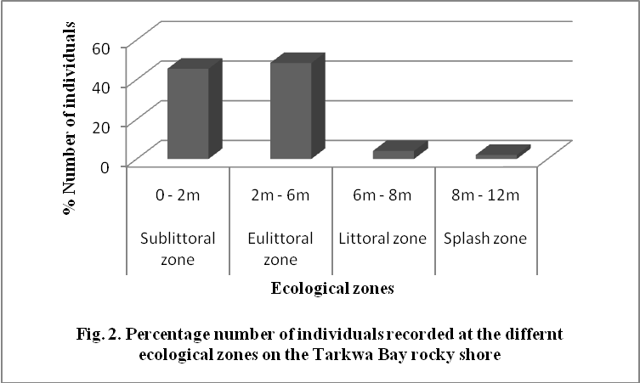

Table 1. Summary of the physical and chemical characteristics of the seawater at Tarkwa Bay; Mean ± Standard Deviation, Minimum and Maximum values given.
Parameters | Mean ± SD | Minimum | Maximum
Air temperature (ºC) | 29.47 ± 1.92 | 27.00 | 32.00
Water temperature (ºC) | 28.35 ± 1.63 | 26.00 | 30.00
Salinity (‰) | 26.35 ± 1.90 | 23.60 | 29.00
pH |  | 7.40 | 7.70
DO (mg/l) | 4.45 ± 0.52 | 3.50 | 4.90
TDS (mg/l) | 17.02 ± 0.90 | 16.60 | 18.40
Nitrate (ppm) | 8.26 ± 0.29 | 7.95 | 8.75
Phosphate (ppm) | 2.83 ± 0.17 | 2.50 | 3.00
Alkalinity (ppm CaCO₃) | 197.50 ± 3.82 | 195.00 | 200.00
BOD (mg/l) | 14.00 ± 1.15 | 12.00 | 15.00
COD (mg/l) | 24.17 ± 4.52 | 20.00 | 31.00

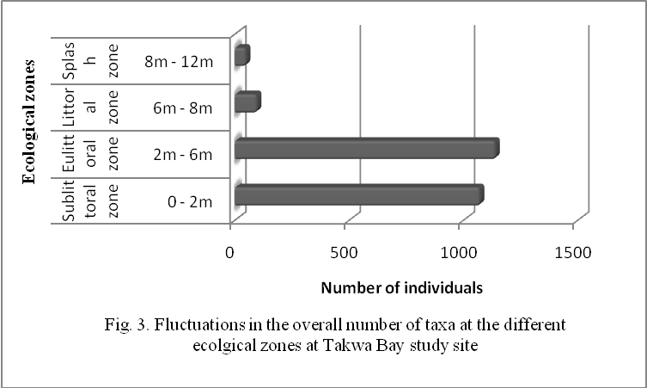

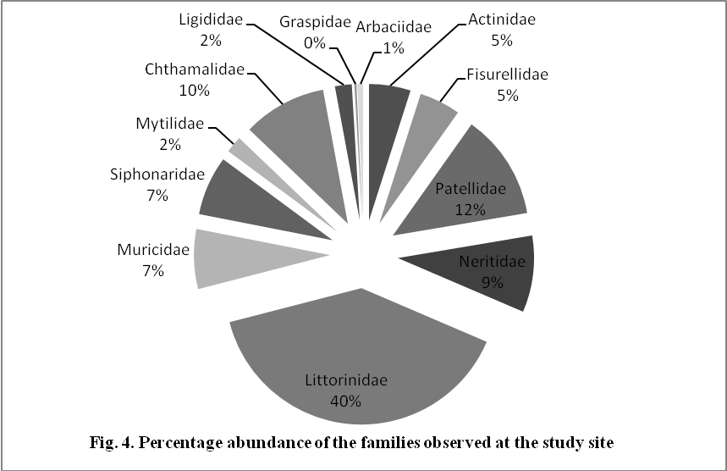

Table 2. The composition, distribution and abundance of macrobenthic invertebrates on the artificial rocky shores of Tarkwa Bay, May 2003 – Apeil 2004.
 | 0-2 Meters |  | 2-4 Meters |  | 4-6 Meters |  | 6-8 Meters |  | 8-10 Meters |  | 10-12 Meters |  | Overall
 | No of Taxa | No of Indiv. | No of Taxa | No of Indiv. | No of Taxa | No of Indiv. | No of Taxa | No of Indiv. | No of Taxa | No of Indiv. | No of Taxa | No of Indiv. | No of Taxa | No of Indiv.
COELENTERATA
ANTHOZOA
ACTINIDAE (Sea anemone) | 1 | 90 | 1 | 26 |  |  |  |  |  |  |  |  | 1 | 116
MOLLUSCA
GASTROPODA
FISURELLIDAE (Fissurela nubecula) | 1 | 69 | 1 | 35 | 1 | 11 |  |  |  |  |  |  | 1 | 115
PATELLIDAE (Patella safiana) | 1 | 133 | 1 | 125 | 1 | 37 |  |  |  |  |  |  | 1 | 295
NERITIDAE (Nerita senegalensis) | 1 | 146 | 1 | 68 | - | - |  |  |  |  |  |  | 1 | 214
MESOGASTROPODA
LITTORINIDAE | 3
Littorina punctata | 1 | 215 | 1 | 173 | 1 | 126 | 1 | 82 | 1 | 29 | 1 | 7 | 1 | 605
Littorina cingulifera | 1 | 117 | 1 | 103 | 1 | 5 | 1 | 3 | 1 | 8 |  |  | 1 | 236
Tectarius granosus |  |  |  |  | 1 | 57 | 1 | 2 | 1 | 4 |  |  | 1 | 63
MURICIDAE | 2
Thais haemastoma | 1 | 89 | 1 | 47 |  |  |  |  |  |  |  |  | 1 | 136
Thais nodosa | 1 | 31 |  |  |  |  |  |  |  |  |  |  | 1 | 31
SIPHONARIDAE (Siphonaria pectinata) | 1 | 84 | 1 | 70 | 1 | 12 |  |  |  |  |  |  | 1 | 166
BIVALVA
MYTILIDAE (Brachyodontes niger) | 1 | 47 |  |  |  |  |  |  |  |  |  |  | 1 | 47
ARTHROPODA
CRUSTACEA
CHTHAMALIDAE (Chthalmalus dentatus) | 1 | 28 | 1 | 60 | 1 | 146 |  |  |  |  |  |  | 1 | 234
LIGIDIDAE (Ligia gracilipes) | 1 |  |  |  | 1 | 38 | 1 | 9 |  |  |  |  | 1 | 47
GRASPSIDAE (Plagusia depressa) | 1 | 6 |  |  |  |  |  |  |  |  |  |  | 1 | 6
ECHINODERMATA
ECHINOIDEA
ARBACIIDAE (Arbacia lixula) | 1 | 16 |  |  |  |  |  |  |  |  |  |  | 1 | 16
Total | 13 | 1071 | 9 | 707 | 8 | 432 | 4 | 96 | 3 | 41 | 1 | 7 | 15 | 2,354

Corresponding Author:
Dr. Clement Aghatise Edokpayi
Department of Marine Sciences
Benthic Ecology Laboratory
University of Lagos, Nigeria
E-mail: klemedokpayi@gmail.com

References
- American Public Health Association (APHA) Standard Methods for the Examination of Water and Waste Water 1998 20th Edn.
- Edmunds, J. Sea Shells and Other Molluscs found on West African Shores and Estuaries. 1978 Ghana University Press, Accra. 146pp.
- Hill, H. B. and Webb, J. E. The ecology of Lagos lagoon II: The topography and physical features of Lagos harbour and Lagos lagoon. 1958 Phil. Trans. Roy. Soc. Bull. Vol. 341: 319 – 333.
- Nwankwo, D. I. Cyanobacteria bloom species in coastal waters of South-Western Nigeria. 1993 Archiv fur Hydrobiologie. 4: 533 – 542.
- Nwankwo, D. I. The influence of sawmill wastes on diatom population of Okobaba, Lagos, Nigeria. 1998 Nig. J. Bot. 11: 15 – 24.
- Oyenekan, J.A. Benthic macrofaunal communities of Lagos lagoon, Nigeria. 1988 Nig. J. Sc. 21: 45 – 50.
- Yankson, K. and Kendall, A. A student’s guide to the sea shore of West Africa. Darwin Initiative 2001 Report 1. Ref. 162/7/451. 132pp.

7/7/2010

