Survival Rate In Poly Culture Of Catfish Heteroclarias /Tilapia (Oreochromis Niloticus), Fed 2% Body Weight

Solomon, J.R And Boro, S.G.

Department Of Biological Sciences
Faculty Of Science, University Of Abuja, Nigeria (+234).
johnsol2004@yahoo.com

ABSTRACT: A twelve week experiment was conducted in the botanical garden of the department of Biological Sciences, University of Abuja, To assess survival rate in Polyculture of catfish Heteroclarias/ Tilapia Oreochromis niloticus at different stocking ratios of 8 Heteroclarias/ 8 Oreochromis niloticus, 8 Heteroclarias/ 16 Oreochromis niloticus and 8 Heteroclarias/ 32 Oreochromis niloticus (1:1, 1:2 and 1:4) were fed formulated diet twice daily of fish meal and rice bran containing 28% crude protein, 8% crude fat, 1.6% crude fiber, 4.5% moisture and 6.2% ash at 2% body weight. The result of the present study showed, statistically significant different (p<.5%) two-way ANOVA for Heteroclarias/ Oreochromis niloticus 1:1, while no significant different (p>.5%) two- way ANOVA for Heteroclarias/ Oreochromis niloticus 1:2 and 1: 4. The study proved that, fingerlings Heteroclarias/ Oreochromis niloticus should be stocked at ratio of Heteroclarias/ Oreochromis niloticus 1:1. [New York Science Journal 2010;3(9):68-78]. (ISSN: 1554-0200).

Key Words: Fish meal, rice bran, Heteroclarias and Nile Tilapia (Oreochromis niloticus).

Introduction And Literature Review
In Africa, especially in Nigeria, the species mostly cultured are Clarias gariepinus, Heterobranhcus species and their hybrids. The reasons for their culture are based on their fast growth rate, disease resistance high stocking density, aerial respiration, high feed conversion efficiency among others. Aquaculture in Nigeria is in the developing stage, because it has not been able to meet the demand and supply of the ever – increasing population. Catfish are cultured conveniently under mono and Polyculture systems (Reich 1975).
However, with the intensification of tank culture system where fish culturists rely solely on artificial feed as the only food resource of closely related species of the same family and of the same feeding habit, this type of system, there is the culture of only one single, species known as monoculture. Most catfish culturists in Africa especially in Nigeria have practiced any of these culture systems without knowing the best culture system for their fish. These farmers believe that culturing different species of catfish together or separately have little or no effect on their growth performance as well as their survival.
The major preliminary condition in setting up a polycultured system is to identify an ideal stocking ratio which takes into consideration the intensity of species interaction and utilization of different ecological strata’s and a better valorization of the water body (Billad, 1980). In a catfish/tilapia polyculture system, stocking of tilapia at densities equal to or greater than 25% of the weight of stocked catfishes (Hash, 1980). The positive effect of polycultured with predatory fish species in an additional source of food which is later represent by tilapia larvae (Pompa, 1978). Different combination of fish species in polycultured systems have been practiced throughout the world (Elmendo, 1980).
Studies on the growth performance and survival of fish especially the salmon species under the mono and duo culture systems have been reported. Salmon species in duo culture system had better growth than those in monoculture system. (Mork 1982), (Nor dvedt and Holm 1991), reported that salmon species in duo culture system had better than those in monoculture system. However, Salmon reared in duo culture did not grow significantly better than those reared in monoculture no different in growth increments between monoculture of one species and polyculture of several species within the same period (Shephard, 1988). However one species might affect the environment to prove the growth condition for the other species, these increased stocking density will increase interspecific and intraspecific competition and fish production will slow down the body weight at harvest of catfish (160 – 190g) was twice those of tilapia (50 – 70g) range (Alan, 1994). Experimental studies on the hybridization of Heterobranchus longifilis and Clarias garienpinus, which lead to hybrids with valuable characteristics for culture (Heent and Lublenkhot, 1985). Hybrid morphology was intermediate to that of the parents and had a faster growth and survival (Legendre et al; 1991). Intraspecific hybridization of fish has been considered to combine valuable traits from two or more species to obtain hybrids that exceed both parents' species (Pan and Zeng, 1986).
The Nile Tilapia (Oroechromis Niloticus) generally is good for polyculture traits because it does not effect the growth and production of most of the species (Cruz, 1980). Observation shows that, the highest stocking ratio Clarias monganese/Tilapia were 1:4 and 1:8) had a higher but lower individual weight gains (Sunset and Bayne, 1978). The production in a Tilapia monoculture system was lower than in polyculture with Macrobrachium (Guerrero et al; 1977). An individual species could be used as a predator for recruitment control under different stocking ratio (Bedaroi, 1985). The aim of catfish/tilapia polyculture systems is to increase productivity base on the availability of tilapia larvae (Stainer, 1979).
Most of the commercial feed millers in Nigeria are poultry based, fish feed production remain negligible and often incidental through the methodology of producing fish feed is not quite different from poultry; it consumes much time and money than poultry. Many of the machines required are not even available within the country and where they can be improvised local fabrication, the fund becomes a problem to the medium scale farmers. Fish body is mainly protein especially Animal sources (fish meal) is always canvassed (lovell, 1980). Nutrients are better and much higher plants sources, this single reason have been a factor militating against cheap source of fish feed since fish meal is expensive. The prices of other plant source e.g. groundnut cake, soybean meal have recently grown up due to poor cultivation and competition with man and livestock (Fasaking et al; 2000).
Poor feed leads to slow growth, high feed conservation ratio, low survival, disease and poor harvest (Eyo, 2001). Good quality feed when fed at recommended rate and other water quality conditions that are adequate lead to profitability in fish culture managements (Sogbensan et al; 2003).
The hybridization of Heterobranchus. longifilis and Clarias garienpinus, which leads to hybrids with valuable characteristics for culture (Hecht and Lublenkhof, 1985). Hybrid morphology was intermediate that of the parents and had a faster growth performance (Lengendre et al; 1991). Intra-specific hybridization of fish has been considered to combine valuable traits from two or more species to obtain hybrids that exceed both parent species (Naevdal et al; 1987).
The final body weight of stocking ratio 1:1, 1:3 and 1:5 (Hybrid: Tilapia) fed rice bran/blood meal was not significant different, though the combine net produced of hybrid and Tilapia was highest in the 1:5 stocking ratio, which produced highest Tilapia recruits (Solomon, 2006). The feeding of Heteroclarias, fingerlings on maggot diets resulted in high survival rate (Sogbensan et al; 2006). Maggot is readily available free from man’s competition and has been accredited for its high quality protein with amino acids profile showing its biological value to be superior to Soybean and groundnut Cake (Adejinmi, 2000). This organism can be included in fish feed to promote feeds like chironomids, toad earthworm polycheates, duckweed, water hyacinth, garden snail mussels, Lizard and frog (Sogbesan et al; 2005). Maggots are easily digested by fish (Jhringram 1983). Heteroclarias, fingerlings fed combined animal protein feed has better weight gain, daily growth index, relative weight gain, metabolic growth rate and specific growth rate values than those fed single animal protein source feed (Mazid; et al; 1997).
Tilapia feed of 25% crude protein is fed at 5% body weight (Falayi 2008). The Production and survival of Shrimps was improved in an intensive polyculture system with red Tilapia (Akiyama and Anggawati 1999). While the presence of Nile tilapia resulted in better growth and survival of shrimp at 0.4 Tilapia /m² but poorer shrimp performance at 0.6 Tilapia /m² in Semi-intensive culture (Gonzales-carr, 1988). Red Tilapia of larger size (60-100g) at densities of 0.2 and 0.3 Tilapia/m², which resulted in higher fish standing crops (Akiyama and Aggawati, 1999). In intensive shrimp monoculture, wastes derived from feeding after stimulate phytoplankton growth and lead to dense blooms in ponds and the collapses of phytoplankton can cause shrimp stresses (Briggs and Fung-Smit ,1998). And Mortality through disease, Oxygen depletion, and increased metabolic toxicity (Fast and Menasveta, 2000). Study showed that the concentrations of chlorophyll ‘a’ in the tilapia-shrimp polyculture ponds were not lower than those in the shrimp monoculture ponds. Probably, the roles of Nile tilapia are not to reduce phytoplankton biomass but to stabilize water quality in the tilapia shrimp polyculture (Tian; et al; 2004).
The forms and modes included wet Chicken manure broad casted into culture water, wet chicken manure tied in jute bags and dry chicken manure broadcasted into pond, the effect was compared on the growth rate Oreochromis Niloticus (Okonji and Olanusi, 2000). Mean comparison showed that the wet chicken manure broadcasted into culture units produced the highest growth performance in terms of total weigh gain, absolute growth rate, and was recommended that wet chicken manure broadcasted directly into culture ponds of Oreochromis niloticus, should be adopted as best option of fertilizing (Okongi and Olanusi, 2000).
Observation was made on the aggressive behavior of the fingerlings of two fish species, Heterobranchus bidorsalis and Oroechromis niloticus, commonly used in polyculture of an indoor aquarium Tanks measuring 30cm x 45 cm x 60cm, was recommended that stocking of Heterobranchus bidorsalis and Oreochromis niloticus, in polyculture increased the survival rate and harvestable number of Heterobranchus bidorsalis (Okonji, 2004).
The cannibalistic nature of Clarias gariepinus, multiple sorting is essential, for fry/fingerlings rearing, screening of tanks with mosquito nets is recommended to prevent dragonfly and other predatory insects from breeding in the ponds (Adewunai, 2009).
Feeding of catfishes in grow outs are perhaps the most documented in literature, various efforts have been made to establish the crude protein and amino acid requirement of Clarias gariepinus (Ayinla, 1988).
The survival rate for Heteroclarias, hybrid was low in all the stocking ratios. This is common in low and high polycultured densities (Tidwell and Mims, 1990). Experimental studies showed that fingerlings of different species of Clariid catfish have different growth performance and different feed utilization efficiency under different culture system (Adewolu et al; 2008). It was observed that hybrids exhibited a high degree of cannibalism and a resulting high individual growth rate with a corresponding low production (yield) due to high mortality rate (van der Waal, 1978).
Weight gain of Clarias gariepinus, Heterobranchus longitilis and their hybrid reared in all the three stocking (culture systems viz: monoculture, duo culture and trio culture), monoculture system gave the best weight gain (Adewolu et at; 2008). Tilapia yield decreased due to the presence of hybrid which led to competition for food (Lazerd, 1980). Tilapia uncontrolled high reproduction ratio gives excessive recruitment and resulting low yields of harvestable size Tilapia from cultured pond (Guero, 1982). During the one way ANOVA, Proved significant due to the fact that growth was dependent on population densities (Le Cren, 1965). Tilapia recruitment had the lowest value, with a higher annual production obtained (Schoonbee and Prinsloo, 1988).
In a polyculture setting shrimp and Nile Tilapia can utilize different niches. In extensive culture Tilapia can filter feed on phytoplankton and Zooplankton in the upper water column, while shrimp spend most of the time in the pond bottom grazing on bacterial films on the bottom substrate and on the detritus setting from above. In intensive culture receiving pelleted feeds, Tilapia may monopolize the feed especially for floating feed (Fast and Menasveta, 2000).
A one – hectare polyculture pond can be initially stocked with 20,000 Tilapia fingerling of mean weight 2g and 2000 carp fingerling mean weight at 10g. Tilapia fingerlings are to be fed in first 2 months during which feed with 25-30% c.p can be fed to the fish. These requirements meet the need of tilapia and carp fishes and subsequently with fry and fingerlings would eventually serve as food for the catfish to be stocked after two months. At the beginning of the third month (when fry are noticed in pond) 500 catfish fingerlings of mean weight 3-4g can be stocked to include the earlier stocked fishes (Okoye, 1996). The fry fingerlings bred by tilapia would now serve as food and 50 percent of the earlier stocked and many of their progeny may be cannibalized by the stocked catfish (Okoye, 1996).
Temperature is a vital parameter for growth which ranged from 23-28⁰C, and (Degani et al, 1998). Confirmed 27⁰C as the ideal temperature, the better specific growth rate which is affected by body weight (Hogendoorn and Koops, 1983).

MATERIALS AND METHODS
AQUARIUM AND TREATMENTS
Three glass aquaria each having a dimension of 1.165m³ was used in the experiment base on laboratory subjection. The aquaria were obtained from the department of biological sciences, University of Abuja. There were 3 treatments having different Ratios and Stocking densities designated A,B and C each of their aquaria was stocked at Ratio of 8 catfish Heteroclarias and 8 Tilapia Oreochromis niloticus fingerlings, (A) 8 catfish Heteroclarias/16 Tilapia Oreochromis niloticus (B) fingerlings and 8 catfish Heteroclarias /32 Tilapia Oreochromis niloticus fingerlings (1:1,1:2 and 1:4) respectively. The catfish Tilapia fingerlings stocked in each aquarium were of the same size. This is to investigate cannibalism. 30 fingerlings of catfish Heteroclarias fingerlings of Tilapia Oreochromis niloticus were obtained from Ajima fish farm, Kuje Abuja. The fishes were acclimated for Seven days in the Biological science garden. The initial individual weight, length, mean length and mean weight were recorded. Fishes were assigned to their respective ratios and densities. The fishes were starved for 24 hours to empty the gut content and prepare them for experimental formulated diet. This exercise helps in making the fishes hungry and thus be adapted to the new formulated feed. The fishes were fed 2% of their body weight and the aquaria were aerated, the aquaria were covered with mosquito net to prevent fingerlings from jumping out, intrusion of insects and others forging bodies (lizards, geckos etc) freshwater was used throughout the experiments.

PROXIMATE ANALYSIS OF FISH MEAL AND RICE BRAN
METHODOLOGY FOR PROXIMATE ANALYSIS
Proximate analysis also known as nutritive value is applied to investigate if the sample could be formulated into a diet as a source of protein or energy.

Moisture: This is essential in monitoring the moisture % in powered food/sample to avoid the risk of contamination by fungi and bacteria during storage.

Ash: These consist of oxidizing organic matter in the sample of the ash remaining. It is also considered as total mineral or organic content.

Crude lipids: This method involves extraction of fats/oil from the sample using the appropriate organic solvent.

Crude protein: For the amount of protein present in the food.
Procedures
- Aluminum crucible was washed and dried in the oven at 105⁰C, cool in the desiccators.
- Aluminum crucible was weighed (W1)
- Weight of sample in the reweighed crucible was recorded (W2).
- The oven was set at a temperature of 105⁰C (i.e. above water boiling point), for total moisture removal.
- Sample was placed in the oven, cool in the desiccators after one hour and weighed. Repeat this was repeated consecutively till the weight is constant.
- Final weight (W3) was recorded.
- Moisture content was calculated in percentage as:
% moisture = W2 – W3
W2 – W1 X 100

ASH DETERMINATION
Procedures
- Porcelain crucible was washed, dried and weighed (W1)
- A known gram of sample was place in the crucible (W2)
- The crucible containing the sample was placed in a
Furnace at a temperature of 550⁰C for 5 – 8hrs.
- It was Removed after incineration and cool in the
Dedicator. Then, the weigh (W3) was recorded.
- Ash content was calculated in percentage as:
% Ash = W3 – W1
W2 – W1 X 100

CRUDE FIBRE DETERMINATION
Procedures
- About 2g of the sample was weighed into a round bottom flask.
- About 100m1 of 0.25m sulphuric acid was added, boiled under reflux for 30mins.
- The hot solution was filtered, and then washed severally with warm water until its acid free.
- The residue was transferred back into the flask
Quantitatively.
- About 100m1 of 0.25m NaOH solution was poured and Boil for 30mins.
- It was filtered under suction and washed with warm
Water until its base free.
- The weight of crucible (W1) was recorded, then added
The sample and weighed (W2).
- It was dried in the oven at 1050C for 2hrs, cool and
Weighed (W3).
- Calculated as the percentage crude fiber, using the formula as in percentage moisture determination.

CRUDE LIPID (FAT) DETERMINATION
Procedures
- About 2g of moisture free sampled was weighed
Transferred into a thimble.
- Using soxhlet extraction was, allowed to reflux for about
6hrs using an organic solvent e.g. hexane, petroleum ether.
- Thimble was removed with care, dry in the oven at 105 –
100⁰C for 1hr.
- The oven transferred into the desiccators and allows cooling;
Then weighed.
- Calculation;
% Fat = Weight of fat X 100
Weight of sample

CRUDE PROTEIN (NITROGEN) DETERMINATION
Procedures
- About 1.5g of sample was weighed accurately into Pyrex Kjedahi flask.
- About 10g of potassium Sulphate was added and 0.7g of
Mercury (as catalyst), was Poured 25m1 conc. H₂SO₄,
Shaked until content is mixed.
- The flask was incline at 60⁰C, closed the flask with a
Loosely fitting glass stopper or funnel.
- was heated gently until frothing stops. When foaming
Ceases heat was, increase heat and continue for 90 –
120mins until solution becomes colorless.
- Solution was allowed to cool, when cold, was added
Carefully a little at a time and with frequent shaking 100ml
Of water and cool the flask.
- About 25ml of 0.5m Sodium Thiosulphare was added.
- Few fragments of porous porcelair was added, followed by
Excess of 70ml cold 50% NaOH.
- Distill off Ammonia was distill off into excess standard acid
(100ml).
- A blank determination was carried out exactly as above
But with the Nitrogen – containing sample omitted.
- Was Titrated with NaOH – (blank titration).
- Using 2 drops of methyl red.

FEEDING AND MEASUREMENT
The proximate analysis of fishmeal and rice brand. Fish meal contained (72.91% crude protein, 8% lipid, 15.82% crude fiber, 15.03% 4.63% Ash, and 2.61% moisture) and rice bran (1.51% crude protein, 10.96% lipid, 34.82% cradle fiber, 11.51 Ash and 10.11% moisture).
Formulated diet chemical component of fish meal and rice bran ( 28% crude proteins , 8% crude fat , 1.6% crude fiber, 4.5% and 6.2% ash was used). Percentage impute of prepared feed fed to fingerlings of Heteroclarias/Oreochromis was 45.1g fish meal, 35.9 rice bran, 10.8g minerals premix and salt 8.2g (%). Procedure. Fish meal was granded and was mixed with other ingredient /input of the above percentage in the total feed prepared, pap was used to bind the mixture after which was pelleted using pelleting machine and was dried.
The fingerlings were fed 2% body weight twice daily, morning (8.00am – 9.00am) and evening (5.00pm – 6.00pm). Water was first reduced for the sampling of fish for weight and length measurement. This was done with a scope net. Fisht weigh (g) was taken using a loading balance (Model OHAUS PRECISIM PLUS). The fingerlings were weighted in-groups. In each group Tilapia fingerlings were first weighted because of their fragility. The standard length of fish was taken to the nearest cm with the aid of measuring board. Depleted water was replaced with fresh water to an effective depth of 20 cm after each cleaning.

PHYSIOCHEMICAL PARAMETERS
The physiochemical parameters of the water were carried before polluted water is changed. Both surface water Temperature and atmospheric temperature were read daily to the nearest 0ºc with the aid of mercury in-glass thermometer. The Dissolved oxygen was determined once a week by titration with 0.1 NAOH and the azide modification of the Winkler method (American Public Health Association, 1976). PH was determined with the aid of digital P^{H} meter. Biological oxygen demand was also determined.

NUTRIENT UTILIZATION PARAMETERS
Mean Weight gain (%). This was calculated as
MWG % = final mean weight x100
Initial mean weight
Mean Length gain (%). This was calculated as,
MNG % = final mean length x100
Initial mean length
Specific growth rate (SGR). This was calculated from data on the changes of body weight over given time.

G= Ln WT Ln Wt x 100
T –t
Where WT = final weight,
Wt = Initial weight
T = Final Time
t = initial time
Ln = Natural logarithm.
(Solomon, 2006)
Food conversion efficiency (FCE). The food conversion efficiency was calculated as:
Weight gain X 100
Feed intake 1
Mean Growth Rate (MGR). This was computed using the standard equation.
MGR = W2 – W2 X 100/t
0.5 (W.W2) 1
Where W1 = Initial weight
W2 = Final Weight
t = period of experiment in days
0.5 = constant.
Survival Rate (SR). The survival rate, SR was calculated as total fish number harvested/total fish number stocked expressed in percentage.
SR = Total fish number harvest
Total fish number stocked
(Akinwole et al, 2006).

Data generated were subjected to a One-way and two-way ANOVA using the SPSS (statistical package computer software 2003 version), Duncan multiple range Test. fisher least significant different were used to compare differences among individual mean at (p<.5%).

Result
The results of the production parameters for the three treatments (A, B and C) are presented in table 1, 2 and 3. While the physiochemical parameters are ranged between their tolerable ranges.
All values of the measurement of various production parameters in the three treatment showed that treatment A, had the highest mean weight (g) and length(cm) with values (7.18g, 12.94cm Heteroclarias and 7.133g, 8.66cms for Oreochromis niloticus), and The survival rate of treatment A, 56% (75% Heteroclarias and 37% Oreochromis niloticus). Treatment B had 16% (50% Heteroclarias and 0% Oreochromis niloticus) and treatment C had the lowest 7% (37.5% Heteroclarias and 0% Oreochromis niloticus).The final Mean weight gain% in all the three treatment was highest in treatment A (134.88 Heteroclarias and 0% Oreochromis niloticus), treatment B (114.39 Heteroclarias and 0% Oreochromis niloticus) and lowest in treatment C (106.61 Heteroclarias and 0% Oreochromis niloticus).

Physiochemical parameters
Atmospheric temperature throughout the study period varied between 26ºc and 32ºc while water temperature occurred between 25ºc and 28ºc.The highest water temperature occurred at the month 12th because of increased in atmosphere temperature.
The highest concentration of dissolved oxygen for all the three treatment was recorded in treatment A which varied between 3.1 mg/l and 6.50mg/l while an increase in dissolved oxygen 2.2mgk to 6.01mgk was recorded in treatment C . pH Values in all the three treatments has more or less similar reading ranged between 7.1 and 8.6 mpp. Whereas Biological oxygen demand showed similar concentration throughout the study period for the three treatments ranged between 2.0 and 4.0mg/l.

Table 1: Production measurement for treatment A (1:1)
Parameter | Fish species | 1st week | 2nd week | 3rd week | Fourth week | 5th weed | 6th week | 7th week | 8th week | 9th week | 10th week | 11th week | 12th  week
Means weight (g) | Heteroclarias  O.nitolticus | 9.62  3.51 | 1.937  3.78 | 2.325  3.95 | 2.463  4.11 | 2.814  4.55 | 2.971  4.95 | 3.214  5.15 | 3.82  5.53 | 4.48  5.86 | 5.05  6.52 | 6.25  6.893 | 7.18  7.133
Means length (cm) | Heteroclarias  O.nitolticus | 5.547  5.469 | 5.82  5.720 | 6.25  5.981 | 6.812  6.02 | 7.087  6.44 | 7.223  6.84 | 7.528  7.05 | 8.24  7.28 | 9.45  7.42 | 10.366  7.88 | 11.071  8.5 | 12.943  8.667
Mean weight gain % | Heteroclarias  O.nitolticus | 0.00  0.00 | 119.567  107.692 | 120.030  104.497 | 105.935  104.050 | 114.250  110.705 | 105579  108.791 | 108.178  104.040 | 118.855  107.378 | 117.277  105.967 | 111.607  111.262 | 123.762  105.720 | 134.88  103.481
Mean length gain % | Heteroclarias  O.nitolticus | 0.00  0.00 | 104.921  104.589 | 107.38  104.562 | 103.992  100.65 | 104.0369  106.976 | 101.890  106.211 | 104.222  103.07 | 109.205  103.262 | 114.949  101.923 | 109.693  106.199 | 114.518  103.426 | 109.030  106.257
Feeding  rate | Heteroclarias  O.nitolticus | 0.00 | 12.82 | 20.83 | 21.92 | 28.78 | 31.19 | 29.90 | 33.6 | 46.30 | 51.24 | 71.23 | 73.03
Specific growth rate (SGR) % | Heteroclarias  O.nitolticus | 0.00  0.00 | 0.859  4.49 | 0.736  4.92 | 2.04  5.23 | 2.51  5.77 | 3.035  6.529 | 3.42  7.06 | 2.95  7.55 | 5.416  8.147 | 6..543  8..93 | 7..99  9.75 | 9.733  10.21
Food conversation efficiency | Heteroclarias  O.nitolticus | 0.00 | 4.67 | 2.64 | 1.35 | 2.58 | 1.60 | 1.47 | 2.945 | 2.18 | 1.60 | 6.22 | 7.87
Survival rate | Heteroclarias  O.nitolticus | 100  100 | 100  100 | 100  100 | 100  100 | 100  87.5 | 87.5  87.5 | 87.5  75 | 75  75 | 7.5  62..5 | 75  625 | 75  50 | 75  37..5

Table 2: Production measurement for treatment B (1:2)
Parameter | Fish species | 1st week | 2nd week | 3rd week | Fourth week | 5th weed | 6th week | 7th week | 8th week | 9th week | 10th week | 11th week | 12th week
Means weight (g) | Heteroclarias  O.nitolticus | 1..39  3..521 | 1.41  3.78 | 1.65  3.925 | 1.971  4.128 | 2.342  4.327 | 2.63  4..522 | 2.9  4.782 | 3.12  4.911 | 4.04  5.218 | 5.12  5.616 | 5.48  6.10 | 6.28  - - -
Means length (cm) | Heteroclarias  O.nitolticus | 5..32  5.491 | 5..56  5.593 | 5.925  5.78 | 6.423  5.915 | 6.8926  6.172 | 7.160  6.337 | 7.362  6.75 | 7.78  7.10 | 8.212  7.31 | 8.28  7.615 | 9.31  8.102 | 10.61  - - -
Mean weight gain % | Heteroclarias  O.nitolticus | 0.00  0.00 | 101.43  107.355 | 117.021  103.78 | 115.77  105.22 | 118.822  104.820 | 112.297  104.506 | 110.266  105.749 | 107.586  102.697 | 129.487  106.251 | 129.41  107.627 | 107.03  108.68 | 114.598  - - -
Mean length gain % | Heteroclarias  O.nitolticus | 0.00  0.00 | 101.511  101.182 | 106.564  103.307 | 108.405  102.53 | 107.364  104.344 | 104.169  103.54 | 102.53  106.51 | 105.677  105.185 | 105.55  102.957 | 100.828  104.172 | 112.439  106.395 | 113.963  - - -
Total feeding rate | Heteroclarias  O.nitolticus | 0.00 | 20.55 | 43.00 | 39.59 | 32.31 | 47.6 | 40.6 | 36.4 | 42.0 | 53.2 | 50.4 | 35.8
specific growth rate % | Heteroclarias  O.nitolticus | 0.00  0.00 | 0.30  64.51 | 0.463  4.03 | 0.95  5.22 | 1.55  5.59 | 2.21  5.90 | 2.774  6.36 | 3.763  6.71 | 4.280  70.8 | 6.14  7.68 | 7.48  8.48 | 8.421  - - -
food conversion efficiency | Heteroclarias  O.nitolticus | 0.00 | 1.80 | 1.18 | 1.39 | 4.209 | 2.86 | 2.98 | 1.016 | 2.429 | 2.43 | 4.88 | 3.01
survival rate% | Heteroclarias  O.nitolticus | 100  100 | 100  100 | 100  93.75 | 100  81.25 | 87.5  68.75 | 87.5  50 | 75  37.5 | 75  31.25 | 62.5  31.25 | 62.5  18.25 | 62.5  6.25 | 50  - - -

Table 3: Production measurement for treatment C (1:4)
Parameter | Fish species | 1st week | 2nd week | 3rd week | Fourth week | 5th weed | 6th week | 7th week | 8th week | 9th week | 10th week | 11th week | 12th week
Means weight (g) | Heteroclarias  O.nitolticus | 1.0625  3.48 | 1.2625  3.75 | 1.471  3.80 | 1.882  3.904 | 2.012  4.10 | 2.593  4.27 | 2.928  4.65 | 3.28  4.76 | 3.902  4.92 | 4.392  5.011 | 4.816  - - - | 5.12  - - -
Means length (cm) | Heteroclarias  O.nitolticus | 5.61  5.49 | 5.825  5.611 | 5.992  5.793 | 6.123  5.897 | 6.416  6.012 | 6.698  6.188 | 6.961  6.314 | 7.103  6.915 | 7.568  7.1314 | 7.917  7.713 | 8.519  - - - | 9.122  - - -
Mean weight gain % | Heteroclarias  O.nitolticus | 0.00  0.00 | 118.87  107.75 | 116.56  101.33 | 127.940  102.736 | 106.90  105.020 | 128.87  104.146 | 112.91  108.899 | 112.021  102.365 | 118.963  103.36 | 112.55  101.849 | 109.65  - - - | 106.312  - - -
Mean length gain % | Heteroclarias  O.nitolticus | 0.00  0.00 | 103.83  102.204 | 102.849  103.243 | 102.185  101.81 | 104.78  101.95 | 104.395  101.11 | 103.926  102.036 | 102.03  109.51 | 106.54  103.129 | 1048.61  108.155 | 107.607  - - - | 107.078  - - -
Total feeding rate % | Heteroclarias  O.nitolticus | 0.00 | 35.0 | 67.0 | 61.6 | 53.2 | 74.04 | 59.64 | 64.4 | 57.4 | 40.6 | 23.6 | 20.2
specific growth rate | Heteroclarias  O.nitolticus | 0.00  0.00 | 0.80  4.44 | 0.540  4.75 | 0.65  4.84 | 1.191  5.17 | 1.74  5.51 | 2.75  6.011 | 3.43  6.45 | 4.35  6.69 | 5.42  6.92 | 6.27  - - - | 6.91  - - -
food conversion efficiency | Heteroclarias  O.nitolticus | 0.00 | 1.171 | 0.77 | 1.38 | 0.95 | 1.52 | 2.320 | 1.925 | 3.25 | 3.030 | 4.334 | 3.24
survival rate % | Heteroclarias  O.nitolticus | 100  100 | 100  96.88 | 87.5  90.63 | 75  70.12 | 75  62.5 | 75  53.125 | 50  37.5 | 50  25 | 50  15.63 | 50  6.25 | 37.5  - - - | 37.5  - - -

DISCUSSION AND CONCLUSION
Physiochemical parameter such as atmospheric temperature, water temperature, PH, dissolved oxygen and Biological oxygen demand (mg/l) were determined for abnormal concentration throughout the rearing period. Likely abnormal concentration of any of these physiochemical parameters may have been the cause of fish death. However, nutritional and density stress are additional parameters for fish death. Thus, high survival rate and cannibalism were observed in treatments with higher stocking densities.
The atmospheric and water temperature recorded during the study period ranged between 26ºc to 32ºc and 25ºc to 28ºc respectively. Water and atmospheric temperature readings in all the treatment (A, B and C) were within a permissible range. Thus, shows that the readings were within a required or tolerable ranged for the culture of fish. Swann et A; 1990, recorded the normal range of temperature for culture of catfish and Tilapia (Heteroclarias and Oreochromis niloticus) culture were between 23º – 32ºc.
The pH (hydrogen ion concentration) record for the three treatments ranged from between 7 and 8.8 gm/l. Treatment A (1:1) had the lowest values ranging from 7.0 to 8.0gm/l, B (1:2) had values ranging from 7.1 8.2. while treatment C (1:4) had the highest values ranging from 7.0 to 8.8gm/l. This may have resulted to the different stocking densities. The results demonstrated that concentration of in all the three treatments were alkaline and within the permissible range (6.0-9.0) for the culture of catfish/Tilapia. High level can be influence by the elevation of some of the water qualities parameter (Akinwole and Fatirotic, 2006).
At the early weeks of the present study, concentration of oxygen were high but gradually lowered as the growth of fishes (fingerlings) were achieved in treatment A and dissolved oxygen decreased, this could be considered frequently below the permissible level for good growth of catfish/tilapia (Oyewole and Faturti, 2006; Young et al; 2006). The low level resulted due to metabolic activities of the fishes and of bacteria decaying organic material such as under utilized feed were the major contributors to this demand. However, the survival of Heteroclarias, is not dependent upon oxygen in the water since it is equipped to obtain energy by gulping air, and means that, inadequate dissolved oxygen is not lethal to catfish growth (Brown, 1957). While the survival of tilapia (Oreochromis niloticus) is solely dependent upon dissolved oxygen, this may be the cause why Tilapia fishes could not survival in treatment B and C. It may have seriously affected the health of the fish (Tilapia) and facilitate the spread of disease. Mayer, (1970), reported that the role of low dissolved oxygen level in promotes bacterial infections. Whatever conditions occurred in the aquarium was minimal during the last two weeks and may have affected the survival/ growth of the fishe, as indicated by terminated slope of Tilapia mean weight curve (Appendices 2, 4 and 6).
At the end of twelve month of study, values of the measurement of various production parameter in all the three different stocking ratios, HxC/ Oreochromis niloticus (8:8) HxC/ Oreochromis niloticus (8:16), and HxC/ Oreochromis niloticus(8:32) (1:1,1:2 and 1:4) showed that final mean length (cm) and weight gain% (12cm Heteroclarias and 8.66cm Oreochromis niloticus) exceed that of treatment B (10.61cm Heteroclarias and 0 cm Oreochromis niloticus) and treatment C (9.12 cm HxC and O cm O niloticus), and treatment A mean weight gain(%) (134.88 (%) Heteroclarias and 103.48(%) O. niloticus) and C (106. 31(%) Heteroclarias, O. niloticus) Table 1, 2 and 3) and figure (2, 4 and 6.). The single fact in both the final length (cm) and weight gain percentage for the three treatments may be related to the availability of food and space, as such decreased in competition among fishes in the aquarium. Alon, (1994), stated that increase in stocking density will increase interspecific and intraspecific competition and fish production will slow down the body weight at harvest catfish/Tilapia.
The final feeding rate value varies between treatments A; (73.6g) exceeded that of treatment B (35.8g).
The specific growth rate of treatment A (9.Heteroclarias and 10.21% Oreochromis niloticus) exceeded treatment B (8.42 % Heteroclarias and O% O. niloticus). The food conversion efficiency was higher in treatment A (7.8%) exceeded treatment B (4.01) and treatment C (3.24). Also the survival rate varies between treatment, with treatment A, 56% (75 % Heteroclarias and 37.5% Oreochromis niloticus) exceeded treatment B, 3.9% (50 Heteroclarias and O% Oreochromis niloticus) and treatment C, 7% (37.5% Heteroclarias and 0% Oreochromis niloticus), Tables (1, 2, and 3). This result is in relation with Tang et al, 1978, which states that survival decreases as stocking density increase.
Treatment C observed the highest mortalities especially, Oreochromis niloticus which may be due to handling stress and probably over crowding during weekly samplings. This study also observed that fishes in treatment C (40, fish capacity) were most likely under high stress rather than those in treatment B, (24 fish per capacity) and A (16, fish per capacity). It was also observed that catfish (Heteroclarias) feeds on one another and on Tilapia (Oreochromis. niloticus) (Tidwek and Mims 1990). Yield decreased due to the presence of hybrid which leads to competition for food (Lazerd, 1980).
The survival rate on the Productivity of Catfish Heteroclarias /Tilapia (Oreochromis niloticus) was statistically analyzed using A the One way and Two ANOVA.
One-way ANOVA of Heteroclarias for treatment A, showed a significant different (F=1.015533; P-Value =0.4157161; df = 71; F crit = 2.353809; P<.5%) Appendix 7. Treatment B no significant different (df = 71; F=72.49855; P-value = 1.855E – 25; F cret = 2.353809, (P >.5%) Appendix 8. Treatment C had no significant different (df = 71; f = 4.518017; P – value = 0.00013305; F crit = 2.352809; P> .5%) Appendix 9. while Oreochromis niloticus showed no significant different in all treatments (A, B and C) with treatment A (df = 83; F = 7.9990615; P-value = 1.03E -06; F crut =2.218817; P > .5%) Appendix 10
Treatment B, no significant different (df=89; F=34.595533 P-Value = 5.924E-22; F crit = 2.123408; P > .5%) Appendix 11 and treatment C no significant different (df = 83, F=34.51387 P-value = 3.873E – 21, F crit = 2.13263 P >.5%) Appendix 12.
Two – way ANOVA for Heteroclarias/Oreochromis niloticus for treatment A. The analysis showed a significant different (df=95; F = 1.032136; P-value = 0.41585622; F crit = 2.13099; P<.5%) Appendix 13. Treatment B no. significant different (df = 95; F= 58.60441; P – Value = 0.00, F crit = 2.13099; P >.5%). Appendix 14. Treatment C no. significant different (df= 95; F= 9.41875; P-value 2.18714E.08; F crit 2.13099; P >.5%) Appendix 15. Significant different enhances performance while no significant different may be due to handling stress.
CONCLUSION
The final mean body weight of stocking ratios 1:1,1:2 and 1:4 (Heteroclarias and Oreochromis niloticus) fed fish meal and rice bran was different though the mean weight (g), mean length (cm), and Survival rate were highest in ratio (1:1). The survival rate (Heteroclarias) was significantly different (p<.5%). While that of (Oreochromis niloticus) was not (p>.5%). The final mean body weight of stocking ratio. 1:1, 1:3 and 1:4 (Hybrid: Tilapia) fed rice bran/blood meal was not significantly different, though the combine net production of hybrid and Tilapia was highest in 1:4 stocking ratio which produced the highest Tilapia recruits (Solomon, 2006). When the amount of fish stock exceeds the currying capacity of the water supply, water quality and condition of fish deteriorate and mortality increases due to rapid spread of protozoa’s, bacterial diseases and parasites (Vigai et al; 2002).
The present study showed that hybrids catfish (Heteroclarias) can with stand water quality/handling stress and survive at high stocking density, While tilapia can not. Heteroclarias, should be encouraged because it performed better and indigenous zooplankton should be promoted because it will drastically reduce the cost of production (Ojutiku, 2008). The present study also advice that fingerlings of catfish (Heteroclarias)/Tilapia (Oreochromis niloticus) of the same size/length should not be stocked at the same time, if to be stocked together, fingerlings of Tilapia are to be stocked for the two to three month before Heteroclarias, are stocked this is to enhance the feeding of Heteroclarias on tilapia larvae and water quality should be checked. The pond culture of catfish/Tilapia in Nigeria has potential profit to boost economic success. Therefore, fish farmers are here by advice to improve their productivity.

REFERENCES
- Afinowi, M. A. and Marioghae I. (1986). Summary of Agriculture Activities in Nigeria.prowel. H(ed). Research priorities from Africa Aquaculture report of a workshop, Dakar, Senegal, IDrc-MR, pp: 149.
- Akinwole, A.O. and Faturoti, E.O. (2006). Biological Performance of Africa Catfish (Clarias garienpinus) Cultured in Recirculation system in Ibadan. Aqua cultural Engineering 36: 18-23
- Akiyama, D.M and Anggawa, A.M. (1999). Polyculture of shrimp and Tilapia in East Java. America Soya been Association (ASA) Technical Bulletin A Q 47pp7
- Alan, B. (1994). Polyculture Works Well in Malawi. Society Pp 200-216.
- Brain, FD and Army C. (1980). Induced Fish Breeding South East Asia Asia report of workshop held in Singapore. Pp 158.
- Briggs, M.R and Funje –Smith (1998). A nutrient budget of some intensive marine shrimp pond ponds in Thailand Aquaculture Fisheries Manage 25: 789.
- Brown, M.E (1957). The Physiology of fish's vol 1, Academic Press, Inc. New York PP 447.
- Cru, E.N and Laudenica I.L. (1980). Polyculture of Milk fish (Chaenos Chanos) Furkal all male Nike Tilapia (T. niloticus and snake head (Ophicephalus striatus) in fresh water ponds with supplementary feeding. Aquaculture 20(3) 231
- Degain G. Benzuty, and Levanon, D. (1988). The Effect of different Dietary Protein Sources and Temperature on the Growth and Feed Utilization of Africa Catfish Clarias garienpinus (Burchell). Journal of Aquaculture Banidjah 40 (4) pp 113.
- Edwards, P; Pulling, R.S, and Gender J A (1989). Research and Education for the Development of Integrated Crop Livestock Fish Farming Systems in the Tropics. ICLARM studies and Reviews International center living Aquatic Resource management Manila Philippines pp210
- Fast and Menasueta, (2000). Polyculture of Shrimps Tilapia and Nile Tilapia. A review of fisheries Science 8(2) 151-233
- Faybenro, O. A; and Akegbejo – Samson. (2000). Optimum Protein Requirement of Diets Formulated for Economic Growth of H. Niloticus. Journal of fish technology. vol. 2 20-29.
- Fagbnro, O.A .(2001). Feeding stuff digestibility in cultural freshwater fish species in Nigerian in proceeding fish nutrition and fish feed technology. Journal of fish technology. (3) pp 26-31.
- Guerrero, R.D. and Guerrero L.A (1979). Culture of Tilapia Niloticus and Macrobrachium Species Separately And In Combination In Freshwater Fish Ponds. Philippine Journal of Fish14(2).
- Guerrero, R.D (1982). The Biology and Culture of Tilapia Proceeding of the International Conferences on the Biology and Culture of Tilapia. Fish Aquaculture 2(13) pp 43.
- Gonzales-Corre, K. (1988).Polyculture of Tiger Shrimp (Peaeus monodon ) with Nile Tilapia (Oreochromis niloticus) in the brackish water fish ponds Symposium on Tilapia in Aquaculture, Manila Philippines pp15-20 .
- Holm, J.C .(1989). Mono and Duo Culture of Juveniles Atlantic Salmon and Arctic Char Can j. Fish.
- Holgendoorn, H. and Koops W.J. (1983). Growth and Production of African Catfish Clarias Lazera II Artifical Reproduction Aquaculture. Pp 39-53
- Hecht, T. and Lablankhot (1985). Clarias Garienpinus and Heterobranchus us Longifilis (Clarriclae. Pscs) A New Hybrid for Agriculture.3(5) H 620.
- Jobling, M. K. and pirhonan, J. (1998). Feeding Time Feed Intake And Growth Browt Salmo, Salmo Salar And Browt Salmon Truta, and Reared In Mono-Culture And Duo-Culture at constant low temperature. Aquaculture 163, 73-84
- Lovell, R. T. (1989) Nutrient and feeding fish. Van Nostrand Rein Hold; Publish ed. New York, USA pp 249
- Larzard, A. (1976). Controlled Propagation Of The Africa Catfish And Affect Of Feeding Regime In Fingerlings Culture. Fishing in Aquaculture pp 60
- M.C Ginty, A. S, (1983). Population Dynamic Of Peacock Bas Cichla Ocellaris And Tilapia Niloticus In Fertilized Ponds .International symposium on Tilapia in Aquaculture, Israel pp-13, 86-988
- Mork,O.J (1982). Growth Of Three Salmon Species In Mono And Double Culture (Salmon Salard). L.S trutta and S.Gairdneri Rich Aquaculture 27 141-147
- M C. A. S. (1985). Effect Of Predation Large Mouth Bass In Fish Production Ponds Stocked With Tilapia Niloticus vol. 2 Pp.76
- Madu C. T. Okoye and Ita E. O (1988) A review of Hatchery Management Procedures for the Production of Claries (Mudfish SP) Fingerlings vol.6 Pp.81
- Mazid; M.M.; Zahu, N.N; Begum, M.Z; Aliu and Faher, (1997) formulation of cost-effective feeds from locally available ingredients for carp polyculture system for increase production Aquaculture vol. 8 Pp. 71
- Mayer, F.P (1970). Seasonal Fluctuations in the incidence of disease of fish farms A symposium on Sniezko (ed) pp 21-29 .
- Madu, C.T. Sogbesan and Ibiyo L.M. (2003).Some Non conventional fish feed resources in Nigeria New-Bussa pp 73-82.
- Mordvedt. R. and Hom, J.C. (1991). Atlantic Salmon in duo Culture with Arctic Char Decreased a Aggression Enhance Growth and Stocking Density Potential.
- Okoye, F. C. (1996). Species Combination And Stocking Density In Ponds. Polyculture of fish vol 2(3) 49.
- Okonji V.A and Olanusi, (2000). Effect of different forms and modes of application of chicken manure of growth performance of Oreochromis niloticus. Journal of West of Africa Fisheries Vol. 9 Pp. 451.
- Olarewaju, O. and Dada A.A. (1997). Comparative Growth and Survival of Catfish Clarias Species and Their Hybrid try Under Outdoor Nursery Management System.NIFFR ,Annual New Bussa , pp 115.
- Okoye, F.C; Falaye, A.E; Asekome, L.(2000). Growth Performance of Pure strain of Clarias garienpinus and Oreochromis niloticus with the hybrid of Heterobranchus Longifilis and Clarias garienpinus in polyculture system in earthen pond. Annual Report MIFER New Bussa. Pp 70
- Popma, J.T. (1978). Experiments on the Effects of Tilapia Radalic Boulan Gerga Sterindochner in Tanks. Inf Tec.cent. pisce 2: 63-67.
- Pan, I. H; and Zheng W.B. (1986). Study on the Artificial Crossing of Tilapia Fuscus with Clarias Parera and the culture Effect of the Hybrids. Hydrobiology. 10(1):Pp. 96.
- Reich, K. (1975). Multi-Species fish Culture Poly-Culture in Isreal. Bainidgeh 27 (1):Pp. 85.
- Solomon, J. R. (2006).Polyculture of Herterobranchus/Clarias Hybrid with Tilapia Niloticus using Extensive, and Semi – Intensive feeding regime. Best journal of science pp 93.
- Solomon,R. J (2006). Stocking Ratio Heterobranchus/Clarias Hybrid with Tilapia Niloticus Using Extensive and Semi – Intensive feeding regime. Best journal of science pp 92.
- Swann, and Ladon (1990). A basic Overview if Aquaculture: History, water quality, types of aquaculture and production methods in Illinois –Indiana sea Grant Programmed extension bulletin As 457 and Il in SG-E- 90-2 pp 10.
- Tidwell, J.H and Mims, S.D (1990). Winter Polyculture of rainbow trout’s fingerling. Journal of Aquaculture 3(2) pp 39-40.
- Van der Waal, (1978). Some Breeding and Production Experiment with Clarias Garienpinus Burchell Pp. 74.
- Viveen, W. J; Richter C.J.J; Van Oordt P.G. W; Jamssen J. A.
    - L, and Haisman (1985). Manuel Bratique de Pisciculture du Poison Chat Africa (Clarias garienpinus). A New Hybrid for Agriculture vol. 3 Pp. 150.

Appendix 1- Production parameters for treatment A (1:1)
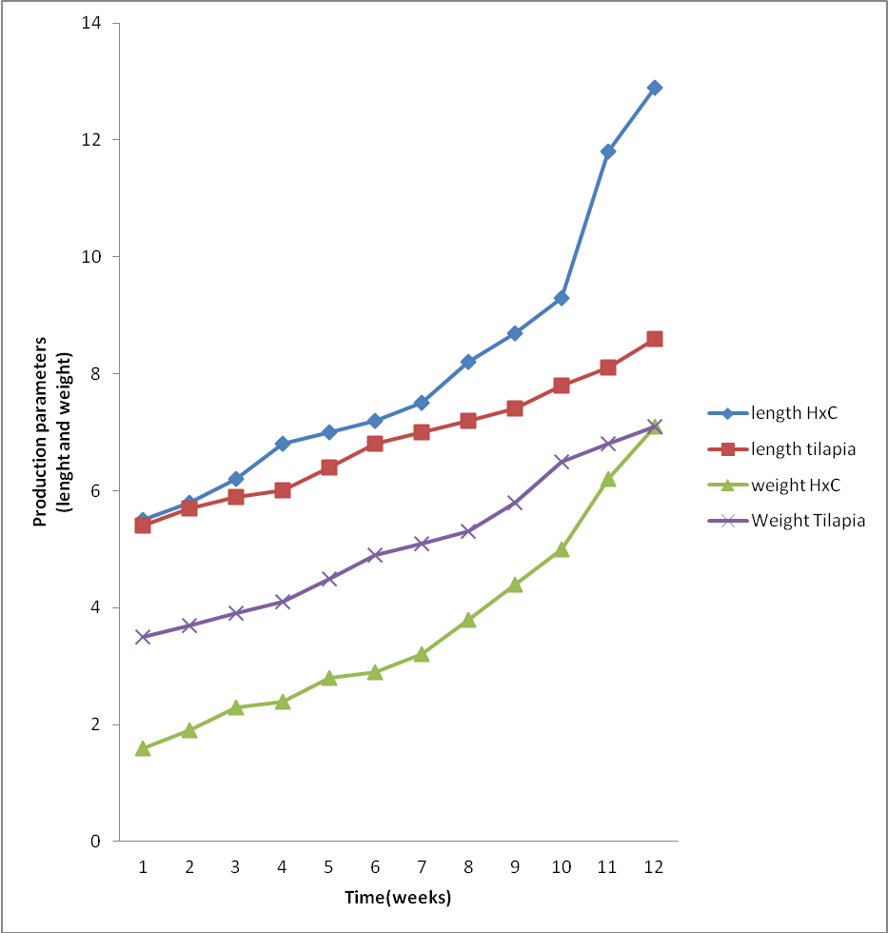

Appendix 2- Production Parameters for Treatment A, (Survival Rate%).
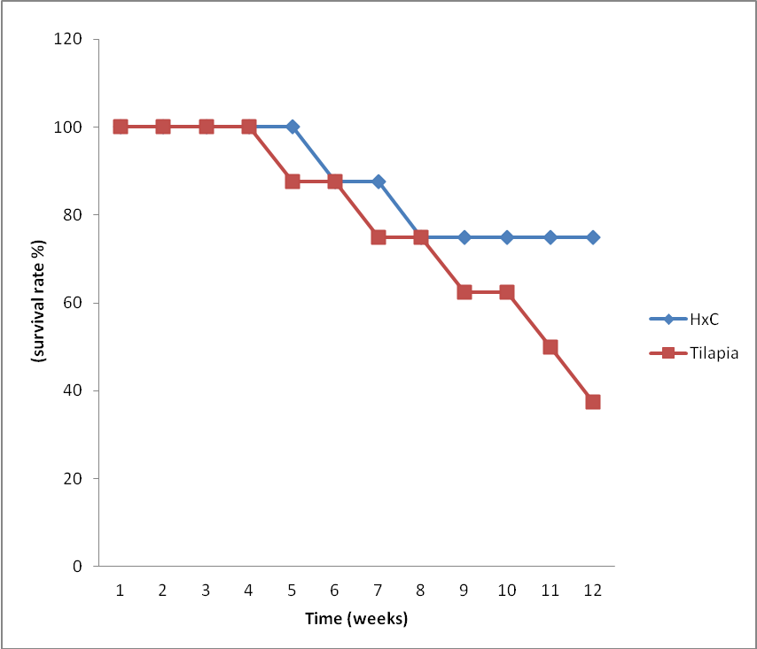

Appendix 3- Production parameters for Treatment B (1:2)
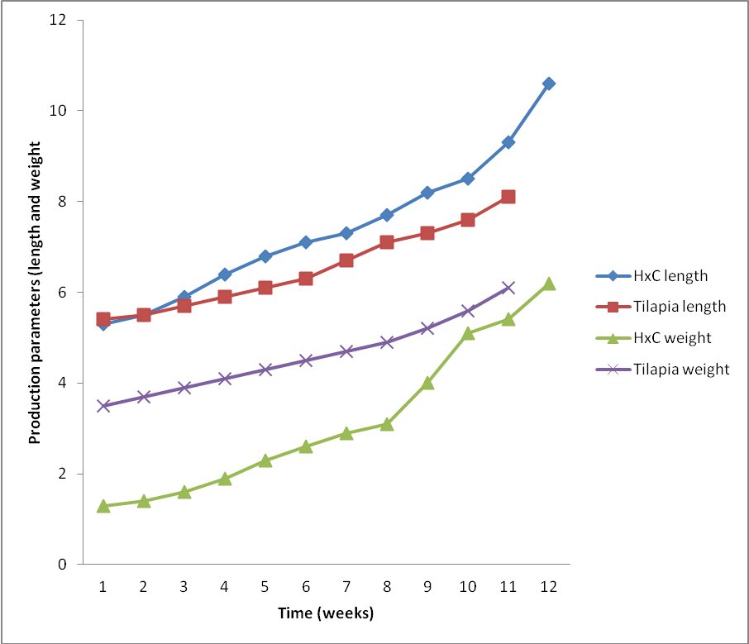

Appendix 4-Production parameters of Treatment B 1:2 (Survival Rate%)
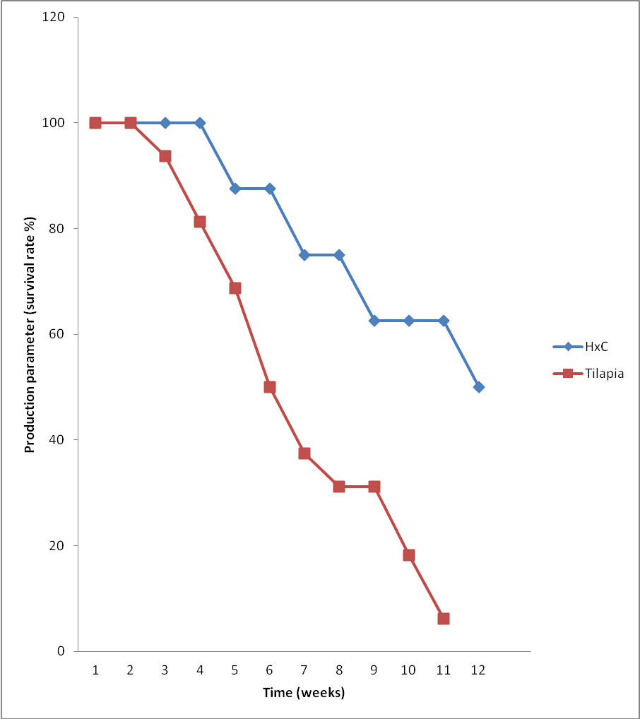

Appendix 5- Production Parameters for Treatment C (Survival Rate%)
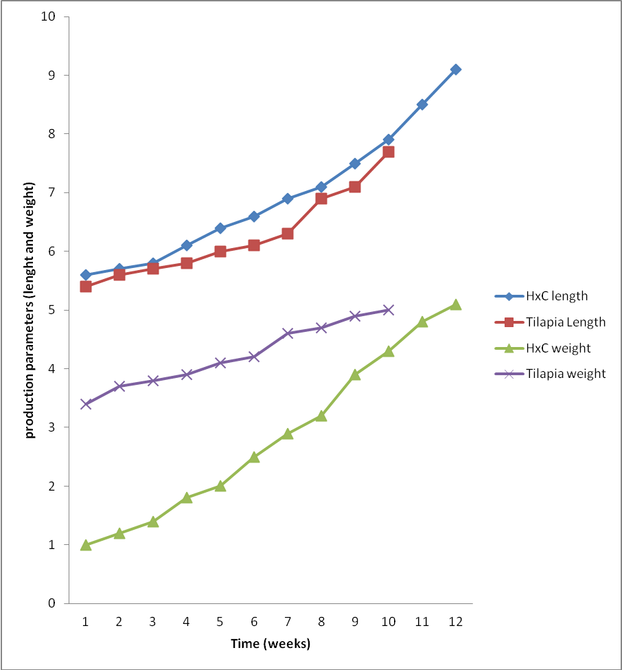

Appendix 6- Production Parameters for Treatment C (Survival Rate%)
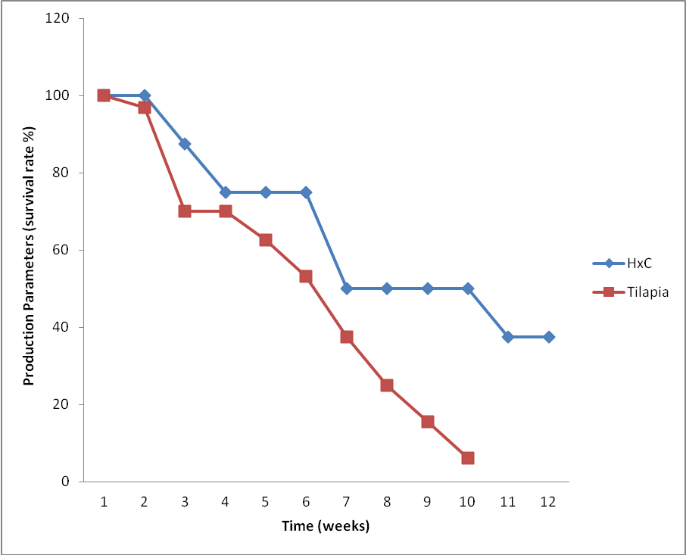

6/15/2010

