Impact of coal mining on plant diversity and tree population structure in Jaintia Hills district of Meghalaya, North East India

Kiranmay Sarma¹, S.P.S. Kushwaha², Khuraijam Jibankumar Singh³
¹University School of Environment Management, GGS Indraprastha University, Kashmere Gate,
Delhi–110 403, INDIA (Email: kiranmayipu@gmail.com)
² Forestry and Ecology Division, Indian Institute of Remote Sensing, Dehradun–248 001, INDIA
(Email: spskushwaha@gmail.com)
³ R&D Division, North East Centre for Environmental Education and Research, Sagolband Tera Sapam Leirak, Imphal–795001, Manipur, INDIA. (Email: neceer.imp@gmail.com)

Abstract: The present study was undertaken to analyze the impact of coal mining on plant diversity and tree population structure as affected by its proximity. The study revealed that the number of tree species was low in all the mining sites due to various activities during the mining as compared to adjacent unmined area, however, mining sites was represented by higher number of herbaceous species (31-41 species) than the unmined area (23 species). Pinus kesiya in the mining area, and Camellia caudata, Castanopsis purpurella and Quercus griffithii in unmined area were among the dominant trees. Majority of species showed contagious distribution pattern in the unmined and mined areas. The dominance-distribution pattern showed log-normal distribution in unmined area while it was resemble with broken-stick series model in the mined area. Shannon diversity index for tree and shrub species were low in mined areas as compared to that of the unmined area, however, diversity index of ground vegetation did not differ among the mined and unmined areas. Simpson’s dominance index shows a reverse trend to that of diversity index. The tree density was more (1040 stems ha⁻¹) in the unmined area than the mined areas (515 and 646 stems ha⁻¹) while density of herbaceous species was higher in mined areas than the unmined area. The trees of medium girth class contributed to the maximum stand density in the mined areas, while in the unmined site the trees of low girth class contributed to the maximum stand density. The higher basal area in the mined areas, in spite of low stand density, could be mainly due to the existence of trees of high girth as they were not damaged by the miners during the mining operations. [New York Science Journal 2010;6(9):79-85]. (ISSN: 1554-0200).

Keywords: Coal mining, distance gradient, rat-hole, species diversity, stand density.

1. Introduction
Mining causes massive damage to the landscapes and biological communities and impact of severity depends on whether the mine is working or abandoned, mining methods, and the geological conditions (Bell et al. 2001). The problems of waste rock dumps during mining become devastating to the landscape, as a result, natural plant communities get disturbed and the habitats become impoverished, presenting a very rigorous condition for plant growth. Various studies have emphasized to assess the vegetation structure and species diversity of an ecosystem (Ruiz-Jaén et al. 2005, Dorren et al. 2004). Measures of vegetation structure provide information on habitat suitability, ecosystem productivity and successional pathways (Silver et al. 2004, Wang et al. 2004) while species diversity provide information on susceptibility to invasion and trophic structures (Nicholas and Nicholas 2003).
The state of Meghalaya, northeast India is bestowed with rich natural vegetation as well as large reserve of mineral resources. During the last few decades, there has been phenomenal increase in mining of coal, limestone, sillimanite and clay, causing large-scale destruction and deterioration in the environment. Coal deposits of the state occur as thin seams (30 cm to 1.5 m) in sedimentary rock, sandstone and shale of the Eocene age (Guha Roy 1991, Sarma 2002, Barik et al. 2006). The coal found in the state has low ash content, high volatile matter, high calorific value and comparatively high sulphur content (Anon 1985).
Coal extraction in the state is done using primitive sub-surface mining method i.e., ‘rat-hole’ mining. The indiscriminate and unscientific mining, absence of post-mining treatment and management of mined areas are making the fragile ecosystems more vulnerable to environmental degradation hence leading to large scale land cover/ land use changes (Tiwari 1996). Because of the complex (traditional) landholding systems in the state very little governmental control can be exercised on the lands. Therefore, mining is done under customary rights and is not covered by any mining act, rule or any other legislation (Anon 1992).
Various studies have been conducted on vegetation composition and soil properties of mining areas by several workers in different parts India as well as in the state (Pandey et al. 1993, Rai 2002, Sarma et al. 2004, Sarma 2005, Barik et al. 2006). Nevertheless, none of the above studies emphasized about comparative study on the plant diversity and population structure in the region to compare the study about the loss of plant diversity and changes in tree population structure due to mining. Therefore, an understanding of impact of mining on plant diversity and comparative analysis in change in species diversity and population structure is a prerequisite to understand the overall impact on the vegetation as affected due its proximity to the mining site.

2. Materials and Methods
A study area of about 400 km² was selected in the core of the coal mining belt of the Jaintia Hills district (92°13´52´´ to 92°25´16´´E and 25°16´7´´ to 25°27´28´´N) (Fig. 1) in the state of Meghalaya, northeast India. Lad Rymbai, the major centre for coal mining was taken as the centre of the study area, which is located about 16 km east of Jowai, the district headquarters of Jaintia Hills. To analyze the impact of coal mining on vegetation, distance gradient analysis was carried out. The structure and composition of vegetation was studied in four different directions from the centre of the study area (circular transects). The radius of the first circle i.e., Zone-I was 2 km. The distance from the periphery of the first transect to the periphery of the second transect was also 2km and was considered as Zone-II. Likewise, Zone-III and Zone-IV were also delineated (Fig. 2).
The topography of the area is undulating and elevation ranges from 700 m to 1400 m asl. The soil is sandy in nature, reddish brown to yellow brown in colour, acidic in reaction, low water holding capacity and has low organic matter and nutrients (Das Gupta 1999, Dkhar 2002). The climate of the study site was monsoonic. The rainy season occurs during mid-May to September and about 80% of the total annual rainfall occurs during this period. October and November is the transition period (autumn). The period between December and February is characterized by cold and dry weather conditions. March to mid-May is the warm period. The annual rainfall ranges from 379 cm to 791 cm with an average of 585 cm per year. The mean minimum and maximum temperature ranges from 7.8°C (January) to 24.5°C during August and average relative humidity is maximum during July (85%) and minimum (61%) during December (Sarma 2005).
The community characteristics of vegetation in coal mining areas sampling was done at every two km interval taking 24 samples plots for trees, shrubs and herbs from each transect. The vegetation of mined areas was compared with that of an adjacent undisturbed forest, i.e., Tubre Sacred Grove by sampling 0.1ha area. Quadrates of 10m × 10m were randomly placed in each of the selected zones used for trees (>15 cm cbh), 5 m × 5 m for shrubs/saplings (<15 cm cbh) and 1m x 1m for herbs/seedlings (<1 m height) were used for sampling the vegetation. The species encountered in the quadrats were identified with the help of the regional floras (Kanjilal et al. 1934-1940, Haridasan and Rao 1985-1987), Herbaria of Botany Department, North-Eastern Hill University, Shillong and Botanical Survey of India, North-Eastern Circle, Shillong. Quantitative community characteristics such as frequency, density, basal area and importance value index (IVI) of each species were determined using methods outlined by Misra (1968) and Mueller-Dombois and Ellenberg (1974). Shannon-Wiener diversity index and Simpson’s dominance index were also computed following Magurran (1988). Population structure of the community was assessed based on density-diameter distribution.

3. Results
Floristic composition
The tree species showed a drastic reduction in their number in all zones of the mining sites to that of unmined sites. Unmined site was represented by twenty seven tree species, however, tree species richness ranges between 3 and 11 species in different zones of mined site (Table 1). It was apparent from the study that the number of tree species was more in the peripheral zone than the inner zones at mining site. There was not much variation in the number of species in first three zones of the area. The shrub species did not show much variation in species diversity between unmined and mined areas while there was remarkable increase in the number of herbaceous species in mined areas (31-41 species) as compared to unmined (23 species) area (Table 1).

Density dominance distribution and diversity
The tree density was comparatively more (1040 stems ha⁻¹) in the unmined area than the mined areas where stand density ranged between 515 and 646 stems ha⁻¹. The density of shrubs/saplings did not vary much between the sites while density of herbaceous species was higher in mined areas (154-178 individual m⁻²) than the unmined (32 individual m⁻²) area (Table 1). Based on density, mined sites were mostly dominated by Pinus kesiya, however, Castanopsis purpurella and Quercus griffithii were among the most dominant tree species in unmined area.
In terms of importance value, Pinus kesiya was the dominant tree species followed by Schima wallichii in all the zones of mining areas while Camellia caudata, Castanopsis purpurella and Quercus griffithii were the dominant tree species in the unmined area. In the shrub layer, Eupatorium adenophorum and Melatostema nepalensis were the dominant species followed by Lantana camara in different zones of the mining area, and Psychotria erratica, Cassia floribunda, Shutaria vestida, and Plectranthus striantus in the unmined area. Paspalum orbiculare has dominated in all zones of the mining area and Globba clarkii, Selaginella semicordata and Panicum brevifolium were the dominant herbaceous species in the unmined area. The dominance-distribution curve was log-normal in the unmined area while distribution curves resembles with broken-stick series model in the mined areas (Fig. 3).
In the unmined area, majority of tree and shrub species showed contagious distribution pattern (85% and 89%) while in mined areas all species showed contagious distribution pattern (Sarma 2005). Shannon-Wiener diversity index for tree and shrub species were low in mined areas as compared to that of the unmined area, however, diversity index of ground vegetation did not vary much among the mined and unmined areas. Simpson’s dominance index shows a reverse trend to that of diversity index in all the stands and at each layer of vegetation (Table 1).

Population structure
The trees of medium girth class (56-95cm) has contributed to the maximum (62%) stand density in the mined areas and lower girth class was represented by only 43 (Zone-II) to 244 (Zone-III) individual ha ⁻¹. However, in the unmined site the trees of low girth class (15-55cm) had contributed to the maximum (85%) stand density, and there after showed a decline trend (Fig. 4a). The basal area was comparatively more (22.39 to 32.61 m² ha⁻¹) in the mined areas than the unmined area (21.94 m² ha⁻¹). Comparatively low basal area in spite of high population density in the unmined site was mainly because that lower girth class had contributed only 15 percent of the total basal area. Although higher girth class was represented by only a few individuals but it has contributed to the maximum basal area (about 11 m² ha⁻¹) in all the sites (Fig. 4b). The higher basal area in the mined areas in spite of low stand density could be mainly due to the existence of trees of high girth as they were not damaged by the miners during the mining operations.

Table 1 Taxonomic diversity, density (trees-ha⁻¹, shrubs and ground species m⁻²) and diversity indices in the unmined and mined areas

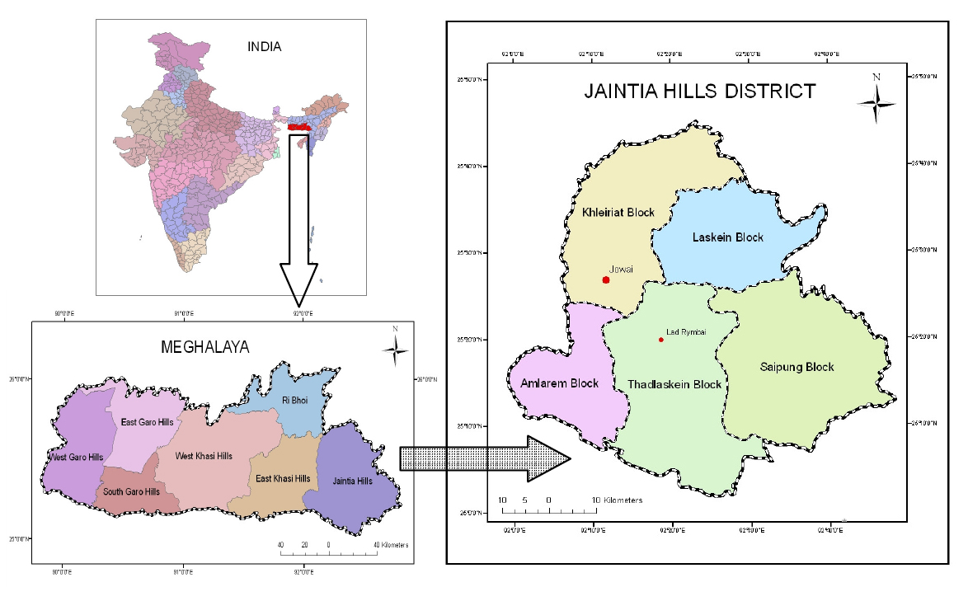
Figure 1. Location of the study area in Jaintia Hills district of Meghalaya
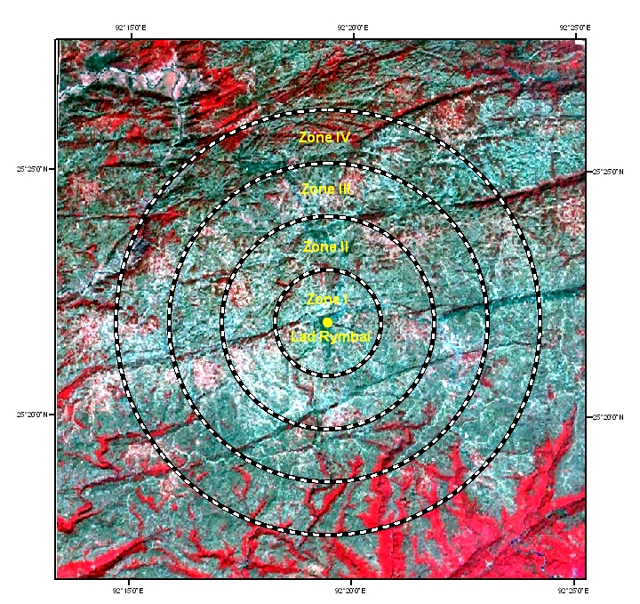
Figure 2. Conceptual framework of different coal mine impact zones

Figure 3. Dominance-distribution pattern of plant species in unmined and mined areas of Jaintia Hills districts of Meghalaya
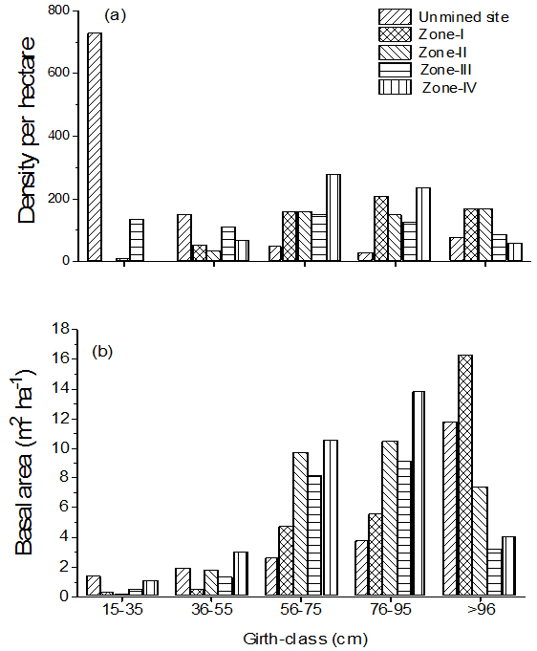
Figure 4. Density-distribution (a) and basal area (b) of trees in different girth class in unmined and mined areas of Jaintia Hills district of Meghalaya

4. Discussions
Due to extensive coal mining, large areas of Jaintia Hills district of Meghalaya, northeast India have been degraded and have resulted in unfavourable habitat conditions for plants growth. The prevailing habitat conditions in these areas have reduced the chances of regeneration of many species, thereby reducing the number of species in the mined areas. The higher number of herbaceous species in the mined areas than in unmined areas could be due to colonizing ability of herbs in the degraded area. Similar observations were made by several workers in the coal mining areas in different parts of the world (Cornwell 1971, Jha and Singh 1990, Das Gupta 1999, Sarma 2002).
Since the mined and unmined areas were located at similar climatic, edaphic and physiographic features the differences in species composition could be attributed mainly due to the mining activities (Jha and Singh 1990, Lyngdoh et al. 1992, Das Gupta 1999). Sarma (2002) have also reported low species diversity in the mined areas as compared to unmined areas from Nokrek biosphere reserve of Meghalaya. The high importance value of Pinus kesiya and Schima wallichii in mining areas suggest their ability to grow in the disturbed environments as they are the successional and light demanding species. The higher importance value of herbaceous species like Paspalum orbiculare in the mining areas suggests that it can multiply rapidly in the disturbed environments. This perennial grass by virtue of its stolon and rooting at each node can bind the soil particles, making the soil more stable. Low nutrient habitats are usually colonized by species having low relative growth rates and these adaptations enable colonizing species to maximize the nutrient uptake and ensure high nutrient use efficiency in low nutrient environments (Lyngdoh 1995, Das Gupta 1999, Sarma 2005).
Dominance-diversity curves have been used to interpret the dominance of species in the community in relation to resource apportionment and niche space (Whittaker 1975). The log-normal distribution pattern as observed in the unmined area suggests that there was more or less an even apportionment of resources among the members of the important species. However, the broken-stick model curves in the mined areas were attributed due to presence of less number of species and stress environments where conditions were not favourable for plant growth. Species diversity was low on mined stands, but the species that grow here appear to have developed tolerance. The diversity index for herbaceous species increased with mining suggesting that mining operation enhanced the colonization of certain species in the newly created habitats (Lyngdoh 1995, Das Gupta 1999, Sarma 2005).
Patchiness, or the degree to which individuals are aggregated or dispersed, is crucial to the understanding of how species uses resources. Besides, the distribution pattern of species population is often related to its productive biology. Ashton (1972) indicated that in the absence of major disturbance, soil and water conditions play a major role in controlling species distribution pattern. The contagious distribution of the species suggests the increase in fragmentation of the natural vegetation due to mining (Sarma 2002).
The greater tree diversity in unmined area as compared to that of the mined areas could be due to presence of a large number of young individual in the former site, while in the later they were logged during mining and dumping of coal. Population structure in the unmined area indicated stable tree population structure and suggests that the forest is growing and would continue to exist. However, in the mined areas, the tree density in all the girth classes was low which could be due to rampant and random clearing of forest areas for mining purpose that has led to drastic change in tree population structure and does not indicate the continued existence of the forest. The higher basal area in the mined areas though it had low density, could be attributed to the existence of bigger trees.

Conclusion
Extensive coal mining in the study area has led to shrinkage of land use/land cover and created a landscape dotted with mine spoils. The impact of mining on vegetation was less in the outer most zones. The disturbance during the mining has reduced the chances of regeneration of species, thereby, reducing the number of species in the mined areas. The number of herbaceous species colonizing in the mined areas was found to be higher than in the unmined areas. The diversity index for herbaceous species increased with mining proximities suggested that mining operation favoured colonizing of certain species in newly created habitats. It is evident from the results of the study that the mining activities are detrimental to the plant diversity. Thus it is advisable that such activities have to be strictly regulated to avoid further damage to the species and scientific mining has to be taken up in a proper manner to minimize further damage to the vegetation. Appropriate rehabilitation measures using some of the above said plant species in the mine areas need to be taken up. Hence findings of the present study could be useful for formulating the Management Plan for the mined affected areas.

Acknowledgements:
The authors are thankful to Dean, Indian Institute of Remote Sensing, Dehradun for providing facilities during the course of study and Herbarium Curator, North-Eastern Hill University, Shillong for plant identification.

Corresponding Author:
Kiranmay Sarma
University School of Environment Management, GGS Indraprastha University, Kashmere Gate,
Delhi–110 403, INDIA
Email: kiranmayipu@gmail.com

References
- Anon. Technical Report of the Directorate of Mineral Resources. Government of Meghalaya. Shillong. Meghalaya. 1985.
- Anon. Cottage coal mining in the state of Meghalaya and its impact on the environment. In Gupta, A. and Dhar, D.C. (eds.), Environment Conservation and Wasteland Development in Meghalaya. Meghalaya Science Society. Shillong. India. 1992.
- Ashton PS. The quarternery geomorphological history of Western Malaysis and lowland forest phytogeography. Trans. Second Aberdeen Hull Symposium Malaysian Ecology. 1972; 35-42.
- Barik SK, Pandey HN, Tiwari BK, Sarma K, Singh B.Coal mining in Meghalaya: An environmental perspective. Regional Centre, National Afforestation and Eco-Development Board, North Eastern Hill University, Shillong. India. 2006;1-21.
- Bell FG, Bullock SET, Halbich TFJ, Lindsey P. Environmental impacts associated with an abandoned mine in the Witbank Coalfield, South Africa. International Journal of Coal Geology 2001; 45: 195-216.
- Cornwell SM. Anthracite mining spoils in Pennsylvania. I. Spoil classification and plant cover studies. Journal of Applied Ecology 1971; 8:401-409.
- Das Gupta S. Studies on vegetal and microbiological processes in coal mining affected areas. Ph.D. Thesis. North Eastern Hill University, Shillong. India. 1999.
- Dkhar A. Impact of coal mining on micro-landforms in Jaintia Hills district, Meghalya. M. Phil. Dissertation. North Eastern Hill University, Shillong. India. 2002.
- Dorren LKA, Berger F, Imeson, AC, Maier B, Rey F. Integrity, stability and management of protection forests in the European Alps. Forest Ecology and Management. 2004; 195, 165-176.
- Guha Roy PK. Coal mining in Meghalaya and its impact on environment. Exposure 1991;4:31-33.
- Haridasan K, Rao RR. Forest Flora of Meghalaya. 2 Vol. Bishen Singh Mahendra Singh, Dehra Dun, India.
- Jha AK, Singh JS. Revegetation of mine spoils: review and case study. In: Dhar BB (ed.), Environmental Management of Mining Operations. Ashish Publishing House. New Delhi. 1985-1987; 300-326.
- Kajilal UN, Kanjilal PC, Das A, Bor NL. Flora of Assam. 5 vol. Government Press. Shillong. India. 1934-1940.
- Lyngdoh T. Community dynamics and edaphic changes in relation to coal mining in Jaintia Hills, Meghalaya. Ph.D. Thesis, North-Eastern Hill University, Shillong, India. 1995.
- Lyngdoh T, Tripathi RS, Das AK. Vegetation dynamics on coal mine spoils of Jaintia Hills in Meghalaya (North East India) undergoing natural recovery. Acta Oecologia 1992; 13(6): 767-775.
- Magurran AE. Ecological Diversity and its Measurement. University Press, Cambridge. 1988.
- Misra R. Ecology Work Book. Oxford & IBH Publication, New Delhi. 1968.
- Mueller-Dombois D, Ellenberg H. Aims and Methods of Vegetation Ecology. John Wiley & Sons. New York. 1974.
- Nichols OG and Nichols FM. Long-term trends in faunal recolonization after bauxite mining in the jarrah forest of south-western Australia. Restor. Ecol. 2003;11: 261-272.
- Pandey HN, Tripathi RS, Uma Shankar, Boral L. Study site, vegetation and soil. Meghalaya State Pollution Control Board. Final Technical Report. North Eastern Hill University. Shillong. 1993; 1-63.
- Rai RK. Implication of coal mining on environment in Jaintia Hils, Meghalaya. In: Passah PM, Sarma AK (eds.), Jaintia Hiils, A Meghalaya Tribe: Its Environment, Land and People. Reliance Publishing House. New Delhi. 2002; 113-119.
- Ruiz-Jaén MC, Aide TM. Vegetation structure, species diversity, and ecosystem processes as measures of restoration success. Forest Ecology and Management. 2005; 218(1-3):159-173.
- Sarma, K. Coal mining and its impact on environment of Nokrek Biosphere Reserve, Meghalaya. Ph.D. Thesis. North Eastern Hill University, Shillong. India. 2002.
- Sarma K. Impact of coal mining on vegetation: a case study in Jaintia Hills district of Meghalaya, India. M.Sc. Thesis. International Institute for Geoinformation Science and Earth Observation (ITC). Enschede. The Netherlands. 2005.
- Sarma K, Barik SK, Rai RK. Impact of coal mining on Nokrek Biosphere Reserve of Meghalaya. In: Hussain Z, Barik SK (eds.), Development of Geoenergy Resources and Its Impact on Environment and Man of Northeast India. Regency Publications. New Delhi. 2004; 229-259.
- Silver Wl, Kueppers LM, Lugo AE, Ostertag R, Matzek V. Carbon sequestration and plant community dynamics following reforestation of tropical pasture. Ecol. Alli. 2004;14:1115-1127.
- Tiwari BK. Impact of coal mining on ecosystem health in Jaintia Hills, Meghalaya. In: Ramakrishnan PS, Purohit, AN, Saxena KG, Rao KS, Maikhuri RK (eds.), Conservation and Management of Biological Resources in Himalaya. G. B. Pant Institute of Himalayan Environment and Development, Almora. Oxford IBH Co. New Delhi. 1996; 466-475.
- Wang J, Borsboom AC, Smith GC. Flora diversity of farm forestry plantations in southeast Queensland. Ecol. Manage. Restor 2004; 5: 43-51.
- Whittaker RH. Communities and Ecosystems. Mc Milan Publishing Company. New York. 1975.

7/16/2010

