Improving the leather performance via treatment with different adducts and grafting with 1-Vinyl-2- pyrrolidinone

H.E. Nasr and A. Ismail

Department of Polymers and Pigments, National Research Center, Dokki, Cairo-Egypt
ismaelahmed1@yahoo.com

Abstract: Leather was treated with different aldehyde and ketone sodium bisulphite adducts to improve its physical and mechanical properties. Acetaldehyde sodium bisulphite (AcSBS), glutraldehyde sodium bisulphate (GSBS), cyclohexanone sodium bisulphite (ChSBS) and octylaldehyde sodium bisulphate (OSBS) adducts were prepared to be used for treatment of the leather. The treatments were carried out at different adduct concentrations (0.5-3.0%). The performance of leather treatment was evaluated in terms of tensile strength (TS) and elongation percent at break (E%), hardness as well as water uptake %. The data obtained showed that all the studied adducts increase the leather performance compared with the untreated one. Moreover, leather treated with octyldehyde sodium bisulphate adduct showed the highest tensile strength with the lowest hardness and water uptake %. The treated leather was grafted with 1-Vinyl-2- pyrrolidinone (VP) monomer using redox initiation system composed of potassium persulphate (KPS) as oxidizing agent and the previously used adduct modifying agent as reducing one. The optimum graft yield was studied by changing the type of adducts, liquor ratio, temperature and time of the reaction as well as initiator and monomer concentrations. Higher graft yield of ca. 15.42 % was obtained by using octaldehyde sodium bisulphite adduct at 60ºC for 1 hr using 1/20 liquor ratio and KPS and VP concentrations of 0.5 and 4 gm respectively. The grafted leather is characterized with respect to FTIR, SEM and thermal gravimetric analysis. The obtained grafted modified leather samples showed greater dyeing performance with acid dyes and an appropriate improvement in hardness and TS compared with the blank leather sample. [New York Science Journal 2010;3(9):112-119]. (ISSN: 1554-0200).

Keywords: Leather, grafting,1-Vinyl-2- pyrrolidinone, characterization, dyeing,

Introduction
Chemical modification of leather fibers by different methods such as graft copolymerization or finishing treatments was a target of many researchers. Some of these articles are oriented to produce new leather products, such as leather boards, with keeping the natural appearance of leather. The researches clarified that observed improvement in the mechanical properties of tanned or untanned leather fibers were obtained using acrylic monomers, such as methyl methacrylate (MMA), butyl acrylate (BA) ⁽¹⁻⁵⁾. Madera-Santana and Vázquez Moreno prepared the graft polymerization of methyl methacrylate (MMA) monomer onto short leather fibers (SLF) as a function of the monomer/leather fiber ratio. This chemical modification was made by aqueous emulsion polymerization initiated by a redox system. Composites formulated with SLF without chemical modification showed lower tensile and band impact properties in comparison with composites formulated with treated fibers. The micrographs manifested the polymer deposition on both individual fibers and bundles of SLF. The study also revealed that PMMA may interpenetrate the SLF network and deposit in large and coarse aggregates the individual fibers, but without occupation of the voids in the fiber net ⁽⁶⁾. Abd El-Ghaffar et al.,⁽⁷⁾ studied the graft copolymerization of ethyl acrylate, butyl acrylate, and 2-ethyl hexyl acrylate onto leather using benzoyl peroxide as an initiator to improve leather mechanical and hydrophobic properties. Optimum conditions for grafting such as monomer and initiator concentrations, as well as temperature and time of grafting beside liquor ratio were extensively investigated. The study concluded that pronounced decrease of water uptake was occurred on using 2-ethyl hexyl acrylate and butyl acrylate monomers.
The kinetics of the grafting polymerization of glycidyl methacrylate (GMA) onto leather was studied using redox initiation systems composed of ammonium persulfate (AmPS), potassium persulfate (PPS) and sodium persulfate (SPS) as oxidizing agent and developed reducing adduct represented as acetone sodium bisulfite (ASBS)⁽⁸⁾. The results showed that the rate of grafting of (GMA) onto leather was highly influenced by the initiation system type, emulsifier and monomer concentration. The result demonstrated that the powers were 1.06, 0.48, and 0.43 for AmPS/ASBS, PPS/ASBS and SPS/ASBS respectively, while its values were 1.41, 0.70, and 0.81 using different (GMA) concentrations for the three initiator types in successive. The apparent activation energy was calculated for each initiation system and was found to be 180.8, 361.63, and 542.45 kcal. Grafting emulsion copolymerization of methyl methacrylate (MMA) with butyl acrylate (BuA) of different molar ratios onto natural leather was carried out using the redox initiation system of potassium persulfate (PPS) developed as an oxidizing agent and some sodium bisulphite adducts as reducing agents ⁽⁹⁾. Sodium dodecyl sulphate (SDS) was used as an anionic emulsifier. The grafted leather was characterized via FTIR, SEM and thermal gravimetric analysis. Moreover, the grafted leather was evaluated through water absorption, tensile strength, dyeing performance and hardness measurements. The obtained results revealed that the physical and mechanical properties of the modified leather were enhanced.
The present work is aimed to study the feasibility of using different adducts systems, composed of (AcSBS), (GSBS), (ChSBS) and (OSBS) for modifying the some properties of the leather such as mechanical and physical performance. The work is extended to include the application of the best obtained pretreated leather sample in graft emulsion copolymerization using 1-Vinyl-2- pyrrolidinone (VP) monomer. The factors affecting the emulsion graft copolymerization of VP were studied. FTIR, thermal gravemetric analysis, water absorption, hardness, dyeing with an acid dye as well as tensile strength and elongation (%) of the grafted leather, pretreated leather and ungrafted leather were also characterized.

Experimental
Materials
Leather
The chrome-tanned cow leather selected for investigation was supplied from 6-October tanner located at Misr-Elkadima region,Cairo, Egypt. The delivered leather was washed with water, drained and finally neutralized.

Chemicals
1-Vinyl-2- pyrrolidinone was provided by Merck– Schuchardt, Germany, it is redistilled before use and stored at –20ºC. Potassium persulphate, cyclohexanone, acetaldehyde, octylaldehyde, glutradehyde, and sodium bisulphite were supplied by BDH Company. The other chemicals were of laboratory grade.

Preparation of acetaldehyde, glutradehyde, hexanone and octylaldehyde adducts
The sodium bisulphite adducts of each of acetaldehyde, glutradehyde cyclohexanone and octylaldehyde were prepared by the addition of sodium bisulphite on the carbonyl of each of acetaldehyde, glutradehyde, octylaldehyde and cyclohexanone respectively^{(10,11)} .

Leather treatment and grafting method
Acetaldehyde, glutraldehyde, cyclohexanone and octylaldehyde sodium bisulphate adducts were prepared to be used for leather treatment. The treatments were carried out at different adduct concentrations of adduct (0.5-3.0%). 1-Vinyl-2- pyrrolidinone monomer was introduced into a conical flask containing water, pretreated leather and potassium prsulphate as oxidizing agent using the recipe given in Table (1).The flask components are mechanically stirred at 200 rpm. The homopolymer is extracted from the grafted leather by washing with water till a constant weight of leather.
The graft yield was calculated according to the following equation
Graft yield = (W₂-W₁) / W₁x100
Where, W₂ = weight of grafted leather and W₁ = weight of ungrafted leather

Dyeing methods
Each of ungrafted leather and poly 1-Vinyl-2- pyrrolidinone -g- leather was independently dyed with acid dye. The dyeing was carried out using conventional exhaustion method at dye concentration of 0.2%, Liquor ratio of 1:50, and pH of 4-4.5 at 80ºC for 1 hr.

Testing and analysis
FT-IR spectroscopy was carried out using Perkin Elmer FTIR (300E, JASCO type– Japan). The Thermogravimetric (TG) was carried out at a temperature range of 30ºC to 800ºC under nitrogen atmosphere with heating rate of 10ºC/min using Shimadzu TGA-50, Japan. The water absorption capacity for the grafted and ungrafted leather samples were measured according to the standard method of testing ⁽¹²⁾. The tensile strength and elongation at break for the studied samples were measured using Instron Machine (model 1195) according to the standard method of testing ⁽¹³⁾. The hardness was measured by shore A, Harterpufer apparatus according to standard method of testing ⁽¹⁴⁾. The color strength (K/S) values of all examined dyed samples were evaluated using Optimatch 3100 Spectrophotometer.

Table (1): Recipe of graft polymerization of leather by 1-Vinyl-2- pyrrolidinone
Components | Amount | Function
Pretreated leather | 5gm | Substrate and variable type of adducts which act as reducing agents
KPS | Variable | Oxidizing agent
1-Vinyl-2- pyrrolidinone | Variable | Monomer
Water | Variable | Medium

Results and discussion
The reaction between the aldehydic or ketonic compounds with sodium bisulfite can be summarized as follows:

R- CHO + NaHSO₃ R-CH(OH)(SO₃Na) (1)
R= CH₃- for acetaldehyde and R= CH₃-(CH₂)₆- for octaldehyde
In case of glutraldehyde the reaction proceed as follows
CHO-(CH₂)₄-CHO+NaHSO CH(OH)(SO₃Na)-(CH₂)₄-CH(OH)(SO₃Na). (2)
R₁-CO-R₂ + NaHSO₃ R₁-C(OH)(SO₃Na)-R₂
R₁ and R₂ = CH3CH2- for cyclohexanone

Leather was pretreated with different aldehydic or ketonic adduct compounds to acquire some desirable properties such as improving tensile strength, elasticity, dyeing availability as well as to minimizing the swelling behavior. On the other hand, the presence of these adducts on the molecular structure of leather will magnify the grafting copolymerization properties with different monomers. Choosing VP monomer in grafting copolymerization of modified leather was of our interest to meet the point of view of increasing the elasticity and dyeing performance. The evidence of leather modification with aldehydic or ketonic adducts as well as grafting with VP is summarized.

Effect of pretreatment of the leather with different adduct type and concentration on its performance
Figures 1 and 2 show the effect of different adduct types and concentrations (0.5- 3%) on the performance of the treated leather expressed as tensile strength (kg), elongation (%) and hardness (shore). It is evident that, regardless of the adduct types increasing the concentration of adducts was accompanied by observed increase in the leather performance up to concentration of 2% after which level off. This could be due to plasticizing effect of the examined adducts as plasticizer. The plasticizing criteria of the adducts could be thought from the coating character initialized via hydrogen bond interaction that occurred between the leather amino groups and sulphonic groups bounded with alkyl groups having varied number of carbon atoms (equations 1-3). The plasticizing effect of the studied adducts is confirmed by the graphs of SEM which is seen in figures 10. On the other hand, for the studied treated compounds, octyldehyde sodium bisulphite adducts shows the most significant performance effect and lower water uptake property as shown by Figure 3. The variation in leather performance and water uptake (%) follows the following order: octaldehyde> cyclohexanone> glutradehyde> acetaldehyde. This proves that the compound having higher aliphatic normal long chain groups is the most suitable plasticizing effect and less gain for water molecules.

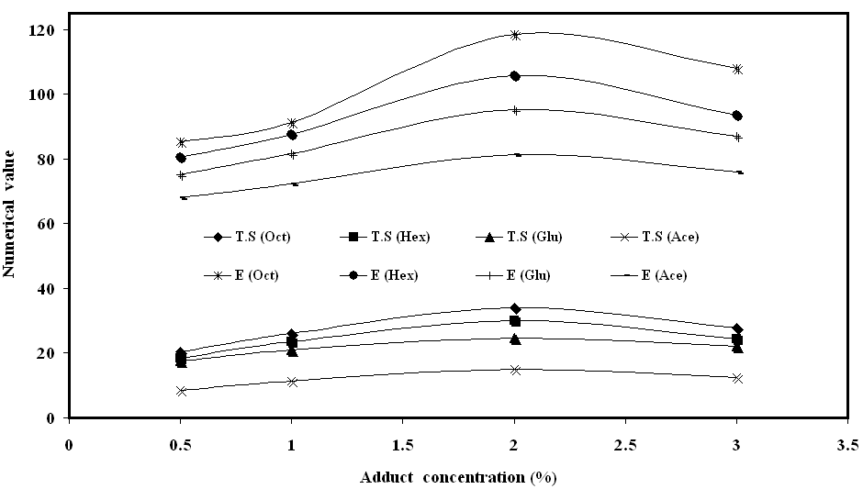
Figure (1): The effect of different type of adducts on the tensile strength and elongation % of treated leather.

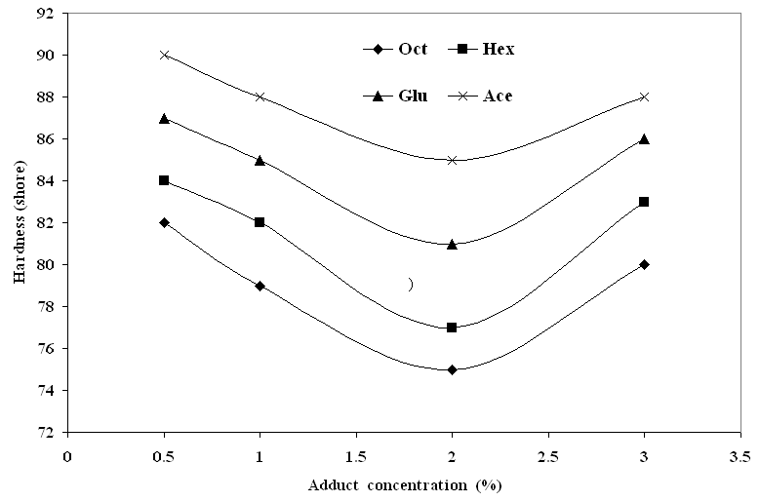
Figure (2): The effect of different types of adducts on the hardness of the treated leather.
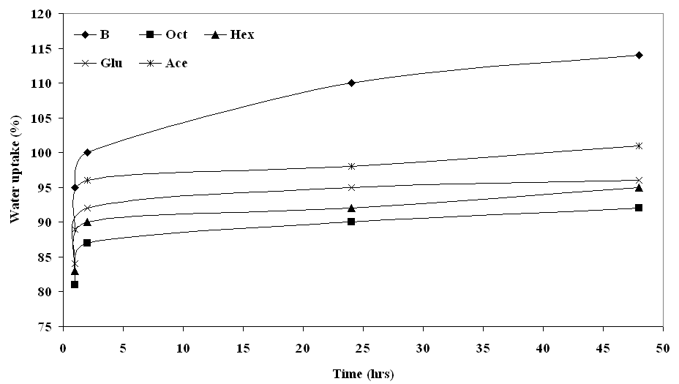
Figure (3): The effect of different types of adducts on the water up take %. of the treated leather.

Graft copolymerization of VP onto pretreated leather

Effect of different adduct types and concentrations

The data illustrated in Figure (4) shows the effect KPS concentration (2.5-20mmol/l) on the grafting yield of VP onto pretreatment leather with different concentrations of AcSBS, GSBS, ChSBS, OSBS. It is evident, regardless of the adduct type used, that the grafting yield increases as the initiator concentration increases up to certain level 10 mmol/l after which the grafting levels off. This could be recognized to the increase in number of free radical species on the leather backbone as well as in the polymerization medium, which act in favor of grafting and homopolymerization thereby enhancing the polymer yield ⁽¹⁵⁾. Moreover, the magnitude of the grafting obtained by using the initiation system composed of KPS as oxidizing agent and OSBS adduct as pretreatment reagent was the higher and ASBS the lowest while each of HSBS and GSBS was intermediate. The obtained data reflect the availability of OSBS adduct to enhance initiator decomposition i.e free radicals and faster forming leather macroradical. The latter has tendency to capture the double bond of VP molecule to initiate grafting as well as creating best favorable conditions for polymer propagation in the proximity of leather molecule. For the examined adducts the sequence of the graft yield % follows the following order: OSBS> HSBS> GSBS>ASBS.

Effect of time and temperature

Figure (5&6) show the effect of time and temperature on the degree of grafting of VP (400 mmol/l) onto pretreatment leather with OSBS in the presence of KPS as an oxidizing agent. It is clear that the grafting % of VP onto pretreated leather increases gradually with time up to 1 hrs, extra time leads to constant degree of grafting % due to the depletion in monomer by time. Moreover, rising the polymerization temperature from 50ºC to 60ºC causes a significant increase in the grafting (%) and further increase in temperature leads to level off. Increasing the polymerization temperature is expected to cause: (a) faster rate of persulphate decomposition, giving rise to more free radicals, (b) increasing the swellability of leather and mobility of VP molecules, creating a suitable environment for monomer diffusion from aqueous phase to the leather phase ⁽⁵⁾, and (c) increasing the rate of termination. Factors (a) and (b) are expected to cause higher grafting yield while factor (c) leads to lower grafting.

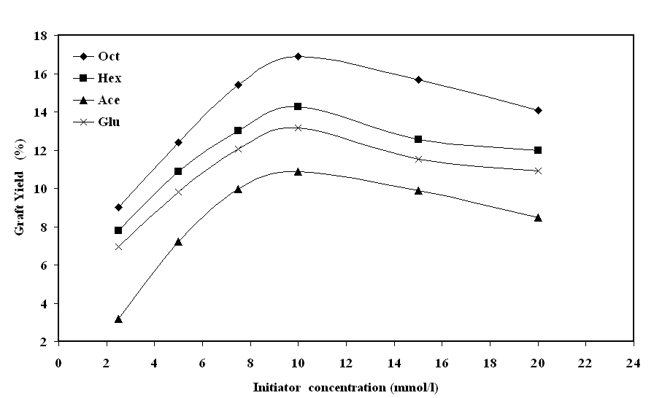

Figure (4): The effect of initiatior concentration on the GY % of grafted leather.

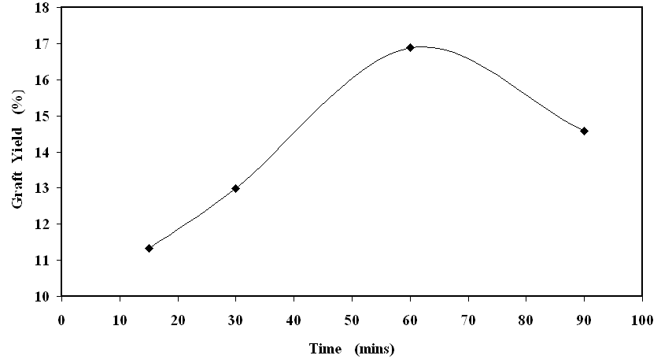
Figure (5): The effect of reaction time on the GY % of grafted leather.

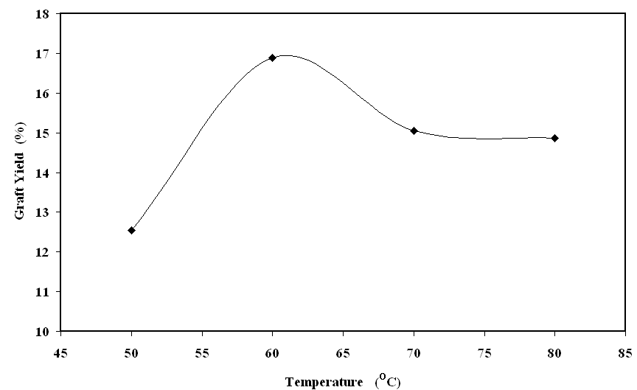
Figure (6): The effect of reaction temperature on the GY % of grafted leather.

Effect of monomer concentration
Figure (7) shows the effect of VP monomer concentration (200-500mmol/l) on the graft yield on the pretreated leather with OSBS. It is obvious that the grafting yield increases with increase of monomer concentration within the range studied. This may be due to the fact that ^{(5, 16)}, at higher monomer concentration more number of growing polymer chains are available near collagen matrix which are mainly utilized for grafting polymerization.
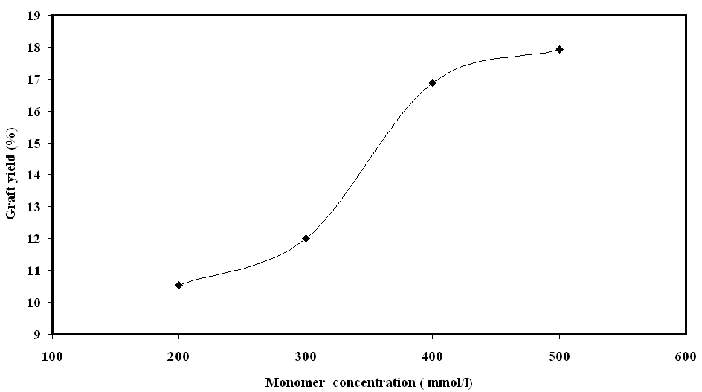
Figure (7): The effect of VP concentration on the GY % of grafted leather.

Leather Characterization
FTIR
Figure (8 a&b) shows the IR spectra of the native leather (BL) and VP grafted pretreated leather. It is evident that both spectra have similar peaks such as a wide band at 3410 cm⁻¹ which is corresponding to the hydroxyl group. The presence of short peaks around 3070 cm⁻¹ and 2930 cm⁻¹ are due to the asymmetrical stretching bands of -CH3 and =NH bonds, respectively. The C=O group in native leather (Figure 8a) is characteristic at 1642 cm⁻¹, while it observed with higher intensity in PVP-g-leather at 1665 cm⁻¹ (Figure 8b), which may be considered as a proof for leather grafting ^{(17,18)}. For the two spectrums the presence of characteristic band at 1548 is related to carboxyl groups.

Thermogravemetric analysis (TG/ DTG)
Thermogravemetric analysis TGA is a simple and accurate method for studying the decomposition pattern and the thermal stability of the polymers. Figure 9 (a&b) shows the primary thermograms and derivatograms for the native (BL), leather treated with OSBS (L-t-OSBS) and VP grafted pretreated leather (L-t-OSBS-g-poly-VP) having graft yield of 14.6%. As is evident the native leather sample has an initial weight loss of 14.1% around 100^{O}C, which is mainly due to the evaporation of absorbed moisture⁽⁵⁾. The main decomposition proceeds in two steps (RF), the first one with weight loss of 36.7 occurs at decomposition temperature (T_{d}) of 320 ºC and the second with weight loss of 14.5% occurs at T_{d} of 455^{O}C. The leather treated with OSBS shows a behavior similar to the native leather. On the other hand, for the L-t-OSBS-g-poly-VP the first degradation occurs due to the absorbed moisture and results in a weight loss of 10.2%. Also, the main decomposition process started at a relatively lower temperature than that of ungrafted leather. This could be due to the degradation effect caused either by the action of grafting bath, including the persulphate free radicals and pH medium, or due to opening up the leather chains structure with the deposited grafted chains. The DTG curve (Fig. 9b) shows two inflections with T_{d} of 210^{O}C and 320^{O}C, and weight losses of 9.2% and 45.4%, respectively. The first inflection could be due to the degradation of poly-VP grafted chains while the second inflection with the sharp peak records the same T_{d} of native leather. Our finding is in accordance with previous work in which TGA thermograms for leather grafted with poly methyl methacrylate (PMMA) showed two inflections for each of leather and PMMA, respectively⁽⁶⁾.

Morphological study
A morphological studies were carried out for some selected samples : (a) untreated leather; (b) leather treated with CSBS ; (c) leather treated with OSBS; (d) leather treated with CBSB and grafted with VP monomer; and (e) leather treated with OBSB and grafted with VP monomer and the graphs are shown in Figure (10). It is seen that the un-grafted leather (Figure 9a) is characterized by opening up structure i.e the surface seems to be smooth and completely separated. The graphs of the leather treated with the suggested adducts showed more uniform and blocking of the leather pores. This criteria manifests the role of adducts as sizing agent with proper film forming properties to the leather inter-chains. More blocking and film forming properties are for OBSB than CBSB (Figure 10 b & c) can be recognized due to the effect of long chain alkyl groups of octyl groups which act as plasticizing agent for leather. So, it could be considered that the adducts act as coating materials for leather fibers. When the pretreated leather samples are grafted with VP monomer the surface becomes more uniform film coating as well as disappearance of pores and separation of leather chains are the predominate (Figure 10 d & e).

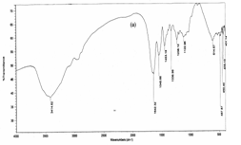
(a)

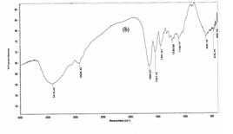
(b)
Figure (8): The FTIR spectra of a)- ungrafted leather and b)- L-t- OBSB-g-poly-VP

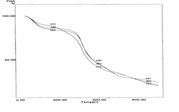
(a)

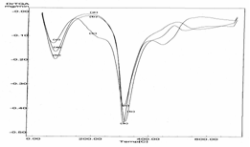
(b)
Figure (9): Thermogravimetric analysis (TGA) and differential thermogravimetric of: a)- ungrafted leather; b)- L-t- OBSB ; and c) L-t- OBSB -g-poly-VP

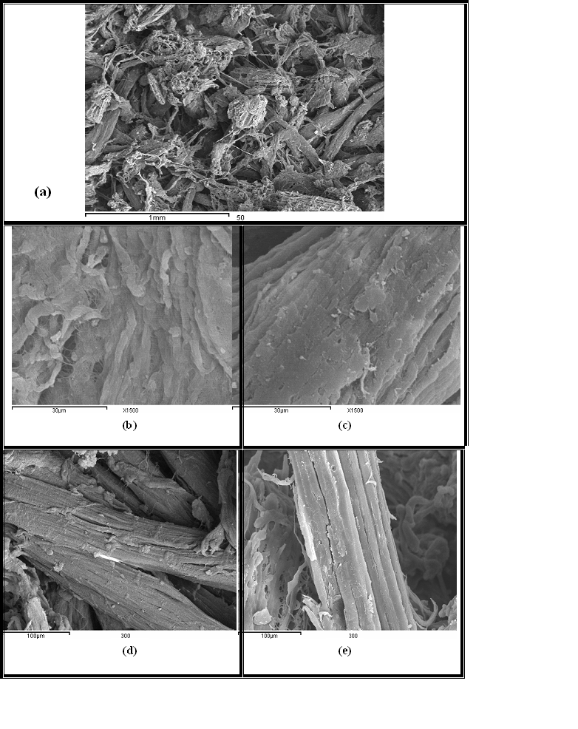
(a)

Figure (10): SEM photographs for a) untreated leather; b) L-t-CSBS; c) L-t- OSBS; d) L-t- CSBS-g-poly-VP; and e) L-t- OBSB -g-poly-VP

Table (2): Effect of grafting % of polyvinyl pyrrolidinone on color strength (k/s), tensile strength, elongation and hardness of leather.
Graft % | K/S | Tensile strength (kg force) | Elongation (%) | Hardness (shore)
Blank leather | 15 | 9.1 (± 0.4) | 64.4 (± 3.4) | 95 (± 3)
(L-t-OSBS) | 11 | 23.7 (± 0.3) | 91.6 (± 5.0) | 74 (± 2)
4.8 | 17 | 17.6 (± 0.8) | 80.7 (± 2.3) | 83 (± 4)
7.9 | 21 | 19.9 (± 0.6) | 85.1 (± 3.1) | 85 (± 2)
10.1 | 24 | 22.6 (± 0.9) | 89.2 (± 1.7) | 84 (± 4)
12.4 | 25 | 24.9 (± 1.1) | 93.0 (± 2.7) | 88 (± 3)
17.7 | 27 | 18.5 (± 1.4) | 84.6 (± 1.9) | 91(± 2)

Evaluation of the grafted leather via dyeing property and mechanical performances
The effect of grafting % of polyvinyl pyrrolidinone on the acid dyeing property and mechanical performance of grafted leather is shown in table (1). The data represents many interesting points: (i) chemical modification of leather with OSBS brings about substantial improvement in the mechanical performance expressed as tensile strength (TS), elongation percent (E%) and hardness (shor) while there is a decrease in the acid dyeing property, the latter is due to repulsion interaction between the acid dye and the sulfite groups incorporated in the leather structure; (ii) when the pretreated leather is subjected to graft copolymerization the mechanical properties firstly decreased due to the degradation action of grafting bath condition represented by pH and initiator free radicals, on the contrary the acid dyeing increased due to deposition of PVP in the leather structure ⁽¹⁸⁾ , (iii) increasing the grafting % up to 12.4 % results in gradual improvement in each of mechanical and dyeing properties due the role of PVP as film forming and plasticizing effect as seen in figure 10; (iv) further increase beyond 12.4% causesleather opening structure which in turn initiate decreasing the mechanical properties, meanwhile the k/s is still rising due to the favorable effect of PVP on acid dyeing.

Conclusion
Treatment of leather with different aldehydic and ketonic adducts represented as AcSBS, GSBS, ChSBS and OSBS improves the mechanical properties expressed as TS, E%, hardness and decrease the water uptake. OSBS adduct is more effective in its performance due to its plasticizing effect of the long chain normal alkyl group. The presence of these adducts in the molecular structure of leather plays an important role in enhancing the leather grafting by VP monomer. Increasing graft % is directly proportional to the improvement of dyeing property and the mechanical performance but up to certain value (12.4%) after which level off.

References
1. H. Okawa and K. Shirai K, “Basic Studies On
The Manufacture Of Leatherboard From
Chrome Collagen Fiber”; Journal of American
Leather Chemists Association., 67;(4) 148-
162(1972).
2. E.H. Harria, M.M. Taylor, and S.H. Feairheller,
“Graft Polymerization. Iii. Some Properties Of
The Leather Obtained From The Graft
Polymerization Of Vinyl Monomers Onto
Chrome-Tanned Nigerian Hairsheep”; Journal
of American Leather Chemists Association.,.
69,(5) 182 (1974).

3. E.F. Jordan, B. Arthymyshin, A.L. Evertt, M.V.

Hannigan and S.F .Feairheller; “Polymer-leather

composites. I. Process and location study for

the deposition of selected acrylate monomers

by polymerization into chrome-tanned

cattlehide”; Journal of Applied Polymer Science;

25, (11); 2621-2647; (1980).
4. O.A. Mohamed, A.B.Moustafa, M.A. Mehawed
and N.H.El-Sayed; “Styrene and butyl
methacrylate copolymers and their application
in leather finishing”; Journal of Applied Polymer
Science;.111, (3); 1488-1495 (2009).
5. T. J. Madera-santana and M. J. Aguilar–Vega;
“Production of leather-like composites using
chemically modified short leather fibers. I:
Chemical modification by emulsion
polymerization”; Polymer composites, 23, (1) 49-
60 (2002).
6. T. J. Madera-Santana and F. Vázquez Moreno,
“Graft polymerization of methyl methacrylate
onto short leather fibers”; Polymer Bulletin 42,
(3) 329-336 (1999).
7. A.M. Abd El-Ghaffar, N.H. El-Sayed and
A.masoud, “Modification of leather properties
by grafting. I. Effect of monomer chain on the
physico-mechanical properties of grafted
leather”; Journal of Applied Polymer Science, 89,
(6)1478-1483 (2003).
8. K. A. Shaffei, A. B. Moustafa, W. S. Mohamed;
“Grafting emulsion polymerization of glycidyl
methacrylate onto leather by chemical initiation
systems”; Journal of Applied Polymer Science.,
109, (6) 3923-2931 (2008).
9. A.S.Badran, H.E.Hanaa, N.R.Halawany and
W.S.Mohamed,; “Modification of Natural
Leather by Grafting Emulsion
Copolymerization Technique”; Polymer- plastic
Technology and Engineering, 46, (1) 79-83 (2007).
10. A.S. Badran, M.M. Ayoub, M.A. Abd El-Ghaffar,
H.E. Nasr, and A. A. Abd- El-Hakim,
“Preparation and characterization of
polystyrene and styrene-butyl acrylate
copolymer latices”; Eur. Polymer J., 33, (4),537-
541 (1997)
11. A.S. Badran, H.E. Nasr, A. E. M. Ali, G. M. El-
Enany and A. A. Abd- El-Hakim;
“Microemulsion polymerization of styrene
using developed redox initiation system and
study of rheological properties of obtained
lattices”; Journal of Applied Polymer Science.,
77, (6)1240-1249(2000).
12. ASTM method, D 2099-05.
13. ASTM method, D 2209-2004
14. ASTM method, D2240, Din 53505
15. S.H.Samaha, H.E. Nasr and A. Hebeish;
“Synthesis and Characterization of Starch-
Poly(vinyl Acetate) Graft Copolymers and their
Saponified Form”; J. of Polym. research, 12,(5)
343-353 (2005).
16. M. Celik and M. Sacak, Synthesis and
characterization of starch-poly(methyl
methacrylate) graft copolymers”; Journal of
Applied Polymer Science, 86,(1) 53-57 (2002).
17- A. Slistan-Grijalva, R. Herrera-Urbina, J.F.
Rivas-Silva, M. A´valos-Borja, F.F. Castillon-
Barraza and A. Posada-Amarillas; Synthesis of
silver nanoparticles in a polyvinylpyrrolidone
(PVP) paste, and their optical properties in a
film” Materials Research Bulletin, 43, (1) 90-96
(2008).
18- H.M. Fahmy, M.H. Abo-Shosha and N.A.
Ibrahim; “Finishing of cotton fabrics with poly
(N-vinyl-2-pyrrolidone) to improve their
performance and antibacterial properties”;
Carbohydrate Polymers, 77, (4) 845-850 (2009).

7/9/2010

